Constrained Nucleoside Analogues – Crystal and Molecular Structure of 6,5'-O-Anhydrouridines Fixed in the Anti Conformation

Roman Gajda,^{1*} Maciej Bagiński,^{1,2} Ewelina Tomczyk,^{1,2} Adam Mieczkowski^{2*} and Krzysztof Woźniak¹
¹Biological and Chemical Research Centre, Department of Chemistry, University of Warsaw,
Żwirki i Wigury 101, 02-089 Warszawa, Poland.
²Institute of Biochemistry and Biophysics, Polish Academy of Sciences 5a, Pawińskiego Street, 02-106 Warsaw, Poland

Corresponding Author
* Roman Gajda romanbg@chem.uw.edu.pl; Adam Mieczkowski amiecz@ibb.waw.pl;

Keywords
cyclonucleosides; 6,5’-O-anhydrouridine; constrained molecules; intermolecular interactions

Abstract
A series of analogues of anhydrouridine have been synthesized and their crystal structures established using X-ray diffraction. For all cases, the ribose ring has O(4')-exo, C(4')-endo pucker and the pyrimidine base is in the anti conformation. Investigated compounds crystallise in different crystal systems (monoclinic, orthorhombic), have different space group symmetry (P2_{1,} P2₁2₁2₁) and exhibit different intermolecular interactions (halogen and hydrogen bonds) among molecules in their crystal lattices. Moreover, in the case of the 5-benzyl-6,5'-O-anhydrouridine a significant positional disorder is present with the phenyl rings existing in two orientations.

Introduction
There are different families of constrained nucleoside analogues such as bicyclonucleosides [1], cyclic phosphorus esters [2] nucleotide di(tri)mers [3] and cyclonucleosides. The last group of compounds are derivatives of natural nucleosides with an additional covalent bond between the sugar moiety and heterocyclic (purine or pyrimidine) base [4-10]. When compared to the classical nucleosides, they possess more rigid structure and fixed conformation responsible for their special properties and applications in biochemistry and medicine [11].
The biochemically relevant cyclonucleosides include 2,2’-O-anhydrocytidine (Ancitabine), a cytidine deaminase-resistant prodrug of antileucemic drug, Aracytosine (Cytarabine) [12] which also exhibits antiviral activity [13]. Close analogues, 5-substitued 2,2’-O-anhydrouridines, are deprived of any antileucemic activity, however they exhibit a strong inhibition effect on the uridine phosphorylase (UrdPase) and significantly enhance the therapeutic effect of anticancer drugs [14-16]. As the binding of the nucleoside utilizing enzymes to substrates strongly depends on torsion angles and conformation of the nucleosides, cyclonucleosides can serve as convenient conformational probes for enzymatic reactions. As 2,2’-O-anhydrouridines, possessing the N-glycosidic bond fixed in the syn-conformation strongly bind to UrdPase, it was concluded that this enzyme requires the syn-conformation of substrates [13]. This conclusion was supported by an observation that 6,5’-O-anhydrouridines with N-glycosidic bond fixed in the a anti-range, have no effect nor affinity for UrdPase [17]. 6,5’-O-Anhydrouridines were transformed into their 2’,3’-cyclic phosphates which underwent a hydrolysis with ribonuclease A (RNase-A) to the corresponding 3’-phosphates [18]. Although the rates of hydrolyses turn out to be slower, when compared with those of natural substrates, these results revealed, that interaction with RNase-A requires an anti conformation for the efficient dephosphorylation of 5’-phoshate ester. Finally, pyrimidine cyclonucleosides could also be formed as tandem lesions during the γ-radiolysis of nucleic acids affecting both sugar and heterocyclic moiety [19-20] or be applied into the synthesis of antisense oligonucleotides [21-22].
In this work we present details of structures of three cyclonucleosides: 5-benzyl-6,5'-O-anhydrouridine, 5-chloro-6,5'-O-anhydrouridine and 3-(4-methoxybenzyl)-5-methyl-6,5'-O-anhydrouridine. All of them have the same core built of uracil and furanose rings additionally linked between 5'-O and 6-C positions, thus, giving tricyclic structure constructed of combination of 6-, 7- an 5-membered rings. The position numbering scheme in these derivatives is shown in Figure 1.
Figure 1. Position numbering in 6,5'-O-anhydrouridine.

Structural formulae of 5-benzyl-6,5'-O-anhydrouridine, 5-chloro-6,5'-O-anhydrouridine and 3-(4-methoxybenzyl)-5-methyl-6,5'-O-anhydrouridine are presented in Figure 2. For clarity they will be further described in the text as derivatives 1-3.
1 2 3
Figure 2. Structural formulas of 6,5'-O-anhydrouridine derivatives investigated in this work.
Experimental

Preparation of compounds
The 5-benzyl-6,5’-O-anhydrouridine (1) and 5-chloro-6,5’-O-anhydrouridine (2) compounds were synthesized according to the procedures already published in literature [23]. Whereas 3-(4-methoxyphenyl)-5-methyl-6,5’-O-anhydrouridine (3) was synthesized in reactions which are schematically presented in Figure 3. In the first step, 5-methyl-2’,3’-isopropylidene-6,5’-O-anhydrouridine (4) was alkylated with 4-methoxybenzyl chloride in a presence of potassium carbonate in DMF [24], which resulted in the formation of 3-(4-methoxybenzyl)intermediate (5), deprotected with TFA solution to the final anhydronucleoside 6 in the final step. The whole procedure described in details is provided below.
4 5 3

Figure 3. Reagents and conditions: (a) 4-MeOC₆H₄CH₂Br, K₂CO₃, DMF, rt, 20 h; b) TFA:H₂O 8:2, rt, 20 h.

In the first step, 0.69 mL (5.07 mmol, 1.5 eq) of 4-methoxybenzyl chloride and 1.40 g (10.14 mmol, 3 eq) of potassium carbonate were added to 1.00 g (3.38 mmol, 1 eq) of 5-methyl-2’,3’-isopropylidene-6,5’-O-anhydrouridine (4) dissolved in 10 mL of dry DMF, and reaction mixture was stirred for 20 h at rt. The reaction mixture was diluted with 50 mL of ethyl acetate and the organic phase was washed out three times with 50 mL of water. The organic phase was dried over magnesium sulphate, and all volatiles were evaporated under the reduced pressure. The residue was purified on silica gel using hexane:ethyl acetate 7:3 giving 1.25 g (89% yield) of 5 as a white solid. Mp = 131.2-132.3 °C.
In the second step, 1.20 g (2.88 mmol, 1 eq) of 5 was dispersed in 20 mL of 8:2 TFA:H₂O in a round-bottom flask and stirred 20 h at rt. The volatiles were evaporated under the reduced pressure and co-evaporated three times with small volume of toluene. The residue was dissolved in methanol, evaporated with silica gel and chromatographed using 2.5-5% methanol in CHCl₃. The final compound 6 was obtained as white crystals in 83% yield (0.90 g). Mp = 223.0-223.5 °C. The ¹H NMR analysis confirmed the structure and purity of 3-(4-methoxybenzyl)-5-methyl-6,5'-O-anhydrouridine (3) (see Figure 4).

Figure 4. The ¹H NMR spectrum of 3-(4-methoxybenzyl)-5-methyl-6,5'-O-anhydrouridine (3). ¹H NMR (500 MHz, DMSO-d₆): 7.27 (part of AA’XX” spin system, 2H, H_{Ar}), 6.86 (part of AA’XX” spin system, 2H, H_{Ar}), 6.27 (s, 1H, H_{1’}), 5.45 (d, J=6.5 Hz, 1H, OH_{2’}), 5.19 (d, J=2.5 Hz, 1H, OH_{3’}), 4.90 (s, 2H, H_{Bn}), 4.58 (d, J=12.5 Hz, 1H, H_{5’b}), 4.38 (m, 2H, H_{2’}, H_{4’}), 4.31 (bs, 1H, H_{3’}), 3.92 (d, J=12.5 Hz, 1H, H_{5’a}), 3.71 (s, 1H, OMe), 1.76 (s, 1H, Me_{C5}).

Commercially available chemicals were of reagent grade and used as received. The reactions were monitored by thin layer chromatography (TLC) analysis using silica gel plates (Kieselgel 60F₂₅₄, E. Merck). Column chromatography was performed on Silica Gel 60M (0.040-0.063 mm, E. Merck). The ¹H NMR spectrum was recorded at Chemistry Department, Warsaw University using a Varian Unity Plus spectrometer (500 MHz) in DMSO-d₆. The shift values are in parts per million relative to SiMe₄ as internal reference. The resonance assignments are based on peak integration, peak multiplicity and 2D correlation experiments. Multiplets were assigned as s (singlet), bs (broad singlet), d (doublet), m (multiplet). H_{AC} – signals from acetonide group. H_{a}, H_{b} – signals from geminal protons.

X-ray structure determination
All of the investigated derivatives were recrystallized in methanol to obtain single crystals suitable for further X-ray data collections. Single-crystal X-ray diffraction experiments were carried out using Agilent SuperNova and KUMA diffractometers equipped with Cu and Mo radiation source, respectively. Collection of the X-ray data as well as unit cell refinement and initial data reduction was performed using the CrysAlis Pro software [25]. The structures were solved by direct methods using the program SHELXS and refined with SHELXL [26]. CCDC 1050403 (1), CCDC 1050404 (2) and CCDC 1050405 (3) entries contain the supplementary crystallographic data (CIF files) for this paper. They can be obtained free of charge from the Cambridge Crystallographic Data Centre via www.ccdc.cam.ac.uk/data_request/cif or from the authors.
Table 1. Selected crystal data for spherical refinement of 1, 2 and 3.
 | 1 | 2 | 3
Chemical formula | C₁₆H₁₆N₂O₆ | C₉H₉ClN₂O₆ | C₁₈H₂₀N₂O₇
M_{r} | 332.31 | 276.63 | 376.36
Crystal system, space group | Monoclinic, P2₁ | Orthorhombic, P2₁2₁2₁ | Orthorhombic, P2₁2₁2₁
temperature (K) | 100 | 100 | 100
a (Å) | 5.02114 (11) | 5.3869 (3) | 5.0009 (4)
b (Å) | 32.6293 (9) | 11.2194 (8) | 14.0800 (12)
c (Å) | 9.1556 (2) | 17.5096 (11) | 23.8468 (17)
β (°) | 105.042 (2) | 90.0 | 90.0
V (Å³) | 1448.63 (6) | 1058.23 (12) | 1679.1 (2)
Z | 4 | 4 | 4
Radiation type | Cu Kα | Mo Kα | Mo Kα
Crystal shape | Needle | Needle | Needle
Colour | Colourless | Colourless | Colourless
Crystal size (mm) | 0.14 × 0.03 × 0.03 | 0.29 × 0.11 × 0.06 | 0.46 × 0.09 × 0.04
Measured reflections | 27853 | 21644 | 22970
independent reflections | 5785 | 3601 | 4040
Observed reflections [I > 2σ(I)] | 5021 | 2844 | 2715
R_{int} | 0.070 | 0.096 | 0.099
θ values (°) | θ_{max} = 76.9, θ_{min} = 2.7 | θ_{max} = 32.2, θ_{min} = 2.2 | θ_{max} = 28.8, θ_{min} = 2.2
(sin θ/λ)_{max} (Å⁻¹) | 0.632 | 0.750 | 0.677
Range of h, k, l | h = -6→5  k = -40→38  l = -11→11 | h = -7→8  k = -16→16  l = -26→26 | h = -6→6  k = -18→18  l = -31→31
Refinement on | F² | F² | F²
R[F² > 2σ(F²)], wR(F²), S | 0.040, 0.086, 1.03 | 0.047, 0.095, 1.03 | 0.053, 0.089, 1.04
No. of reflections | 5785 | 3601 | 4040
No. of parameters | 510 | 165 | 248
No. of restraints | 1 | 0 | 0
H-atom treatment | H-atom parameters constrained | H-atom parameters constrained | H-atom parameters constrained
Δρ_{max}, Δρ_{min} (e Å⁻³) | 0.23, -0.24 | 0.46, -0.36 | 0.24, -0.25

Results and discussion

X-ray single-crystal structure analysis
Amongst all the structures of cyclonucleosides deposited up to now in Cambridge Structure Database, there are only a few which are build of uracil and furanose, bridged in this way that the linker forms seven-membered ring. Structures of 6,6'-cyclo-5',6'-dideoxy-allofuranosyluracil [27], 6,5'-anhydro-6-hydroxy-2',3'-O-isopropylideneuridine [28], 6,6'-(S)-cyclo-2'-deoxyuridine [9] and 3,5-dimethyl-2',3':O⁶,5'-dianhydro-uridine [29] are the most similar to the ones investigated in this work (see Figure 5). The simplest one, 6,6'-cyclo-5',6'-dideoxy-allofuranosyluracil, crystallizes in the space group P2₁. All the other, which are more substituted, crystallize in the P2₁2₁2₁ space group. These space groups are the most common for biological compounds deposited in the Protein Data Bank (PDB). Both molecules: 6,6'-(S)-cyclo-2'-deoxyuridine [9] as well as molecule of 6,6'-cyclo-5',6'-dideoxy-allofuranosyluracil [27] do not possess an oxygen atom embedded directly into the linker between the uracil and furanose fragments. However, in the first case, this linker is substituted by hydroxyl group. Moreover, the structure consists water molecules, four per unit cell. These water molecules form many additional intermolecular short O−H···O contacts. Neither of the molecules described in this paper has solvent molecules present in the crystal structure.
In the case of 6,6'-cyclo-5',6'-dideoxy-allofuranosyluracil [27] there are no solvent molecules nor additional hydroxyl groups. However, a very specific intermolecular O−H···O hydrogen bond does exist in this structure. It is formed between the oxygen atom from the five-membered furanose ring and the hydroxyl group of the neighbouring furanose. Among compounds investigated in this paper no such interaction was found. Most probably because it needs a specific molecular arrangement and bulky substituents, such as benzyl or methoxybenzyl, simply prevent it.
The molecule of 3,5-dimethyl-2',3':O⁶,5'-dianhydro-uridine [29] differs from compounds described in this paper because instead of two hydroxyl group on the furanose ring there exists an oxirane ring which is less effective in forming the O···H−O intermolecular contacts. The last example of a similar cyclonucleoside, 6,5'-anhydro-6-hydroxy-2',3'-O-isopropylideneuridine [28], has dioxolane ring instead of two hydroxyl group. All the enumerated differences occurring between the molecules mentioned above and those investigated in this paper cause that patterns of intermolecular interactions are not easy to compare.

Figure 5. Molecules of constrained cyclonucleosides similar to compounds investigated in this paper. From left to right: 6,6'-cyclo-5',6'-dideoxy-allofuranosyluracil [27], 6,5'-anhydro-6-hydroxy-2',3'-O-isopropylideneuridine [28], 6,6'-(S)-cyclo-2'-deoxyuridine [9] and 3,5-dimethyl-2',3':O⁶,5'-dianhydro-uridine [29].

Taking molecular conformation into consideration, one can see that in all the cases of similar cyclonucleosides (Figure 5), the base/sugar relative orientation is imposed and determined as anti. Simultaneously, the sugar ring, conformation of which is not imposed, in each case adopts an O(4')-exo, C(4')-endo twist conformation. This is clearly a hint that for compounds investigated in this paper the same type of puckering is expected.

5-benzyl-6,5'-O-anhydrouridine (1). The derivative 1 crystallizes in the P2₁ space group of the monoclinic crystal system with two molecules (see Figure 6 - Ortep drawing of both disordered molecules) in the asymmetric unit and four in the whole unit cell. The molecules are placed in general positions. The 3D structure (Figure 7) is stabilized by two types of intermolecular hydrogen bonds: N−H···O and O−H···O, namely: N3−H3···O16, N27−H27···O40, O17−H17···O31 and O41−H41···O7, respectively. Moreover, phenyl rings in both moieties exhibit a positional disorder as they exists in two positions. Basic information about the structure 1 is presented in Table 1 (full Table S1 in supporting imformation).

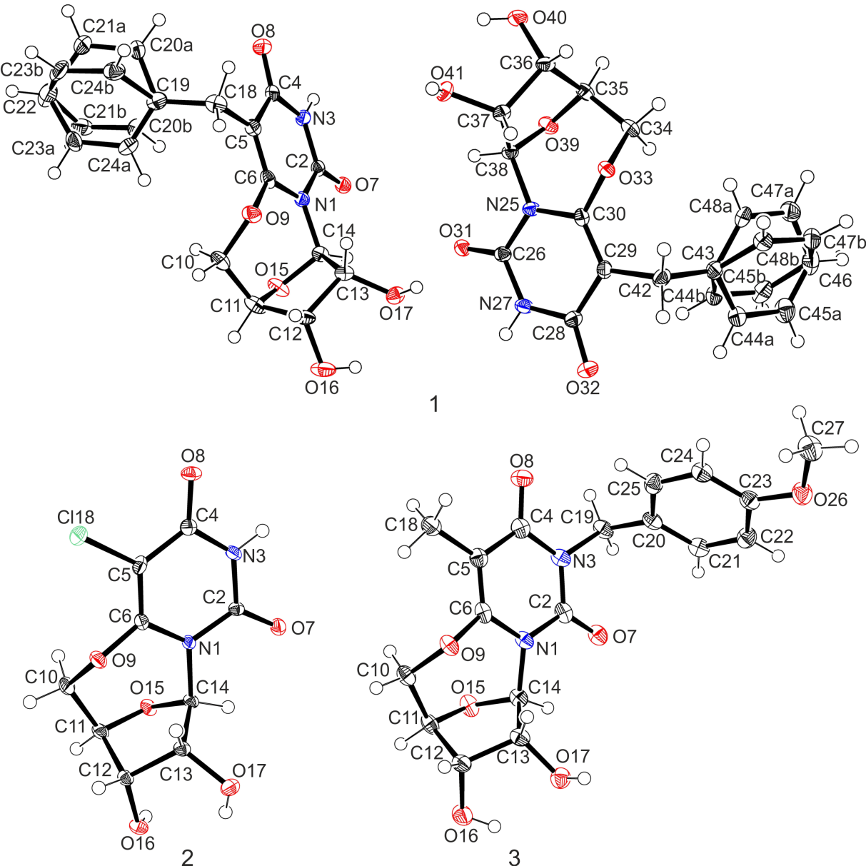
Figure 6. ORTEP drawing showing 50% thermal ellipsoids of 1 (two moieties in the asymmetric unit), 2 and 3. Hydrogen atoms are shown as open circles.

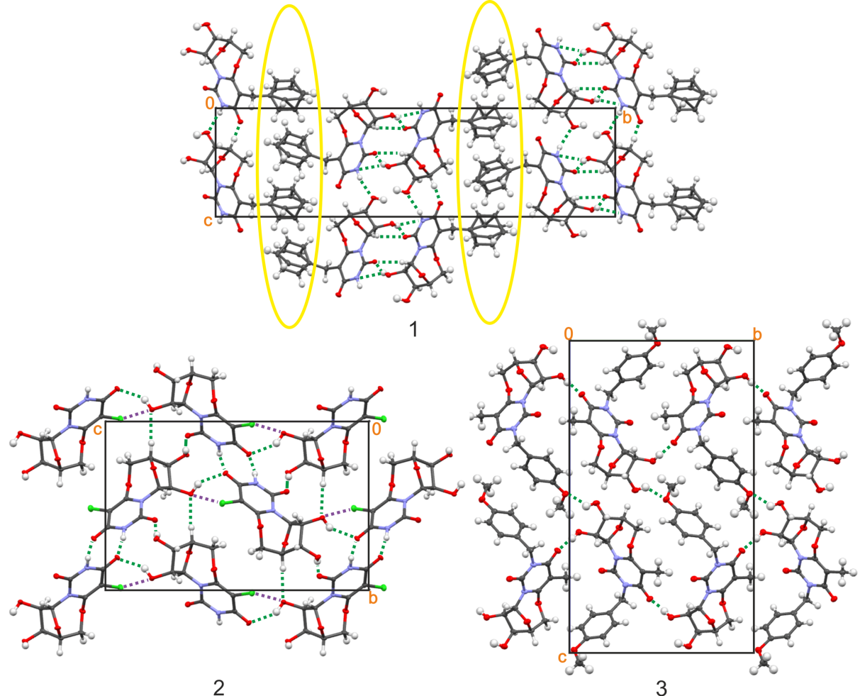

Figure 7. (1) Molecular arrangement in the unit cell of 1, view along the a axis zones encircled by yellow ellipses represents areas where occur many short contacts between disordered phenyl rings. (2) Molecular arrangement in the unit cell of 2, view along the a axis, violet dotted lines represents C−Cl···O halogen interactions. (3) Molecular arrangement in the unit cell of 3, view along the a axis. In all cases, dotted green lines represents the shortest intermolecular contacts (sum of the Van der Waals radii minus 0.2 Ǻ).

The disorder of the benzyl ring in 1 significantly affects the molecular arrangement in the crystal lattice in this way that molecules form specific parallel layers (see Figure 7). The C=O, N−H and O−H groups, which form intermolecular hydrogen bonds, join two molecular layers. Whereas disordered benzyl rings, which do not participate in intermolecular bonds, are directed outside molecular layers. The geometry of selected intermolecular hydrogen bonds is presented in Table 2. Only the contacts shorter than 3 Å were taken into consideration.

Table 2. Geometrical parameters of shortest intermolecular hydrogen interactions in structure of 1, 2 and 3.
Atoms | Symmetry | D−H (Å) | H···A (Å) | D···A (Å) | <(DHA) (°)
1
N3−H3···O16 | x-1, y, z-1 | 0.86 | 2.053 | 2.872 | 159.08
O17−H17···O31 | x, y, z | 0.82 | 1.941 | 2.741 | 164.84
N27−H27···O40 | x, y, z+1 | 0.86 | 2.053 | 2.856 | 155.02
O41−H41···O7 | x+2, y, z | 0.82 | 1.934 | 2.724 | 161.45
2
N3−H3···O8 | x+1/2, -y+1/2, -z+1 | 0.88 | 1.896 | 2.770 | 171.66
O16−H16···O7 | -x+2, y+1/2, -z+1/2 | 0.84 | 1.916 | 2.737 | 165.37
O17−H17···O8 | -x+3/2, -y+1, z-1/2 | 0.84 | 2.124 | 2.879 | 149.38
3
O17−H17···O8 | -x+2, y+1/2, -z+1/2 | 0.84 | 1.865 | 2.702 | 173.71
O16−H16···O26 | -x+3/2, -y+2, z-1/2 | 0.84 | 2.189 | 2.841 | 134.35

5-chloro-6,5'-O-anhydrouridine (2). The derivative 2 crystallizes in the P2₁2₁2₁ space group of the orthorhombic crystal system with one molecule in the asymmetric unit and four in the whole unit cell. The molecule is located in a general position. Three types of short intermolecular contacts: N−H···O, O−H···O and C−Cl···O exist in this structure. Neither halogen···halogen interactions nor disorder was observed. Basic information about the structure of 2 is presented in Table 1. The Ortep drawing of single molecule of 2 is presented in Figure 6, the molecular arrangement in Figure 7. The core molecular fragment in 2 is substituted with chlorine atom which forms a specific halogen bond, namely: Cl18···O17 (3.06 Ǻ). In general, the molecular structure is stabilized by intermolecular hydrogen bonds O−H···O and N−H···O. These are: N3-H3···O8, O16-H16···O7 and O17-H17···O8, respectively. The geometry of the selected hydrogen bonds is presented in Table 2. Only the contacts shorter than 3 Å were considered.

3-(4-methoxybenzyl)-5-methyl-6,5'-O-anhydrouridine (3). The derivative 3 crystallizes also in the orthorhombic P2₁2₁2₁ space group with one molecule in the asymmetric unit and four in the whole unit cell. The molecule is located in a general position. Only one type of intermolecular hydrogen bond: O−H···O exists in this structure. These are O17-H17···O8 and O16-H16···O26. No disorder is present in the molecule. Basic information about structure 3 is presented in Table 1. The Ortep drawing of single molecule of 3 is presented in Figure 6, the molecular arrangement in Figure 7. The geometry of the selected hydrogen bonds is shown in Table 2. Only the strongest intermolecular distances are considered (shorter than 3 Å).

The common pattern for all of the investigated derivatives are hydrogen bonds between the hydroxyl groups of the sugar ring and carbonyl group of the pyrimidine ring as well as between the carbonyl group and N3−H3 in the derivatives 1 and 2 (in the case of 3, the N3 is substituted by 4-methoxybenzyl).
In Figure 8, Hirshfeld surfaces [30-32] illustrating intermolecular interactions among molecules of investigated compounds are presented. The consecutive rows presents the topology of interactions for the 1, 2 and 3 respectively. Numbered interactions marked on fingerprint plots in column II are as follows: (A) applies to the H···O contacts, (B) to H···H contacts, (C) to the O···H contacts and (D) (existing only in the case of compound 2) applies to the Cl···H intermolecular contacts.
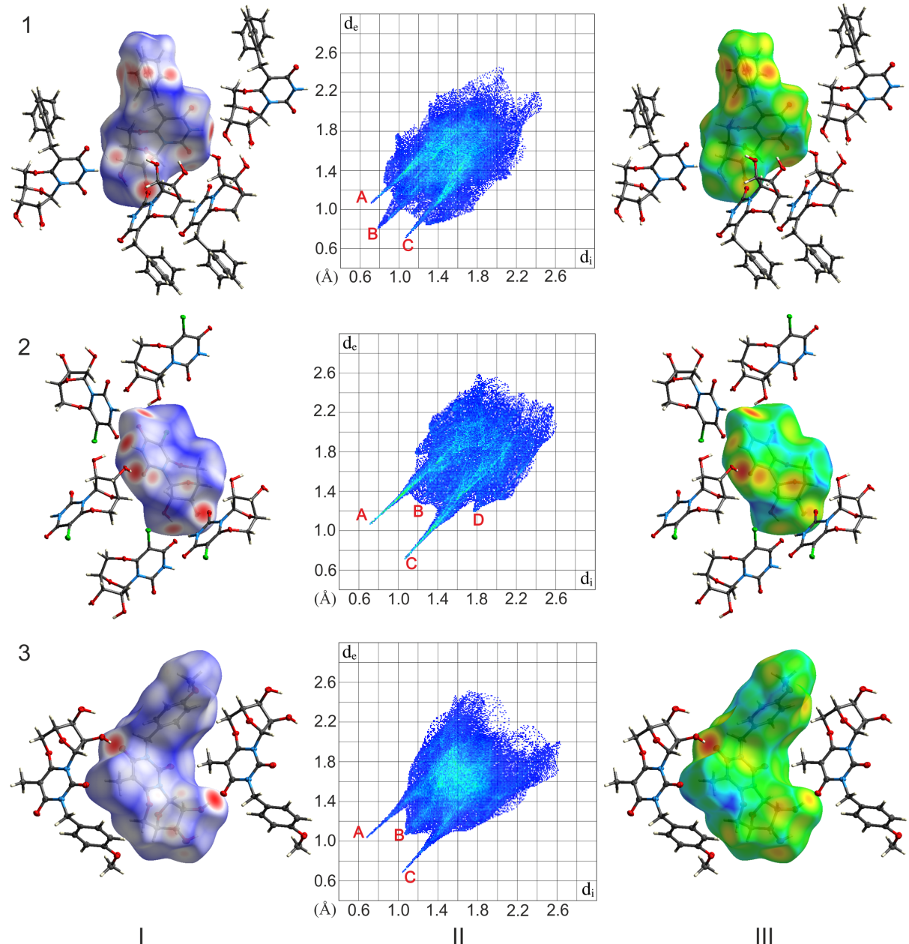
Figure 8. Column I: Hirshfeld surfaces generated with mapped d_{norm} value over the range from 0.643 to 1.224 for 1, from -0.652 to 1.233 for 2 and from -0.688 to 1.309 for 3; Column II: fingerprint plots with intermolecular interactions marked from A to D (description in the text); Column III: Hirshfeld surfaces mapped with d_{e} value illustrating the differences in packing motifs.

Figure 9. Close contacts to the Hirshfeld surface for 1-3 compounds; the percentage contribution to the Hirshfeld surface area for the most significant intermolecular interactions.

A histogram of percentage contributions of essential intermolecular interaction is shown in Figure 9. The percentage contribution of is presented for the four most significant interactions. Other less represented interactions such as H···N, N···O, N···C, C···O, C···C are added together and described as "other". Compounds 1 and 3 are dominated by the H···H contacts (the highest contribution to the Hirshfeld surface - about 50% of all interactions). In the case of compound 2 the most significant contacts are H···O/O···H interactions. The share of H···H and H···C contacts became smaller mostly due to the appearance of H···Cl interactions.

Molecular conformation. The conformation of a cyclonucleoside can be simply defined by some basic parameters such as the glycosidic torsion angle chi (χ) and the puckering of the sugar ring [33]. Puckering of the furanose is described by two parameters: the phase angle of pseudorotation P and the amplitude of pucker v_{max} and can be calculated on the base of equations presented below:
$\tan{P= \frac{\left(θ_{2}+θ_{4}\right)- (θ_{1}+θ_{3})}{2θ_{0}(sin 36+\sin{72})}}$ (1)
$v_{max}=\frac{θ_{0}}{\cos{P}}$ (2)

The glycosidic torsion angle chi (χ) which describes the base/sugar relative orientation, in the case of pyrimidines is defined in terms of the four atoms: O4'-C1'-N1-C2. The sterically preferred ranges for the two domains of glycosidic angles are: anti: -120° > χ > 180° and syn: 0° < χ < 90°. In the case of compounds investigated in this paper, the two domains are bridged so the conformation is imposed. The values of the χ angle in the molecules of 1, 2 and 3 are equal to: -109.19°, -118.86° and -113.06°, respectively. This means that according to the definition mentioned above, the conformation is determined as anti.
The nonplanar conformation of the sugar ring (so called puckering) is defined on the base of the five endocyclic torsion angles within the ring. Calculations of the phase angle of pseudorotation P and the amplitude of pucker were conducted according to procedure described by Altona and Sundaralingam [34]. The phase angle was calculated from the equation (1) and the amplitude from equation (2). The torsion angles χ and θ₀-θ₄ are defined in Figure 10. The values of P and v_{max} are presented in Table 3 (two sets of values for 1 because there are two independent molecules in the asymmetric unit).
Figure 10. Position of the glycosidic torsion angle χ and endocyclic torsion angles θ in the investigated molecules.

Again, in all the cases of molecules investigated in this paper, there is, so called, O(4')-exo and C(4')-endo twist conformation with two adjacent atoms displaced on the opposite sides of a plane through the three other atoms.

Table 3. Values of the phase angle of pseudorotation P and the amplitude of pucker v_{max}.
 | 1 (molecule a) | 1 (molecule b) | 2 | 3
P (°) | 26.0 | 29.0 | 25.0 | 27.4
v_{max} (°) | 41.5 | 42.0 | 42.0 | 38.7

As the only rigid, planar and common part for all the investigated molecules is the pyrimidine ring, an overlay of these particular fragments in all molecules shows some differences between their conformations. This overlay in the plane of the pyrimidine atoms N1, N3 and C5 (Figure 11) shows that in the case of the derivatives 1 and 2, the conformation of the combined core rings is almost identical (see Figure 11A). Despite different space groups in which these derivatives crystallize and different molecular arrangement in the unit cells stabilized by different sets of intermolecular hydrogen bonds, the conformation of the central part of both molecules remains the same. It seems that even disordered benzyl ring in the derivative 1 does not have any significant impact on the rest of the molecule. Simultaneously, the derivative 3 which crystallizes in the same space group as the derivative 2, and does not have any problems with disordered substituent, reveals noticeably distorted ring of sugar moiety in comparison to the derivative 2 (see Figure 11B, blue and green shapes). The situation is, of course, similar when derivatives 1 and 3 are compared.

A B C
Figure 11. Overlay of structures of 6,5'-O-anhydrouridine derivatives: 1 - red molecule, 2 - green molecule, 3 - blue molecule.

Conclusions
We have synthesized a new cyclonucleoside, 3-(4-methoxybenzyl)-5-methyl-6,5'-O-anhydrouridine, and determined its crystal and molecular structure, as well as the structures of the other two - previously synthesized - constrained nucleosides: 5-benzyl-6,5'-O-anhydrouridine and 5-chloro-6,5'-O-anhydrouridine. All the investigated molecules lock the uracil fragment in the anti conformation. The ribose ring has O(4')-exo, C(4')-endo pucker. Different substituents do not affect the conformation of the molecules significantly. The phase angle of pseudorotation P and the amplitude of pucker v_{max} vary within the range from 25° to 29° and from 38.7° to 42°, respectively.

Acknowledgements
This work was supported by Polish Ministry of Science and Higher Education (“Iuventus” grant No. IP2010 026070) and realised as part of POKL 4.1.2-107/09 (co-financed by EC). The equipment used was sponsored in part by the Centre for Preclinical Research and Technology (CePT), a project co-sponsored by European Regional Development Fund and Innovative Economy, The National Cohesion Strategy of Poland. The X-ray studies have been carried out at the Biological and Chemical Research Centre, University of Warsaw, established within the project co-financed by European Union from the European Regional Development Fund under the Operational Programme Innovative Economy, 2007–2013.

References:
[1] D. Honcharenko, O. P. Varghese, O. Plashkevych, J. Barman, J. Chattopadhyaya, J. Org. Chem., 71, (2006), 299-314.
[2] I. Le Clezio, A. Vigroux, J.-M. Escudier, Eur. J. Org. Chem., 12, (2007), 1935-1941.
[3] P. C. Joshi, M. F. Aldersley, D. V. Zagorevskii, J. P. Ferris, Nucleos. Nucleot. Nucl., 31, (2012), 536-566.
[4] A. Mieczkowski, V. Roy, L. A. Agrofoglio, Chem. Rev., 110, (2010), 1828-1856.
[5] Y. Yoshimura, H. Takahata, Molecules, 17, (2012), 11630-11654.
[6] C. Len, M. Mondon, J. Lebreton, Tetrahedron, 64, (2008), 7453-7475.
[7] S. Zhong, M. Mondon, S. Pilard, C. Len, Tetrahedron, 64, (2008), 7828-7836.
[8] T. Kodama, C. Matsuo, H. Ori, T. Miyoshi, S. Obika, K. Miyashita, T. Imanishi, Tetrahedron, 65, (2009), 2116-2123.
[9] C. S. Theile, L. W. McLaughlin, RSC Adv., 2, (2012), 11678-11680.
[10] C. S. Theile, L. W. McLaughlin, Chem. Commun., 48, (2012), 5587-5589.
[11] A. Mieczkowski, L. A. Agrofoglio, Curr. Med. Chem., 17, (2010), 1527-1549.
[12] A. Hamada, T. Kawaguchi, M. Nakano, Clin. Pharmacokinet., 41, (2002), 705-718.
[13] K. Nakamura, Y. Eizuru, K. Kumura, Y. Minamishima, J. Med. Virol., 31, (1990), 141-147.
[14] Z. Veres, A. Szabolcs, I. Shinai, G. Denes, M. Kajtar-Peredy, Biochem. Pharmacol., 34, (1985), 1737-1740.
[15] A. K. Drabikowska, S. Lissowska, Z. Veres, D. Shugar, Biochem. Pharmacol., 36, (1987), 4125-4128.
[16] S. H. Chu, Z. Y. Weng, Z. H. Chen, E. C. Rowe, E. Chu, F. M. N. Naguib, M. El Kouni, S. Cha, M. Y. Chu, Nucleos. Nucleot. Nucl., 7, (1988), 91-102.
[17] M. H. El Kouni, F. M. N. Naguib, S. H. Chu, S. Cha, T. Ueda, G. Gosselin, J.-L. Imbach, Y. F. Shealy, B. A. Otter, Mol. Pharmacol., 34, (1988), 104-110.
[18] T. Ueda, S. Shuto, Chem. Pharm. Bull., 32, (1984), 3410-3416.
[19] A. A. Shaw. J. Cadet, Int. J. Radiat. Biol., 54, (1988), 987-997.
[20] E. Muller, D. Gasparutto, J. Cadet, ChemBioChem, 3, (2002), 534-542.
[21] H. Urata, H. Miyagoshi, T. Kumashiro, T. Yumoto, K. Mori, K. Shoji, K. Gohda, M. Akagi, Org. Biomol. Chem., 2, (2004), 183-189.
[22] T. S. Kumar, A. S. Madsen, J. Wengel, P. J. Hrdlicka, J. Org. Chem., 71, (2006), 4188-4201.
[23] A. Mieczkowski, P. Peltier, T. Zevaco, L. A. Agrofoglio, Tetrahedron, 65, (2009), 4053-4059.
[24] I. Nowak, M. J. Robins, J. Org. Chem., 72, (2007), 2678-2681.
[25] Agilent Technologies Agilent Technologies UK Ltd., 2012, Oxford, UK, Xcalibur/SuperNova CCD system, CrysAlisPro Software system, Version 1.171.36.32.
[26] Sheldrick, G. M. Acta. Cryst. A 2008, 64, 112–122.
[27] Y. Yamagata, K. Tomita, H. Usui, T. Sano, T. Ueda, Chem. Pharm. Bull., 37, (1989), 1971-1976.
[28] S. S. Mande, T. P. Seshadri, M. A. Visvamitra, Acta Cryst. C, 44, (1988), 138-141.
[29] M. Marton-Meresz, J. Kuszmann, I. Pelczer, L. Parkanyi, T. Koritsanszky, A. Kalman, Tetrahedron, 39, (1983), 275-285.
[30] J. J. McKinnon, M. A. Spackman, A. S. Mitchell, Acta Cryst. B, (2004), 60, 627-668.
[31] M. A. Spackman, D. Jayatilaka, Cryst. Eng. Comm., (2009), 11, 19-32.
[32] J. J. McKinnon, M. A. Spackman, Chem. Eur. J., (1998), 4 (11), 2136-2141.
[33] "Principles of nucleic acids structure", Stephen Neidle.
[34] C. Altona, M. Sundaralingam, J. Am. Chem. Soc., , (1972), 8205-8212.

SUPPORTING INFORMATION
Table S1. Full crystal data for spherical refinement of 1, 2 and 3.
 | 1 | 2 | 3
Chemical formula | C₁₆H₁₆N₂O₆ | C₉H₉ClN₂O₆ | C₁₈H₂₀N₂O₇
M_{r} | 332.31 | 276.63 | 376.36
Crystal system, space group | Monoclinic, P2₁ | Orthorhombic, P2₁2₁2₁ | Orthorhombic, P2₁2₁2₁
temperature (K) | 100 | 100 | 100
a (Å) | 5.02114 (11) | 5.3869 (3) | 5.0009 (4)
b (Å) | 32.6293 (9) | 11.2194 (8) | 14.0800 (12)
c (Å) | 9.1556 (2) | 17.5096 (11) | 23.8468 (17)
β (°) | 105.042 (2) | 90.0 | 90.0
V (Å³) | 1448.63 (6) | 1058.23 (12) | 1679.1 (2)
Z | 4 | 4 | 4
F(000) | 696 | 568 | 792
D_{x} (Mg m⁻³) | 1.524 | 1.736 | 1.489
Radiation type | Cu Kα | Mo Kα | Mo Kα
No. of reflections for cell measurement | 5610 | 5641 | 3628
θ range (°) for cell measurement | 5.0–76.6 | 2.2–30.6 | 2.9–24.4
μ (mm⁻¹) | 1.00 | 0.39 | 0.12
Crystal shape | Needle | Needle | Needle
Colour | Colourless | Colourless | Colourless
Crystal size (mm) | 0.14 × 0.03 × 0.03 | 0.29 × 0.11 × 0.06 | 0.46 × 0.09 × 0.04
Diffractometer | SuperNova, Dual, Cu at zero, Atlas  diffractometer | Xcalibur, Opal  diffractometer | Xcalibur, Opal  diffractometer
Radiation source | SuperNova (Cu) X-ray Source | Enhance (Mo) X-ray Source | Enhance (Mo) X-ray Source
Monochromator | Mirror | Graphite | Graphite
Detector resolution (pixels mm⁻¹) | 5.2195 | 8.4441 | 8.4441
Scan method | ω scans | ω scans | ω scans
Absorption correction | Multi-scan | Multi-scan | Multi-scan
T_{min}, T_{max} | 0.752, 1.000 | 0.522, 1.000 | 0.765, 1.000
Measured reflections | 27853 | 21644 | 22970
independent reflections | 5785 | 3601 | 4040
observed reflections [I > 2σ(I)] | 5021 | 2844 | 2715
R_{int} | 0.070 | 0.096 | 0.099
θ values (°) | θ_{max} = 76.9, θ_{min} = 2.7 | θ_{max} = 32.2, θ_{min} = 2.2 | θ_{max} = 28.8, θ_{min} = 2.2
(sin θ/λ)_{max} (Å⁻¹) | 0.632 | 0.750 | 0.677
Range of h, k, l | h = -6→5  k = -40→38  l = -11→11 | h = -7→8  k = -16→16  l = -26→26 | h = -6→6  k = -18→18  l = -31→31
Refinement on | F² | F² | F²
R[F² > 2σ(F²)], wR(F²), S | 0.040, 0.086, 1.03 | 0.047, 0.095, 1.03 | 0.053, 0.089, 1.04
No. of reflections | 5785 | 3601 | 4040
No. of parameters | 510 | 165 | 248
No. of restraints | 1 | 0 | 0
H-atom treatment | H-atom parameters constrained | H-atom parameters constrained | H-atom parameters constrained
Weighting scheme | w = 1/[σ²(F_{o}²) + (0.0342P)² + 0.1907P]  where P = (F_{o}² + 2F_{c}²)/3 | w = 1/[σ²(F_{o}²) + (0.0377P)²]  where P = (F_{o}² + 2F_{c}²)/3 | w = 1/[σ²(F_{o}²) + (0.0291P)²]  where P = (F_{o}² + 2F_{c}²)/3
(Δ/σ)_{max} | 0.001 | 0.001 | 0.001
Δρ_{max}, Δρ_{min} (e Å⁻³) | 0.23, -0.24 | 0.46, -0.36 | 0.24, -0.25

