Toxins 2015, 7, 1-x manuscripts; doi:10.3390/toxins70x000x
OPEN ACCESS
toxins
ISSN 2072-6651
www.mdpi.com/journal/toxins
Article
A simple and rapid procedure for the detection of genes coding for Shiga toxins and other DNA sequences by visual observation of PCR- derived signal directly in the reaction tube
Bożena Nejman-Faleńczyk¹*, Sylwia Bloch¹, Aleksandra Januszkiewicz², Alicja Węgrzyn³, Grzegorz Węgrzyn¹
¹ Depratment of Molecular Biology, University of Gdańsk, Wita Stwosza 59, 80-308 Gdańsk, Poland; E-Mails: bozena.nejman@ug.edu.pl (B.N-F); sylwia.bloch@biol.ug.edu.pl (S.B.); grzegorz.wegrzyn@biol.ug.edu.pl (G.W.);
² Department of Bacteriology, National Institute of Public Health - Public Institute of Hygiene, 24 Chocimska Street, 00-791 Warsaw, Poland; E-Mail: ajanuszkiewicz@pzh.gov.pl(A.J.);
³ Laboratory of Molecular Biology (affiliated with the University of Gdansk), Institute of Biochemistry and Biophysics, Polish Academy of Sciences, Wita Stwosza 59, 80-308 Gdansk, Poland; E-Mail: alicja.wegrzyn@biol.ug.edu.pl (A.W.)
* Author to whom correspondence should be addressed; E-mail: bozena.nejman@ug.edu.pl; Tel.: +48 58 523 6038; Fax: +48 58 523 6025.
Academic Editor:
Received: / Accepted: / Published:

Abstract: A novel procedure for detection of specific DNA sequences has been developed. The procedure is based on the already known method employing PCR with appropriate primers and a sequence-specific DNA probe labeled with the fluorescent agent, 6-carboxylfluorescein (FAM) at the 5’ end and the fluorescence quencher BHQ-1 (Black Hole Quencher) at the 3’ end. However, instead of detection of the fluorescence signal with the use of real-time PCR cyclers, fluorescence/luminescence spectrometers or fluorescence polarization readers, as in all previously reported procedures, we propose visual observation of the fluorescence under UV light directly in the reaction tube. An example for specific detection of the Shiga toxin-producing Escherichia coli (STEC) strains, by detecting Shiga toxin genes is demonstrated. The method appeared specific, simple, rapid and cost effective. It may be suitable for the use in research laboratories as well as in diagnostic units of medical institutions, even those equipped with only a thermocycler and UV transilluminator, particularly if rapid identification of a pathogen is required.
Keywords: DNA amplification; detection methods; PCR product detection; Shiga toxin-producing Escherichia coli; stx genes.

1. Introduction
Polymerase chain reaction (PCR) is widely used in both basic research and biotechnological and medical applications, to such an extent that it is considered a very common technique for most genetic analyses. Although the reaction conditions can be optimized to get the best specificity and efficiency, perhaps the detection of specific PCR products is the rate-limiting step in vast majority of PCR-based techniques. A number of methods for detection of such products have been proposed and reported; among them, gel electrophoresis and various hybridization procedures (e.g. dot-blot, Southern blot, reverse hybridization, DNA enzyme immunoassay etc.) predominate [1-9]. A wide range of commercialized diagnostic methods is based on combination of PCR and gel electrophoresis. The main disadvantage of such combination is the lack of possibility to distinguish between specific and non-specific amplification products, thus, many laboratories use additional techniques to confirm the specificity of the amplified PCR product [10]. Despite the fact that different methods could improve sensitivity or specificity of the detection, such procedures, which are performed after the DNA amplification reaction, are time consuming, laborious and/or requiring specialized and expensive equipment [12-15]. This could be a real problem, particularly if rapid detection of a specific signal is crucial and the presence of sophisticated equipment is problematic, like in diagnostic procedures performed in local (small) medical laboratories. Therefore, we aimed to develop a simple and rapid procedure for detection of specific PCR products, which could be used even in basically-equipped laboratory.
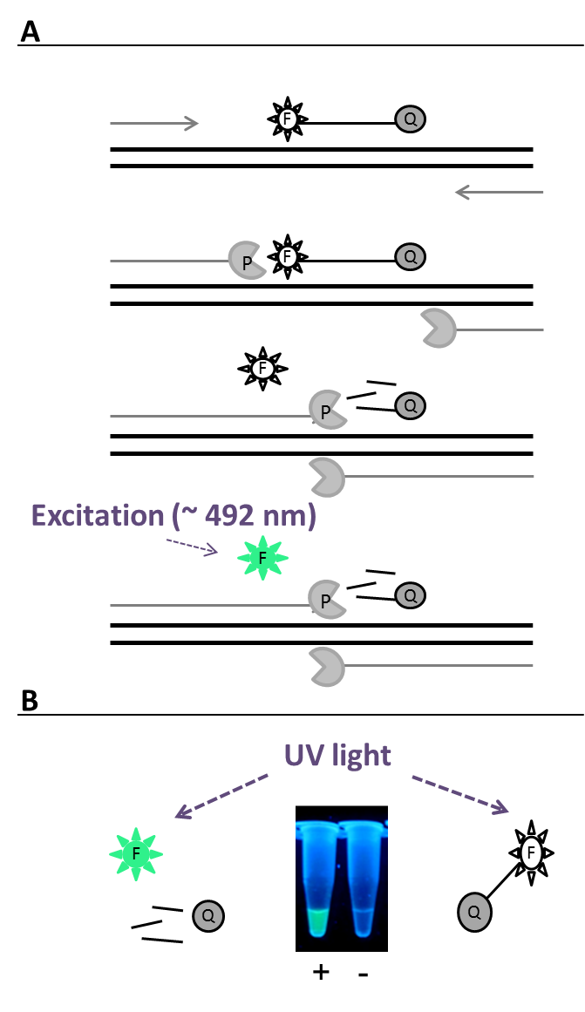
One of the already known methods for detection of the presence of certain DNA sequences is based on the PCR reaction with appropriate primers and specific probes labeled with the fluorescent agent, 6-carboxylfluorescein (FAM) at the 5’ end and the fluorescence quencher BHQ-1 (Black Hole Quencher) at the 3’ end . FAM is a fluorescein derivative with excitation peak at 492 nm and emission peak at 517 nm [16-19]. According to this method, the fluorescence may appear only if the probe hybridizes to the target DNA region and is subsequently degraded by the Taq DNA polymerase extending a specific primer designed to amplify a DNA fragment that includes the probe binding site. In such a case FAM is no longer located in the proximity of BHQ-1, thus its fluorescence is not quenched and light might be emitted after excitation at appropriate wavelength [16,18,19] (Figure 1A). However, in previously reported procedures employing this phenomenon, the fluorescence emitted by FAM was detected using light excitation sources of wavelength in the range of visible spectrum, near to the excitation maximum of FAM (~ 492 nm), such as lasers and diodes in real-time PCR cyclers, fluorescence/luminescence spectrometers or fluorescence polarization readers [18,20,21] which made them relatively expensive. Thus, we asked if it is possible to simplify the detection procedure, to make it inexpensive and rapid, while still keeping its sensitivity at an acceptable level. We would like to propose different detection manner of fluorescence emitted by FAM, released from the BHQ-1 influence, based on the excitation with light outside the visible range i.e. ultraviolet light, directly in reaction tube (Figure 1B). The modification we aimed to introduce allow to confirm the presence of the target DNA, amplified during PCR reaction in the test tube, without the need of running agarose gel electrophoresis. Such method would be particularly desired in detection of pathogenic microorganisms, especially those requiring rapid diagnostic methods.
Figure 1. (A) A scheme for the procedure of detection of specific DNA sequences reported in this work. The procedure is based on the already known method employing PCR with DNA polymerase (designated as P), appropriate primers and a sequence-specific DNA probe labeled with the fluorescent agent, FAM, (designated as F) at the 5’ end and the fluorescence quencher, BHQ-1 (designated as Q), at the 3’ end. (B) Visual observation of the fluorescence under UV light at 302 nm directly in the reaction tube is proposed, instead of detection of the fluorescence signal with the use of real-time PCR cyclers, fluorescence/luminescence spectrometers or fluorescence polarization readers, and as an alternative to gel electrophoresis technique. PCR reactions with (+) and without (-) target, pathogenic DNA, were analyzed.
One of pathogenic microorganisms which should be rapidly detected is Shiga toxin-producing Escherichia coli (STEC), also called verotoxic E. coli, and thus, we decided to use these bacteria in testing the new procedure. STEC is a group of bacterial strains belonging to the normally non-pathogenic species (E. coli), which gained genes making them serious pathogens [22]. Best known examples are genes coding for Shiga toxins (stx), located on lambdoid prophages called Shiga toxin-converting (shortly Stx) prophages which are responsible for their transmission between E. coli species [23]. When infecting human intestine, such bacteria may cause serious symptoms, which are especially severe in the case of a subset of STEC, called enterohemorrhagic E. coli (EHEC). These symptoms include bloody diarrhea, which can progress to hemorrhagic colitis or hemolytic uremic syndrome [24]. Importantly, treatment of patients infected with STEC is often problematic as many antibiotics stimulate induction of Shiga toxin-converting prophages, the event which is necessary for efficient expression of Shiga toxin genes, thus, enhancing severity of the disease symptoms [25]. The importance of STEC-dependent health problems can be highlighted by results of the recent outbreak that occurred in Germany in 2011, when out of over 4,000 symptomatic infections, over 50 patients died [26-29].
Since treatment of patients infected with STEC should be considerably different from that recommended in the case of other infectious diseases, it was stressed that proper and rapid identification of the pathogen is crucial when production of Shiga toxin is supposed [30]. This implies that rapid diagnostic procedures are required. However, contrary to early predictions, serological tests are not adequate for STEC detection, as Shiga toxins can be produced by various E. coli serotypes [23]. Therefore, DNA-based methods appears to be mandatory for unequivocal identification of STEC. Nevertheless, although different sophisticated methods for very precise and even quantitative determination of the presence of these bacteria have become available, as summarized recently [30], vast majority of them are either time-consuming or expensive or both. Therefore, such method may be excellent for more detailed analyses, but perhaps unavailable or even useless for rapid detection of STEC infection in small laboratories, like those located in many provincial hospitals. Hence, we assumed that development of a simple, specific and quick method for rapid detection of STEC may be an example for potential usefulness of the novel procedure described in this report.

2. Results and Discussion
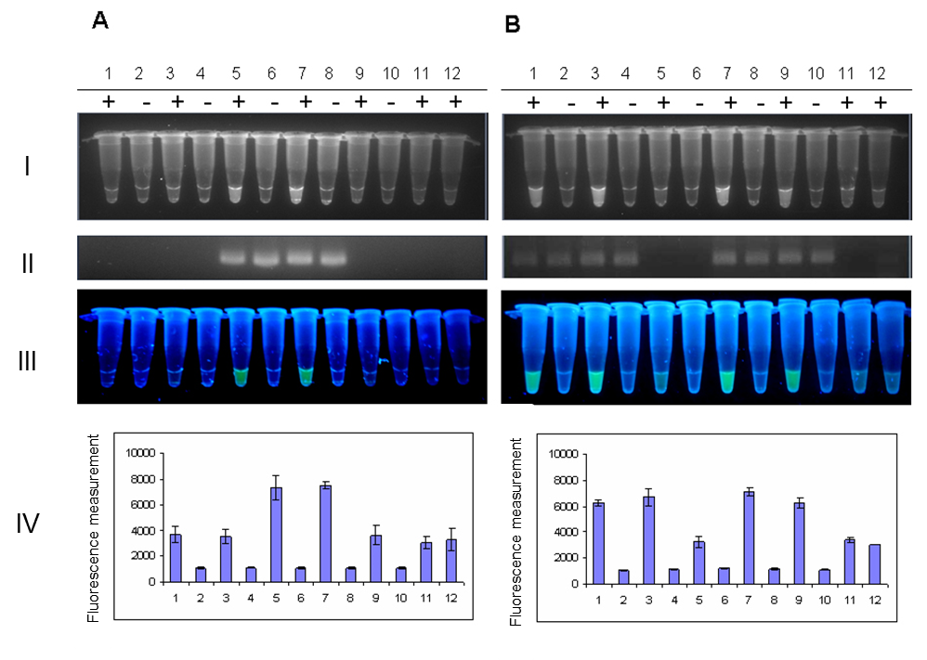
The specific PCR amplification of fragments of genes encoding for Shiga toxins 1 and 2, in the presence of probes labeled with the fluorescent agent FAM and the fluorescence quencher BHQ-1, was performed according to already known method [16, 17]. In the procedure described in this report, we propose to detect the specific fluorescent signal by simple observation of the reaction tube over a UV transilluminator (Figure 1B). We found that detection of such a signal is unequivocal, and the signal is specific. When 20 different E. coli strains (Table 1) were investigated, the fluorescence occurred only when genomes of the tested bacteria contained the target gene(s) (either stx1 or stx2 or both). We observed 100% compatibility between results obtained by proposed method and results presented in Table 1, obtained by methods determined as “gold standards”. Figure 2 shows examples of these experiments, with controls including analyses of PCR products by agarose gel electrophoresis and results of measurement of the generated, during each PCR reaction, fluorescence signal at 485/535 nm. The fluorescence light, emitted in response to UV exposure, was compatible with the agarose gel band patterns and measurements of fluorescence signal on plate reader. As described previously [31], the FAM-BHQ labelled probe, which is not degraded during PCR reaction (because of lack of the target DNA), exhibit some level of background fluorescence. In negative controls, the background fluorescence comes from the unhybridized probe itself and is typical for such linear probes because of the relatively long distance between fluorescence reporter and quencher which results in the inefficient quenching. The level of the background fluorescence can be detected by sensitive fluorescence detectors like real-time PCR cyclers or plate readers as in this particular case (Figure 2, panel A-IV columns 1, 3, 9, 11, 12 and panel B-IV columns 5, 11, 12). Interestingly, as indicated on Figure 2 (panels A and B, row I) in the proposed method, the level of the background fluorescence is low enough and not visible during observation of the tubes under UV light.

Figure 2. The analysis of STEC strains: 286/00 (stx1⁻ stx2⁺) (lanes 1-2), 201/01 (stx1⁻ stx2⁺) (lanes 3-4), 319/01 (stx1⁺ stx2⁻) (lanes 5-6), 44/02 (stx1⁺ stx2⁺) (lanes 7-8), and 174/03 (stx1⁻ stx2⁺) (lanes 9-10) for the presence of the gene encoding (A) Shiga toxin 1 and (B) Shiga toxin 2, using PCR with a FAM- and BHQ-1 labelled probe (+) or without such a probe (-). Detection of the signal from the probe tox1probe or tox2probe, complementary to the gene encoding Shiga toxin 1 or Shiga toxin 2, respectively, was performed using: (I) the gel documentation system Gel Doc XR – Bio-Rad, (II) analysis of PCR products by agarose gel electrophoresis, (III) UV transilluminator, or (IV) measurement of the fluorescence signal at 485/535 nm (means of 3 experiments ± SD) on plate reader. The control reaction performed without the DNA template (lane 11), and the reaction performed with genomic DNA of the E. coli MG1655 strain, which does not contain genes coding for Shiga toxin 1 and 2 (lane 12), are shown.

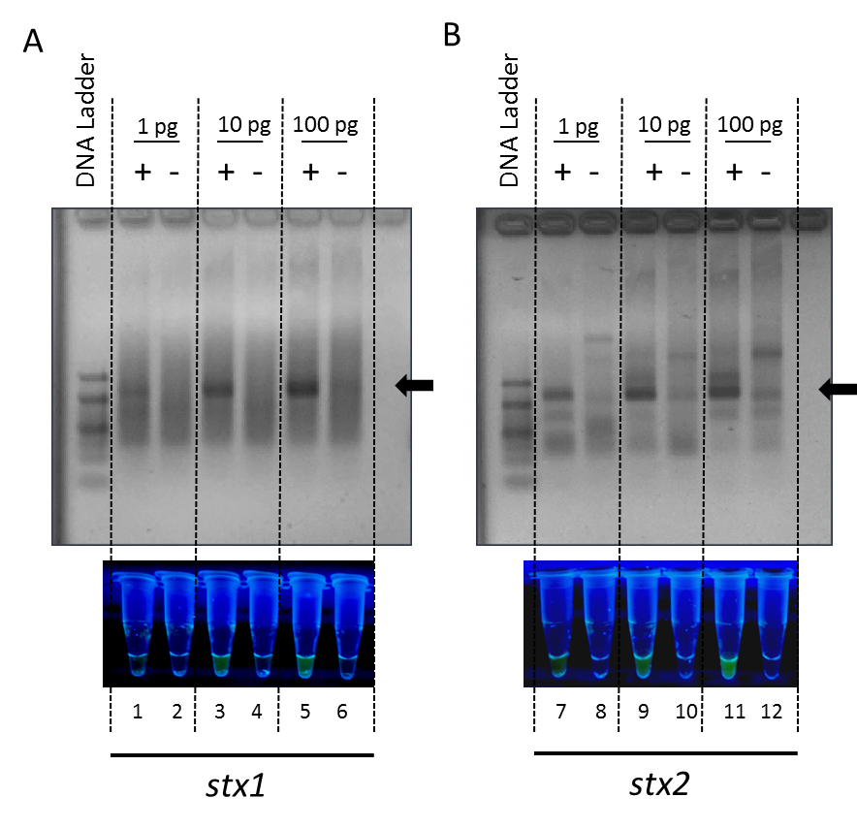
Due to the fact that phages bearing stx1 and stx2 genes can be transmitted to previously non-pathogenic E. coli bacteria [32,33] which naturally occur in the human gut, the detection of these genes might be difficult and give false positive results as nonspecifically primed reaction may occur [34,35]. Keeping this in mind, we decided to check how the proposed method works in situation with increased risk of nonspecific primer binding. For that, we used DNA coming from EDL933W strain which is stx-positive (+) and stx-negative (-) E. coli K12 strain MG1655 as the representative of non-pathogenic bacteria. DNA was used in different amounts: 1, 10 and 100 pg , prepared as ten-fold dilutions of 1 ng of genomic DNA which correspond to the 168, 1680 and 16800 CFU, respectively. Additionally, we increased number of PCR cycles to 40, as an excessive cycling is one of the ways which increases the opportunity for nonspecific amplification [36,37]. As expected, analysis of PCR products by agarose gel electrophoresis allowed us to identify smeared and nonspecific bands, especially occurring in the case of stx2 detection (Figure 3). Note, that the similar problem with nonspecific binding during PCR-based detection of stx2 gene was also described previously by Fagan and collaborators [34]. Importantly, even in the case of appearance of nonspecific PCR products (which is likely to occur during testing of previously unknown, natural isolates of bacteria), the fluorescence is not detected over a UV transilluminator, contrary to the presence of DNA bands and smears on an electrophoregram (Figure 3). The proposed by us, post-PCR visual observation of the fluorescence directly in the tube, allows to avoid false positive results in dubious situation when the nonspecific PCR product has a size close to the size of a target amplicon (Figure 3, lane 12). The specificity of presented method is increased in comparison with conventional PCR because of the probe which is an additional complementary regions within the template DNA. This may indicate that interpretation of the results of the test performed according to the proposed procedure is easier than that of the traditional PCR-based assay, thus, the former method is more specific, while as indicated on Figure 3, its sensitivity places at the similar level equal to 10 pg for both genes .

Figure 3. The analysis of STEC stx-positive strain (+) EDL933W and stx-negative (-) MG1655 strain of E. coli K12 bacteria for the presence of the genes encoding Shiga toxins 1 and 2 and occurrence of nonspecific PCR products using PCR with a FAM- and BHQ-1 labelled probe. Detection of the signal from the probes tox1probe or tox2probe, complementary to the gene encoding Shiga toxin 1 or Shiga toxin2, respectively was performed by analysis of PCR products by agarose gel electrophoresis and using UV transilluminator. Black arrows indicate the size of target PCR products: 196 bp for stx1 and 211 bp for stx2 .
The total time required for the procedure proposed in this report is as short as 1.5 h, including genomic DNA isolation and PCR amplification with simultaneous annealing and extension steps (see Experimental Section for details). As the detection method is based on simply PCR reaction, the only special equipment necessary to follow this consists of a thermocycler and UV transilluminator, which are usually available in most laboratories (including those located in provincial hospitals), so it can be easily applied for rapid, preliminary detection of not only STEC bacteria but also other pathogens. Following this, we found that this procedure may be used in detection of tick-transmitted bacteria. We performed PCR amplification with primers and probe that are complementary to sequence encoding 16S rRNA of Bartonella henselae under the same conditions as those used for detection of stx genes (Figure 4, lane 3). Again, a signal was detected only in the presence of B. henselae DNA, indicating specificity of the assay (Figure 4).
As described previously [38,39], non-specificity is the serious problem of PCR-based detection of 16S rRNA sequences of bacteria that are transmitted by ticks. Massung and Slater [38] indicated that one of the evaluated PCR based-assays, designed for detection of 16S rRNA gene of Anaplasma phagocytophilum, the human granulocytic ehrlichiosis (HGE) agent, may amplify also 16S rRNA of other tick bacteria: Rickettsia rickettsii and Bartonella henselae, the non-HGE agents. Similarly to described above difficulties with false positive detection of STEC infections, such a scenario may result in the false diagnosis of HGE infection and unappropriate medical treatment in both situations. Hence, there is a need to improve the specificity of PCR-based detection assays, and we believe that our method (as an alternative to standard PCR or its supplementation), could be a solution of this problem.
In summary, we propose a simple, rapid and inexpensive procedure for detection of the specific fluorescence signal after the PCR reaction with primers designed for amplification of particular DNA fragment. As examples for the usefulness, we have demonstrated that this method is suitable for identification of the presence of STEC and B. henselae.

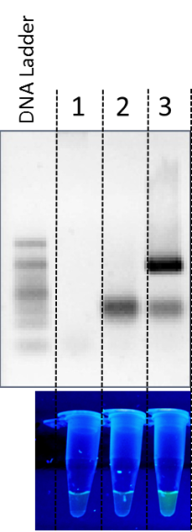

Figure 4. The analysis of the DNA from Bartonella henselae strain Huston-1 for the presence of the sequence encoding 16S rRNA using PCR amplification with a FAM- and BHQ-1 labelled probe. Detection of the signal from the probe 16SrRNABhprobe complementary to the gene encoding 16S rRNA was performed by analysis of PCR products by agarose gel electrophoresis and using UV transilluminator. The control reactions were performed without the primers (lane 1) or DNA template (lane 2). The target PCR product of size 180 bp is indicated by the black arrow (lane 3).

3. Experimental Section

3.1. Bacterial strains
Escherichia coli strains were descended from collections of National Institute of Public Health - National Institute of Hygiene (Warsaw, Poland) and Department of Molecular Biology of the University of Gdańsk (Poland). Characteristics of all strains is provided in Table 1. STEC strains were identified by using the commonly accepted methods (“gold standards”), i.e. by employing commercially available cytotoxic test on the Vero cell line [40] or commercially available VTEC-RPLA assay (Oxoid Ltd, Basingstoke, United Kingdom) as described previously [41]. Additionally, the results were confirmed by the PCR-based method [42, 43].
Table 1. Escherichia coli strains
No. | Strain | Serotype | stx1 status | stx2 status
1 | 286/00 | O157 | - | +
2 | 44/02 | O157 | + | +
3 | 174/03 | O157 | - | +
4 | 49/04 | O157 | + | +
5 | 365/05 | O157 | + | +
6 | 206/06 | O157 | + | +
7 | 443//07 | O157 | + | +
8 | 474/07 | O157 | + | +
9 | 9/08 | O157 | - | +
10 | 221/08 | O157 | + | +
11 | 371/08 | O157 | - | +
12 | 171/09 | O157 | - | +
13 | 74/10 | O157 | - | +
14 | 245/10 | O111 | - | +
15 | 251/10 | O157 | + | +
16 | 201/01 | O26 | - | +
17 | 319/01 | O26 | + | -
18 | 571 | O157 | + | +
19 | EDL933W | O157 | + | +
20 | MG1655 | K12 | - | -

3.2. DNA amplification and detection of signals specific for particular DNA sequences
Genomic DNA from bacterial strains was isolated by either the boiling method [44] or in accordance to the method described previously [45]. Genomic DNA from Bartonella henselae strain Houston-1 (cat. No 49882D-5) was provided by ATCC. DNA concentration was determined using NanoDrop 1000 purchased from Thermo Fisher Scientific (Waltham, MA, USA).
Primers used in PCR reactions were as follows: tox1F (5’- GAC GAT ACC TTT ACA GTT AAA GTG GGT) and tox1R (5’- TCT CCG CCT GCT ATT TTC ACT) for stx1 (coding for Shiga toxin 1), and tox2F (5’- TTC CAA GTA TAA TGA GGA TGA CAC A) and tox2R (5’- CCC ACA TAC CAC GAA TCA GGT) for stx2 (coding for Shiga toxin 2) and 16SrRNABhF (5’ – CGT CAG TAA TGG ACC AGT GAG CC) and 16SrRNABhR (5’ GCA TGT AGG ATA TTT AAG TCA GAG). The lengths of reaction products were 196 and 211 bp, for stx1 and stx2, respectively and 180 bp for 16S rRNA. The probes added to PCR reactions at concentration 150 nM were labeled at the 5’ end with the fluorescent agent FAM (6-carboxylfluorescein), and at the 3’ end with the fluorescence quencher BHQ-1 (Black Hole Quencher). The nucleotide sequences of the probes were as follows: tox1probe (for stx1) - 5’-(FAM)-AAT CTT CAG TCT CTT CTT CTC AGT GCG CAA AT-(BHQ-1); tox2probe (for stx2) - 5’-(FAM)-AAT CTG CAA CCG TTA CTG CAA AGT GCT CA-(BHQ-1) and 16SrRNABhprobe (for 16S rRNA of Bartonella henselae) - 5’-(FAM)-TAC CTC TAC ACT CAG AAT TCC ACT CAC CTC TTC CA-(BHQ-1). The sequences of these probes were designed, and the modified probes were purchased from Oligo.pl (Warsaw, Poland) and Sigma Aldrich (St. Louis, MO, USA).
The PCR reactions were performed with the use of Taq polymerase, employing the DFS-Taq DNA Polymerase kit (BIORON GmbH, Ludwigshafen, Germany), and dNTPs (Thermo Fisher Scientific, Waltham, MA, USA) under conditions recommended by the manufacturers and using following program: 2 min initial denaturation at 95ºC, followed by 28 (or 40 in experiment from Figure 3) cycles of denaturation for 15 sec, simultaneous annealing and extension, for 1 min at 60 ºC. In the presence of stx1 or stx2 in the tested genome of E. coli strain or sequence of 16S rRNA in the genomic DNA of Bartonella henselae, fluorescence appeared after the PCR reaction. This fluorescence was observed in a dark room over a UV transilluminator (Vilber Lourmat, Marne-la-Vallѐe, France) and photos were taken using digital camera Panasonic Lumix DMC-FX60 (Panasonic, Osaka, Japan). Measurement of the fluorescence signal at 485/535 nm were performed using plate reader VIKTOR 1420 (Perkin Elmer, Waltham, MA, USA). PCR amplification products were separated via 2% agarose (Prona, Spain) gel electrophoresis, performed at 100V and visualized, after staining with ethidium bromide (Sigma Aldrich, St. Louis, MO, USA), using the gel documentation system Gel Doc XR (Bio-Rad Laboratories, Hercules, CA, USA).

4. Conclusions
A new specific rapid and inexpensive procedure for identification of bacteria containing pathogenic genes has been developed. The method is based on detection of the fluorescent signal under UV light directly in the reaction tube.

Acknowledgments
This work was supported by The National Centre for Research and Development, the LIDER Programme (grant no. LIDER/21/92/L-3/11/NCBR/2012) and Foundation for Polish Science Ventures Programme co-financed by the EU European Regional Development Fund (grant no. Ventures/2009-3/6). The new procedure for detection of Shiga toxin genes described in this report achieved patent protection (no PL218839 B1) granted by Polish Patent Office.

Author Contributions
B.N-F. has contributed to the conception and the design of the study, participated in performance of all the experiments, analyzed and interpreted the results, was a principal investigator in the project grants and has been involved in preparation of the manuscript. S.B. participated in the performance of experiments which results are presented in Figure 3, analyzed output data and has been involved in preparation of the manuscript. A.J. collected and identified the STEC strains and carried out the isolation of their DNA. A.W and G.W supervised the study and participated in its design, have been involved in drafting the manuscript and have given final approval of the manuscript.

Conflicts of Interest
The authors declare no other conflicts of interest.

References and Notes
- Armua-Fernandez, M.T.; Nonaka, N.; Sakurai, T.; Nakamura, S.; Gottstein, B.; Deplazes, P.; Phiri, I.G.; Katakura, K.; Oku, Y. Development of PCR/dot blot assay for specific detection and differentiation of taeniid cestode eggs in canids. Parasitol. Int. 2011, 60, 84–89.
- Curry, E.; Pratt, S.L.; Kelley, D.E.; Lapin, D.R.; Gibbons, J.R. Use of a Combined Duplex PCR/Dot Blot Assay for more sensitive genetic characterization. Biochem. Insights 2008, 1, 35–39.
- Boerner, B.; Weigelt, W.; Buhk, H.J.; Castrucci, G; Ludwig, H. A sensitive and specific PCR/Southern blot assay for detection of bovine herpesvirus 4 in calves infected experimentally. J. Virol. Methods 1999, 83, 169–180.
- Ryschkewitsch, C.; Jensen, P.; Hou, J.; Fahle, G.; Fischer, S.; Major, E.O. Comparison of PCR-southern hybridization and quantitative real-time PCR for the detection of JC and BK viral nucleotide sequences in urine and cerebrospinal fluid. J. Virol. Methods 2004 , 121, 217–221.
- Hsu, Y.C.; Yeh, T.J.; Chang, Y.C. A new combination of RT-PCR and reverse dot blot hybridization for rapid detection and identification of potyviruses. J. Virol. Methods 2005, 128, 54–60.
- Kong, F.; Gilbert, G.L. Multiplex PCR-based reverse line blot hybridization assay (mPCR/RLB) – a practical epidemiological and diagnostic tool. Nat. Protoc. 2007, 1, 2668–2680.
- Jantos, C.A.; Roggendorf, R.; Wuppermann, F.N.; Hegemann, J.H. Rapid detection of Chlamydia pneumoniae by PCR-enzyme immunoassay. J. Clin. Microbiol. 1998, 36, 1890–1894.
- Mantero, G.; Zonaro, A.; Albertini, A.; Bertolo, P; Primi, D. DNA enzyme immunoassay: general method for detecting products of polymerase chain reaction. Clin. Chem. 1991, 37, 422–429.
- Osawa, Y.; Ikebukuro, K.; Motoki, H.; Matsuo, T.; Horiuchi, M.; Sode, K. (2008) The simple and rapid detection of specific PCR products from bacterial genomes using Zn finger proteins. Nucleic Acids Res. 2008, 36, e68.
- Bartlett, J.M.S.; Stirling, D. Methods in Molecular Biology: PCR Protocols, 2nd ed.; Humana Press: New York, USA, 2003.
- Findlay, J.B.; Atwood, S.M.; Bergmeyer, L.; Chemelli, J.; Christy, K.; Cummins, T.; Donish, W.; Ekeze, T.; Falvo, J.; Patterson, D. Automated closed-vessel system for in vitro diagnostics based on polymerase chain reaction. Clin. Chem. 1993, 39, 1927–1933.
- Kai, E.; Ikebukuro, K.; Hoshina, S.; Watanabe, H; Karube; I. Detection of PCR products of Escherichia coli O157:H7 in human stool samples using surface plasmon resonance (SPR). FEMS Immunol. Med. Microbiol. 2000, 29, 283–288.
- Hsu, T.M.; Law, S.M.; Duan, S.; Neri, B.P.; Kwok, P.Y. Genotyping single-nucleotide polymorphisms by the invader assay with dual-color fluorescence polarization detection. Clin. Chem. 2001, 47, 1373–1377.
- Espy, M.J.; Uhl, J.R.; Sloan, L.M., Buckwalter, S.P.; Jones, M.F.; Vetter, E.A.; Yao, J.D.; Wengenack, N.L.; Rosenblatt, J.E.; Cockerill, F.R.; Smith, T.F. Real-time PCR in clinical microbiology: applications for routine laboratory testing. Clin. Microbiol. Rev. 2006, 19, 165–256.
- Park, S.; Zhang, Y.; Lin, S.; Wang, T.H.; Yang S. Advances in microfluidic PCR for point-of-care infectious disease diagnostics. Biotechnol. Adv. 2011, 29, 830-839.
- Livak, K.J.; Flood, S.J.; Marmaro, J.; Giusti, W.; Deetz, K. Oligonucleotides with fluorescent dyes at opposite ends provide a quenched probe system useful for detecting PCR product and nucleic acid hybridization. PCR Methods Appl. 1995, 4, 357–362.
- Heller, L.C.; Davis, C.R.; Peak, K.K.; Wingfield, D.; Cannons, A.C.; Amuso, P.T.; Cattani, J.; Comparison of methods for DNA isolation from food samples for detection of Shiga toxin-producing Escherichia coli by real-time PCR. Appl. Environ. Microbiol. 2003, 69, 1844–6.
- Bustin, S.A. Absolute quantification of mRNA using real-time reverse transcription polymerase chain reaction assays. J. Mol. Endocrinol. 2000, 25, 169–193.
- Didenko, V.V. DNA probes using fluorescence resonance energy transfer (FRET): designs and applications. Biotechniques 2001, 31, 1106-1116, 1118, 1120–1121.
- Gelmini, S.; Orlando, C.; Sestini, R.; Vona, G.; Pinzani, P.; Ruocco, L.; Pazzagli, M. Quantitative polymerase chain reaction-based homogeneous assay with fluorogenic probes to measure c-erbB-2 oncogene amplification. Clin. Chem. 1997, 43, 752–758.
- Latif, S.; Bauer-Sardina, I.; Ranade, K.; Livak, K.J.; Kwok, P.Y. Fluorescence polarization in homogeneous nucleic acid analysis II: 5'-nuclease assay. Genome Res. 2001, 11, 436–440.
- Hunt, J.M. Shiga toxin-producing Escherichia coli (STEC). Clin. Lab. Med. 2010, 30, 21–45.
- Bloch, S.K.; Felczykowska, A.; Nejman-Faleńczyk, B. Escherichia coli O104:H4 outbreak--have we learnt a lesson from it? Acta Biochim Pol. 2012, 59, 483-488.
- Gyles, C.L. Shiga toxin-producing Escherichia coli: An overview. J. Anim. Sci. 2007, 85, 45–62.
- Serna, A.; Boedeker, E.C. Pathogenesis and treatment of Shiga toxin-producing Escherichia coli infections. Curr. Opin. Gastroenterol. 2008, 24, 38–47.
- Mellmann, A.; Harmsen, D.; Cummings, C. A.; Zentz, E. B.; Leopold, S. R.; Rico, A.; Prior, K.; Szczepanowski, R.; Ji, Y.; Zhang, W.; McLaughlin, S.F.; et al. Prospective genomic characterization of the German enterohemorrhagic Escherichia coli O104:H4 outbreak by rapid next generation sequencing technology. PLoS One 2011, 6, e22751.
- Beutin, L.; Martin, A. Outbreak of Shiga toxin-producing Escherichia coli (STEC) O104:H4 infection in Germany causes a paradigm shift with regard to human pathogenicity of STEC strains. J. Food Prot. 2012, 75, 408–418.
- Karch, H.; Denamur, E.; Dobrindt, U.; Finlay, B.B.; Hengge, R.; Johannes, L.; Ron, E.Z.; Tønjum, T.; Sansonetti, P.J.; Vicente, M. The enemy within us: lessons from the 2011 European Escherichia coli O104:H4 outbreak. EMBO Mol. Med. 2012, 4, 841–848.
- Werber, D.; Krause, G.; Frank, C.; Fruth, A.; Flieger, A.; Mielke, M.; Schaade, L.; Stark, K. Outbreaks of virulent diarrheagenic Escherichia coli - are we in control? BMC Med. 2012, 10, 11.
- Łoś, J.M.; Łoś, M.; Węgrzyn, G. Bacteriophages carrying Shiga toxin genes: genomic variations, detection and potential treatment of pathogenic bacteria. Future Microbiol. 2011, 6, 909–924.
- Fang, W.J.’ Jin, D.Z.; Luo, Y.; Li, H.; Zheng, Y.; Zhang, Z.; Gu, H.; Zheng, S.S. A DNA minor groove binder shows high effectiveness as a quencher for FRET probes. Bioorg Med Chem Lett. 2014, 24, 3956-3960.
- Smith, D.L.; James, C.E.; Sergeant, M.J.; Yaxian, Y.; Saunders, J.R.; McCarthy, A.J.; Allison, H.E. Short-tailed stx phages exploit the conserved YaeT protein to disseminate Shiga toxin genes among enterobacteria. J. Bacteriol. 2007, 189, 7223-7233.
- Yue, W.F.; Du, M.; Zhu, M.J. High temperature in combination with UV irradiation enhances horizontal transfer of stx2 gene from E. coli O157:H7 to non-pathogenic E. coli. PLoS One 2012, 7, e31308.
- Fagan, P.K.; Hornitzky, M.A.; Bettelheim, K.A.; Djordjevic, S.P. Detection of shiga-like toxin (stx1 and stx2), intimin (eaeA), and enterohemorrhagic Escherichia coli (EHEC) hemolysin (EHEC hlyA) genes in animal feces by multiplex PCR. Appl Environ Microbiol. 1999, 65, 868-872.
- Botkin, D.J.; Galli. L.; Sankarapani, V.; Soler, M.; Rivas, M.; Torres, A.G. Development of a multiplex PCR assay for detection of Shiga toxin-producing Escherichia coli, enterohemorrhagic E. coli, and enteropathogenic E. coli strains. Front Cell Infect Microbiol. 2012, 14, 2:8.
- Fazekas, A.J.; Steeves, R.; Newmaster, S.G. Improving sequencing quality from PCR products containing long mononucleotide repeats BioTechniques 2010, 48, 277–285.
- Lorenz, T. C. Polymerase Chain Reaction: Basic Protocol Plus Troubleshooting and Optimization Strategies. J. Vis. Exp. 2012, 63, e3998.
- Massung, R.F.; Slater, K.G. Comparison of PCR assays for detection of the agent of human granulocytic ehrlichiosis, Anaplasma phagocytophilum. J Clin Microbiol. 2003, 41, 717-722.
- Qurollo, B.A.; Riggins, D.; Comyn, A.; Zewde, M.T.; Breitschwerdt, E.B. Development and validation of a sensitive and specific sodB-based quantitative PCR assay for molecular detection of Ehrlichia species. J Clin Microbiol. 2014, 52, 4030-4032.
- Konowalchuk, J.; Speirs, J.I.; Stavric, S. Vero response to a cytotoxin of Escherichia coli. Infect. Immun. 1977, 18, 775–779.
- Januszkiewicz, A.; Wołkowicz, T.; Chróst, A.; Szych, J. Characterization of the Shiga toxin-producing Escherichia coli O26 isolated from human in Poland between 1996 and 2014. Lett Appl Microbiol. 2015, 60, 605-608.
- Rüssmann, H.; Kothe, E.; Schmidt, H.; Franke, S.; Harmsen, D.; Caprioli, A.; Karch, H. Genotyping of Shiga-like toxin genes in non-O157 Escherichia coli strains associated with haemolytic uraemic syndrome. J. Med. Microbiol. 1995, 42, 404–410.
- Januszkiewicz, A.; Szych, J.; Rastawicki, W.; Wołkowicz, T.; Chróst, A.; Leszczyńska, B.; Kuźma, E.; Roszkowska-Blaim, M.; Gierczyński, R. Molecular epidemiology of a household outbreak of Shiga-toxin-producing Escherichia coli in Poland due to secondary transmission of STEC O104:H4 from Germany. J Med Microbiol. 2012, 61, 552-558.
- Queipo-Ortuño, M.I.; De Dios Colmenero, J.; Macias, M.; Bravo, M.J.; Morata, P. Preparation of bacterial DNA template by boiling and effect of immunoglobulin G as an inhibitor in real-time PCR for serum samples from patients with brucellosis. Clin. Vaccine Immunol. 2008, 15, 293–296.
- Gierczyński, R.; Kałuzewski, S.; Rakin, A.; Jagielski, M.; Zasada, A.; Jakubczak, A.; Borkowska-Opacka, B.; Rastawicki, W. Intriguing diversity of Bacillus anthracis in eastern Poland-the molecular echoes of the past outbreaks. FEMS Microbiol. Lett. 2004, 239, 235–240
Reference list: We recommend the use of reference management software to prepare the references list (e.g., Endnote, http://endnote.com/styles/MDPI.ens).
© 2015 by the authors; licensee MDPI, Basel, Switzerland. This article is an open access article distributed under the terms and conditions of the Creative Commons Attribution license (http://creativecommons.org/licenses/by/4.0/).

