TRANSAUTOPHAGY: European network for multidisciplinary research and translation of autophagy knowledge

Caty Casas^{1*}, Patrice Codogno², Marcello Pinti³, Henri Batoko⁴, María Morán⁵, Tassula Proikas-Cezanne⁶, Fulvio Reggiori⁷, Agnieszka Sirko⁸, María S. Soengas⁹, Guillermo Velasco¹⁰, Jon Lane¹¹, Andrea Cossarizza^{3*}

¹ Neuroscience Institute and Dept. of Cell Biology, Physiology and Immunology Universitat Autònoma de Barcelona, , Barcelona, Spain.
² Institut Necker Enfants-Malades (INEM) U1151-CNRS UMR 8253, University Paris Descartes-Sorbonne Paris Cité, 75014 Paris, France
³ University of Modena and Reggio Emilia, via Campi 287, 41125 Modena, Italy.
⁴ Université Catholique de Louvain, Croix du Sud 4, 1348 Louvain-la-Neuve, Belgium.
⁵ Hospital Universitario 12 de Octubre Research Institute (i+12), Madrid, CIBERER U723, Spain.
⁶ Eberhard Karls University, International Max Planck Research School, 72076 Tuebingen, Germany.
⁷ University Medical Center Groningen, 9713 AV Groningen, The Netherlands.
⁸ Institute of Biochemistry and Biophysics, Polish Academy of Sciences, 02-106 Warsaw, Poland.
⁹ Melanoma Group, Spanish National Cancer Research Centre, 28029 Madrid, Spain.
¹⁰ Complutense University and Instituto de Investigaciones Sanitarias San Carlos, 28040 Madrid, Spain.
¹¹ Cell Biology Laboratories, School of Biochemistry, University of Bristol, Bristol, BS81TD, UK.

*Corresponding authors:
Caty Casas Louzao, Unitat de Fisiologia Mèdica, Facultat de Medicina, Universitat Autònoma de Barcelona, E-08193 Bellaterra, Barcelona, Spain. Tel: +34-935811324, Fax: +34-935812986, E-mail: Caty.Casas@uab.cat
Andrea Cossarizza, Dept. of Surgery, Medicine, Dentistry and Morphological Sciences, via Campi 287, 41125 Modena, Italy. Tel. +390592055415, email: andrea.cossarizza@unimore.it

A collaborative consortium, named “TRANSAUTOPHAGY”, has been created among European research groups, comprising more than 150 scientists from 21 countries studying diverse branches of basic and translational autophagy. The consortium was approved in the framework of the Horizon 2020 Programme in November 2015 as a COST Action of the European Union (COST means: CO-operation in Science and Technology), and will be sponsored for 4 years.
TRANSAUTOPHAGY will form an interdisciplinary platform for basic and translational researchers, enterprises and stakeholders of diverse disciplines (including nanotechnology, bioinformatics, physics, chemistry, biology and various medical disciplines). TRANSAUTOPHAGY will establish 5 different thematic working groups, formulated to cooperate in research projects, share ideas, and results through workshops, meetings and short term exchanges of personnel (among others). TRANSAUTOPHAGY aims to generate breakthrough multidisciplinary knowledge about autophagy regulation, and to boost translation of this knowledge into biomedical and biotechnological applications..

It is well evident that the interest in the process of autophagy has dramatically increased during the past two decades. Indeed, the number of publications found in PubMed with the term “autophagy” appearing in the title or abstract is experiencing an exponential growth. Considering discrete 5-year intervals, the number of papers containing the word “autophagy” published in 1996-2000 was 220, then 694, then 4,815, and finally, from 2011 to date, 15,407 (Pubmed search: November 24th, 2015). The two guidelines (1,2) published in 2008 and 2012 by scientists working in the autophagy field to establish good practices in analysis and interpretation of data are among the most cited papers in the past years, and a third version is expected in the next months (3). Such interest is not only purely scientific, i.e., aimed at identifìying new factors or mechanisms, but also connected to the potential of autophagy modulation for both biomedical purposes, including the development or use of drugs, and for addressing environmental and agricultural challenges.
Several national associations for autophagy research such as the CFATG in France (cftag.org), the Nordic Autophagy Network (nordicautophagy.org) and the Spanish Autophagy Group have risen to celebrate annual meetings that gather most of the national laboratories working on this topic. These associations had their first joint meeting in 2014, and since then more national networks on the topic of autophagy have been established, including the UK Autophagy Network and in Germany the Autophagy Study Group under the roof of the German Society for Biochemistry and Molecular Biology. This evidences the will and necessity for international networking, that has finally found an European dimension under the umbrella of Horizon 2020. More than 150 European scientists (listed in Annex 1) from 21 countries (Figure 1), along with one COST international partner from the US, have congregated in a consortium named “TRANSAUTOPHAGY”, and a proposal to the European Union for developing a coordinated action in the fremewok of the Cooperation in Science and Technology – COST – Association has been accepted.
In the last years, through genetic, molecular and cellular approaches in yeast, in animals , and plants, researchers have learned that autophagy plays crucial roles in differentiation and development, cellular and tissue homeostasis, protein and organelle quality control, metabolism, immunity, and protection against aging and diverse diseases (e.g., heart failure, liver inflammation, impaired long-lived humoral immunity, Parkinson’s disease). An increasing number of human diseases are being linked to polymorphisms or mutations in autophagy genes (e.g., Danon’s cardiomyopathy, Crohn’s disease, Vici syndrome, asthma, breast and colon cancer), and numerous studies are addressing the clinical effects of deficiencies in autophagy or altered balance between autophagy and inflammation.
The molecular mechanisms and the physiology of autophagy in the plant cells are less clear than in animals. The details of how autophagy functions in pathogen-triggered programmed cell death in plants, seed protein accumulation, senescence, tolerance to nutrient deprivation, abiotic stresses, and redox homeostasis are not well understood. Basic questions such as why and how mechanistically reduced autophagy renders plant more sensitive to environmental cues are still unanswered. Moreover, it is unknown how many types of autophagy pathways are active in plant cells, which types of autophagy are involved in pathogen-triggered programmed cell death, or how some pathogens use the autophagy pathway to manipulate the plant immune system. Due to the presence of the selective autophagy cargo receptor, autophagy can also be a selective process which targets the specific proteins, protein aggregates and organelles for degradation. Not only the “core” autophagy but also the receptors and adapters of selective autophagy are evolutionary conserved. This fact justifies the broad transkingdom approach in this Action.
To cover, at least partially, some of these gaps in the knowledge, in a 4-year program TRANSAUTOPHAGY plans to reach several challenging objectives, that include:
- increasing knowledge and technological breakthroughs in autophagy;
- standardizing technological procedures through multidisciplinary joined guidelines;
- reporting white-papers for policy makers;
- bridging separate disciplines, such as nanotechnology, bioinformatics, physics, chemistry, biology and medicine;
- increasing common projects on healthy aging, prevention, diagnosis or treatment of diseases;
- finding new methods to improve crop production, generate alternative energy, and reduce CO₂ emissions;
- promoting and integrating new discoveries into system-biology-based databases;
- increasing autophagy modulators for translational uses; boosting the number of biomedical products related to autophagy with patent licensing for biomedical or biotechnological purposes;
- supervising and increasing the inclusion of female cohorts in pre-clinical and clinical studies.
In order to reach the aforementioned goals, researchers of the TRANSAUTOPHAGY network have been organized in 5 Working Groups (WG) (Figure 1), where half of WG leaders are women, which will be highly collaborative within them, and will spend strong interactive efforts among disciplines and specific areas. Several activities will start, and new instruments will be created, that include: “think-tank” Committees for Biotechnology and Biomedical translation, made up of experienced experts; annual and periodic foresight workshops to promote synergies, open innovation, collaboration in common projects, and specific translational research actions; deal-making between basic researchers and technological and pharmaceutical companies; participation of younger researchers to informal meetings for brainstorming during annual conferences; annual conferences that will promote breakthrough visibility to non-expert audiences; training activities for fostering scientific and technical exchange of knowledge. Early-Career Investigators will benefit for opportunities for partnering. A Dissemination Committee will maintain an active website that incorporates links to companies and patients’ associations. Moreover, researchers from small and medium-sized Enterprises (SME) will be encouraged to participate to all activities, and Working Groups with a multidisciplinary composition of stakeholders, including SME and big companies, will be created.
In conclusion, TRANSAUTOPHAGY network will facilitate an easy and fast exchange of scientific discoveries, techniques, and resources. For the new generation of researchers, this Action will favor co-mentoring and increase opportunities to perform high-quality science. New discoveries will enhance creation of high-quality job opportunities, ideas for spin-off companies, and market opportunities. In addition, gender balance in biomedical research will benefit due to persistent alert on this issue within the consortium. Finally, the network will help to ridge and circumvents traditional gaps and obstacles in knowledge translation by sharing experiences and offering direct links with specific officers, and would serve as the catalyst for implementation of scientific discoveries to the benefit of the society.

References

1. Klionsky DJ, et al. Guidelines for the use and interpretation of assays for monitoring autophagy in higher eukaryotes. Autophagy 2008; 4:151-75.
2. Klionsky DJ, et al. Guidelines for the use and interpretation of assays for monitoring autophagy. Autophagy 2012; 8:445-544.
3. Klionski DJ, et al. Guidelines for the use and interpretation of assays for monitoring autophagy (2nd edition). Autophagy 2016 (in press).

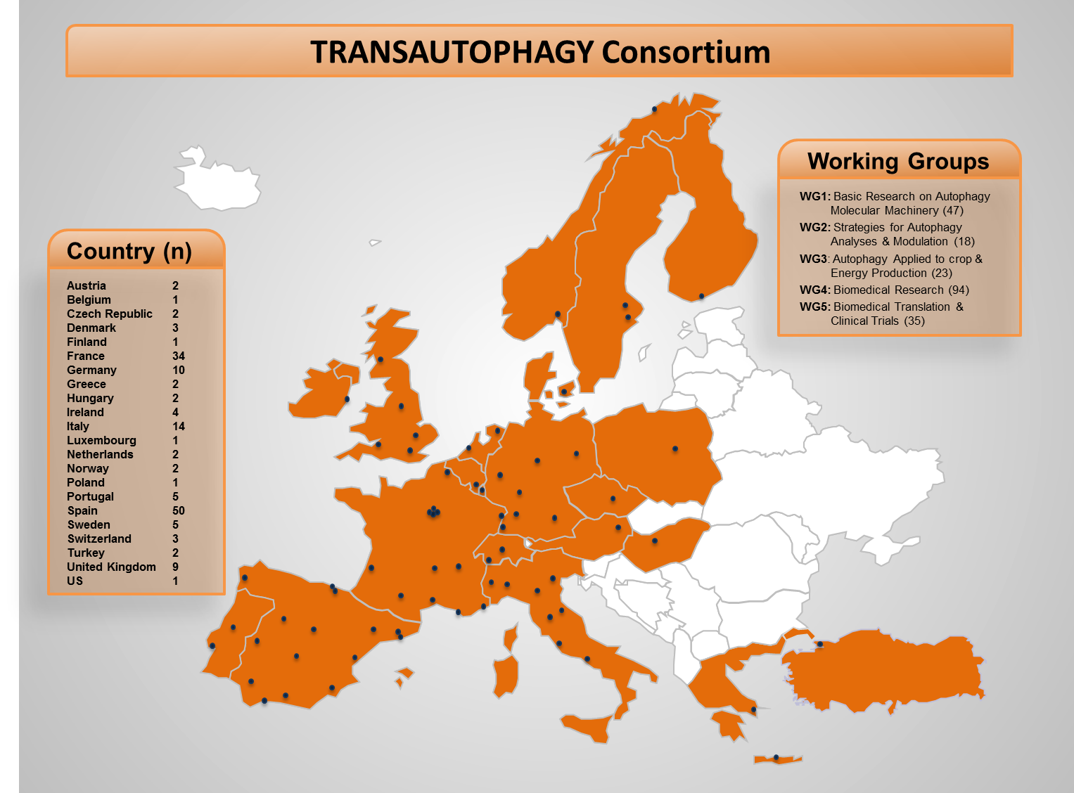

Figure 1. Distribution of European cities where TRANSAUTOPHAGY groups are active and distributed into Working Groups (WG) with the number of Researchers participating in each one , and number of groups operating in each country.

Annex 1: List of participating groups and cities.

Austria: C. Kraft (Vienna), S. Martens (Vienna).

Belgium: H. Batoko (Louvain).

Czech Republic: M. Cahova (Prague), V. Zarsky (Prague).

Denmark: F. Cecconi (Copenhagen), M. Jaattela (Copenhagen), M. Petersen (Copenhagen).

Finland: E.-L. Eskelinen (Helsinki).

France: S. Lanone (Creteil), A. Moris (Paris), A. Esclatine (Paris), A. Rozieres (Lyon), B. Dehay (Bordeaux), V. Cecile (Toulouse), C. Masciaux-Daubresse (Versailles), C. Boulanger (Paris), C. Viret (Bron), C. Berlioz-Torrent (Paris), F. Machta-Grigoriu (Paris), F. Pinet (Lille), F. Lafont (Lille), F. Lezoualc’h (Toulouse), G. Kroemer (Paris), H. Nguyen (Clermont-Ferrand), J. Iovanna (Marseille), I. Vergne (Toulouse), C. Marelli (Montpellier), M. Faure (Lyon), M. Bianchi (Gif sur Yvette), M. Djavaheri-Mergny (Bordeaux), N. Pallet (Paris), P. Codogno (Paris), P. Auberger (Nice), S. Pattingre (Montpellier), P.E. Rautou (Paris), M. Priault (Bordeaux), R. Legouis (Gif sur Yvette), S. Lotersztajn (Paris), S. Giuriato (Toulouse), S. Muller (Strasbourg), D. Tosi (Montpellier), F. Ichas (Pessac).

Germany: A. Fernie (Potsdam), C. Behrends (Frankfurt), E. Isono (Munchen), F. Baluska (Bonn), I. Dikic (Frankfurt), J. Dengjel (Freiburg), M. Thumm (Goettingen), S. Fulda (Frankfurt), T.Avin-Wittenberg (Potsdam), T. Proikas-Cezanne (Tuebingen).

Greece: L. Stefanis (Athens), N. Tavernarakis (Heraklion).

Hungary: G. Juhasz (Budapest), Z. Gaspari (Budapest).

Ireland: F. Bertoli (Dublin), J. Murray (Dublin), K. Dawson (Dublin), M. Rehm (Dublin).

Italy: A. Ballabio (Pozzuoli), A. Cossarizza (Modena), D. Goletti (Rome), E. Emanuele (Robbio), F. Penna (Turin), G.M. Fimia (Rome), G. Buonocore (Siena), M. Pinti (Modena), M. Sandri (Padua), M.C. Albertini (Urbino), M. Chiariello (Siena), M. Mori (Siena), S. Carloni (Urbino), W. Balduini (Urbino).

Luxembourg: B. Janji (Luxembourg City).

Netherlands: A. Meijer (Leiden), F. Reggiori (Groningen)

Norway: A. Simonsen (Oslo), T. Johansen (Tromso).

Poland: A. Sirko (Warsaw).

Portugal: H. Vieira (Lisbon), H. Girão (Coimbra), M. Ricardo Pereira (Coimbra), R. Baptista (Coimbra), R. Matthiesen (Lisbon).

Spain: C. Casas (Barcelona), A. Alonso (Leioa), A. Zorzano (Barcelona), A. Serrano (Sevilla), C. Guillen (Madrid), C. Gotor (Sevilla), M. Gonzalo Claros (Malaga), C. Alonso (Madrid), D. Ruiz-Molina (Madrid), D. Ruano Caballero (Sevilla), F.X. Pimentel-Muinos (Salamanca), F. Goni (Leioa), F. Suarez (Malaga), F. Novio (Barcelona), F. Sevilla (Murcia), F. Wandosell (Madrid), G. Velasco (Madrid), J. Diaz-Nido (Madrid), J.M. de la Fuente (Zaragoza), J. Ruberte (Barcelona), J.A. Sanchez Alcazar (Sevilla), J.M. Fuentes (Caceres), J.M. Garcia Fernandez (Sevilla), J.L. Crespo (Sevilla), J.M. Jerez (Malaga), J. Casas (Barcelona), J.A.G. Ranea (Malaga), J.M. Sepulveda (Madrid), J. Lorenzo (Barcelona), L.M. Sandalio (Granada), I.M. Ricardo (Zaragoza), M.L. Martinez Chantar (Derio), M. Moran (Madrid), M. Soengas (Madrid), M.D. Cordero (Sevilla), M. Martinez-Vicente (Barcelona), M.A. Martin (Madrid), M. Lopez (Santiago de Compostela), N. Apostolova (Castellon), N.S. Coll (Barcelona), P. Boya (Madrid), P.S. Testillano (Madrid), P. Munoz-Canoves (Barcelona), R. Delgado (Madrid), R. Escalante (Madrid), R. Sanchez-Prieto (Albacete), J. Farres (Barcelona), D. Prous (Barcelona), J. Ballesteros (Madrid).

Sweden: A. De Milito (Stockholm), D. Grandér (Stockholm), D. Hofius (Uppsala), J. Martinsson (Stockholm), P. Bozhkov (Uppsala).

Switzerland: H-U. Simon (Bern), J. Puyal (Lausanne), M.P. Tschan (Bern)

Turkey: A. Kosar (Istanbul), D. Gozuacik (Istanbul).

United Kingdom: D. Rubinsztein (Cambridge), J. King (Sheffield), J. Lane (Bristol), H. Jungbluth (London), K. Ryan (Glasgow), M. Gegg (London), N. Ktistakis (Cambridge), P. Lovat (Newcastle), S. Tooze (London).

USA/Spain: A. Lucia (Madrid).

European Commission: B. Mograbi (Nice).

