Protein AMPylation by an evolutionarily conserved pseudokinase

Anju Sreelatha¹, Samantha S. Yee^{1†}, Victor A. Lopez¹, Brenden C. Park¹, Lisa Kinch², Sylwia Pilch³, Kelly A. Servage¹, Junmei Zhang^{1††}, Jenny Jiou², Monika Karasiewicz³, Małgorzata Łobocka³, Nick Grishin^{2,4}, Kim Orth^{1,4, 5}, Roza Kucharczyk³, Krzysztof Pawłowski⁶, Diana R. Tomchick^{2,5}, and Vincent S. Tagliabracci^{1,7,8*}

¹Department of Molecular Biology, University of Texas Southwestern Medical Center, Dallas, TX 75390, USA.
²Department of Biophysics, University of Texas Southwestern Medical Center, Dallas, TX 75390, USA.
³Institute of Biochemistry and Biophysics, Polish Academy of Sciences, Warsaw, Poland.
⁴Howard Hughes Medical Institute, Dallas, TX 75390, USA.
⁵Department of Biochemistry, University of Texas Southwestern Medical Center, Dallas, TX 75390, USA.

⁶Warsaw University of Life Sciences, Warsaw, Poland
⁷Harold C. Simmons Comprehensive Cancer Center, University of Texas Southwestern Medical Center, Dallas, Texas 75390, USA
⁸Hamon Center for Regenerative Science and Medicine, University of Texas Southwestern Medical Center, Dallas, Texas 75390, USA
† Current address: Department of Pharmacology, The University of Texas Health Science Center at San Antonio, San Antonio, Texas 78229-3900, United States
†† Current address: Department of Pharmaceutical Sciences, School of Pharmacy, University of Pittsburgh, Pittsburgh, PA 15261, USA.
*Correspondence: Vincent S. Tagliabracci (vincent.tagliabracci@utsouthwestern.edu)
Abstract
Approximately 10% of human protein kinases are believed to be inactive and named pseudokinases because they lack residues required for catalysis. Here we show that the highly conserved pseudokinase selenoprotein-O (SelO) transfers AMP from ATP to Ser, Thr and Tyr residues on protein substrates (AMPylation), uncovering a previously unrecognized activity for a member of the protein kinase superfamily. The crystal structure of a SelO homolog reveals a protein kinase-like fold with ATP flipped in the active site, thus providing a structural basis for catalysis. SelO pseudokinases localize to the mitochondria and their activity is regulated by the formation of an intramolecular disulfide bridge. SelO AMPylates proteins involved in redox homeostasis and this activity is necessary for the proper cellular response to oxidative stress. Our results suggest that AMPylation may be a more widespread post translational modification than previously appreciated and that pseudokinases should be analyzed for alternative transferase activities.
Keywords: adenylylation, kinase structure, oxidative stress, selenocysteine, SELENOO

Introduction
Protein kinases are an important class of enzymes that transfer phosphate from ATP to protein substrates, a process known as phosphorylation (Fischer, 2013). Virtually every cellular activity is regulated by protein kinases, and abnormal phosphorylation has been linked to numerous diseases. More than 500 human protein kinases have been identified and assembled into an evolutionary tree known as the human “kinome” (Manning et al., 2002). However, research is largely biased toward kinases with well-established roles in disease; it has been estimated that the molecular functions of more than 50% of human kinases remain uncharacterized (Fedorov et al., 2010). Furthermore, several new kinase families have been identified that are so different, they were not included on the human kinome tree. These include the Fam20 and Fam69 families of secretory pathway kinases (Dudkiewicz et al., 2013; Tagliabracci et al., 2012) and the selenocysteine (Sec)-containing protein Selenoprotein-O (SelO) (Dudkiewicz et al., 2012).
About 10% of human protein kinases are predicted to be inactive and referred to as pseudokinases because they are missing residues located in highly conserved sequence motifs believed to be required for ATP binding and catalysis (Manning et al., 2002). Pseudokinases serve a multitude of non-catalytic roles, such as allosteric regulators or scaffolding functions (Eyers and Murphy, 2013; Kung and Jura, 2016; Taylor et al., 2013; Zeqiraj and van Aalten, 2010). For example, the Fam20A pseudokinase binds to and increases the stability and activity of the secretory pathway kinase Fam20C, thus acting as an allosteric regulator (Cui et al., 2015). Similarly, the HER3 pseudokinase, although reported to have low catalytic activity, serves mostly as an allosteric activator for other members of the EGFR family of receptor kinases (Jura et al., 2009; Shi et al., 2010). These studies have highlighted the importance of pseudokinases in human biology and their diverse signaling functions make them attractive drug targets (Bailey et al., 2015; Byrne et al., 2017).
Pseudokinases were initially predicted to be inactive if they were missing one or more of the three critical residues known to participate in phosphotransfer in active kinases (Manning et al., 2002). These include 1) the VAIK motif in the β3-strand, where the Lys positions the α and β phosphates of ATP for catalysis (K72 using protein kinase A; PKA nomenclature) 2) the HRD motif located in the catalytic loop, where the Asp acts as the catalytic base (PKA; D166) and 3) the DFG motif; where the Asp binds the divalent cation to coordinate the β and γ phosphates of ATP (PKA; D184). However, some predicted pseudokinases have evolved compensatory mechanisms to catalyze phosphorylation by migration of active site residues including the WNK family of kinases (Min et al., 2004) and the protein O-mannosyl kinase, SGK196 (Zhu et al., 2016). Such compensatory mutations are often difficult to identify by primary amino acid sequence alone and have resulted in the wrongful annotation of some kinases as inactive.
We previously predicted SelO to adopt a protein kinase fold (Dudkiewicz et al., 2012). However, its sequence suggests that SelO would be an inactive pseudokinase because it lacks the catalytic Asp (PKA; D166) (Figures 1A and S1). Human SelO localizes to the mitochondria and incorporates the 21st genetically encoded amino acid selenocysteine (Sec) (Han et al., 2014; Kryukov et al., 2003). Structurally, Sec is similar to Cys but contains a selenium atom in place of sulfur. The resulting selenol group has a lower pKa than the sulfur-containing thiol group and is deprotonated at physiological pH, resulting in higher nucleophilicity and oxidoreductase efficiency (Labunskyy et al., 2014). Twenty-five selenoproteins are encoded in the human genome and many are involved in cellular redox homeostasis (Kryukov et al., 2003). In higher eukaryotes, most SelO homologs contain a single Sec near the carboxy terminus (Han et al., 2014; Kryukov et al., 2003). In lower eukaryotes and all prokaryotes containing a SelO homolog, an invariant Cys occupies the equivalent position (Figure 1B). For simplicity, we will use the SelO name for the entire family regardless of whether or not the protein contains a Sec.
SelO is highly conserved, having homologs widespread among most eukaryotic taxa and is also common in many major bacterial taxa (Dudkiewicz et al., 2012). Despite this sequence-based indicator of a universal role across kingdoms, the molecular function of SelO is unknown. In fact, when prioritizing targets for experimental study, Koonin and colleagues listed SelO among the top ten most-attractive “unknown unknowns’’ because of phyletic spread and potential to reveal new and exciting biology (Galperin and Koonin, 2004).
Here we report the crystal structure of a SelO homolog, which reveals a protein kinase-like fold. Remarkably, the ATP in the active site is flipped relative to the orientation of ATP in the active site of canonical kinases. Our structural studies led us to discover that the SelO pseudokinases are in fact active enzymes, yet transfer AMP, instead of phosphate, to Ser, Thr and Tyr residues on protein substrates (AMPylation aka adenylylation). Furthermore, we uncover that SelO plays an evolutionarily conserved role in the cellular response to oxidative stress by AMPylating proteins involved in redox homeostasis. We anticipate that the results of this work will have important implications for redox biology and may have the potential to define new paradigms of cellular regulation and signal transduction.

Results
SelO is one of the most highly conserved members of the protein kinase and selenoprotein families
To demonstrate the unique conservation of SelO, we performed basic local alignment search tool (BLAST) analyses against the Representative Proteomes RP55 database limited to bacteria using known human kinase domains and selenoproteins as queries in the search. We represent conservations of these different kinase and selenoprotein families as a plot of E-value vs. sequence identity of the top bacterial protein returned from the search (Figure 1C). Our results indicate that SelO is one of the most highly conserved members of either the human protein kinase families or the various selenoprotein families. Among bacteria, SelO is ubiquitous in Proteobacteria and Cyanobacteria while in other phyla it is less frequent. Among eukaryotes, in most phyla there is on average one SelO gene per genome, while chordates and arthropods are exceptions, having an average of two or 0.14 genes per genome, respectively.

SelO adopts a protein kinase fold with ATP flipped in the active site
To gain insight into the function of the SelO pseudokinases, we solved the crystal structure of the SelO homolog from the gram-negative plant pathogen Pseudomonas syringae bound to an ATP derivative AMP-PNP (Figures 2A and S2A). Despite the unique sequence found in the SelO family, P. syringae SelO adopts a protein kinase-like fold consisting of 12 β-strands and 22 α-helices. The kinase core (β4-α14) consists of a β-strand-rich N-lobe and an α-helical-rich C-lobe connected by a flexible linker and can be superimposed onto protein kinase CK1 with a root mean square derivation (rmsd) of 3.5 Å over 164 Cα atoms (Figure S2B). The SelO N-lobe includes the regulatory αC helix (Figure 2A, orange) packing against the core β-sheet (Figure 2A, magenta), while the C-lobe includes a pseudo-catalytic loop lacking HRD, followed by an apparent activation loop. An N-terminal extension (α1-α5, white) stabilizes the N-lobe β-sheet, and the unique C-terminal domains, CTD1 (α15-α19) and CTD2 (α20-α22), contact the C-lobe and the αC helix, respectively. There is no clear electron density for the last 12 residues, including the C-terminal Cys/Sec, suggesting that this region is disordered.
Using the SelO kinase domain to query existing structures for similarity (using Dali or VAST) identifies a number of different kinase domains as top hits. The closest SelO structures have similar scores and include the aerobactin synthase IucA, the plant receptor kinase BRASSINOSTEROID INSENSITIVE 1, and the human interleukin-1 receptor-associated kinase 4, and tyrosine kinase Syk.
The SelO nucleotide sits in a cleft between the two lobes of the kinase domain. Remarkably, the AMP-PNP molecule is flipped in the active site when compared to canonical protein kinases. The γ-phosphate, which is normally transferred to protein in a kinase reaction, is buried in a pocket between the two lobes of the kinase domain (Figure 2B). In fact, after superposition of the kinase domains, the SelO α, β, and γ-phosphates occupy the positions of the typical γ, β, and α-phosphates of protein kinases, respectively (Figures 2B, 2C and S2C). The binding site for the flipped nucleotide adenine base and sugar ribose is formed by unique insertions in two SelO loops: the β6-β7 (Gly-rich loop) and the β8-αC loop (colored white, Figures 2B and D).

SelO transfers AMP from ATP to protein substrates
The flipped orientation of ATP in the active site led us to hypothesize that the SelO proteins could transfer adenosine monophosphate (AMP) to protein substrates (AMPylation aka adenylylation) (Casey and Orth, 2017). We incubated recombinant E. coli (ydiU), S. cerevisiae (FMP40) and H. sapiens SelO with [γ³²P]ATP or [α³²P]ATP of similar specific radioactivity and observed ³²P-incorporation into the WT proteins only when [α³²P]ATP was used as substrate (Figures 3A, B, C). Mutation of the active site metal binding DFG motif in the SelO proteins abolished ³²P incorporation. E. coli and human SelO, but not the inactive mutants, were immunoreactive to an anti-Thr AMP antibody (Figures S3A and S3B) (Hao et al., 2011). Likewise, mass spectrometry (MS) analysis revealed tryptic peptides from WT SelO proteins but not the inactive mutants, with mass shifts of 329 Da, consistent with the covalent addition of AMP to Ser, Thr and Tyr residues (Figure 3D and S3C). Furthermore, E. coli SelO, but not the inactive mutant, could AMPylate the generic protein kinase substrate myelin basic protein (MBP) in a time dependent manner (Figure 3E). SelO prefers ATP over other nucleotides as a co-substrate (Figure S3D) and displayed a K_{m} for ATP of ~2.0 μM (Figure S3E). Thus, the SelO pseudokinases can AMPylate protein substrates.
Unique interactions within the SelO active site facilitate nucleotide binding and AMPylation.
Several interactions within the SelO active site contribute to the inverted orientation of the nucleotide, including K113 (PKA K72) that coordinates the γ-phosphate of ATP (Figure 4A). K113 extends into the active site and is stabilized by E136 from the α6/αC helix. The formation of this ion pair, which typically positions the α-phosphate of ATP, is considered a hallmark of the activated state of a protein kinase (Taylor and Kornev, 2011). Two invariant arginine’s (R176 and R183) also form interactions with the γ-phosphate. R176 extends into the active site from β12 and R183 lies in the flexible hinge region that connects the N-lobe to the C–lobe (Figure 4A). Mutations of K113, E136, R176 or R183 to Ala inactivates E. coli SelO (Figure 4B). Most kinases require a divalent cation to orient the phosphates of ATP. In the P. syringae SelO structure, Mg²⁺ and Ca²⁺ are bound to the α and β phosphates of AMP-PNP and are coordinated by N253 and D262 (PKA N171 and D184). Mutations of these residues to Ala abolished E. coli SelO activity (Figure 4B). SelO was predicted to be a pseudokinase because it lacks the catalytic Asp (PKA D166), which deprotonates the phosphoacceptor hydroxyl on the protein substrate. However, we anticipate that D252 in P. syringae SelO could fulfill this role because of its conservation, proximity to the α-phosphate of ATP and its mutation to Ala inactivates the enzyme. Collectively, the active site of P. syringae SelO reveals evolutionarily conserved interactions that provide this family of kinases with the unique ability to transfer AMP to protein substrates.

SelO is a redox active mitochondrial protein
The N-terminus of eukaryotic SelO proteins contains a predicted mitochondrial targeting peptide (mTP). When overexpressed in mammalian cells as a GFP-fusion protein, human SelO localizes to the mitochondria (Han et al., 2014). We expressed S. cerevisiae SelO in yeast as a C-terminally tagged GFP fusion protein and observed co-localization with the mitochondrial resident protein citrate synthase (Figure S4A). Mitochondrial localization was dependent on the presence of the mTP (residues 1-23) because a truncated mutant of SelO failed to localize to the mitochondria (Figure S4A). Furthermore, we fractionated yeast extracts by sucrose gradient centrifugation and detected endogenous SelO in fractions enriched for the mitochondrial resident protein porin (Figure S4B). Thus, S. cerevisiae SelO is a mitochondrial protein and its localization depends on a functional mTP.
Many mitochondrial proteins are subjected to redox regulation, including several selenoproteins. To test the redox function of SelO, we purified the E. coli protein under non-reducing conditions and observed a doublet when the protein was resolved by non-reducing SDS PAGE (Figure 5A). The faster migrating species was converted to the slower migrating species upon treatment with the reducing agent dithiothreitol (DTT). Likewise, endogenous S. cerevisiae SelO migrated as two distinct species during non-reducing SDS PAGE and was also sensitive to DTT (Figure 5B). MS analysis of E. coli SelO identified an intramolecular disulfide bond between Cys272 and Cys476 (Figure 5C). To confirm the sites of modification, we incubated E. coli SelO with the cysteine alkylating agent 4-acetamido-4′-maleimidylstilbene-2,2′- disulfonic acid (AMS). AMS reacts with free thiols resulting in a change in electrophoretic mobility that can be easily observed by SDS PAGE. AMS reduced the electrophoretic mobility of WT SelO, only in the presence of the reducing agent, Tris(2-carboxyethyl) phosphine (TCEP). However, AMS reduced the electrophoretic mobility of the C272A and C476A mutants in the absence of TCEP (Figure 5D). Collectively, these results suggest that E. coli SelO forms an intramolecular disulfide bond between a Cys in the activation loop and the Cys at the C-terminus, the latter being replaced by a Sec in higher eukaryotes (Figures 1A and 5E).
The formation of disulfide bonds occurs primarily in the oxidizing environment of the secretory pathway. However, some mitochondrial proteins can also form disulfide or selenyl-sulfide bonds as part of their catalytic mechanism (Collet and Messens, 2010). To test whether the SelO disulfide bond regulates its activity, we incubated E. coli SelO purified under non-reducing conditions, with MBP and [α³²P]ATP and observed low levels of AMPylation (Figure 5F). However, addition of DTT or the thioredoxin system that uses reducing equivalents from NADPH to reduce disulfides, markedly increased SelO activity. Therefore, E. coli SelO activity is regulated by the formation of an intramolecular disulfide bridge.

SelO AMPylates proteins involved in redox biology
Based on the chemistry of the AMPylation reaction and the location of the adenine ring of ATP in the SelO crystal structure, we reasoned that using a biotinylated ATP analog would be an efficient strategy to identify proteins AMPylated by SelO. In this reaction, biotinylated AMP would be transferred to proteins, which would greatly facilitate isolation and identification of SelO substrates. We incubated E. coli SelO with Biotin-17-ATP (Figure 6A) and E. coli or yeast mitochondrial extracts. Remarkably, several biotinylated proteins were observed in extracts incubated with WT SelO but not the inactive mutant (Figure 6B). To identify SelO targets, we enriched biotinylated proteins by avidin pulldown and identified potential SelO substrates by mass spectrometry, several of which have roles in oxidative phosphorylation and redox biology (Table S2). Among our top candidates are sucA, the bacterial homolog of the E1 component of the alpha-ketoglutarate dehydrogenase complex (Frank et al., 2007) and glutaredoxin (grx), a small thioredoxin-like protein that catalyzes the removal of covalently linked glutathione from Cys residues on proteins (de-glutathionylation; Figure S6A) (Shelton et al., 2005).
To test whether E. coli sucA and grxA are AMPylated by SelO in cells, we co-expressed E. coli SelO or the inactive mutant with His-tagged sucA or grxA and analyzed Ni NTA affinity purified proteins for AMPylation by mass spectrometry. We identified AMPylated tryptic peptides on sucA and grxA that were present when co-expressed with WT but not inactive SelO (Figures S5). Notably, we identified Thr405 on sucA and Tyr13 on grxA to be potential sites of modification. Protein immunoblotting of sucA using an anti-Thr AMP antibody confirmed Thr405 was the major site of AMPylation (Figure 6C). Likewise, SelO AMPylated WT grxA in vitro but not the Y13F mutant (Figure 6D). Thus, SelO can AMPylate Thr and Tyr residues on protein substrates both in vitro and in vivo.
To determine the substrate specificity of SelO, we performed AMPylation reactions using E. coli grxA as a model substrate. Alanine substitutions of the Cys at the -2 and Pro at the -1 positions, or replacing the AMP-acceptor Tyr with a Ser or a Thr, markedly inhibited SelO-mediated AMPylation (Figure S6B). However, analysis of the auto AMPylation sites in E. coli, yeast and human SelO (Figure S3C), and the grxA and sucA sites (Figure S5), did not reveal any obvious primary sequence requirements for SelO-catalyzed AMPylation. Therefore, SelO appears to require additional factors beyond the primary amino acid sequence of the substrate.

SelO-mediated AMPylation protects S. cerevisiae from oxidative stress
The substrates identified from the biotin pull down experiments and the fact that Sec-containing proteins are typically involved in redox homeostasis, led us to hypothesize that SelO is involved in the cellular response to oxidative stress. Yeast grown on non-fermentable carbon sources induce oxidative stress through mitochondrial respiration (Farrugia and Balzan, 2012; Grant et al., 1997). We detected an increase in S. cerevisiae SelO protein levels in cells grown on the non-fermentable carbon sources glycerol, lactate and acetate (Figure 7A). These results are consistent with previous studies showing that yeast SelO mRNA expression correlates with the stress response and is induced in respiring cells (Tu et al., 2005).
We challenged WT and SelO deficient S. cerevisiae with H₂O₂ and observed a decrease in survival in SelO KO cells (Figure 7B). Cell viability was fully complemented by WT SelO but not the inactive mutant. Moreover, we incubated WT and SelO KO yeast with the redox-cycling compound menadione, which increases cellular reactive oxygen species (Zadzinski et al., 1998). SelO deficient yeast displayed a menadione-dependent growth defect that was fully rescued by WT S. cerevisiae SelO but not the catalytically inactive mutant (Figure 7C). Collectively, these results suggest that SelO-mediated AMPylation of proteins protects S. cerevisiae from oxidative stress.
SelO regulates global S-glutathionylation levels in bacteria and yeast
The reversible oxidative modification of cysteine residues on proteins with a molecule of glutathione (S-glutathionylation) is emerging as a ubiquitous and essential mechanism for protecting proteins exposed to oxidative conditions (Mieyal and Chock, 2012). Under oxidative stress, protein thiols can become reversibly oxidized to sulfenic acids that are protected from over-oxidation by S-glutathionylation. Protein S-glutathionylation is reversed by the grx family of de-glutathionylation enzymes, which form a mixed disulfide intermediate to restore the free thiol on target proteins (Shelton et al., 2005). Interestingly, Tyr13 in E. coli grxA, which is AMPylated by SelO, lies within the highly conserved redox active site of the enzyme (¹¹C-P-Y-C¹⁵) and interacts with glutathione (Figure S6C and D). Therefore, we hypothesized that SelO-mediated AMPylation of grx family members would regulate S-glutathionylation of proteins in vivo. Under normal growth conditions, SelO deficient E. coli and yeast showed a modest decrease in global S-glutathionylation as judged by protein immunoblotting using a S-glutathionylation specific antibody (Figure 7D & E). However, when cells were treated with oxidized glutathione (GSSG) or diamide, conditions known to increase protein S-glutathionylation (Ghezzi et al., 2002; Sun et al., 2012), we observed a marked decrease in S-glutathionylation levels in both bacterial and yeast SelO KO cells. Collectively, these results suggest SelO regulates protein S-glutathionylation levels by AMPylation of the grx family of enzymes.

Discussion
Our structural analysis of P. syringae SelO has unexpectedly discovered a previously unrecognized activity for a member of the protein kinase superfamily. There are other enzymes in nature that can AMPylate protein substrates on amino acid side chains, including glutamine synthase adenylyltransferase (GS ATase) (Shapiro and Stadtman, 1968), the Legionella effector DrrA/SidM (Muller et al., 2010) and proteins containing the Fic domain (Worby et al., 2009; Yarbrough et al., 2009). However, SelO is unique because it has a protein kinase fold. GS ATase and DrrA adopt an α+β nucleotidyltransferase fold and catalyze AMPylation using a conserved G-X₁₁-D-X-D motif (Holm and Sander, 1995). In DrrA, the second Asp of the motif acts as a general base to deprotonate the protein substrate Tyr, which then acts as a nucleophile on the α-phosphate of ATP (Gavriljuk et al., 2014). Fic family proteins adopt a mainly α-helical bundle fold with a conserved H-X-F-X-(D/E)-(A/G)-N-(G/K)-R motif (Kinch et al., 2009; Xiao et al., 2010). The Fic motif His residue acts as the general base in catalysis, while the Arg positions the β-phosphate and stabilizes the developing negative charge on the α-phosphate during catalysis (Luong et al., 2010). A second Arg just upstream of the Fic motif forms a hydrogen bond with the γ-phosphate of the bound nucleotide. Interestingly, the Fic-related Doc toxin is thought to use inverted ATP to phosphorylate protein substrates (Castro-Roa et al., 2013). Analogous to the Fic/Doc proteins, our results suggest that a flip of the ATP in protein kinases allows the switch between AMPylation and phosphorylation of protein substrates.
In each of the known folds capable of catalyzing AMPylation, a key conserved residue acts as a general base to deprotonate the protein target Tyr/Thr residue. Sequence conservation of the SelO active site suggests the catalytic Asp that performs this function (D252 in P. syringae SelO) has migrated from the canonical position in traditional protein kinases. Accordingly, mutagenesis supports a critical role for this residue in catalysis (Figure 4B). To gain understanding of the potential SelO peptide binding site, we superimposed the SelO kinase domain with activated FGFR2 kinase bound to a peptide substrate (Figure S7A) (Chen et al., 2007). The canonical protein kinase active site Asp (PKA; D166) approaches the substrate Tyr OH from one side, while the migrated SelO active site Asp approaches from the opposite side. A Pro residue at the C-terminus of the FGFR2 activation loop that positions the substrate peptide Tyr is replaced by a conserved aromatic residue (F82) from the SelO Gly-rich loop insert. Two additional SelO family conserved residues from the Gly-rich loop insert (Q81) and the β8-αC insert (R122) that define the flipped ATP site might also contribute to an extended SelO peptide substrate binding site.
The SelO C-terminal domains (CTDs) bridge the regulatory αC helix with the activation loop and position the αC helix in the active conformation. This interaction resembles the activation of cyclin dependent kinase CDK2 by cyclin A (Jeffrey et al., 1995). The CDK2 regulatory αC helix PSTAIRE motif retains a conserved RE (PKA E91) in the same position as the invariant RE from SelO (Figure S7B & C). The Arg residues from both kinases form key hydrogen bond interactions with the activation loops, while the Glu residues form an ion pair with their corresponding Lys (PKA K72) marking the activated state of the protein kinase. In the absence of cyclin, the αC helix and the activation loop of free CDK2 adopt alternate conformations rendering the kinase inactive. The free CDK2 regulatory helix rotates away from the active site pocket, disrupting residues involved in orienting phosphate and coordinating Mg²⁺. The free CDK2 activation loop covers the active site and prevents ATP access. The SelO CTD2 prevents such a rotation of the regulatory αC helix in the present SelO structure. The disordered C-terminus extending from CTD2 plays a role in inactivating the kinase by forming a disulfide bond with a Cys in the activation loop. Analogous to CDK2, this inactivation could involve a conformational change of the CTD to allow rotation of the regulatory αC helix or an alternate conformation of the activation loop driven by disulfide bond formation, or both.
Interestingly, in the crystal structure of P. syringae SelO, the conserved activation loop cysteine (C279, corresponding to C272 of E. coli SelO) is in a position compatible with formation of a disulfide bond with another cysteine, C246 (the Cβ-Cβ distance is 3.8Å). The C246 (not present in E. coli SelO) is located only seven residues away from the predicted catalytic D252. Thus, the activating mechanism of intramolecular disulfide exchange may be more complex in some members of the SelO family possessing more than one cysteine in the activation loop or in the catalytic loop. Future work will be needed to confirm the physiological importance of the selenylsulfide/disulfide bond and its role in regulating AMPylation activity of SelO from different species.
We have developed a strategy using a biotinylated ATP derivative to identify SelO substrates. Notably, we identified the glutaredoxins and the E1 component of the alpha ketoglutarate dehydrogenase complex, sucA, to be direct substrates of E. coli SelO. Glutaredoxin is a small redox protein involved in reducing cellular disulfides and removes glutathione from Cys residues on proteins (Shelton et al., 2005). sucA is a component of the 2-oxoglutarate dehydrogenase complex, which catalyzes a rate-limiting step of the tricarboxylic acid cycle (TCA) and is thought to be a mitochondrial redox sensor (McLain et al., 2011). Interestingly, both grxA and sucA are AMPylated on highly conserved active site residues (Figure S6C-F), suggesting that AMPylation may regulate the activities of these proteins. Indeed, total protein S-glutathionylation levels were decreased in SelO deficient E. coli and yeast (Figure 7D), suggesting that AMPylation of the grx family of enzymes is an evolutionarily conserved mechanism to regulate protein S-gluathionlyation levels in cells.
Tyr13 on grxA is located adjacent to the glutathione binding cysteine residue (Figure S6D) and studies have indicated that the aromatic sidechain of Tyr13 provides a niche for glutathione binding and subsequent deglutathionyation acitivity (Saaranen et al., 2009). Therefore, AMPylation of Tyr13 may impose steric hinderance for glutathione binding and would therefore inactivate the enzyme. Similar to SelO mutants, yeast glutaredoxin mutants are more sensitive to oxidative stress induced by menadione and hydrogen peroxide treatment (Luikenhuis et al., 1998). In the case of sucA, Thr405 lies within a disordered active site loop that coordinates Mg²⁺ and mediates dimerization (Frank et al., 2007; Wagner et al., 2011). Studies are underway to determine whether AMPylation of sucA regulates the formation of the alpha-ketoglutarate dehydrogenase complex and/or affects its activity. Collectively, the highly conserved SelO sequence, AMPylation sites in substrates (grxA, sucA), and enzymatic activity, suggest that SelO regulates an ancient, conserved oxidative stress defense mechanism in prokaryotes and eukaryotes.
In higher eukaryotes, SelO homologs contain a Sec, whereas a Cys is present in the equivalent position in lower eukaryotes and all prokaryotes with a SelO homolog. Most human selenoproteins have homologs with a Cys in place of the Sec. Incorporation of Sec is energetically expensive; however, the evolutionary advantage of using Sec as opposed to Cys is incompletely understood. Although selenoproteins are considered superior catalysts, it was recently shown that the selenoprotein glutathione peroxidase 4 (GPX4), requires its Sec to prevent irreversible over-oxidation (Ingold et al., 2018). We propose that SelO has evolved a Sec to increase the redox potential of the resulting selenylsulfide bond and/or prevent irreversible over-oxidation, both of which would regulate AMPylation activity.
In summary, we have discovered a new activity for a member of the protein kinase superfamily, which has revealed the molecular function of one of the twenty-five selenoproteins in humans. Our results highlight the structural and biochemical diversity of the protein kinase superfamily and underscore a novel mechanism of redox regulation. Importantly, our results suggest that AMPylation may be more widespread than previously appreciated and that “inactive” kinases should be analyzed for alternative transferase activities.

Acknowledgements
We thank Drs. Joseph Goldstein, Eric Olson, Peter Roach, Greg Taylor and members of the Tagliabracci laboratory for insightful discussions. We also thank Christine Nolan and Greg Urquhart for technical assistance. Results shown in this report are derived from work performed at the Argonne National Laboratory, Structural Biology Center at the Advanced Photon Source. This work was supported by NIH Grants R00DK099254 (V.S.T.), GM094575 (N.V.G), GM115188 (K.O.), T32DK007257-37 (A.S.) and T32GM008203-29 (V.A.L.), Welch Foundation Grants I-1911 (V.S.T), I-1505 (N.V. G), I-1561 (K.O.), the Once upon a Time…Foundation (K.O.) and a CPRIT grant RP170674 (V.S.T.) and the Polish National Science Centre grant 2014/15/B/NZ1/03359 (K.P.). V.S.T. is the Michael L. Rosenberg Scholar in Medical Research and a Cancer Prevention Research Institute of Texas Scholar (RR150033).
Author contributions
A.S. and V.S.T. designed the experiments. A.S, S.S.Y, V.A.L., B.C.P, S.P., J.J., M.K., M.L., R.K., D.R.T. and V.S.T conducted the experiments. J.Z. and K.A.S. performed the mass spectrometry. L.K, N.G, and K.P. performed the bioinformatics. M.L and K.O. provided essential reagents. A.S., L.K., K.P., and V.S.T wrote the manuscript with input from all authors.
Declaration of Interests
The authors declare no competing interests.

References
Bailey, F.P., Byrne, D.P., McSkimming, D., Kannan, N., and Eyers, P.A. (2015). 2) Going for broke: targeting the human cancer pseudokinome. Biochem J 466, 201.
Byrne, D.P., Foulkes, D.M., and Eyers, P.A. (2017). Pseudokinases: update on their functions and evaluation as new drug targets. Future Med Chem 9, 245-265.
Casey, A.K., and Orth, K. (2017). Enzymes Involved in AMPylation and deAMPylation. Chem Rev.
Castro-Roa, D., Garcia-Pino, A., De Gieter, S., van Nuland, N.A.J., Loris, R., and Zenkin, N. (2013). The Fic protein Doc uses an inverted substrate to phosphorylate and inactivate EF-Tu. Nat Chem Biol 9, 811-817.
Chen, H., Ma, J., Li, W., Eliseenkova, A.V., Xu, C., Neubert, T.A., Miller, W.T., and Mohammadi, M. (2007). A molecular brake in the kinase hinge region regulates the activity of receptor tyrosine kinases. Mol Cell 27, 717-730.
Collet, J.F., and Messens, J. (2010). Structure, function, and mechanism of thioredoxin proteins. Antioxid Redox Signal 13, 1205-1216.
Cui, J., Xiao, J., Tagliabracci, V.S., Wen, J., Rahdar, M., and Dixon, J.E. (2015). A secretory kinase complex regulates extracellular protein phosphorylation. eLife 4.
Dudkiewicz, M., Lenart, A., and Pawlowski, K. (2013). A novel predicted calcium-regulated kinase family implicated in neurological disorders. PLoS One 8, e66427.
Dudkiewicz, M., Szczepinska, T., Grynberg, M., and Pawlowski, K. (2012). A novel protein kinase-like domain in a selenoprotein, widespread in the tree of life. PLoS One 7, e32138.
Eyers, P.A., and Murphy, J.M. (2013). Dawn of the dead: protein pseudokinases signal new adventures in cell biology. Biochemical Society transactions 41, 969-974.
Farrugia, G., and Balzan, R. (2012). Oxidative stress and programmed cell death in yeast. Front Oncol 2, 64.
Fedorov, O., Muller, S., and Knapp, S. (2010). The (un)targeted cancer kinome. Nat Chem Biol 6, 166-169.
Fischer, E.H. (2013). Cellular regulation by protein phosphorylation. Biochem Biophys Res Commun 430, 865-867.
Frank, R.A., Price, A.J., Northrop, F.D., Perham, R.N., and Luisi, B.F. (2007). Crystal structure of the E1 component of the Escherichia coli 2-oxoglutarate dehydrogenase multienzyme complex. J Mol Biol 368, 639-651.
Galperin, M.Y., and Koonin, E.V. (2004). 'Conserved hypothetical' proteins: prioritization of targets for experimental study. Nucleic Acids Res 32, 5452-5463.
Gavriljuk, K., Schartner, J., Itzen, A., Goody, R.S., Gerwert, K., and Kotting, C. (2014). Reaction mechanism of adenylyltransferase DrrA from Legionella pneumophila elucidated by time-resolved fourier transform infrared spectroscopy. J Am Chem Soc 136, 9338-9345.
Ghezzi, P., Romines, B., Fratelli, M., Eberini, I., Gianazza, E., Casagrande, S., Laragione, T., Mengozzi, M., Herzenberg, L.A., and Herzenberg, L.A. (2002). Protein glutathionylation: coupling and uncoupling of glutathione to protein thiol groups in lymphocytes under oxidative stress and HIV infection. Mol Immunol 38, 773-780.
Grant, C.M., MacIver, F.H., and Dawes, I.W. (1997). Mitochondrial function is required for resistance to oxidative stress in the yeast Saccharomyces cerevisiae. FEBS Lett 410, 219-222.
Han, S.J., Lee, B.C., Yim, S.H., Gladyshev, V.N., and Lee, S.R. (2014). Characterization of mammalian selenoprotein o: a redox-active mitochondrial protein. PLoS One 9, e95518.
Hao, Y.H., Chuang, T., Ball, H.L., Luong, P., Li, Y., Flores-Saaib, R.D., and Orth, K. (2011). Characterization of a rabbit polyclonal antibody against threonine-AMPylation. J Biotechnol 151, 251-254.
Holm, L., and Sander, C. (1995). DNA polymerase beta belongs to an ancient nucleotidyltransferase superfamily. Trends Biochem Sci 20, 345-347.
Ingold, I., Berndt, C., Schmitt, S., Doll, S., Poschmann, G., Buday, K., Roveri, A., Peng, X., Porto Freitas, F., Seibt, T., et al. (2018). Selenium Utilization by GPX4 Is Required to Prevent Hydroperoxide-Induced Ferroptosis. Cell 172, 409-422 e421.
Jeffrey, P.D., Russo, A.A., Polyak, K., Gibbs, E., Hurwitz, J., Massague, J., and Pavletich, N.P. (1995). Mechanism of CDK activation revealed by the structure of a cyclinA-CDK2 complex. Nature 376, 313-320.
Jura, N., Shan, Y., Cao, X., Shaw, D.E., and Kuriyan, J. (2009). Structural analysis of the catalytically inactive kinase domain of the human EGF receptor 3. Proc Natl Acad Sci U S A 106, 21608-21613.
Kinch, L.N., Yarbrough, M.L., Orth, K., and Grishin, N.V. (2009). Fido, a novel AMPylation domain common to fic, doc, and AvrB. PLoS One 4, e5818.
Kryukov, G.V., Castellano, S., Novoselov, S.V., Lobanov, A.V., Zehtab, O., Guigo, R., and Gladyshev, V.N. (2003). Characterization of mammalian selenoproteomes. Science 300, 1439-1443.
Kung, J.E., and Jura, N. (2016). Structural Basis for the Non-catalytic Functions of Protein Kinases. Structure 24, 7-24.
Labunskyy, V.M., Hatfield, D.L., and Gladyshev, V.N. (2014). Selenoproteins: molecular pathways and physiological roles. Physiol Rev 94, 739-777.
Luikenhuis, S., Perrone, G., Dawes, I.W., and Grant, C.M. (1998). The yeast Saccharomyces cerevisiae contains two glutaredoxin genes that are required for protection against reactive oxygen species. Mol Biol Cell 9, 1081-1091.
Luong, P., Kinch, L.N., Brautigam, C.A., Grishin, N.V., Tomchick, D.R., and Orth, K. (2010). Kinetic and structural insights into the mechanism of AMPylation by VopS Fic domain. J Biol Chem 285, 20155-20163.
Manning, G., Whyte, D.B., Martinez, R., Hunter, T., and Sudarsanam, S. (2002). The protein kinase complement of the human genome. Science 298, 1912-1934.
McLain, A.L., Szweda, P.A., and Szweda, L.I. (2011). alpha-Ketoglutarate dehydrogenase: a mitochondrial redox sensor. Free Radic Res 45, 29-36.
Mieyal, J.J., and Chock, P.B. (2012). Posttranslational modification of cysteine in redox signaling and oxidative stress: Focus on s-glutathionylation. Antioxid Redox Signal 16, 471-475.
Min, X., Lee, B.H., Cobb, M.H., and Goldsmith, E.J. (2004). Crystal structure of the kinase domain of WNK1, a kinase that causes a hereditary form of hypertension. Structure 12, 1303-1311.
Muller, M.P., Peters, H., Blumer, J., Blankenfeldt, W., Goody, R.S., and Itzen, A. (2010). The Legionella effector protein DrrA AMPylates the membrane traffic regulator Rab1b. Science 329, 946-949.
Saaranen, M.J., Salo, K.E., Latva-Ranta, M.K., Kinnula, V.L., and Ruddock, L.W. (2009). The C-terminal active site cysteine of Escherichia coli glutaredoxin 1 determines the glutathione specificity of the second step of peptide deglutathionylation. Antioxid Redox Signal 11, 1819-1828.
Shelton, M.D., Chock, P.B., and Mieyal, J.J. (2005). Glutaredoxin: role in reversible protein s-glutathionylation and regulation of redox signal transduction and protein translocation. Antioxid Redox Signal 7, 348-366.
Shi, F., Telesco, S.E., Liu, Y., Radhakrishnan, R., and Lemmon, M.A. (2010). ErbB3/HER3 intracellular domain is competent to bind ATP and catalyze autophosphorylation. Proc Natl Acad Sci U S A 107, 7692-7697.
Sun, R., Eriksson, S., and Wang, L. (2012). Oxidative stress induced S-glutathionylation and proteolytic degradation of mitochondrial thymidine kinase 2. J Biol Chem 287, 24304-24312.
Tagliabracci, V.S., Engel, J.L., Wen, J., Wiley, S.E., Worby, C.A., Kinch, L.N., Xiao, J., Grishin, N.V., and Dixon, J.E. (2012). Secreted kinase phosphorylates extracellular proteins that regulate biomineralization. Science 336, 1150-1153.
Taylor, S.S., and Kornev, A.P. (2011). Protein kinases: evolution of dynamic regulatory proteins. Trends Biochem Sci 36, 65-77.
Taylor, S.S., Shaw, A., Hu, J., Meharena, H.S., and Kornev, A. (2013). Pseudokinases from a structural perspective. Biochemical Society transactions 41, 981-986.
Tu, B.P., Kudlicki, A., Rowicka, M., and McKnight, S.L. (2005). Logic of the yeast metabolic cycle: temporal compartmentalization of cellular processes. Science 310, 1152-1158.
Wagner, T., Bellinzoni, M., Wehenkel, A., O'Hare, H.M., and Alzari, P.M. (2011). Functional plasticity and allosteric regulation of alpha-ketoglutarate decarboxylase in central mycobacterial metabolism. Chem Biol 18, 1011-1020.
Xiao, J., Worby, C.A., Mattoo, S., Sankaran, B., and Dixon, J.E. (2010). Structural basis of Fic-mediated adenylylation. Nat Struct Mol Biol 17, 1004-1010.
Zadzinski, R., Fortuniak, A., Bilinski, T., Grey, M., and Bartosz, G. (1998). Menadione toxicity in Saccharomyces cerevisiae cells: activation by conjugation with glutathione. Biochem Mol Biol Int 44, 747-759.
Zeqiraj, E., and van Aalten, D.M. (2010). Pseudokinases-remnants of evolution or key allosteric regulators? Curr Opin Struct Biol 20, 772-781.
Zhu, Q., Venzke, D., Walimbe, A.S., Anderson, M.E., Fu, Q., Kinch, L.N., Wang, W., Chen, X., Grishin, N.V., Huang, N., et al. (2016). Structure of protein O-mannose kinase reveals a unique active site architecture. eLife 5.
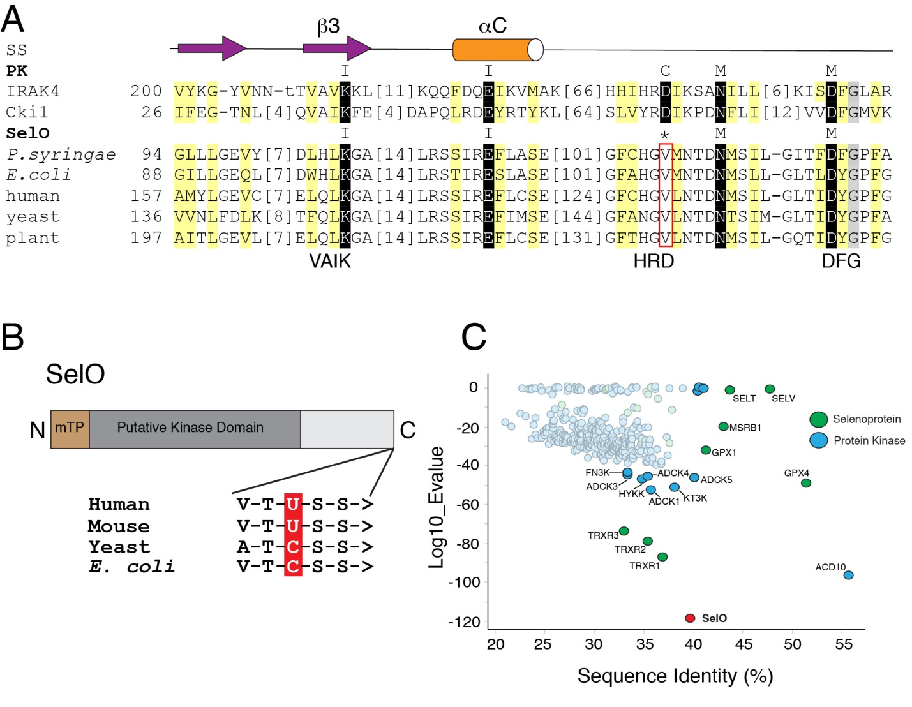

Figure 1. SelO is an evolutionarily conserved pseudokinase.
(A) Multiple sequence alignment highlighting conserved active site residues in the SelO pseudokinases. Conserved positions in SelO and protein kinases (PK) are highlighted yellow (hydrophobic) and gray (small). Conserved catalytic motif residues are highlighted black and labeled above: ion pair (I; VAIK), catalytic (C, HRD) and Mg²⁺-binding (M, DFG). Starting residue numbers are indicated before the alignment, with omitted residue numbers in brackets. Secondary structure elements are indicated above the alignment as arrow (strand) and cylinder (helix). SS: Secondary structure; PK: protein kinase. Cki1, Human protein kinase CK1; IRAK4, interleukin-1 receptor-associated kinase 4.
(B) Schematic representation of the SelO protein depicting the predicted mTP and kinase domain. The amino acid sequences at the C-terminus of the human, mouse, yeast and E. coli proteins are shown, highlighting the Sec (U) in the human and mouse proteins and Cys (C) in the yeast and E. coli proteins. > denotes the C-terminus.
(C) BLAST analysis depicting the closest bacterial homologs retrieved from a search using the human protein kinases (blue) and selenoproteins (green) as queries. SelO is in red.

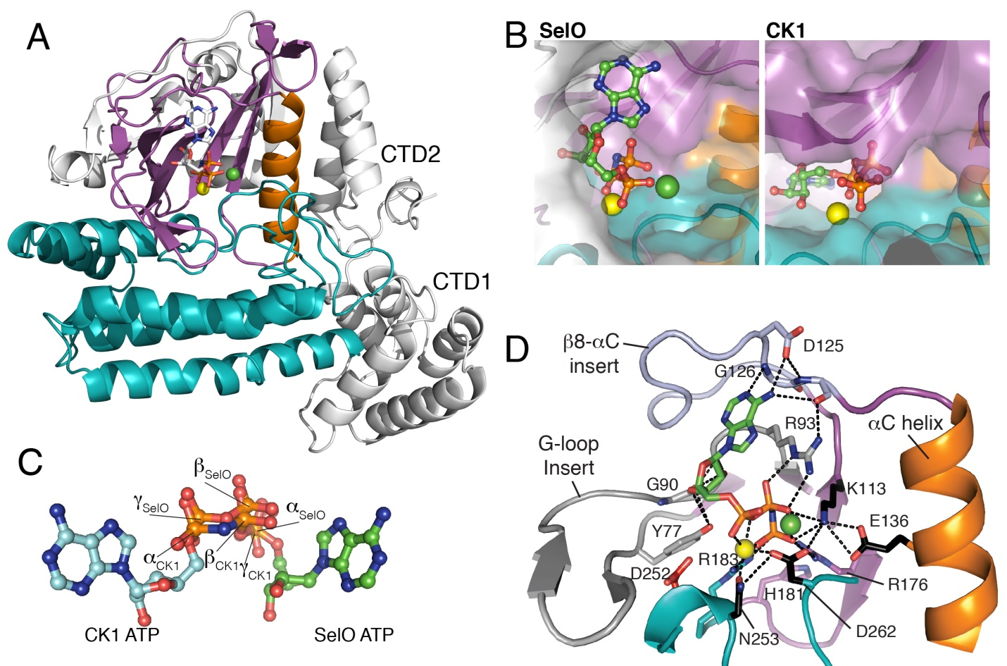Figure 2. The crystal structure of P. syringae SelO reveals an atypical protein kinase fold with ATP flipped in the active site.
(A) Ribbon representation of P. syringae SelO. The N- and C-lobes are shown in magenta and teal, respectively. The αC helix is in orange. The N-terminal extension and C-terminal domains are in white. The AMP-PNP is shown in stick representation and the Mg²⁺ and Ca²⁺ ions are shown as yellow and green spheres, respectively.
(B) Surface representations illustrating the orientation of the nucleotide in the active site of P. syringae SelO (left), colored as above, but with N-lobe insertions shown in white, and protein kinase CK1 (right, pdb: 1csn) in the same orientation as SelO.
(C) Ball-and-stick representation of SelO and CK1 nucleotides superimposed. The α, β, and γ phosphates of SelO and CK1 are highlighted.
(D) Enlarged image of the nucleotide-binding pocket of P. syringae SelO highlighting the flipped ATP binding pocket. Two unique SelO insertions bind the flipped nucleotide, including a G90 and Y77 from the elongated G-loop (light blue) that form hydrogen bonds (black dotted lines) with the ribose ring and R93 that forms hydrogen bonds with the β-phosphate, as well as D125 and G126 from the β8-αC insert (gray) forming hydrogen bonds with the nucleotide. Two Arg sidechains (R176 and R183) form a unique charged pocket for the γ-phosphate, with the sidechains from R183 and H181 replacing the canonical ATP nucleotide binding site.

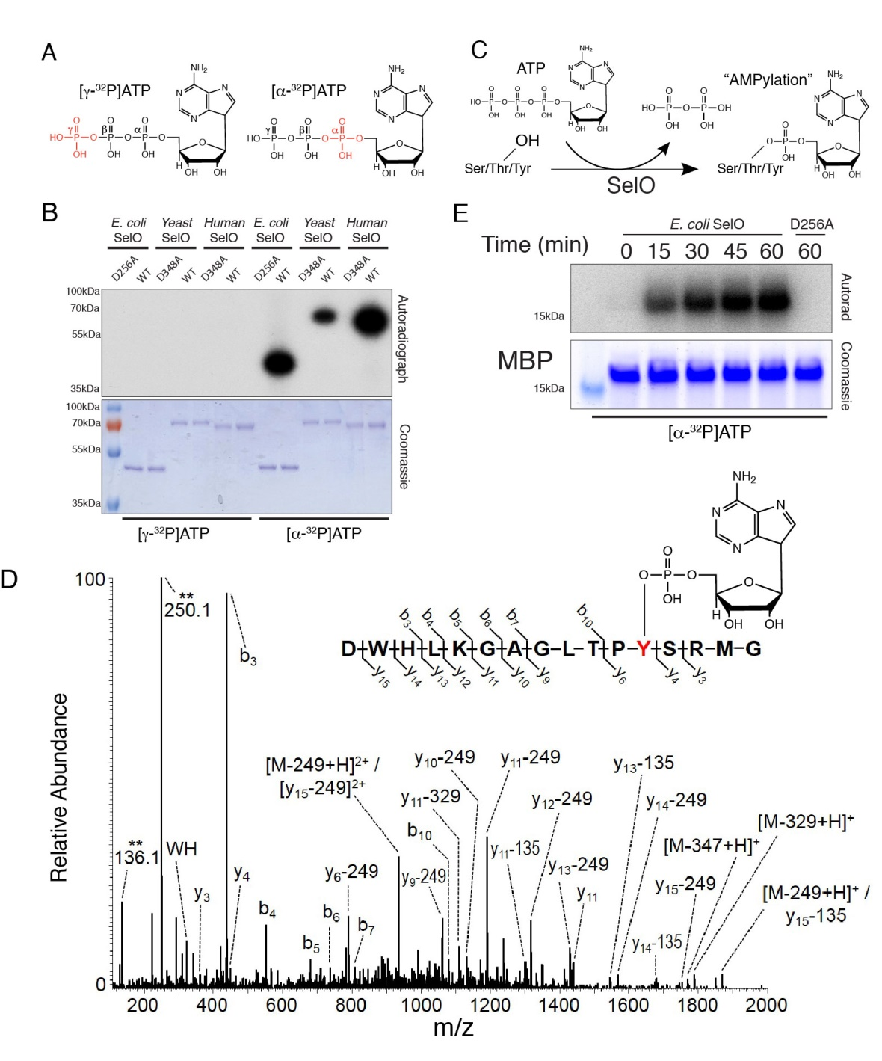

Figure 3. SelO pseudokinases AMPylate protein substrates.
(A) Structure of the ATP molecule highlighting the position of the ³²P on the γ-phosphate (left) or α-phosphate (right) in red.
(B) Autoradiograph depicting the incorporation of γ-³²P from [γ-³²P]ATP (left) or α-³²P from [α-³²P]ATP (right) using E. coli, S. cerevisiae and human SelO (U667C), or catalytically inactive mutants. Reaction products were resolved by SDS-PAGE and visualized by Coomassie blue staining (lower) and autoradiography (upper).
(C) Proposed reaction catalyzed by the SelO pseudokinases.

(D) MS/MS spectrum of an AMPylated E. coli SelO peptide ion. The precursor ion, m/z 1059.47 (2+), of the AMPylated peptide was subjected to HCD fragmentation to generate the spectrum shown. Fragment ions containing the modified residue show characteristic mass shifts corresponding to loss of the AMP group (-329, -249, and -135 Da). Unique ions corresponding to neutral loss of the AMP group (labeled with **) are present at 136.1 and 250.1 Da.
(E) Time dependent incorporation of α-³²P from [α-³²P]ATP into MBP by SelO or SelO D256A. Reaction products were analyzed as in (B).

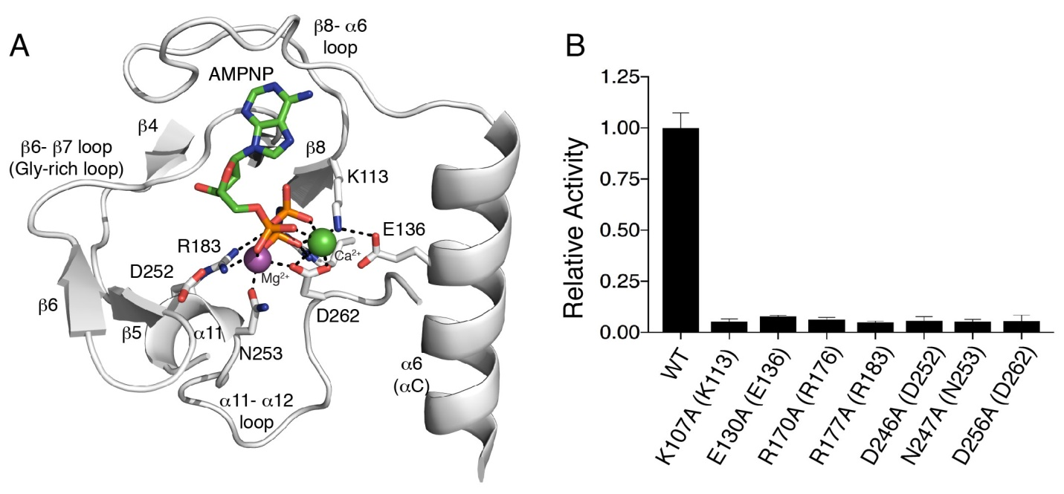

Figure 4. A unique active site architecture in P. syringae SelO facilitates ATP binding and AMPylation activity.
(A) Enlarged image of the nucleotide-binding pocket of P. syringae SelO showing the detailed molecular interactions important for nucleotide binding and catalysis. Interactions are shown as dashed lines. The AMP-PNP molecule is shown in stick and the Mg²⁺ and Ca²⁺ ions are shown as purple and green spheres, respectively.
(B) Activity of E. coli SelO or active site mutants using MBP and [α-³²P]ATP as substrates. Reaction products were resolved by SDS-PAGE and radioactive gel bands were excised and quantified by scintillation counting. The numbering in parentheses corresponds to the residues in P. syringae SelO.

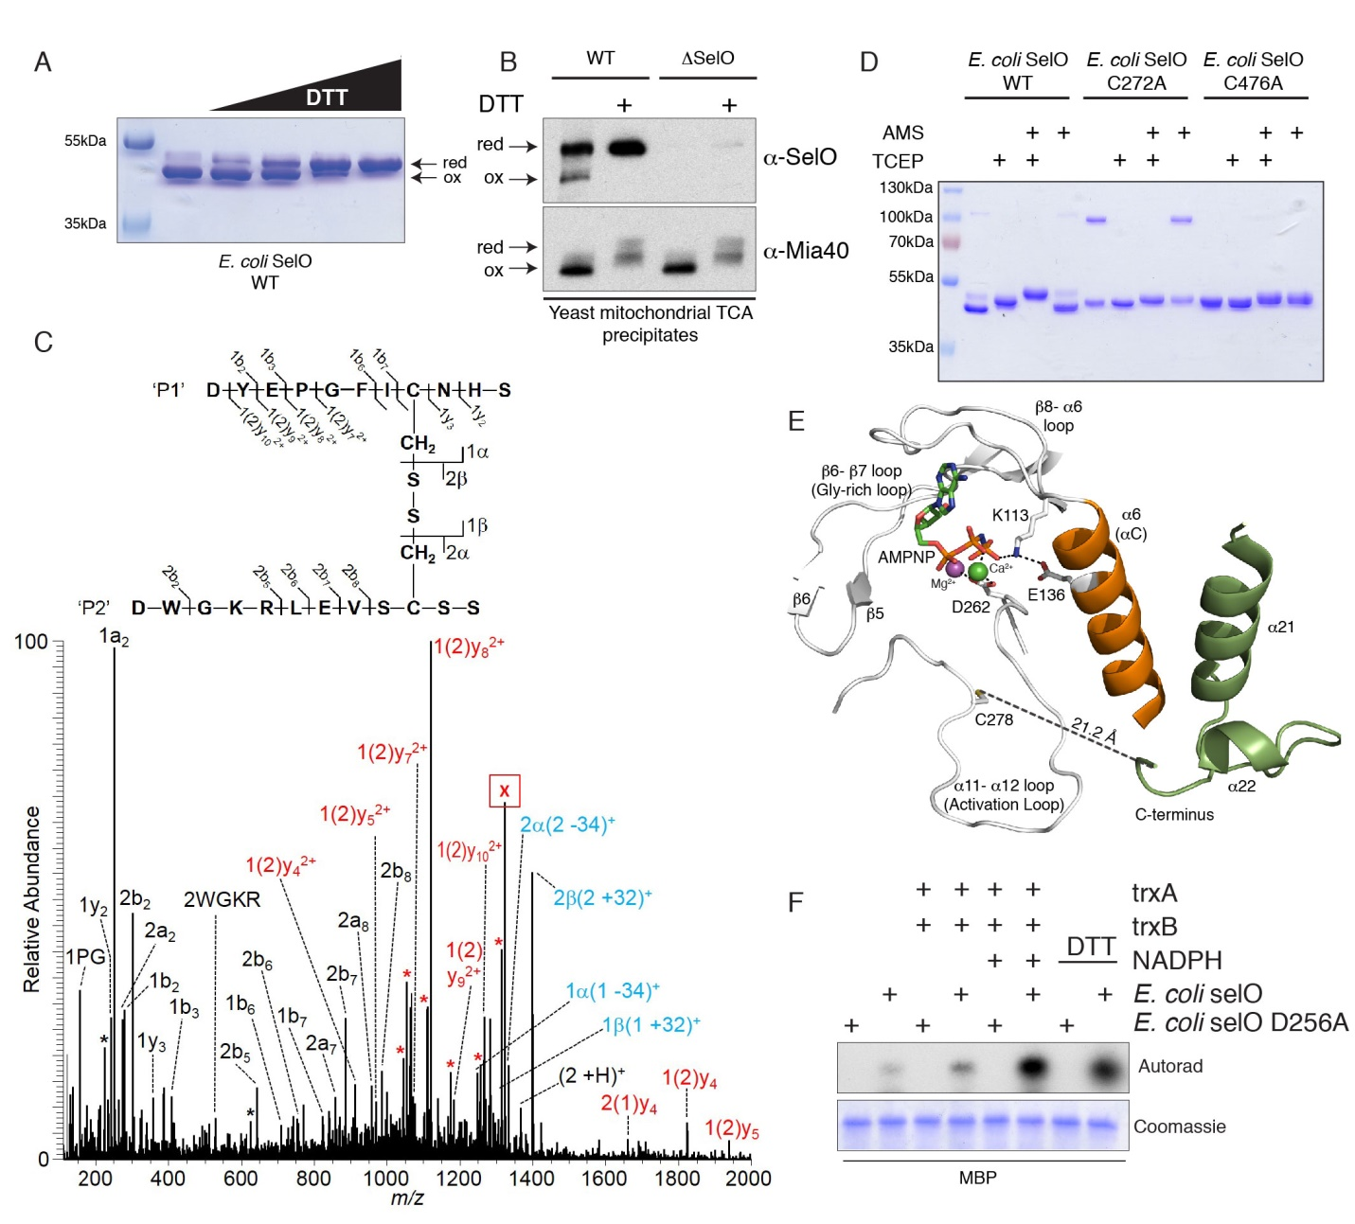

Figure 5. SelO activity is regulated by an intramolecular disulfide bridge.
(A) Non-reducing SDS PAGE and Coomassie blue staining analysis of recombinant E. coli SelO purified in the absence of reducing agent and incubated with increasing concentrations of DTT (0 - 1mM).
(B) Non-reducing SDS PAGE and protein immunoblotting of yeast mitochondrial TCA precipitates depicting endogenous S. cerevisiae SelO and Mia40. TCA precipitates were treated with or without DTT prior to electrophoresis.
(C) MS/MS spectrum of E. coli SelO peptides linked by a disulfide bond: DYEPGFICNHS / DWGKRLEVSCSS. The precursor ion, m/z 1323.07 (2+) (labeled with “X”), was subjected to HCD fragmentation to generate the spectrum shown. Peaks labeled with an asterisk (*) correspond to neutral loss of ammonia (-17 Da) or water (-18 Da) from fragment ions. The peak labels are color coded depending on the status of the disulfide bond (SS) for that particular ion: black (no SS), red (intact SS), and blue (asymmetric cleavage of SS, α or β).
(D) Non-reducing SDS PAGE and Coomassie blue staining analysis of recombinant E. coli SelO or the C272A and C476A mutants purified under non-reducing conditions and incubated with the reducing agent TCEP or the alkylating agent AMS. The species at ~100kDa in the SelO C272A mutant is a dimer formed between two molecules of E. coli SelO linked by an intermolecular disulfide.
(E) Enlarged image of the active site highlighting the activation loop C278 (C272 in E. coli SelO) and the C-terminus of the protein. The α6 (αC equivalent) is in orange and the α21 and α22 helices are in green. The AMP-PNP molecule is shown in stick and the Mg²⁺ and Ca²⁺ ions are shown as purple and green spheres, respectively.
(F) Incorporation of ³²P AMP from [α-³²P]ATP by E. coli SelO or the D256A mutant under non-reducing or reducing conditions (DTT or the thioredoxin system). (trxA; E. coli thioredoxin, trxB; E. coli thioredoxin reductase). Reaction products were analyzed as in Figure 3B.

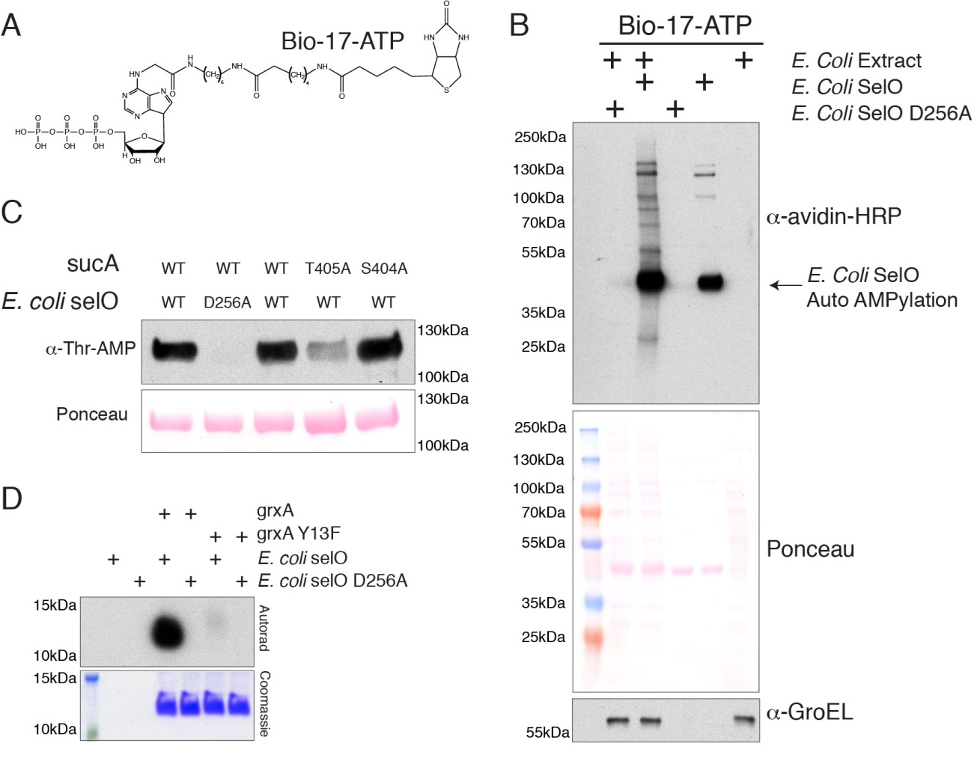

Figure 6. SelO AMPylates mitochondrial proteins
(A) Structure of biotin-17-ATP (bio-17-ATP) used in these experiments to identify SelO substrates.
(B) Representative blot using avidin-HRP to detect biotinylated proteins following incubation of E. coli extracts with bio-17-ATP and E. coli SelO or the D256A mutant. The Ponceau stained membrane and an immunoblot for GroEL are shown as loading controls.
(C) α-Thr-AMP protein immunoblotting of Ni-NTA affinity purified His-tagged sucA (or mutants) from SelO KO E.coli extracts expressing untagged WT SelO or the inactive mutant. The Ponceau stained membrane is shown.
(D) Autoradiograph depicting the incorporation of α-³²P AMP from [α-³²P]ATP by E. coli SelO or the D256A mutant into E. coli grxA. Reaction products were analyzed as in Figure 3B.

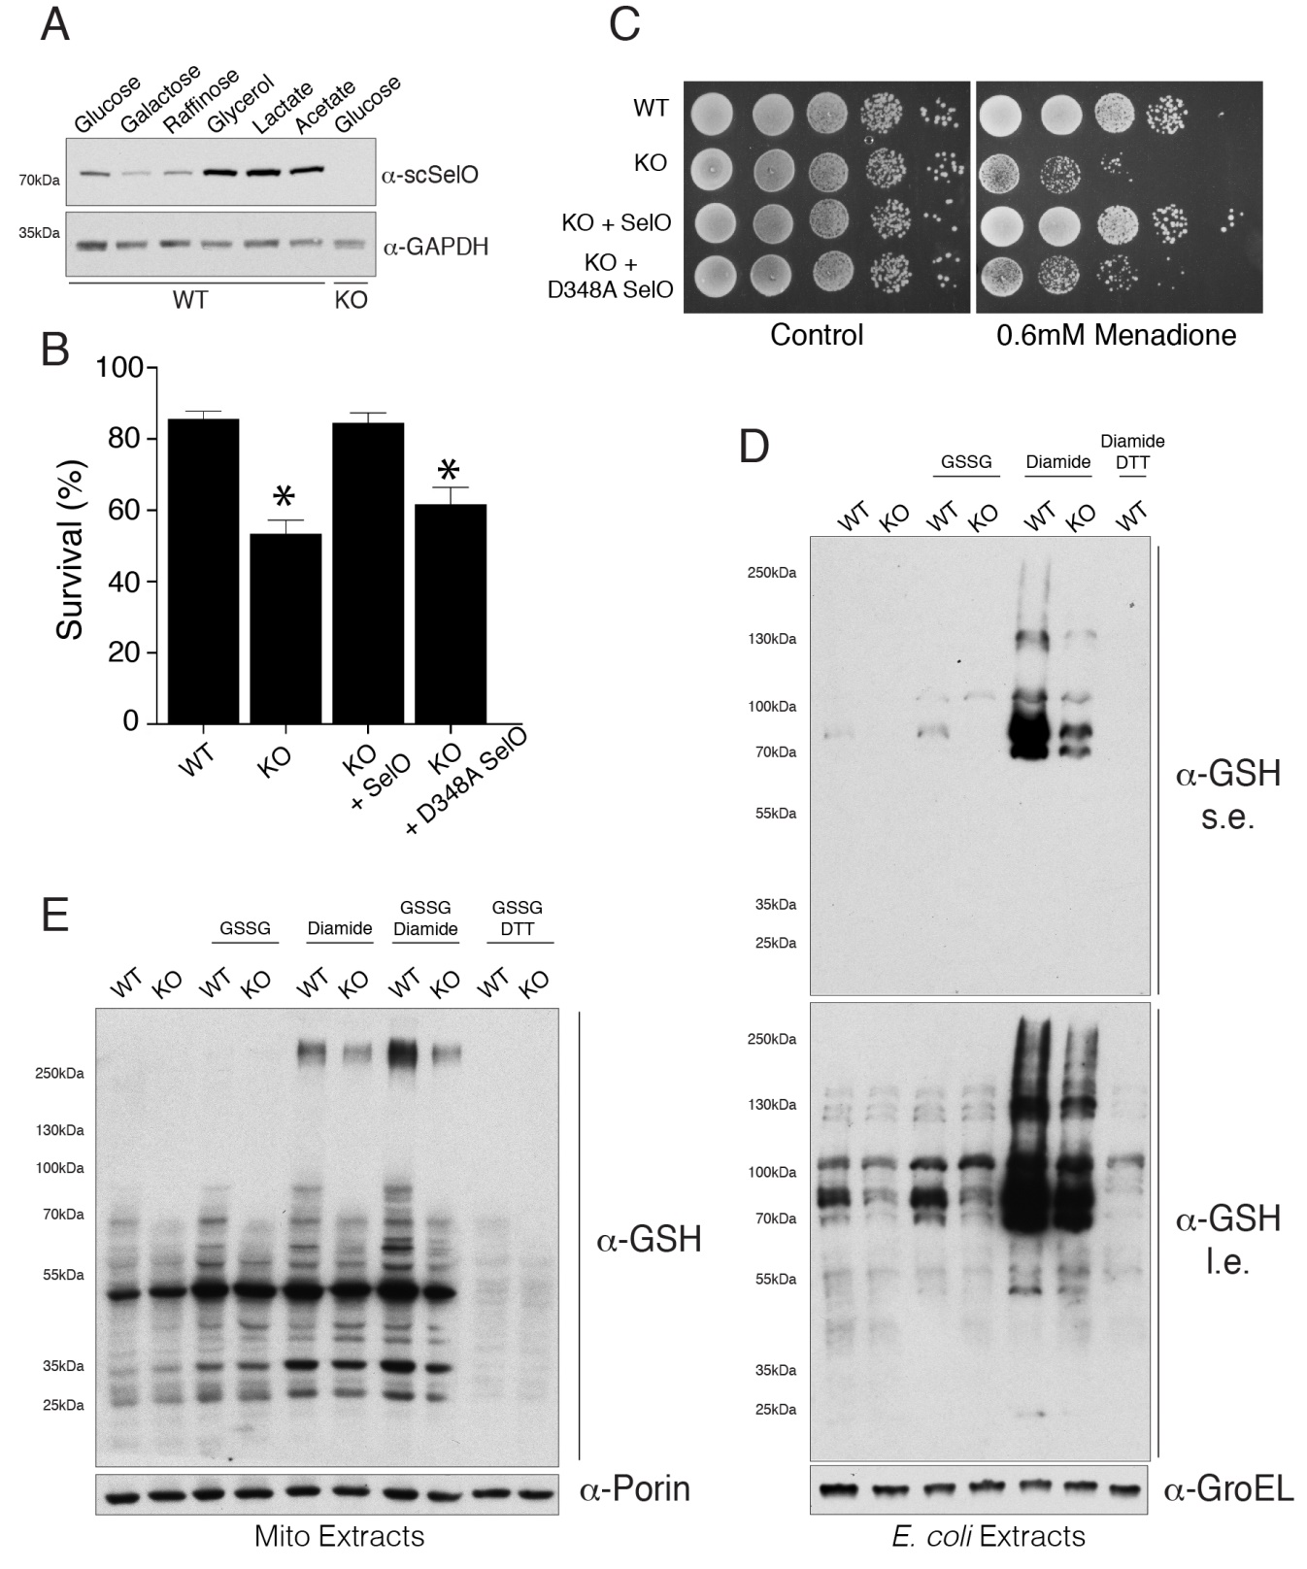

Figure 7. SelO protects yeast cells for oxidative stress and regulates protein S-glutathionylation
(A) Representative protein immunoblots of WT and SelO KO yeast cell extracts (strain MR6) grown in medium with the indicated carbon source. S. cerevisiae SelO (ScSelO) and GAPDH (loading control) are shown.
(B) Percent survival of S. cerevisiae WT, SelO KO or SelO KO cells (strain MR6) complemented with WT or D348A SelO following treatment with 100 μM H₂O₂ in glucose minimal medium for 200 min at 28°C. Results represent the mean of 3 independent experiments. * p < 0.005 vs WT.
(C) Representative growth assays of S. cerevisiae (strain BY4741) untreated (left) or 0.6 mM menadione treated (right). WT, SelO KO or SelO KO complemented with WT or D348A SelO strains were analyzed.
(D) Representative protein immunoblots of WT and SelO KO E. coli extracts following treatment of intact cells with oxidized glutathione (GSSG) or diamide. Cells were also treated with diamide followed by DTT as a negative control. Extracts were probed with anti-glutathionylation (GSH) and E. coli GroEL (loading control). Results are representative of at least 3 independent experiments. s.e. (short exposure). l.e. (long exposure).
(E) Representative protein immunoblots of crude mitochondrial extracts isolated from WT and SelO KO S. cerevisiae (strain MR6) following treatment of intact mitochondria with oxidized glutathione (GSSG) and/or diamide. Mitochondria were also treated with GSSG followed by DTT as a negative control. Extracts were probed with anti-glutathionylation (GSH) and S. cerevisiae porin (loading control). Results are representative of at least 3 independent experiments.

