Yeast models of mutations in the mitochondrial ATP6 gene found in human cancer cells

Katarzyna Niedzwiecka^{1$}, Anna Magdalena Kabala^{1,2$}, Jean-Paul Lasserre², Déborah Tribouillard-Tanvier^{2#}, Pawel Golik^{1,3}, Alain Dautant², Jean-Paul di Rago², Roza Kucharczyk¹*

¹Institute of Biochemistry and Biophysics, Polish Academy of Sciences, Warsaw, Poland
²Institut de Biochimie et Génétique Cellulaires, CNRS UMR5095, Université de Bordeaux, 1 rue Camille Saint-Saëns, 33077 Bordeaux cedex, France.
³Institute of Genetics and Biotechnology, Faculty of Biology, University of Warsaw, Poland
#Research associate from INSERM.

$These authors equally contributed
*To whom correspondence should be addressed. Email: roza@ibb.waw.pl, Phone: +48 225921221, Fax: +48 226584636

Abstract

Since the discovery of somatic mtDNA mutations in tumor cells, multiple studies have focused on establishing a causal relationship between those changes and alterations in energy metabolism, a hallmark of cancer cells. Yet the consequences of these mutations on mitochondrial function remain largely unknown. In this study, Saccharomyces cerevisiae has been used as a model to investigate the functional consequences of four cancer-associated missense mutations (8914C>A, 8932C>T, 8953A>G, 9131T>C) found in the mitochondrial MT-ATP6 gene. This gene encodes the a-subunit of F₁F_{O}-ATP synthase, which catalyzes the last steps of ATP production in mitochondria. Although the four studied mutations affected well-conserved residues of the a-subunit, only one of them (8932C>T) had a significant impact on mitochondrial function, due to a less efficient incorporation of the a-subunit into ATP synthase. Our findings indicate that these ATP6 genetic variants found in human tumors are neutral mitochondrial genome substitutions with a limited, if any, impact on the energetic function of mitochondria.

Keywords: ATP synthase, MT-ATP6, mitochondria, bioenergetics, cancer, mtDNA mutation.

- Introduction

Cancer cells actively metabolize glucose producing excessive lactic acid and, at the same time, consume oxygen via oxidative phosphorylation (OXPHOS), a phenomenon called ‘aerobic glycolysis’ or the ‘Warburg effect’ (Warburg, 1956a, b). Warburg interpreted this as a consequence of mitochondrial dysfunction. In support to this hypothesis, a number of studies reported that tumor mitochondria are structurally and functionally abnormal and incapable of generating normal levels of energy (Chen et al., 2009; Galluzzi et al., 2010; John, 2001; Ramanathan et al., 2005). Furthermore, nuclear mutations in key mitochondrial metabolic enzymes, such as succinate dehydrogenase (SDH), fumarate hydratase (FH) and isocitrate dehydrogenase 1 and 2 (IDH1/2) have been linked to uterine leiomyomas and paragangliomas (Bardella et al., 2011; Berrada et al., 2013; Gupta et al., 2012; Ward et al., 2010; Xiao et al., 2012). Altered mitochondrial metabolism can have wide spread effects, such as an increase production of reactive oxygen species (ROS) and reduced Ca²⁺ uptake, which can in turn modulate the activities of several transcription factors, such as HIF1α (hypoxia-inducible factor 1α), induce apoptosis and activate mitochondrial-nucleus retrograde signaling pathways (Wallace, 2012). Based on these findings, it has been proposed that cancer is primarily a metabolic disease (Seyfried and Shelton, 2010).
Almost two thousands of mitochondrial DNA (mtDNA) mutations have been found in various tumors, in the D-loop region and in RNA and protein-encoding genes (Lu et al., 2009). However, for most of them, their impact on mitochondrial function has not been characterized and a role for these mutations in tumorigenesis remains elusive. Most data about a possible link between mtDNA mutations and cancer come from studies using cell lines bearing detrimental mtDNA mutations from patients with mitochondrial cytopathies. For instance, cybrids containing a common HeLa nucleus and mtDNA with mutations of the MT-ATP6 gene (8993T>G and 9176T>G) leading to NARP (neuropathy ataxia retinitis pigmentosa) or LS (Leigh) syndromes proved to confer an advantage in the early stage of tumor growth in a nude mice assay (Shidara et al., 2005). In another study, PC3 prostate cancer cell lines in which the 8993T>G mutation was introduced, generated much larger tumors than cells carrying wild type mtDNA (Petros et al., 2005). It has been argued that the 8993T>G and 9176T>G mutations promote tumorigenesis by preventing apoptosis (Shidara et al., 2005). As mutations in mtDNA affecting the efficiency of the OXPHOS system result in an increased ROS production, this mechanism may be linked to ROS signaling (Gupta et al., 2012). Indeed, ROS levels were shown to be elevated in 8993T>C cybrids (Carrozzo et al., 2004b; Mattiazzi et al., 2004). Whereas a strong increase in ROS levels should induce apoptosis, a moderate increase in ROS may lead to the up-regulation of antioxidant enzymes and, therefore, stimulate tumor growth. Such mechanism was postulated in a colorectal cell line, where a heteroplasmic, but not homoplasmic, MT-ND5 mutation promoted tumorigenesis by an alteration of ROS production (Park et al., 2009).
Given the high mutational rate of the mitochondrial genome and the presence of numerous family or population-specific polymorphisms, it is difficult to distinguish between a neutral mtDNA variant and a disease-causing mutation. Multiple studies have also determined that the effects of deleterious mtDNA mutations may be exacerbated by concomitant mtDNA nucleotide changes that are not pathogenic per se and by unknown factors in the nuclear genetic background, i.e. so-called modifier genes (Cai et al., 2008; Swalwell et al., 2008). Owing to the absence of mutagenesis methods for the mammalian mitochondrial genomes, S. cerevisiae has been utilized as an alternative model to investigate mtDNA mutations found in patients. Mitochondrial genetic transformation can be achieved in S. cerevisiae in a highly controlled fashion, by the biolistic delivery into mitochondria of in-vitro-made mutated mtDNA fragments, followed by their integration into wild type mtDNA by homologous DNA recombination (Bonnefoy and Fox, 2001). Unable to stably maintain heteroplasmic mtDNA (Okamoto et al., 1998), it is relatively easy to obtain yeast homoplasmic populations where all mtDNA molecules carry a mutation of interest. Several groups have exploited these attributes for the study of various pathogenic mtDNA mutations, for example in the genes encoding subunits of complexes III (MT-CYB), IV (MT-CO1, MT-CO3) (Meunier, 2001; Meunier et al., 2013) and V (MT-ATP6) (Kucharczyk et al., 2010; Kucharczyk et al., 2013; Kucharczyk et al., 2009a; Kucharczyk et al., 2009b; Rak et al., 2007a; Vindrieux et al., 2013), and in MT-tRNA genes (Feuermann et al., 2003; Montanari et al., 2008), which have helped to better define the functional consequences of these mutations. Importantly, the consequences of these mutations in yeast corresponded to the reported severity of these mutations in humans in most cases, likely reflecting a high level of evolutionary conservation within the regions of the affected proteins and RNAs.
In this study, yeast has been used as a model to investigate the functional consequences of four missense mutations (8914C>A, 8932C>T, 8953A>G and 9131T>C) of the MT-ATP6 gene found in thyroid, parathyroid, prostate and breast cancer cells (Abu-Amero et al., 2006; Costa-Guda et al., 2007; Petros et al., 2005; Tan et al., 2002). The MT-ATP6 gene encodes an essential component (a-subunit) of F₁F_{O}-ATP synthase (or complex V) that enables this enzyme to produce ATP by utilizing the energy from the electrochemical proton gradient across the mitochondrial inner membrane during electron transfer to oxygen by respiratory chain. Among four studied mutations, only one affected the function of ATP synthase, which argues against a role, at least for the three other mutations, in carcinogenesis by compromising the energetic activity of mitochondria.

- Materials and Methods
  - Yeast strains and growth media. The sources and genotypes of the strains used in this study are listed in Table 1. Yeast cells were grown on standard yeast rich media (1% Bacto yeast extract, 2% Bacto peptone) with 2% of glucose (YPGA), 2% of galactose (YPGalA), 2% of glycerol (YPGlyA), supplemented with 40 mg/L of adenine and 2% of Bacto agar for solid media (Sherman, 1991).

Table 1. Genotypes and sources of yeast strains. ρ⁰ refers to the complete absence of mtDNA. ρ⁺ designates a complete mitochondrial genome. ρ⁻ cells contain only a fragment of the mitochondrial genome. The four ρ⁺ yeast cancer models investigated in this study (RKY60, RKY61, AKY1, and AKY2) are isogenic to the MR6 wild type yeast strain, except for the mtDNA atp6 mutation.

Strain | Nuclear genotype | mtDNA | Ref.
DFS160 | MATa leu2Δ ura3-52 ade2-101 arg8::URA3 kar1-1 | ρº | Steele et al., 1996
NB40-3C | MATa lys2 leu2-3,112 ura3-52 his3ΔHinDIII arg8::hisG | ρ⁺ cox2-62 | Steele et al., 1996
MR6 | MATa ade2-1 his3-11,15 trp1-1 leu2-3,112 ura3-1 CAN1 arg8::hisG | ρ⁺ ATP6 | Rak et al., 2007b
MR10 | MATa ade2-1 his3-11,15 trp1-1 leu2-3,112 ura3-1 CAN1 arg8::hisG | ρ⁺ atp6::ARG8^{m} | Rak et al., 2007b
RKY57 | MATα leu2Δ ura3-52 ade2-101 arg8::URA3 kar1-1 | ρ⁻ atp6-P157T | This study
RKY58 | MATα leu2Δ ura3-52 ade2-101 arg8::URA3 kar1-1 | ρ⁻ atp6-P163S | This study
AKY8 | MATα leu2Δ ura3-52 ade2-101 arg8::URA3 kar1-1 | ρ⁻ atp6-I170V | This study
AKY9 | MATα leu2Δ ura3-52 ade2-101 arg8::URA3 kar1-1 | ρ⁻ atp6-L232P | This study
RKY60 | MATa ade2-1 his3-11,15 trp1-1 leu2-3,112 ura3-1 CAN1 arg8::hisG | ρ⁺ atp6 P157T | This study
RKY61 | MATa ade2-1 his3-11,15 trp1-1 leu2-3,112 ura3-1 CAN1 arg8::hisG | ρ⁺atp6-P163S | This study
AKY1 | MATa ade2-1 his3-11,15 trp1-1 leu2-3,112 ura3-1 CAN1 arg8::hisG | ρ⁺atp6-I170V | This study
AKY2 | MATa ade2-1 his3-11,15 trp1-1 leu2-3,112 ura3-1 CAN1 arg8::hisG | ρ⁺atp6-L232P | This study

  - ATP6 mutagenesis. A schematic description of the method used to create the yeast ATP6 cancer models is provided in Figure 1. Nucleotide and amino-acid changes induced by the mutations studied in the human a-subunit, and their equivalents in yeast are listed in Table 2. The QuikChange XL Site-directed Mutagenesis Kit of Stratagene and the following mutagenic oligonucleotides were used for the mutagenesis of the yeast ATP6 gene (in bold is the modified codon): 5’GGTTGAGTATTCTTCTCATTATTCGTAACTGCTGGTACACCATTACC (P157T); 5’TCATTATTCGTACCTGCTGGTACACCATTATCATTAGTACCTTTATTAGTTATTATTGAAACTTTATCTTATTTCGCTAGA (P163S); 5’CCATTAGTACCTTTATTAGTTGTTATTGAAACTTTATCTTATTTCGCTAGAGC (I170V); and 5’GCTATGATCTTAGCCATTATGATGCCAGAATTCACTGGCCGTCGTTTTACAACGTCG (L232P). Mutagenesis was performed on a BamHI-EcoRI fragment containing the 5’part of the ATP6 gene cloned into pUC19 (plasmid pSDC8, (Zeng et al., 2007a)). The mutated ATP6 fragments were liberated and ligated at the same sites with pJM2 (Steele et al., 1996). The resulting plasmids are called (pRK29 (with the P157T change), pRK27 (P163S), pRK30 (I170V), and pRK36 (L232P). The 3’ part of the wild type ATP6 locus, excised from pSDC9 (Rak et al., 2007a) with SapI + EcoRI, was introduced in these plasmids, resulting in the final plasmids used for yeast transformation: pRK33, pRK31, pAK4-6, and pAK5-1, respectively. These plasmids were introduced by co-transformation with the nuclear selectable LEU2 gene contained in the Yep351 plasmid, into the DFS160 strain devoid of mtDNA (ρº), by microprojectile bombardment using a biolistic PDS-1000/He particle delivery system (Bio-Rad) as described (Bonnefoy and Fox, 2001). The DFS160 strain carries a mutation (kar1-1) that delays nuclear karyogamy (Conde and Fink, 1976). Mitochondrial transformants were identified among the Leu+ nuclear transformants by their ability to produce respiring clones when mated to the non-respiring NB40-3C strain, bearing a partial deletion in the mitochondrial COX2 gene. The resulting synthetic ρ⁻ mtDNA clones were called RKY57 (ρ⁻ P157T change), RKY58 (ρ⁻ P163S), AKY8 (ρ⁻ I170V), and AKY9 (ρ⁻ L232P) (Table 1). These clones were crossed to MR10 strain (Rak et al., 2007b) with a Δarg8 nucleus and in which the coding sequence of ATP6 gene was replaced by ARG8^{m} (atp6::ARG8^{m}), a mitochondrial version of the nuclear ARG8 gene encoding a mitochondrial protein involved in arginine biosynthesis (Steele et al., 1996). In these crosses the mutated atp6 genes can replace the ARG8^{m} marker by mtDNA recombination, resulting in strains with a complete (ρ+) mtDNA carrying one of the atp6 mutations: RKY60 (ρ⁺ P157T), RKY61 (ρ⁺ P163S), AKY1 (ρ⁺ I170V) and AKY2 (ρ⁺ L232P) (Table 1). These clones were identified by arginine auxotrophy and verified by DNA sequencing.
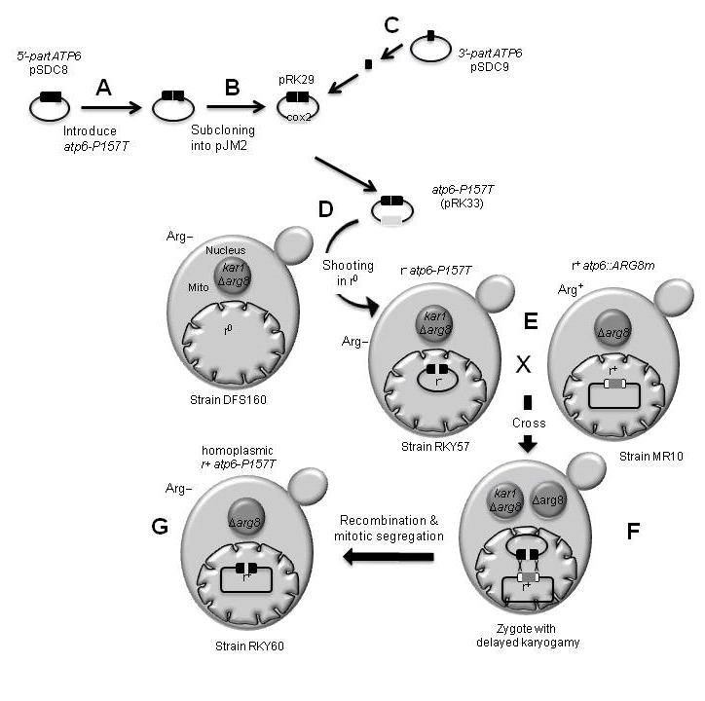

Figure 1. Construction of yeast model bearing a human mtDNA cancer mutation in the ATP6 gene. Steps A, B, C describe the construction of the pRK33 plasmid bearing the yeast ATP6 gene with the P157T mutation and the COX2 gene as a marker for mitochondrial transformation. (D) pRK33 was introduced into the DFS160 strain mitochondria, devoid of mtDNA (ρ⁰), which has a null allele of the nuclear ARG8 gene (arg8Δ) and a mutation (kar1-1) that strongly delays nuclear fusion, enabling mtDNA transfer from one haploid nuclear background to another (Conde and Fink, 1976). (E) The resulting synthetic ρ⁻ strain (RKY57), unable grow in the absence of external arginine (Arg−), was crossed with an arginine prototrophic (Arg⁺) strain that contains ρ⁺ mtDNA deleted for ATP6 (atp6Δ::ARG8m). ARG8m is a mitochondrial version of a nuclear gene (ARG8) and encodes a yeast mitochondrial protein involved in arginine biosynthesis (Steele et al., 1996). (F) Since the ARG8m clone used for the deletion of ATP6 is flanked by ∼100 bp of the ATP6 locus on each side, homologous recombination can mediate the replacement of ARG8m with the atp6-P157T gene. (G) The subsequent mitotic segregation then produces ρ⁺ cells with the atp6-P157T mutation, in a pure (homoplasmic) form that can be identified by virtue of their inability to grow in the absence of arginine.

  - Measurement of mitochondrial respiration, ATP synthesis and mitochondrial membrane potential. Mitochondria were prepared by the enzymatic method as described (Guerin et al., 1979). For all assays, they were diluted to 0.15 mg/ml in 10 mM Tris-maleate (pH 6.8), 0.65 M sorbitol, 0.3 mM EGTA, and 3 mM potassium phosphate. Oxygen consumption rates were measured using a Clarke electrode after consecutive addition of 4 mM NADH (state 4 respiration), 150 µM ADP (state 3) or 4 µM carbonyl cyanide m-chlorophenylhydrazone (CCCP) (uncoupled respiration), as described previously (Rigoulet and Guerin, 1979). The rates of ATP synthesis were determined as in (Rak et al., 2007b), in the presence of 4 mM NADH and 750 µM ADP; aliquots were withdrawn from the oxygraph cuvette every 15 seconds and the reaction was stopped with 3.5% (w/v) perchloric acid, 12.5 mM EDTA. The samples were then neutralized to pH 6.5 by addition of KOH, 0.3 M MOPS. Synthesized ATP was quantified using a luciferin/luciferase assay (ATPLite kit from Perkin Elmer) on a LKB bioluminometer. Participation of the F₁F_{O}-ATP synthase to ATP production was assessed by measuring the sensitivity of ATP synthesis to oligomycin (3 μg/ml). Variations in mitochondrial membrane potential (ΔΨ) were evaluated as in (Emaus et al., 1986) by monitoring the quenching of rhodamine 123 fluorescence (0.5 μM) using a λ_{exc} of 485 nm and a λ_{em} of 533 nm under constant stirring using a FLX Spectrofluorimeter (SAFAS, Monaco). The specific ATPase activity at pH 8.4 of non-osmotically protected mitochondria was measured as described in (Somlo, 1968). Student’s t-test was used to assess significant differences with the respective control.

  - Determination of ROS levels in cells. The cytosolic superoxide (O₂–), hydroxyl (OH–) and peroxynitrite (ONOO–) anions accumulation were measured by flow cytometry using dihydroethidium (DHE, Sigma). Cells were grown in YPGA, YPGalA or YPGlyA media to OD=1-2. 3 OD of cells were then converted to protoplasts with zymolyase 20T (AsmBio) for 1 hour at 37°C in PBS pH 7.5/1 M sorbitol buffer. Protoplasts were washed twice and diluted to 1x10⁷/ml density in the same buffer and 10 µM of DHE were added. The next day, the cells were washed with PBS pH 7.5/1 M sorbitol and suspended to 1x10⁶/ml concentration for flow cytometry using BD FACS Calibur. The cells were sonicated and then subjected to FACS analysis; 10,000 cells were counted for each sample. Student’s t-test was used to assess significant differences with the respective control.

  - Miscellaneous procedures. Scoring ρ⁻/ρ⁰ cells in yeast cultures, SDS–PAGE and BN–PAGE, Western blotting and pulse labeling of mtDNA encoded proteins were performed as described in (Rak et al., 2007b), except that precast Novex 3-12% Bis-tris gels were used for BN-PAGE.

  - Multiple sequence alignment and homology modelling of yeast ac₁₀ complex. Multiple sequence alignment of ATP synthase a-subunits was performed using ClustalW (Thompson et al., 1994). TMHMM 2.0 and PSIPRED 3.3 servers were used to predict transmembrane segments and secondary structures, respectively (Buchan et al., 2013; Krogh et al., 2001). Figure 2A was drawn using the ESPRIPT program (Robert and Gouet, 2014). The homology model of yeast ac₁₀ complex is based on the atomic model built in the cryo-electron microscopy density map of the bovine ATP synthase (pdb:5arh; emdb:3166) (Zhou et al., 2015) and the yeast c₁₀-ring crystal structure (pdb:2hld) (Kabaleeswaran et al., 2006). It was built using Phire2 (Kelley et al., 2015), regularized using Coot (Emsley et al., 2010; Pettersen et al., 2004), and energy minimized using Phenix (Adams et al., 2010). Figure 2B was drawn using Pymol (DeLano WL, DeLano Scientific, San Carlos California, USA, 2002).

- Results
The four MT-ATP6 mutations investigated in this study (8914C>A, 8932C>T, 8953A>G and 9131T>C) affect well conserved residues of the a/6 subunit from various origins (Homo sapiens, Escherichia coli, Saccharomyces cerevisiae, Arabidopsis thaliana, Alligator mississippiensis, Brachydanio rerio, Caenorhabditis elegans, Cionia intestalis, Drosophilia melanogaster, Neurospora crassa, Podospora anserina and Xenopus laevis (Kucharczyk et al., 2009c); see also Figure 2A). These mutations lead to the following amino acid changes in the human a-subunit: P130T, P136S, I143V and L202P, respectively (Figure 2A). The corresponding ATP6 codons in yeast were modified to induce equivalent amino acid changes: P157T, P163S, I170V and L232P, respectively (Table 2, Figure 2A).

Table 2. Cancer-related mutations in human ATP6 and their equivalents in yeast. * according to MITOMAP (www.mitomap.org); n.d., not determined; A.a., amino acid; Ps, polymorphic site; Frequency, means occurrence in mtDNA from cancer samples.

In human |  |  |  |  |  |  |  | In yeast
Type of tumor | Nucleotide change | A.a.  change | Hetero-plasmy | Ps* | Frequency | Ref. |  | Codon change | A.a. change
Thyroid | 8914C>A | P130T | Yes | No | 2 / 26 | Abu-Amero et al., 2006 |  | CCT>ACT | P157T
Prostate | 8932C>T | P136S | n.d. | Yes | n.d. | Petros et al., 2005 |  | CCA>TCA | P163S
Para-thyroid | 8953A>G | I143V | n.d. | Yes | 1 / 34 | Costa-Guda et al., 2007 |  | ATT>GTT | I170V
Breast | 9131T>C | L202P | No | No | 1 / 19 | Tan et al., 2002 |  | TTA>CCA | L232P

  - Topological positions of cancer related mutations in the a-subunit.
The a-subunit and a ring of c-subunits (8 in humans (Watt et al., 2010), 10 in yeast (Stock et al., 1999)) are responsible for proton transport across the membrane domain (F_{O}) of ATP synthase (Fillingame et al., 2003; Walker, 2013). This transport drives the rotation of the c-ring and leads to conformational changes in the catalytic domain (F₁) of the enzyme ultimately promoting ATP synthesis. Cryo-electron microscopy analysis of ATP synthase from mammals, fungi and bacteria have revealed four horizontal membrane-intrinsic α-helices (MH) in the a-subunit running along the c-ring (Allegretti et al., 2015a; Morales-Rios et al., 2015; Zhou et al., 2015). Due to the high conservation of a- and c-subunits during evolutin, a structural homology model of this 4-helix bundle was constructed for the yeast a-subunit (referred to as aMH2-5) in interaction with the c₁₀-ring (Watt et al., 2010) (Figure 2B). In the N-terminal domain of the a-subunit, the density maps of bovine ATP synthase (Zhou et al., 2015) revealed an additional hydrophilic helical segment (referred to as aHα) located in the matrix and a helical segment that spans the membrane (referred to as aTM1). As a result, the N-ter of aTM1 is located in the IMS. Consistent with this, it has been shown that the yeast protein is synthesized as a precursor containing a stretch of 10 residues on the N-ter that is cleaved in the inter membrane space (Michon et al., 1988; Osman et al., 2007; Zeng et al., 2007b). aTM1 is located on the outer surface of the complex. Indeed, previous cross-linking experiments have provided strong indication that aTM1 belongs to the contact zone between two ATP synthase monomers (Velours et al., 2011). Two electrically charged residues (aR186 and cE59) known to be involved in the transfer of protons between a-subunit and the c-ring, are located at the interface between a-subunit and the c-ring, near the middle of the membrane (Fillingame et al., 2003; Walker, 2013). A hydrophilic cleft on the external side of the inner membrane is presumed to enable protons to reach cE59 from the IMS and, upon c-ring rotation, the protons are supposed to be released into a second hydrophilic cleft on the matrix side of the membrane (Allegretti et al., 2015b) (Figure 2B).
Three of the four studied Atp6p mutations are located on the matrix side of the membrane, in the loop connecting aMH3 and aMH4 (P157T, P163S), and in the beginning of aMH4 (I170V). The fourth one (L232P) is more embedded in the membrane in aMH5 (Figure 2B).

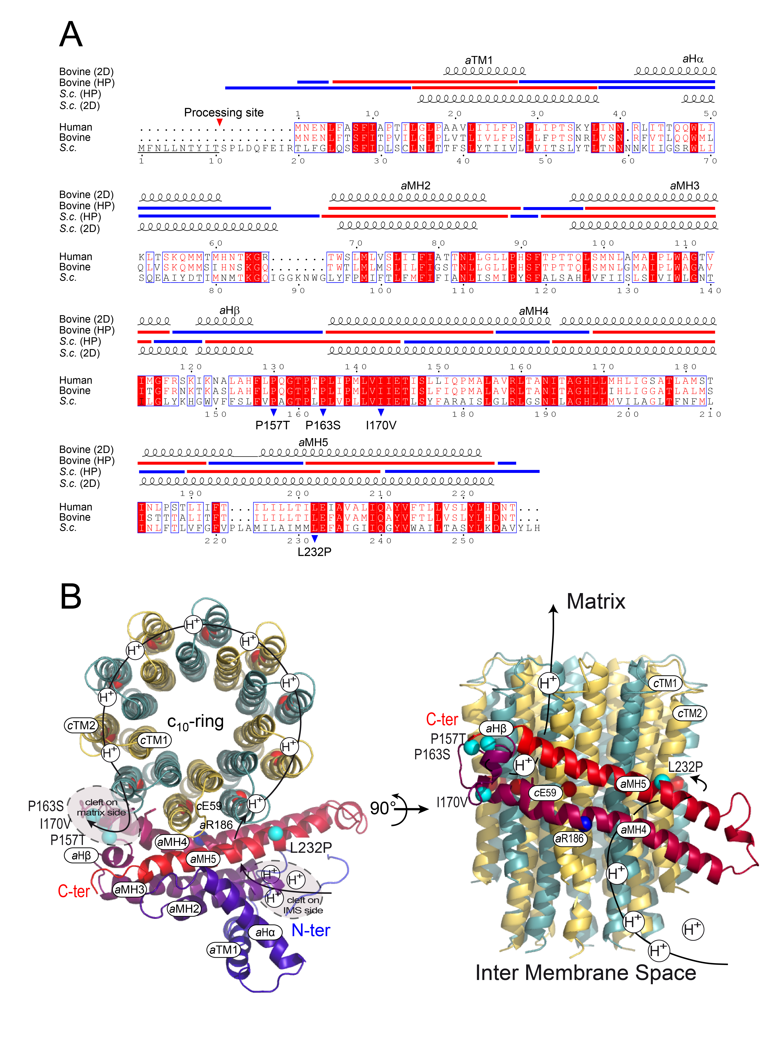
Fig. 2. Sequence alignments of a-subunits from human, bovine and yeast S. cerevisiae and 3D topology of cancer-related mutations in the yeast ac₁₀ model. (A) Human (top) and yeast (bottom) amino-acid sequences are numbered. The yeast protein contains a cleavable 10 residues stretch at the N-ter, as indicated. Blue arrowheads indicate the cancer-related mutations investigated in this study, and the mutated residues are numbered according to the yeast a-subunit. Above the alignment, bovine and yeast proteins are predicted by PSIRED (2D, secondary structure) and TMHMM (HP, hydropathy plot). Hydrophilic and hydrophobic regions are indicated by blue and red lines, respectively. (B) The figure shows a structural homology model of the yeast a-subunit in complex with the c₁₀-ring (PDB id: 2hld) viewed from the matrix (left) and from the membrane plane (right). The aR186 and cE59 residues and the cancer-related mutations (P157T, P163S, I170V and L232P) are shown as blue, red and cyan spheres, respectively. The arrowed line indicates the proton pathway during ATP synthesis. Protons enter and exit the c-ring/a-subunit through hydrophilic clefts within the membrane, represented by grey areas surrounded by dashed lines (Allegretti et al., 2015b). For clarity, the predicted aTM1, aHα and aHM2-3 helices are not represented in the right panel. The a-subunit is coloured using a linear ramp from blue (N-ter) to red (C-ter); adjacent c-subunits are in different colours (gold and green).

  - Respiratory growth and stability of the mitochondrial genome
The optimal growth temperature for yeast is 28°C. At 37°C, mitochondria display some partial damage, apparently due to heat sensitivity of the yeast mitochondrial translation system (Dibrov et al., 1998; Lefebvre-Legendre et al., 2001). Since our study aimed to model human mtDNA mutations in yeast their consequences were investigated in yeast cells grown at 28°C and 36°C (not at 37°C, in order to limit the detrimental heat effect). Neither of the studied Atp6p mutations presented an obvious effect on yeast growth on fermentable substrates (glucose) or carbon sources, where the presence of a functional ATP synthase is required (like glycerol), both at 28°C and 36°C (Figure 3A,B). These results did not necessarily mean that the activity of ATP synthase was unaffected in the mutants. Indeed, a decrease in its activity by at least 80% is necessary for the affectation of the respiratory growth in yeast (Kucharczyk et al., 2010; Mukhopadhyay et al., 1994). Mutations in ATP6 often increased, for unknown reason, the production of ρ⁻/ρ⁰ petite cells issued from large deletions in the mtDNA (Bietenhader et al., 2012; Contamine and Picard, 2000; Rak et al., 2007a; Kucharczyk et al., 2009). Interestingly, one of the mutants analyzed in this study (P163S) had a significantly higher tendency to lose mtDNA when grown at 36°C (55% of petites versus 34% in the MR6 wild type strain), indicating that this mutation is possibly detrimental to ATP synthase at elevated temperature.
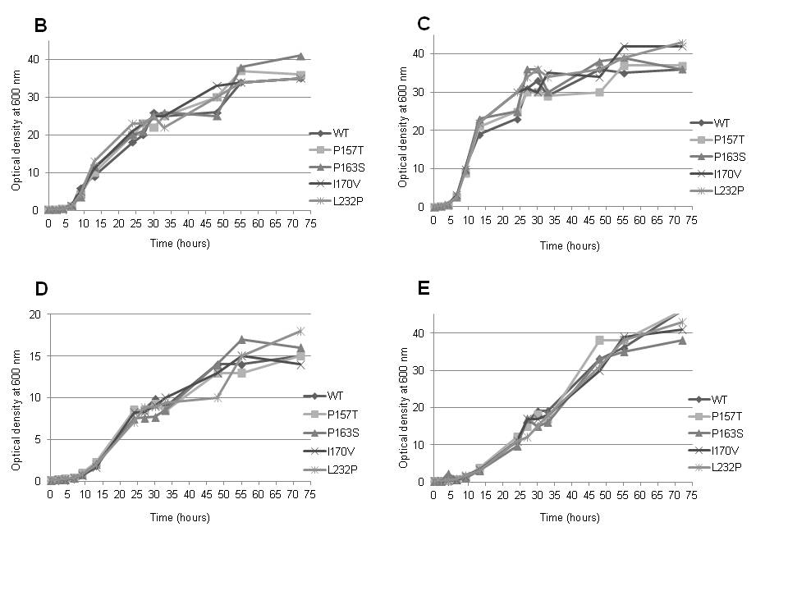

Fig. 3. Influence of cancer-related mutations in Atp6p on yeast respiratory growth. (A) Fresh liquid glucose cultures of wild type yeast and the strains with cancer-related atp6 mutations were serially diluted and spotted on rich glucose and rich glycerol plates. The plates were photographed after 4 days of incubation at the indicated temperatures. (B-D) Growth curves in liquid glucose (B, C) or glycerol (D, E) at 28°C (B, D) or 36°C (C, E). The growth tests are representative of at least two replicates.

  - Mitochondrial respiration and ATP synthesis
The impact of the cancer related atp6 mutations on oxidative phosphorylation was evaluated by measuring the rates of oxygen consumption and ATP synthesis in isolated, osmotically-protected, mitochondria. The mutant mitochondria isolated from cells grown at 28°C respired and produced ATP like the corresponding wild type mitochondria (Figure 4A,B). When grown at 36°C, the P163S mutant displayed significant deficits (60%) in both respiration and ATP synthesis with respect to the wild type (Figure 4C,D). The residual respiratory activity in this mutant was efficiently (3-4 fold) stimulated by CCCP as in wild type yeast, indicating that the passive permeability to protons of the inner mitochondrial membrane was not modified in the P163S mutant. Respiration and ATP synthesis rates were much less affected in the other mutants grown at 36°C.

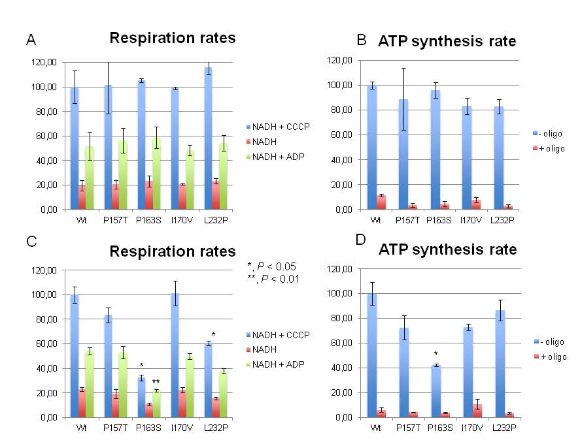
Fig. 4. Influence of cancer-related mutations in Atp6p on yeast mitochondrial respiration and ATP synthesis. Mitochondria were isolated from wild type yeast and the mutant strains with cancer-related mutations in the mitochondrial ATP6 gene grown in rich galactose medium, at 28°C (A, B) or 36°C (C, D). Oxygen consumption rates were measured after consecutive addition of 4 mM NADH (state 4 respiration), 150 µM ADP (state 3) or 4 µM carbonyl cyanide m-chlorophenylhydrazone (CCCP) (uncoupled respiration); they are expressed in percentage of the uncoupled respiration of wild type mitochondria (panels A and C). The rates of ATP synthesis were determined using 4 mM NADH and 750 µM ADP, in the presence/absence of 3 μM oligomycin as indicated, and are expressed in percent with respect to wild type mitochondria (Panels B and D). The error bars and P-values indicated by * were calculated from three independent experiments.

  - Mitochondrial membrane potential
The consequences of the Atp6p mutations were further evaluated by monitoring variations in mitochondrial membrane potential (ΔΨ), through the fluorescence quenching of rhodamine 123. In these experiments, all the mutant mitochondria behaved mostly like the controls, except those from the P163S mutant grown at 36°C. As shown in Figure 5, these mitochondria required a much longer time to erase the drop in ΔΨ induced by the addition of ADP upon energization of the mitochondrial inner membrane with ethanol. This reflects a slower phosphorylation rate of the added ADP by ATP synthase, which is consistent with the lower rate of ATP synthesis measured in these mitochondria (see above).

Fig. 5. Influence of the cancer related atp6-P163S mutation on mitochondrial membrane potential in yeast cells grown at 36°C. Mitochondria were isolated from wild type yeast and the atp6-P163S mutant grown at 36°C. Variation in mitochondrial membrane potential was monitored by rhodamine 123 fluorescence quenching. 0.5 μg/ml rhodamine 123, 0.15 mg/ml mitochondrial proteins (Mito), 10 μl ethanol (EtOH), 0.2 mM potassium cyanide (KCN), 50 μM ADP, and 3 μM CCCP were added. The shown profiles are representative of three independent experiments.

  - ATP synthase assembly/stability
The influence of the Atp6p mutations on the assembly/stability of ATP synthase was investigated by Blue-Native-Polyacrylamide Gel Electrophoresis (BN-PAGE). In the conditions used here, ATP synthase was mainly detected as dimeric (V2) and monomeric (V1) species, and as low amounts of free F₁ particles. Fully assembled F₁F_{O} complexes normally accumulated in all mutant samples, except those from the P163S mutant grown at 36°C in which higher amounts of free F₁ particles were detected (Figure 6A). This could be due to a less efficient synthesis or a defective assembly of the mutated Atp6p. Pulse labeling experiments of the mtDNA-encoded proteins in P163S cells grown at 36°C revealed mostly unaffected synthesis of the mutated Atp6p (Figure 6C). However, its steady-state concentration was substantially decreased (Figure 6B). It can be inferred that at elevated temperatures, the P163S mutation partially compromises the incorporation of Atp6p into ATP synthase, followed by a rapid degradation of the unassembled protein.

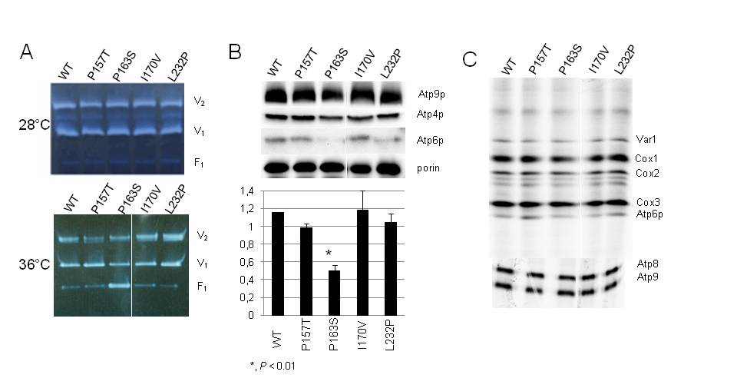

Fig. 6. Influence of cancer-related mutations in the mitochondrial ATP6 gene on the assembly/stability and synthesis of Atp6p in yeast. Mitochondria were prepared from wild type yeast and the strains with cancer-related mutations in the mitochondrial ATP6 gene grown at 28°C or 36°C. (A) BN-PAGE analyses of mitochondrial proteins. Mitochondrial protein complexes were extracted with 2% digitonin and 100 μg of protein samples were run in BN gels. Dimeric (V2) and monomeric (V1) F₁F_{O} complexes, and free F₁ were revealed in gel by their ATPase activity. (B) SDS-PAGE analyses of mitochondrial proteins isolated from strains grown at 36°C. Samples of 20 µg of mitochondrial proteins were run in a 12% polyacrylamide SDS-containing gel and probed with antibodies against the indicated proteins. Densitometry of Atp6p content in two independent experiments normalized to porin is shown. (C) Mitochondrial protein synthesis. Proteins encoded by mtDNA were labeled in whole 36°C-grown cells with [35S]-(methionine+cysteine) for 20 min in the presence of cycloheximide to inhibit cytosolic protein synthesis. Following the labeling reactions, total protein extracts were prepared from the cells (0.2 OD at 650 nm) and separated by SDS-PAGE. For a better resolution of Cox3p and Atp6p, a 12% polyacrylamide gel containing 6 M urea was used (up). The Atp8p and Atp9p were separated using a 16.5% polyacrylamide gel (bottom). The gels were dried and analyzed with a PhosphorImager. The results shown in panels A,B, D are representative of two independent experiments.

  - ROS levels in cells
Defects in mitochondrial oxidative phosphorylation often lead to an increased production of reactive oxygen species, because of a higher rate of electron diversion to oxygen from their normal pathway (Houstek et al., 2006). Given the importance of ROS in cell-signaling pathways during tumorigenesis (Gupta et al., 2012), the impact of the studied atp6 cancer mutations on the accumulation of ROS in cells was evaluated, using dihydroethidium as a probe (Stephens et al., 2003). As controls, we analyzed yeast cells deleted for the SOD1 gene, which encodes a cytosolic copper-zinc superoxide dismutase that enables detoxification of superoxide (Rexroth et al., 2012) and wild type cells treated for 45 minutes with 20 µM Antimycin A, an inhibitor of complex III (Dzierzbicki et al., 2012). As expected, higher ROS levels were observed in sod1Δ cells and in wild type cells treated with Antimycin A, whereas none of the analyzed mutants showed an increased accumulation of ROS with respect to untreated wild type yeast cells (Figure 7).

Fig. 7. Influence of cancer-related atp6 mutations on the accumulation of ROS in yeast cells. Cells cultured to OD=1 in rich glucose medium at 28°C were treated with zymolyase to remove their wall and then incubated with 10 μM dihydroethidium overnight at 4°C. Cells displaying elevated ROS levels were scored by flow cytometry (FL1 channel, 10000 cells). The error bars and P-values (*) were calculated from three independent experiments.

- Discussion
We previously investigated seven mutations (9176T>G, 8851T>C, 8993T>G, 9191T>C, 9176T>C, 8993T>C, and 9185T>C) in the yeast mitochondrial ATP6 gene equivalent to mutations found in individuals with neuropathy, ataxia and retinitis pigmentosa (NARP), Leigh Syndrome (LS), or bilateral striatal lesions in childhood (BSLC) (Kucharczyk et al., 2010; Kucharczyk et al., 2013; Kucharczyk et al., 2009a; Kucharczyk et al., 2009b; Rak et al., 2007a; Vindrieux et al., 2013). All these mutations significantly decreased the rate of mitochondrial ATP synthesis in yeast, by 30 to >95% compared to the wild type, due to functional impairment or a less efficient incorporation of the a-subunit into ATP synthase. Importantly, these findings in yeast correspond to the reported severity of these mutations in humans, which likely reflects a high level of evolutionary conservation within the affected regions of the a/6 subunit (Baracca et al., 2000; Baracca et al., 2007; Carrozzo et al., 2000; Carrozzo et al., 2004a; Cortes-Hernandez et al., 2007; De Meirleir et al., 1995; Dionisi-Vici et al., 1998; Houstek et al., 2006; Mattiazzi et al., 2004; Morava et al., 2006).
The present study on the four cancer-related ATP6 variants (8914C>A, 8932C>T, 8953A>G and 9131T>C) using yeast as a model reveals a complete different picture. Indeed, while these mutations affect relatively well-conserved residues of the a-subunit, only one of them (8932C>T) had a significant impact on ATP synthase characterized by a less efficient assembly/stability of the a-subunit in yeast cells grown at elevated temperatures. In this respect, it is interesting to note that all the residues affected by these mutations (P157, P163, I170, and L232 respectively (yeast numbering) are in quite remote positions from the contact zone near the middle of the membrane where protons are exchanged between the a-subunit and the c-ring (Figure 2B). However, the detrimental consequences of the 8932C>T mutation indicate that the P163 residue, located in a loop connecting the last two membrane embedded helical segments of the a-subunit (aMH4 and aMH5), is important for an efficient folding of the protein whereas the three other residues may be considered as not critical, neither for the assembly nor for the functioning of ATP synthase. The almost normal production of ROS in the mutants provides another line of evidence that the analyzed mutations have only mild if any effect on the functioning of ATP synthase.
Since the discovery of somatic mtDNA mutations in tumor cells, multiple studies (reviewed in (Senyilmaz and Teleman, 2015; Wallace, 2012)) have focused on establishing a causal relationship between those changes and the alterations in energy metabolism that are a hallmark of cancer cells. The picture that emerges from recent studies suggests that perturbations in mitochondrial OXPHOS can contribute to cancer progression by activating retrograde signaling pathways that modulate nuclear gene expression in a conductive way towards tumorigenesis (Gaude and Frezza, 2014; Guha and Avadhani, 2013; Senyilmaz and Teleman, 2015; Srinivasan et al., 2015). Nevertheless, functional mitochondrial genome is essential in cancer cells, as the ρ⁰ derivatives devoid of mtDNA generally exhibit reduced tumorigenicity (Cavalli et al., 1997; Morais et al., 1994; Weinberg et al., 2010). In cybrid cell lines injected into athymic mice mild mtDNA mutations increase tumorigenicity, while those that cause severe mitochondrial dysfunction prevent tumor formation (Cruz-Bermudez et al., 2015).
On the other hand, it is clear that many of the somatic mtDNA variants found in cancer samples are passenger mutations that do not offer any particular advantage in tumor progression. Such mutations are fixed by genetic drift in a rapidly expanding clonal population of proliferating cancer cells, and are thus a result rather than a cause of the carcinogenic process. Many such variants correspond to polymorphic sites and mutational hotspots (Vega et al., 2004). In a recent comprehensive study of 1675 tumor–normal pairs from 31 tumor types, no evidence of positive selection was found for any of the 1907 identified somatic mtDNA substitutions (Ju et al., 2014). The mutational signature of tumor somatic substitutions is similar to that of germline mutations in primate population evolution, indicating that the mtDNA replication and repair mechanisms are not significantly altered in cancer cells, and genetic drift is the main force behind their accumulation. The surplus of non-synonymous mtDNA substitutions is a general feature of the young branches of the human phylogenetic tree (Kivisild et al., 2006), a description that also fits the rapidly evolving cancer cell populations. While the existence of driver mtDNA mutations that contribute to cancer progression seems to be well documented, the majority of somatic mitochondrial genome variation in tumors appears to be neutral.
The results obtained in the present study indicate that none of the studied ATP6 variants are likely to have a significant effect on the functioning of the mitochondrial ATP synthase. The 8914C>A, 8953C>G and 9131T>C variants are likely neutral substitutions, like the majority of somatic mtDNA substitutions in cancers (Ju et al., 2014). In fact, the 8953A>G variant was reported as a polymorphism in one individual (Loo et al., 2011), and a 9130C>A variant leading to an amino acid substitution (L202M) in the same residue as 9131T>C (L202P) is reported in two sequences in the MITOMAP database (Lott et al., 2013).
Interestingly, 8932C>T is the only variant that gave an observable phenotype (albeit only at an elevated temperature) when modeled in yeast, and it is also a known polymorphic site, reported in 126 mtDNA sequences in the MITOMAP database. While it is still likely that this variant is a neutral polymorphism in humans, and that the effect observed in yeast is due to the differences between these two systems, it has to be noted that not all human mtDNA polymorphisms are truly neutral. Substitutions in mtDNA, including in the ATP synthase subunit genes were found to be under positive selection, hypothetically related to cold climate adaptations (Mishmar et al., 2003; Ruiz-Pesini et al., 2004). The temperature-sensitive phenotype in yeast mutants raises the intriguing possibility that P163S plays a role in human cancer cells or climate adaptation, although further research is clearly warranted.
There are, however, other possible explanations of the reported results. Cancer can be viewed as an evolutionary process where metabolic adaptation occurs from the interplay of mutation generation, genetic drift, and clonal selection (Gerlinger et al., 2014; Lipinski et al., 2016). Parallels between putative roles of mtDNA mutations in climate adaptation and in tumor progression could therefore hint at effects that could not be revealed by simple phenotype analysis. In tumorigenesis, as well as in evolution, the selective effect of a mutation is often dependent on epistatic interactions with other genetic factors, as well as with the environment. Mutations that appear to be neutral could thus reveal their selective role in the context of specific genetic changes and/or environmental conditions. As yeast genetics offers unparalleled possibilities such as the combination of different mitochondrial and nuclear mutations, as well as phenotypic high-throughput screening, and multigenerational evolutionary experiments, models like the ones described here could provide an excellent starting point to look for these interactions and to work towards a systems level understanding of the role of mitochondrial genome changes in cancer and evolution.

Acknowledgements
We thank prof. Rodrigue Rossignol for reading carefully our manuscript and for his helpful comments. This work was supported by the National Science Centre of Poland nr 1932/B/P01/2010/39 to R.K, AFM (Association Française contre les Myopathies) to J.-P.dR, the EU Operational Programme Innovative Economy via the Foundation for Polish Science grant TEAM/2010-6/6 to P.G, and Agence Nationale de La Recherche (ANR-12-BSV8-024) to A.D.

- References

Abu-Amero, K.K., Alzahrani, A.S., Zou, M., Shi, Y., 2006. Association of mitochondrial DNA transversion mutations with familial medullary thyroid carcinoma/multiple endocrine neoplasia type 2 syndrome. Oncogene 25, 677-684.
Adams, P.D., Afonine, P.V., Bunkoczi, G., Chen, V.B., Davis, I.W., Echols, N., Headd, J.J., Hung, L.W., Kapral, G.J., Grosse-Kunstleve, R.W., McCoy, A.J., Moriarty, N.W., Oeffner, R., Read, R.J., Richardson, D.C., Richardson, J.S., Terwilliger, T.C., Zwart, P.H., 2010. PHENIX: a comprehensive Python-based system for macromolecular structure solution. Acta crystallographica. Section D, Biol. Crystal. 66, 213-221.
Allegretti, M., Klusch, N., Mills, D.J., Vonck, J., Kuhlbrandt, W., Davies, K.M., 2015a. Horizontal membrane-intrinsic alpha-helices in the stator a-subunit of an F-type ATP synthase. Nature 521, 237-240.
Baracca, A., Barogi, S., Carelli, V., Lenaz, G., Solaini, G., 2000. Catalytic activities of mitochondrial ATP synthase in patients with mitochondrial DNA T8993G mutation in the ATPase 6 gene encoding subunit a. J. Biol. Chem. 275, 4177-4182.
Baracca, A., Sgarbi, G., Mattiazzi, M., Casalena, G., Pagnotta, E., Valentino, M.L., Moggio, M., Lenaz, G., Carelli, V., Solaini, G., 2007. Biochemical phenotypes associated with the mitochondrial ATP6 gene mutations at nt8993. BBA 1767, 913-919.
Bardella, C., Pollard, P.J., Tomlinson, I., 2011. SDH mutations in cancer. BBA 1807, 1432-1443.
Berrada, N., Al-Bouzidi, A., Ameur, A., Abbar, M., El-Mzibri, M., Ameziane-El-Hassani, R., Benbacer, L., Khyatti, M., Qmichou, Z., Amzazi, S., Attaleb, M., 2013. Human papillomavirus detection in Moroccan patients with bladder cancer. J. Inf. Dev. Coun. 7, 586-592.
Bietenhader, M., Martos, A., Tetaud, E., Aiyar, R.S., Sellem, C.H., Kucharczyk, R., Clauder-Munster, S., Giraud, M.F., Godard, F., Salin, B., Sagot, I., Gagneur, J., Dequard-Chablat, M., Contamine, V., Hermann-Le Denmat, S., Sainsard-Chanet, A., Steinmetz, L.M., di Rago, J.P., 2012. Experimental relocation of the mitochondrial ATP9 gene to the nucleus reveals forces underlying mitochondrial genome evolution. PLoS Genet. 8, e1002876.
Bonnefoy, N., Fox, T.D., 2001. Genetic transformation of Saccharomyces cerevisiae mitochondria. Meth. Cell Biol. 65, 381-396.
Buchan, D.W., Minneci, F., Nugent, T.C., Bryson, K., Jones, D.T., 2013. Scalable web services for the PSIPRED Protein Analysis Workbench. Nuc. Acids Res. 41, W349-357.
Cai, W., Fu, Q., Zhou, X., Qu, J., Tong, Y., Guan, M.X., 2008. Mitochondrial variants may influence the phenotypic manifestation of Leber's hereditary optic neuropathy-associated ND4 G11778A mutation. J. Genet. Genomics 35, 649-655.
Carrozzo, R., Murray, J., Santorelli, F.M., Capaldi, R.A., 2000. The T9176G mutation of human mtDNA gives a fully assembled but inactive ATP synthase when modeled in Escherichia coli. FEBS Letters 486, 297-299.
Carrozzo, R., Rizza, T., Lucioli, S., Pierini, R., Bertini, E., Santorelli, F.M., 2004a. A mitochondrial ATPase 6 mutation is associated with Leigh syndrome in a family and affects proton flow and adenosine triphosphate output when modeled in Escherichia coli. Acta Paediatr. Suppl. 93, 65-67.
Carrozzo, R., Rizza, T., Stringaro, A., Pierini, R., Mormone, E., Santorelli, F.M., Malorni, W., Matarrese, P., 2004b. Maternally-inherited Leigh syndrome-related mutations bolster mitochondrial-mediated apoptosis. J. Neurochem. 90, 490-501.
Cavalli, L.R., Varella-Garcia, M., Liang, B.C., 1997. Diminished tumorigenic phenotype after depletion of mitochondrial DNA. Cell Growth Differ. 8, 1189-1198.
Chen, Y., Cairns, R., Papandreou, I., Koong, A., Denko, N.C., 2009. Oxygen consumption can regulate the growth of tumors, a new perspective on the Warburg effect. PLoS One 4, e7033.
Conde, J., Fink, G.R., 1976. A mutant of Saccharomyces cerevisiae defective for nuclear fusion. Proc. Natl. Acad. Sci. USA 73, 3651-3655.
Contamine, V., Picard, M., 2000. Maintenance and integrity of the mitochondrial genome: a plethora of nuclear genes in the budding yeast. Microbiol. Mol. Biol. Rev. 64, 281-315.
Cortes-Hernandez, P., Vazquez-Memije, M.E., Garcia, J.J., 2007. ATP6 homoplasmic mutations inhibit and destabilize the human F1F0-ATP synthase without preventing enzyme assembly and oligomerization. J. Biol. Chem. 282, 1051-1058.
Costa-Guda, J., Tokura, T., Roth, S.I., Arnold, A., 2007. Mitochondrial DNA mutations in oxyphilic and chief cell parathyroid adenomas. BMC Endocrine Disorders 7, 8.
Cruz-Bermudez, A., Vallejo, C.G., Vicente-Blanco, R.J., Gallardo, M.E., Fernandez-Moreno, M.A., Quintanilla, M., Garesse, R., 2015. Enhanced tumorigenicity by mitochondrial DNA mild mutations. Oncotarget 6, 13628-13643.
De Meirleir, L., Seneca, S., Lissens, W., Schoentjes, E., Desprechins, B., 1995. Bilateral striatal necrosis with a novel point mutation in the mitochondrial ATPase 6 gene. Pediatric neurology 13, 242-246.
Dibrov, E., Fu, S., Lemire, B.D., 1998. The Saccharomyces cerevisiae TCM62 gene encodes a chaperone necessary for the assembly of the mitochondrial succinate dehydrogenase (complex II). J. Biol. Chem. 273, 32042-32048.
Dionisi-Vici, C., Seneca, S., Zeviani, M., Fariello, G., Rimoldi, M., Bertini, E., De Meirleir, L., 1998. Fulminant Leigh syndrome and sudden unexpected death in a family with the T9176C mutation of the mitochondrial ATPase 6 gene. J. Inh. Met. Dis. 21, 2-8.
Duvezin-Caubet, S., Caron, M., Giraud, M.F., Velours, J., di Rago, J.P., 2003. The two rotor components of yeast mitochondrial ATP synthase are mechanically coupled by subunit delta. Proc. Natl. Acad. Sci. USA 100, 13235-13240.
Duvezin-Caubet, S., Rak, M., Lefebvre-Legendre, L., Tetaud, E., Bonnefoy, N., di Rago, J.P., 2006. A "petite obligate" mutant of Saccharomyces cerevisiae: functional mtDNA is lethal in cells lacking the delta subunit of mitochondrial F1-ATPase. J. Biol. Chem. 281, 16305-16313.
Dzierzbicki, P., Kaniak-Golik, A., Malc, E., Mieczkowski, P., Ciesla, Z., 2012. The generation of oxidative stress-induced rearrangements in Saccharomyces cerevisiae mtDNA is dependent on the Nuc1 (EndoG/ExoG) nuclease and is enhanced by inactivation of the MRX complex. Mutation Res. 740, 21-33.
Emaus, R.K., Grunwald, R., Lemasters, J.J., 1986. Rhodamine 123 as a probe of transmembrane potential in isolated rat-liver mitochondria: spectral and metabolic properties. BBA 850, 436-448.
Emsley, P., Lohkamp, B., Scott, W.G., Cowtan, K., 2010. Features and development of Coot. Acta crystallographica. Section D, Biol. Crystal. 66, 486-501.
Feuermann, M., Francisci, S., Rinaldi, T., De Luca, C., Rohou, H., Frontali, L., Bolotin-Fukuhara, M., 2003. The yeast counterparts of human 'MELAS' mutations cause mitochondrial dysfunction that can be rescued by overexpression of the mitochondrial translation factor EF-Tu. EMBO Rep. 4, 53-58.
Fillingame, R.H., Angevine, C.M., Dmitriev, O.Y., 2003. Mechanics of coupling proton movements to c-ring rotation in ATP synthase. FEBS Lett. 555, 29-34.
Galluzzi, L., Morselli, E., Kepp, O., Vitale, I., Rigoni, A., Vacchelli, E., Michaud, M., Zischka, H., Castedo, M., Kroemer, G., 2010. Mitochondrial gateways to cancer. Mol. Aspects Med. 31, 1-20.
Gaude, E., Frezza, C., 2014. Defects in mitochondrial metabolism and cancer. Cancer & metabolism 2, 10.
Gerlinger, M., McGranahan, N., Dewhurst, S.M., Burrell, R.A., Tomlinson, I., Swanton, C., 2014. Cancer: evolution within a lifetime. Ann. Rev. Genet. 48, 215-236.
Guerin, B., Labbe, P., Somlo, M., 1979. Preparation of yeast mitochondria (Saccharomyces cerevisiae) with good P/O and respiratory control ratios. Meth. Enzym. 55, 149-159.
Guha, M., Avadhani, N.G., 2013. Mitochondrial retrograde signaling at the crossroads of tumor bioenergetics, genetics and epigenetics. Mitochondrion 13, 577-591.
Gupta, S.C., Hevia, D., Patchva, S., Park, B., Koh, W., Aggarwal, B.B., 2012. Upsides and downsides of reactive oxygen species for cancer: the roles of reactive oxygen species in tumorigenesis, prevention, and therapy. Antioxid. Red. Sign. 16, 1295-1322.
Houstek, J., Pickova, A., Vojtiskova, A., Mracek, T., Pecina, P., Jesina, P., 2006. Mitochondrial diseases and genetic defects of ATP synthase. BBA 1757, 1400-1405.
John, A.P., 2001. Dysfunctional mitochondria, not oxygen insufficiency, cause cancer cells to produce inordinate amounts of lactic acid: the impact of this on the treatment of cancer. Med. Hypotheses 57, 429-431.
Ju, Y.S., Alexandrov, L.B., Gerstung, M., Martincorena, I., Nik-Zainal, S., Ramakrishna, M., Davies, H.R., Papaemmanuil, E., Gundem, G., Shlien, A., Bolli, N., Behjati, S., Tarpey, P.S., Nangalia, J., Massie, C.E., Butler, A.P., Teague, J.W., Vassiliou, G.S., Green, A.R., Du, M.Q., Unnikrishnan, A., Pimanda, J.E., Teh, B.T., Munshi, N., Greaves, M., Vyas, P., El-Naggar, A.K., Santarius, T., Collins, V.P., Grundy, R., Taylor, J.A., Hayes, D.N., Malkin, D., Group, I.B.C., Group, I.C.M.D., Group, I.P.C., Foster, C.S., Warren, A.Y., Whitaker, H.C., Brewer, D., Eeles, R., Cooper, C., Neal, D., Visakorpi, T., Isaacs, W.B., Bova, G.S., Flanagan, A.M., Futreal, P.A., Lynch, A.G., Chinnery, P.F., McDermott, U., Stratton, M.R., Campbell, P.J., 2014. Origins and functional consequences of somatic mitochondrial DNA mutations in human cancer. eLife 3.
Kabaleeswaran, V., Puri, N., Walker, J.E., Leslie, A.G., Mueller, D.M., 2006. Novel features of the rotary catalytic mechanism revealed in the structure of yeast F1 ATPase. EMBO J. 25, 5433-5442.
Kelley, L.A., Mezulis, S., Yates, C.M., Wass, M.N., Sternberg, M.J., 2015. The Phyre2 web portal for protein modeling, prediction and analysis. Nature Prot. 10, 845-858.
Kivisild, T., Shen, P., Wall, D.P., Do, B., Sung, R., Davis, K., Passarino, G., Underhill, P.A., Scharfe, C., Torroni, A., Scozzari, R., Modiano, D., Coppa, A., de Knijff, P., Feldman, M., Cavalli-Sforza, L.L., Oefner, P.J., 2006. The role of selection in the evolution of human mitochondrial genomes. Genetics 172, 373-387.
Krogh, A., Larsson, B., von Heijne, G., Sonnhammer, E.L., 2001. Predicting transmembrane protein topology with a hidden Markov model: application to complete genomes. J. Mol. Biol. 305, 567-580.
Kucharczyk, R., Ezkurdia, N., Couplan, E., Procaccio, V., Ackerman, S.H., Blondel, M., di Rago, J.P., 2010. Consequences of the pathogenic T9176C mutation of human mitochondrial DNA on yeast mitochondrial ATP synthase. BBA 1797, 1105-1112.
Kucharczyk, R., Giraud, M.F., Brethes, D., Wysocka-Kapcinska, M., Ezkurdia, N., Salin, B., Velours, J., Camougrand, N., Haraux, F., di Rago, J.P., 2013. Defining the pathogenesis of human mtDNA mutations using a yeast model: the case of T8851C. Int. J. Biochem. Cell Biol. 45, 130-140.
Kucharczyk, R., Rak, M., di Rago, J.P., 2009a. Biochemical consequences in yeast of the human mitochondrial DNA 8993T>C mutation in the ATPase6 gene found in NARP/MILS patients. BBA 1793, 817-824.
Kucharczyk, R., Salin, B., di Rago, J.P., 2009b. Introducing the human Leigh syndrome mutation T9176G into Saccharomyces cerevisiae mitochondrial DNA leads to severe defects in the incorporation of Atp6p into the ATP synthase and in the mitochondrial morphology. Hum. Mol. Genet. 18, 2889-2898.
Kucharczyk, R., Zick, M., Bietenhader, M., Rak, M., Couplan, E., Blondel, M., Caubet, S.D., di Rago, J.P., 2009c. Mitochondrial ATP synthase disorders: molecular mechanisms and the quest for curative therapeutic approaches. BBA 1793, 186-199.
Lefebvre-Legendre, L., Vaillier, J., Benabdelhak, H., Velours, J., Slonimski, P.P., di Rago, J.P., 2001. Identification of a nuclear gene (FMC1) required for the assembly/stability of yeast mitochondrial F(1)-ATPase in heat stress conditions. J. Biol. Chem. 276, 6789-6796.
Lipinski, K.A., Barber, L.J., Davies, M.N., Ashenden, M., Sottoriva, A., Gerlinger, M., 2016. Cancer Evolution and the Limits of Predictability in Precision Cancer Medicine. Trends Cancer 2, 49-63.
Loo, J.H., Trejaut, J.A., Yen, J.C., Chen, Z.S., Lee, C.L., Lin, M., 2011. Genetic affinities between the Yami tribe people of Orchid Island and the Philippine Islanders of the Batanes archipelago. BMC Genet. 12, 21.
Lott, M.T., Leipzig, J.N., Derbeneva, O., Xie, H.M., Chalkia, D., Sarmady, M., Procaccio, V., Wallace, D.C., 2013. mtDNA Variation and Analysis Using MITOMAP and MITOMASTER. Current Prot. Bioinformatics 1(123):1.23.1-1.23.26.
Lu, J., Sharma, L.K., Bai, Y., 2009. Implications of mitochondrial DNA mutations and mitochondrial dysfunction in tumorigenesis. Cell Res. 19, 802-815.
Mattiazzi, M., Vijayvergiya, C., Gajewski, C.D., DeVivo, D.C., Lenaz, G., Wiedmann, M., Manfredi, G., 2004. The mtDNA T8993G (NARP) mutation results in an impairment of oxidative phosphorylation that can be improved by antioxidants. Hum. Mol. Genet. 13, 869-879.
Meunier, B., 2001. Site-directed mutations in the mitochondrially encoded subunits I and III of yeast cytochrome oxidase. Biochem. J. 354, 407-412.
Meunier, B., Fisher, N., Ransac, S., Mazat, J.P., Brasseur, G., 2013. Respiratory complex III dysfunction in humans and the use of yeast as a model organism to study mitochondrial myopathy and associated diseases. BBA 1827, 1346-1361.
Michon, T., Galante, M., Velours, J., 1988. NH2-terminal sequence of the isolated yeast ATP synthase subunit 6 reveals post-translational cleavage. Europ. J. Biochem. / FEBS 172, 621-625.
Mishmar, D., Ruiz-Pesini, E., Golik, P., Macaulay, V., Clark, A.G., Hosseini, S., Brandon, M., Easley, K., Chen, E., Brown, M.D., Sukernik, R.I., Olckers, A., Wallace, D.C., 2003. Natural selection shaped regional mtDNA variation in humans. Proc. Natl. Acad. Sci. USA 100, 171-176.
Montanari, A., Besagni, C., De Luca, C., Morea, V., Oliva, R., Tramontano, A., Bolotin-Fukuhara, M., Frontali, L., Francisci, S., 2008. Yeast as a model of human mitochondrial tRNA base substitutions: investigation of the molecular basis of respiratory defects. RNA 14, 275-283.
Morais, R., Zinkewich-Peotti, K., Parent, M., Wang, H., Babai, F., Zollinger, M., 1994. Tumor-forming ability in athymic nude mice of human cell lines devoid of mitochondrial DNA. Cancer Res. 54, 3889-3896.
Morales-Rios, E., Montgomery, M.G., Leslie, A.G., Walker, J.E., 2015. Structure of ATP synthase from Paracoccus denitrificans determined by X-ray crystallography at 4.0 A resolution. Proc. Natl. Acad. Sci. USA 112, 13231-13236.
Morava, E., Rodenburg, R.J., Hol, F., de Vries, M., Janssen, A., van den Heuvel, L., Nijtmans, L., Smeitink, J., 2006. Clinical and biochemical characteristics in patients with a high mutant load of the mitochondrial T8993G/C mutations. Am. J. Med. Genet. Part A 140, 863-868.
Mukhopadhyay, A., Uh, M., Mueller, D.M., 1994. Level of ATP synthase activity required for yeast Saccharomyces cerevisiae to grow on glycerol media. FEBS Lett. 343, 160-164.
Okamoto, K., Perlman, P.S., Butow, R.A., 1998. The sorting of mitochondrial DNA and mitochondrial proteins in zygotes: preferential transmission of mitochondrial DNA to the medial bud. J. Cell Biol. 142, 613-623.
Osman, C., Wilmes, C., Tatsuta, T., Langer, T., 2007. Prohibitins interact genetically with Atp23, a novel processing peptidase and chaperone for the F1Fo-ATP synthase. Mol. Biol. Cell 18, 627-635.
Park, J.S., Sharma, L.K., Li, H., Xiang, R., Holstein, D., Wu, J., Lechleiter, J., Naylor, S.L., Deng, J.J., Lu, J., Bai, Y., 2009. A heteroplasmic, not homoplasmic, mitochondrial DNA mutation promotes tumorigenesis via alteration in reactive oxygen species generation and apoptosis. Hum. Mol. Genet. 18, 1578-1589.
Petros, J.A., Baumann, A.K., Ruiz-Pesini, E., Amin, M.B., Sun, C.Q., Hall, J., Lim, S., Issa, M.M., Flanders, W.D., Hosseini, S.H., Marshall, F.F., Wallace, D.C., 2005. mtDNA mutations increase tumorigenicity in prostate cancer. Proc. Natl. Acad. Sci. USA 102, 719-724.
Pettersen, E.F., Goddard, T.D., Huang, C.C., Couch, G.S., Greenblatt, D.M., Meng, E.C., Ferrin, T.E., 2004. UCSF Chimera--a visualization system for exploratory research and analysis. J. Computat. Chem. 25, 1605-1612.
Rak, M., Tetaud, E., Duvezin-Caubet, S., Ezkurdia, N., Bietenhader, M., Rytka, J., di Rago, J.P., 2007a. A yeast model of the neurogenic ataxia retinitis pigmentosa (NARP) T8993G mutation in the mitochondrial ATP synthase-6 gene. J. Biol. Chem. 282, 34039-34047.
Rak, M., Tetaud, E., Godard, F., Sagot, I., Salin, B., Duvezin-Caubet, S., Slonimski, P.P., Rytka, J., di Rago, J.P., 2007b. Yeast cells lacking the mitochondrial gene encoding the ATP synthase subunit 6 exhibit a selective loss of complex IV and unusual mitochondrial morphology. J. Biol. Chem. 282, 10853-10864.
Ramanathan, A., Wang, C., Schreiber, S.L., 2005. Perturbational profiling of a cell-line model of tumorigenesis by using metabolic measurements. Proc. Natl. Acad. Sci. USA 102, 5992-5997.
Rexroth, S., Poetsch, A., Rogner, M., Hamann, A., Werner, A., Osiewacz, H.D., Schafer, E.R., Seelert, H., Dencher, N.A., 2012. Reactive oxygen species target specific tryptophan site in the mitochondrial ATP synthase. BBA 1817, 381-387.
Rigoulet, M., Guerin, B., 1979. Phosphate transport and ATP synthesis in yeast mitochondria: effect of a new inhibitor: the tribenzylphosphate. FEBS Lett. 102, 18-22.
Robert, X., Gouet, P., 2014. Deciphering key features in protein structures with the new ENDscript server. Nuc. Acids Res. 42, W320-324.
Ruiz-Pesini, E., Mishmar, D., Brandon, M., Procaccio, V., Wallace, D.C., 2004. Effects of purifying and adaptive selection on regional variation in human mtDNA. Science 303, 223-226.
Sandrock, T.M., O'Dell, J.L., Adams, A.E., 1997. Allele-specific suppression by formation of new protein-protein interactions in yeast. Genetics 147, 1635-1642.
Senyilmaz, D., Teleman, A.A., 2015. Chicken or the egg: Warburg effect and mitochondrial dysfunction. F1000prime reports 7, 41.
Seyfried, T.N., Shelton, L.M., 2010. Cancer as a metabolic disease. Nutr Metab (Lond) 7, 7.
Sherman, F., 1991. Getting started with yeast. Meth. Enzym. 194, 3-21.
Shidara, Y., Yamagata, K., Kanamori, T., Nakano, K., Kwong, J.Q., Manfredi, G., Oda, H., Ohta, S., 2005. Positive contribution of pathogenic mutations in the mitochondrial genome to the promotion of cancer by prevention from apoptosis. Cancer Res. 65, 1655-1663.
Somlo, M., 1968. Induction and repression of mitochondrial ATPase in yeast. Eur. J. Biochem. 5, 276-284.
Srinivasan, S., Guha, M., Dong, D.W., Whelan, K.A., Ruthel, G., Uchikado, Y., Natsugoe, S., Nakagawa, H., Avadhani, N.G., 2015. Disruption of cytochrome c oxidase function induces the Warburg effect and metabolic reprogramming. Oncogene 227, [Epub ahead of print].
Steele, D.F., Butler, C.A., Fox, T.D., 1996. Expression of a recoded nuclear gene inserted into yeast mitochondrial DNA is limited by mRNA-specific translational activation. Proc. Natl. Acad. Sci. USA 93, 5253-5257.
Stephens, A.N., Khan, M.A., Roucou, X., Nagley, P., Devenish, R.J., 2003. The molecular neighborhood of subunit 8 of yeast mitochondrial F1F0-ATP synthase probed by cysteine scanning mutagenesis and chemical modification. J. Biol. Chem. 278, 17867-17875.
Stock, D., Leslie, A.G., Walker, J.E., 1999. Molecular architecture of the rotary motor in ATP synthase. Science 286, 1700-1705.
Swalwell, H., Blakely, E.L., Sutton, R., Tonska, K., Elstner, M., He, L., Taivassalo, T., Burns, D.K., Turnbull, D.M., Haller, R.G., Davidson, M.M., Taylor, R.W., 2008. A homoplasmic mtDNA variant can influence the phenotype of the pathogenic m.7472Cins MTTS1 mutation: are two mutations better than one? Eur. J. Hum. Genet. 16, 1265-1274.
Tan, D.J., Bai, R.K., Wong, L.J., 2002. Comprehensive scanning of somatic mitochondrial DNA mutations in breast cancer. Cancer Res. 62, 972-976.
Tetaud, E., Godard, F., Giraud, M.F., Ackerman, S.H., di Rago, J.P., 2014. The depletion of F(1) subunit epsilon in yeast leads to an uncoupled respiratory phenotype that is rescued by mutations in the proton-translocating subunits of F(0). Mol. Biol. Cell 25, 791-799.
Thompson, J.D., Higgins, D.G., Gibson, T.J., 1994. CLUSTAL W: improving the sensitivity of progressive multiple sequence alignment through sequence weighting, position-specific gap penalties and weight matrix choice. Nuc. Acids Res. 22, 4673-4680.
Vega, A., Salas, A., Gamborino, E., Sobrido, M.J., Macaulay, V., Carracedo, A., 2004. mtDNA mutations in tumors of the central nervous system reflect the neutral evolution of mtDNA in populations. Oncogene 23, 1314-1320.
Velours, J., Stines-Chaumeil, C., Habersetzer, J., Chaignepain, S., Dautant, A., Brethes, D., 2011. Evidence of the proximity of ATP synthase subunits 6 (a) in the inner mitochondrial membrane and in the supramolecular forms of Saccharomyces cerevisiae ATP synthase. J. Biol. Chem. 286, 35477-35484.
Vindrieux, D., Augert, A., Girard, C.A., Gitenay, D., Lallet-Daher, H., Wiel, C., Le Calve, B., Gras, B., Ferrand, M., Verbeke, S., de Launoit, Y., Leroy, X., Puisieux, A., Aubert, S., Perrais, M., Gelb, M., Simonnet, H., Lambeau, G., Bernard, D., 2013. PLA2R1 mediates tumor suppression by activating JAK2. Cancer Res. 73, 6334-6345.
Walker, J.E., 2013. The ATP synthase: the understood, the uncertain and the unknown. Biochem. Soc. Trans. 41, 1-16.
Wallace, D.C., 2012. Mitochondria and cancer. Nat. Rev. Cancer 12, 685-698.
Warburg, O., 1956a. On respiratory impairment in cancer cells. Science 124, 269-270.
Warburg, O., 1956b. On the origin of cancer cells. Science 123, 309-314.
Ward, P.S., Patel, J., Wise, D.R., Abdel-Wahab, O., Bennett, B.D., Coller, H.A., Cross, J.R., Fantin, V.R., Hedvat, C.V., Perl, A.E., Rabinowitz, J.D., Carroll, M., Su, S.M., Sharp, K.A., Levine, R.L., Thompson, C.B., 2010. The common feature of leukemia-associated IDH1 and IDH2 mutations is a neomorphic enzyme activity converting alpha-ketoglutarate to 2-hydroxyglutarate. Cancer Cell 17, 225-234.
Watt, I.N., Montgomery, M.G., Runswick, M.J., Leslie, A.G., Walker, J.E., 2010. Bioenergetic cost of making an adenosine triphosphate molecule in animal mitochondria. Proc. Natl. Acad. Sci. USA 107, 16823-16827.
Weinberg, F., Hamanaka, R., Wheaton, W.W., Weinberg, S., Joseph, J., Lopez, M., Kalyanaraman, B., Mutlu, G.M., Budinger, G.R., Chandel, N.S., 2010. Mitochondrial metabolism and ROS generation are essential for Kras-mediated tumorigenicity. Proc. Natl. Acad. Sci. USA 107, 8788-8793.
Xiao, M., Yang, H., Xu, W., Ma, S., Lin, H., Zhu, H., Liu, L., Liu, Y., Yang, C., Xu, Y., Zhao, S., Ye, D., Xiong, Y., Guan, K.L., 2012. Inhibition of alpha-KG-dependent histone and DNA demethylases by fumarate and succinate that are accumulated in mutations of FH and SDH tumor suppressors. Genes Dev. 26, 1326-1338.
Zeng, X., Kucharczyk, R., di Rago, J.P., Tzagoloff, A., 2007a. The leader peptide of yeast Atp6p is required for efficient interaction with the Atp9p ring of the mitochondrial ATPase. J. Biol. Chem. 282, 36167-36176.
Zeng, X., Neupert, W., Tzagoloff, A., 2007b. The metalloprotease encoded by ATP23 has a dual function in processing and assembly of subunit 6 of mitochondrial ATPase. Mol. Biol. Cell 18, 617-626.
Zhou, A., Rohou, A., Schep, D.G., Bason, J.V., Montgomery, M.G., Walker, J.E., Grigorieff, N., Rubinstein, J.L., 2015. Structure and conformational states of the bovine mitochondrial ATP synthase by cryo-EM. eLife 4.

