Agnieszka Halas, Michal Krawczyk and Ewa Sledziewska-Gojska
Institute of Biochemistry and Biophysics, Polish Academy of Sciences, 02-106 Warsaw, Poland

PCNA SUMOylation protects against PCNA polyubiquitination-mediated, Rad59-dependent, spontaneous, intrachromosomal gene conversion.

Key words: Homologous recombination; gene conversion; Siz1-dependent PCNA SUMOylation, Mms2/Rad5-dependent PCNA ubiquitination; S. cerevisiae.

Correspondence: Ewa Sledziewska-Gojska esg@ibb.waw.pl and Agnieszka Halas halas.agnieszka@ibb.waw.pl
Institute of Biochemistry and Biophysics, Polish Academy of Sciences, ul. Pawinskiego 5A, 02-106 Warsaw, Poland
Tel: 48 22 592 11 25
Fax: 48 39 12 16 23
Abstract
Homologous recombination is crucial in both the maintenance of genome stability and the generation of genetic diversity. Recently, multiple aspects of the recombination machinery functioning at arrested DNA replication forks have been established, yet the roles of diverse modifications of PCNA, the key platform organizing the replication complex, in intrachromosomal recombination have not been comprehensively elucidated. Here, we report how PCNA SUMOylation and/or polyubiquitination affects recombination between direct repeats in S. cerevisiae. Our results show that these PCNA modifications primarily affect gene conversion, whereas their effect on the recombination-mediated deletion of intervening sequences is much less obvious. Siz1-dependent PCNA SUMOylation strongly limits Rad52/Rad51/ Rad59-dependent gene conversion. A 5- to 10-fold increase in the frequency of such recombination events is observed in Siz1-defective strains, but this increase is fully suppressed when PCNA polyubiquitination is also compromised. PCNA polyubiquitination can stimulate gene conversion in both PCNA SUMOylation-proficient and SUMOylation-deficient strains. On the other hand, in PCNA polyubiquitination-deficient strains, the lack of PCNA SUMOylation does not affect GC levels. Therefore, we postulate that the antirecombinogenic activity of Siz1 mainly concerns recombination induced by PCNA polyubiquitination. In the absence of PCNA SUMOylation, the frequency of PCNA polyubiquitination-mediated gene conversion is not only increased, but it is also channeled into the Rad59-dependent pathway. Additionally, we show a weak inhibitory effect of Rad5 on Rad52/Rad59-directed single-strand annealing.
Highlights
- PCNA polyubiquitination stimulates spontaneous intrachromosomal gene conversion.
- Siz1 activity (responsible for PCNA SUMOylation) specifically limits PCNA polyubiquitination-induced recombination.
- PCNA SUMOylation channels gene conversion into a RAD59-independent pathway.
- Rad5 inhibits single-strand annealing between direct repeats, independent of the role of Rad5 in PCNA polyubiquitination.
1. Introduction
The complex process of faithful duplication of genetic material in S phase of the cell cycle is crucial for the maintenance of genetic stability. To avoid chromosomal rearrangements and point mutations, DNA replication must be facilitated by various mechanisms, among which DNA damage tolerance (DDT) and homologous recombination (HR) are involved in the repair of single-stranded gaps occurring in replicated DNA across template lesions or other obstacles blocking replication fork progression. DDT depends on the Rad6/Rad18-mediated ubiquitin conjugation system, which either directs translesion synthesis (TLS) polymerases to bypass damaged DNA in an error-free or error-prone manner (Nelson et al., 1996; Johnson et al., 1999; Prakash et al., 2005) or activates error-free damage avoidance by Rad5-Ubc13-Mms2-mediated template switching (TS). In this process, the newly synthesized strand of the sister chromatid is transiently used as a template by the regular replicative polymerase (Torres-Ramos et al., 2002; Blastyak et al., 2007). Additionally, HR engages products of the RAD52 epistasis group of genes to rescue stalled or collapsed replication forks by searching for and/or invading and copying information from a homologous template (Zhang and Lawrence., 2005; Gangavarapu et al., 2007; San Filippo et al., 2008; Krejci et al., 2012). Based on genetic analysis, genes encoding enzymes involved in HR and DDT have been assigned to different epistatic groups. However, the relationship between the HR and DDT pathways seems to be more complex than was originally believed, as recent results suggest that recombination proteins are involved in the TS pathway (Gangavarapu et al., 2007; Blastyak et al., 2007. Vanoli et al., 2010 Gonzalez-Prieto et al., 2013: Barlow and Rothstein, 2009).
The access of various repair machineries to a stalled replication fork is mainly regulated by the modifications of proliferating cell nuclear antigen (PCNA). Three molecules of PCNA form a replication processivity clamp, which also functions as a platform recruiting repair factors to DNA (Moldovan et al., 2007; Chen et al., 2011; Haracska et al., 2001). Monoubiquitination of Lys 164 in PCNA, mediated by the Rad6/Rad18 complex, stimulates TLS by enhancing the intrinsic affinity of TLS polymerases for PCNA through their ubiquitin-binding motifs (Prakash et al., 2005). On the other hand, the Ubc13/Mms2 ubiquitin-conjugating complex, acting in concert with the Rad5 ubiquitin ligase, decorates monoubiquitinated PCNA with a Lys 63-bound polyubiquitin chain, which in turn initiates TS. How PCNA polyubiquitination stimulates template switching remains enigmatic from a mechanistic point of view.
Consistent with the roles of TLS and TS in DNA damage tolerance, the level of PCNA mono- and polyubiquitination increases after exposure of eukaryotic cells to replication-blocking agents (Chang et al., 2006; Davies et al., 2008). The enzymes responsible for ubiquitinating PCNA are also involved in the maintenance of genetic stability in untreated cells, as defects in Rad6, Rad18, Rad5, Mms2 and/or Ubc13 cause spontaneous mutator phenotypes (Broomfield et al., 1998; Brusky et al., 2000; Cejka et al. 2001; Halas et al., 2011).
In addition to ubiquitination, Lys 164 of PCNA can also be SUMOylated by the SUMO-conjugating enzyme Ubc9, which cooperates in this process with the SUMO ligase Siz1. The SUMOylation of PCNA occurs in S phase, independent of replication stress (Hoege et al., 2002), and is believed to have an antirecombinogenic effect. Accordingly, PCNA SUMOylation defect caused by deletion of the SIZ1 gene allows Rad52-dependent HR to suppress sensitivity to the lethal and mutagenic effects of UV in yeast defective in TS (Papouli et al., 2005; Pfander et al., 2005; Friedl et al., 2001; Halas et al., 2011). The DNA strand annealing activity of Rad52 plays a central role in the recombinogenic repair of DNA double-strand breaks (DSBs) and stalled or collapsed replication forks as well as in the repair of single-stranded DNA gaps and shortened telomeres. Based primarily on studies addressing double-strand break (DSB) repair, at least two major Rad52-dependent HR pathways have been discerned (Ivanov et al., 1996; Kang et al., 2000; McDonald et al., 1994). One requires the formation of a Rad51 filament on single-stranded DNA, which initiates invasion of DNA duplex by the Rad51 nucleofilament and D-loop formation. This recombination pathway is stimulated by Rad55, Rad57 and Rad54 accessory proteins and primarily leads to gene conversion (GC). The second pathway is independent of Rad51-mediated strand invasion; it relies on single-strand annealing (SSA) activity mediated by Rad52 and often also requires Rad59, which enhances the annealing activity of Rad52 (Wu et al., 2006; Davis and Symington 2003). Both Rad51-dependent and Rad51-independent pathways have also been identified among spontaneous recombination events.
In response to PCNA SUMOylation, Srs2 is recruited to replication sites. Srs2 is a UvrD-like helicase that can dismantle Rad51 presynaptic nucleofilaments and thereby prevent DNA strand invasion (Krejci et al., 2003; Veaute et al., 2003). In addition, recent reports show that SUMOylated PCNA, acting in concert with Srs2, limits the synthesis-dependent extension of a recombination intermediate (Burkovics et al., 2013; Marini and Krejci, 2012), pointing to an additional mechanism by which PCNA SUMOylation can affect HR. How the PCNA SUMOylation-mediated mechanisms affect different pathways of spontaneous intrachromosomal HR is not clear. Additionally, the complex relationships between HR and error-free DDT (Branzei et al., 2008; Minca and Kowalski 2010) give rise to the question of what the roles PCNA polyubiquitination and its interplay with PCNA SUMOylation are in recombination.
In the current study, we analyzed spontaneous recombination between direct repeats located over 5 kb apart to determine how Rad5 and Mms2 (responsible for PCNA polyubiquitination) and Siz1 (which mediates PCNA SUMOylation) affect Rad51-dependent intrachromosomal GC and Rad51-independent SSA in the yeast S. cerevisiae. We found that PCNA SUMOylation protects against noncanonical GC, which in addition to Rad52 and Rad51 is dependent on Rad59 and PCNA polyubiquitination.
2. Materials and methods
2.1 Yeast strains
The haploid Saccharomyces cerevisiae strains used to determine intrachromosomal recombination rates are listed in Table 1. All of the strains are derivatives of YWT-6 [MATa ade2-1(och) his3-11,15 leu2EcoRI::URA3::leu2-BstEII trp1-1(am) ura3-1 can1-100 RAD5⁺] and LSY1892 [MATa ade2-n-URA3-ade2-a his3-11,15 leu2-3,112 trp1-1(am) can1-100 RAD5⁺], carrying the recombination systems described in Zheng et al. (2011) and Fung et al. (2009), respectively.
Table 1. Saccharomyces cerevisiae strains
Strain | Relevant genotype | Source
YWT6 (HKY660-2A) | MATa ade2-1(och) his3-11,15 leu2EcoRI::URA3::leu2-BstEII trp1-1(am) ura3-1 can1-100 RAD5+ | Zheng et al., 2011
YAH158 | YWT6 rad51::kanMX4 | This study
YAH170 | YWT6 rad5::kanMX4 | This study
YAH176 | YWT6 rad5::hphMX4 | This study
YAH177 | YWT6 rad5::natMX4 | This study
YKA2 | YWT6 rad5::kanMX4 mms2::natMX4 | This study
YAH174 | YWT6 rad5::kanMX4 siz1::hphMX4 | This study
YAH163 | YWT6 rad52::kanMX4 | This study
YAH165 | YWT6 rad5::HIS3 rad59::kanMX4 | This study
YAH179 | YWT6 rad5:natMX rad59::kanMX4 | This study
YAH182 | YWT6 rad5::natMX4 siz1::hphMX4 rad59::kanMX | This study
YMK3 | YWT6 mms2::natMX4 | This study
YKA3 | YWT6 mms2::natMX4 rad5::kanMX4 | This study
YAH152 | YWT6 mms2::natMX4 siz1::hphMX4 | This study
YAH160 | YWT6 mms2::natMX4 siz1::hphMX4 | This study
YAH145 | YWT6 mms2::natMX4 rad59::kanMX4 | This study
YAH162 | YWT6 mms2::natMX4 rad5::HIS3 siz1::hphMX4 | This study
YAH147 | YWT6 mms2::natMX4 rad5::HIS3 | This study
YAH146 | YWT6 rad59::kanMX4 | This study
YAH144 | YWT6 siz1::hphMX4 | This study
YAH154 | YWT6 siz1::hphMX4 mms2::natMX4 | This study
YAH175 | YWT6 siz1::hphMX4 rad5::kanMX | This study
YAH143 | YWT6 siz1::hphMX4 rad59::kanMX | This study
YMK14 | YWT6 rad5::natMX4 siz1::hphMX4 | This study
YMK16 | YWT6 mms2::natMX4 siz1::hphMX4 rad59::kanMX4 | This study
YMK17 | YWT6 siz1::hphMX4 mms2::natMX4 rad::59kanMX4 | This study
YMK22 | YWT6 rad5::kanMX4 mms2::natMX4 rad59::hphMX4 | This study
YMK23 | YWT6 mms2::natMX4 rad59::kanMX4 rad5::hphMX4 | This study
LSY1892 | MATa ade2-n-URA3-ade2-a his3-11,15 leu2-3,112 trp1-1(am) can1-100 RAD5+ | Fung et al., 2009
YAH194 | LSY1892 rad5::natMX4 | This study
YAH186 | LSY1892 mms2::natMX4 | This study
YAH187 | LSY1892 rad59::kanMX4 | This study
YMK39 | LSY1892 siz1::hphMX4 | This study
YAH199 | LSY1892 siz1::hphMX4 mms2::natMX4 | This study
YAH196 | LSY1892 siz1::hphMX4 rad5::natMX4 | This study
YAH195 | LSY1892 siz1::hphMX4 rad59::kanMX | This study
YAH188 | LSY1892 rad5:natMX rad59::kanMX4 | This study
YAH189 | LSY1892 mms2::natMX4 rad59::kanMX4 | This study
YAH197 | LSY1892 mms2::natMX4 siz1::hphMX4 rad59::kanMX4 | This study
YMK43 | LSY1892 rad5::kanMX4 mms2::natMX4 rad59::hphMX4 | This study

Targeted genes disruptions were performed via direct transformation of yeast cells with PCR-amplified disruption cassettes. kanMX4 disruption cassettes were amplified through PCR using genomic DNA from appropriate BY4741 derivatives (Euroscarf) carrying deletions of ORFs of interest, with the corresponding primers A and D from the Saccharomyces Genome Deletion Project. The rad5::HIS3 cassette was amplified via PCR as described previously (Halas et al., 2011). Strains disrupted with natMX4 or hphMX4 cassettes were constructed by replacing the kanMX4 marker in the BY4741-derived kanMX4 strains (Euroscarf) with the natMX4 or hphMX4 marker according to the procedure of Goldstein and McCusker (1999). The desired integrants were verified through PCR and subsequent analysis of the respective DNA repair phenotypes.
2.2 Recombination assay:
To study the recombination between the leu2 repeats, yeast strains were first grown on plates containing synthetic complete (SC) medium without uracil (to ensure that the strains maintained the recombination reporter), then plated on YPD plates supplemented with 1% adenine (YPDA) and grown for 2–3 days to obtain single colonies. Single colonies from the YPDA plates were dispersed in 1 ml of sterile H₂O. The number of recombinants that occurred via SSA was estimated by plating 100 μl of the cell suspension (or an appropriate dilution) on SC plates supplemented with 5-fluoroorotic acid at 750 mg/l (5-FOA plates). GC events were detected by plating 100 μl of the cell suspension (or an appropriate dilution) on SC plates without uracil and leucine. To estimate the number of colony forming units (CFU), serial dilutions were plated on SC plates. The plates were incubated at 30°C for 3 days before counting. The frequency of recombination was calculated as the ratio of Ura⁺ Leu⁺ revertans or FOA^{R} mutants to the number of CFU. The data from 20-100 independent cultures from 3-20 independent experiments were used for determination of the recombination frequency in each strain. At least two independently obtained strains of each genotype were employed in the assays. Confidence intervals (95%) and P values for the statistical differences in recombination frequencies between the analyzed strains were determined using t-test in the Statgraphics Centurion XVII program. The recombination between direct repeats of ade2 alleles was investigated according to Fung et al. (2009).
3. Results
3.1. Requirement of Rad52, Rad51 and Rad59 for spontaneous intrachromosomal recombination between direct repeats.
To analyze the genetic requirements for spontaneous intrachromosomal recombination, we used the method described by Zheng et al. (2011), employing haploid yeast strains carrying the leu2-ecoRI::URA3::leu2-bstEII recombination system on the left arm of chromosome III. In this system, direct 2.4 kb repeats of leu2 alleles harboring different mutations are located 5.3 kb apart. Rad51-dependent GC between the repeats leads to a Leu⁺ Ura⁺ phenotype, whereas resistance to 5FOA, resulting from the deletion of URA3 (located in the intervening sequence between the leu2 repeats) reflects Rad51-independent SSA events (Fig 1).
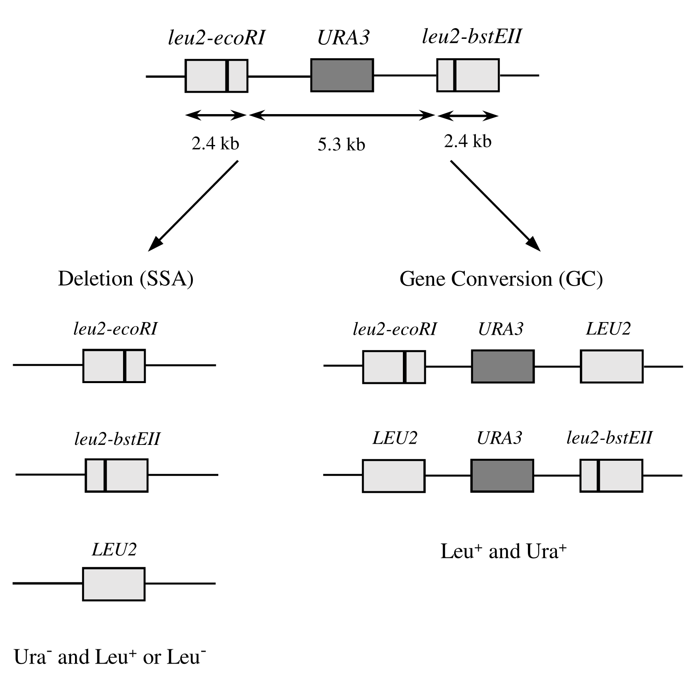
Fig. 1. Direct repeats recombination cassette and selectable products of recombination-mediated deletion and gene conversion (according to Zheng et al., 2011).
As expected, based on the known role of Rad52 in recombination, in yeast proficient in both PCNA SUMOylation and ubiquitination, Rad52 deficiency caused a major decrease in the frequency of both Leu⁺ Ura⁺ and FOA^{R} isolates. (Fig. 2A and B). Also consistent with the role of Rad51 in strand invasion during GC, deletion of RAD51 decreased the frequency of Leu⁺ Ura⁺ recombinants by more than one hundred-fold (Fig. 2A). The majority of GC-derived Leu⁺ Ura⁺ prototrophs were Rad59 independent. However, a small fraction of them were found to require Rad59, the protein that stimulates Rad52-mediated strand annealing activity.
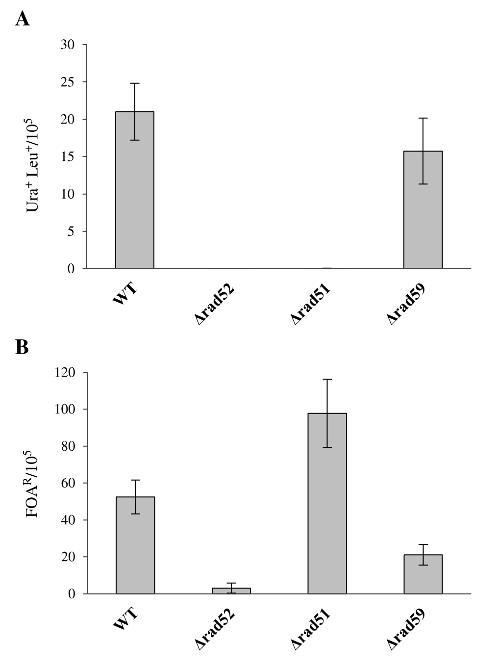
Fig. 2. Effects of Rad52, Rad51 and Rad59 deficiency on HR between direct repeats. (A) Frequency of GC detected as Ura⁺ Leu⁺ segregants. (B) Frequency of SSA detected as FOA^{R} segregants. (A, B) The results represent the mean values of 8 independent experiments with YWT6 (wt), YAH163 (rad52), YAH158 (rad51) and YAH146 (rad59) strains. Error bars indicate standard deviations. The P values referring to statistical differences between the recombination frequencies of the analyzed strains were below 0.05, except for that corresponding to the difference between the Ura⁺Leu⁺ frequency in wt and Δrad59, for which P=0.06.

The frequency of FOA^{R} colonies reflecting URA3 deletions due to SSA was not decreased by Rad51 deficiency (Fig. 1B). On the contrary, such recombinants were more frequent in the rad51 strain, consistent with the known compensatory increase in the level of SSA caused by a GC defect in strains devoid of Rad51(Jablonovich et al., 1999; Shor et al., 2002 ). In the analyzed recombination system with 2.4 kb-long repeats, most FOA^{R} recombination events required both Rad52 and Rad59, whereas Rad59 was dispensable in 40% of the Rad52-dependent events (Fig. 2B, S1). This result corroborates earlier findings showing that the requirement for Rad59 in SSA depends on the length of the DNA to be annealed, with longer sequences being able to undergo Rad52-mediated annealing without the assistance of Rad59 (Sugawara et al., 2000).
3.2. Effects of PCNA modifications on recombination leading to deletion of intervening sequence between direct repeats.
To determine whether diverse PCNA modifications affect SSA between direct repeats, we analyzed the effects of Siz1, Mms2 and/or Rad5 deficiency on the frequency of FOA^{R} recombinants. Disruption of SIZ1, precluding the SUMOylation of PCNA, increased the frequency of recombination-mediated deletions to a non-significant extent (P > 0.05) (Fig. 3). This increase was due solely to Rad59-independent events, though it also failed to reach statistical significance (P = 0.05).
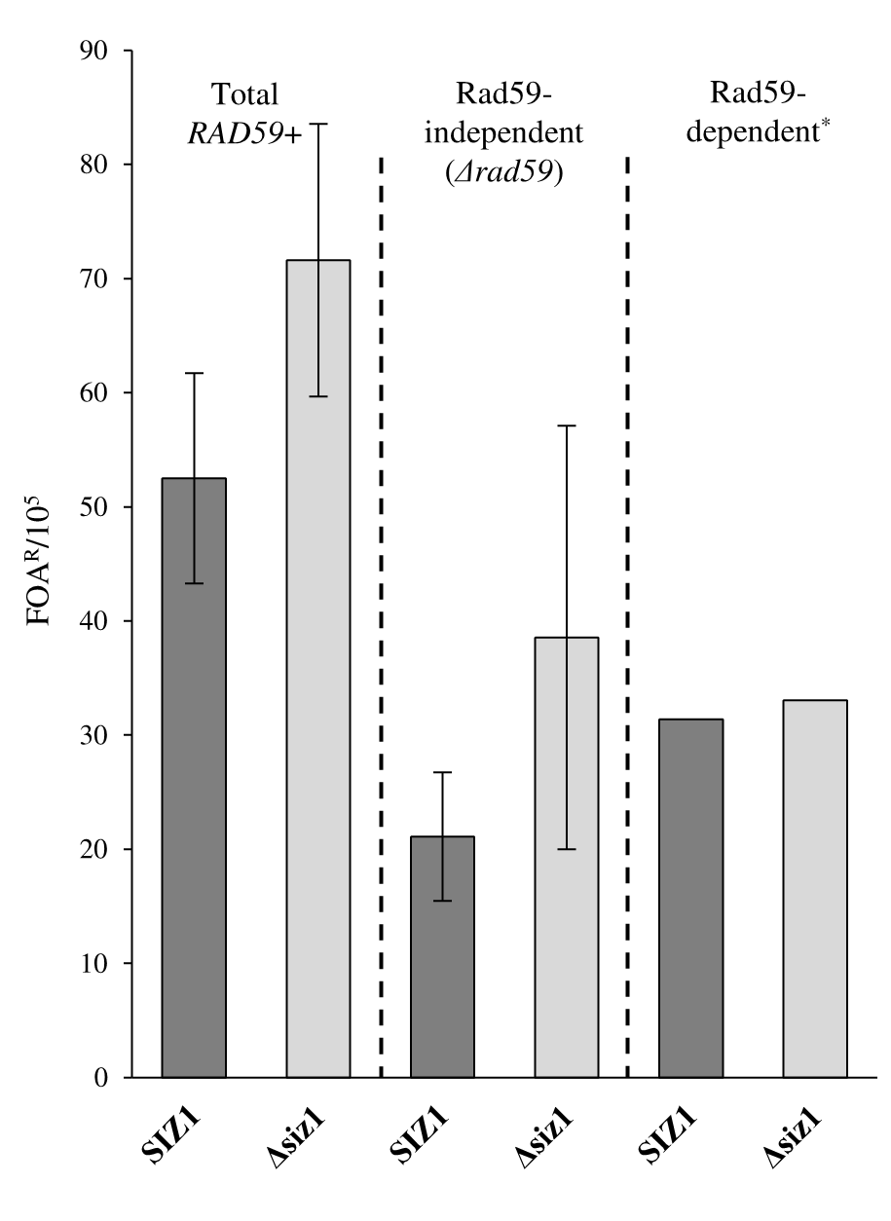
Fig. 3 Effect of PCNA SUMOylation on the frequency of Rad59-dependent and Rad59-independent recombination-mediated deletion of intervening sequence between direct repeats. Frequency of recombination-mediated deletion detected as FOA^{R} segregants. *The frequency of Rad59-dependend FOA^{R} was calculated by the subtracting data obtained for derivatives deficient in Rad59 (Rad59-independent events) from those obtained for the respective Rad59-proficient strains (total). The results represent the mean values from 16 independent experiments with the YWT6 (wt), YAH144 (siz1), YAH146 (rad59) and YAH143 (rad59siz1) strains. The bars indicate standard deviations.

Interestingly, no such tendency was observed in cells carrying MMS2 or RAD5 disruptions, which result in deficiency of PCNA polyubiquitination. In the presence of either defect, the frequency of Rad59-independent events was similar in Siz1-proficient and Siz1-deficient cells (Fig. 4 A, B). Thus, PCNA SUMOylation inhibits recombination-mediated Rad59-independent deletion only when PCNA polyubiquitination is undisturbed. In turn, PCNA polyubiquitination has a profound stimulatory effect on recombination-mediated Rad59-independent deletion events only in the absence of PCNA SUMOylation. These results suggest that at least a portion of the PCNA polyubiquitination-stimulated events is inhibited by PCNA SUMOylation.
The frequency of canonical Rad52/59-dependent SSA was more than doubled by RAD5 deletion in yeast proficient in PCNA SUMOylation (Fig. 4A), indicating that Rad5 moderately inhibits this type of SSA. This inhibitory effect is not due to the PCNA ubiquitinating activity of Rad5, as the frequency of Rad52/Rad59-mediated deletions remained unchanged in the absence of Mms2, a subunit of the polyubiquitinating complex.
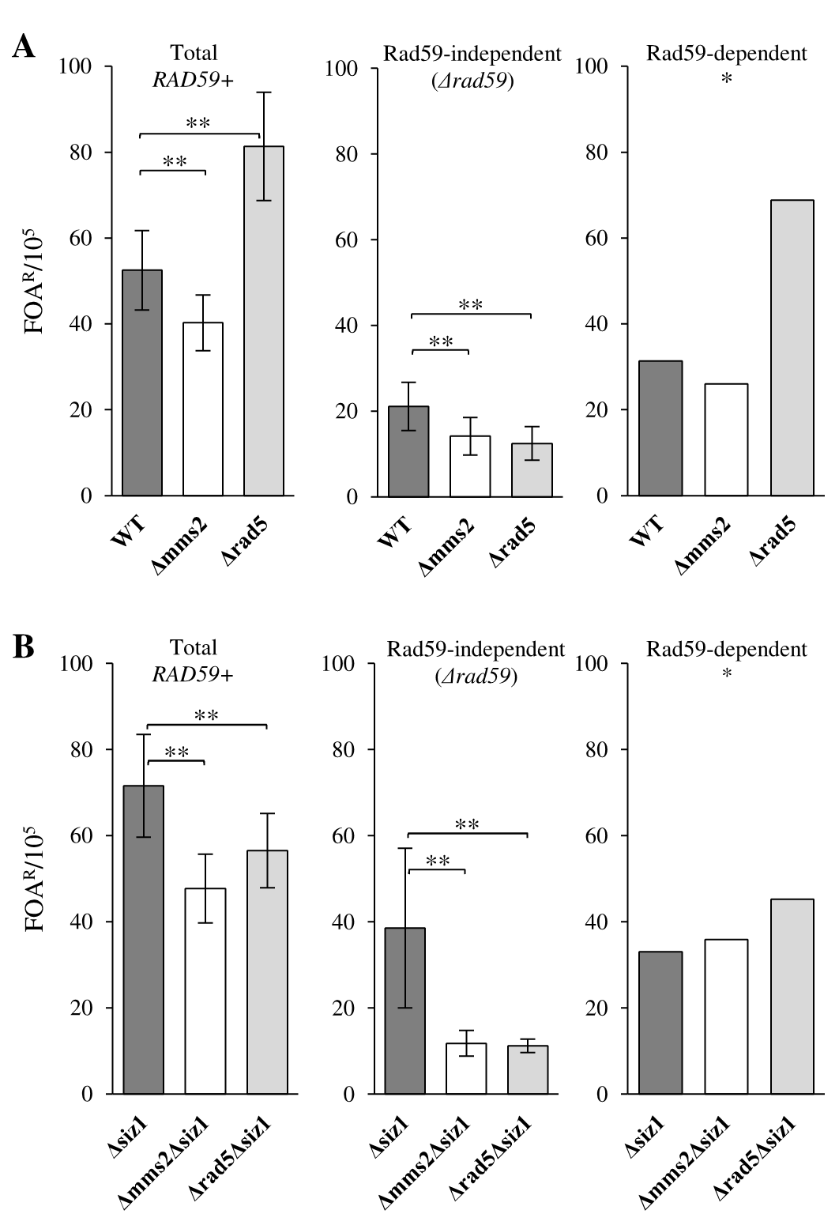
Fig. 4. Effects of Mms2, Rad5 and Siz1deficiency on the frequency of Rad59-dependent and Rad59-independent recombination-mediated deletions between direct repeats. (A) Rate of deletions detected as FOA^{R} in YWT6 (wt) and its derivatives: YMK3 (mms2), YAH177 (rad5), YAH146 (rad59), YAH145 (rad59 mms2 ) and YAH179 (rad59 rad5 ). (B) Rate of deletions detected as FOA^{R} in YAH144 (siz1) and its derivatives: YAH154 (siz1 mms2), YMK14 (siz1 rad5), YAH143 (siz1 rad59), YMK17 (siz1 rad59 mms2) and YAH182(siz1rad59 rad5). *The frequency of Rad59-dependent FOA^{R} was calculated by subtracting the data obtained for derivatives deficient in Rad59 (Rad59-independent events) from those obtained for the respective Rad59-proficient strains (total). The results represent the mean values from 18-20 independent experiments. The bars indicate standard deviations. **P <0.05

We found no substantial effect of PCNA SUMOylation or polyubiquitination on the frequency of canonical Rad52/59-dependent SSA. The results showing that the PCNA modifications exclusively affect the frequency of Rad59-independent events indicate that the Rad59-dependent and Rad59-independent mechanisms of recombination-mediated deletions show more fundamental differences than previously anticipated (Sugawara et al., 2000; Krogh and Symington, 2004).
3.3. PCNA SUMOylation suppresses Rad59-dependent GC stimulated by PCNA polyubiquitination.
Deficiency of Siz1 increased the frequency of the formation of Leu⁺ Ura⁺ colonies (Fig. 5), consistent with the common notion of an antirecombinogenic activity of PCNA SUMOylation. Rather unexpectedly, the increase solely concerned Rad51/Rad59-dependent GC, which showed a nearly ten-fold-increased frequency, leading to a marked change in the proportion of Rad59-dependent to Rad59-independent GC events (Fig. 5B). This result indicates that PCNA SUMOylation protects cells against spontaneous Rad59-dependent GC. In contrast, the frequency of Rad59-independent GC was over two-fold lower in the siz1 deletion strain than in SIZ1⁺, indicating that PCNA SUMOylation causes weak, but significant stimulation of Rad59-independent gene conversion and/or that in the absence of PCNA SUMOylation, the recombination intermediates are channeled into the pathway dependent on Rad59.
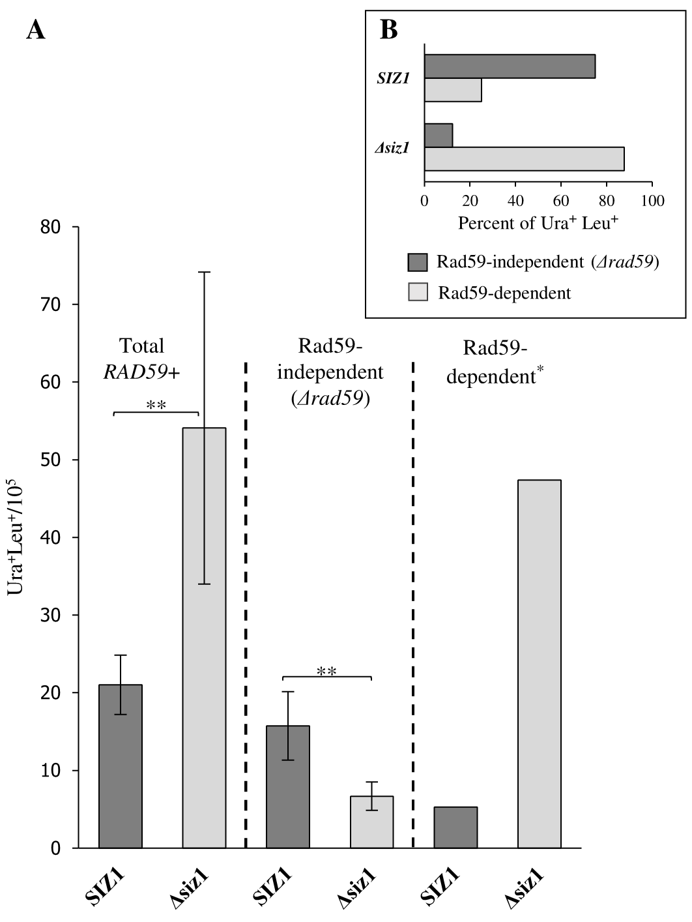
Fig. 5. PCNA SUMOylation affects the frequency of Rad59-dependent and Rad59-independent GC between direct repeats detected as Ura⁺Leu⁺ segregants (A). Distribution of Rad59-dependent and Rad59-independent events charted as the percentage of the total rate of GC (B). Frequency of Rad59-dependent and Rad59-independent GC in the YWT6 (wt), YAH144 (siz1), YAH146 (rad59) and YAH143 (rad59siz1) strains. *The frequency of Rad59-dependent GC was calculated by subtracting the data obtained for derivatives deficient in Rad59 (Rad59-independent events) from those obtained for the respective Rad59-proficient strains (total). The results represent mean values of 16 independent experiments. The bars indicate standard deviations. **P<0.05

Disruption of RAD5 or MMS2, disabling PCNA polyubiquitination, caused a several-fold decrease in the frequency of Leu⁺Ura⁺ colonies (Fig 6A). A similar decrease was observed in the double mms2rad5 mutant (Table S1), confirming epistatic interaction between genes encoding subunits of the polyubiquitination complex in this recombination pathway. Thus, PCNA polyubiquitination stimulates spontaneous GC between repeated sequences. In SUMOylation-proficient cells the stimulatory effect specifically concerned canonical Rad59-independent GC, and not Rad59-dependent GC. On the contrary, in PCNA SUMOylation-deficient cells, Rad59-dependent GC was found to be dependent on PCNA polyubiquitination in almost 90% of events (Fig. 6B). This contrasting effect of PCNA polyubiquitination on GC, dependent on the PCNA SUMOylation status, supports the hypothesis that in the absence of PCNA SUMOylation, GC is channeled into the mechanism requiring Rad59. Taken together, the results show that in the absence of PCNA SUMOylation, the frequency of Rad59-dependent GC increases, and this increase depends on PCNA polyubiquitination. Thus, PCNA SUMOylation inhibits recombination stimulated by PCNA polyubiquitination.
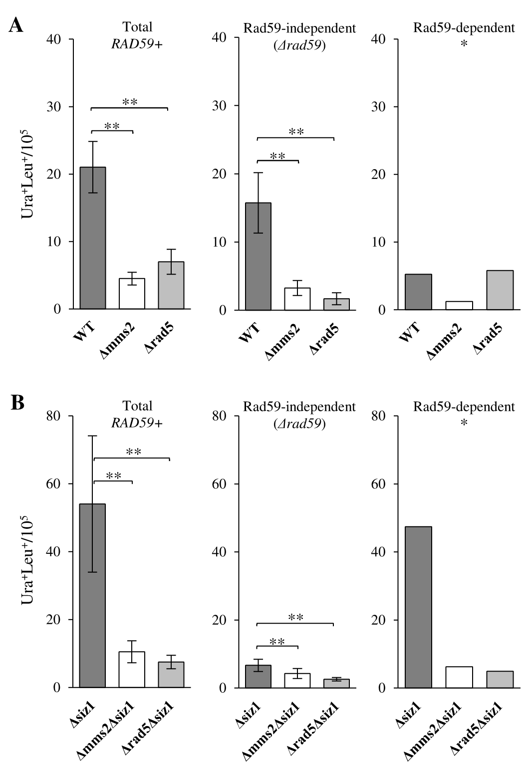
Fig. 6. Effects of Mms2, Rad5 and Siz1 deficiency on the frequency of Rad59-dependent and Rad59-independent GC. (A) Rate of GC detected as Ura⁺Leu⁺ in YWT6 (wt) and its derivatives: YMK3 (mms2), YAH177 (rad5), YAH146 (rad59), YAH145 (rad59 mms2 ) and YAH179 (rad59 rad5 ). (B) Rate of GC detected as Ura⁺Leu⁺ in YAH144 (siz1) and its derivatives: YAH154 (siz1 mms2), YMK14 (siz1 rad5), YAH143 (siz1 rad59), YMK17 (siz1 rad59 mms2) and YAH182 (siz1 rad59 rad5). *The frequency of Rad59-dependent Ura⁺Leu⁺ was calculated by subtracting data obtained for derivatives deficient in Rad59 (Rad59-independent events) from those obtained for the respective Rad59-proficient strains (total). The results represent the mean values for 18 independent experiments. The bars indicate standard deviations. **P <0.05
To verify the role of PCNA modifications in the regulation of GC, we used an alternative system in which direct repeats are located on chromosome XV. This system involves two repeats of differently mutated ade2 alleles, separated by URA3 (Fung et al., 2009). The frequency of GC between ade2 repeats in the LSY1892 control strain was an order of magnitude higher than that observed for leu2 repeats in YWT6. Additionally, the siz1 deletion, resulting in deficiency of PCNA SUMOylation, further increased the Ura+Ade+ frequency (Fig. 7). This only 2-fold increase indicates that the antirecombinogenic effect of PCNA SUMOylation is less pronounced in this system than in GC between leu2 repeats. Nevertheless, similar to the results obtained for leu2 repeats, the increase in the frequency of URA+ADE+ segregants solely concerned Rad59-dependent GC, the frequency of which increased over 5-fold due to siz1 mutation. In contrast, in the Rad59-deficient strain, deletion of siz1 did not affect the frequency of GC. This result confirms that PCNA SUMOylation protects against noncanonical Rad59-dependent GC between direct repeats.
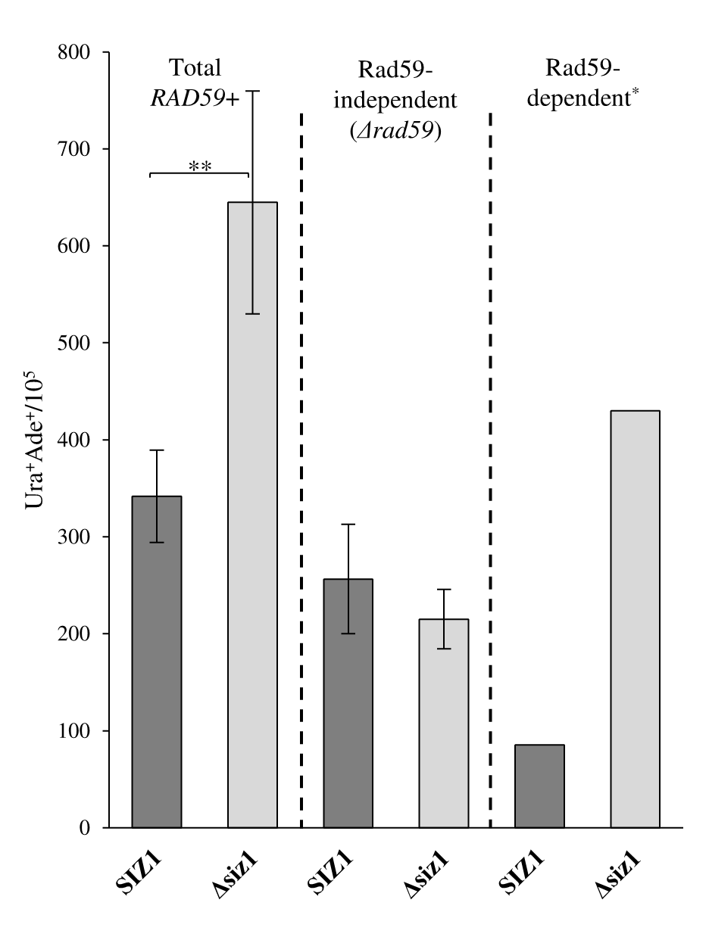
Fig. 7. Effect of PCNA SUMOylation on the frequency of Rad59-dependent and Rad59-independent GC between direct repeats detected as Ura⁺Ade⁺ segregants. Frequency of Rad59-dependent and Rad59-independent GC in LSY1892 (wt), YMK39 (Δsiz1), YAH187 (rad59) and YAH195 (rad59siz1) strains. *The frequency of Rad59-dependent GC was calculated by subtracting the data obtained for derivatives deficient in Rad59 (Rad59-independent events) from those obtained for the respective Rad59-proficient strains (total). The results represent the mean values for 7 independent experiments. The bars indicate standard deviations. **P<0.05

According to the results obtained with leu2 repeats, deletions of either RAD5 or MMS2 decreased the frequency of GC between ade2 repeats and, in contrast to PCNA polyubiquitination-proficient strains, PCNA SUMOylation status had a marginal effect on the frequency of GC in these mutants (Fig. 8). The results obtained for both systems consistently showed that PCNA SUMOylation protects against PCNA polyubiquitination-mediated, Rad59-dependent GC between direct repeats.
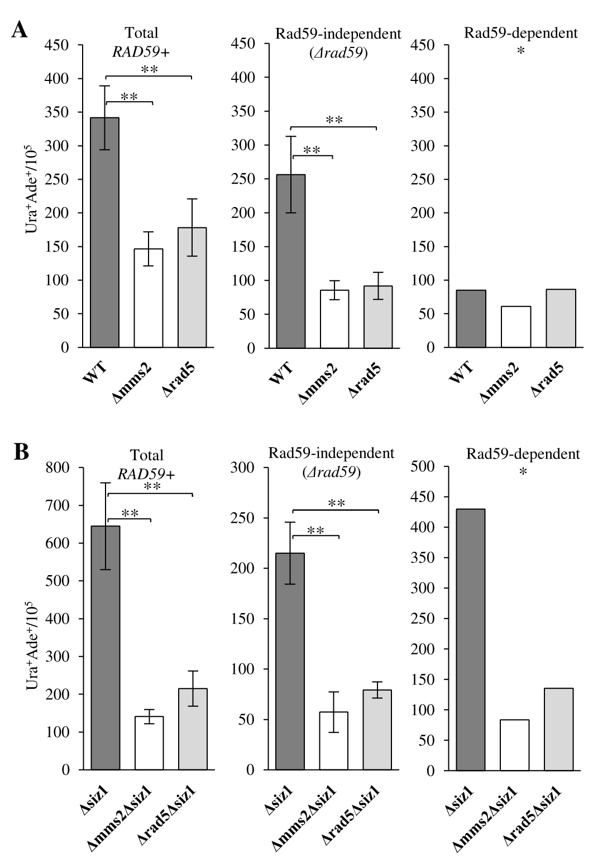
Fig. 8. Effects of Mms2, Rad5 and Siz1 deficiency on the frequency of Rad59-dependent and Rad59-independent GC. (A) Rate of GC detected as Ura⁺Ade⁺ in LSY1892 (wt) and its derivatives: YAH186 (mms2), YAH194 (rad5), YAH187(rad59), YAH189 (rad59 mms2 ) and YAH188 (rad59 rad5 ). (B) Rate of GC detected as Ura⁺Ade⁺ in YMK39 (siz1) and its derivatives: YAH199 (siz1 mms2), YAH196 (siz1 rad5), YAH195 (siz1 rad59), YAH197 (siz1 rad59 mms2) and YMK43 (siz1rad59 rad5). *The frequency of Rad59-dependent Ura⁺Ade⁺ was calculated by subtracting the data obtained for derivatives deficient in Rad59 (Rad59-independent events) from those obtained for the respective Rad59-proficient strains (total). The results represent the mean values for 7 independent experiments. The bars indicate standard deviations. **P <0.05

Discussion
PCNA SUMOylation is involved in the inhibition of recombination during DNA replication. This widely accepted notion was anticipated based on experiments showing that a defect in the Siz1 ligase, responsible for PCNA SUMOylation, suppressed lethality and mutagenesis in a recombination-dependent manner in DA-deficient cells treated with MMS or UV (Papouli et al., 2005; Pfander et al., 2005; Schiestl et al., 1990; Halas et al., 2011). However, much remains to be learned about the type and the genetic requirements of intrachromosomal recombination affected by PCNA SUMOylation. Here, we show that the inhibitory effect of PCNA SUMOylation predominantly concerns GC. This finding is consistent with the role of PCNA SUMOylation in recruiting the Srs2 helicase, responsible for Rad51 nucleofilament disruption, to stalled replication fork (Aguilera et al., 1988; Pfander et al., 2005). Intriguingly, PCNA SUMOylation exclusively affects the GC pathway, which requires Rad59, in addition to Rad52 and Rad51.
Rad59 is homologous to the N-terminus of Rad52. Its activity of binding and annealing complementary single-stranded DNA is relevant not only to Rad51-independent recombination by SSA but also to synthesis-dependent strand annealing (SDSA), an important Rad51-dependent mechanism of DSB repair (Feng et al., 2007). During this type of recombinational repair, the capture of the second DNA end likely involves RPA-coated ssDNA, which can be reannealed by Rad52 in a highly specific reaction involving Rad59 (Bai and Symington 1996). Cooperation between Rad51 and Rad59 has also been noticed in spontaneous recombination between inverted repeats (Spell and Jinks-Robertson 2003). A small Rad59-dependent fraction of spontaneous GC between direct repeats was also detected in the current study in SUMOylation-proficient cells. This fraction of GC increased 5-10-fold in yeast deficient in PCNA SUMOylation, demonstrating that Rad59-dependent GC is a specific target for the antirecombinogenic activity of PCNA SUMOylation. On the other hand, our results showed that Siz1 deficiency can cause a moderate decrease in the frequency of canonical Rad51-dependent/Rad59-independent GC. This surprising decrease in the frequency of Rad59-independent GC between leu2 repeats, accompanied by an increase of the frequency of Rad59-dependent GC caused by Siz1 deficiency, strongly suggests that in addition to its overall antirecombinogenic activity, PCNA SUMOylation may specifically channel GC to the Rad59-independent pathway. This dual effect resembles the two molecular activities of Srs2 which accumulates at the replication fork due to PCNA SUMOylation: 1) the interaction with Rad51, dislodging it from the presynaptic filament (Krejci et al., 2003; Veaute et al., 2003; Robert et al., 2006); and 2) polymerase delta/ PCNA complex disassembly, limiting the tracts of repair DNA synthesis (Burkovics et al., 2013). While stimulation of GC due to a lack of the first activity seems obvious, the biological consequences of the absence of a mechanism limiting D-loop extension are not apparent. Our results suggest that in the absence of PCNA SUMOylation, the enhancement of D-loop-mediated strand extension may generate an obstacle to the re-annealing of the recombining strand. Similar to the SDSA pathway, this can create a requirement for Rad59 to support Rad52 annealing activity to complete the recombination process.
Additionally, the presented results indicate that PCNA polyubiquitination stimulates spontaneous intrachromosomal recombination, in addition to its known function in DNA damage avoidance. Several earlier investigations have addressed the roles of Rad18 and/or Rad5 in homologous recombination, showing both inhibitory (Friedl et al., 2001) and stimulatory (Pfander et al., 2005; Mott and Symington., 2011) effects of these proteins. Since both Rad18 and Rad5 have additional functions in the replication fork and/or recombination beyond their roles in PCNA polyubiquitination, we analyzed the epistatic relationships between Mms2 and Rad5 in their effect on particular recombination pathways. This analysis allowed distinguishing the effects of Mms2 and Rad5 on recombination stemming from their role in PCNA polyubiquitination from those unrelated to this role. The results indicate that a deficiency of Rad5, a protein with ubiquitin ligase and helicase activities, causes an increase in SSA and a decrease in the frequency of GC, but only the effect on GC appears to be connected with PCNA polyubiquitination. The inhibitory effect of Rad5 on SSA results from an activity of Rad5 independent of its role in Rad5/Ubc13/Mms2 ubiquitination. In turn, PCNA polyubiquitination has very little effect on SSA but has an evident stimulatory effect on spontaneous intrachromosomal GC. Bearing in mind the scarcely detectable level of polyubiquitinated PCNA in intact, non-stressed yeast cells, our results showing that 50-80% of GC events are prevented in polyubiquitination-deficient strains indicate that the pro-recombinogenic activity of this PCNA modification is quite high.
Our results also show that PCNA SUMOylation decreases the frequency of recombination stimulated by PCNA polyubiquitination. The increased frequency of polyubiquitination-dependent GC in mutant deficient in PCNA SUMOylation cannot be explained by simple competition between these two modifications for Lys164 in PCNA, as it was previously shown that a lack of PCNA SUMOylation does not increase the level of PCNA ubiquitination (Papouli et al. 2005). An alternative explanation of this increase is based on the assumption that polyubiquitination is accompanied by SUMOylation of the same trimeric PCNA clamp to achieve a basal level of intrachromosomal recombination. Cooperation between PCNA polyubiquitination and SUMOylation, requiring the simultaneous presence of both PCNA modifications in the replication fork, has previously been shown to play a key role in damage tolerance via template switching in cells under replication stress (Branzei et al., 2008; Urulangodi et al., 2015). The current results show that under normal (nonstressed) conditions, PCNA SUMOylation is involved in the prevention of recombination stimulated by PCNA polyubiquitination. It is also worth noting that in PCNA polyubiquitination-deficient cells, PCNA SUMOylation scarcely affects intrachromosomal recombination between direct repeats, if at all. This indicates that recombination prompted by PCNA polyubiquitination is the major target of the antirecombinogenic activity of PCNA SUMOylation. We therefore conclude that the main function of PCNA SUMOylation during S phase is to inhibit unwanted recombination prompted by PCNA polyubiquitination. The effects of PCNA modifications on spontaneous GC between direct repeats are outlined in Fig. 9, based on the frequencies of GC between leu2 alleles.
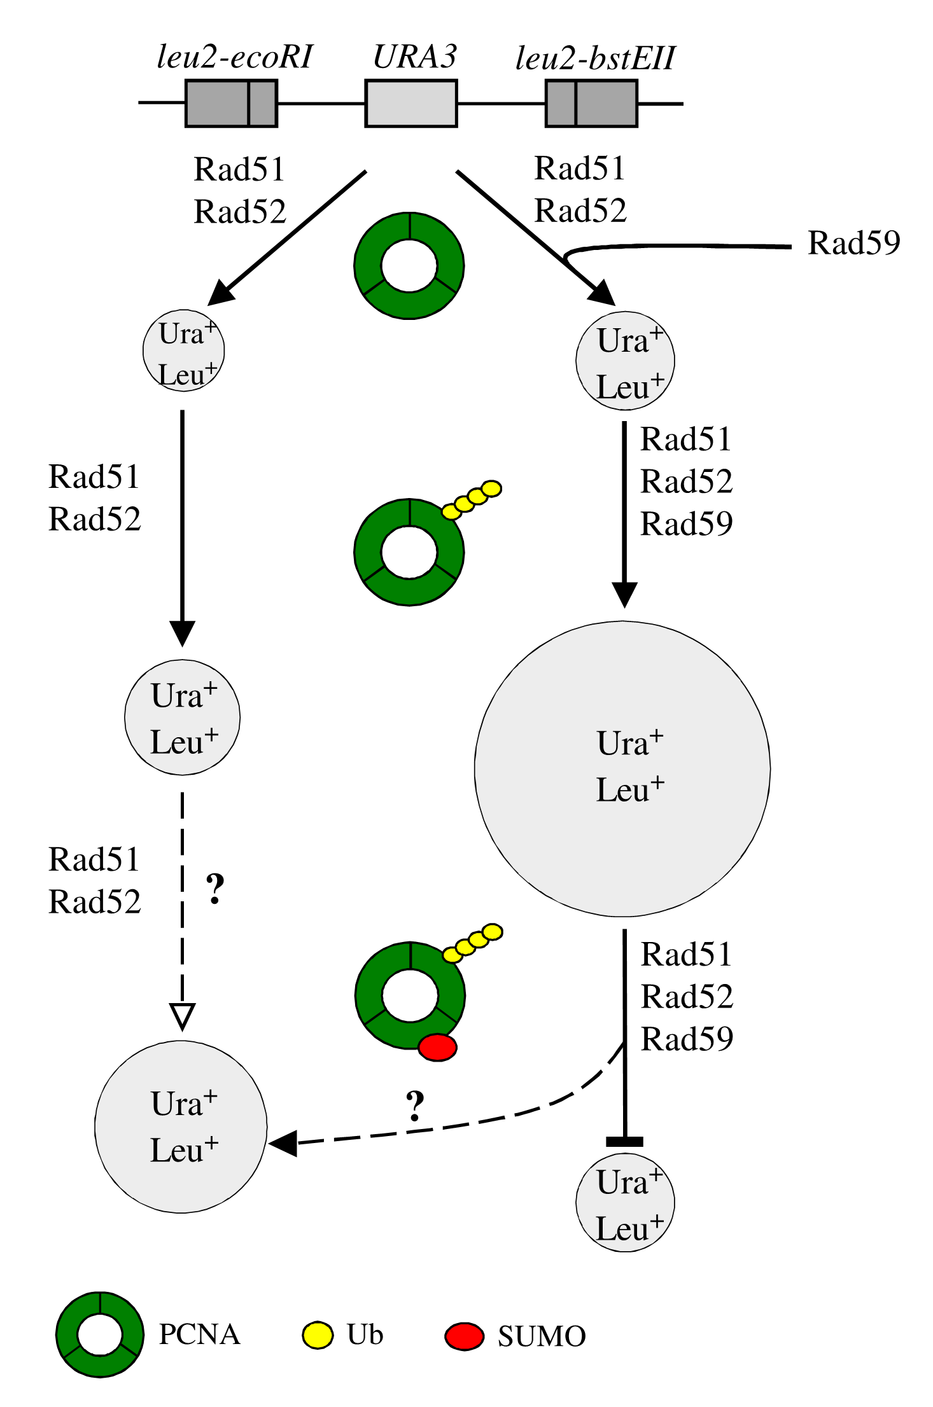
Fig. 9. Schematic representation of the effects of polyubiquitination and SUMOylation of PCNA on Rad59-independent and Rad59-dependent GC between direct repeats. In the absence of the PCNA modification, the pools of GC events that are dependent and independent on Rad59 are comparable. Polyubiquitination of PCNA stimulates GC, predominantly increasing the pool of Rad59-dependent events. This increase is completely alleviated by the SUMOylation of polyubiquitinated PCNA. In contrast, the presence of both modifications on PCNA causes a moderate increase in the pool of GC events that are Rad59 independent. We propose that this increase reflects the PCNA SUMOylation-mediated channeling of Rad59-dependent GC (prompted by PCNA polyubiquitination) into the recombination mechanism that does not require Rad59.

Conflict of interest
The authors declare that there are no conflicts of interests.

Acknowledgments
We thank Drs. Hannah Klein and Lorraine Symington for kindly providing the yeast strains carrying recombination systems. This work was supported by Grant N N303 819440 from the Polish National Science Center

References
Aguilera A. Klein HL (1988) Genetic control of intrachromosomal recombination in Saccharomyces cerevisiae. I. Isolation and genetic characterization of hyper-recombination mutations. Genetics 119: 779-790.
Bai Y, Symington LS (1996) A Rad52 homolog is required for RAD51-independent mitotic recombination in Saccharomyces cerevisiae. Genes Dev. 10:2025-37.
Barlow JH, Rothstein R (2009) Rad52 recruitment is DNA replication independent and regulated by Cdc28 and the Mec1 kinase. EMBO J. 28: 1121–1130.
Blastyák A, Pintér L, Unk I, Prakash L, Prakash S, Haracska L (2007) Yeast Rad5 protein required for postreplication repair has a DNA helicase activity specific for replication fork regression. Mol Cell. 28:167-75.

Branzei D, Vanoli F, Foiani M. (2008) SUMOylation regulates Rad18-mediated template switch. Nature : 915-20
Broomfield S, Chow BL, Xiao W (1998) MMS2, encoding a ubiquitin-conjugating-enzyme-like protein, is a member of the yeast error-free postreplication repair pathway. Proc Natl Acad Sci USA. 95:5678-83.
Brusky J, Zhu Y, Xiao W (2000) UBC13, a DNA-damage-inducible gene, is a member of the error-free postreplication repair pathway in Saccharomyces cerevisiae. Curr Genet. 37:168-74.

Burkovics P, Sebesta M, Sisakova A, Plault N, Szukacsov V, Robert T, Pinter L, Marini V, Kolesar P, Haracska L, Gangloff S, Krejci L (2013) Srs2 mediates PCNA-SUMO-dependent inhibition of DNA repair synthesis. EMBO J. 32:742-55.
Cejka P, Vondrejs V, Storchová Z (2001) Dissection of the functions of the Saccharomyces cerevisiae RAD6 postreplicative repair group in mutagenesis and UV sensitivity. Genetics 159: 953-63
Chang DJ, Lupardus PJ, Cimprich KA (2006) Monoubiquitination of proliferating cell nuclear antigen induced by stalled replication requires uncoupling of DNA polymerase and minichromosome maintenance helicase activities.J. Biol. Chem. 281:32081–88
Chen J, Bozza W, Zhuang Z (2011) Ubiquitination of PCNA and its essential role in eukaryotic translesion synthesis. Cell Biochem. Biophys 60: 47–60.
Davis AP, Symington LS (2003) The Rad52-Rad59 complex interacts with Rad51 and replication protein A. DNA Repair 7:1127-34
Davies AA, Huttner D, Daigaku Y, Chen S, Ulrich HD (2008) Activation of ubiquitin-dependent DNA damage bypass is mediated by replication protein A. Mol. Cell 29:625–36
Feng Q, Düring L, de Mayolo AA, Lettier G, Lisby M, Erdeniz N, Mortensen UH, Rothstein R. (2007) Rad52 and Rad59 exhibit both overlapping and distinct functions. DNA Repair 6:27-37.

Friedl AA, Liefshitz B, Steinlauf R, Kupiec M (2001) Deletion of the SRS2 gene suppresses elevated recombination and DNA damage sensitivity in rad5 and rad18 mutants of Saccharomyces cerevisiae. Mutat. Res. 486: 137–146.

Fung CW, Mozlin AM, Symington LS (2009) Suppression of the double-strand-break-repair defect of the Saccharomyces cerevisiae rad57 mutant. Genetics 181: 1195–1206.
Gangavarapu V, Prakash S, Prakash L (2007) Requirement of RAD52 group genes for postreplication repair of UV-damaged DNA in Saccharomyces cerevisiae. Mol Cell Biol. 27:7758-64.
Goldstein AL, McCusker JH. (1999) Three new dominant drug resistance cassettes for gene disruption in Saccharomyces cerevisiae. Yeast 15:1541-53.

Gonzalez-Prieto R, Munoz-Cabello AM, Cabello-Lobato MJ, Prado F (2013) Rad51 replication fork recruitment is required for DNA damage tolerance. EMBO J. 32: 1307–1321
Halas A, Podlaska A, Derkacz J, McIntyre J, Skoneczna A, Sledziewska-Gojska E (2011)The roles of PCNA SUMOylation, Mms2-Ubc13 and Rad5 in translesion DNA synthesis in Saccharomyces cerevisiae. Mol Microbiol 80:786-97

Haracska L, Kondratick CM, Unk I, Prakash S, Prakash L (2001) Interaction with PCNA is essential for yeast DNA polymerase eta function. Mol. Cell. 8: 407–415
Hoege C, Pfander B, Moldovan GC, Pyrowolakis G, Jentsch S (2002) RAD6-dependent DNA repair is linked to modification of PCNA by ubiquitin and SUMO. Nature 419: 135-141
Ivanov EL, Sugawara N, Fishman-Lobell J, Haber JE (1996) Genetic requirements for the single-strand annealing pathway of double-strand break repair in Saccharomyces cerevisiae, Genetics 142: 693–704.

Jablonovich Z, Liefshitz B, Steinlauf R, Kupiec M (1999) Characterization of the role played by the RAD59 gene of Saccharomyces cerevisiae in ectopic recombination. Curr Genet 36: 13-20.
Johnson RE, Prakash S, Prakash L (1999) Efficient Bypass of a Thymine-Thymine Dimer by Yeast DNA Polymerase, Polη Science . 283: 1001-1004
Kang LE, Symington LS (2000) Aberrant double-strand break repair in rad51 mutants of Saccharomyces cerevisiae, Mol. Cell. Biol. 20: 9162–9172
Krejci L, Van Komen S, Li Y, Villemain J, Reddy MS, Klein H, Ellenberger T, Sung P (2003) DNA helicase Srs2 disrupts the Rad51 presynaptic filament. Nature 423: 305–309.
Krejci L, Altmannova V, Spirek M, Zhao X. (2012) Homologous recombination and its regulation. Nucleic Acids Res. 40:5795-818
Krogh BO, Symington LS (2004) Recombination proteins in yeast. Annu Rev Genet.38:233-71.
Marini V, Krejci L (2012) Unwinding of synthetic replication and recombination substrates by Srs2. DNA Repair 11: 789– 798
McDonald JP, Rothstein R (1994) Unrepaired heteroduplex DNA in Saccharomyces cerevisiae is decreased in RAD1 RAD52-independent recombination. Genetics 137: 393–405.

Minca EC, Kowalski D (2010) Multiple Rad5 activities mediate sister chromatid recombination to bypass DNA damage at stalled replication forks. Mol Cell 38:649-61.
Moldovan GL, Pfander B, Jentsch S (2007) PCNA, the maestro of the replication fork. Cell 129: 665–6.
Mott C, Symington LS (2011) RAD51-independent inverted-repeat recombination by a strand-annealing mechanism. DNA Repair 10: 408-15.
Nelson JR, Lawrence CW, Hinkle DC (1996) Thymine-thymine dimer bypass by yeast DNA polymerase zeta. Science 272:1646-9
Papouli E, Chen S, Davies AA, Huttner D, Krejci L, Sung P, Ulrich HD (2005) Crosstalk between SUMO and ubiquitin on PCNA is mediated by recruitment of the helicase Srs2p. Mol. Cell 19:123–133.
Pfander B, Moldovan GL, Sacher M, Hoege C, Jentsch S (2005) SUMO-modified PCNA recruits Srs2 to prevent recombination during S phase. Nature 436:428–433.
Prakash S, Johnson RE, Prakash L (2005) Eukaryotic translesion synthesis DNA polymerases: specificity of structure and function. Annu Rev Biochem.;74:317-53
Spell RM, Jinks-Robertson S (2003) Role of mismatch repair in the fidelity of RAD51- and RAD59-dependent recombination in Saccharomyces cerevisiae. Genetics 165: 1733–1744
Robert T, Dervins D, Fabre F, Gangloff S (2006) Mrc1 and Srs2 are major actors in the regulation of spontaneous crossover. EMBO J 25: 2837–2846

San Filippo J, Sung P, Klein H (2008) Mechanism of eukaryotic homologous recombination. Annu Rev Biochem. 77:229-57
Schiestl RH, Prakash S, Prakash L (1990) The SRS2 suppressor of rad6 mutations of Saccharomyces cerevisiae acts by channeling DNA lesions into the RAD52 DNA repair pathway. Genetics 124:817–831.
Shor E, Gangloff S, Wagner M, Weinstein J, Price G, Rothstein R (2002) Mutations in homologous recombination genes rescue top3 slow growth in Saccharomyces cerevisiae. Genetics. 162:647-62
Sugawara N, Ira G, Haber JE (2000) DNA length dependence of the single-strand annealing pathway and the role of Saccharomyces cerevisiae RAD59 in double-strand break repair. Mol. Cell. Biol. 20:5300–5309.

Torres-Ramos CA, Prakash S, Prakash L 2002 Requirement of RAD5 and MMS2 for postreplication repair of UV-damaged DNA in Saccharomyces cerevisiae. Mol Cell Biol. 22:2419-26

Urulangodi M, Sebesta M, Menolfi D, Szakal B, Sollier J, Sisakova A, Krejci L, Branzei D. (2015) Local regulation of the Srs2 helicase by the SUMO-like domain protein Esc2 promotes recombination at sites of stalled replication. Genes Dev. 29:2067-80
Wu Y, Sugiyama T, Kowalczykowski SC (2006) DNA annealing mediated by Rad52 and Rad59 proteins. J Biol Chem 281:15441-9
Vanoli F, Fumasoni M, Szakal B, Maloisel L Branzei D (2010) Replication and recombination factors contributing to recombination-dependent bypass of DNA lesions by template switch. PLoS Genet., 6, e1001205

Veaute X, Jeusset J, Soustelle C, Kowalczykowski SC, Le Cam E, Fabre F (2003) The Srs2 helicase prevents recombination by disrupting Rad51 nucleoprotein filaments, Nature 423: 309–312.

Zhang H, Lawrence CW (2005) The error-free component of the RAD6/RAD18 DNA damage tolerance pathway of budding yeast employs sister-strand recombination. Proc Natl Acad Sci U S A 102:15954-9
Zheng X,Epstein A, Klein HL (2011) Methods to study mitotic homologous recombination and genome stability. Methods Mol Biol.745:3-13

