Graphical Abstract
To create your abstract, type over the instructions in the template box below.
Fonts or abstract dimensions should not be changed or altered.
In vivo antileukemic activity of novel adenosine derivatives bearing boron cluster modification
Jolanta D. Żołnierczyk, Agnieszka B. Olejniczak, Adam Mieczkowski, Jerzy Z. Błoński, Zofia M. Kiliańska, Tadeusz Robak, Zbigniew Z. Leśnikowski*
Laboratory of Molecular Virology and Biologcal Chemistry, Institute of Medicinal Biology, Polish Academy of Sciences, Lodowa 106 Str., 92-232 Lodz, Poland.

Leave this area blank for abstract info.
 | Bioorganic & Medicinal Chemistry  journal homepage: www.elsevier.com
In vitro antileukemic activity of novel adenosine derivatives bearing boron cluster modification
Jolanta D. Żołnierczyk ª, Agnieszka B. Olejniczak ^{b}, Adam Mieczkowski ^{c}, Jerzy Z. Błoński ^{d}, Zofia M. Kiliańska ª, Tadeusz Robak ^{d} and Zbigniew J. Leśnikowski ^{e}∗
ª Department of Cytobiochemistry, Faculty of Biology and Environmental Protection, University of Łódź, Pomorska 141/143, 90-236 Łódź, Poland
^{b} Screening Laboratory, Institute of Medical Biology Polish Academy of Sciences, Lodowa 106, 92-232 Łódź, Poland
^{c} Department of Biophysics, Institute of Biochemistry and Biophysics Polish Academy of Sciences, Pawińskiego 5a, 02-106 Warsaw, Poland
^{d} Department of Hematology, Medical University of Łódź, Ciołkowskiego 2, 93-510 Łódź, Poland
^{e} Laboratory of Molecular Virology and Biological Chemistry Institute of Medical Biology Polish Academy of Sciences, Lodowa 106, 92-232 Łódź, Poland

ARTICLE INFO | ABSTRACT
Article history:  Received  Received in revised form  Accepted  Available online | A series of adenosine derivatives bearing a boron cluster were synthesized and evaluated for their cytotoxicity against primary peripheral mononuclear cells from the blood of 17 patients with leukemias (16 CLL and 1 very rare PLL), as well as from 5 healthy donors used as a control. Among the tested agents, two, i.e., compounds 1 and 2, displayed high in vitro cytotoxicity and proapoptotic potential on leukemic cells, with only scarce activity being seen against control cells. Biological tests related to apoptosis revealed the activation of the main execution apoptotic enzyme, procaspase-3, in CLL and PLL cells exposed to compounds 1 and 2. Moreover, the above compounds indicated high activity in the proteolysis of the apoptotic markers PARP-1 and lamin B1, fragmentation of DNA, and the induction of some changes in the expression of the Mcl-1, protein apoptosis regulator in comparison with control cells.  2009 Elsevier Ltd. All rights reserved.
Keywords:
anti-leukemia activity
adenosine
boron clusters
cladribine
fludarabine
apoptotic potential

- Introduction
Chronic lymphocytic leukemia (CLL) is the most common type of adult leukemia in western countries. CLL cells are typically B-cells in origin, with the T-cell variant of the disease occurring rarely. CLL is characterized by an accumulation of transformed B lymphocytes in blood, bone marrow and lymphoid tissues.^{1,2} It is characterized by a highly heterogeneous course and does not always require chemotherapy.^{2,3} Nevertheless, it is thought to be incurable since relapse usually takes place after an initial remission. Although purine nucleoside analogs routinely used in CLL treatment (cladribine, fludarabine) have notably improved progression-free survival (PFS), overall survival (OS) has not altered significantly. Therefore, new molecules have been tested in search of better CLL treatment.⁴⁻⁶ The CLL cells circulating in peripheral blood remain mostly in the G0/G1 phase of the cell cycle, with only a slight percentage of them dividing.^{7,8} On the other hand, bone marrow and lymphoid follicles outside the primary lymphoid organs produce the leukemic cells which supply blood for CLL lymphocytes. The simultaneous coexistence of quiescent and cycling cells represents a special challenge in CLL therapy. Hence, the most efficient antileukemic strategy should target both of these cell fractions.^{9,10}
It has been indicated that CLL may transform into more aggressive lymphomas (Richter's syndrome) or leukamias e.g. prolymphocytic leukemia (PLL). PLL is a very rare lymphoproliferative disorder accounting for 1-2% of all lymphocytic leukemias. The proportion of prolymphocytes among circulating lymphoid cells is often higher than 90%.¹¹ It is more aggressive than CLL and is characterized by poor prognosis. The average OS for PLL is approximately 3 years. Purine nucleoside analogs are usually ineffective in PLL treatment, which may be due to widespread loss of tumor protein p53 (TP53) expression in these cells. At present, the most effective PLL therapy is based on monoclonal antibodies such as Rituximab/MabThera and Alemtuzumab/Campath, which recognize B-lymphocyte antigen CD20 and CD52 molecules, respectively. Sometimes the distinction between CLL and PLL is impossible, in which case the condition is referred to as mixed CLL/PLL leukemia, with the number of prolymphocytes in the blood between 10% and 55%.¹²
As mentioned above, among the anticancer drugs used to treat these leukemias, the majority are nucleoside derivatives applied alone or in combinations with other drugs/antibodies.¹³⁻¹⁷ Examples of medicinal preparations based on nucleoside structure include cytarabine (cytosine arabinoside, ara-C, Cytosar®), cladribine (2-chloro-2’-deoxyadenosine, Litak®), clofarabine (2-chloro-2’-deoxy-2’-fluoroadenosine, Clolar®) and fludarabine (2-fluoro-arabinoadenosine 5’-phosphate/F-ara-AMP, Fludara®): the last three being adenosine derivatives.^{18,19} Fludarabine, the soluble form of 2-fluoro-arabinoadenosine, is rapidly dephosphorylated to 2-fluoro-araA within minutes of intravenous infusion. It is generally accepted that these adenosine derivatives are within cells phosphorylated to mono-, di-, and triphosphate form by cytosolic kinases. The nucleoside triphosphates derived from drugs compete with natural nucleotides, thus disrupting cellular processes.¹⁹ When incorporated into the DNA or RNA strands of the cancer cell, they promote the termination of DNA/RNA chains and/or inhibition of DNA/RNA polymerase activity. Another possible mechanism of the anticancer activity of these nucleoside analogs is the inhibition of enzymes participating in the metabolism of nucleotides and nucleic acids.^{18,19} These drugs are also able to induce programmed cell death, i.e. apoptosis. The impairment of this process is of importance in the pathogenesis of numerous cancers, including CLL.²⁰⁻²⁴
At present, the gold standard for CLL therapy is the combination of purine nucleoside analogs, fludarabine or cladribine, with rituximab and cyclophosphamide, an alkylating agent, described as FCR or CCR, respectively.^{14,15} However, in patients not eligible for such intensive treatment because of comorbidities, less effective drugs might be applied. However, as with experimental anticancer preparations, a large number of currently available antileukemic drugs have several disadvantages that narrow their clinical utility, such as limited effectiveness, severe side effects and the emergence of drug-resistant cancer variants which pose an increasing problem for disease management. Thus, there is still a strong need to identify new targets for antileukemic chemotherapy and to develop novel anticancer compounds and treatment strategies. Among new approaches assigned for CLL, much attention is paid to agents with the ability to turn on the apoptosis process.^{22,23}
Herein, we propose the use of carboranes, members of the vast boron cluster family of compounds, for modification of selected nucleoside designs. The use of carboranes as pharmacophores and modifying units was made popular by the pioneering work of Endo and colleagues.²⁵ However, the hydrophobic properties of carboranes have already been used to modify the biological activity of biomolecules, for example, to influence the synthesis and biological properties of enkephalin-like peptides containing carboranylalanine in place of phenylalanine.²⁶ Due to their spherical shape and lipophilicity, carboranes are used in most cases as surrogates for heterocycles, annulated carbon rings, or most popularly, for substituted or unsubstituted phenyl rings.²⁷⁻³⁰
Numerous modifications of biomolecules with boron clusters have been previously synthesized as the carriers of boron for the boron neutron capture therapy (BNCT) of cancers.³¹⁻³⁴ However, the unique properties of carboranes are not dependent on BNCT, as they change the properties of molecules to which they are bound, affecting their solubility, stability or ligand-receptor interactions. Recently it has been shown that some adenosine derivatives can act as modulators of purinergic receptor activity³⁵⁻³⁷ or can be used to modify antiviral drugs.^{38,39}
The recent appeal of boron clusters for the pharmaceutical industry lies in the knowledge that these clusters are abiotic and therefore chemically and biologically orthogonal to native cellular components, i.e. they are stable and inert in biological environments, and they are resistant to catabolism, which is a desirable property for biological applications. In addition, boron clusters may be used to target biological receptors that appear to be unaffected by nonboron-containing organic molecules by interacting with these receptors through diverse mechanisms.²⁸⁻³⁰
Hence, greater knowledge of whether boron cluster modified adenosine molecules are able to interfere with biological processes going in the leukemic cells would be valuable. It seems plausible that boron cluster-bearing adenosine might induce apoptosis in the similar way as cladribine or fludarabine, which are used in the therapy of leukemias.^{40,41} The following report presents results supporting this hypothesis and confirming the considerable anti-leukemic activity of selected adenosine-boron cluster conjugates in comparison with known drugs.
- Results and discussion
  - Synthesis of adenosine derivatives bearing a boron cluster
The present study investigates the cytotoxicity and proapoptotic potential of 2’-deoxyadenosine, adenosine and arabino-adenosine modified with a carborane cluster (C₂B₁₀H₁₁) against peripheral blood mononuclear cells (PBMCs) of CLL and PLL patients, as well as those of healthy volunteers. The nucleoside derivatives substituted at C-2, C-8 and N-6 positions of the purine nucleobase and 2’position of the sugar residue of the adenosine or 2’-deoxyadenosine, compounds 1-5, 9 and 10 were tested (Chart 1).
Chart 1. Structure of 2-fluoro-9-(β-D-arabinofuranosyl)adenine 5’-monophosphate (fludarabine), 2-chloro-9-(β-D-2’-deoxyribofuranosyl)adenine (cladribine), 8-ethynyl-(1,12-dicarba-closo-dodecacarboran-2-yl)-9-(β-D-2’-deoxyribofuranosyl)adenine (1), 2-ethynyl-(1,12-dicarba-closo-dodecacarboran-2-yl)-9-(β-D-2’-ribofuranosyl)adenine (2), 2’-O-{[3-propyl-(1,12-dicarba-closo-dodekaboran-1-yl)]-1N-1,2,3-triazol-4-yl}methyl-9-(β-D-ribofuranosyl)adenine (3), 2’-O-{[3-propyl-(1,12-dicarba-closo-dodecaboran-1-yl)]-1N-1,2,3-triazol-4-yl}propyl-9-(β-D-ribofuranosyl)adenine (4), 6-N-[(3-oxapentoxy)-7,8-dicarba-nido-undecacarboran-10-yl]-9-(β-D-ribofuranosyl)adenine (5), 2-ethynyl-(1,12-dicarba-closo-dodecaboran-2-yl)-9-(β-D-arabinofuranosyl)adenine (9) and 8-ethyl-(1,12-dicarba-closo-dodecaboran-2-yl)-9-(β-D-arabinofuranosyl)adenine (10).

Previously described compounds (1, 2, 4 and 5) and newly synthesized adenosine derivatives containing 1,12-dicarba-closo-dodecacarborane boron clusters (3, 9 and 10), Chart 1, were evaluated. The Sonogashira-type cross coupling between 2-iodo-9-(β-D-2’-deoxyfuranosyl)adenine (6) or 2-iodo-9-(β-D-arabinofuranosyl)adenine (7) and 2-ethynyl-1,12-dicarba-closo-dodecaborane (8), a boron cluster donor containing a triple bond was used to tether the modification to the nucleoside acceptor (compounds 1, 2 and 9), Scheme 1.^{36,42}
Scheme 1. Synthesis of 2-ethynyl-(1,12-dicarba-closo-dodecaboran-2-yl)-9-(β-D-arabinofuranosyl)adenine (9) and 2-ethyl-(1,12-dicarba-closo-dodecaboran-2-yl)-9-(β-D-arabinofuranosyl)adenine (10). i. 2-ethynyl-1,12-dicarba-closo-dodecacarborane (8), Pd(PPh₃)₄, CuI, Et₃N, DMF; ii. Pd/H₂

Compounds 3 and 4 modified at 2’ position of the nucleoside sugar residue were prepared according to the “click chemistry” coupling method between boron cluster acceptor, 2’-O-(1-propyn-3-yl)-9-(β-D-arabinofuranosyl)adenine or 2’-O-(1-pentyn-5-yl)-9-(β-D-arabinofuranosyl)adenine and boron cluster donor, 1-(3-azidopropyl)-1,12-dicarba-closo-dodekaborane, as described [36, 43, 44]. Tethering of the negatively-charged 7,8-dicarba-nido-undekaborane to the nucleobase moiety of the adenosine at position N-6 (compound 5) was achieved via dioxane ring opening of the oxonium adduct of the boron cluster and cyclic ether as described.^{35,44,45} Compound 10 was obtained from 9 via palladium catalyzed reduction of the triple bond (Scheme 1).⁴⁶ 2-Iodo-9-(β-D-arabinofuranosyl)adenine (7) was synthesized in four steps procedure from 2-iodo-9-(β-D-ribofuranosyl)adenine (6) with total yield 31%. The procedure was carried out according to Yamada et al. with some modifications.⁴⁷
  - Biological evaluation
    - Cytotoxicity and apoptosis induction.
Cytotoxicity tests were first performed to select the most active molecules and to choose the optimal compound concentrations for consequent comparative analyses of the novel agents modified with carborane cluster, as well as the conventional anticancer drugs, i.e. cladribine and fludarabine. The cytotoxicity of the tested agents used at increasing concentrations was evaluated cytometrically in leukemic and normal PBMC cells after 24 and 48 h exposure. The viability of PBMCs from the blood of CLL patients and healthy volunteers was determined cytometrically by propidium iodide (PI) staining (Fig. 1).
The leukemic PBMCs were found to be sensitive to all novel nucleoside derivatives with the exception of compound 5. In contrast, normal PBMCs were less sensitive to the tested agents than the leukemic ones. Moreover, adenosine derivatives substituted with boron cluster at C-8 (1) and C-2 (2) were found to demonstrate the highest CLL cell killing activity. Compound 1 seemed to be more cytotoxic and exhibited higher anti-leukemic potential against CLL cells than compound 2. Importantly however, compound 2 was found to be less cytotoxic against normal PBMCs than 1 (Fig. 1). Moreover, compound 2 demonstrated lower cytotoxicity against normal cells than fludarabine. The adenosine derivatives substituted with a boron cluster at the 2’ position of the sugar (compounds 3 and 4) were toxic to both leukemic and normal cells. Compound 5, with substitution at N-6, demonstrated very low activity in leukemic cells.
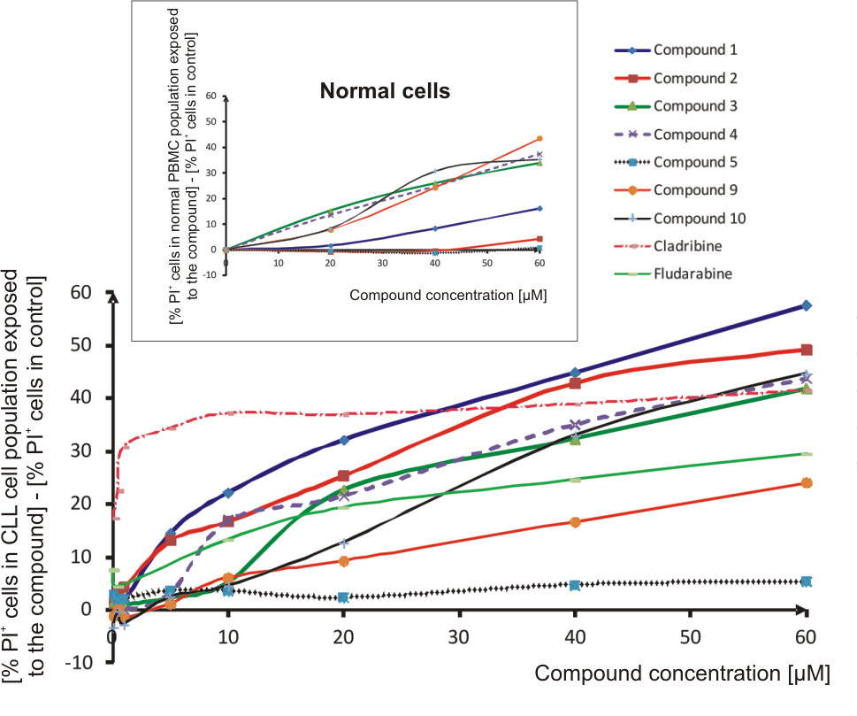
Fig. 1. Cytotoxicity of adenosine derivatives bearing a boron cluster and clinically used adenosine substituted at C-2 with chlorine (cladribine) and fluorine (fludarabine) against CLL and normal PBMC cells (insert) at various concentrations after 48h. The results are presented as the difference between percentage of PI positive (PI+) leukemic or normal cells exposed to increasing dose of the used agents and percentage of PI+ cells exposed to media or media containing DMSO only (vehicle control). Data is expressed as the mean value of 3-4 experiments. The 15 µM concentration of compounds 1 and 2 was chosen as cytotoxic for CLL, but safe for normal ones. The above concentration was used for the following experiments.

Prompted by the high activity of compound 2 against CLL cells and its low toxicity against normal cells we synthesized, by analogy to fludarabine, its arabino counterpart in two variants, first with ethynyl linker between carbon 2 of nucleobase and the boron cluster (compound 9) and the second one containing ethyl linker (compound 10). Compound 10 was obtained via the palladium-catalyzed reduction of 9. Unfortunately, both compounds appeared to be less active than compound 2, therefore further biological evaluation was focused on compounds 1 and 2. However, it is worth noting for the sake of structural optimization that compound 10, containing a more flexible ethyl linker, was more active than compound 9, bearing rigid ethynyl spacer (Scheme1).
The 15 µM concentration at which compound 1 and 2 were found to be safe for normal PBMCs was selected for further analyses of their potential to induce apoptosis. The viability and apoptosis rate were investigated in cell samples obtained from peripheral blood of 13 patients with leukemia, i.e. 12 cases of CLL and 1 case of PLL, using a Membrane Permeability/Dead Cell Apoptosis Kit. Both newly-synthesized compounds demonstrated pro-apoptotic potential against CLL cells (Fig. 2) at 15 µM, while being practically nontoxic to normal cells. The experiments with cladribine at concentration of 0.15 µM (clinically used dose) and 15 µM, as well as fludarabine at 15 µM demonstrated high cytotoxic potential in leukemic cells but also some cytotoxicity against normal ones (data not shown). It is worth noting that agents 1 and 2 differed in their apoptosis-inducing potential in PLL cells. Our preliminary data suggests that compound 2 appears to be highly potent against PLL cells, a very rare hematological malignancy: the anti-leukemic potential of compound 2 against these cells was even higher than that of cladribine and fludarabine (Fig. 2B).
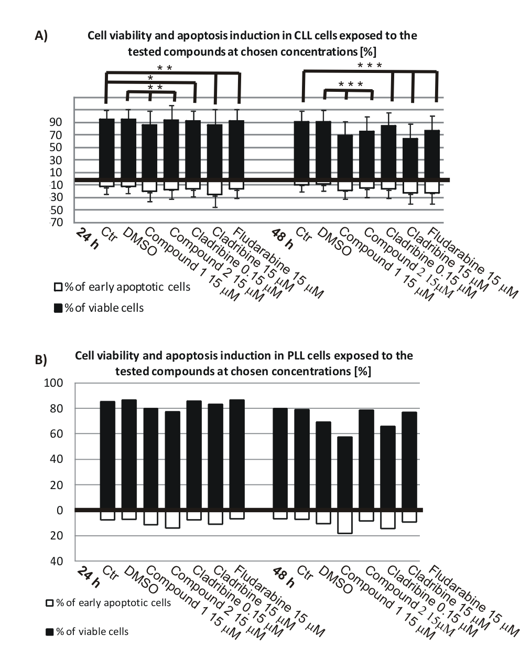
Fig. 2. The viability and apoptosis rate in CLL (A), and PLL (B) PBMCs after their exposure to conventional antileukemic agents: cladribine (0.15 and 15 µM) and fludarabine (15 µM), as well as the novel compounds 1 and 2 at chosen concentration (15 µM), assessed by the Membrane Permeability/Dead Cell Apoptosis Kit. The results of viability and apoptosis induction in CLL cells are presented as the mean values ± SD. A p-value of 0.01-0.02 (*) is considered as statistically significant, p-value 0.002-0.01 (**) statistically very significant, p<0.002 (***) as extremely significant according to Wilcoxon signed-rank test.

    - Caspase 3 activation.
Caspase 3 is a main executioner cysteinyl protease which realizes apoptosis process on extrinsic/receptor and intrinsic/mitochonrial pathway.^{48,49} In the present investigation we revealed the increase of cell numbers with caspase 3 active form among CLL and PLL cells treated with the most effective adenosine derivative bearing boron cluster, i.e. compound 1 and 2 in comparison with control (Fig. 3). Our analysis, conducted after 48 h cell exposure to examined compounds, confirmed that both leukemia cell types, i.e. CLL and PLL indicated a high antileukemic potential of adenosine modified at C-2 and C-8 positions with boron cluster related to apoptosis induction. Among CLL cells exposed to compound 1 and 2 the population of CLL cells containing active caspase 3 increased almost twice from 12.6% and 10.0% in control and vehicle control (DMSO), to 25.5% and 23.1%, respectively (Fig. 3A). The examined leukemic cells contained a little higher population with active caspase 3 after their exposure to cladribine at clinically applied concentration (30.6%), and much higher after treatment with 15 µM fludarabine (42.6%). Interestingly, the number of PLL cells with active form of caspase 3 raised after the exposure to compound 2 from 9.4% and 10.6% in control and vehicle control, respectively, to 28.5% (Fig. 3B). Similar effect was observed after the incubation of PLL cells with cladribine at concentration of 15µM which recursively exceeds its level in serum of patients during antileukemic therapy. By contrast, the number of caspase-3-positive cells among PLL cells incubated with 0.15 µM cladribine and fludarabine was only slightly increased (11.8% in both cases). It is of note that compound 1 affected PLL cells weaker than compound 2 which was confirmed by caspase 3 activation in 16.1% of leukemic cells only (Fig. 3 B).
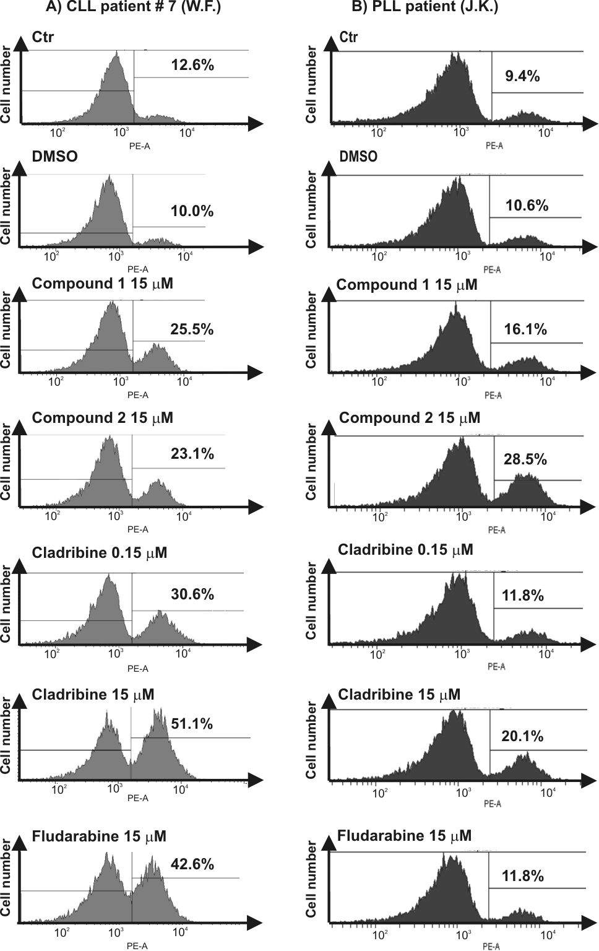
Fig. 3. Percentage of apoptotic cells in CLL (A) and PLL (B) cells after their exposure to conventional antileukemic agents: cladribine (0.15 and 15 µM) and fludarabine (15 µM), as well as the novel compounds 1 and 2 at chosen (15 µM) concentration assessed by PE Active Caspase-3 Apoptosis Kit.

    - Western blot analyses.
The expression of apoptosis-related proteins was assessed in CLL and PLL cells exposed to the chosen compounds. All examined adenosine derivatives triggered proteolysis of PARP-1 full length protein (116 kDa) and lamin B1 (67 kDa) to their products with molecular weight of 89 kDa and 44 kDa, respectively, appearing during apoptosis course (Fig. 4).^{50,51}
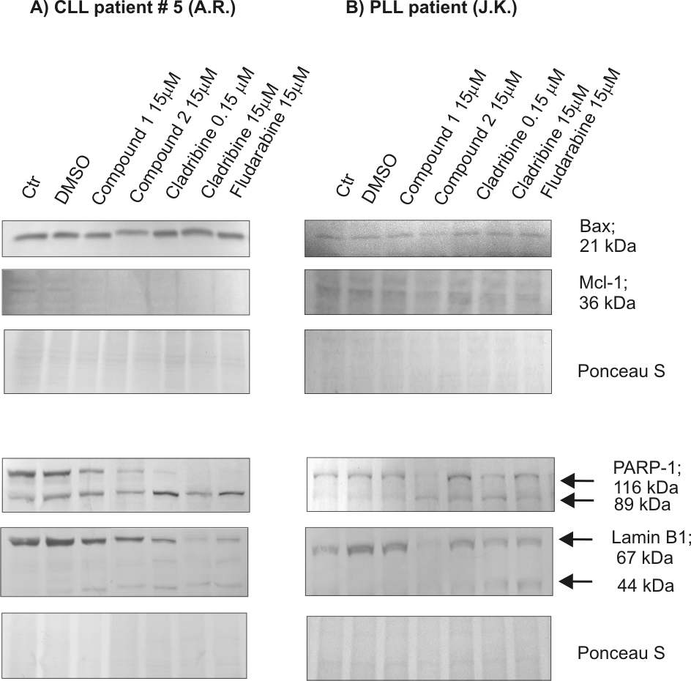
Fig. 4. The expression of apoptosis-related proteins in CLL (A) and PLL (B). PBMCs after 48-hour exposure to conventional antileukemic agents: cladribine (0.15 and 15 µM) and fludarabine (15 µM), as well as the novel compounds 1 and 2 at chosen (15 µM) concentration assessed by Western blot.

Moreover, the expression of apoptosis regulators, i.e. Bax (pro-apoptotic) and Mcl-1 (anti-apoptotic) proteins from Bcl-2 family^{19,24,52} was also examined in adenosine derivative-treated leukemic cells. However, there were some individual differences between basal levels of these apoptotic regulators in model cells, as well as the changes in their cellular levels after the studied compound exposure were diverse. For instance, there were no significant alterations in Bax expression in the cell samples obtained from PLL patient exposed to the novel nucleosides. While, an essential increase of Bax expression level were seen in cladribine and fludarabine-treated cells (patient #5). On the other hand, in PBMC samples from blood of studied patients with CLL a clear decrease of Mcl-1 expression level in comparison to control cells was observed after cell exposure to all the used compounds (Fig. 4A).
    - DNA fragmentation.
To check whether the examined compounds bearing boron cluster are potent to activate enzymatic cleavage of DNA between nucleosomes producing “apoptotic ladder,” a typical event of apoptosis,^{53,54} agarose gel electrophoresis of DNA samples isolated from exposed cells was performed. At present, it is accepted that main activity in DNA-ladder formation in apoptotic cells is represented by DFF/CAD (DNA fragmentation factor/caspase activated DNase) followed by caspase 3-dependent cleavage of DFF/CAD-IDFF/ICAD complexes.⁵⁵ As it is illustrated in Fig. 5, the electrophoregrams of DNA isolated from the equal number of examined CLL (Fig. 5A) and PLL (Fig. 5B) cells after exposure, revealed the increasing amounts of DNA fragments comparing to control ones. Interestingly, the formation of the ladder after CLL cell exposure to compound 1 and 2 at 15 μM concentration indicated close extend of DNA fragmentation, whereas PLL cells treated with compound 2 were characterized by enhanced ability to make DNA fragments, comparing with compound 1, and similar to cladribine and fludarabine at dose of 15 µM (Fig. 5 A, B).
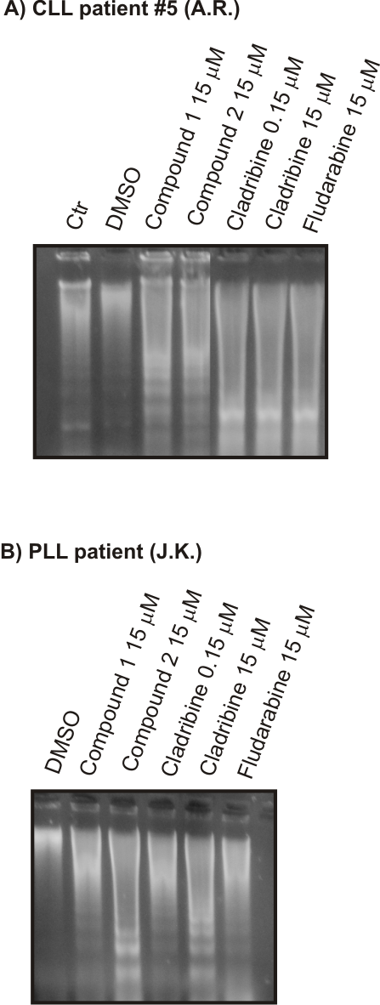
Fig. 5. DNA fragmentation in CLL (A) and PLL (B). PBMCs after 48-hour exposure to conventional antileukemic agents: cladribine (0.15 and 15 µM) and fludarabine (15 µM), as well as the novel compounds 1 and 2 (15 µM) assessed by agarose gel electrophoresis.

- Conclusion
Herewith, we provide a first report on antileukemic activity of adenosine derivatives bearing boron cluster at different locations of the nucleoside molecule. In vitro screening of the above modifications in comparison with clinically used drugs, cladribine and fludarabine, against CLL, PLL and normal control cells was carried out. The cytotoxity and proapoptotic potential of the new compounds were established.
It is worthy to point out that modification of adenosine with boron cluster at C-2 (compound 2) and C-8 (compound 1) of purine ring leads to products with high cytotoxicity against CLL and PLL cells at 15-20 µM, whereas normal cells of healthy donors are resistant to this concentration. Interestingly, the adenosine derivatives 3 and 4 bearing boron cluster at C-2’of sugar residue and at amino group at C-6 of nucleobase (compound 5) are cytotoxic to both cell types or indicate small activity in leukemic and normal cells, respectively. Complementary biological studies demonstrated that compounds 1 and 2 possess, similarly as clinically used antileukemic drugs – cladribine and fludarabine, high proapoptotic potential. The obtained data revealed also that compounds 1 and 2 are potent to activate caspase 3, the enzyme which is involved in proteolysis of numerous proteins (e.g. PARP-1, Mcl-1) and to activate a key endonuclease, DNA fragmentation factor/caspase activated DNase (DFF/CAD), which functions are relevant for the formation of apoptotic ladder.
In summary, a novel type of adenosine derivatives highly active against CLL and PLL was identified. Derivatives modified with boron cluster at C-2 or C-8 express high cytotoxicity towards leukemic cells and are low in toxicity towards normal cells, a highly advantageous property. They induce also apoptosis in CLL and PLL cells. The observed characteristic of these compounds might be of clinical importance.
- Experimental section
  - Patients and biological materials
Mononuclear cells were isolated from peripheral blood of 16 (CLL) and 1 (PLL) previously untreated patients in different stages of the disease (I – IV) according to Rai classification.⁵⁶ The studied patients showed an expression of CD5, CD19, and CD23 antigens on the surface of the leukemic cells and monoclonality for the light chains of their immunoglobin as established using standard clinical assays. Additionally, the peripheral mononuclear cells from blood of five healthy volunteers were isolated to compare biological activity of adenosine derivatives in normal and leukemic cells.
  - Materials
Adenosine and 2’-O-deoxyadenosine was purchased from Pharma-Waldhof GmbH (Düsseldorf, Germany). 1,3-Dichloro-1,1,3,3-tetraisopropyldisiloxane and 1M tetra-butylammonium fluoride (TBAF) solution in THF was from Sigma-Aldrich (Sp. z o.o. Poznan, Poland). Column chromatography was performed on silica gel 230-400 mesh and TLC was performed on silica gel F254 plates, both purchased from Sigma-Aldrich (Steinheim, Germany). Solvents were purchased in the highest available quality.
Cladribine (Biodrybina) and fludarabine were purchased from the Institute of Biotechnology and Antibiotics Bioton (Warsaw, Poland) and Schering AG (Berlin, Germany), respectively. The purity of compounds 1-5 and 9, 10 was established by HPLC and exceeded 95%. 1, t_{R} = 20.80 min;³⁵ 2, t_{R} = 21.28 min;³⁶ 3, t_{R} = 38.35 min;³⁶ 4, t_{R} = 52.62 min;³⁶ 5, t_{R} = 16.80 min;³⁵ 9, t_{R} = 39.39 min; 10, t_{R} = 38.23 min.

  - General Procedures
Nuclear Magnetic Resonance (NMR). ¹H-NMR, ¹³C-NMR and ¹¹B-NMR spectra were recorded on a Bruker Avance III 600 MHz spectrometer equipped with BB inverse probe-head, the spectra for ¹H, ¹³C, and ¹¹B nuclei were recorded at 600.26 MHz, 150.95 MHz and 192.59 MHz, respectively. Deuterated solvent was used as standard for ¹H-NMR and ¹³C-NMR, while BF₃/(C₂H₅)₂O was used as standard for ¹¹B-NMR. All chemical shifts are reported in ppm (δ) relative to internal standards. The following abbreviations were used to explain the multiplicities: s = singlet, d = doublet, dd = doublet of doublets, bs = broad singlet, q = quarted, m = multiplet. Coupling constants are reported in Hertz.
Mass spectrometry. Fast atom bombardment (FAB, Gly) mass spectra were recorded on a Finnigan MAT (Bremen, Germany). The M. S. m/z was measured in a positive and negative mode. Calculation of the theoretical molecular mass was performed using the “Show Analysis Window” option in ChemDraw 12.0. The calculated m/z corresponds to calculated values based on the average mass of the elements consisting natural isotopes.
Attenuated Total Reflectance−Fourier Transform Infrared (ATR−FTIR) spectroscopy measurements. Infrared absorption spectra were recorded using a Smart iTR diamond attenuated total reflectance (ATR) attachment on a Nicolet 6700 FT-IR spectrometer (Thermo Scientific) equipped with a ETC EverGlo* source for the IR range, Ge-on-KBr beam splitter, and DLaTGS detector. Samples to be analyzed were placed on a diamond ATR element in the solid form. For data acquisition and processing Omnic 8.1 software program was used.

Ultraviolet spectroscopy measurements (UV). UV measurements were performed with a GBC Cintra10e UV-VIS spectrometer (Dandenong, Australia). Samples for UV experiments, ca. 0.5 A₂₆₀ ODU of each compound, were dissolved in 95% C₂H₅OH. The measurement was performed at ambient temperature.
HPLC analysis. HPLC analysis of compounds 1, 2 and 5 was performed on a Hewlett-Packard 1050 system using an Econosil C18 (5 µm, 4.6 x 250 mm) column. All analyses were run at ambient temperature. HPLC conditions were as follows: 20 min from 0% D to 100% D, 5 min 100% D, and 5 min to 0% D. Buffer A contained 0.1 M TEAB (pH 7.0) in a mixture of acetonitrile and water (1:49, v/v), and buffer D contained 0.1 M TEAB (pH 7.0) in a mixture of acetonitrile and water (3:2, v/v). HPLC analysis of compounds 3, 4, 9 and 10 was performed on the Dionex Ultimate 3000 system using an Agilent Zorbax-SB-C18 column (5 µm, 4.6 × 250 mm); the following gradient conditions were used: 50 min from 0% D to 100% D, 5 min 100% D, and 5 min to 0% D. Flow rate 1.0 mL/min. The composition of buffers A and D was as described above. UV detection was performed at λ = 268 nm.
8-Ethynyl-(1,12-dicarba-closo-dodecacarboran-2-yl)-9-(β-D-2’-deoxyfuranosyl)adenine (1) [35] and 2-ethynyl-(1,12-dicarba-closo-dodecacarboran-2-yl)-9-(β-D-2’-ribofuranosyl)adenine (2) were obtained as described.³⁶
2’-O-{[3-propyl-(1,12-dicarba-closo-dodecaboran-1-yl)]-1N-1,2,3-triazol-4-yl}propyl-9-(β-D-ribofuranosyl)adenine (4) was synthesized as described earlier.³⁶
6-N-[(3-oxapentoxy)-7,8-dicarba-nido-undecacarboran-10-yl]-9-(β-D-2’-deoxyribofuranosyl)adenine (5) was obtained as described earlier.³⁵
2-iodo-9-(β-D-ribofuranosyl)adenine (6) was synthesized from guanosine as previously described.^{40,41}
2-iodo-9-(β-D-arabinofuranosyl)adenine (7) was obtained from 6 as described.⁴⁷
2-ethynyl-1,12-dicarba-closo-dodecaborane (8) was obtained according to the literature method.⁵⁷
Synthesis of 2’-O-{[3-propyl-(1,12-dicarba-closo-dodecaboran-1-yl)]-1N-1,2,3-triazol-4-yl}methyl-9-(β-D-ribofuranosyl)adenine (3). 2’-O-(1-propyn-3-yl)-9-(β-D-ribofuranosyl)adenine⁵⁸ (15.3 mg, 0.050 mmol, 1 eq) and 1-(3-azidopropyl)-1,12-dicarba-closo-dodekaborane)³⁶ (12.5 mg, 0.055 mmol, 1.05 eq) were dissolved in a mixture of tert-butanol and water (1mL, 1:1 v/v). Next, freshly-prepared solutions of CuSO4 × 5H2O (0.0025 mmol, 5 % mol, 25 μL of 100 mM solution) and potassium ascorbate (0.005 mmol, 10 % mol, 50 μL of 100 mM solution) were added simultaneously. The reaction mixture was stirred at room temperature while reaction progress was monitored by TLC (CH₂Cl₂: CH₃OH, 8:2 v/v or (CH₂Cl₂: CH₃OH, 9:1 v/v). After reaction completion (usually 24 h), the solvent was evaporated under vacuum. The crude product was purified by silica gel column chromatography using a gradient of methanol in methylene chloride as an eluent. The pure compound was lyophilized from a mixture of tert-butanol and water (1:1, v/v). 3: Yield: 26.6 mg (55 %); TLC (CH₂Cl₂:CH₃OH, 9:1 v/v): R_{f} = 0.34; UV-Vis (96% EtOH): λ_{max} = 260.09 nm; ¹H NMR (CD₃OD): 0.85-0.91 (m, 2H, CH₂ of -CH₂CH₂-para-carborane), 1.45-1.60 (m, 2H, CH₂ of -CH₂CH₂-para-carborane), 0.5-3.00 (bm, 10H, BH), 3.55-3.80 (ABX, 2H, H-5’), 3.92-4.03 (part X of ABX spin system, 1H, H-4’), 4.04-4.10 (m, 1H, H-3’), 4.25-4.32 (2d, 1H, H-2’, ³J_{HH} = 4.88, ³J_{HH} = 4.89), 4.30-4.63 (m, 4H, NCH₂CH₂, OCH₂), 5.86 (d, 1H, H-1’, ³J_{HH} = 6.44), 7.53 (s, 1H, H^{triazol}), 8.00 (s, 1Η, Η−2), 8.06 (s, 1Η, Η−8); FT-IR (KBr/cm⁻¹): ν_{max} = 3419 (OH), 2958, 2930, 2872 (CH₂), 2607 (BH); MS (Gly, FAB, +Ve): m/z = 534.4 [M] (C₁₈H₃₂B₁₀N₈O₄, calculated: 534.35, 100 %).
Synthesis of 2-ethynyl-(1,12-dicarba-closo-dodecaboran-2-yl)-9-(β-D-arabinofuranosyl)adenine (9). The synthesis was performed under anhydrous conditions in an argon atmosphere. 2-iodo-9-(β-D-arabinofuranosyl)adenine (7, 144.5 mg, 0.37 mmol), 2-ethynyl-1,12-dicarba-closo-dodecaborane (8, 75.3 mg, 0.45 mmol), CuI (8.8 mg, 0.046 mmol), Pd(PPh₃)₄ (18.4 mg, 0.016 mmol) were placed in an oven-dried flask (130°C) and then dissolved in anhydrous DMF (2.6 mL) and Et₃N (0.9 mL). The resultant solution was stirred for 75 min at room temperature and then for 70 min at 80°C. After the reaction was complete (CH₂Cl₂/MeOH, 4:1), the solvents were evaporated under reduced pressure in a 40°C water bath and residue was dissolved in 10 mL ethyl acetate. The resultant solution was extracted with deionised water (2 x 20 mL). The organic fractions were collected together, washed with 0.5% aqueous EDTA (1 x 10 mL), dried over anhydrous magnesium sulphate and concentrated under reduced pressure. The crude product was purified by silica gel column chromatography (8 g, 230-400 mesh) using 10% methanol in chloroform as an eluent. Yield: 125.5 mg (79%). TLC (CH₂Cl₂/CH₃OH, 4:1): R_{f} = 0.49, (CH₂Cl₂/CH₃OH, 9:1): Rf = 0.18; UV-Vis (96% EtOH): λ_{max} = 297.0 nm, 265.0 nm, 238.6 nm, λ_{min} = 248.8 nm, 283.2 nm; ¹H NMR (CD₃OD): 1.70-2.88 (m, 10H, B-H); 3.40, 3.65 (2 x s, 2 x 1H, C-H^{p-carborane}); 3.86-3.93 (2q, 2H, H-5’); 4.00 (dd, 1H, ³J_{HH} = 8.2 Hz, 4.5 Hz, H-4’); 4.30-4.34 (2 x t, 2 x 1H, H-2’ and H-3’); 6.42 (d, 1H, ³J_{HH} = 4.6 Hz, H-1’) ; 8.44 (s, 1H, H-8); ¹³C NMR (CD₃OD): 63.40 (C-5’), 66.13 (C^{p-carborane}), 68.91 (C^{p-carborane}), 77.95, 78.55 (C-2’, C-3’), 86.92, 87.38 (C-1’, C-4’), 120.42 (C-5), 144.24 (C-8), 147.86 (C-4), 151.57 (C-2), 157.94 (C-6); ¹¹B{H} (CD₃OD): -14.89 (s), -14.16 (s), -13.25 (s); FT-IR (ATR/cm-1): ν = 3500-3000 (OH, NH), 2953 (CH2), 2919 (CH2), 2850 (CH2), 2614 (BH), 1655 (NH₂), 1590, 1504, 1454 (C=C^{arom}), 1042 (C-O); MS (FAB, Gly): m/z = 433.3 [M], calc. for C₁₄H₂₃B₁₀N₅O₄ = 433.7.
Synthesis of 2-ethyl-(1,12-dicarba-closo-dodecaboran-2-yl)-9-(β-D-arabinofuranosyl)adenine (10). 2-Ethynyl-(1,12-dicarba-closo-dodecaboran-2-yl)-9-(β-D-arabinofuranosyl)adenine (9) (52.3 mg, 0.12 mmol) was dissolved in 10 mL of ethanol then 30 mg of palladium on activated charcoal (10% Pd basis) was added to the solution. The reaction vessel was connected to a balloon filled with hydrogen and the reaction mixture was stirred at room temperature for 20 h. The resultant solution was filtered through Celite, evaporated and the crude product was purified by silica gel column chromatography (2 g, 230-400 mesh) using 10% methanol in chloroform as an eluent. Yield: 30.4 mg (58%). TLC (CH₂Cl₂/CH₃OH, 4:1): R_{f} = 0.48, (CH₂Cl₂/CH₃OH, 9:1): R_{f} = 0.18; UV-Vis (96% EtOH): λ_{max} = 261.9 nm; ¹H NMR (CD₃OD): 1.48-1.51 (m, 2H, CH₂^{linker}), 1.55-2.85 (m, 10H, B-H), 2.89-2.92 (m, 2H, CH₂^{linker}), 3.22 (s, 1H, C-H^{p-carborane}), 3.86-3.93 (2q, 2H, H-5’), 4.00-4.02 (dd, ³J_{HH} = 8.2 Hz, 4.3 Hz, 1H, H-4’), 4.29-4.34 (2t, 2x 1H, H-2’, H-3’), 6.44-6.45 (d, 1H, ³J_{HH} = 4.6 Hz, H-1’), 8.31 (s, 1H, H-8); ¹³C NMR (CD₃OD): 40.18 (C^{linker}) 63.62 (C-5’), 65.97 (C^{p-carborane}), 68.74 (C^{p-carborane}), 78.34, 78.62 (C-2’, C-3’), 86.96, 87.28 (C-1’, C-4’), 118.83 (C-5), 143.19 (C-8), 152.43 (C-4), 157.98 (C-2), 169.04 (C-6); ¹¹B{H} (CD₃OD): -18.08 (s), -15.31 (s), -14.66 (s), -13.70 (s), -3.91 (s); FT-IR (ATR/cm-1): ν = 3500-3000 (OH, NH₂), 2953 (CH₂), 2923 (CH₂), 2849 (CH₂), 2602 (BH), 1667 (NH₂), 1601, 1581, 1507, 1454 (C=C^{arom}), 1043 (C-O); MS (FAB, Gly): m/z = 436.4 [M-1]-, calc. for C₁₄H₂₇B₁₀N₅O₄ = 437.7.
Isolation of leukemia and normal peripheral blood mononuclear cells. The mononuclear cells (PBMCs) were isolated from the peripheral blood of previously untreated CLL and PLL patients, and healthy volunteers. The study was approved by the Local Ethics Committee of the University of Lodz (KBBN-UŁ/II/24/2012) and all patients gave their written consent. The PBMCs were isolated by Histopaque-1077 density gradient centrifugation. Leukemia and normal cell pellets were then suspended in phosphate buffered saline (PBS) and divided into the parts needed for the planned experiments.
Cytotoxicity and apoptosis evaluation. PBMC samples were cultured in RPMI 1640 medium supplemented with heat-inactivated 10% fetal bovine serum, L-glutamine, and antibiotics (streptomycin 100 μg/ml, penicillin 100 U/ml) at 37°C, 5% CO₂, fully-humidified atmosphere.
For cytotoxicity evaluation, the leukemic cells were incubated in culture medium without tested agents (control) or were exposed to dimethyl sulfoxide (DMSO; vehicle control) at concentrations of 0.08%-0.4%, as well as to cladribine, fludarabine, and adenosine modified with boron cluster at the C-8 (1) and C-2 (2) positions of the purine ring; all at concentrations of 0.1-60 µM. The cytotoxicity was assessed cytometrically after 24 and 48 h incubation. After propidium iodide staining, a Membrane Permeability/Dead Cell Apoptosis Kit (Molecular Probes, InvitrogenTM) was used to examine the contribution of apoptosis to cell death induction after exposure to the applied agents. The analyses were performed on BD LSR II flow cytometry using FACSDiva Version 6.1.2 software. Ten thousand events were examined for each analysis. The distinction between living (YO-PRO-negative/propidium iodide-negative), early apoptotic (YO-PRO-positive/propidium iodide-negative) and dead (YO-PRO-positive/propiodium iodide-positive) cells was based on the differences in their permeability for fluorescent dyes. The results are shown as the percent of viable and early apoptotic cells in gated PBMC population, respectively. The cytotoxicity of normal PBMCs, isolated from volunteers without leukemia, was evaluated using the same tests after 24 and 48 h exposure to the examined agents at concentrations of 20 µM, 40 µM, and 60 µM. For further analyses, all tested agents were applied at a concentration of 15 µM. In addition, cladribine was also used at a concentration of 0.15 µM, which corresponds to the cladribine concentration observed in the serum of leukemic patients during anticancer therapy.²⁰
Caspase-3 activation assay. The percentage of leukemic PBMCs with active form of caspase 3 was measured cytometrically by PE Active Caspase-3 Apoptosis Kit, BD Pharmingen, according to the manufacturer's protocol. The assays were conducted after incubation either with the agents, without the agents (control) or with just DMSO (vehicle control) for 48 h. A BD LSR II flow cytometer was used and the analyses were performed using FACSDiva Version 6.1.2 software.
Western blot analysis. Control PBMCs, with no agents applied, as well as the cell samples exposed to DMSO (vehicle control) and the tested agents were lysed (4°C, 1 h) in a buffer containing 10 mM Tris-HCl (pH agent-7.5), 300 mM NaCl, 1% Triton X-100, 2 mM MgCl₂, 0.1 M DTT, and protease inhibitors as described previously.⁵⁹ Protein content was estimated according to the Lowry method⁶⁰ and the cell lysates were prepared for subsequent Western blotting analysis. Protein samples (50 μg/lane) were separated by SDS polyacrylamide gel electrophoresis (SDS-PAGE) on 8.0 or 12.5% slab gels⁶¹ and electrotransfered onto Immobilon P.⁶² Membrane staining with 0.5% Ponceau S solution was performed to confirm equal protein loading and completeness of the transfer. The membranes were saturated in 5.0% skim milk in TBS (10 mM Tris-HCl, pH 7.5, 150 mM NaCl) for 1 hour at ambient temperature, and then incubated overnight with antibodies specific to Mcl-1 (1:1000), Bax (1:1000), PARP-1 (1:1000), and lamin B (1:1000), all from Santa Cruz Biotechnology Inc. Antigen recognition was performed with anti-rabbit IgG (whole molecule)-horse peroxidase or anti-goat IgG-horse peroxidase antibody produced in goat or rabbit, respectively. The antigen-antibodies complexes were detected with Novex HRP Chromogenic substrate (TMB) from Invitrogen or, alternatively, by chemiluminescence.
DNA fragmentation. DNA fragmentation was performed by agarose electrophoresis as described previously [53] with slight modifications. Briefly, after washing with PBS, 6 x 10⁶ CLL cells were lysed and treated with proteinase K (0.2 mg/ml) in a buffer containing 5 mM Tris-HCl, pH 8.0, 20 mM EDTA, 0.5% Triton X-100 for about 12 h at 37ºC. DNA was extracted twice with buffered phenol/chloroform/isoamyl alcohol (25:24:1), and precipitated with a 0.1 volume of 3 M sodium acetate and 2 volumes of ethanol at -20ºC, overnight. DNA precipitates were washed twice with 75% ethanol, dissolved in triple-distilled water, and digested with RNase A (1 mg/ml) for 2 h at 37ºC. Finally, DNA samples were electrophoresed by standard agarose gel (2.0%) electrophoresis. The gels were stained with 10 µg/ml ethidium bromide. To visualize apoptotic alterations in DNA integrity, the gels were observed under UV after staining.
Preparation of whole cell lysates. Control and treated leukemic cells were lysed (4 ºC; 20 min) in a buffer containing 10 mM Tris-HCl (pH 7.5), 300 mM NaCl, 1% Triton X-100, 2 mM MgCl₂, 0.1 M DTT, and protease inhibitors previously.⁶³ Protein content was estimated colorimetrically.⁶⁰
Statystical analysis. The analysis was performed using Wilcoxon signed-rank test. A P value ≤0.05 was considered as statistically significant.
Acknowledgments
This work was supported in part by the National Science Center, Poland, grant 2014/13/B/NZ1/03989 (ZJL) and European Regional Development Fund under the Operational Programme Innovative Economy grant POIG.01.01.02-10-107/09 (ZJL, ABO), in addition, contributions from the Statutory Fund of IMB PAS and statutory support from the University of Lodz (grant 545/479) are also gratefully acknowledged. The equipment used (AM) was sponsored in part by the Centre for Preclinical Research and Technology (CePT), a project co-sponsored by the European Regional Development Fund and Innovative Economy, The National Cohesion Strategy of Poland.
Supplementary data
Additional Figures illustrating ¹H-, ¹³C- and ¹¹B-NMR, MS, FT-IR, UV, spectra and HPLC runs for compounds 9 and 10.
References
- Hoyer, J. D.; Ross, C. W.; Li, C-Y.; Witzig, T. E; Gascoyne, R. D.; Dewald, G.W.; Hanson, C. A. Blood 1995, 86, 1163.
- Kristinsson, S. Y.; Dickman, P. W.; Wilson, W. H.; Caporaso, N.; Björkholm, M.; Landgren, O. Haematologica 2009, 94, 1259.
- Eichhorst, B.; Dreyling, M.; Robak, T.; Montserrat, E.; Hallek, M. Ann. Oncol., Suppl. 2011, 6, 50.
- O’Brien, S. Hematology Am. Soc. Hematol. Educ. Program 2008, 459.
- Rogalińska, M.; Kiliańska, Z.M. Anticancer Agents Med. Chem. 2010,10, 666.
- Wu, M.; Akinleye, A.; Zhu, X. J. Hematol. Oncol. 2013, 6, DOI: 10.1186./1756-8722-6-36.
- Decker, T.; Hipps, S.; Ringshausen, I.; Bogner, C.; Oelsner, M.; Schneller, F.; Peschel, C. Blood 2003, 101, 278.
- Chiorazzi, N.; Ferrarini, M. Hematol. Am. Soc. Hematol. Educ. Program 2006, 237.
- Calissano, C.; Damle, R. N.; Marsilio, S.; Yan, X. J.; Yancopoulos, S.; Hayes, G.; Emson, C.; Murphy, E. J.; Hellerstein, M. K.; Sison, C.; Kaufman, M. S.; Kolitz, J. E.; Allen, S. L.; Rai, K. R.; Ivanovic, I.; Dozmorov, I. M.; Roa, S.; Scharff, M. D.; Li, W.; Chiorazzi, N. Mol. Med. 2011, 17, 1374.
- Smolewski, P.; Witkowska, M.; Korycka-Wołowiec, A. ISRN Oncol. 2013, Doi:10.1155/2013/740615.
- Dearden, C. Hematol. Am. Soc. Hematol. Educ. Program 2012, 645.
- Davi, F.; Maloum, K.; Michel, A.; Pritsch, O.; Mognac, C.; Macintyre, E.; Salomon-Nguyen, F.; Binet, J. L.; Dighiero, G.; Merle-Beral, H. Blood 1996, 88, 3953.
- Tausch, E.; Mertens, D.; Stilgenbauer, S. F1000 Prime Rep. 2014, 6, Doi: 10.12703/ P6-65.
- Keating, M. J.; O’Brien, S.; Albitar, M.; Lerner, S.; Plunkett, W.; Giles, F.; Andreeff, M.; Cortes, J.; Faderl, S.; Thomas, D.; Koller, C.; Wierda, W.; Detry, M. A.; Lynn, A.; Kantarjian, H. J. Clin. Oncol. 2005, 18, 4079.
- Robak, T.; Smolewski, P.; Cebula, B.; Szmigielska-Kaplon, A.; Chojnowski, K.; Błoński, J. Z. Cancer 2006, 107, 1542.
- O’Brien, S. M.; Kantarjian, H. M.; Cortes, J.; Beran, M.; Koller, C. A.; Giles, F. J.; Lerner, S.; Keating, M. J. Clin. Oncol. 2001, 19 1414.
- Robak, T.; Błoński, J. Z.; Kasznicki, M.; Góra-Tybor, J.; Dwilewicz-Trojaczek, J.; Stella-Hołowiecka, B.; Wołowiec, D. Hematol. J. 2002, 3, 244.
- Gandhi, V.; Plunket,W. Combination Strategies for Purine Nucleoside Analogs, in: B.D. Cheson, (Ed.), Chronic Lymphoid Leukemias, Marcel Dekker, Inc. New York, 2001, 195.
- Van den Neste, E.; Cardoen, S.; Offner, F.; Bontemps, F. Int. J. Oncol. 2005, 4 1113.
- Castejón, R.; Vargas, J. A.; Briz, M.; Berrocal, E.; Romero, Y.; Gea-Banacloche, J. C.; Fernández, M. N.; Durantez, A. Leukemia 1997, 11, 1253.
- Marzo, I.; Perez-Galan, P.; Giraldo, P.; Rubio-Felix, D.; Anel, A;. Naval, J. Biochem. J. 2001, 35, 537.
- Droin, N.; Guéry, L.; Benikhlef, N.; Solary, E. Cancer Lett. 2013, 332, 325.
- Reed, J. C. Blood 2008, 111, 3322.
- Pepper, C.; Lin, T. T.; Pratt, G.; Hewamana, S.; Brennan, P.; Hiller, L.; Hills, R.; Ward, R.; Starczynski, J.; Austen, B.; Hooper, L.; Stankovic, T.; Fegan, C. Blood 2008, 112, 3538.
- Endo, Y.; Iijima, T.; Kagechika, H.; Ohta, K.; Kawachi, E.; Shudo, K. Chem. Pharm. Bull. 1999, 47, 585.
- Schwyzer, R.; Do, H. Q.; Eberle, A. N.; Fauchére, J-L. Helv. Chim. Acta. 1981, 64, 2078.
- Leśnikowski, Z. J. Coll. Czech. Chem. Commun. 2007, 72, 1646.
- Lesnikowski, Z.J. “New Opportunities in Boron Chemistry for Medical Applications”, in: N.S. Hosmane, (Ed.), Boron Sciences. New Technologies and Applications, CRC Press, Boca Raton, 2011, 3.
- Issa, F.; Kassiou, M.; Rendina, L. M. Chem. Rev. 2011, 111, 5701.
- Scholz, M.; Hey-Hawkins, E. Chem. Rev. 2011, 111, 7035.
- Sjoberg, S.; Carlsson, J.; Ghaneolhosseini, H.; Gedda, L.; Hartman, T.; Malmquist, J.; Naeslund, C.; Olsson, P.; Tjarks, W. J. Neuro-Oncol. 1997, 33, 41.
- Bregadze, V.; Semioshkin, A.; Sivaev, I. Appl. Radiat. Isotopes 2011, 69, 1774.
- Valliant, J. F.; Guenther. K. J.; King, A. S.; Morel, P.; Schaffer, P.; Sogbein, O. O.; Stephenson, K. A. Coordin. Chem. Rev. 2002, 232, 173.
- Armstrong, A. F.; Valliant, J. F. Dalton Trans. 2007, 4240..
- Bednarska, K.; Olejniczak, A. B.; Wojtczak, B. A.; Sułowska, Z.; Leśnikowski, Z. J. ChemMedChem 2010, 5, 749.
- Bednarska, K.; Olejniczak, A.; Piskała, A.; Klink, M.; Sułowska, Z.; Leśnikowski, Z. J. Bioorg. Med. Chem. 2012, 20, 6621.
- Bednarska, K.; Olejniczak, A. B.; Klink, M.; Sułowska, Z.; Leśnikowski, Z. J. Bioorg. Med. Chem. Lett. 2014, 24, 3073.
- Adamska, A.; Olejniczak, A. B.; Zwoliński, K.; Szczepek, W. J.; Król, E.; Szewczyk, B.; Grynkiewicz, G.; Leśnikowski, Z. J. Acta Pol. Pharm. 2012, 69, 1218.
- Olejniczak, A. B.; Adamska, A. M.; Paradowska, E.; Studzinska, M.; Suski, B.; Lesnikowski, Z. J. Acta Pol. Pharm. 2013, 70, 489.
- Robins, M. J.; Uznański, B. Can. J. Chem. 1981, 59, 2601.
- Matsuda, A.; Shinozaki, M.; Yamaguchi, T.; Homma, H.; Nornoto, R.; Miyasaka, T.; Watanabe, Y.; Abiru, T. J. Med. Chem. 1992, 35, 241.
- Sonogashira, K.; Tohda, Y.; Hagihara, N. A. Tetrahedron Lett. 1975, 16, 4467.
- Wojtczak, B. A.; Olejniczak, A. B.; Leśnikowski, Z. J. „Nucleoside Modification with Boron Clusters and Their Metal Complexes” in: S.L. Beaucage, (Ed.), Current Protocols in Nucleic Acid Chemistry, John Wiley & Sons Inc., Chapter 4, Unit 4.37, 2009, pp 1-26.
- Wojtczak, B. A.; Andrysiak, A.; Grüner B.; Leśnikowski, Z. J. Chem. Eur. J. 2008, 14, 10675.
- Olejniczak, A. B.; Plesek, J.; Leśnikowski, Z. J. Chem. Eur. J. 2007, 13, 311.
- Saito, Y.; Matsumoto, K.; Bag, S. S.; Ogasawara, S.; Fujimoto, K.; Hanawa, K.; Saito, I. Tetrahedron 2008, 64, 3578.
- Yamada, T.; Yamanishi, K. EP 0967220 A1, December 29, 1999.
- Pop, C.; Salvesen, G. S. J. Biol. Chem. 2009, 284, 21777.
- Rogalińska, M.; Błoński, J. Z.; Komina, O.; Góralski, P.; Żołnierczyk, J. D.; Piekarski, H.; Robak, T.; Kiliańska, Z. M.; J. Węsierska-Gadek J. Cell. Biochem. 2010, 109, 217.
- Scovassi, A. I.; Poirier, G. G. Mol. Cell. Biochem. 1999, 199, 125.
- Rao, L.; Perez, D.; White, E. J. Cell. Biol. 1996, 135, 1441.
- Żołnierczyk, J. D.; Borowiak, A.; Błoński, J. Z.; Cebula-Obrzut, B.; Rogalińska, M.; Kotkowska, A.; Wawrzyniak, E.; Smolewski, P.; Robak, T.; Kiliańska, Z. M. Pharmacol. Rep. 2013, 65, 460.
- Bellosillo, B.; Vilamor, N.; Colomer, D.; Pons, G.; Montserrat, E.; Gil, J. Blood 1999, 94, 2836.
- Nagata, S.; Nagase, H.; Kawane, K.; Mukae, N.; Fukuyama, H. Cell Death Differ. 2003, 10, 108.
- Widłak, P.; Li, P.; Wang, X.; Garrard, W. C. J. Biol. Chem. 2000, 275, 8226.
- Cheson, B. D.; Bennett, J. M.; Grever, M.; Kay, N.; Keating, M. J.; O’Brien, S.; Rai, K. R. Blood 1996, 46, 4990.
- Jiang, W.; Knobler, C. B.; Curtis, C. E.; Mortimer, M. D.; Hawthorne, M. F. Inorg. Chem. 1995, 34, 3491.
- Jawalekar, A. M.; Op De Beeck, M.; van Delft, F. L.; Madder, A. Chem. Commun. 2011, 47, 2796.
- Kobylińska, A.; Bednarek, J.; Błoński, J. Z.; Hanausek, M.; Walaszek, Z.; Robak, T.; Kiliańska, Z. M. Oncol. Rep. 2006, 16, 1389.
- Lowry, O. H.; Rosebrough, N. J.; A.L. Farr, R.J. Randall, Protein measurement with the Folin phenol reagent, J. Biol. Chem. 1951, 193, 265.
- Laemmli, U. K.; Nature 1970, 227, 680.
- Towbin, H.; Staechelin, T.; Gordon, J. Proc. Nat. Acad. Sci. U.S.A. 1979, 76, 4350.
- Żołnierczyk, J. D.; Błoński, J. Z.; Robak, T.; Kiliańska, Z. M.; Węsierska-Gadek, J. Ann. N. Y. Acad. Sci. 2009, 1171, 124.

 Corresponding author. Tel.: (+48) 42-272-36-30; fax: (+48) 42-272-36-30; e-mail: zlesnikowski@cbm.pan.pl

