A Mild and Efficient Approach to 6H-Oxazolo[3,2-f]pyrimidine-5,7-dione Scaffold via Unexpected Rearrangement of 2,3-Dihydropyrimido[6,1-b][1,5,3]dioxazepine-7,9(5H,8H)-diones: A Synthesis, Crystallographic Studies and Cytotoxic Activity Screening

Adam Mieczkowski,^{1,}* Milena Bazlekowa,² Maciej Bagiński,³ Jacek Wójcik,¹ Alicja Winczura,¹ Agnieszka Miazga,¹ Somayeh Shahmoradi Ghahe,² Roman Gajda,⁴ Krzysztof Woźniak,⁴ Barbara Tudek^{1,2}

¹Institute of Biochemistry and Biophysics, Polish Academy of Sciences 5a, Pawińskiego Street, 02-106 Warsaw, Poland,
²Institute of Genetics and Biotechnology, Faculty of Biology, University of Warsaw 5a, Pawińskiego Street, 02-106 Warsaw, Poland,
³Department of Chemistry, University of Warsaw 1, Pasteura Street, 02-093 Warsaw, Poland
⁴ Biological and Chemical Research Centre, Department of Chemistry, University of Warsaw 101, Żwirki i Wigury Street, 02-089 Warsaw, Poland

* Corresponding author. Address: Institute of Biochemistry and Biophysics, Polish Academy of Sciences, 5A Pawińskiego St., 02-106 Warszawa, Poland. Fax +48 22 592 35 06, E-mail address:amiecz@ibb.waw.pl

Key words: 6,5’-O-anhydrouridines, oxazolopyrimidines, dioxazepine rearrangement, ring contraction, cytotoxicity

ABSTRACT

We report a mild and efficient approach to the optically pure 6H-oxazolo[3,2-f]pyrimidine-5,7-dione scaffold via an unexpected rearrangement and ring contraction of 2,3-dihydropyrimido[6,1-b][1,5,3]dioxazepine-7,9(5H,8H)-diones derived from nucleoside precursors. The developed procedure enables the synthesis of a wide range of compounds with great structural diversity. The structure of the obtained compounds was confirmed by NMR spectra and single crystal X-ray structural analysis. The final products were tested for the cytotoxic effect on one non-cancerous (fibroblasts) and six cancer cell lines of different origin (colon, glioma, breast, cervix, vulvar, and lung). The synthesized products are low molecular weight compounds with lead-like properties suitable for a medicinal chemistry optimization program.

GRAPHICAL ABSTRACT:

1. Introduction

The 6H-oxazolo[3,2-f]pyrimidine-5,7-dione motive could serve as a convenient scaffold for the design of bioactive molecules with activity against various therapeutic targets (Fig. 1). Oxazolopyrimidine 1 and structurally related compounds were designed as potential selective inhibitors of collagenase 3 (matrix metalloproteinase 13),¹ whereas derivative 2 exhibited potent activity against human gonadotropin-releasing hormone (hGnRH) receptor with binding affinity in the low nanomolar range (4.5 nM).² 6H-Oxazolo[3,2-f]pyrimidine-5,7-diones can be readily synthesized as racemates by the reaction of 2-alkenyloxazolines with isocyanates³ or 2-alkyloxazolines with α,α-disubstituted diacid chlorides.⁴⁻⁶ Such compounds have also been obtained in a cyclisation-hydrogen halide elimination reaction from 5-halogeno-1-(3-hydroxypropyl)uracils after treatment with base.^{7,8}
Fig. 1 Examples of biologically active 6H-oxazolo[3,2-f]pyrimidine-5,7-dione derivatives 1-2 and synthetic targets 3 in the current project

As a part of our on-going research on the design and synthesis of new, medicinally relevant heterocyclic derivatives such as peptidomimetics,⁹ benzodiazepine¹⁰ and nucleoside analogues,¹¹⁻¹³ we developed the synthesis of optically pure derivatives of (S)-3-hydroxy-2,3-dihydro-6H-oxazolo[3,2-f]pyrimidine-5,7-dione 3a-k (Schemes 1-3), which could serve as a new structural scaffold for drug design. Our work on the synthesis of novel fused pyrimidine ring systems was partially inspired by results of Chen and colleagues¹⁴ who reported the synthesis of purine N³,5'-cyclo-2',3'-seconucleosides from N³,5'-cyclonucleosides as possible HIV non-nucleoside reverse transcriptase inhibitors (NNRIs). Although the described compounds did not exhibit any antiretroviral activity, the reported results revealed the possibility of application of cyclonucleosides as valuable substrates for the synthesis of novel fused heterocyclic systems. In this work we utilised 6,5’-O-anhydrouridine nucleosides synthesise of 2’,3’-seconucleoside derivatives using the Chen protocol¹⁴ and investigated the cytotoxic effect of the synthesised products.

2. Results and Discussion

In initial experiments, we used 6,5’-O-anhydrouridine derivatives 4a-c, the synthesis of which was recently published by one of us (Scheme 1).¹¹ Thus, nucleosides 4a-c were dispersed in water and treated with sodium periodate which resulted in substrate dissolution after several minutes. When no more starting material was detected by LRMS and TLC (typically 15 min), sodium borohydride was added and the reaction mixture left at room temperature for 20 h. In most cases the sole product was isolated from the reaction mixture by column chromatography. Analysis of the NMR spectra and single X-ray structure of one of the analogue 3d (Scheme 2) revealed that the obtained products possessed the structure of 6H-oxazolo[3,2-f]pyrimidine-5,7-dione 3 instead of the expected 2,3-dihydropyrimido[6,1-b][1,5,3]dioxazepine-7,9(5H,8H)-dione 5 and that rearrangement/ring contraction of the dioxazepine ring in 4 had occurred under conditions described by Chen.

Scheme 1. Reagents and conditions: (a) NaIO₄, H₂O, rt, 15 min; (b) NaBH₄, H₂O, rt, 20 h. (yields added to the scheme)
After the unexpected transformation of 6,5’-O-anhydrouridine nucleosides 4a-c to the 6H-oxazolo[3,2-f]pyrimidine-5,7-dione derivatives 3a-c, we decided to further explore this reaction using previously unknown N³-substituted derivatives 4d-i (Scheme 2).
Scheme 2. Reagents and conditions: (a) R²-X, K₂CO₃, DMF, 18 h, rt; b) TFA:H₂O (8:2), rt 18 h; (c) NaIO₄, H₂O, rt, 30-60 min; (d) NaBH₄, H₂O, rt, 1 h. (yields added, scheme corrected)

Consequently, isopropylidene-protected derivatives 6a-c were treated with alkyl or benzyl halides in DMF in the presence of anhydrous potassium carbonate resulting in formation of the appropriate alkyl derivatives 7a-f.¹⁵ Additionally, during the previously reported synthesis of 6a,¹¹ we were also able to isolate a small amount of 5,3-dimethyl derivative 7f (18%). 6,5’-O-Anhydrouridine nucleosides 7a-f were deprotected under standard conditions using TFA:H₂O (8:2) giving 4d-i derivatives. Deprotected nucleosides 4d-i were treated with sodium periodate followed by sodium borohydride which resulted in the formation of 6H-oxazolo[3,2-f]pyrimidine-5,7-diones 3d-i. We also investigated the possibility of modification of the target molecules side chains (Scheme 3). Thus, oxazolo[3,2-f]pyrimidine-5,7-dione 3a was treated with iodine and triphenylphosphine in THF resulting in the formation of derivative 3j with high yield. Compound 3j, bearing two iodide groups, could undergo further modifications via alkylation with amines, alcohols, phenols and thiols. Derivative 3a was also treated with DAST, which led to the fluorinated product 3k in low yield. The ORTEP drawings for representative compounds 3d and 3j with atomic labels are presented in Fig. 2.

Scheme 3. Reagents and conditions: (a) I₂, PPh₃, THF, rt, 18 h; (b) DAST, DCM, 0 ºC, 1.5 h. (yields added)

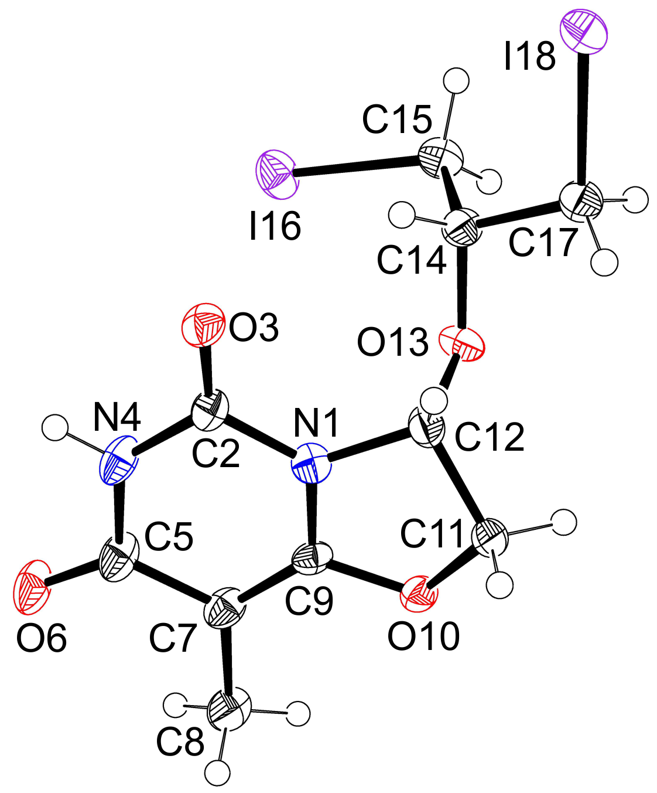
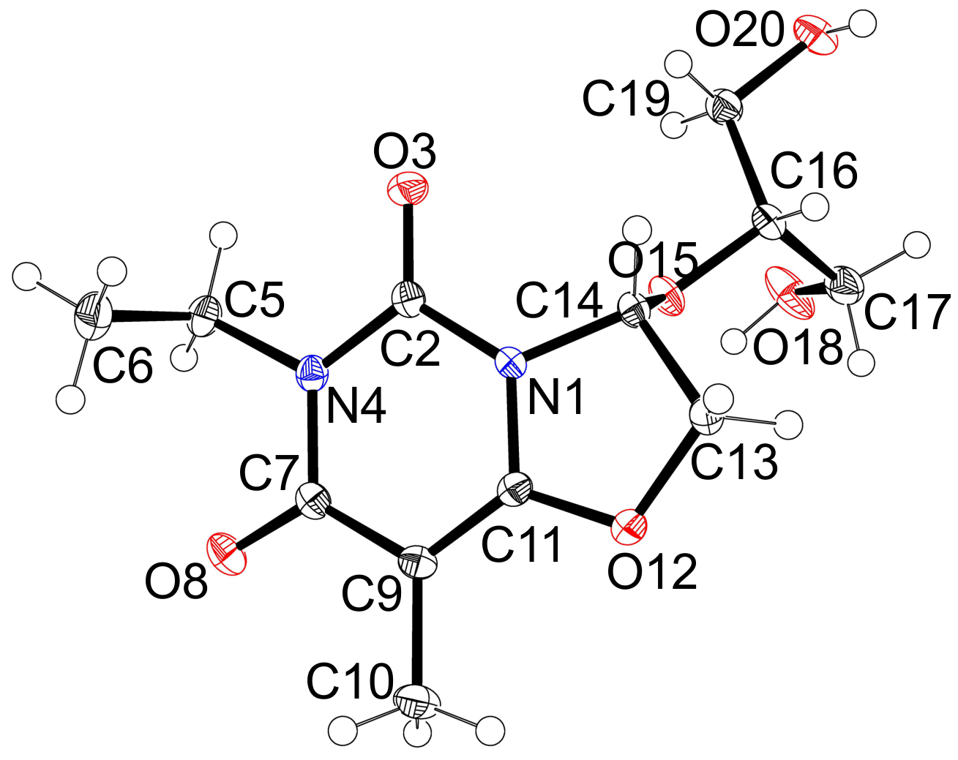

(a) (b)
Fig. 2. ORTEP drawing showing 50% thermal ellipsoids of 3d (a) and 3j (b). Hydrogen atoms are shown as open circles.

To get more information about the rearrangement step, the reaction of 4a was performed in the NMR tube and it’s progress was tracked by observation of changes of H_{1’} proton signal (Fig. 3). The H_{1’} proton signal for 4a was observed at 6.36 ppm (Fig 3a). Five minutes after addition of sodium periodate, we observed the disappearance of substrate signal and appearance of four proton signals at 6.49 ppm, 6.41 ppm, 6.32 ppm and 6.23 ppm in 0.38:0.30:0.10:0.22 ratio, respectively. Based on the analysis of mass and NMR spectra of reaction mixture, we assumed formation of mixture of aldehyde hydrates (Fig 3b). Next, we added NaBH₄ to the NMR tube and after 8 minutes we observed the complete disappearance of four signals and formation of new main product giving proton signal at 5.62 ppm, and minor product giving signal at 6.13 ppm (ratio 92:8 respectively, Fig. 3c). After 60 minutes from addition of NaBH₄ we observed the initially-formed product (proton signal at 5.62) and the rearranged, final product (proton signal at 6.11) in ratio 1:1 (Fig 3d). Consequently, after 120 minutes from addition of NaBH₄, the ratio of initially-formed and rearranged products changed to 23:77, respectively (Fig 3e). Finally, after 20 h we only observed signal corresponding to the rearranged product (Fig 3f). All attempts towards the isolation of initially-formed compound only led to the final product. Based on above observations, we assumed that the spontaneous rearrangement step occurs after reduction of dialdehyde with sodium borohydride. We hypothesize, that it involves the attack of OH_{2’} group of substrate 4a on the C6 position of uracil ring and formation of 6,2’-O bond with concurrent opening the 6,5’-O ether bridge.

Fig. 3. Tracking of reaction progress by observation of position of anomeric H_{1’} proton signal in 4a

The synthesised 6H-oxazolo[3,2-f]pyrimidine-5,7-diones 3a-3k were tested in vitro to determine their cytotoxic activity against six cancer cell lines: U87 (glioma), MCF-7 (breast), HeLa (cervix), A549 (lung), A431 (vulvar), HCT-116 (colon) and also a non-cancer cell line, K-21 (fibroblasts). It has already been reported that structurally related pyrimido[1,6-c][1,3]oxazines exhibited moderate cytotoxic activity against breast and renal cancer cells in vitro.^{16,17} Additionally the anticancer drug – Camptothecin was used as a positive control. The obtained IC₅₀ values are shown in Table 1.

Table 1 Calculated IC₅₀ values of 6H-oxazolo[3,2-f]pyrimidine-5,7-diones versus HeLa, HCT-116, U87, MCF-7, A431, A549 and K-21 cell lines in vitro.

cell line | K-21 | HCT-116 | U87 | MCF-7 | Hela | A431 | A549
Compound number | IC₅₀ values (mM)
3a | >5 | 3 | 2.7 | 1.07 | 3.3 | >5 | 3.6
3b | 2.6 | 2.1 | 1.7 | 1.75 | 1.8 | 2.78 | 2.25
3c | 3.5 | 3.4 | 2.5 | 1.4 | 3 | 2.2 | 4.5
3d | 3.7 | 3.5 | 3.2 | 3.15 | 3.3 | 3.8 | 3.6
3e | 2 | 1.55 | 2.3 | 1.4 | 1.3 | 1.22 | 1.6
3f | 0.56 | 0.8 | 0.55 | 0.4 | 0.6 | 0.6 | 0.5
3g | >5 | >5 | >5 | >5 | >5 | >5 | >5
3h | 3.1 | 3 | 2.8 | 2.7 | 3.2 | 2.75 | 2.9
3i | >5 | >5 | >5 | >5 | >5 | 5 | >5
3j | 0.2 | 0.15 | 0.12 | 0.23 | 0.1 | 0.09 | 0.4
3k | >5 | 3 | >5 | >5 | 2.75 | >5 | >5
Camptothecin | 5.0x10⁻⁴ | 2.0x10⁻⁴ | 5.4x10⁻⁴ | 7.2x10⁻⁴ | 4.3x10⁻⁴ | 2.6x10⁻⁴ | 2.8x10⁻⁴

Each derivative of the synthesized 6H-oxazolo[3,2-f]pyrimidine-5,7-diones 3a-3k has a different cytotoxic effect depending on the type of treated cell line. The highest cytotoxic effect was observed for compound 3j and A431 (Table 1) was the cell line the most sensitive to this compound. The least cytotoxic effect was observed for compound 3g: the IC₅₀ values for all studied cell lines were above 5 mM. One of the studied compounds – 3a was significantly more toxic (5-fold) for one of the studied cell lines (breast cancer cells, MCF-7) than for non-cancerous fibroblasts, K21 (Table 1). MCF-7 cells were also 2.5 times more sensitive to compound 3c than K21 cells.

3. Conclusions

A series of novel, optically pure 6H-oxazolo[3,2-f]pyrimidine-5,7-diones 3a-3k were synthesized from 6,5’-O-anhydrouridine precursors through a novel rearrangement and contraction of the dioxazepine ring. The structures of the obtained compounds were confirmed by NMR spectra and single crystal X-ray structural analysis. The developed procedure enables the synthesis of a wide range of compounds with great structural diversity. The synthesized products are low molecular weight compounds with lead-like properties suitable for a medicinal chemistry optimization program. The cytotoxic effect of the synthesized compounds have been evaluated against several cell lines: U87, MCF-7, HeLa, A549, A431, HCT-116 and K-21. Although the synthesized compounds exhibited a rather weak cytotoxic effect on the investigated cell lines, the results and observed effects could help in the design of more active and selective inhibitors. Further structure optimization is now under investigation in our laboratory and will be reported elsewhere in due course.

4. Acknowledgements
This work was supported by Polish Ministry of Science and Higher Education (“Iuventus” grant No. IP2010 026070). The equipment used was sponsored in part by the Centre for Preclinical Research and Technology (CePT), a project co-sponsored by European Regional Development Fund and Innovative Economy, The National Cohesion Strategy of Poland. We thank Jacek Olędzki for recording the ES-MS spectra.

Supplementary data
Supplementary data (analytical data, figure represented viability plots of cell lines and detailed crystallographic studies) associated with this article can be found, in the online version, at

Crystal structures were deposited at the Cambridge Crystallographic Data Centre; 3d (CCDC 1433245) and 3j (CCDC 1433246).

References
1. Dyer, R. D.; Harter, W. G.; Hicks, J. L.; Johnson, A. R.; Li, J. J.; Roark, W. H.; Shuler, K. R. WO 02/064599 A1, 2002.
2. Pontillo, J.; Chen, S. Bioorg. Med. Chem. Lett. 2005, 15, 1407.
3. Elliott, M. C.; Kruiswijk, E. Willock, D. J. Tetrahedron 2001, 57, 10139.
4. Zhou, A.; Pittman, C. U. Jr. Tetrahedron Lett. 2005, 46, 2045.
5. De Silva, H. I.; Chatterjee, S.; Henry, W. P.; Pittman, C. U. Jr. Synthesis 2012, 44 3453.
6. Zhou, A.; Pittman, C. U. Jr. Synthesis 2006, 38, 37.
7. Jokic, M.; Skaric, V. J. Chem. Soc. Perkin Trans. 1 1990, 2225.
8. Copik, A.; Suwinski, J.; Walczak, K.; Bomikowska, J.; Czuba, Z.; Krol, W. Nucleosides Nucleotides Nucleic Acids 2002, 21, 377.
9. Mieczkowski, A.; Koźmiński, W.; Jurczak, J. Synthesis 2010, 42, 221.
10. Mieczkowski, A.; Jurczak, J. Tetrahedron 2010, 66, 2514.
11. Mieczkowski, A.; Peltier, P.; Zevaco, Z.; Agrofoglio, L.A. Tetrahedron 2009, 65, 4053.
12. Mieczkowski, A.; Blu, J.; Roy, V.; Agrofoglio, L.A. Tetrahedron 2009, 65, 9791.
13. Roy, V.; Mieczkowski, A.; Topalis, D.; Berteina-Raboin, S.; Deville-Bonne, D.; Agrofoglio, L. A. Synthesis 2008, 40, 2127.
14. Chen, G. S. ; Chen, C. -S.; Chien, T. -C. ; Yeh, J. -Y. ; Kuo, C. -C.; Talekar, R. S.; Chern, J. -W. Nucleosides Nucleotides Nucleic Acids 2004, 23, 347.
15. Nowak, I.; Robins, M. J. J. Org. Chem. 2007, 72, 2678.
16. Hsu, L. -Y.; Lin, C. -H. Heterocycles 1996, 43, 2687.
17 Hsu, L. -Y.; Chang, Y. -M.; Lin, C. -H.; Drach, J. C. Nucleosides Nucleotides Nucleic Acids 1996, 15, 1835.

