Concerted action of NIC relaxase and auxiliary protein MobC in RA3 plasmid conjugation
Jolanta Godziszewska^{1,3}, Gabriel Moncalián², Matilde Cabezas², Aneta A. Bartosik¹, Fernando de la Cruz² and Grazyna Jagura-Burdzy¹ *
¹Institute of Biochemistry and Biophysics PAS, Department of Microbial Biochemistry, 02-106 Warsaw, Poland
²Departamento de Biología Molecular and Instituto de Biomedicina y Biotecnología de Cantabria (IBBTEC), Universidad de Cantabria-CSIC, C/ Albert Einstein 22, 39011 Santander, Spain
³Present address: Warsaw University of Life Sciences (WULS-SGGW), Faculty of Human Nutrition and Consumer Sciences, Laboratory of Food Chemistry, 02-776 Warsaw, Poland
*Author for correspondence:
Institute of Biochemistry and Biophysics, PAS, 02-106 Warsaw, Pawinskiego 5A, Poland, tel: +48 22 592 1212, fax: +48 22 592 21 90, email: gjburdzy@ibb.waw.pl

Running title: NIC relaxase from plasmid RA3 of IncU incompatibility group

Keywords: broad-host-range plasmid, IncU, conjugative transfer, MOB_{P4} relaxase, oriT

Summary
Conjugative transfer of the broad-host-range RA3 plasmid, the archetype of the IncU group, relies on the relaxase NIC that belongs to the as yet uncharacterized MOB_{P4} subfamily. NIC contains the signature motifs of HUH relaxases involved in Tyr nucleophilic attack. However, it differs in the residue involved in His activation for cation coordination and was shown here to have altered divalent cation requirements.
NIC is encoded in the mobC-nic operon preceded directly by oriT, where mobC encodes an auxiliary transfer protein with a dual function: autorepressor and stimulator of conjugative transfer. Here an interplay between MobC and NIC was demonstrated. MobC is required for efficient NIC cleavage of oriT in supercoiled DNA whereas NIC assists MobC in repression of the mobC-nic operon. A 7-bp arm of IR3 (IR3a) was identified as the binding site for NIC and the crucial nucleotides in IR3a for NIC recognition were defined. Fully active oriT_{RA3} was delineated to a 47-bp DNA segment encompassing a conserved cleavage site sequence, the NIC binding site IR3a and the MobC binding site O_{M}. This highly efficient RA3 conjugative system with defined requirements for minimal oriT could find ample applications in biotechnology and computational biology where simple conjugative systems are needed.

Introduction
Horizontal gene transfer (HGT) has a major effect on the diversity of bacterial genomes. Conjugation, specified by mobile genetic elements (conjugative plasmids and integrative and conjugative elements), seems to be the most efficient way for horizontal exchange of genetic material (Halary et al., 2010).
The general scheme for conjugative ssDNA transfer comprises three important steps: i/ formation of the relaxosome at the origin of transfer (oriT), and preparation of ssDNA for transfer, ii/ transferosome assembly by a type IV secretion system (T4SS) involved in donor-recipient recognition and secretion of the nucleoprotein complex, and iii/ delivery of the relaxosome to the transferosome by a type IV coupling protein (de la Cruz et al., 2010; Zechner et al., 2000). The specificity of the conjugation machinery is mainly provided by interactions of the relaxase with oriT (Caryl and Thomas, 2006; Guasch et al., 2003; Hekman et al., 2008; Larkin et al., 2005; Lucas et al., 2010; Luo et al., 1995; Pansegrau et al., 1993; Williams and Schildbach, 2006). Conjugative relaxases recognize and bind a specific sequence in the oriT and cleave it in a strand specific manner, covalently binding the 5’ end of the nicked strand through a tyrosine residue in a transesterification reaction (Carballeira et al., 2014; Grandoso et al., 2000; Llosa et al., 1996). They can function on their own (e.g., MobM of pMV158) or are assisted in their functions by one e.g., MobA of pC221 (Caryl et al., 2004; Caryl and Thomas, 2006) or more auxiliary proteins e.g., TrwC of R388, MbeA of ColE1, TraI of F or TraI of RK2 (Bowie and Sauer, 1990; Furste et al., 1989; Lum et al., 2002; Lovett and Helinski, 1975; Moncalian and de la Cruz, 2004; Moncalian et al., 1999a; 1999b; Nelson et al., 1995; Ragonese et al., 2007; Varsaki et al., 2009; 2012; Ziegelin et al., 1989; 1991; 1992). The relaxases accompany the ssDNA during its transfer to the recipient, re-join the ends and may also participate in the replication of the complementary strand (de la Cruz et al., 2010; Draper et al., 2005; Pansegrau and Lanka, 1996).
The conjugative relaxases vary in the number of active tyrosine residues in the catalytic center, the mechanism of cleavage and re-joining of plasmid DNA during conjugative transfer, type of divalent cation involved in the cleavage reaction, the ability to interact with various proteins, and domain structure (Pansegrau et al., 1993; 1994; Llosa et al., 1996; Grandoso et al., 1994; 2000; Dash et al., 1992; Byrd et al., 2002; Matson and Ragonese, 2005). They have been assigned to six MOB families (Francia et al., 2004; Garcillán-Barcia et al., 2009). Four of the relaxase families (MOB_{F}, MOB_{Q}, MOB_{P} and MOB_{V}) belong to the HUH endonuclease superfamily carrying the HUH motif composed of two His residues separated by a hydrophobic residue and the Y motif containing one (1Y) or two (2Y) catalytic Tyr residues (Chandler et al., 2013). The HUH enzymes require for activity a divalent metal ion to facilitate positioning of the phosphodiester bond for cleavage. It is presumed that Mg²⁺ or Mn²⁺ are the physiological co-factors although various divalent ions may be used in vitro (Boer et al., 2006; Datta et al., 2003; Edwards et al., 2013; Larkin et al., 2007; Lorenzo-Diaz et al., 2011). The His pair of the HUH motif provides two ligands for the metal ion coordination, and the third ligand seems to be invariably a polar residue of Glu, Asp, His or Gln (Chandler et al., 2013). Although representatives of the three largest families, MOB_{P}, MOB_{F} and MOB_{Q}, have been studied for years, structural data is only available for three relaxases of the MOB_{F} family, TrwC of R388, TraI of pCU1 (MOB_{F11}) and TraI of F plasmid (MOB_{F12}), and two relaxases of the MOB_{Q} family, MobA of R1162 plasmid and NES of pLW1043 (Datta et al., 2003; Edwards et al., 2013; Guasch et al., 2003, Monzingo et al., 2007; Nash et al., 2010). Understanding the mechanisms of relaxase functioning will help combat plasmid spreading and is especially important for broad-host-range conjugative plasmids capable of replication in and transmission between evolutionarily distant species (Lujan et al., 2007). Moreover, the specific activities of the relaxases can find biotechnological applications where precise processing of DNA is required (Gonzales-Prieto et al., 2013).
The broad-host-range conjugative plasmid RA3, the IncU archetype, transfers with efficiency of one transconjugant per donor, replicates and is stably maintained in species from alpha-, beta- and gammaproteobacteria (Kulinska et al., 2008; 2011; Ludwiczak et al., 2013; Godziszewska et al., 2014). The horizontal spreading of RA3 is determined by a contiguous region of 23 kb designated conjugative transfer module and comprising three operons (Fig. 1A). The bicistronic mobC-nic operon adjacent to the stability module (Kulinska et al., 2008; 2011) encodes the auxiliary transfer protein MobC (Godziszewska et al., 2014) and the relaxase NIC. The divergently oriented (back-to-back) long operon from orf33 to traC3 encodes fourteen Mpf (Mating pair formation) proteins, four proteins putatively involved in the Dtr (DNA transfer) functions, and a coupling protein VirD4. The tri-cistronic operon orf34-orf35-orf36 has also been shown to be a part of the conjugative transfer module (J. Godziszewska, unpublished).
The relaxase NIC of the IncU plasmids RA3 (Kulinska et al., 2008), pFBAOT6 (Rhodes et al., 2004), pMBU13 and pMBU17 (Brown et al., 2013), is a protein of 331 amino acids with an N-terminal relaxase/mobilisation nuclease domain with three conserved motifs (Fig. S1). Together with its closest homologs encoded by plasmids from the PromA group (Marques et al., 2001; Schneiker et al., 2001; Tauch et al., 2002; van der Auwera et al., 2009) NIC_RA3 was classified to an as yet unstudied group of MOB_{P4} relaxases (Garcillán-Barcia et al., 2009). Structural predictions classify the RA3 DNA binding protein MobC to the RHH family together with other auxiliary transfer proteins like TraY and TraM of F, TrwA of R388 and MbeC of ColE1 (Bowie and Sauer, 1990; Moncalian and de la Cruz, 2004; Ragonese et al., 2007; Varsaki et al, 2009). MobC is an auxiliary transfer protein of dual function: it binds to DNA at mobCp and thereby represses the mobC-nic operon, and is required (without DNA binding) for an efficient conjugative transfer (Godziszewska et al., 2014).
oriT with the nick site motif characteristic for MOB_{P4} and MOB_{P11} relaxases (Tauch et al., 2002; Garcillán-Barcia et al., 2009) has been mapped to a 417-bp intergenic region between the partitioning operon korA-incC-korB-orf11 and the mobC-nic operon (Kulinska et al., 2008). This region is highly structured with various direct and inverted repeats and functions as oriT and parS, the cis-acting sites for conjugation and stable maintenance functions, respectively, and the mobC promoter (Fig. 1B). The two direct repeats (DR1 and DR2) and the inverted repeat IR-SnaBI in this region have been assigned the function of partitioning the cis-acting parS motifs (Kulinska et al., 2011). Recently we have demonstrated that KorB of RA3 (ParB homolog) bound to parS acts as an additional repressor for mobCp (Kulinska et al., 2016) tuning down the transfer functions when active partition proceeds.
Further analysis (Godziszewska et al., 2014) has limited the fully functional oriT to a 116-bp region with three IR sequences (IR2, IR3 and IR4) and confirmed the role of the cleavage site in the bottom strand of the motif AATCCTG↑C, as shown in Fig. 1C. Whereas the degenerated palindromic sequence IR4 located between the -35 and -10 motifs of mobCp was identified as an operator (O_{M}) for the MobC autorepressor (Godziszewska et al., 2014), neither the NIC_RA3 binding site nor the significance of the inverted repeat motifs IR2 and IR3 with the arms moved apart (Fig. 1C) and flanking mobCp have been established yet.
In this report we mapped the minimal oriT and defined the sequence requirements for efficient NIC binding. We also analyzed the role of MobC in NIC_RA3 relaxase processing of minimal oriTs. Special metal requirements of NIC are also described. The study highlights a concerted action of MobC and NIC in RA3 plasmid processing and transcriptional repression.

Results
Minimal oriT of RA3
RA3 oriT was previously mapped to a 417-bp intergenic region at the junction between the stability and conjugative transfer modules (Kulinska et al., 2008), and then limited to 116 bp (Fig. 1C; Godziszewska et al., 2014). In this work, the minimal oriT_{RA3} was delineated by using pUC18 vector with different length oriT fragments inserted to establish which specific sequences are sufficient to be recognized and processed by the cognate relaxase and which are required to maximize the productivity of mobilization. First, a 61 bp long fragment (oriT61) encompassing the conserved motif with the nick site (nic sequence), single arms of the palindromic sequences IR2a and IR3a, and the MobC binding site O_{M} (IR4), or a similar size but without IR2a and with both arms of IR3 (oriT60hairpin) were cloned into pUC18 and tested for mobilization by the RA3 plasmid. Both fragments inserted into pUC18 seemed to contain all the cis-acting sites required for mobilization by RA3 with an efficiency comparable to that of pUC18 carrying the full 417-bp intergenic fragment (almost one transconjugant/ donor cell) (Fig. 2A and the first panel in 2B). This results suggesting that neither IR2a nor IR3b are strictly required for conjugative DNA processing was confirmed by cloning a 47-bp fragment (oriT47, RA3 coordinates 9736-9782 in Fig. 1C), which rendered pUC18 fully mobilizable by RA3 (Fig. 2A). Two next inserts deprived of O_{M}, a 45-bp fragment containing IR2a (oriT45), and a 31-bp fragment (oriT31) without IR2a, were also active in mobilization, although with a frequency two orders of magnitude lower than oriT47 (Fig. 2A). The difference between the transfer frequency for oriT45 versus oriT31 (a few fold higher for pUC18 oriT45) was statistically significant by Student’s t-test (p=0.05). The role of the IR2a arm needs to be verified. The minimal oriT25 (25 bp) that still enabled transfer of pUC18 (although with a frequency 10-fold lower than that observed for oriT31) contained the conserved motif with the nick site and IR3a without the two distal nucleotides. Further deletion of the remaining part of IR3a (oriT20) made pUC18 non-mobilizable at a detectable frequency. In conclusion, although the shortest oriT was limited to the nic sequence and an adjacent palindromic arm IR3a shortened by 2 nt (oriT25), an intact IR3a and the presence of the MobC binding site O_{M} in oriT47 provides mobilization efficiency by RA3 more than three orders of magnitude higher.
In the majority of oriT regions analyzed, the nick site (nic) is embedded in or lies within short distance from an inverted repeat recognized by the cognate relaxase or by some auxiliary relaxosomal protein (Zechner et al., 2000). Whereas the nic-proximal arm of such palindrome is sufficient to initiate the nicking reaction and the covalent binding of ssDNA by the relaxase the distal arm is important in recipient cells for hairpin formation (Carballeira et al., 2014). In oriT_{RA3} next to the nic sequence lies an atypical IR3 with its 7-nt arms separated by 26 nt, overlapping the mobC promoter motifs and surrounding O_{M} (Fig. 1C). The deletion mapping of minimal oriT strongly suggested an important role of IR3a but not IR3b in efficient transfer (Fig. 2) raising the question about the role of IR3 arms in NIC binding.
To analyze the role of IR3, first a 31-bp insert containing nic-sequence and the whole IR3 palindrome with arms brought close together (14+8hairpin) was cloned into pUC18. Such plasmid was mobilized by RA3 with a frequency <10⁻⁷ indicating that the 14+8hairpin insert was inactive as oriT (Fig. 2B bottom panel). This strongly suggested that the NIC_RA3 processes oriT when the palindromic arms of IR3 are separated by 26 bp, as in the natural context of RA3, but not when they lie next to each other. In vitro studies on the NIC relaxase activity with the use of 14+8hairpin ss oligonucleotide (as shown in Fig. 1D) confirmed that this sequence was indeed not susceptible to be cleaved by NIC relaxase (see below).
To understand the significance of the 26-bp spacer between IR3 arms, a 60-bp version of oriT (oriT60hairpin) and its various derivatives were analyzed (Fig. 2B.) Since this DNA fragment also determines a MobC binding site and mobC promoter activity (RNAP binding motifs -35 and -10), the constructed derivatives had either randomized O_{M} or RNAP binding sites or both, but preserved the distance between intact IR3 arms. The modification of mobCp -35/ -10 motifs and O_{M} in pUC18 oriT60hairpin O_{M}^{x}mobCp^{x} derivative abolished its ability to be mobilized by RA3 (transfer efficiency <10⁻⁷). This was in contrast to pUC18 oriT31 that lacked O_{M} and mobCp but also the IR3b arm and was transferred with an efficiency 10⁻². Thus, somehow the presence of intact IR3 is detrimental for NIC activity when the binding sites for MobC and/ or RNAP are inactivated. Mobilization was fully restored in pUC18 oriT60hairpin mobCp^{x} in which O_{M} was left intact (Fig. 2B) and partially restored in pUC18 oriT60hairpin O_{M}^{x} (transfer efficiency 6x10⁻⁴), in which RNAP binding motifs were preserved. This data suggests that the negative impact of the IR3b arm on NIC binding may be overcome by the binding of MobC in the spacer region between the IR3 arms or, to lesser extent, by RNAP interactions.
Moving IR3b 5 bp closer to IR3a in pUC18 oriT55hairpin had no effect on the frequency of transfer as long as O_{M} was present (compare oriT55hairpin and oriT55hairpin O_{M}^{x} in Fig. 2B).
It was noticed previously that introduction of a three-nucleotide substitution into the nic-proximal part of IR3a (GCAATTT→tagATTT; IR3a^{X}) within the 417-bp oriT fragment (Godziszewska et al., 2014) decreased mobilization of pJSB7.18 plasmid by RA3 more than 100-fold in comparison to the plasmid with the wt insert. Now we have observed that truncation of IR3a by two nic-distal nucleotides in the oriT25 insert led only to a 10-fold decrease in mobilization in comparison to oriT31 with the intact IR3a (Fig. 2A).
To define the role of particular nucleotides in IR3a, a series of oriT31s with single substitutions in IR3a at positions C₁G₂T₃T₄A₅A₆A₇ (numbering indicates distance from the cleavage site in the bottom strand in Fig. 1C) were cloned into pUC18 and tested for mobilization by RA3 (Fig. 3). The modified oriT31^{X} with three substitutions in IR3a (C₁-T₃, variant IR3a^{X} tested previously in oriT417, Godziszewska et al., 2014) was included in the analysis as well as the wt oriT31 insert as a control. pUC18 oriT31^{X} and three derivatives with a single change at positions C₁, G₂ or T₃ were not mobilized by RA3 at a detectable level (frequency <10⁻⁷), while substitutions in other positions only decreased the transfer frequency 5- to 12-fold in comparison to pUC18 oriT31. These results confirmed that the three IR3a nucleotides closest to the nick site are essential for RA3 mobilization.
Regulation of mobCp by MobC and NIC
The conserved nick site and the IR3a sequence recognized by NIC_RA3 relaxase are adjacent to the mobC promoter (50 bp upstream of the predicted transcription start site for mobC, Fig. 1C), which suggested that NIC could affect expression from mobCp. To check whether NIC regulates mobCp on its own or possibly assists MobC in the repression of mobCp, the following three-plasmid system was used. The promoter-probe vector pPT01 (Macartney et al., 1997) was used to transcriptionally fuse the mobCp fragment (417 bp) with a promoter-less xylE cassette to obtain pJSB7.9 (Godziszewska et al., 2014). To deliver MobC and NIC in trans, pJSB4.1 (tacp-mobC_{RA3}), a derivative of the medium-copy-number expression plasmid pAMB39 based on pBBR1MCS-1, and pJSB5.3 (tacp-nic_{RA3}), a derivative of the high-copy-number expression vector pGBT30, were used. The expression of mobCp (monitored by spectrophotometric assay of XylE activity) was analyzed in the triple transformants grown without IPTG induction. It had previously been shown (Godziszewska et al., 2014) that MobC is a potent repressor and even under such conditions the leaky character of tacp provides a sufficient amount of MobC to cause a 10-fold repression of mobCp.
E. coli DH5α(pJSB7.9.mobCp-xylE) was transformed with four pairs of plasmids: pGBT30/ pAMB39 (empty expression vectors as a control); pJSB4.1 tacp-mobC/ pGBT30, pAMB39/ pJSB5.3 tacp-nic, or pJSB4.1 tacp-mobC/ pJSB5.3 tacp-nic. The extracts from logarithmically growing cultures of these four strains were assayed for XylE activity. These experiments indicated that MobC but not NIC is the repressor of mobCp (Fig. 4A, top panel). Although on its own NIC had no effect on the transcriptional activity of mobCp, it potentiated up to 10-fold the repression exerted by MobC. The differences in XylE activity in the presence of MobC versus MobC and NIC were significant according to Student’s paired two tailed t-test (p<0.01).
From a collection of mutant derivatives of pJSB7.9 plasmid (Godziszewska et al., 2014) we chose two variants, pJSB7.17 having a two-nucleotide substitution in the MobC binding site O_{M} (further described as O_{M}^{xx}) and pJSB7.18 with a three-nucleotide substitution in the IR3a sequence tested in oriT31C₁-T₃ (further described as IR3a^{x}). It has previously been demonstrated that the 417-bp fragment carrying O_{M}^{xx} is bound by MobC with a 10-fold lower affinity in vitro and shows a 15-fold lower MobC repression index for mobCp in vivo, but exhibits an unaffected mobilization frequency of pJSB7.17 in comparison to pJSB7.9 (Godziszewska et al., 2014). In contrast, the IR3a^{x} presence in the 417-bp fragment that decreased the mobilization frequency of pJSB7.18 in comparison to pJSB7.9, affected neither the MobC binding affinity in vitro nor in vivo. Expression of the mutant versions of mobCp-xylE transcriptional fusions was analyzed in the presence of combinations of expression vectors as for wt mobCp-xylE fusion.
The mobCpO_{M}^{xx} variant produced only a 20% decrease of activity (measured by XylE level) in the presence of MobC (Fig. 4A middle panel) and a 40% decrease in the presence of both MobC and NIC proteins (not statistically significant differences according to Student’s paired two-tailed t-test, p-value>0.01). This result confirmed that NIC repression of mobCp relied on interactions with MobC bound at its operator site (O_{M}). The mutated IR3a^{x} in pJSB7.18 had no impact on the extent of repression by MobC on its own (Fig. 4A), and no statistically significant enhancement of the MobC repression by NIC was observed for this mutant. So it has been concluded that a cooperative repression of mobCp by MobC and NIC is observed only when the both proteins effectively interact with DNA at their specific binding sites.
To verify these observations triple transformants’ cultures were grown as for the XylE assays and used for RNA isolation. RT-qPCR with pairs of primers for xylE and the repA gene of the promoter-probe vector, was then performed. In general the relative level of xylE transcript versus repA transcript confirmed the previous enzymatic assays (Fig. 4B). A significant enhancement of MobC repression by NIC was observed only in wt mobCp (pJSB7.9) when both proteins had their binding sites intact. It was noticeable that the presence of a high-copy-number plasmid with tacp-nic even when uninduced had a strong effect on the cells when MobC was not delivered in trans and led to the variations in relative transcript levels. The changes observed in expression of mobCp in the presence of NIC alone seemed to be non-significant according to Student’s t-test (p>0.01).
Characteristics of NIC_RA3 activities in vitro
MOB_{P} represents the largest relaxase family (Garcillán-Barcia et al., 2009) with several distinguishable clades, among them MOB_{P4} which includes the IncU plasmids. Studies on the RA3 relaxosome thus help to characterize the MOB_{P4} group. In order to better understand the role of the auxiliary protein MobC in NIC_RA3 activity, we reproduced DNA processing by the NIC_RA3 relaxase in vitro.
a/ DNA recognition and cleavage activity of NIC_RA3
The NIC_RA3 relaxase was overproduced in E. coli BL21 (DE3)(pJSB6.3 T7p-nic) and purified as a His₆-NIC hybrid protein. Since even low concentrations of IPTG inhibited culture growth, the yield of purified NIC protein was low. The purified His₆-NIC was tested for DNA binding and nicking activity with a Cy5-labeled 61-nt oligonucleotide (Fig. 1D) used as ss oriT or ds oriT after annealing to the complementary unlabeled strand.
In the EMSA experiments (Fig. 5A, B & C) His₆-NIC bound both substrates, ss oriT and ds oriT, with a similar affinity, K_{app} about 450 nM (K_{apparent} – concentration of the protein at which 50% of the DNA fragment is bound). A single NIC- ds oriT complex was formed (Fig. 5B) whereas two complexes of different mobility were seen with ss oriT_{RA3} probably due to the binding of NIC to the original 61-nt oligonucleotide and a 36-nt fragment after cleavage (Fig. 5A). No interactions of His₆-NIC with non-specific ssDNA were detected (Fig. 5C).
Cy5-labeled ssDNA containing oriT_{RA3} (61 nt) was also used to directly test the cleavage activity of His₆-NIC. Under conditions used (Experimental Procedures), the 61-nt oligonucleotide was cut with low efficiency into two fragments, of which only the 36-nt one retained the 5’ label and was detected on the gel (Fig. 5D). No cleavage of the corresponding ds fragment was detected (data not shown). Since the N-terminal His-tag could have been responsible for the observed low enzymatic activity of His₆-NIC, the nic gene was cloned into pET29c to produce NIC-His₆. The C-terminally tagged NIC-His₆ was efficiently over-produced in E coli C41 without a noticeable toxic effect. No difference in the cleavage activity of NIC-His₆ on ssDNA oriT was observed in comparison to His₆-NIC (Fig. 5E). To check if MobC would enhance the NIC activity, His₆-MobC was over-produced, purified as described previously (Godziszewska et al., 2014) and added to the NIC reaction mixture. No significant enhancement of the NIC cleavage activity in vitro was detected in the presence of His₆-MobC (Fig. 5E).
b/covalent complexes of NIC with cleaved oligonucleotides
Conjugative relaxases cleave DNA in a site- and strand-specific manner by a transesterification reaction mediated by a tyrosine residue in the presence of divalent metal ions (mainly Mg²⁺). After cleavage the relaxase remains covalently bound to the 5’-end of the cleaved DNA strand via a phosphotyrosyl linkage. For better visualization of the NIC cleavage reaction we decided to analyse the intermediate products - complexes of NIC covalently bound to 5’-end of the cleaved oligonucleotide.
NIC-His₆ tagged and untagged NIC were efficiently over-produced in E coli C41 and purified by sequential column chromatography and assayed for cleavage/ binding activity. Three different ss oligonucleotides similar to those successfully used for TrwC analysis were designed (Lucas et al., 2010). They all contained nic sequence (Fig. 1D) and IR3a, the nic-proximal arm of IR3 palindrome. The oligonucleotides designated 14+8 and 14+18 had additional sequences of different lengths downstream of the cleavage site. The third oligonucleotide 14+18hairpin (also tested in vivo in mobilization experiments, Fig. 2B) contained the IR3b arm added next to IR3a (Fig. 1D). SDS-PAGE analysis of reaction mixtures comprising the NIC or NIC-His₆ relaxase, oligonucleotides and Mg²⁺ revealed slower-migrating bands corresponding to NIC with covalently bound DNA substrate after nicking reaction revealing the same substrate specificity of the two NIC forms. They poorly cleaved oligonucleotides 14+8 and 14+18 and did not process the 14+18hairpin oligonucleotide (data not shown).
When different divalent cations were tested in the binding-cleavage reactions the activities of both NIC and NIC-His₆ were significantly enhanced by Mn²⁺ or Ni²⁺ presence in the reaction mixture in comparison to Mg²⁺ (Fig. 6A).
To find the structural differences between NIC and other HUH relaxases that would explain their differential cation requirements, we performed structural prediction and modeling of NIC on the Protein Homology/analogY Recognition Engine (PHYRE) Web Server. As expected, NIC was found to be a homolog of RSF1010/ R1162 MobA (Monzingo et al., 2007) and other HUH relaxases such as TrwC (Guasch et al., 2003) and TraI (Datta et al., 2003). A 3D model of NIC was generated by homology modeling using R1162_miniMobA (PDB access 2SN6) as a template. Residues 42-186 of NIC could be modelled at >90% accuracy (Fig. 6C), although the sequence identity between NIC and miniMobA is only 25% (Fig. S4). The residues involved in the Tyr nucleophilic attack and the HUH motif shown to participate in metal coordination in members of this family of proteins are conserved (Boer et al., 2006; Larkin et al., 2005; Monzingo et al., 2007). However, in NIC_RA3, the residue potentially involved in the His activation for cation coordination is different than in the other studied homologs. Instead of an acidic residue (e.g., E74 in MobA of R1162, Fig. S2), NIC contains the hydrophobic residue V108 unable to stabilize the His coordination conformation and thus supposedly Mg²⁺ cannot be coordinated efficiently by NIC_RA3.
Two mutant nic alleles were constructed to produce relaxases with amino acids substitutions V108A or V108E, respectively. Purified C-terminally His-tagged NIC variants were tested for cleavage and covalent binding of oligonucleotide 14+18 in the presence of Mn²⁺ or Mg²⁺ (Fig. 6D and E). Both variants demonstrated similar cleavage/ covalent binding activity in the presence of 10 mM Mn²⁺ as WT NIC-His₆ but differed in the activity in the presence of 10 mM Mg²⁺ (Fig. 6D). Quantification of ssDNA-NIC complex formation showed that the WT NIC-His₆ activity in the presence of Mg²⁺ equaled 45% of that with Mn²⁺. The V108A substitution increased the activity with Mg²⁺ to 85%, while the V108E one to 115% of the activity observed of WT NIC-His₆ with Mn²⁺. The different activities of the two NIC mutant variants are even more pronounced at a lower Mg²⁺ concentration of 1 mM (Fig. 6E).
The nicV108A and nicV108E alleles were also introduced into pBGS18 carrying a complete conjugative module (pJSB1.83 and pJSB1.84, respectively) and tested for conjugative transfer between E. coli strains. No difference was noticed in the transfer frequency (1 transconjugant per donor) between a plasmid producing WT NIC_RA3 and its mutated versions NICV108A and NICV108E confirming that the modified proteins were fully active in vivo.
c/ Nicking of supercoiled plasmid DNA in vitro
Previous studies on the role of MobC in conjugation (Godziszewska et al., 2014) have demonstrated that deletion of mobC leads to a 1000-fold decrease in the frequency of transfer of a plasmid with the RA3 conjugative module. However, no effect of MobC on the cleavage of oriT oligonucleotide (ss or ds) by NIC_RA3 was detected in the present study using an in vitro assay (Fig. 5D). To clarify this apparent discrepancy, the in vitro activity of the NIC-His₆ relaxase in the presence or absence of His₆-MobC was analyzed using supercoiled (SC) pUC18 with 417-bp oriT_{RA3} (pJSB2.9). As a control, supercoiled pUC18 without the insert was used (Fig. 7A). Neither NIC-His₆ nor His₆-MobC alone affected the balance between the different topological forms of pJSB2.9. However, NIC-His₆ and His₆-MobC together produced a shift from the supercoiled (SC) towards the open-circle (OC) form of pJSB2.9 whereas pUC18 superhelicity was unaffected (Fig. 7A). These results show that MobC is required for the oriT-specific nicking activity of NIC_RA3 towards supercoiled DNA.
The pUC18 derivatives with different oriT variants previously analyzed for mobilization ability were then used in the nicking assay (Fig. 7B). pJSB2.43 oriT61, pJSB2.44 oriT45, and pJSB2.50 oriT31 were also nicked efficiently by NIC-His₆ only in the presence of His₆-MobC. The relaxation of pJSB2.44 and pJSB2.50, both with O_{M} deleted, confirmed the earlier observation that MobC binding to DNA is not required to enhance nicking by NIC. The 31-bp insert with three nucleotides in the IR3a arm modified (oriT31C₁-T₃, pJSB2.54) did not allow nicking of the plasmid under conditions used, as expected from the mobilization assay.

Discussion
The conjugative transfer system of the IncU plasmid RA3 represents one of the most efficient, broad-host-range HGT processes. The frequency of the RA3 transfer between E. coli and representatives of alpha-, beta- and other gammaproteobacteria is as high as one transconjugant per donor cell in 2-h mating. On the basis of the amino acid sequence of the NIC relaxase, the RA3 conjugative transfer system has been classified into the MOB_{P} family (Garcillán-Barcia et al., 2009). The widely occurring MOB_{P} relaxases belong to the HUH endonuclease superfamily with a single Tyr residue in the active center (Pansegrau et al., 1993) and are clearly split into several clades designated MOB_{P1} to MOB_{P12} (Garcillán-Barcia et al., 2009). Representatives of the IncU group, e.g., RA3 (Kulinska et al., 2008), pFBAOT6 (Rhodes et al., 2004), pMBU13 and pMBU17 (Brown et al., 2013) constitute the MOB_{P4} clade together with the PromA group of plasmids (van der Auwera et al., 2009). Besides sequencing data, no information about relaxases of the MOB_{P4} group is available. Thus, in this work we characterized a range of NIC activities and the role of the auxiliary protein MobC in their stimulation.
The fully active minimal oriT of RA3 was delineated to 47 bp containing the nic sequence, a 7-bp arm of the IR3 palindrome (IR3a) and the MobC binding site O_{M}. Constructs with oriT deprived of O_{M} were mobilized by RA3 with a 100-fold lower frequency. These results suggested that by binding at O_{M} the transfer auxilliary MobC protein could enhance the NIC_RA3 activity at oriT. However, in vitro experiments showed that MobC was required not only to induce NIC cleavage of supercoiled plasmid DNA with oriT417 or oriT61 but also with oriT45 and oriT31 with O_{M} deleted. In conclusion, MobC mainly stimulates the NIC activity through direct protein-protein interactions but, when bound to O_{M}, it may further assist the NIC_RA3 positioning at oriT. This concerted action could be particularly important under natural conditions of a limited amount of the relaxase produced by RA3, as exemplified by the mobilization experiments of the pUC18 derivatives. The interactions between NIC and MobC will be studied further.
It was shown here that IR3a is a NIC_RA3 recognition site. It is a part of IR3, an atypical inverted repeat with the two arms separated by 26 bp and in this way enclosing the O_{M} and mobC promoter motifs. Single-substitution mutant studies clearly demonstrated that not all IR3a nucleotides are equally important for the NIC binding, indicating a critical role of the three nucleotides CGT proximal to the nick site.
In the in vitro cleavage/ covalent binding tests only oligonucleotides containing the single nick-proximal arm of IR3, IR3a, were processed by NIC_RA3 whereas the 14+8hairpin containing the both arms of the palindrome without an intervening sequence was completely refractory to the cleavage/ binding reaction. Also in vivo this palindromic structure apparently precluded NIC binding and oriT processing since the 14+8hairpin insert failed to direct plasmid mobilization by RA3.
Those results were unexpected since in other oriTs the presence of an inverted repeat in the same position relative to the nic sequence as in the 14+8hairpin is critical for their activity, the nic-proximal arm of the palindrome being required for transfer initiation and the nick-distal arm for hairpin formation in the recipient and completion of the transfer (Carballeira et al., 2014; Luo et al., 1995; Williams and Schildbach, 2006). The inhibitory effect of IR3b on NIC binding at IR3a was absent in pUC18oriT60hairpin when the arms of the palindrome were separated by the native 26-nt spacer bearing O_{M} and RNAP binding motifs (mobCp). Randomization of the 26 nt between IR3a and IR3b to eliminate binding of MobC and RNAP, abolished mobilization while the presence of intact -35 and -10 motifs in the 26-nt spacer partially restored the mobilization ability. Full mobilization activity was exhibited by all constructs where O_{M} was left intact. This suggests steric hindrance by proteins bound in the spacer region (with a major role of MobC) as a means of protecting IR3a from negative interference by IR3b and facilitating NIC cleavage of oriT. Such interference may have an important regulatory function during establishment of RA3 plasmid in the new host when repressors like MobC are not yet synthesized. Further studies are needed to verify this hypothesis and to elucidate how NIC_RA3 overcomes the requirement for hairpin formation in the recipient to complete the processing of the transferred DNA in all constructs deprived of IR3b.
The NIC_RA3 binding site, IR3a, overlaps -35 motif of mobCp. The regulatory studies presented here have revealed an important role of NIC in potentiating the repression of mobCp by MobC, making it a tightly autoregulated circuit. A similar autoregulatory role of a relaxase MobA in conjunction with an auxiliary protein has been demonstrated for p1-p3 promoters in the oriT of RSF1010/R1162 (Frey et al., 1992).
Both NIC relaxase and auxiliary MobC protein participate in two seemingly self-excluding processes: initiation of transfer and limiting their own synthesis. To fully succeed in any of these processes they both should be bound to specific sites in DNA. Further studies are required to establish the signals for the fine tuning of the switching on/off of the RA3 conjugation process.
Our in vivo studies were complemented by in vitro analysis. It showed that NIC binds linear dsDNA as well as ssDNA and does not need MobC for the cleavage of such oligonucleotides.
Experiments with purified NIC have demonstrated that DNA cleavage and covalent binding of the cleaved oligonucleotide proceeds more efficiently in the presence of Ni²⁺ or Mn²⁺ rather than Mg²⁺. This is in stark contrast to, e.g., TraI relaxase of F plasmid which preferentially uses Mg²⁺ as cofactor (Datta et al., 2003; Larkin et al., 2005; Lujan et al., 2007). A 3D homology model of NIC with R1162_miniMobA (PDB access 2SN6) as a template confirmed the conservation of residues involved in the Tyr nucleophilic attack on DNA and of the HUH motif participating in metal coordination, but the residue involved in His activation for the cation coordination was different in NIC_RA3 than those in MobA and other analyzed relaxases (Boer et al., 2006; Larkin et al., 2005; 2007; Monzingo et al., 2007). Whereas the anionic residues D85 in R388 TrwC, D81 in F plasmid TraI and E74 in R1162 MobA (Fig. S2) are involved not only in the deprotonation of the active Tyr, but also in stabilization of the His for metal ion coordination, the NIC_RA3 equivalent V108 should not be able to help Mg²⁺ to be efficiently coordinated. After changing this hydrophobic residue for Glu, NICV108E variant showed a restored cleavage activity in the presence of Mg²⁺. The V108A mutant also showed better Mg²⁺-cleavage activity than WT NIC although it was less active than V108E. Thus, the presence of valine avoids Mg²⁺-dependent cleavage not only because of the lack of H-bond with H152, but also by stereo chemical impediment. Notably, NES of pLW1043 (Edwards et al., 2013) and MobM of pMV158 (Lorenzo-Diaz et al., 2011) reported to be more active in the presence of Mn²⁺ or Ni²⁺ than Mg²⁺ also contain a hydrophobic residue in the position equivalent to V108 of NIC_RA3 (Fig. S3). Moreover, a hydrophobic residue is found in all other MOB_{P4} relaxases instead of an acidic residue (Fig. S1). If our model is correct this suggests similar requirements for metal cofactors of these proteins.
This study defined the minimal requirements for RA3 conjugation demonstrating that RA3 is one of the genetically simplest conjugative systems found in nature. It also specified the biochemical properties of NIC_RA3, the representative of MOB_{P4} subgroup. The interplay between NIC relaxase and its auxilliary protein MobC may provide the fine tuning of conjugative process by controlling the level of relaxase and its activity.

Experimental Procedures
Bacterial strains and growth conditions
Escherichia coli strains used were DH5α [F⁻(Φ80dlacZΔM15) recA1 endA1 gyrA96 thi-1 hsdR17(r_{k}⁻m_{k}⁺) supE44 relA1 deoR Δ(lacZYA-argF)U196] and its Rif^{R} derivative, BL21(DE3) F⁻ ompT hsdS_{B} (r_{B}⁻m_{B}⁻) gal dcm (λDE3) (Novagen Inc) and C41(λDE3) derivative of BL21(DE3) suitable for overproduction of toxic proteins (Novagen Inc). Bacteria generally were grown in L broth (Kahn et al., 1979) at 37ºC or on L agar (L broth with 1.5% w/v agar) supplemented with appropriate antibiotics: benzyl penicillin, sodium salt (150 μg ml⁻¹ in liquid media and 300 μg ml⁻¹ in agar plates) for penicillin resistance, kanamycin 50 μg ml⁻¹ for kanamycin resistance and chloramphenicol 10 μg ml⁻¹ for chloramphenicol resistance. L agar used for blue/white screening contained 0.1 mM IPTG and X-gal (40 μg ml⁻¹).
Plasmid DNA isolation, analysis, cloning and manipulation
Plasmid manipulations were carried out by standard procedures (Sambrook et al.,1989). All plasmids used in this study are listed in Table 1. Standard PCR (Mullis et al., 1986) was performed with pairs of primers listed in Table S1. PCR derived clones were verified by sequencing at the DNA Sequencing and Oligonucleotide Synthesis Laboratory, Institute of Biochemistry and Biophysics, using dye terminator sequencing and an ABI 377 Perkin Elmer automated sequencer.
Complementary oligonucleotides encoding variants of oriT region were annealed and cloned into SmaI cut pUC18 vector. Two expression vectors, medium-copy number pAMB9.37 based on pBBR1MCS-1 of IncA/C group (Kovach et al., 1994) and the high-copy number vector pGBT30 (Jagura-Burdzy et al.,1991), based on the pMB1 replicon were used for allele cloning in the regulatory studies, whereas for overproduction and purification the nic orf was re-cloned into pET28a, pET29c or pET3a vectors (Novagen Inc).
Site-directed mutagenesis in vitro
To introduce mutations in the nic gene an enzymatic assembly of DNA molecules was used (Gibson et al., 2009). Complementary mutagenic primers for nicV108A introduced KpnI restriction site whereas mutagenic primers for nicV108E introduced SacI restriction site for screaning. Each mutagenic primer was paired with a primer annealing to the vector sequence and used in standard PCR reactions to amplify fragments with ends overlapping required vector sequence (pET29c or pBGS18) and nic gene. Linearized vector (pET29c or pBGS18) and two appropriate PCR fragments introducing nic mutation were assembled by use of NEBuilder HiFi DNA Assembly Master Mix (NEW ENGLAND BioLabs). Plasmid DNA from transformants was screened for the presence of the restriction site introduced by the mutagenic primers and then introduced modification was verified by DNA sequencing.
Bacterial transformation
Competent cells of E. coli were prepared by the standard CaCl₂ method (Sambrook et al., 1989).
Conjugation procedure
E. coli DH5α(RΑ3) was transformed with pUC18 derivatives carrying different parts of oriT_{RA3} and such double transformants were used as donors in conjugation with DH5α Rif^{R} as a recipient. Overnight cultures of the donor and recipient strains (100 μl each) were mixed on L agar plates and incubated for 2 hours at 37ºC. Cells were scrapped, re-suspended in L broth and aliquots of serial 10-fold dilutions were plated onto L agar plates with 100 μg ml⁻¹ rifampicin and 300 μg ml⁻¹ penicillin to estimate the number of transconjugants. In parallel 100 μl of donor strain culture was incubated on L agar plate for 2 hours at 37ºC and treated the same way to establish the titer of donor cells in the conjugation mixture. The transfer frequency was calculated as the number of transconjugants per donor cell.
Determination of catechol 2,3-dioxygenase activity (XylE)
XylE activity (the product of xylE) was assayed spectrophotometrically in the cleared extracts from logarithmically growing cultures (Zukowski et al., 1983). One unit of catechol 2,3-dioxygenase activity is defined as the amount of enzyme needed to convert 1 μmol of catechol to 2-hydroxymuconic semialdehyde in 1 minute per mg of protein. Protein concentration was determined using the Bradford method (Bradford, 1976).
RNA isolation and RT-qPCR analysis
Three independent cultures of each analyzed strain (transformants of DH5α used in the regulatory xylE assays) were inoculated and grown overnight in L broth at 37ºC supplemented with appropriate antibiotics. Cultures were diluted 1:100 into fresh L broth and propagated with shaking at 37ºC. 2 ml aliquots of each culture in logarithmic phase of growth (OD₆₀₀=0.5-0.6) were subjected to RNA extraction.
Total RNA was isolated from three cultures of each strain (biological replicates) using an RNeasy mini-kit (Qiagen) according to the manufacturer’s instructions. The DNase treatment of total RNA using TURBO DNase kit (Ambion) was applied to eliminate DNA contamination. The RNA concentration was estimated using Nano Drop ND-1000 Spectrophotometer.
The RNA samples were used for RT-qPCR analysis. Three biological replicates of total RNA (6 μg) from each strain served as templates for cDNA synthesis with SuperScipt VILO Master Mix reverse transcriptase (Invitrogen). The cDNAs were purified using QiaQuick PCR purification Kit (Qiagen) and then used as templates in qPCR performed with 5x HOT FIREPol EvaGreen qPCR Mix Plus (Solis BioDyne). The specifically designed qPCR primers (Table S1) were used to amplify reference repA gene of pSC101 vector and target xylE gene. Before use, primers were tested for equal efficiency of the qPCR reactions. Only efficiency values of about 0.95 or more were accepted.
Each PCR reaction contained 4 μl 5x HOT FIREPol EvaGreen qPCR Mix Plus (Solis BioDyne), 2 μl of diluted cDNA, and each of the forward and reverse primers at 0.6 μM; nuclease-free water was added to obtain a final volume of 20 μl. qPCR was performed using the Light Cycler 480 (Roche). PCR products were amplified according to the following protocol: one cycle at 95°C for 15 min, followed by 40 cycles at 95°C for 15 s, 60ºC for 20 s and 72°C for 20 s. The melting curve was 65 to 95°C with increments of 0.5°C/s. In each run, a negative control (no cDNA) and a standard curve to calculate the efficiency of the quantitative PCR reaction for each primer set were included.
30 ng of cDNA from each biological replicate were analyzed in three technical replicates. Changes in xylE reporter gene expression between control strain with empty expression vectors and strains producing either NIC, MobC or NIC/ MobC were calculated with normalization of Ct values to mean Ct value for reference plasmidic gene repA. Relative quantification was performed by the ΔΔCt method (Livak and Schmittgen, 2001; Pfaffl, 2001).
Over-expression and purification of MobC and NIC
His₆-MobC was purified as described before (Godziszewska et al., 2014). Since over-production of His₆-NIC in the E. coli strain BL21(DE3)(pJSB6.3) was detrimental for the growth the standard IPTG induction was modified (Supplementary Methods). Alternatively two other forms of NIC: untagged and C-terminally tagged NIC-His₆, or mutated NICV108A-His₆ and NICV108E-His₆ were efficiently over-produced in E coli C41 cells and purified as described in the Supplementary methods. Plasmid pET3a:nic carries the nic gene cloned between the NdeI and BamHI sites of vector pET3a whereas pET29c:nic-His₆, pET29a:nicV108A-His₆, pET29a:nicV108E-His₆ carry the nic alleles without stop codon and cloned between the NdeI and XhoI sites of the vector.
Analysis of protein-DNA interactions by electrophoretic mobility shift assay (EMSA)
The substrates used in the reactions were either Cy5 labeled oligonucleotide (#31, #32) or ds oligonucleotides (annealed primers #31 and #11; Table S1). The protein-DNA binding reactions were performed in the final volume of 20 μl of the binding buffer (50 mM Tris-HCl pH 8.0; 10 mM MgCl₂; 50 mM NaCl; 0.1 mg ml⁻¹ BSA), and increasing amounts of His₆-NIC or NIC-His₆ added. Complexes were analyzed on a native 10% polyacrylamide gel in 0.5 TBE buffer (45 mM Tris-borate, 1 mM EDTA). The gels were run at 100 V for 1.5 h and DNA was visualized using FluorchemQ MultiImage III camera (Alpha Innotech) and Alpha Innotech – Alpha View program.
Assays of NIC relaxase nicking activity
A/ Nicking activity on supercoiled plasmid DNA
Reaction mixtures (final volume 20 μl) contained 100 ng of supercoiled DNA of pUC18 or its derivatives, 10 or 20 pmole of purified NIC-His₆ and/or 17.5 pmole of His₆-MobC in the nicking buffer (20 mM Tris-acetate, pH 7.9, 50 mM potassium acetate, 10 mM magnesium acetate, 10 mg ml-1 BSA). After 1.5 h at 37°C a proteinase K (5 mg ml⁻¹) was added together with SDS (0.5% w/v) and incubated for 30 min at 37°C. Products of nicking reactions were separated on 1% agarose gels, stained with the ethidium bromide and visualized under UV light.
B/ Analysis of ssDNA cleavage products
The 2.5 pmoles of Cy5-labeled oligonucleotide #31 (Table S1) were used in the cleavage reaction conducted with different amounts of His₆-NIC protein (0, 4.5, 9, 19 pmole, respectively) in the nicking buffer for 1.5 h at 37°C. To some reaction mixtures 17.5 pmole of His₆-MobC was added. The proteins were removed by incubation with proteinase K (final concentration 5 mg ml⁻¹) and 0.5% (w/v) SDS for 30 min at 37°C. The products were analyzed on a native 10% polyacrylamide gel in 0.5 TBE buffer (45 mM Tris-borate, 1 mM EDTA). The conditions of DNA separation and visualization were as for EMSA experiments.
C/ ssDNA-NIC complex formation
DNA substrates (Fig. 1D) were commercially synthesized by Sigma-Aldrich (Spain). Each substrate was resuspended in miliQ water, heated to 95ºC for 10 min, and then either allowed to cool passively to room temperature or snap cooled on ice. Cleavage was carried out by incubating 1 mg ml⁻¹ NIC (or NIC-His₆) with 15 μM of each oligonucleotide at 37ºC for one hour in 10 mM Tris-HCl, pH 7.6, 0.01-10 mM MgCl₂ (as indicated), 375 mM NaCl and 15 μM EDTA. MgCl₂ was substituted by MnCl₂ or NiCl₂ when indicated. The reaction was stopped by adding SDS and heating. The cleavage activity was checked by the lower mobility of the Protein-DNA covalent complexes on 10% or 12% acrylamide gels analyzed by SDS-PAGE. There was always a molar excess of oligonucleotides to guarantee that all the protein is in complex with some oligonucleotide.

Acknowledgements
Work in GJB laboratory was financed by the National Science Centre in Poland (grant 2011/03/B/NZ1/06540) and by grant MNiSW 7793/B/P01/2011/40. Work in the FdlC and GM laboratories was financed by the Spanish Ministry of Economy and Competitivity (BFU2014-55534-C2) and by the European Seventh Framework Program (project 612146/FP7-ICT-2013-10 (PLASWIRES)).
Author contributions
GJB and FC contributed in the conception and design of the study. JG, GM, MC and AAB participated in data acquisition, analysis and presentation. GJB, FC and GM wrote the manuscript. All authors contributed in editing and revising the manuscript. All authors approved the content of the article.
All authors declare no conflict of interest.

References
Boer, R., Russi, S., Guasch, A., Lucas, M., Blanco, A.G., Pérez-Luque, R., et al. (2006) Unveiling the molecular mechanism of a conjugative relaxase: The structure of TrwC complexed with a 27-mer DNA comprising the recognition hairpin and the cleavage site. J Mol Biol 358: 857–869.
Bowie, J.U., and Sauer, R.T. (1990) TraY proteins of F and related episomes are members of the Arc and Mnt repressor family. J Mol Biol 211: 5–6.
Bradford, M.M. (1976) A rapid and sensitive method for the quantitation of microgram 486 quantities of protein utilizing the principle of protein-dye binding. Anal Biochem 72: 248–254.
Brown, C.J., Sen, D., Yano, H., Bauer, M.L., Rogers, L.M., Auwera, G.A. Van der, and Top, E.M. (2013) Diverse broad-host-range plasmids from freshwater carry few accessory genes. Appl Environ Microbiol 79: 7684–7695.
Byrd, D.R. (2002) Structure-function analysis of Escherichia coli DNA helicase I reveals non-overlapping transesterase and helicase domains. J Biol Chem 277: 42645–42653.
Caryl, J.A., Smith, M.C.A. and Thomas, C.D. (2004) Reconstitution of a staphylococcal plasmid-protein relaxation complex in vitro. J Bacteriol 186: 3374–3383.
Caryl, J.A., and Thomas, C.D. (2006) Investigating the basis of substrate recognition in the pC221 relaxosome. Mol Microbiol 60: 1302–1318.
Carballeira, J.D., Gonzalez-Perez, B., Moncalian, G., and de la Cruz, F. (2014) A high security double lock and key mechanism in HUH relaxases controls oriT-processing for plasmid conjugation. Nucleic Acids Res 42: 10632–10643.
Chandler, M., Cruz, F. de la, Dyda, F., Hickman, A.B., Moncalian, G., and Ton-Hoang, B. (2013) Breaking and joining single-stranded DNA: the HUH endonuclease superfamily. Nat Rev Micro 11: 525–538.
Dash, D.K., Traxler, B.A., Panicker, M.M., Hackney, D.D., and Minkley, E.G. Jr. (1992) Biochemical characterization of Escherichia coli DNA helicase I. Mol Microbiol 6: 1163–1172.
Datta, S., Larkin, C., and Schildbach, J.F. (2003) Structural insights into single-stranded DNA binding and cleavage by F factor TraI. Structure 11: 1369–1379.
de la Cruz, F., Frost, L.S., Meyer, R.J., and Zechner, E.L. (2010) Conjugative DNA metabolism in Gram-negative bacteria. FEMS Microbiol Rev 34: 18–40.
Draper, O., Cesar, C., Elvira, Machon, C., de la Cruz, F., and Llosa, M. (2005) Site-specific recombinase and integrase activities of a conjugative relaxase in recipient cells. PNAS 102: 16385–16390.
Edwards, J.S., Betts, L., Frazier, M.L., Pollet, R.M., Kwong, S.M., Walton, W.G., et al. (2013) Molecular basis of antibiotic multiresistance transfer in Staphylococcus aureus. Proc Natl Acad Sci 110: 2804–2809.
Francia, M.V., Varsaki, A., Garcillán-Barcia, M.P., Latorre, A., Drainas, C., and de la Cruz, F. (2004) A classification scheme for mobilization regions of bacterial plasmids. FEMS Microbiol Rev 28: 79–100.
Frey, J., Bagdasarian, M.M., and Bagdasarian, M. (1992) Replication and copy number control of the broad host-range plasmid RSF1010. Gene 113: 101–106.
Fürste, J.P., Pansegrau, W., Ziegelin, G., Kröger, M., and Lanka, E. (1989) Conjugative transfer of promiscuous IncP plasmids: interaction of plasmid-encoded products with the transfer origin. Proc Natl Acad Sci USA 86: 1771–1775.
Garcillán-Barcia, M.P., Francia, M.V., and de la Cruz, F. (2009) The diversity of conjugative relaxases and its application in plasmid classification. FEMS Microbiol Rev 33: 657–687.
Gibson, D.G., Young, L., Chuang, R.Y., Venter, J.C., Hutchison, C.A. 3rd and Smith, H.O. (2009) Enzymatic assembly of DNA molecules up to several hundred kilobases. Nat Methods 6: 343-345.
Godziszewska, J., Kulińska, A., and Jagura-Burdzy, G. (2014) MobC of conjugative RA3 plasmid from IncU group autoregulates the expression of bicistronic mobC-nic operon and stimulates conjugative transfer. BMC Microbiol 14: 235.
González-Prieto, C., Agúndez, L., Linden, R.M., and Llosa, M. (2013) HUH site-specific recombinases for targeted modification of the human genome. Trends Biotechnol 31: 305–312.
Grandoso, G., Avila, P., Cayon, A., Hernando, M.A., Llosa, M., and de la Cruz, F. (2000) Two active-site tyrosyl residues of protein TrwC act sequentially at the origin of transfer during plasmid R388 conjugation. J Mol Biol 295: 1163–1172.
Grandoso, G., Llosa, M., Zabala, J.C., and de la Cruz, F. (1994) Purification and biochemical characterization of TrwC, the helicase involved in plasmid R388 conjugal DNA transfer. Eur J Biochem 226: 403–412.
Guasch, A., Lucas, M., Moncalian, G., Cabezas, M., Perez-Luque, R., Gomis-Ruth, F.X., et al. (2003) Recognition and processing of the origin of transfer DNA by conjugative relaxase TrwC. Nat Struct Mol Biol 10: 1002–1010.
Halary, S., Leigh, J.W., Cheaib, B., Lopez, P., and Bapteste, E. (2010) Network analyses structure genetic diversity in independent genetic worlds. Proc Natl Acad Sci USA 107: 127–132.
Hekman, K., Guja, K., Larkin, C., and Schildbach, J.F. (2008) An intrastrand three-DNA-base interaction is a key specificity determinant of F transfer initiation and of F TraI relaxase DNA recognition and cleavage. Nucleic Acids Res 36: 4565–4572.
Jagura-Burdzy, G., Ibbotson, J.P., and Thomas, C.M. (1991) The korF region of broad-host-range plasmid RK2 encodes two polypeptides with transcriptional repressor activity. J Bacteriol 173: 826–833.
Kahn M, Kolter R, Thomas C, Figurski D, Meyer R, Remaut E, and Helinski DR (1979) Plasmid cloning vehicles derived from plasmids ColE1, F, R6K, and RK2. Methods Enzymol 68: 268–280.
Kovach, M.E., Phillips, R.W., Elzer, P.H., Roop, R.M., and Peterson, K.M. (1994) pBBR1MCS: a broad-host-range cloning vector. Biotechniques 16: 800–802.
Kulinska, A., Cao, Y., Macioszek, M., Hayes, F., and Jagura-Burdzy, G. (2011) The centromere site of the segregation cassette of broad-host-range plasmid RA3 is located at the border of the maintenance and conjugative transfer modules. Appl Environ Microbiol 77: 2414–2427.
Kulinska, A., Czeredys, M., Hayes, F., and Jagura-Burdzy, G. (2008) Genomic and functional characterization of the modular broad-host-range RA3 plasmid, the archetype of the IncU group. Appl Environ Microbiol 74: 4119–4132.
Kulinska, A., Godziszewska, J., Wojciechowska, A., Ludwiczak, M., Jagura-Burdzy, G. (2016) Global transcriptional regulation of backbone genes in broad-host-range plasmid RA3 from the IncU group involves segregation protein KorB (ParB Family). Appl Environ Microbiol 82: 2320–2335.
Larkin, C., Datta, S., Harley, M.J., Anderson, B.J., Ebie, A., Hargreaves, V., and Schildbach, J.F. (2005) Inter- and intramolecular determinants of the specificity of single-stranded DNA binding and cleavage by the F factor relaxase. Structure 13: 1533–1544.
Larkin, C., Haft, R.J., Harley, M.J., Traxler, B., Schildbach, J.F. (2007) Roles of active site residue and the HUH motif of the F plasmid TraI relaxase. J Biol Chem 282:33707-33713.
Livak, K.J. and Schmittgen, T.D. (2001) Analysis of relative gene expression data using real time quantitative PCR and the 2^{-ΔΔCt} method. Methods 25: 402–408.
Llosa, M., Grandoso, G., Hernando, M.A., and de la Cruz, F. (1996) Functional domains in protein TrwC of plasmid R388: dissected DNA strand transferase and DNA helicase activities reconstitute protein function. J Mol Biol 264: 56–67.
Lorenzo-Diaz, F., Dostal, L., Coll, M., Schildbach, J.F., Menendez, M., and Espinosa, M. (2011) The MobM relaxase domain of plasmid pMV158: thermal stability and activity upon Mn²⁺ and specific DNA binding. Nucleic Acids Res 39: 4315–4329
Lovett, M.A., and Helinski, D.R. (1975) Relaxation complexes of plasmid DNA and proteins II. Characterization of the proteins associated with the unrelaxed and relaxed complexes of plasmid ColE1. J Biol Chem 250: 8790– 8795.
Lucas, M., Gonzalez-Perez, B., Cabezas, M., Moncalian, G., Rivas, G., and de la Cruz, F. (2010) Relaxase DNA binding and cleavage are two distinguishable steps in conjugative DNA processing that involve different sequence elements of the nic site. J Biol Chem 285: 8918–8926.
Ludwiczak, M., Dolowy, P., Markowska, A., Szarlak, J., Kulinska, A., and Jagura-Burdzy, G. (2013) Global transcriptional regulator KorC coordinates expression of three backbone modules of the broad-host-range RA3 plasmid from IncU incompatibility group. Plasmid 70: 131–145.
Lujan, S. A., Guogas, L. M., Ragonese, H., Matson, S. W., and Redinbo, M. R. (2007) Disrupting antibiotic resistance propagation by inhibiting the conjugative DNA relaxase. Proc Natl Acad Sci U. S. A. 104: 12282–12287.
Lum, P.L., Rodgers, M.E., and Schildbach, J.F. (2002) TraY DNA recognition of its two F factor binding sites. J Mol Biol. 321: 563-578.
Luo, Y, Gao, Q., and Deonier, R.C. (1995) Boundaries of the nicking region for the F plasmid transfer origin, oriT. Mol Microbiol 15: 829-837.
Macartney, D.P., Williams, D.R., Stafford, T., and Thomas, C.M. (1997) Divergence and conservation of the partitioning and global regulation functions in the central control region of the IncP plasmids RK2 and R751. Microbiology 143: 2167–2177.
Marques, M.V., Silva, A.M. da, and Gomes, S.L. (2001) Genetic organization of plasmid pXF51 from the plant pathogen Xylella fastidiosa. Plasmid 45: 184–199.
Matson, S.W., and Ragonese, H. (2005) The F-Plasmid TraI protein contains three functional domains required for conjugative DNA strand transfer. J Bacteriol 187: 697–706.
Moncalián, G., Cabezón, E., Alkorta, I., Valle, M., Moro, F., Valpuesta, J.M., Goñi, F.M., and de la Cruz, F. (1999a) Characterization of ATP and DNA binding activities of TrwB, the coupling protein essential in plasmid R388 conjugation. J Biol Chem 274: 36117-24.

Moncalián, G., and de la Cruz, F. (2004) DNA binding properties of protein TrwA, a possible structural variant of the Arc repressor superfamily. Biochim Biophys Acta 1701: 15–23.

Moncalián, G., Valle, M., Valpuesta, J.M., and de la Cruz, F. (1999b) IHF protein inhibits cleavage but not assembly of plasmid R388 relaxosomes. Mol Microbiol 31: 1643-52.
Monzingo, A.F., Ozburn, A., Xia, S., Meyer, R.J., and Robertus, J.D. (2007) The structure of the minimal relaxase domain of MobA at 2.1 \AA resolution. J Mol Biol 366: 165–178.
Mullis, K., Faloona, F., Scharf, S., Saiki, R., Horn, G., and Erlich, H. (1986) Specific enzymatic amplification of DNA in vitro: the polymerase chain reaction. Cold Spring Harb Symp Quant Biol 1: 263–273.
Nash, R.P., Habibi, S., Cheng, Y., Lujan, S.A., Redinbo, M.R. (2010) The mechanism and control of DNA transfer by the conjugative relaxase of resistance plasmid pCU1. Nucleic Acids Res 38: 5929–5943.
Nelson, W.C., Howard, M.T/, Sherman, J.A., and Matson, S.W. (1995) The traY gene product and integration host factor stimulate Escherichia coli DNA helicase I-catalyzed nicking at the F plasmid oriT. J Biol Chem 270: 28374-80.
Pansegrau, W. and Lanka, E. (1996) Mechanisms of initiation and termination reactions in conjugative DNA processing. Independence of tight substrate binding and catalytic activity of relaxase (TraI) of IncPα plasmid RP4. J Biol Chem 271:13068–13076.
Pansegrau, W., Lanka, E., Barth, P.T., Figurski, D.H., Guiney, D.G., Haas, D., et al. (1994) Complete nucleotide sequence of Birmingham IncPα plasmids: compilation and comparative analysis. J Mol Biol 239: 623–663.
Pansegrau, W., Schröder, W., and Lanka, E. (1993) Relaxase (TraI) of IncP alpha plasmid RP4 catalyzes a site-specific cleaving-joining reaction of single-stranded DNA. Proc Natl Acad Sci USA 90: 2925–2929.
Pfaffl, M.W. (2001) A new mathematical model for relative quantification in real time RT–PCR. Nucleic Acids Res 29: 2002–2007.
Ragonese, H., Haisch, D., Villareal, E., Choi, J.-H., and Matson, S.W. (2007) The F plasmid-encoded TraM protein stimulates relaxosome-mediated cleavage at oriT through an interaction with TraI. Mol Microbiol 63: 1173–1184.
Rhodes, G., Parkhill, J., Bird, C., Ambrose, K., Jones, M.C., Huys, G., et al. (2004) Complete nucleotide sequence of the conjugative tetracycline resistance plasmid pFBAOT6, a member of a group of IncU plasmids with global ubiquity. Appl and Environ Microbiol 70: 7497–7510.
Sambrook, J., Fritsch, E.F., and Maniatis, T. (1989) Molecular cloning, a laboratory manual. 2 nd ed., Cold Spring Harbor, NY: Cold Spring Harbor Press.
Schneiker, S., Keller, M., Dröge, M., Lanka, E., Pühler, A., and Selbitschka, W. (2001) The genetic organization and evolution of the broad host range mercury resistance plasmid pSB102 isolated from a microbial population residing in the rhizosphere of alfalfa. Nucleic Acids Res 29: 5169–5181.
Spratt, B.G., Hedge, P.J., te Heesen, S., Edelman, A., and Broome-Smith, J.K. (1986). Kanamycin-resistant vectors that are analogues of plasmids pUC8, pUC9, pEMBL8 and pEMBL9. Gene 41: 337–342.
Tauch, A., Schneiker, S., Selbitschka, W., Pühler, A., Overbeek, L.S. van, Smalla, K., et al. (2002) The complete nucleotide sequence and environmental distribution of the cryptic, conjugative, broad-host-range plasmid pIP02 isolated from bacteria of the wheat rhizosphere. Microbiol 148: 1637–1653.
Williams, S.L., and Schildbach, J.F. (2006) Examination of an inverted repeat within the F factor origin of transfer: context dependence of F TraI relaxase DNA specificity. Nucleic Acids Res 34: 426–435.
Van der Auwera, G., Król, J., Suzuki, H., Foster, B., Van Houdt, R., Brown, C., et al. (2009) Plasmids captured in C. metallidurans CH34: defining the PromA family of broad-host-range plasmids. Antonie van Leeuwenhoek 96: 193–204.
Varsaki, A., Lamb, H.K., Eleftheriadou, O., Vandera, E., Thompson, P., Moncalián, G., de la Cruz, F., Hawkins, A.R., and Drainas, C. (2012) Interaction between relaxase MbeA and accessory protein MbeC of the conjugally mobilizable plasmid ColE1. FEBS Lett 586: 675-9.
Varsaki, A., Moncalián, G., Pilar Garcillán-Barcia, M. del, Drainas, C., and de la Cruz, F. (2009) Analysis of ColE1 MbeC unveils an extended ribbon-helix-helix family of nicking accessory proteins. J Bacteriol 191: 1446–1455.
Yanisch-Perron, C., Vieira, J., and Messing, J. (1985) Improved M13 phage cloning vectors and host strains: nucleotide sequences of the M13mp18 and pUC19 vectors. Gene 33: 103–119.
Zechner, E.L., de la Cruz, F., Eisenbrandt, R., Grahn, A.M.,Koraimann, G., Lanka, E., Muth, G., Pansegrau, W., Thomas, C.M., Wilkins, B.M., Zatyka, M. (2000) Conjugative-DNA transfer processes. In: Thomas, C.M. (Ed.), The Horizontal Gene Pool, Bacterial Plasmids Gene Spread. Harwood Academic Publishers, Amsterdam, pp. 87–174.
Ziegelin, G., Fürste, J.P., and Lanka, E. (1989) TraJ protein of plasmid RP4 binds to a 19-base pair invert sequence repetition within the transfer origin. J Biol Chem 264: 11989–11994.
Ziegelin, G., Pansegrau, W., Lurz, R., and Lanka, E. (1992) TraK protein of conjugative plasmid RP4 forms a specialized nucleoprotein complex with the transfer origin. J Biol Chem 267: 17279-86.
Ziegelin, G., Pansegrau, W., Strack, B., Balzer, D., Kröger, M., Kruft, V., and Lanka, E. (1991) Nucleotide sequence and organization of genes flanking the transfer origin of promiscuous plasmid RP4. DNA Seq 1: 303-27.
Zukowski, M.M., Gaffney, D.F., Speck, D., Kauffmann, M., Findeli, A., Wisecup, A., and Lecocq, J.P. (1983) Chromogenic identification of genetic regulatory signals in Bacillus subtilis based on expression of a cloned Pseudomonas gene. Proc Natl Acad Sci USA 80: 1101–1105.

Tables
Table 1. Plasmids used in this study
Designation |  | Relevant features | Copy number | References
pAMB9.37 |  | pBBR1MCS-1 with lacI^{q}, tacp, expression vector |  | Ludwiczak et al., 2013
pBBR1MCS-1 |  | BHR¹, IncA/C, Cm^{R} | medium | Kovach et al., 1994
pBGS18 |  | ori_{MB1}, Km^{R} | high | Spratt et al., 1986
pET3a |  | ori_{MB1}, Ap^{R}, T7p, T7 tag, MCS, T7 terminator | medium | Novagen
pET28a |  | ori_{MB1}, Km^{R}, T7p, lacO, His₆-tag, T7 tag, MCS, T7 terminator | medium | Novagen
pET29c |  | ori_{MB1}, Km^{R}, T7p, lacO, S-tag, MCS, His₆-tag, T7 terminator | medium | Novagen
pGBT30 |  | ori_{MB1}, Ap^{R}, lacI^{q}, tacp expression vector | high | Jagura-Burdzy et al., 1991
pGEM-T Easy |  | ori_{MB1}, linear vector for cloning of PCR products | high | Novagen
pJSB2.9 |  | ori_{MB1}, Ap^{R}, mobCp (RA3 coordinates 9435-9852) | high | Godziszewska et al., 2014
pJSB2.43 |  | ori_{MB1}, Ap^{R}, oriT61 | high | Godziszewska et al., 2014
pJSB2.44 |  | ori_{MB1}, Ap^{R}, oriT45 | high | Godziszewska et al., 2014
pJSB2.57 |  | ori_{MB1}, Ap^{R}, oriT45_{RA3}, lacI^{q}, tacp-mobC-nic, Tra_{RA3}, korCp-korC | high | Godziszewska et al., 2014
pJSB4.1 |  | pBBR1MCS-1, lacI^{q}, tacp-mobC | medium | Godziszewska et al., 2014
pJSB5.1 |  | ori_{MB1}, Ap^{R}, lacI^{q}, tacp-mobC | high | Godziszewska et al., 2014
pJSB6.1 |  | ori_{MB1}, Km^{R}, T7p-mobC, | medium | Godziszewska et al., 2014
pJSB7.9 |  | ori_{SC101}, Km^{R}, mobCp- xylE | medium | Godziszewska et al., 2014
pJSB7.17 |  | ori_{SC101}, Km^{R}, mobCpmutVIII²-xylE | medium | Godziszewska et al., 2014
pJSB7.18 |  | ori_{SC101}, Km^{R}, mobCpmutIX³-xylE | medium | Godziszewska et al., 2014
pPT01 |  | ori_{SC101}, Km^{R}, promoter-less xylE | medium | Macartney et al., 1997
pUC18 |  | ori_{MB1}, Ap^{R} | high | Yanisch-Perron et al., 1985
RA3 |  | BHR, IncU, Cm^{R}, Sm^{R}, Su^{R} | low | Hayes F.
¹ BHR - broad-host-range
² two-nucleotide substitution in MobC operator O_{M}, here designated O_{M}^{xx}
³ three-nucleotide substitution in IR3a arm of inverted repeat, here designated IR3a^{x}
Plasmids constructed in this study
Designation | Description
pET3a-nic | nic orf cloned between NdeI and BamHI sites of pET3a
pET29c-nic | nic orf cloned between NdeI and XhoI sites of pET29c to produce NIC-His₆
pJSB1.80 | pBGS18 mobCp-mobC-nic’; EcoRI-SmaI fragment from pJSB3.4
pJSB1.81 | pBGS18 mobCp-mobC-nicV108A’; an enzymatic assembly of two mutagenic fragments, PCR amplified on pJSB1.80 with the use of pairs of primers #41/ #44 and #42/ #43
pJSB1.82 | pBGS18 mobCp-mobC-nicV108E’; an enzymatic assembly of two mutagenic fragments, PCR amplified on pJSB1.80 with the use of primers #39/ #44 and #40/ #43
pJSB1.83 | pBGS18 mobCp-mobC-nicV108A, Tra_{RA3}, korCp-korC; SmaI-SalI fragment from pJSB2.57 carrying ‘nic, Tra_{RA3}, korCp-korC inserted into pJSB1.81
pJSB1.84 | pBGS18 mobCp-mobC-nicV108E, Tra_{RA3} korCp-korC; SmaI-SalI fragment from pJSB2.57 carrying ‘nic, Tra_{RA3}, korCp-korC inserted into pJSB1.82
pJSB2.50 | pUC18 oriT31; annealed primers #5 and #6, inserted in the SmaI site (RA3 coordinates 9736-9766)
pJSB2.52 | pUC18 oriT25; annealed primers #7 and #8, inserted in the SmaI site of pUC18 (RA3 coordinates 9736-9760)
pJSB2.53 | pUC18 oriT20; annealed primers #3 and #4, inserted in the SmaI site (RA3 coordinates 9736-9755)
pJSB2.54 | pUC18 oriT31^{x}; annealed primers #9 and #10; inserted in the SmaI site (RA3 coordinates 9736-9766; GCA→TAG at positions 9756-9758)
pJSB2.60 | pUC18 oriT31-1; annealed primers #13 and #14; inserted in the SmaI site (RA3 coordinates 9736-9766; G→C at position 9756)
pJSB2.61 | pUC18 oriT31-2; annealed primers #15 and #16, inserted in the SmaI site (RA3 coordinates 9736-9766; C→G at position 9757)
pJSB2.62 | pUC18 oriT31-3; annealed primers #17 and #18, inserted in the SmaI site (RA3 coordinates 9736-9766; A→T at position 9758)
pJSB2.63 | pUC18 oriT31-4; annealed primers #19 and #20, inserted in the SmaI site (RA3 coordinates 9736-9766; A→T at position 9759)
pJSB2.64 | pUC18 oriT31-5; annealed primers #21 and #22, inserted in the SmaI site (RA3 coordinates 9736-9766; T→A at position 9760)
pJSB2.65 | pUC18 oriT31-6; annealed primers #23 and #24, inserted in the SmaI site (RA3 coordinates 9736-9766; T→A at position 9761)
pJSB2.66 | pUC18 oriT31-7; annealed primers #25 and #26, inserted in the SmaI site (RA3 coordinates 9736-9766; T→A at position 9762)
pJSB2.68 | pUC18 oriT60hairpin; annealed primers #27 and #28, inserted in the SmaI site (RA3 coordinates 9736-9795)
pJSB2.69 | pUC18 14+8hairpin; annealed primers #29 and #30, inserted in the SmaI site (RA3 coordinates 9740-9761; with additional arm of repeat - IR3b)
pJSB2.70 | pUC18 oriT47; annealed primers #47 and #48, inserted in the SmaI site (RA3 coordinates 9736-9782)
pJSB2.71 | pUC18 oriT60hairpinO_{M}^{x}mobCp^{x}; annealed primers #49 and #50, inserted in the SmaI site (RA3 coordinates 9736-9795, with randomized O_{M} and mobCp )
pJSB2.72 | pUC18 oriT60hairpinmobCp^{x}; annealed primers #51 and #52 inserted in the SmaI site (RA3 coordinates 9736-9795, with randomized mobCp )
pJSB2.73 | pUC18 oriT55hairpin; annealed primers #53 and #54, inserted in the SmaI site (RA3 coordinates 9736-9795, with IR3b 5 nt closer to IR3a )
pJSB2.76 | pUC18 oriT60hairpinO_{M}^{x}; annealed primers #55 and #56, inserted in the SmaI site (RA3 coordinates 9736-9795, with randomized O_{M} )
pJSB2.77 | pUC18 oriT55hairpinO_{M}^{x}; annealed primers #57 and #58, inserted in the SmaI site (RA3 coordinates 9736-9795, with randomized O_{M} and 5-nt deletion between IR3a and IR3b)
pJSB3.3 | pGEM-T easy nic, PCR fragment amplified with the use of primers #1 and #2 (RA3 coordinates 10360-11355)
pJSB3.4 | pGEM-T easy mobCp-mobC-nic; PCR fragment amplified with the use of primers #59 and #2 (RA3 coordinates 9435-11355)
pJSB4.3 | pBBR1MCS-1 lacI^{q} tacp-nic, BamHI-SalI fragment from pJSB5.3
pJSB5.3 | pGBT30 tacp-nic, EcoRI-SalI fragment from pJSB3.3
pJSB6.3 | pET28a T7p-nic, EcoRI-SalI fragment from pJSB3.3
pJSB6.78 | pET29c nicV108A; an enzymatic assembly of two mutagenic fragments, PCR amplified on pET29c nic with the use of pairs of primers #41/ #46 and #42/ #45
pJSB6.79 | pET29c nicV108E; an enzymatic assembly of two mutagenic fragments, PCR amplified on pET29c nic with the use of pairs of primers #39/ #46 and #40/ # 45
Figure legends
Fig. 1. Organization of RA3 region between stability and transfer modules
A. RA3 conjugative transfer module. Orfs are coloured according to their predicted function in conjugation: light grey - homologs of Mpf (mating pair formation) system, dark grey - Dtr proteins (DNA replication and transfer), black indicates a homolog of coupling protein VirD4. Transcripts are symbolized by thin arrows above the graph. B. Intermodular par-tra region containing parS and oriT sequences. Direct repeats (DR) and inverted repeats (IR) identified in this region are indicated. The parS region involved in partitioning is shown according to Kulinska et al. (2011), where the IR-SnaBI palindrome is the primary binding site for KorB (ParB). The nic sequence is marked. mobC promoter motifs are boxed. C. Nucleotide sequence of mobCp/oriT region. Region between nucleotides 9722 and 9839 of RA3 is shown [GenBank: DQ401103]. Putative mobC promoter motifs are boxed and putative regulatory sequences are marked by arrows. Black triangle indicates the NIC cleavage site in the conserved sequence. Ribosome binding site and initiation codon for MobC are in bold. D. Oligonucleotides used in analysis of NIC activity in vitro. Three ss oligonucleotides 14+8; 14+18; and 14+8hairpin encompassing cleavage site and surrounding sequences (bottom strand in panel C) were tested as substrates for NIC cleavage-joining activity in vitro. 14+8hairpin has IR3b arm (in italics) moved next to IR3a. Oligonucletide 61 was a substrate in EMSA and NIC cleavage reaction. Important features are indicated.
Fig. 2. Mapping of minimal oriT_{RA3}. Double stranded oligonucleotides of indicated length were cloned into pUC18 and introduced into E. coli DH5α (RA3). Sequences of oligonucletide inserts are shown with important motifs marked. pUC18 with a 417-nt oriT fragment (pJSB2.9) and empty pUC18 were used as controls in conjugation experiments. The DH5α (RA3)(pUC18 derivative) strains were used as donors in conjugation with DH5α Rif^{R} recipient. The frequency of plasmid mobilization is expressed as the number of Ap^{R} Rif^{R} transconjugants per donor cell with the standard deviation from at least three experiments. The level of significance in transfer frequency was tested for each individual strain against donor strain with pUC18oriT417 using Student’s paired two-tailed t-test. p-value ≤0.05 was chosen as statistically significant. ND - not detected, frequency <10⁻⁷.
A. Data for all donor strains were compared individually to control strain with pUC18 oriT417 and additionally between pairs of strains indicated by brackets. Significant differences are marked by asterisks (p-value ≤0.05). B. DNA sequences of different variants of oriT60hairpin (both arms of IR3 included) with scrambled MobC binding site (O_{M}^{x}) or promoter motifs (mobCp^{x}) or no intervening sequence between IR3 arms (oriT14+8hairpin) are shown. Substituted nucleotides are in lower case, deletion of 5 nt is indicated. Only unmodified O_{M} and mobCp motifs are labelled as in wt sequence. Data for all donor strains were compared individually to control strain with pUC18oriT417. Significant differences are marked by asterisks (p value ≤0.05).
Fig. 3. Site-directed mutational analysis of IR3a. Thirty-one-nt long ds oligonucleotides with substitutions in IR3a arm, as indicated, were cloned in pUC18 and introduced into E.coli DH5α (RA3). As a control plasmid pUC18oriT31 was applied. The double transformants were used as donors in conjugation with DH5α Rif^{R} strain. Transfer efficiency is expressed as the number of transconjugants per donor cell with standard deviation from at least three experiments. ND - below detection limit, frequency <10⁻⁷. The level of significance in transfer frequency was tested for each individual strain against donor strain with pUC18oriT31 using Student’s paired two-tailed t-test p≤0.01. Statistically significant differences are marked by two asterisks in the diagram.
Fig. 4. Co-repressor activity of NIC_RA3. A. Enzymatic assay. E. coli strains DH5α (pJSB7.9 mobCp-xylE), DH5α (pJSB7.17 mobCpO_{M}^{xx}-xylE) and DH5α (pJSB7.18 mobCpIR3a^{x}-xylE) were transformed with pairs of compatible expression plasmids, empty pBBR1MCS-1 and pGBT30 or their derivatives overproducing MobC (pJSB4.1 tacp-mobC) and NIC (pJSB5.3 tacp-nic). Positions of mutations in mobCp region are marked. XylE activity was assayed in extracts from logarithmically growing cultures of triple transformants without IPTG induction and is shown relative to the appropriate control strain with two empty expression vectors, with standard deviation from at least three independent assays. For each strain with a given mobCp-xylE transcriptional fusion the bars represent XylE activity in strains co-transformed with (top to bottom): empty vectors pBBR1MCS-1 and pGBT30, pJSB4.1 tacp-mobC and empty pGBT30, empty pBBR1MCS-1 and pJSB5.3 tacp-nic, and pJSB4.1 tacp-mobC and pJSB5.3 tacp-nic. The level of significance of difference in XylE activity was tested for each strain with combination of expression plasmids against control strain with two empty vectors using Student’s paired two-tailed t-test. Asterisks mark statistically significant differences (p<0.01). Additionally the XylE data from cultures producing MobC versus cultures producing MobC/ NIC in each set of strains were compared using t-test. Significant difference was found only for wt mobCp (p<0.01) as indicated by asterisks above the bracket. B. Transcript analysis by RT-qPCR. Total RNA was isolated from three cultures of each triple transformant strain used for enzymatic assays (biological replicates). After purification RNA samples were subjected to RT-qPCR analysis, cDNA from each biological replicate was analyzed in three technical replicates by qPCR with two pairs of primers for xylE and plasmidic repA gene. Changes in xylE reporter gene expression between control strain with empty expression vectors and strains producing either NIC, MobC or NIC/ MobC were calculated with normalization of Ct values to mean Ct value for the reference plasmidic gene rep101. Standard deviation for at least six replicates is indicated. The level of significance of differences in the relative xylE assays was tested for each strain with combination of expression plasmids against control strain with two empty vectors using Student’s paired two-tailed t-test (p<0.01). Additionally data from cultures producing MobC versus data from cultures producing MobC/ NIC in each set of strains were compared using t-test. Significant difference was found only for wt mobCp (p<0.01) as indicated by asterisks above the bracket.
Fig. 5. NIC binding and cleavage of oriT61. A. NIC binding to ss oriT. 5’ Cy5-labelled 61-nt oligonucleotide (#31 in Table S1, 2.5 pmole) was incubated with His₆-NIC (0, 5, 10, or 20 pmole) in binding buffer. After separation on native 10% polyacrylamide gel, Cy5 fluorescence was visualized by FluorchemQ MultiImage III (Alpha Innotech). Arrows indicate DNA-NIC complexes. B. NIC binding to ds oriT. 5’ Cy5-labelled 61-nt oligonucleotide (#31) was annealed to unlabelled complementary strand (#11 in Table S1). The ds oriT61 (2.5 pmole) was incubated with His₆-NIC (0- 20 pmole) in binding buffer and analyzed as described above. C. NIC binding to non-specific ssDNA. 5’ Cy5-labelled ss oligonucleotide (#32 in Table S1, 2.5 pmole) was incubated with His₆-NIC (0-20 pmole) in binding buffer and analyzed as described above. D. Cleavage of ss oriT61 by His₆-NIC. 5’ Cy5-labelled 61-nt oligonucleotide (#31 in Table S1, 2.5 pmole) was incubated with His₆-NIC (0-20 pmole) in nicking buffer. After proteinase K treatment in the presence of SDS DNA fragments were separated on native 10% polyacrylamide gel and visualized as above. Arrow indicates the cleavage product of 36 nt. E. NIC-His₆ cleavage activity in the presence of MobC. 5’ Cy5-labelled 61-nt oligonucleotide (#31 in Table S1, 2.5 pmole) was incubated with NIC-His₆ (0-20 pmole) in nicking buffer. Where indicated, His₆-MobC was added (15 pmole). Reaction conditions and analysis as above. Cleavage 36-nt product is indicated by arrow.
Fig. 6. Dependence of NIC cleavage/ covalent binding activity on divalent cations.
A. Cleavage/ covalent binding of ss 14+8 oligonucleotide. 0.1 mM of untagged NIC protein was incubated with 70 μM ss 14+8 oligonucleotide (Fig. 1D) in the presence of 5 mM different divalent cations and reaction mixture was separated by SDS–PAGE on 10% gel and stained with Coomassie Brilliant Blue to visualize NIC covalently bound to 5’-end of the cleaved oligonucleotide. In the first lane NIC protein without oligonucleotide added. White arrows indicate NIC, black arrows point out the complexes between NIC-His₆ and the cleaved oligonucleotide. B. Comparison of cleavage/ covalent binding activities of NIC-His₆ and untagged NIC. 0.1 mM of NIC-His₆ or untagged NIC were incubated with 70 μM oligonucleotide: 14+8 or 14+18 (Fig. 1D) in the presence of 5 mM Mn²⁺ or Ni²⁺ and reaction mixtures were analyzed as in A. C. 3D model of the relaxase domain of RA3 NIC. A 3D model was generated by homology modelling using RSF1010_miniMobA (access 2SN6) as a template. One-hundred and fifty-five residues (42-186) of NIC could be modelled at >90% accuracy, although the sequence identity between NIC and miniMobA is only 25%. Amino acid residues presumably important for activity are shown as stick models and labelled. D. Comparison of cleavage/ covalent binding activities of NIC-His₆, NICV108A-His₆ and NICV108E-His₆ in the presence of Mg²⁺ or Mn²⁺. 0.1 mM of NIC variants were incubated with 70 μM oligonucleotide 14+18 either in the presence of EDTA, 10 mM Mg²⁺ or Mn²⁺ cations (as indicated). The complexes were separated by SDS–PAGE on 10% gel and stained by Coomassie blue. Black arrows point out NIC-oligonucleotide complexes formed with different efficiency in the presence of Mg²⁺. E. Comparison of cleavage/ covalent binding activities of NICV108A-His₆ and NICV108E-His₆ in the presence of different concentrations of Mg²⁺. 0.1 mM of NIC variants were incubated with 70 μM oligonucleotide 14+18 in the presence of 10 mM Mg²⁺ (lanes 1 and 6), 1 mM Mg²⁺ (lanes 2 and 7)¸ 0.1 mM Mg²⁺ (lanes 3 and 8) or 0.01 mM Mg²⁺ (lanes 4 and 9). Complexes were separated by SDS–PAGE on 10% gel and stained by Coomassie blue. Black arrows point out NIC-oligonucleotide complexes formed.
Fig. 7. Nicking activity of NIC-His₆ on supercoiled plasmid DNA. A. Supercoiled plasmid (100 ng), control pUC18 (empty vector) or pJSB2.9oriT417 fragment (417 bp), was incubated for 30 min at 37ºC in nicking buffer with 10 or 20 pmole of NIC-His₆) and, where indicated, with 7.5 pmole of His₆-MobC. After proteinase K and SDS treatment the reaction mixtures were separated on 1% agarose gel, stained with ethidium bromide and visualized under UV. Arrows indicate OC forms. B. Supercoiled pUC18 derivatives (100 ng) with different versions of minimal oriT inserted were treated as above.

Figures
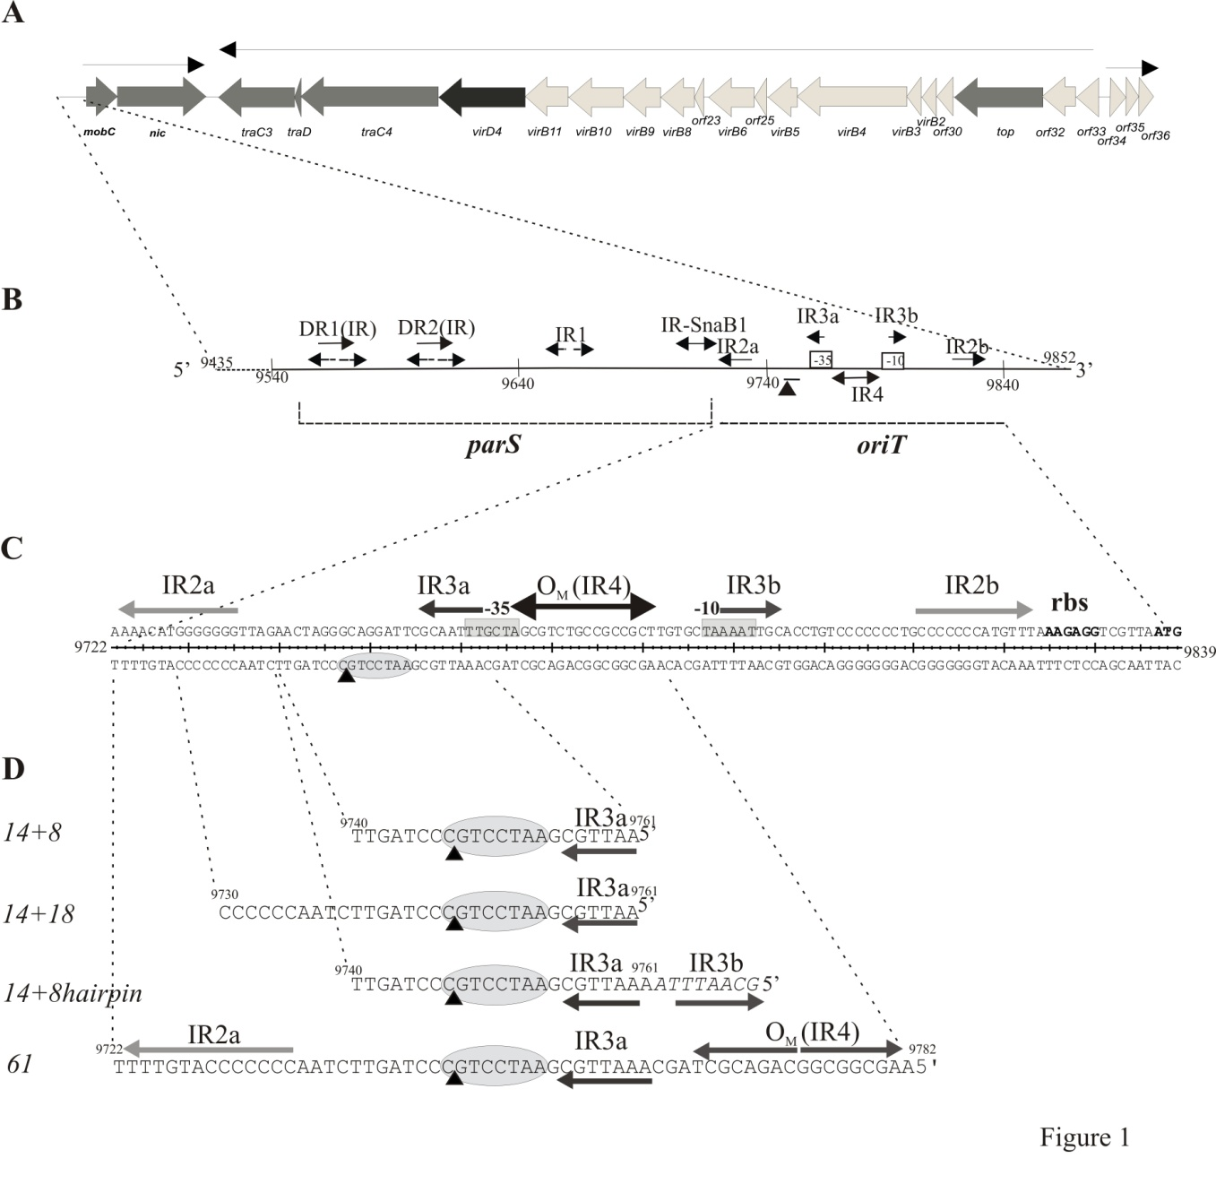
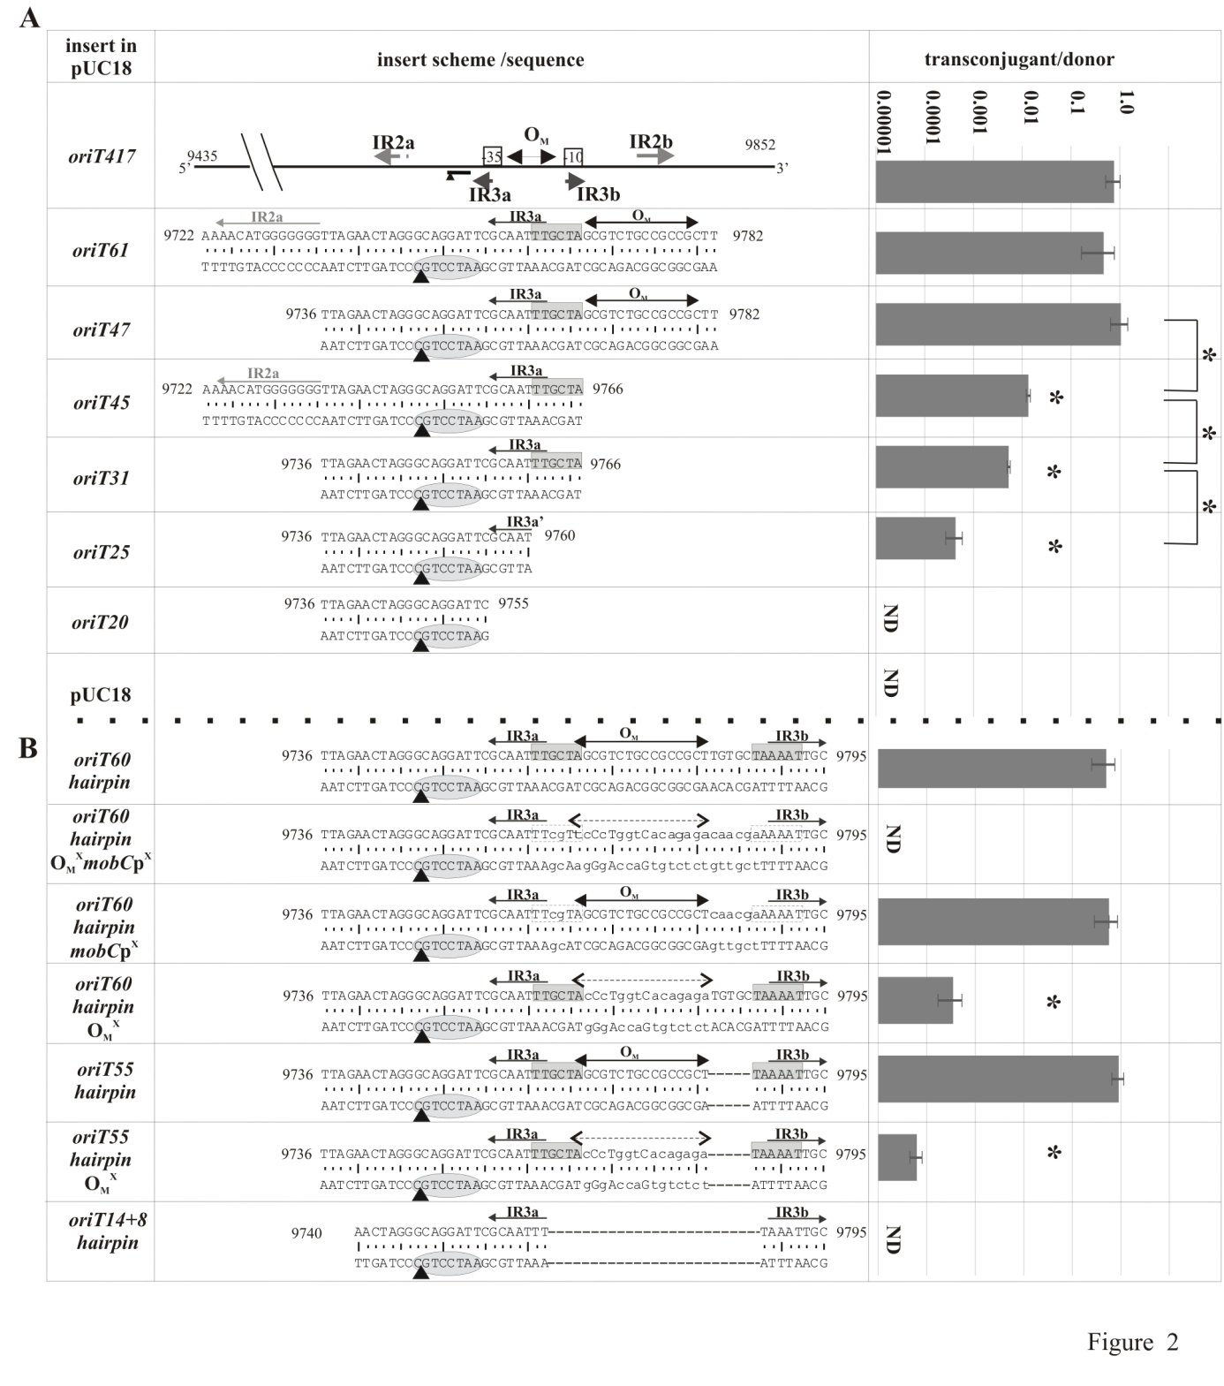

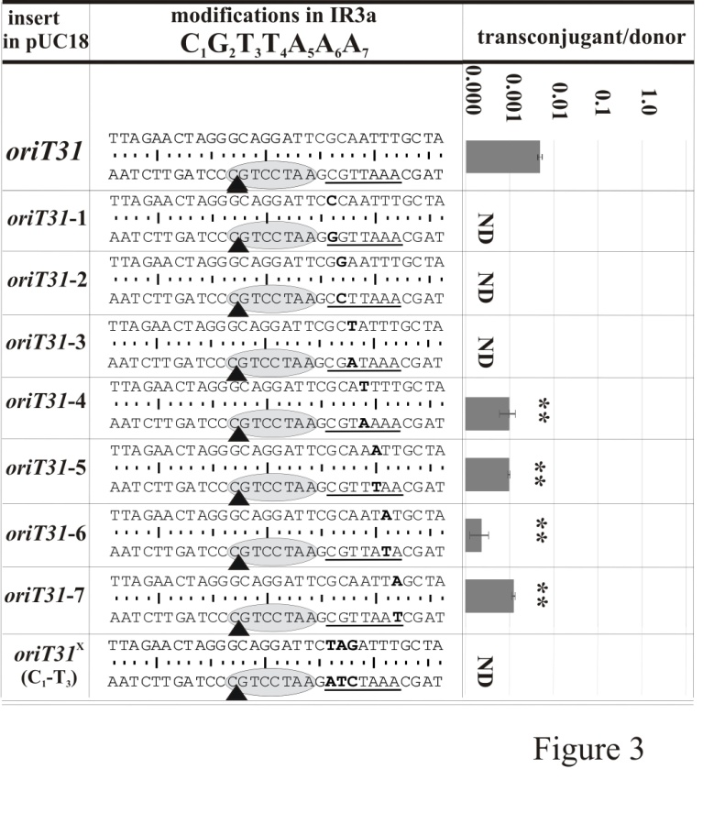

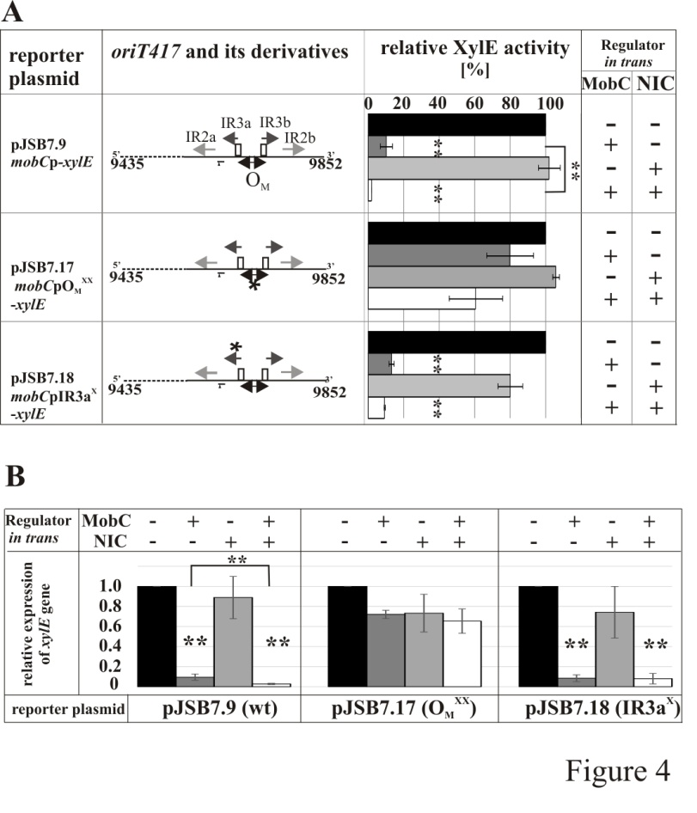

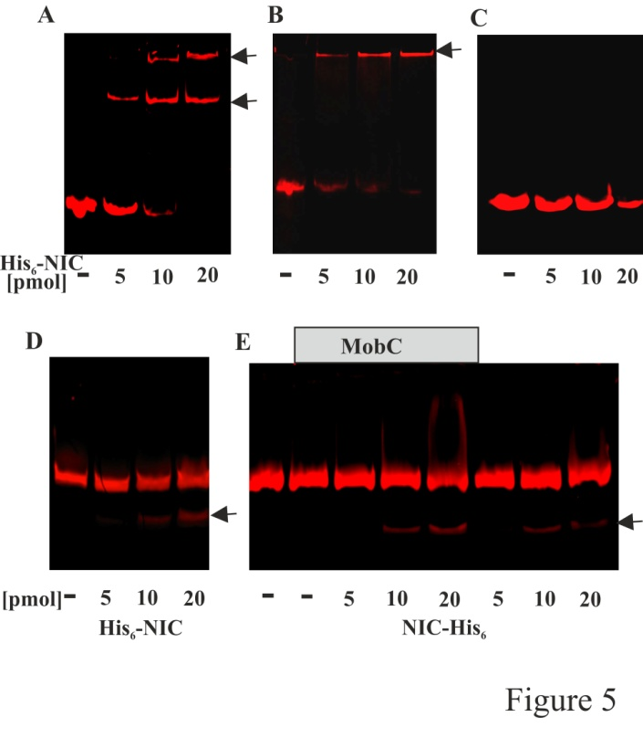

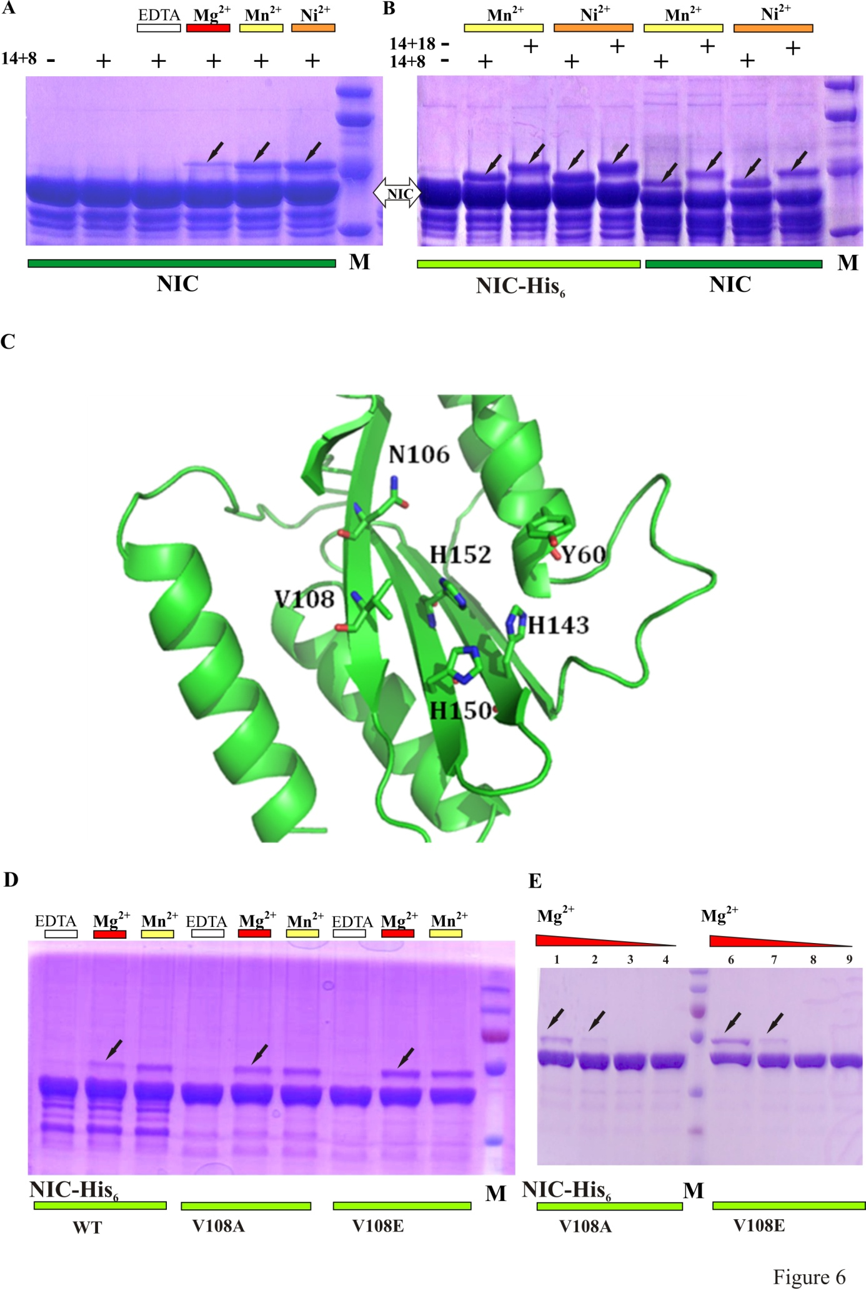
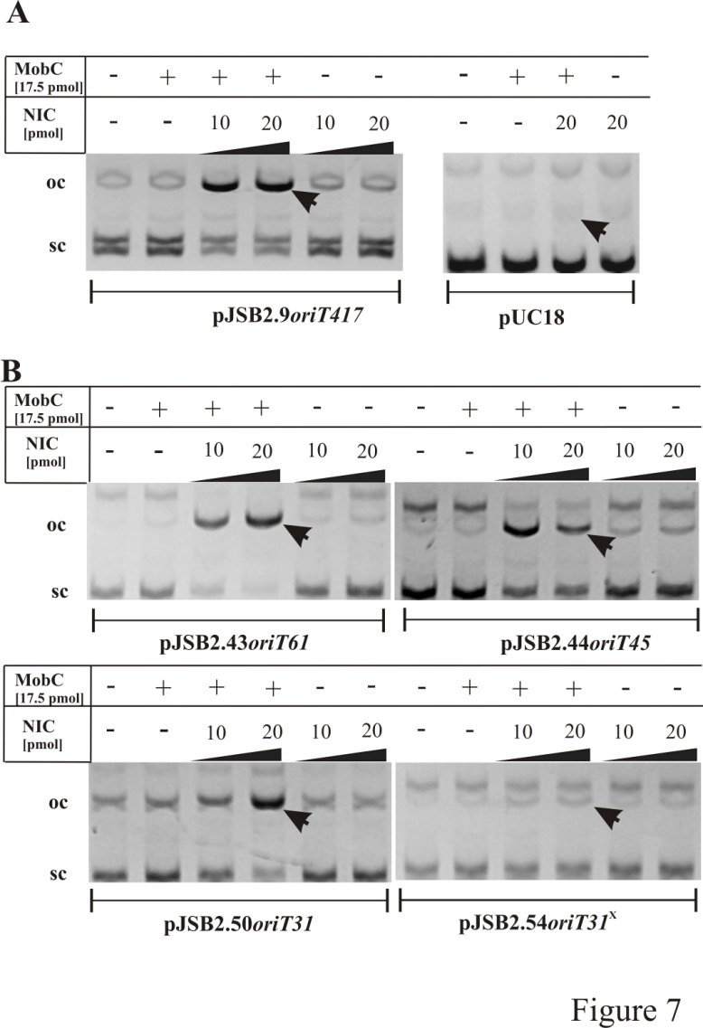

Abbreviated Summary
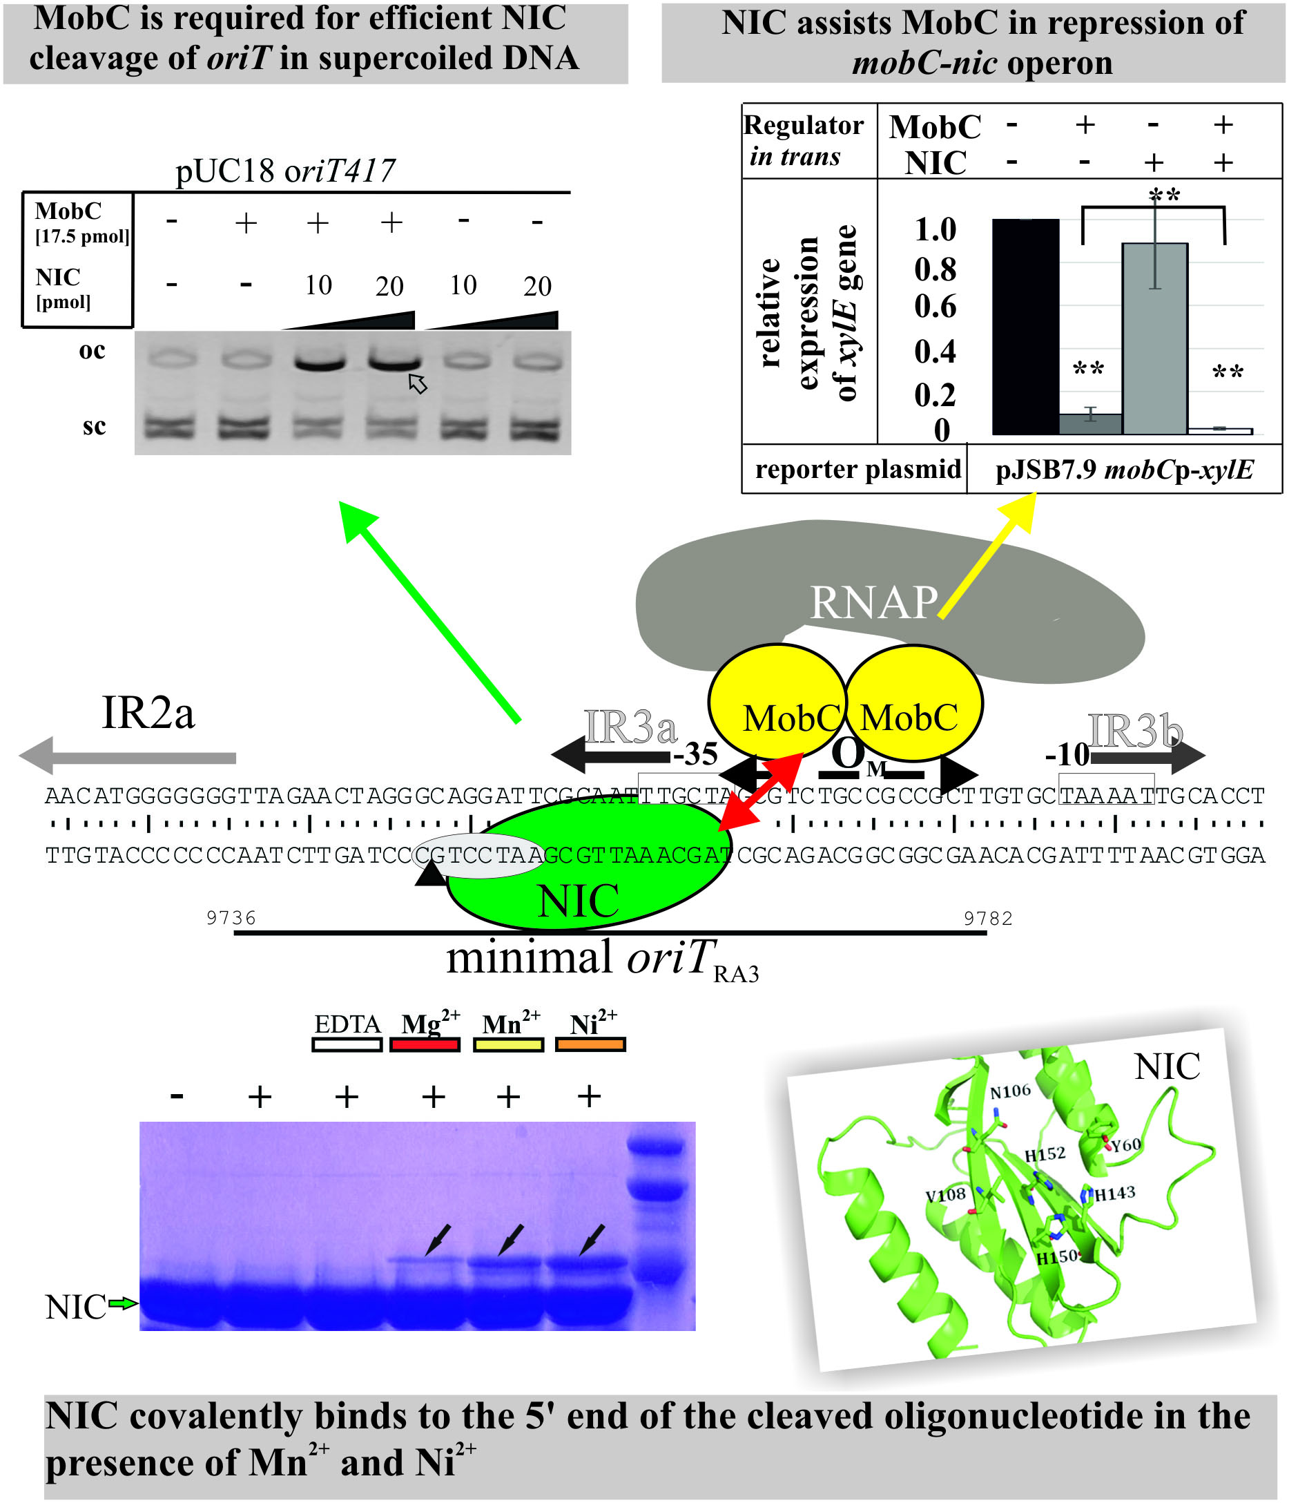
The mobC-nic operon of broad-host-range conjugative RA3 plasmid (IncU incompatibility group) encodes HUH relaxase NIC (MOB_{P4} subgroup) and a transcriptional regulator MobC. Here we delineated minimal oriT_{RA3}, identified the NIC_RA3 binding site and its metal ions preference. The interplay between these two proteins was demonstrated: the MobC participates in the efficient NIC cleavage of supercoiled oriT_{RA3} and NIC_RA3 potentiates the MobC repression of the mobC promoter.

SUPPLEMENTARY INFORMATION

Concerted action of NIC relaxase and auxiliary protein MobC in RA3 plasmid conjugation
Jolanta Godziszewska, Gabriel Moncalián, Matilde Cabezas, Aneta A. Bartosik, Fernando de la Cruz and Grazyna Jagura-Burdzy

List of content:
1. Table S1. Oligonucleotides used in this study
2. Fig. S1. Amino acids sequence alignment of relaxases from MOB_{P4} subfamily.
3. Fig. S2. NIC_RA3 and MobA_R1162 sequence alignment.
4. Fig. S3. Comparison of N-terminal parts of the relaxases NIC_RA3, MobA_R1162, NES_pLW1043 and MobM_pMV158.
5. Supplementary methods

Table S1. Oligonucleotides used in this study
#1 | nic1 | CGGAATTCATGAATAAGGGCTATGACACTCTAGCCGGG
#2 | nic2 | CGGTCGACTTATCTCTCGTCTTCGTCCC
#3 | wt20D | GAATCCTGCCCTAGTTCTAA
#4 | wt20G | TTAGAACTAGGGCAGGATTC
#5 | wt31G | TTAGAACTAGGGCAGGATTCGCAATTTGCTA
#6 | wt31D | TAGCAAATTGCGAATCCTGCCCTAGTTCTAA
#7 | wt25G | TTAGAACTAGGGCAGGATTCGCAAT
#8 | wt25D | ATTGCGAATCCTGCCCTAGTTCTAA
#9 | 31TAGg | TTAGAACTAGGGCAGGATTCtagATTTGCTA
#10 | 31TAGd | TAGCAAATctaGAATCCTGCCCTAGTTCTAA
#11 | oriT61G | AAACATGGGGGGGTTAGAACTAGGGCAGGATTCGCAATTTGCTAGCGTCTGCCGCCGCTTG
#12 | oriT61D | CAAGCGGCGGCAGACGCTAGCAAATTGCGAATCCTGCCCTAGTTCTAACCCCCCCATGTTT
#13 | mut131G | TTAGAACTAGGGCAGGATTCcCAATTTGCTA
#14 | mut131D | TAGCAAATTGgGAATCCTGCCCTAGTTCTAA
#15 | mut231G | TTAGAACTAGGGCAGGATTCGgAATTTGCTA
#16 | mut231D | TAGCAAATTcCGAATCCTGCCCTAGTTCTAA
#17 | mut331G | TTAGAACTAGGGCAGGATTCGCtATTTGCTA
#18 | mut331D | TAGCAAATaGCGAATCCTGCCCTAGTTCTAA
#19 | mut431G | TTAGAACTAGGGCAGGATTCGCAtTTTGCTA
#20 | mut431D | TAGCAAAaTGCGAATCCTGCCCTAGTTCTAA
#21 | mut531G | TTAGAACTAGGGCAGGATTCGCAAaTTGCTA
#22 | mut531D | TAGCAAtTTGCGAATCCTGCCCTAGTTCTAA
#23 | mut631G | TTAGAACTAGGGCAGGATTCGCAATaTGCTA
#24 | mut631D | TAGCAtATTGCGAATCCTGCCCTAGTTCTAA
#25 | mut731G | TTAGAACTAGGGCAGGATTCGCAATTaGCTA
#26 | mut731D | TAGCtAATTGCGAATCCTGCCCTAGTTCTAA
#27 | oriT62G | TTAGAACTAGGGCAGGATTCGCAATTTGCTAGCGTCTGCCGCCGCTTGTGCTAAAATTGC
#28 | oriT62D | GCAATTTTAGCACAAGCGGCGGCAGACGCTAGCAAATTGCGAATCCTGCCCTAGTTCTAA
#29 | 14+8hairpinD | GCAATTTAAAATTGCGAATCCTGCCCTAGTT
#30 | 14+8hairpinG | AACTAGGGCAGGATTCGCAATTTTAAATTGC
#31 | Cy5oriT61D | Cy5-CAAGCGGCGGCAGACGCTAGCAAATTGCGAATCCT  GCCCTAGTTCTAACCCCCCCATGTTT
#32 | Cy5inc230P | Cy5-GATAGCTCTTTGCCATTAAC
#33 | 14+8 | AATTGCGAATCCTGCCCTAGTT
#34 | 14+18 | AATTGCGAATCCTGCCCTAGTTCTAACCCCCC
#35 | xylEG | AACTACCCGGACCACAAACC
#36 | xylED | GCACGGTCATGAATCGTTCG
#37 | rep101qF | CAACCAGAGAGCTGATGAC
#38 | rep101qR | GCTTGAGAACTTGGCATAG
#39 | NicEGSacI | ACCGCTAACCTGGaGCTcTCCATGCCAA
#40 | NicEDSacI | CCTTTGGCATGGAgAGCtCCAGGTTAGC
#41 | NicAGKpnI | ACCGCTAACCTGGcGCTGTCCATGCCAAAGGGtACcGATCCGAAAG
#42 | NicADKpnI | AGCTTTCGGATCgGTaCCCTTTGGCATGGACAGCgCCAGGTTAGCG
#43 | GpBGS | TGTAAAACGACGGCCAGTG
#44 | DpBGS | CACAGGAAACAGCTATGACCA
#45 | pET29G | CCCCTCTAGAAATAATTTTGTTTAACT
#46 | pET29D | CTTTCGGGCTTTGTTAGCAG
#47 | oriT1D | TTAGAACTAGGGCAGGATTCGCAATTTGCTAGCGTCTGCCGCCGCTT
#48 | oriT1G | AAGCGGCGGCAGACGCTAGCAAATTGCGAATCCTGCCCTAGTTCTAA
#49 | oriT2D | TTAGAACTAGGGCAGGATTCGCAATTTcgttccctggtcacagaga caacgaAAAATTGC
#50 | oriT2G | GCAATTTTtcgttgtctctgtgaccagggaacgAAATTGCGAATCCTGCCCTAGTTCTAA
#51 | oriT3D | TTAGAACTAGGGCAGGATTCGCAATTTcgTAGCGTCTGCCGCCGCTcaacgaAAAATTGC
#52 | oriT3G | GCAATTTTtcgttgAGCGGCGGCAGACGCTAcgAAATTGCGAATCCTGCCCTAGTTCTAA
#53 | oriT4G | TTAGAACTAGGGCAGGATTCGCAATTTGCTAGCGTCTGCCGCCGCTTAAAATTGC
#54 | oriT4D | GCAATTTTAAGCGGCGGCAGACGCTAGCAAATTGCGAATCCTGCCCTAGTTCTAA
#55 | oriT60 OM^{X} | TTAGAACTAGGGCAGGATTCGCAATTTGCTAccctggtcacagagaTGTGCTAAAATTGC
#56 | oriT60 OM^{X} | GCAATTTTAGCACAtctctgtgaccagggTAGCAAATTGCGAATCCTGCCCTAGTTCTAA
#57 | oriT55 OM^{X} | TTAGAACTAGGGCAGGATTCGCAATTTGCTAccctggtcacagagaTAAAATTGC
#58 | oriT55 OM^{X} | GCAATTTTAtctctgtgaccagggTAGCAAATTGCGAATCCTGCCCTAGTTCTAA
#59 | kasmob1 | CGGAATTCACATGTTTCTCGTTGGAGGGTGATCA
Restriction enzyme recognition sites are underlined, initiation codon is in bold, lower case letters indicate nucleotide substitutions relative to native sequence. Pairs of complementary oligonucleotides used for cloning into pUC18 are marked by shadowing.
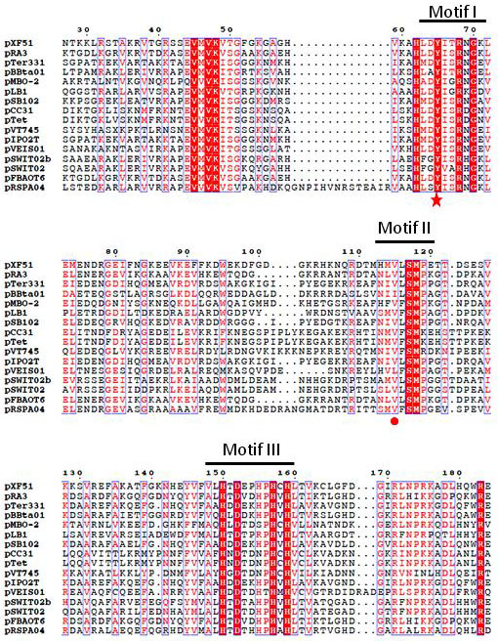
Fig. S1. Amino acids sequence alignment of relaxases from MOB_{P4} subfamily. Identical residues are shown in white on red background, similar residues are shown in red. A red star indicates the conserved catalytic tyrosine, red circle marks the hydrophobic residues in motif II where a polar residue is found in other relaxases. Sequences were plotted with ESPript 2.2.
Fig. S2. NIC_RA3 and MobA_R1162 sequence alignment. Identical residues are shown in white on red background, similar residues in red. Secondary structure elements of the modelled NIC_RA3 protein are shown above the alignment. Sequences were plotted with ESPript 2.2.

Fig. S3. Comparison of N-terminal parts of the relaxases NIC_RA3, MobA_R1162, NES_pLW1043 and MobM_pMV158. Similar residues are shadowed, HUH motifs are labelled in green, residue at position V108 in NIC_RA3 and residues at equivalent positions in other proteins are shown in red. Sequences MobA_R1162 (PDB 2SN6), NES_pLW1043 (PDB 4HT4) and MobM_pMV158 (PDB 4LVM) were aligned with NIC_RA3 by Clustal Omega and verified manually.
Supplementary methods:
1. Purification of His₆-NIC_RA3.
Overnight culture of the E. coli strain BL21(DE3) (pJSB6.3) was diluted 100-fold into 3 l of L broth with kanamycin and grown to A600~0.4 before 0.1 mM IPTG was added for 3 h. Cells were harvested and resuspended in 8 ml of sonication buffer (150 mM NaCl, 50 mM Tris-HCl pH8.0, 10 mM imidazole, 10 mM β-mercaptoethanol, 50 mM Arg, 50 mM Glu, 0.1 mM EDTA, 0.5% Triton X-100, cocktail of protease inhibitors, lysozyme 1 mg ml⁻¹) and incubated on ice for 1 h. After sonication the lysate was cleared by centrifugation at 16600xg for 15 min at 4°C. The supernatant was applied on Äktapurifier system with nickel agarose column (Qiagen) equilibrated with buffer I (150 mM NaCl, 20 mM Tris-HCl pH 8.0, 10 mM imidazole, 10 mM β-mercaptoethanol). His₆-NIC_RA3 was eluted by buffer II (150 mM NaCl, 20 mM Tris-HCl pH 8.0, 600 mM imidazole, 10 mM β-mercaptoethanol). Fractions with His₆-NIC_RA3 were applied on the Resource S (GE Healthcare) - ion exchange chromatography column and eluted by buffer III (10 mM NaPi pH7.5) with increasing concentration of salt (75 mM – 1 M NaCl). Fractions with His₆-NIC_RA3 (eluted at 550 mM NaCl) were concentrated to a volume 0.5 ml on column Vivaspin 2 (Sartorius Stedim Biotech). For the last stage of purification a molecular sieve, Superdex 200 10/300 GL column (GE Healthcare) was used and the protein eluted with buffer IV (10 mM NaPi pH7.5, 550 mM NaCl). The presence of His₆-NIC_RA3 in the fractions was examined by SDS-PAGE, using a PHAST system (Pharmacia) with 12.5% homogenous gel. His₆-NIC_RA3 was stored at 4°C and a concentration of the protein was measured according to standard procedure.
2. Purification of untagged NIC_RA3.
The NIC_RA3 protein was expressed and purified as follows. An overnight culture of E. coli C41(DE3) cells harbouring pET3a:nic plasmid was diluted 20-fold in 1 l of LB medium containing ampicillin (100 μg ml⁻¹) and incubated at 37ºC with shaking until A600 = 0.6. Then, IPTG was added to a final concentration of 0.5 mM. After 3 h further incubation, cells were harvested by centrifugation and stored at -80ºC. Frozen cells were resuspended with a solution containing Tris 100 mM (pH 7.6), NaCl 500 mM, EDTA 1mM, PMSF 1%. The solution was sonicated non-continuously for 10 minutes. The lysate was centrifuged at 40,000g for 15 min at 4ºC. Supernatants were applied to a P11-phosphocellulose column equilibrated in buffer A (50 mM Tris–HCl (pH 7.6), 200 mM NaCl, 0.1 mM EDTA) and eluted at 600 mM NaCl. Fractions containing NIC_RA3 were pooled, diluted to 200 mM NaCl, loaded to a Hi-Trap SPHP (Amersham), and eluted with a linear NaCl gradient (200 mM–1000 mM NaCl) in buffer A. Finally, a gel filtration step was carried out in a Superdex75HR column (Amersham) equilibrated in 100 mM Tris–HCl (pH 7.6), 500 mM NaCl, 0.1 mM EDTA.

3. Purification of NIC_RA3-His_{6,} NIC_RA3V108A-His_{6,} NIC_RA3V108E-His₆
Overproduction of NIC_RA3-His₆ was done as above from E. coli C41(DE3) cells harbouring pET29c:nic plasmid or pET29c:nicV108A plasmid, or pET29c:nicV108E plasmid. After harvesting the cells, the pellet was resuspended in 20 ml of buffer A (50 mM Tris–HCl pH 7.5, 1 M NaCl) containing 0.1 mM PMSF and then sonicated and cleared by centrifugation. Supernatant was loaded onto a 5-ml His-Trap column (GE Healthcare) equilibrated with buffer A. Bound proteins were eluted with a linear gradient of buffer B (50 mM Tris–HCl pH 7.5, 1 M NaCl, 0.5 M imidazole). After His-Trap chromatography, next purification steps were heparin column chromatography and S75 column chromatography as described above for untagged NIC_RA3.

