R468A mutation in perfringolysin O destabilizes toxin structure

and induces membrane fusion

Magdalena Kulma^{a1}, Aleksandra Kacprzyk-Stokowiec^{a1}, Katarzyna Kwiatkowska^{b}, Gabriela Traczyk^{b}, Andrzej Sobota^{b*}, Michał Dadlez^{a,c*}

ª Department of Biophysics, Institute of Biochemistry and Biophysics of the Polish Academy of
Sciences, 5A Pawinskiego St., 02-106 Warsaw, Poland
^{b} Laboratory of Molecular Membrane Biology, Department of Cell Biology, Nencki Institute of Experimental Biology of the Polish Academy of Sciences, 3 Pasteur St., 02-093 Warsaw, Poland
^{c} Institute of Genetics and Biotechnology, Department of Biology, Warsaw University,
1 Miecznikowa St., 02-185 Warsaw, Poland

* Corresponding authors:
Michał Dadlez. Institute of Biochemistry and Biophysics, Department of Biophysics,
5A Pawinskiego St., 02-106 Warsaw, Poland; Tel.: (+48) 22 5923471; fax: (+48) 22 6584766;
E-mail: michald@ibb.waw.pl
Andrzej Sobota. Nencki Institute of Experimental Biology, Department of Cell Biology,
3 Pasteur St., 02-093 Warsaw, Poland; Tel.: (+48) 22 5892463; fax: (+48) 22 8225342;
E-mail: asobota@nencki.gov.pl

Keywords: cholesterol-dependent cytolysin, hydrogen-deuterium exchange, lipid bilayer, liposome aggregation, membrane fusion, toxin

Research highlights:
● R468A mutation in undecapeptide motif destabilizes the PFO structure ● Destabilization of PFO structure induces liposome aggregation and fusion ● Modification of undecapeptide uncovers an additional liposome-binding site in PFO molecule ● Disruption of PFO pore-forming ability reveals alternative mode of PFO action

Abstract
Perfringolysin O (PFO) belongs to the family of cholesterol-dependent cytolysins. Upon binding to a cholesterol-containing membrane, PFO undergoes a series of structural changes that result in the formation of a β-barrel pore and cell lysis. Recognition and binding to cholesterol is mediated by the D4 domain, one of four domains of PFO. The D4 domain contains a conserved tryptophan-rich loop named undecapeptide (E₄₅₈CTGLAWEWWR₄₆₈) in which arginine 468 is essential for retaining allosteric coupling between D4 and other domains during interaction of PFO with the membrane.
In this report we studied the impact of R468A mutation on the whole protein structure using hydrogen-deuterium exchange coupled with mass spectrometry. We found that in aqueous solution, compared to wild type (PFO), PFO^{R468A} showed increased deuterium uptake due to exposure of internal toxin regions to the solvent. This change reflected an overall structural destabilization of PFO^{R468A} in solution. Conversely, upon binding to cholesterol-containing membranes, PFO^{R468A} revealed a profound decrease of hydrogen-deuterium exchange when compared to PFO. This block of deuterium uptake resulted from PFO^{R468A}-induced aggregation and fusion of liposomes, as found by dynamic light scattering, microscopic observations and FRET measurements. In the result of liposome aggregation and fusion, the entire PFO^{R468A} molecule became shielded from aqueous solution and thereby was protected against proteolytic digestion and deuteration. We have established that structural changes induced by the R468A mutation lead to exposure of an additional cholesterol-independent liposome-binding site in PFO that confers its fusogenic property, altering the mode of the toxin action.

- Introduction
Perfringolysin O (PFO) is a pore-forming toxin produced and secreted by the Gram-positive bacterium, Clostridium perfringens, involved in the pathogenesis of gas gangrene [1]. PFO belongs to a group of cholesterol-dependent cytolysins (CDCs) synthesized by many species of bacteria from the genera Clostridium, Streptococcus, Listeria, Bacillus, and Arcanobacterium [2-6]. The common feature of this group of toxins is that they specifically interact with cholesterol-containing membranes. This interaction induces structural changes in the toxin, leading to protein oligomerization, incorporation of protein assemblies into the lipid bilayer, and formation of lytic pores [7-9]. Due to its specificity for binding cholesterol, PFO is successfully used in cell biology studies as a unique probe that recognizes cholesterol in mammalian cells [10, 11].
The crystallographic structure of PFO in solution revealed that the protein is composed of four distinct domains: D1, D2, D3, and D4 [12]. Upon transition from the water-soluble state to a transmembrane pore, each of these domains undergoes a cascade of profound, but well-orchestrated, conformational changes. This process requires several steps, including recognition and binding to cholesterol, oligomerization on the membrane surface during pre-pore formation, and embedding of defined PFO regions into the bilayer to form a transmembrane β-barrel pore, which causes cell lysis [9, 13].
The ability of PFO to recognize and bind to cholesterol-containing membranes is mediated by the D4 domain [14, 15]. Crystallographic studies of the soluble form of PFO revealed that the D4 domain contains nine β-strands; of these, eight are arranged into a compact sandwich composed of two four-stranded β-sheets. At the distal tip of this domain, several functional loops are exposed, including three short loops: L1 (488-493), L2 (398-406), and L3 (434-438) and one longer tryptophan-rich loop, known as the undecapeptide (UDP) which encompasses amino acid residues 458-468 [12, 14]. Loop 1 contains two amino acid residues, Thr 490 and Leu 491, which form part of the cholesterol recognition/binding motif (CRM). These residues are crucial for both cholesterol recognition and initial binding of PFO to the membrane. Any modification of Thr 490 or Leu 491 was shown to cause a detrimental effect on PFO binding to both cell and model membranes [16]. Loops L2, L3, and UDP form a membrane-binding interface that stably anchors the toxin to the membrane surface upon interaction of the CRM with cholesterol [17, 18]. Loop L3 is localized on the far edge of D4, separate from the pocket created by the L1, L2, and UDP loops [12]. Loop L3 plays a minor role in cholesterol recognition, and its effect on binding may be related to nonspecific interactions with the membrane [19, 20]. Mutations in each of these four loops changed the ability of PFO to bind to cholesterol-containing membranes, which indicated that PFO binding required cooperation between all four loops; L1, L2, L3, and UDP [20-23]. Additionally, Shimada and colleagues revealed that, in addition to the loops in D4, two C-terminal β-strands, arranged in antiparallel orientation (452-459 and 465-472) that flanked the UDP, played an important role in cholesterol recognition and binding. These β-strands were also crucial for stabilizing the appropriate PFO structure [24]. Truncation of three amino acids at the C-terminus of PFO disturbed membrane binding, inhibited PFO lytic activity, and prevented denatured PFO from refolding into its native conformation [24].
UDP merits special attention, because this sequence is highly conserved in all CDCs. This region in PFO is composed of 11 amino acids (E₄₅₈CTGLAWEWWR₄₆₈) and contains three out of the six D4 tryptophan residues. These Trp residues are crucial for insertion of PFO into cholesterol-containing membranes and for oligomerization and pore formation by the toxin [25]. Moreover, further research demonstrated that a substitution of arginine 468 to alanine in UDP (PFO^{R468A}) abolished PFO oligomer formation and lytic activity, due to a disruption in the allosteric coupling between the D4 and D3 domains [26]. Based on those results, it was concluded that D4 was structurally coupled to other PFO domains, even though the contact surface between D4 and other domains was small when PFO was in solution.
Studies of pore formation process often involve point mutants that derange the process at different stages. Mechanistic interpretation of the obtained results requires knowledge of their structural properties which is sometimes missing. Due to the fact that R468A mutation abolished PFO oligomerization but preserved cholesterol binding [26], PFO^{R468A} could be served as a model of PFO status after binding to the membrane but preceding next steps in transition to pores [22]. The model is valid under the assumption that the mutation affects only the cholesterol binding faculties of the protein while other properties, like protein structure, remain unchanged. Structural dynamics of PFO can be measured by detecting the kinetics of the exchange between the backbone amide hydrogens and deuterium in solution. This exchange can be quantified with mass spectrometry (HDX-MS). This method provides useful information about the dynamics of structural elements of proteins; it has high reproducibility and precision [27, 28]. Motivated by these considerations we have undertaken the structural studies of R468A PFO variant as well as a series of other variants - W165T [27] and F318A, Y181A [unpublished].
In the present study, we characterized the impact of the R468A mutation on the protein structure and its effect on the interaction of PFO with lipid membranes.
Our results demonstrate that the R468A mutation led to profound led to profound changes in the structural dynamics of the PFO molecule and in the result new cholesterol-independent binding site was exposed altering the mode of interaction of the toxin with lipid membranes.
- Material and methods
  - Plasmid construction
A synthetic PFO gene was prepared with single point mutation in which Cys-459 had been changed to an alanine, and cloned into an expression vector (pGEX-4T3) as described previously [8, 27]. The functional cysteine-less derivative of wild type PFO used in the experiments described below is PFO^{C459A} and here is named as PFO. Tag-less PFO derivatives were obtained by introducing the 5’GAAAACCTGTATTTTCAGGGC3’ sequence, which encoded the ENLYFQG motif recognized by Tobacco Etch Virus (TEV) protease. This sequence was placed between the GST and PFO sequences [10, 27, 44]. The mutant protein, GST-PFO^{R468A}, was generated with site-directed mutagenesis and a pair of primers: 5’ GCC TGG GAA TGG TGG GCG GAT GTC ATC TCA GAA TAT G 3', 5’ CAT ATT CTG AGA TGA CAT CCG CCC ACC ATT CCC AGG C 3’PFO and PFO^{R468A} were overexpressed in E. coli, strain BL21(DE3), and purified as described previously [27]. Briefly, the cells from the IPTG-induced culture were lysed in the presence of 0.35 mg/ml lysozyme and protease inhibitor cocktail (10 min, 4 °C). The suspension was supplemented with 1% Triton X-100 and sonicated on ice (15 min, 0.3 cycle, amplitude 33%). Obtained lysates were clarified by centrifugation at 18000 x g for 30 min, at 4 °C and loaded onto Glutathione-Sepharose 4B column (GE Healthcare). The beads were then thoroughly washed in phosphate buffer pH 7.4 containing 100 mM NaCl, 1 mM DTT and 1 % Triton X-100. GST-tagged proteins were eluted from Glutathione-Sepharose 4B column with 10 mM glutathione, 5 mM DTT, 50 mM Tris, pH 8.0. For purification of untagged PFO and PFO^{R468A}, GST-tagged proteins bound to Glutathione-Sepharose 4B column were cleaved in the presence of 50 μg of TEV protease for 3 h at 30 °C in 50 mM Tris pH 8.0 buffer supplemented with 1 mM DTT. Proteins released from the column were collected and loaded onto a column with HisLink Protein Purification Resin (Promega) to remove TEV protease. PFO and PFO^{R468A} recovered from the column were loaded onto PD-10 desalting column for buffer exchange into 100 mM NaCl, 1 mM DTT, 50 mM Tris, pH 7.4. Fractions containing recombinant proteins were pooled and the buffer was exchanged to buffer containing 50 mM Tris, 100 mM NaCl, and 1 mM DTT, pH 7.4, using PD-10 desalting column (GE Healthcare). Purified protein samples were stored in 20% sucrose at -80 °C.
  - Surface plasmon resonance measurements
We performed surface plasmon resonance (SPR) with a BIAcore 3000 apparatus (BIAcore, GE Healthcare) and L1 chip to analyze the interaction between PFO proteins and large unilamellar vesicles (LUVs). LUVs (100 nm in diameter) containing cholesterol:DOPC or sphingomyelin (SM):DOPC (1:1 molar ratio, 2 mM total concentration) were prepared by extrusion of multilamellar lipid vesicles through polycarbonate filters with 100 nm pores, and attached to the chip, as described earlier [27, 29]. To calculate equilibrium binding constants, different concentration PFO or PFO^{R468A} (in range 0.1-2 µM) was applied at a flow rate of 5 μl/min for 300 s (association phase). Unbound proteins were washed from the L1 chip surface by adding the running buffer (150 mM NaCl, 30 mM Tris-HCl, pH 8.0) for another 300 s (dissociation phase) at a flow rate of 5 μl/min. Equilibrium binding constants were calculated with BIAevaluation software (GE Healthcare) and fitted with a 1:1 Langmuir-type binding model to determine association (k_{a}) and dissociation (k_{d}) rate constants.
In another series of experiments, LUVs (cholesterol:DOPC, 1:1 molar ratio) were attached to the surface of L1 sensor chip for 600 s and washed for 300 s (binding efficiency reached about 8500 resonance units [RU]). Then, the chip was incubated with PFO (for 600 s) or with PFO^{R468A} (for 900 s) and washed again for 300 s. At this stage RU value reached about 9000 RU. After that, the L1 sensor chip was exposed to a second pool of liposomes composed of cholesterol:DOPC or SM:DOPC (2 mM) for 600 s and finally washed with running buffer for 600 s.
  - Susceptibility of toxins to proteolysis
SUVs composed of cholesterol:DOPC (molar ratio 1:1, 2 mM total lipid concentration) were resuspended in buffer containing 30 mM Tris, 150 mM NaCl, pH 7.5 and were incubated with 1 μM PFO or 2 µM PFO^{R468A} at 25 °C for 30 min. The concentration of PFO^{R468A} was twice that of PFO to compensate for the weaker binding of PFO^{R468A} because our preliminary data showed that in these conditions more less equal amounts of both proteins bind to liposomes. After centrifugation (10 000 ×g, 20 min), pellets were resuspended in TBS buffer or TBS supplemented with 0.05% Triton X-100, and incubated at 25 °C for 5 min. Then, the samples were adjusted to pH 2.4, and 50 µl of this solution was added to 50 µl of immobilized pepsin-agarose beads (Thermo Scientific) and incubated for 3 min at 4 °C. Finally, the samples were centrifuged (1 000 ×g for 1 min) to pellet the pepsin-agarose beads. Supernatants were collected, neutralized by the addition of 1/10 volume of 2 M Tris pH 8.0. Subsequently, the samples were supplemented with SDS sample buffer and analyzed by SDS-PAGE.

  - Isolation of liposomes on sucrose cushion
SUVs (cholesterol:DOPC, molar ratio 1:1) were isolated on a sucrose cushion, according to a procedure for isolating crude plasma membrane fractions [30], with some modifications. Briefly, SUVs were incubated with 1 μM PFO or 2 μM PFO^{R468A} in PBS buffer at room temperature for 45 min. Pelleted liposomes were suspended in 800 μl of buffer containing 30 mM Tris, 150 mM NaCl, pH 7.5, overlaid on a 400 μl cushion of 50% sucrose in TBS, and centrifuged (45 000 ×g) for 45 min. The fraction remaining above the sucrose cushion contained unbound protein. The fraction of protein bound to liposomes was located in the upper, opalescent layer of sucrose. Protein aggregates were sedimented and localized on the bottom of the tube. Fractions were collected and analyzed with SDS-PAGE.
  - Dynamic light scattering
Liposome aggregation in the presence of PFO or PFO^{R468A} was determined at 23 °C with a DynaPro NanoStar Dynamic Light Scattering instrument (Wyatt Technology Corporation), equipped with a 30 mW He-Ne laser source (658 nm). The photodiode detector was set at an angle of 90 °. For these experiments, LUVs composed of cholesterol:DOPC or SM:DOPC (2 mM total lipid concentration, molar ratio 1:1) were prepared according to the method described for SPR with the exception that the liposomes were passed through an extruder equipped with membrane pores of 50 nm. Such small LUVs facilitated observations of their enlargement by dynamic light scattering (DLS) during subsequent incubation with protein. Liposomes were diluted to 20 µM with PBS and treated with 10 nM PFO or PFO^{R468A} (protein: cholesterol ratio 1:1000) in PBS for 45 min at 23 °C. Measurements were performed every 10 s during the incubation.
  - Liposome turbidity
Suspension of SUVs (cholesterol:DOPC, molar ratio 1:1, 2 mM lipid concentration) in 30 mM Tris-HCl, 150 mM NaCl, pH 7.5 was supplemented with 1 µM PFO or 2 µM PFO^{R468A} (protein:cholesterol ratio 1:1000 or 1:500, respectively). Turbidity of liposomes was measured in disposable UV-compatible plastic cuvettes at different time points in terms of absorbance at 500 nm on a Spectrocuant Pharo 300 Spectrophotometer (Merck, Darmstadt, Germany).
  - Microscopic observations
Suspension of LUVs (cholesterol:DOPC, molar ratio 1:1, 2 mM lipid concentration) were incubated with 1 μM PFO or PFO^{R468A} at room temperature for up to 30 min. Five μl of the liposome-protein mixture was spotted onto a glass slide, and samples were examined under a Nikon microscope, equipped with a DXM 1200C digital camera.
For electron microscopy, the LUVs/protein suspension was transferred onto carbon-coated grids. Samples were negatively stained with 2% uranyl acetate, and investigated with a JEM-1200EX (JEOL) microscope.
  - Fluorescence resonance energy transfer (FRET) assay
A fluorescence resonance energy transfer (FRET) assay was applied to measure the efficiency of membrane fusion between fluorescent-labeled and unlabeled liposomes [31]. SUVs used for these studies contained cholesterol:DOPC (1:1 molar ratio, 2 mM total lipid concentration) without or with the mixture of 0.1 mM each of Rho-DPPE and NBD-DPPE. Labeled and unlabeled SUVs were suspended at 1:1 (v:v) ratio in a buffer containing 150 mM NaCl, 30 mM Tris-HCl, pH 8.0. The FRET value of this liposome mixture was measured at excitation wavelength of 460 nm and emission spectra between 500 and 630 nm at 1 nm/s on JASCO FP 6500 spectrofluorimeter. Subsequently, the liposome mixture was supplemented with 1 µM PFO or PFO^{R468A} and FRET measurements were conducted for 90 min.
The calculation of the lipid mixing yield was carried out by the following equation:

I₅₂₀^{PFO} _ I₅₂₀⁰
I₅₈₈^{PFO} I₅₈₈⁰
Lipid mixing [%]= x 100 %
I₅₂₀^{triton}_ I₅₂₀⁰
I₅₈₈^{triton} I₅₈₈⁰

The calculation comprises both the donor (I₅₂₀) and acceptor (I₅₈₈) fluorescence intensity. The intensities in absence of PFO proteins were indexed “0“. Maximal value of lipid mixing (I^{triton}) was characterized by high dilution of the fluorescence probes after addition of 0.1 % Triton X-100 and liposome lysis.

Hydrogen-deuterium exchange experiments
HDX experiments were conducted as described previously [27]. Briefly, samples were prepared by incubating 2 mM SUVs (cholesterol:DOPC, molar ratio 1:1) with 1 µM PFO or PFO^{R468A} in PBS buffer at room temperature for 45 min. Next, samples were centrifuged and washed to eliminate unbound proteins. Subsequently, the samples were solubilized in a buffer composed of 30 mM Tris, 150 mM NaCl, pH 7.5, and subjected to the HDX-MS procedure.
Hydrogen-deuterium exchange measurements were started by creating a list of PFO and PFO^{R468A} peptic peptides, based on non-deuterated protein samples. In the next step of the analysis, the samples were diluted into and incubated in the D₂O-based reaction buffer for the required period of time (10 s, 20 min, or 24 h). Then, the hydrogen-deuterium exchange reaction was quenched by addition of pre-chilled D₂O-based stop buffer (2 M glycine, 150 mM NaCl, pH 2.5). Subsequently, the samples were supplemented with Triton X-100 to the final concentration 0.2%, which caused the release of deuterated proteins from liposomes. Next, the sample was injected onto an immobilized pepsin column (Poroszyme; ABI), and it was further separated with the nanoACQUITY ultra-performance liquid chromatography (UPLC) system preceding mass measurements on the SYNAPT G2 HDMS mass spectrometer (Waters, Milford, MA). Peptide identification and HDX data analysis were performed with ProteinLynx Global Server software and the DynamX 2.0 program (Waters, Milford, MA), respectively. The experiments were repeated at least three times. All controls were also performed, including a back-exchange control and a carry-over effect control. Inconclusive and overlapping isotopic envelopes were manually verified and excluded from the final dataset.
Student’s t test for two independent samples with unequal variances and sample sizes was carried out to evaluate differences between the same peptides in two different states (bound to liposomes [PFO_{lipo}] or unbound [PFO_{aq}] form) or from two different protein constructs (PFO and PFO^{R468A}).

- Results
  - PFO^{R468A} binding to cholesterol-containing membranes and its lytic activity
The binding of PFO to cholesterol in the lipid bilayer is the first step in the formation of toxic transmembrane pores. SPR analysis showed that introducing a single point mutation, R468A, into the D4 domain significantly reduced the ability of the protein to bind to cholesterol-containing liposomes (Fig. 1). These studies were performed with liposomes composed of cholesterol:DOPC (molar ratio 1:1) and with a cholesterol:protein ratio in the range from 500:1 to 10000:1.
Analysis of association and dissociation curves indicated that PFO^{R468A} bound to cholesterol:DOPC liposomes significantly weaker than PFO. After 300 s of dissociation, the 2 µM PFO^{R468A} reached about 490 RU, compared to the PFO, which reached about 3670 RU (Fig. 1). The equilibrium dissociation constant (K_{D}) calculated for PFO was 8.58 ×10⁻¹² M, which was 57-fold lower than the K_{D} for PFO^{R468A} (Fig. 1, table).
To estimate the effect of the R468A mutation on PFO lytic activity, we measured carboxyfluorescein release from liposomes composed of cholesterol:DOPC (molar ratio 1:1) . The R468A mutation abolished the lytic activity of PFO at low protein concentrations (0.01-0.1 μM). However, at high PFO^{R468A} concentrations, lytic activity was apparent, and at 4 µM, the mutant protein induced 50% of the maximal carboxyfluorescein release (supplementary Fig. 1). In contrast, PFO reached similar lytic efficiency already at 0.1 µM, and at 2 µM, its lytic activity approached maximum, comparable to lysis with Triton X-100 (supplementary Fig. 1).
  - Structural changes in PFO^{R468A} in aqueous solution
We applied HDX-MS technique that provides information regarding the accessibility of amide protons for deuterium uptake in different regions of a protein. Differences in the exchange kinetics of amide protons allow to distinguish highly structured from unstructured (flexible) regions in a protein.
Figure 2A and B show the results of HDX-MS experiments with PFO and PFO^{R468A} in aqueous solution (PFO_{aq} and PFO_{aq}^{R468A}), after 10 s and 20 min of the hydrogen-deuterium exchange reaction. In Fig. 2 the deuteration pattern of PFO (reproduced from a previous study [27]), was used as a control. The deuteration levels of PFO_{aq} and PFO_{aq}^{R468A} at 10 s and 20 min of exchange are shown schematically, based on the crystallographic structure of PFO (Fig. 2C, D). Data collected after 10 s of incubations highlighted the deuteration process in flexible regions of the protein; longer incubations (20 min) provided insight into protein regions with more stable structures. Compared to PFO, PFO^{R468A} showed higher levels of exchange after 10 s of incubation, and exchange levels below 30% were only observed in a few peptide sequences (Fig. 2A). The regions of PFO_{aq}^{R468A} most susceptible to exchange (deuteration above 80%) included the following amino acid regions: 54-75 (in D2), 132-142 (in D1), and 295-314 (transmembrane helix-2 [TMH2] in D3). The pattern of exchange after 20 min of HDX reaction also revealed increased exchange rates in the mutant PFO_{aq}^{R468A} compared to the PFO_{aq}, and the majority of peptides showed deuterium uptakes above 50% (Fig. 2B). The few exceptional peptides in PFO^{R468A} with exchange rates below 50% spanned amino acid regions 187-195 (N-terminal part of TMH1), 389-409 (loop L2 in D4), and 467-472 (C-terminal part of UDP). The differences in exchange between corresponding peptides in PFO_{aq} and PFO_{aq}^{R468A}, which reflected dissimilarities in structural stability, were best analyzed in subtraction plots (Fig. 3A and B, table S1). Analysis of these plots showed that the majority of regions altered in PFO^{R468A} compared to PFO reflected an overall destabilization of the toxin structure in solution. The most pronounced differences in deuterium uptake between PFO_{aq}^{R468A} and PFO_{aq}, after 10 s of exchange, were observed in two peptides located in D1 (positions 123-131 and 352-365) (Fig. 3A). After 20 min of exchange reaction, an additional peptide in D4 (position 410-416) showed a large difference in the fraction of hydrogen-deuterium exchange between PFO_{aq}^{R468A} and PFO_{aq} (Fig. 3B). A comparison of the HDX patterns in both proteins revealed that only a few regions were more stable in PFO_{aq}^{R468A} than in PFO_{aq}, located at positions: 110-121 (D1), 212-224 (C-terminal part of TMH1 and N-terminal part of β2), 315-351 (β4, β5, and a linker between them), 367-384 (on the border of D1 and D2), and 474-496 (a linker between UDP and loop L1) (Fig. 3A, B). The subtraction plots showed that a single site mutation in the distal end of D4 led to global destabilization of the PFO^{R468A} structure. These major differences in the percentages of deuteration between PFO and PFO^{R468A} are shown schematically, based on the crystallographic structures of PFO after 10 s and 20 min incubations (Fig. 3C and D, respectively). In further studies, far UV CD analysis showed that PFO^{R468A} exhibited a similar secondary structure profile as PFO, indicating that a large difference in deuterium uptake did not result from the global changes in protein structure (supplementary Fig. 2). To analyze the effect of R468A mutation on the global structural changes in PFO the intrinsic tryptophan fluorescence was measured. In solution, the fluorescence spectrum of PFO displayed a λ_{max} of 331 nm, which indicated that tryptophan residues were buried inside the protein structure (supplementary Fig. 3). In contrast, the fluorescence intensity of PFO^{R468A} displayed a red shift of 9 nm reaching λ_{max} of 340 mn (supplementary Fig. 3), which indicated that the tryptophan residues of the PFO mutant were in a different, more hydrophilic environment. Most likely, a hydrophobic pocket which efficiently shielded tryptophan residues from the solvent in PFO was destroyed in the PFO mutant. These data indicate that although R468A mutation does not change significantly the secondary structure of protein, however the changes in structural dynamics of protein revealed by the HDX are enough to affect the tryptophan environment in the molecule.
  - Structural features of PFO^{R468A} in liposomes
Next, the hydrogen-deuterium exchange in PFO^{R468A} was measured in a lipid environment (PFO_{lipo}^{R468A}). We found that, in contrast to the aqueous solution, PFO^{R468A} interacting with cholesterol-containing liposomes revealed a general, substantial, nearly uniform reduction of deuterium uptake (Fig. 4, table S2).
After 10 s of incubation, only eight peptides in PFO_{lipo}^{R468A} showed increased deuterium uptake compared to PFO_{aq}^{R468A}; thus, the vast majority of PFO_{lipo}^{R468A} became strongly protected (Fig. 4A). The impact of the R468A mutation on exchange in PFO_{lipo}^{R468A} was more prominent after 20-min incubations (Fig. 4B); a significant loss of protection was observed in only two peptides (a fragment of TMH1 and a short region of L2) in PFO_{lipo}^{R468A} (Fig. 4B).
Also, in a lipid environment, the amide protons in many regions were more protected in PFO_{lipo}^{R468A} than in PFO_{lipo} (Fig. 5A, B), particularly those in regions that were freely exchangeable in PFO_{lipo}. A detailed analysis of the HDX pattern of PFO_{lipo}^{R468A} after 10 s of incubation showed that only two peptides had deuteration levels above 40%; one was at position: 63-74 (D2 domain) and the other was at 187-195 (N-terminal part of TMH1 in D3) (Fig. 5A). Even after 20 min of incubation, the majority of peptides displayed exchange levels under 40%; indeed, the level of protection was largely uniform across the entire sequence, and the overall exchange level did not significantly increase at 20 min compared to that at 10 s. Only two peptides showed slight increases in the exchange level after 20 min; one was at 62-74 (in D2 domain) and the other was at 187-195 (N-terminal part of TMH1 in D3) (Fig. 5B). In general, all protein regions become trapped in a highly protected state, where they could not increase their deuterium uptake. This suggested that almost whole PFO_{lipo}^{R468A} molecule became uniformly protected in the lipid environment. In contrast, after incorporation into liposomes, PFO maintained more differentiated, intertwined pattern of deuteration along the whole molecule compared to PFO_{lipo}^{R468A} (Fig. 5A, B: compare black and cyan bars). The HDX data is shown schematically, based on the monomeric crystallographic structure of PFO. In Fig. 5C, D the low deuterium uptake represents the protection that occurred across nearly the entire PFO^{R468A} molecule, when it was incorporated into the lipid membrane, both at 10 s (Fig. 5C) and at 20 min (Fig. 5D).
Taken together these results suggested that in the presence of liposomes PFO^{R468A} might induce formation of alternative protein-lipid structures, which prevented the general access of solvent to the protein.
  - The arginine 468 to alanine substitution changed the mode of PFO-liposome interaction
Previous studies demonstrated that, in aqueous solution, PFO at high concentration (ca. 12 µM) exists as a dimer [27, 32]. Destabilization of PFO^{R468A} structure in solution (Fig. 2A-D) suggested that the introduction of the R468A mutation might have altered the pre-oligomerization state of PFO in solution, which eventually disturbed its interaction with cholesterol-containing liposomes. To verify this possibility, we performed size exclusion chromatography. Both PFO and PFO^{R468A} eluted from the gel-filtration column with the same retention volume, indicating that both proteins had a mass of 100 kDa, which corresponded to the expected dimeric form; no monomers or oligomers/aggregates were observed (supplementary Fig. 3).
Although no PFO^{R468A} aggregation was detected in solution, we wondered whether the protein might aggregate upon interaction with cholesterol-containing liposomes. Liposomes incubated with PFO^{R468A} or PFO were subjected to ultracentrifugation on a sucrose cushion to separate liposome-bound proteins from pelleted protein aggregates. SDS-PAGE analysis confirmed SPR data that the R468A mutation reduced the binding of PFO to liposomes, nevertheless no aggregates of PFO^{R468A} were found in these conditions (Fig. 6A). PFO exhibited a greater tendency to form aggregates than PFO^{R468A} (Fig. 6A). These results indicated that the strong protection of PFO^{R468A} peptides against hydrogen-deuterium exchange in the presence of liposomes was not the result of protein self-aggregation.
Therefore, we hypothesized that the low exchange levels observed with PFO_{lipo}^{R468A} might be due to protein masking through protein-induced lipid aggregation. To test this hypothesis, we studied the effect of the R468A mutation on the susceptibility of PFO to pepsin digestion in the presence of liposomes. In this experiment addition of 0.05% Triton X-100 to parallel samples allowed to disperse lipid membranes that might protect PFO molecules from proteolysis. When PFO was bound to cholesterol-containing vesicles, it was sensitive to pepsin digestion, independent of the presence of Triton X-100 (Fig. 6B). This result suggested that the major part of the PFO molecule was localized on the surface of the lipid membrane. In contrast, the majority of PFO^{R468A} was sensitive to pepsin digestion only in the presence of Triton X-100. This finding indicated that the R468A mutation caused PFO to become buried in lipid environment.
  - R468A mutation in PFO induces membrane fusion
The data presented above indicated that PFO^{R468A}, when bound to cholesterol-containing liposomes, was no longer exposed to bulk solvent. This finding suggested that the protein might affect organization of surrounding liposomes which in turn bury the protein. Changes in liposome organization induced by PFO can be detected by measuring changes in the turbidity of a liposome suspension. As shown in Fig. 7A, incubation of PFO^{R468A} with a liposomes (cholesterol:DOPC, molar ratio 1:1) induced a time-dependent increase in liposome turbidity, which suggested an increase in liposome size. Incubating the same liposomes with PFO induced only a transient increase in turbidity, which suggested that PFO induced short-term liposome aggregation, followed by a gradual leakage of liposomes due to pore formation.
To investigate the size of liposomes formed in the presence of mutant PFO, the DLS technique was applied. In the absence of proteins, unilamellar lipid vesicles composed of cholesterol:DOPC (molar ratio 1:1) exhibited, on average, a particle size of 60 nm in diameter (Fig. 7B); moreover, no changes were detected in liposome size for 40 min (Fig. 7B). When these liposomes were incubated with PFO^{R468A} (1:1000 protein:lipid molar ratio), we observed a gradual increase in liposome size. After 30 min of incubation with the protein, the average liposome particle size was 250 nm, and they enlarged slightly more during the next 10 min (Fig. 7B). In contrast, when liposomes were exposed to PFO, we observed less of an increase in liposome size; after 30 min of incubation, the average lipid vesicle size was about 190 nm. However, after next 10 min, the average liposome size decreased to about 140 nm (Fig. 7B). In contrast, when liposomes were depleted of cholesterol (SM:DOPC, molar ratio 1:1), the average liposome size was unaffected by the presence of PFO or PFO^{R468A} (Fig. 7C). That finding indicated that the enlargement of liposome, which was induced prominently by PFO^{R468A}, required the presence of cholesterol. No changes in the size of PFO or PFO^{R468A} molecules were observed in the absence of liposomes; the diameter of both proteins reached about 5 nm indicating that proteins themselves did not aggregate (Fig. 7D).
To analyze the effect of PFO^{R468A} on the size of cholesterol-containing liposomes we applied phase-contrast and electron microscopy. Phase-contrast microscopy revealed that samples with PFO contained many small lipid vesicles (Fig. 8A), moving freely in solution while samples with PFO^{R468A} contained large vesicles (Fig. 8B). When analyzed with electron microscope PFO/liposomes formed conglomerates of vesicles that were 80-230 nm in diameter (Fig. 8C). In striking contrast, PFO^{R468A}/liposomes formed large round vesicles, often 300-500 nm in diameter (Fig. 8D, E). Occasionally, the liposomes merged into tubular structures about 2 µm long (Fig. 8E; note that the magnification in Fig. 8E is twice that of images in Fig. 8C and D). The bilayer surrounding large liposomes induced by PFO^{R468A} was clearly visible in images focused on the equatorial plane of those vesicles (Fig. 8D, E, insets).
The microscopic analysis suggested that the enlargement of cholesterol:DOPC liposomes observed in the presence of PFO^{R468A} resulted from the PFO-induced fusion of their membranes. To verify this assumption we applied FRET technique. In these experiments, two fluorophores covalently bound to DPPE were jointly added to the cholesterol-containing liposomes: NBD-DPPE served as a fluorescence donor and Rho-DPPE as an acceptor. In this method, Rho emission at 588 nm resulting from NBD excitation at 460 nm can be detected if the distance between the these molecules is sufficient small. During fusion of labeled and unlabeled liposomes, the spatial separation of NBD-DPPE and Rho-DPPE probes increases as a result of which FRET decreases with time [31]. Therefore, the acceptor fluorescence also decreases while the donor fluorescence increases. Minimal membrane fusion was estimated for labeled liposomes before adding PFO^{R468A} or PFO. To mimic a complete lipid mixing, NBD/Rho- labeled liposomes were treated with Triton-X-100 (taken as 100%). To analyze the influence of PFO^{R468A} on membrane fusion, the mixture of labeled and unlabeled liposomes was supplemented with PFO^{R468A}. In the presence of PFO^{R468A} the fluorescence of acceptor Rho-DPPE was reduced but NBD-DPPE was increased (Fig. 9A). After 30 min of incubation, the efficiency of lipid mixing reached ca. 4% and after 90 min 20% (Fig. 9B). In contrast, no substantial changes of Rho-DPPE and NBD-DPPE fluorescence was observed in the presence of PFO during 90 min of incubation (Fig. 9B).
  - R468A mutation in PFO exposes cholesterol-independent, liposome-binding sites
To explain why PFO^{R468A} induced liposome fusion, we hypothesized that the mutation may have exposed additional liposome-binding site(s) in the protein, which conferred the ability to interact with more than one liposome, facilitating fusion. To test this hypothesis, we applied a modified SPR analysis of protein/lipid interactions. In the first step, cholesterol-containing liposomes were deposited on the L1 sensor surface (Fig. 10A-D, phase I). Next, PFO or PFO^{R468A} was added to the immobilized liposomes to achieve the response level in dissociation phase of approximately 9000 RU (Fig. 10A-D, phase II). Finally, the PFO/cholesterol-containing liposome layers were supplemented with a new portion of liposomes that either included or were depleted of cholesterol (Fig. 10A-D, phase III). An analysis of the last step of the experiment (magnification in Fig. 10E) revealed that PFO^{R468A}, which was initially bound to cholesterol-containing liposomes, could subsequently bind an additional pool of liposomes, regardless of their cholesterol content. Despite washing, the additional pool of liposomes showed very low dissociation, and they persisted at a level of about 9750 RU (Fig. 10E). Surprisingly, liposome-bound PFO also showed binding the additional pool of liposomes. However, in comparison to PFO^{R468A} this interaction was weaker, particularly in the case of cholesterol-depleted liposomes binding (about 9620 RU). After washing, both cholesterol-containing and cholesterol-depleted liposomes dissociated from PFO; the final response levels were about 9420 and 9270 RU, respectively (Fig. 10E). These results indicated that the binding of PFO^{R468A} to cholesterol-containing membranes led to an exposure of liposome-binding sites that were less displayed in PFO.
- Discussion
Undecapeptide is crucial for interaction of PFO with cholesterol-containing membranes. The amino acid composition of UDP, particularly the presence of the cationic charge on the arginine residues, endows the protein with properties necessary for attracting target membranes and interacting with anionic components of lipid membranes. On the other hand, it was found that the tryptophan residues enabled prolonged association of the peptide with the lipid membrane, which indicated that the proximity of tryptophan residues and polar amino acids enhanced peptide-membrane interactions [21, 33]. In many cases, tryptophan and arginine residues form membrane-penetrating peptides, which allow the protein domain to embed deeply into the lipid bilayer [34, 35, 36]. These properties of the tryptophan-arginine cluster in the UDP motif could explain the weakened interaction of PFO^{R468A} with lipid membranes and following disturbances in the anchoring of PFO in the membrane and in pore formation.
Previous studies indicated that R468A mutation abolished PFO oligomerization and lytic activity as a result of disruption in the allosteric coupling between the D4 and D3 domains but preserved cholesterol binding [26]. These features made the PFO^{R468A} an ideal candidate to characterize structural dynamics of PFO at the first step of pore formation: binding of toxin to cholesterol-containing membranes. In our study we have shown that not only a single step of binding to membrane is affected by the R468A mutation but also its overall structure and the toxicity mode, making the interpretation of results obtained with use of this mutant complex.
Results obtained in the present work showed that the substitution of arginine 468 to alanine at the tip of the D4 domain globally affected PFO architecture, which destabilized the structure of the entire PFO molecule (Figs 2, 3) without changing the overall composition of secondary structure elements (supplementary Fig. 2). Application of HDX-MS technique allowed us to decipher how the single amino acid mutation R468A affects organization of the whole PFO molecule. We showed that, in aqueous solution, PFO^{R468A} was generally less protected against hydrogen-deuterium exchange in all domains, compared to PFO (Figs 2, 3). Moreover, only few regions in PFO^{R468A} were more stable than those of PFO (Fig. 3). Major changes in stability between PFO^{R468A} and PFO were observed in the D4 domain (position 411-416), but instability was also observed in the D1 domain (123-131 and 352-365), located at the other end of the elongated molecule, most distal to the site of mutation. This indicated that a change introduced at the tip of the D4 domain was transmitted allosterically to the opposite end of PFO. In the consequence, the structure of the D1 domain can be disturbed affecting the engagement of D1 in pore formation [27].
The HDX-MS analysis revealed that binding of PFO^{R468A} to cholesterol-containing liposomes causes substantial inhibition of deuterium uptake through the entire PFO^{R468A} molecule. This finding indicated that the R468A mutation either led to an extraordinary stabilization of the PFO structure during interactions with lipid bilayers, or it induced other changes that blocked access of the solvent to the protein (Fig. 4). A line of data points to the latter possibility and indicates that the protection of PFO^{R468A} against hydrogen-deuterium exchange was caused by PFO^{R468A}-induced aggregation and fusion of liposomes which shield the protein from solution (Figs 7, 8, 9). It has been described previously that some native forms of toxins, such as pertussis toxin from Bordetella pertussis [37], C2 toxin from Clostridium botulinum [38], Vibrio cholerae enterotoxin [39], the B subunit of enterotoxin (LTc-B) produced by chicken enterotoxigenic Escherichia coli [40], and the domain 4 fragment of streptolysin O [41] also induced aggregation of liposomes, and the process is relevant to their lytic activity.
Proteins that induce liposome aggregation also exhibit the ability to agglutinate erythrocytes. Hemagglutination was observed, inter alia, for the D4 domain fragment of streptolysin O (SLO) from Streptococcus pyogenes [41]. Due to the fact that SLO belongs to the CDC family and also has high amino acid homology (65%) with PFO, including its D4 domain [42] we can assume that PFO could exhibit properties similar to those of SLO. In particular, one might suppose that like in SLO D4 domain of PFO (in wild type) would be engaged in hemagglutination. Our results indicate that PFO can induce aggregation of cells judging from its ability to induce aggregation of liposomes. This property of PFO was enhanced when the PFO structure was disrupted by removing the arginine at position 468 (Fig. 7). In case of PFO, aggregation behavior was transient and overwhelmed by its lytic activity, leading to leakage of liposomes as a consequence of pore formation. The transient increase in the size of the lipid vesicles could be the result the formation of membrane-bound prepores, in particular at high protein-lipid ratios. In the PFO^{R468A}, formation of transmembrane pores was abolished; instead, liposome aggregation can facilitate membrane fusion (supplementary Fig. 4). It is thus possible that the leakage of carboxyfluorescein from liposomes found at high PFO^{R468A} concentration was a result of membrane destabilization during membrane fusion. This observation differed from the results of Dowd and Tweten (2012), which led to the conclusion that the R468A mutation completely abolished the lytic activity of PFO [26]. This discrepancy between studies probably resulted from the fact that different models of lipid membranes were used: we measured the lytic activity in pure lipid structures (liposomes); in contrast, Dowd and Tweten analyzed the lytic activity in far more complex membrane- erythrocyte membranes. Therefore, it is likely that the lipid composition and the presence of proteins in the erythrocyte plasma membrane may have additionally impaired the interaction between PFO^{R468A} and the membrane [26].
The initial interaction of PFO with the membrane depends on the presence of cholesterol, and it requires the involvement of the D4 domain. Upon binding to cholesterol-containing membranes, PFO undergoes a structural rearrangement, which leads to the incorporation of PFO into the lipid bilayer via the D3 domain; which results in the formation of transmembrane pores. Surprisingly, it seems that the substitution of arginine 468 to alanine abolished this mode of action. Indeed, we observed an alternative interaction between PFO^{R468A} and lipid vesicles. It was found that mutation-induced conformational changes in PFO^{R468A} unveiled buried protein regions that acted as an additional liposomal-binding site and this binding is independent of cholesterol (Fig. 10). The ability to bind concomitantly two vesicles strongly pronounced after R468A mutation can lead to liposome aggregation and fusion (supplementary Fig. 4).
Analysis of the HDX-MS data pointed to a potential region in PFO^{R468A} that could play an essential role in alternative membrane binding. That region, at position 410-416 in D4 domain contains tryptophan residue at position 410 and therefore could participate in forming of an additional site for liposome binding and facilitate liposome aggregation. When PFO^{R468A} was in aqueous solution, this peptide was strongly destabilized; thus, it would be exposed to the outside of the molecule, available for interacting with nearby lipid membranes (Fig. 3). In the presence of liposomes, this peptide exhibited lower deuteration than its counterpart in PFO, which suggested that it was involved in an interaction with lipid membranes (Fig. 5 B, D). Another region in the PFO molecule, at position 63-75 in the D2 domain, became overexposed in PFO^{R468A} upon interacting with liposomes; thus, this region may also contribute to alternative membrane binding. This sequence (FVPKEGKKAGNKF) contains Glu 67 and Lys 70, which can engage in salt bridge formations with Arg 80 and Glu 446, respectively (Fig.11). We speculate that the depletion of arginine 468 disrupted this salt-bridge network, in addition to other bridges that formed in close proximity to this region (Asp380-Lys82, Glu383-Arg83). These salt-bridge disruptions may have caused a structural rearrangement in PFO that exposed unpaired lysine residues to the aqueous environment; then, in turn, the exposed lysine residues can facilitate the interaction of PFO^{R468A} with membranes via the additional binding site. An interaction between Lys 70 and Glu 446, which are localized in different regions of PFO (the D2 and D4 domains, respectively), may be particularly important for maintaining the correct PFO structure. Moreover, this salt bridge may stabilize the conformation required for the structural rearrangement involved in lytic pore formation.
According to this model, PFO^{R468A} monomers (or dimers) bind to two separate liposomes simultaneously and interact with each other, assembling oligomeric-like forms. This tendency of PFO^{R468A} for oligomerization forces an attraction of liposomes to each other and induces liposome aggregation and fusion (supplementary Fig. 4). This mode of action is similar to that observed in SNARE-mediated membrane fusion [43].
In a broader perspective our data suggest that in developing therapeutic methods against toxic proteins, it is important to take into account that blocking a single step, like oligomer formation, may change the mode of toxin action.
Studies presented here have shown that: single site mutation causes more widespread changes in the mode of action of PFO than supposed derangement only of membrane binding, mutation leads to a switch in the action mode of the toxin into membrane fusion that can led to pathological states by an alternate pathway.

REFERENCES
- Awad, M.M., Ellemor, D.M., Boyd, R.L., Emmins, J.J., Rood, J.I. (2001) Synergistic effects of alpha-toxin and perfringolysin O in Clostridium perfringens-mediated gas gangrene. Infect. Immun. 69, 7904-7910; doi: 10.1128/IAI.69.12.7904-7910.2001
- Montoya, M., Gouaux, E. (2003) Beta-barrel membrane protein folding and structure viewed through the lens of alpha-hemolysin. Biochim Biophys Acta. 1609, 19-27; doi: 10.1021/bi972657b
- Benson, E.L., Huynh, P.D., Finkelstein, A., Collier, R.J. (1998) Identification of residues lining the anthrax protective antigen channel. Biochemistry 37, 3941-3948; doi: 10.1021/bi972657b
- Geoffroy, C., Gaillard, J.L., Alouf, J.E., Berche, P. (1987) Purification, characterization, and toxicity of the sulfhydryl-activated hemolysin listeriolysin O from Listeria monocytogenes. Infect. Immun. 55, 1641-1646
- Pokrajac, L., Harris, J.R., Sarraf, N., Palmer, M. (2013) Oligomerization and hemolytic properties of the C-terminal domain of pyolysin, a cholesterol-dependent cytolysin. Biochem. Cell Biol. 91, 59-66; doi: 10.1139/bcb-2012-0065
- Giesemann, T., Jank, T., Gerhard, R., Maier, E., Just, I., Benz, R., Aktories, K. (2006) Cholesterol-dependent pore formation of Clostridium difficile toxin A. J. Biol Chem. 281 10808-10815; doi: 10.1074/jbc.M512720200
- Geny, B., Popoff, M.R. (2006) Bacterial protein toxins and lipids: pore formation or toxin entry into cells. Biol. Cell. 98, 667–678; doi: 10.1042/BC20050082
- Shepard, L. A., Heuck, A. P., Hamman, B. D., Rossjohn, J., Parker, M. W., Ryan, K. R., Johnson, A. E., Tweten, R. K. (1998) Identification of a membrane-spanning domain of the thiol-activated pore-forming toxin Clostridium perfringens perfringolysin O: an alpha-helical to beta-sheet transition identified by fluorescence spectroscopy. Biochemistry 37, 14563–14574; doi: 10.1021/bi981452f
- Shepard, L.A., Shatursky, O., Johnson, A.E., Tweten, R.K. (2000) The mechanism of pore assembly for a cholesterol-dependent cytolysin: formation of a large prepore complex precedes the insertion of the transmembrane beta-hairpins. Biochemistry 39, 10284–10293; doi: 10.1021/bi000436r
- Kwiatkowska, K., Marszalek-Sadowska, E., Traczyk, G., Koprowski, P., Musielak, M., Ługowska, A., Kulma, M., Grzelczyk, A., Sobota, A. (2014) Visualization of cholesterol deposits in lysosomes of Niemann-Pick type C fibroblasts using recombinant perfringolysin O. Orphanet J. Rare Dis. 9, 1-16; doi: 10.1186/1750-1172-9-64
- Ohno-Iwashita Y., Shimada Y., Hayashi M., Iwamoto M., Iwashita S., Inomata M. (2010) Cholesterol-binding toxins and anti-cholesterol antibodies as structural probes for cholesterol localization. Subcell Biochem. 51, 597-621; doi: 10.1007/978-90-481-8622-8_22
- Rossjohn, J., Feil, S.C., McKinstry, W.J., Tweten, R.K., Parker, M.W. (1997) Structure of a cholesterol-binding, thiol-activated cytolysin and a model of its membrane form. Cell. 89, 685-692; doi:10.1016/S0092-8674(00)80251-2
- Hotze, E.M., Heuck, A.P., Czajkowsky, D.M., Shao, Z., Johnson, A.E., Tweten, R.K. (2002) Monomer-monomer interactions drive the prepore to pore conversion of a beta-barrel-forming cholesterol-dependent cytolysin. J Biol Chem. 277, 11597-11605; doi: 10.1074/jbc.M111039200
- Ramachandran, R., Heuck, A.P., Tweten, R.K., Johnson, A.E. (2002) Structural insights into the membrane anchoring mechanism of a cholesterol-dependent cytolysin. Nat. Struct. Mol. Biol. 9, 823-827; doi: 10.1038/nsb855
- Heuck, A.P., Hotze, E.M., Tweten, R.K., Johnson, A.E. (2000) Mechanism of membrane insertion of a multimeric β-barrel protein: perfringolysin O creates a pore using ordered and coupled conformational changes. Mol. Cell. 6, 1233-1242; doi:10.1016/S1097-2765(00)00119-2
- Farrand, A.J., LaChapelle, S., Hotze, E.M., Johnson, A.E., Tweten, R.K. (2010) Only two amino acids are essential for cytolytic toxin recognition of cholesterol at the membrane surface. Proc Natl Acad Sci U S A 107, 4341-6434; doi: 10.1073/pnas.0911581107
- Soltani, C.E., Hotze, E.M., Johnson, A.E., Tweten, R.K. (2007) Structural elements of the cholesterol-dependent cytolysins that are responsible for their cholesterol-sensitive membrane interactions. Proc Natl Acad Sci U S A. 104, 20226–20231; doi: 10.1073/pnas.0708104105
- Johnson, B.B., Heuck, A.P. (2014) Perfringolysin O Structure and Mechanism of Pore Formation as a Paradigm for Cholesterol-Dependent Cytolysins. Subcell. Biochem. 80, 63-81; doi: 10.1007/978-94-017-8881-6_5
- Soltani, C. E., Hotze, E. M., Johnson, A. E., Tweten, R. K. (2007) Specific Protein-Membrane Contacts Are Required for Prepore and Pore Assembly by a Cholesterol-dependent Cytolysin. J. Biol. Chem. 282, 15709–15716; doi:10.1074/jbc.M701173200
- Johnson, B.B., Moe, P.C., Wang, D., Rossi, K., Trigatti, B.L., Heuck, A.P. (2012) Modifications in perfringolysin O domain 4 alter the cholesterol concentration threshold required for binding. Biochemistry 51, 3373-3382; doi: 10.1021/bi3003132
- Heuck, A.P., Tweten, R.K., Johnson, A.E. (2003) Assembly and topography of the prepore complex in cholesterol-dependent cytolysins. J. Biol. Chem. 278, 31218-31225; doi: 10.1074/jbc.M303151200
- Ramachandran, R., Tweten, R. K. & Johnson, A. E. (2004) Membrane-dependent conformational changes initiate cholesterol-dependent cytolysin oligomerization and intersubunit beta-strand alignment. Nat. Struct. Mol. Biol. 11, 697-705.
- Nakamura, M., Sekino N., Iwamoto, M., Ohno-Iwashita, Y. (1995) Interaction of theta-toxin (perfringolysin O), a cholesterol-binding cytolysin, with liposomal membranes: change in the aromatic side chains upon binding and insertion. Biochemistry. 34, 6513-6520
- Shimada, Y., Nakamura, M., Naito, Y., Nomura, K., Ohno-Iwashita, Y. (1999) C-terminal amino acid residues are required for the folding and cholesterol binding property of perfringolysin O, a pore-forming cytolysin. J. Biol. Chem. 274, 18536-18542; doi: 10.1074/jbc.274.26.18536
- Nakamura, M., Sekino-Suzuki, N., Mitsui, K., Ohno-Iwashita, Y. (1998) Contribution of tryptophan residues to the structural changes in perfringolysin O during interaction with liposomal membranes. J. Biochem. 123, 1145-55
- Dowd, K.J., Tweten, R.K. (2012) The Cholesterol-Dependent Cytolysin Signature Motif: A Critical Element in the Allosteric Pathway that Couples Membrane Binding to Pore Assembly. PLoS Pathog. 8(7):e1002787; doi: 10.1371/journal.ppat.1002787
- Kacprzyk-Stokowiec, A., Kulma, M., Traczyk, G., Kwiatkowska, K., Sobota, A., Dadlez, M. (2014) Crucial Role of Perfringolysin O D1 Domain in Orchestrating Structural Transitions Leading to Membrane-perforating Pores: A Hydrogen-Deuterium Exchange Study. J. Biol. Chem.; 289, 28738-28752; doi: 10.1074/jbc.M114.577981
- Jaswal, S.S. (2013) Biological insights from hydrogen exchange mass spectrometry. Biochim. Biophys. Acta. 1834 1188-1201
- Kulma, M., Hereć, M., Grudziński, W., Anderluh, G., Gruszecki, W.I., Kwiatkowska, K., Sobota, A. (2010) Sphingomyelin-rich domains are sites of lysenin oligomerization: implications for raft studies. Biochim. Biophys. Acta. 1798, 471-481; doi: 10.1016/j.bbamem.2009.12.004
- Szymańska, E., Sobota, A., Czuryło, E., Kwiatkowska, K. (2008) Expression of PI(4,5)P2-binding proteins lowers the PI(4,5)P2 level and inhibits FcgammaRIIA-mediated cell spreading and phagocytosis. Eur. J. Immunol. 38, 260-272; doi: 10.1002/eji.200737170
- Struck, D.K., Hoekstra, D., Pagano, R.E. (1981) Use of resonance energy transfer to monitor membrane fusion. Biochemistry. 20, 4093-4099
- Solovyova, A.S., Nöllmann, M., Mitchell, T.J., Byron O. (2004) The solution structure and oligomerization behavior of two bacterial toxins: pneumolysin and perfringolysin O. Biophys. J. 87, 540-552; doi:10.1529/biophysj.104.039974
- Sekino-Suzuki, N., Nakamura, M., Mitsui, K.I., Ohno-Iwashita Y. (1996) Contribution of individual tryptophan residues to the structure and activity of theta-toxin (perfringolysin O), a cholesterol-binding cytolysin. Eur J Biochem. 241, 941-97; doi: 10.1111/j.1432-1033.1996.00941.x
- Vogel, H.J, Schibli, D.J., Jing, W., Lohmeier-Vogel, E.M., Epand, R.F., Epand, R.M. (2002) Towards a structure-function analysis of bovine lactoferricin and related tryptophan- and arginine-containing peptides. Biochem. Cell. Biol. 80, 49-63
- Strøm, M.B., Rekdal, O., Svendsen, J.S. (2002) Antimicrobial activity of short arginine- and tryptophan-rich peptides. J. Pept. Sci. 8, 431-437; doi: 10.1002/psc.398
- Jing, W., Demcoe, A.R., Vogel, H.J. (2003) Conformation of a bactericidal domain of puroindoline a: structure and mechanism of action of a 13-residue antimicrobial peptide. J. Bacteriol. 185, 4938-4947; doi: 10.1128/JB.185.16.4938-4947.2003
- Gupta, R.K., Saxena, S.N., Sharma, S.B., Ahuja, S. (1990) Hemagglutination activities of purified pertussis toxin and filamentous hemagglutinin against erythrocytes from various animals. Microbiol. Immunol. 34, 795-799; doi: 10.1111/j.1348-0421.1990.tb01057.x
- Sugii, S., Kozaki, S. (1990) Hemagglutinating and binding properties of botulinum C2 toxin. Biochim. Biophys. Acta. 1034, 176-179; doi:10.1016/0304-4165(90)90073-6
- Sugii S. (1987) Hemagglutinating activity of Vibrio cholerae enterotoxin. FEMS Microbiol. Lett. 48, 73-77
- Sugii S., Tsuji, T. (1989) Hemagglutinating activity of the B subunit(s) of the heat-labile enterotoxin isolated from chicken enterotoxigenic Escherichia coli. FEMS Microbiol. Lett. 48, 105-108
- Weis, S., Palmer, M. (2001) Streptolysin O: the C-terminal, tryptophan-rich domain carries functional sites for both membrane binding and self-interaction but not for stable oligomerization. Biochim. Biophys. Acta. 1510, 292-299; doi:10.1016/S0005-2736(00)00360-6
- Tweten, R.K. (1988) Nucleotide sequence of the gene for perfringolysin O (theta-toxin) from Clostridium perfringens: significant homology with the genes for streptolysin O and pneumolysin. Infect. Immun. 56, 3235-3240
- Chen, Y.A., Scheller, R.H. (2001) SNARE-mediated membrane fusion. Nat. Rev. Mol. Cell. Biol. 2, 98-106; doi: 10.1038/35052017
- Hayashi, Y., Miclaus, T., Scavenius, C., Kwiatkowska, K., Sobota, A., Engelmann, P., Scott-Fordsmand, J.J., Enghild, J.J., Sutherland, D.S. (2013) Species differences take shape at nanoparticles: protein corona made of the native repertoire assists cellular interaction. Environ. Sci. Technol. 47, 14367-14375; doi: 10.1021/es404132w
FOOTNOTES
Acknowledgements:
Financial support was received from the Foundation for Polish Science TEAM (TEAM/2011-7/1) and from the Foundation for Polish Science SKILLS (65/UD/SKILLS/2014), CEPT (POIG.02.02.00-14-024/08-00), and NanoFun (POIGT.02.02.00-00-025/09-00) programs. Support from the National Science Centre, Poland: MAESTRO grant (2014/14/A/NZ1/00306) to. M.D. and SONATA (DEC-2014/15/D/NZ1/03343) to M.K. is kindly acknowledged.
We thank Krzysztof Tarnowski for excellent technical assistance in HDX-MS measurements and Mariusz Czarnocki-Cieciura for help in dynamic light scattering experiments.

*To whom correspondence may be addressed: Department of Biophysics, Institute of Biochemistry and Biophysics of the Polish Academy of Sciences, 02-106 Warsaw, Tel.: +48 22 5923471, Fax: +48 22 6584766, michald@ibb.waw.pl; Laboratory of Molecular Membrane Biology, Department of Cell Biology, Nencki Institute of Experimental Biology of the Polish Academy of Sciences, 02-093 Warsaw; Tel.: +48 22 5892234, Fax: +48 22 8225342, asobota@nencki.gov.pl
¹ Both authors made complementary and equal contributions to the manuscript.

Author Contributions: M. K. designed the research studies, conducted the experiments, acquired and analyzed the data, wrote and edited the manuscript. A. K. S. conducted the experiments, acquired and analyzed the data. K.K. conducted the experiments, analyzed the data, wrote and edited the manuscript. G. T. conducted the experiments. A.S. designed the research studies, analyzed the data, wrote and edited the manuscript. M.D. designed the research studies, analyzed the data, wrote the manuscript.

Abbreviations: DLS, dynamic light scattering; DOPC, 1,2-di-(9Z-octadecenoyl)-sn-glycero-3-phosphocholine; GST-PFO, glutathione-S-transferase-tagged wild type perfringolysin O; GST-PFO^{R468A}, glutathione-S-transferase-tagged R468A perfringolysin O; HDX-MS, hydrogen deuterium exchange mass spectrometry; LUV, large unilamellar vesicles; NBD-DPPE 1,2-dipalmitoyl-sn-glycero-3-phosphoethanolamine-N-(7-nitro-2-1,3-benzoxadiazol-4-yl); PFO, perfringolysin O; Rho-DPPE, 1,2-dipalmitoyl-sn-glycero-3-phosphoethanolamine-N-lissamine rhodamine B sulfonyl); RU, resonance units; SDS-PAGE, sodium dodecyl sulfate polyacrylamide gel electrophoresis; SM, N-(hexadecanoyl)-sphing-4-enine-1-phosphocholine; SPR, surface plasmon resonance; SUV, small unilamellar vesicles.
FIGURE LEGENDS
Fig. 1. SPR analysis of the binding of PFO^{R468A} to cholesterol. (A, B) SPR sensorgrams show PFO (A) and PFO^{R468A} (B) binding to liposomes composed of cholesterol:DOPC (1:1 molar ratio) immobilized on the surface of an L1 sensor chip. Curves represent the following concentrations of analyte 2 µM (──), 1 µM (─ ─), 0.5 µM (─●─),0.2 µM (-----),0.1 µM (●●●). The kinetic data were globally fitted by using a simple binding model (1:1 Langmuir). The fitted curves are superimposed as gray lines on the sensograms; the fits and calculated equilibrium association constant (K_{A}), equilibrium dissociation constant (K_{D}), association rate constant (k_{a}) and dissociation rate constant (k_{d})for this analysis are shown as table below sensograms. Typical sensograms from four independent experiments are presented.
Fig. 2. Time-dependent hydrogen-deuterium exchange patterns for PFO^{R468A} and PFO in aqueous solution. (Top panels) The fraction of hydrogen-deuterium exchange of amide protons (vertical axis) is shown. PFO (black) and PFO^{R468A} (cyan) samples were incubated with deuterium buffer for (A) 10 s or (B) 20 min. Peptides are represented with horizontal bars, which indicate their lengths and positions in the PFO or PFO^{R468A} amino acid sequence (horizontal axis). Regions that form protein domains (D1-D4), beta strands (β), transmembrane helices (TMH), and C-terminal loops (L1-L3 and UDP) are indicated at the top of the graph. Small differences in the exchanged fractions for different charged states of the peptides or for different overlapping peptides accentuate the good internal consistency of the data. Y-axis error bars are standard deviations calculated from at least three independent experiments. (Bottom panels) The HDX data are represented schematically with color-coding on the monomeric crystallographic structure of PFO (PDB ID: PFO1 (8)). The structures show that the mutation induced different areas of hydrogen-deuterium exchange after (C) 10-s and (D) 20-min incubations. Color coding: red regions: 60-100% exchange; yellow regions: 30-60% exchange; blue regions: 0-30% exchange; grey regions: fragments not covered by the data. (Schematics of PFO in (C) and (D) are reprinted, with permission, from Kacprzyk-Stokowiec et al. Crucial role of perfringolysin O D1 domain in orchestrating structural transitions leading to membrane-perforating pores:
a hydrogen-deuterium exchange study. J Biol Chem. 2014 Oct 10;289(41):28738-52. © the American Society for Biochemistry and Molecular Biology).
Fig. 3. The difference in hydrogen-deuterium exchange patterns between PFO^{R468A} and PFO in aqueous solution. (A, B) The results of subtraction of fraction of exchanged deuteria (Δf) for PFO from PFO after (A) 10 s and (B) 20 min. Only peptides commonly identified in both proteins are shown. The positive values indicate peptides that were stabilized with the PFO^{R468A} mutation, and the negative values indicate regions that were destabilized in PFO^{R468A}. Loss of stability is evenly distributed across the protein sequence. (C, D) Schematic representations of the differences in the fraction percentages of hydrogen-deuterium exchange between PFO and PFO^{R468A} for (C) 10 s and (D) 20 min of deuteration. Color-coding for different levels of exchange are superimposed on diagrams of the monomeric crystallographic structure of PFO. Red and yellow regions refer to peptides that were more stable in PFO than in PFO^{R468A}; cyan, blue, and dark blue regions represent peptides that were more stable in PFO^{R468A} than in PFO; grey regions correspond to peptides unchanged or uncovered by data.
Fig. 4. Changes in the hydrogen-deuterium exchange pattern of PFO^{R468A} in liposomes vs. aqueous solution. Data are prepared by subtraction of the fraction of hydrogen-deuterium exchange of PFO^{R468A} in aqueous solution (PFO_{aq}^{R468A}) from PFO^{R468A} in liposomes (PFO_{lipo}^{R468A}) after (A) 10 s or (B) 20 min. Positive values indicate regions that were stabilized when PFO^{R468A} was incorporated into lipid vesicles; negative values indicate regions that were destabilized when PFO^{R468A} was incorporated into liposomes (error bars were calculated as the square root of the sum of variances of the subtracted numbers).
Fig. 5. Time-dependent hydrogen-deuterium exchange patterns of PFO^{R468A} and PFO incorporated into liposomes. (Top panels) The fraction of hydrogen-deuterium exchange of amide protons (vertical axis) is shown. PFO (black) and PFO^{R468A} (cyan) samples were incubated with deuterium buffer for (A) 10 s or (B) 20 min. Peptides are represented with horizontal bars, which represents their length and position in the PFO or PFO^{R468A} amino acid sequence (horizontal axis). Regions that form protein domains (D1-D4), beta strands (β), transmembrane helices (TMH), and C-terminal loops (L1-L3 and UDP) are indicated at the top of the graph. Y-axis error bars are standard deviations calculated from at least three independent experiments. (Bottom panels) The HDX data are represented with color-coding on schematic representations of the monomeric crystallographic structure of PFO (PDB ID: PFO1 (3)). The structures show that the mutation induced different areas of hydrogen-deuterium exchange rates after (C) 10-s and (D) 20-min incubations. Color coding: red regions: 60-100% exchange; yellow regions: 30-60% exchange; blue regions: 0-30% exchange; grey regions: fragments not covered by the data. (Schematics of PFO in (C) and (D) are reprinted, with permission, from Kacprzyk-Stokowiec et al. Crucial role of perfringolysin O D1 domain in orchestrating structural transitions leading to membrane-perforating pores: a hydrogen-deuterium exchange study. J Biol Chem. 2014 Oct 10;289(41):28738-52. © the American Society for Biochemistry and Molecular Biology).
Fig. 6. Effects of R468A mutation on PFO-lipid interactions. (A) Analysis of aggregates formed by PFO and PFO^{R468A} in the presence of liposomes. PFO or PFO^{R468A} (1 and 2 µM, respectively) were incubated with liposomes (cholesterol:DOPC, molar ratio 1:1) and subjected to ultracentrifugation on a sucrose cushion. The fractions that held proteins bound to liposomes and pelleted aggregates were analyzed by SDS-PAGE. (B) Effect of R468A mutation on PFO susceptibility to pepsin digestion in the presence of liposomes. After 1 µM PFO or 2 µM PFO^{R468A} were incubated with liposomes (cholesterol:DOPC, 1:1) for 30 min at 25 °C, the samples were permeabilized with (+) or without (-) 0.05% Triton X-100, and then, treated with pepsin (pepsin:PFO ratio 1:100 (w:w)). The products of pepsin digestion were analyzed with 12% SDS-PAGE.
Fig. 7. PFO-dependent aggregation of cholesterol-containing liposomes. (A) Time dependent changes in the turbidity of cholesterol-containing liposomes induced by PFO (grey squares) and PFO^{R468A} (black squares). Cholesterol:DOPC liposomes without protein (white triangles) represent the control sample. (B, C, D) Dynamic Light Scattering analysis of liposome size during incubation with PFO or PFO^{R468A}. (B) Size of liposomes composed of cholesterol:DOPC (molar ratio 1:1) incubated with 10 nM PFO (grey bars), 10 nM PFO^{R468A} (black bars), or no protein (light grey bars), for 40 min. (C) Changes in the size of liposomes devoid of cholesterol (SM:DOPC, 1:1) during incubation with PFO (grey bars) or PFO^{R468A} (black bars). Data are representative of three experiments. (D) Sizes of PFO (grey bars) and PFO^{R468A} (black bars) proteins in solution; results represent the mean ± SD of three experiments.
Fig. 8. Fusion of cholesterol-containing liposomes induced by PFO^{R468A}. (A, B) Phase-contrast microscopy images of liposomes (originally 100 nm in diameter) composed of cholesterol: DOPC (molar ratio 1:1), after treating for 30 min with (A) 1 μM PFO or (B) 1 μM PFO^{R468A}. (C, D, E) Electron microscopy images of liposomes (cholesterol:DOPC, molar ratio 1:1; originally 100 nm in diameter), after incubating for 30 min with (C) 1 μM PFO or (D, E)
1 μM PFO^{R468A}. Images shown in insets in (D, E) were focused to allow bilayer visualization.
Fig. 9. FRET analysis of liposome fusion triggered by PFO^{R468A}. Cholesterol:DOPC liposomes (molar ratio 1:1), containing the donor (NBD-DPPE) and acceptor (Rho-DPPE) dye, were mixed with unlabeled liposomes. Acceptor and donor fluorescence emission was monitored over 90 min after addition of 1 µM PFO^{R468A} or PFO. (A) Fluorescence emission after incubation for 90 min with PFO (───), PFO^{R468A} (─ ─ ─) or 0.1 % Triton X-100 (●●●●) . (B) Time dependent changes in the membrane fusion of cholesterol-containing liposomes induced by PFO (filled triangles) and PFO^{R468A} (filled circles).The maximum and minimum FRET was determined as described in Material and Methods. Results of one experiment, representative of three repeats, are shown.
Fig. 10. SPR analysis of PFO^{R468A} bound to cholesterol-containing liposomes revealed an exposure of cholesterol-independent liposome-binding sites. In the first step (I) cholesterol-containing liposomes (cholesterol:DOPC, molar ratio 1:1) were attached to the surface of L1 chip. In the second step (II), (A, B) PFO or (C, D) PFO^{R468A} were incubated with the liposomes. In step three (III), liposomes with cholesterol (A, C) or without cholesterol (B, D) were added to liposome/PFO layers formed in phase II. (E) Magnification of step III from all panels (rectangles in A-D); details of liposome binding are shown for PFO and PFO^{R468A}. Arrows indicate the beginning of washing. Results of one experiment, representative of three repeats, are shown.
Fig. 11. Location of salt bridges in PFO. Four salt bridges (dashed lines) are shown between Glu67-Arg80, Glu446-Lys70, Asp380-Lys82, and Glu383-Arg83; all were localized in the D2 and D4 domains.

FIGURES
Fig.1.
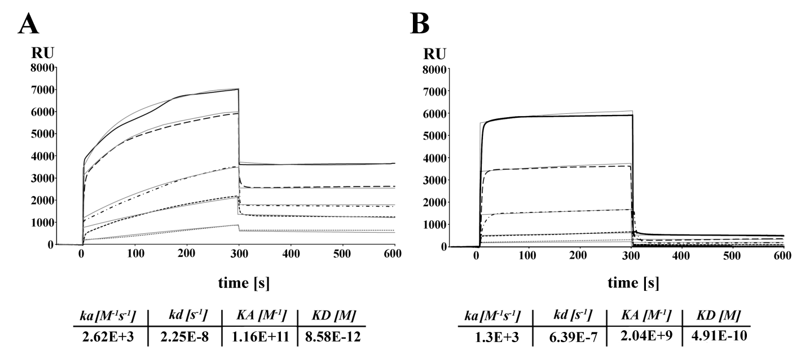

Fig. 2.

Fig. 3.

Fig. 4.
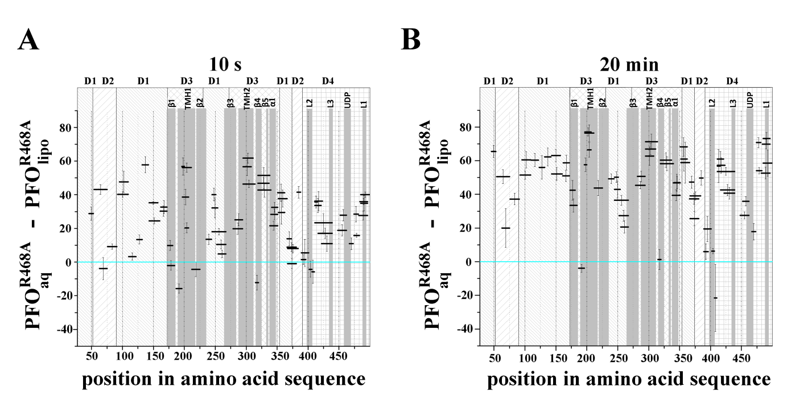

Fig. 5.

Fig. 6.

Fig. 7.

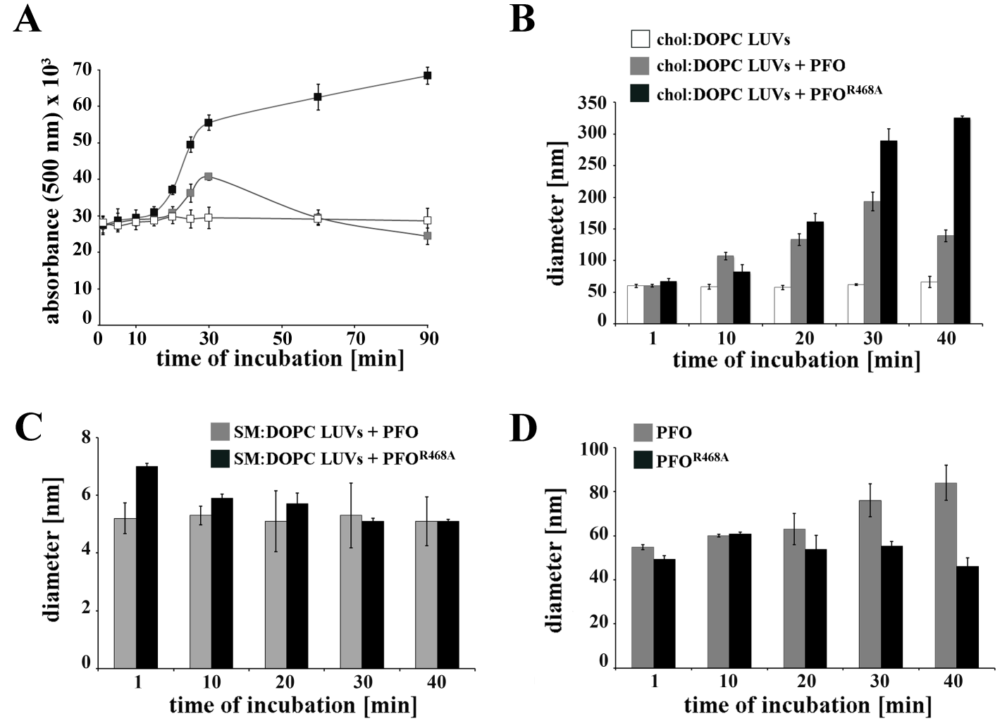

Fig. 8.
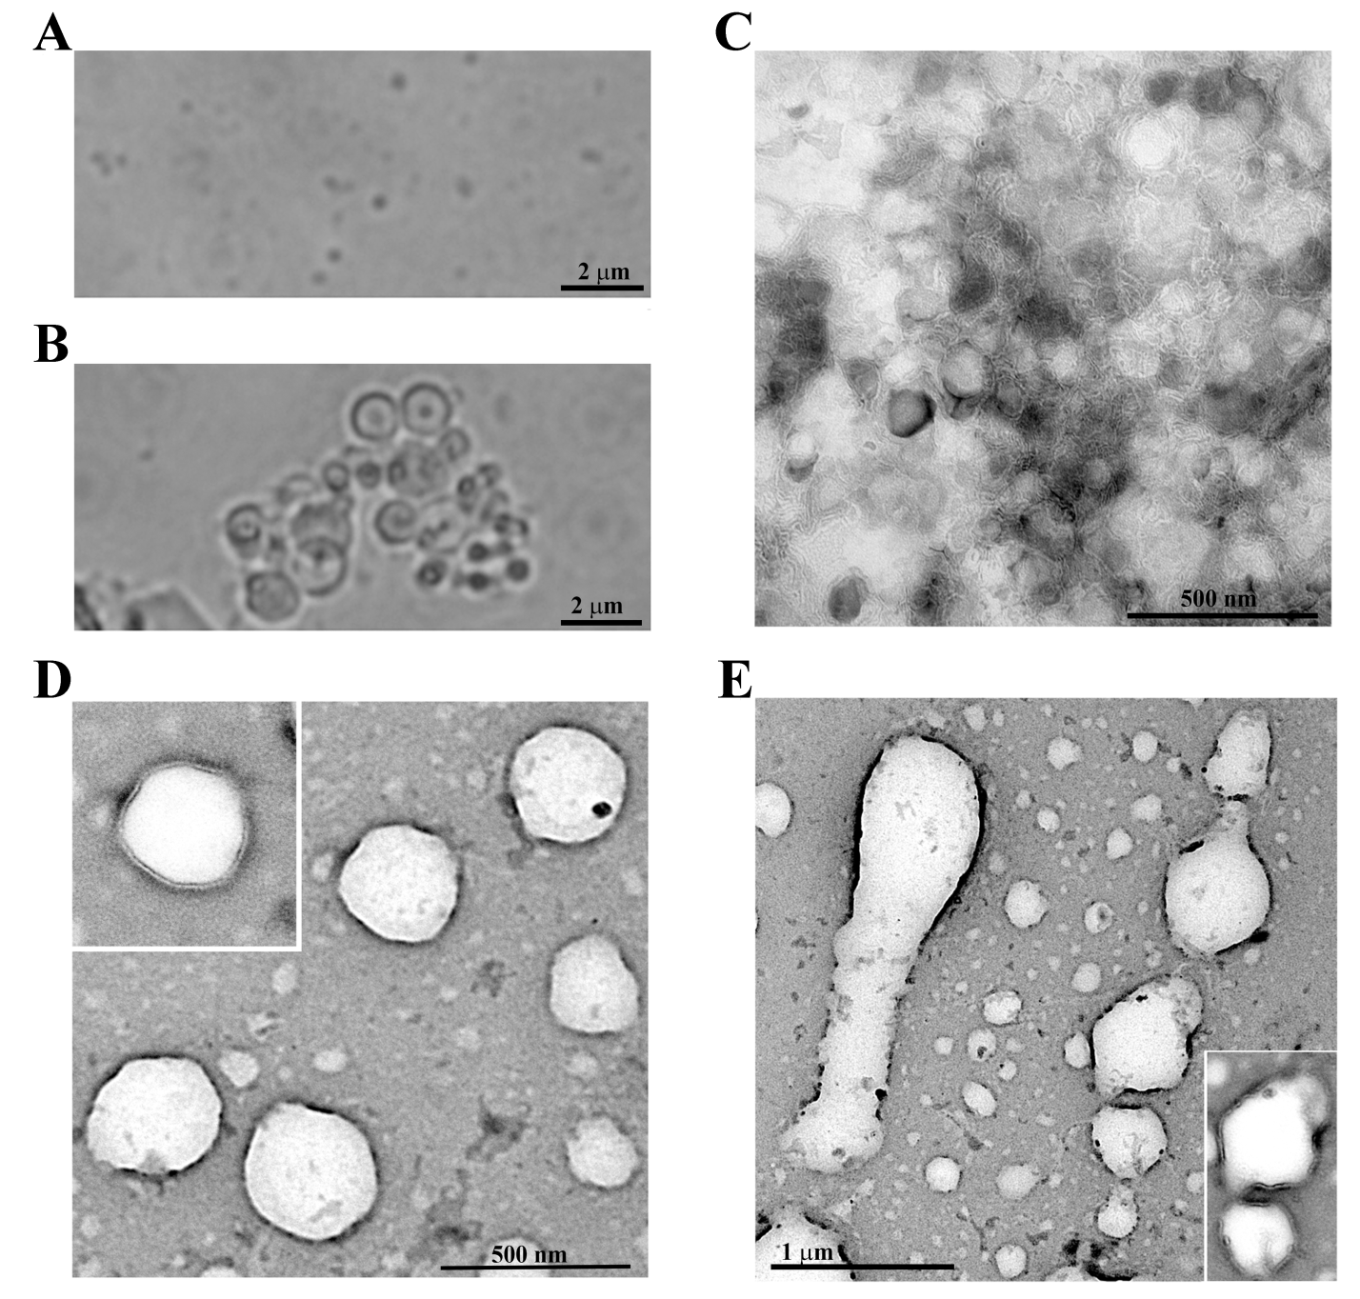

Fig. 9.

Fig. 10.

Fig. 11.
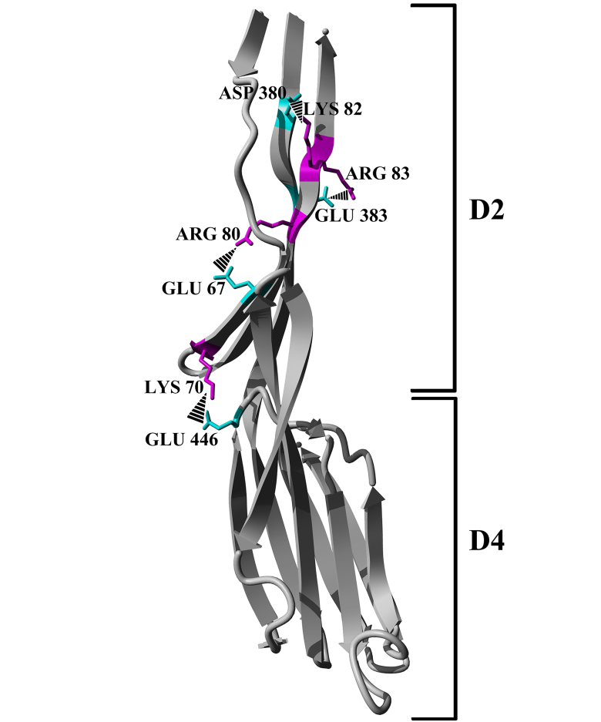
SUPPLEMENTARY INFORMATION

Supplemental experimental procedures

- Carboxyfluorescein release from SUVs
We characterized the pore forming ability of PFO^{R468A} with SUVs composed of cholesterol and DOPC (molar ratio 1:1, 2 mM total lipid concentration). SUVs were prepared by suspension of lipid film in TBS buffer (150 mM NaCl, 50 mM Tris, pH 7.5) containing 50 μM 6-carboxyfluorescein (Sigma), freeze-thawing (the freeze-thaw cycle was repeated six times) and sonication (30 min, 4°C, 0.3 cycle with amplitude 33% in the Branson Sonifier 250). Pelleted vesicles (10 000 × g, 10 min) were resuspended in TBS buffer and incubated with different concentrations of PFO or PFO^{R468A} for 30 min at 37 °C. The amount of carboxyfluorescein released from SUVs was measured with a JASCO FP 6500 spectrofluorimeter at Ex/Em= 492/517. The results are expressed as the percent of carboxyfluorescein release:
% CF = 100(F - F_{i})/(F_{f} - F_{i})
where F_{i} is the initial fluorescence before adding proteins, F is the fluorescence reading at different times, and F_{f} is the final fluorescence determined after addition of Triton X-100 to final concentration 0.1%.

- CD spectroscopy
Circular dichroism was used to examine whether R468A mutation changed the secondary structure of PFO. PFO proteins were dissolved in PBS buffer and final concentration was 4 µM. CD spectra of PFO proteins were recorded between 300 and 190 nm at 0.2 nm/s and 25 °C on the J−815 CD spectrometer (JASCO) using 2 mm cuvettes over the spectral range 270−200 nm.

- Measurement of intrinsic tryptophan fluorescence
To measure the intrinsic fluorescence of tryptophan a total of 200 nM PFO or PFO^{R468A} in 50 mM Tris-HCl (pH 7.5) was excited at 280 nm and the emission was recorded from 300 nm to 380 nm at 1 nm/s. All measurements were made on a JASCO FP 6500 spectrofluorimeter at
25 °C. The spectrum of buffer alone was subtracted from sample emissions.

- Determination of molecular mass with size exclusion chromatography
To determine the oligomeric state of PFO and PFO^{R468A} in aqueous solution, we employed size-exclusion chromatography with a FPLC system (Amersham Pharmacia Biotech). Purified PFO samples (100 μg), suspended in 100 μl of 150 mM NaCl and 30 mM Tris-HCl, pH 7.5, were applied to a Superdex 200 10/300 GL column (GE Healthcare) and analyzed at a flow rate of 0.5 ml/min. The void volume of the column was measured in a separate run, by applying Blue Dextran. The column was calibrated with the following standards (BioRad): thyroglobulin (670,000 Da), γ-globulin (158,000 Da), ovalbumin (44,000 Da), myoglobin (17,000 Da), and vitamin B12 (1,350 Da).

Supplementary figure legends
Fig. 1. Effect of R468A mutation on lytic activity of PFO. Liposomes composed of cholesterol and DOPC (molar ratio 1:1) with encapsulated carboxyfluorescein were incubated with PFO (black) or PFO^{R468A} (gray) for 30 min. The carboxyfluorescein released from liposomes was evaluated fluorimetrically and expressed as a percentage of the total amount of dye released in the presence of 0.1% Triton X-100; results represent the mean ± SD of three experiments.
Fig. 2. Circular dichroism (CD) spectroscopic analysis of PFO and R468 mutant derivative. Samples contained 1 µM PFO (──) and R468A mutant (●●●) in PBS. Spectra were measured in a 2 mm pathlength cuvette at 25 °C. Plot shown represents one of three experiments.
Fig. 3. Intrinsic tryptophan fluorescence spectra of PFO and mutant (R468A). Tryptophan fluorescence spectra of 200 nM PFO (──) and R468A mutant (─ ─ ─) were recorded from 300–380 nm at 25 °C. The excitation wavelength was 280 nm. Data were collected at 0.5 nm wavelength resolution. Plot shown is representative of three independent measurements.
Fig. 4. Analysis of molecular weight of PFO and its PFO^{R468A} mutant by size exclusion chromatography. Elution profiles from size exclusion chromatography of PFO (solid line) and PFO^{R468A} (dotted line) in aqueous solution, performed on a Superdex 200 column. Solid grey line shows elution profile of molecular weight standards. Plot shown represents one of three experiments.
Fig. 5. Schematic illustration of the lipid membrane fusion process induced by PFO^{R468A}. Domains of PFO, D1, D2, D3, D4 are indicated as different-colored boxes. The substitution of arginine 468 (right) triggers a structural rearrangement in PFO. Upon interaction with cholesterol-containing membranes, PFO^{R468A} initiates liposome aggregation and fusion.

Supplementary figures

Fig. 1.
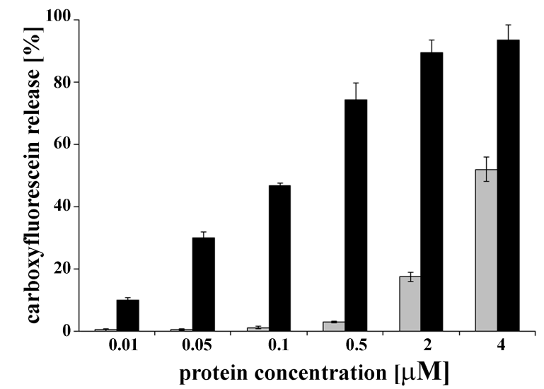

Fig. 2.
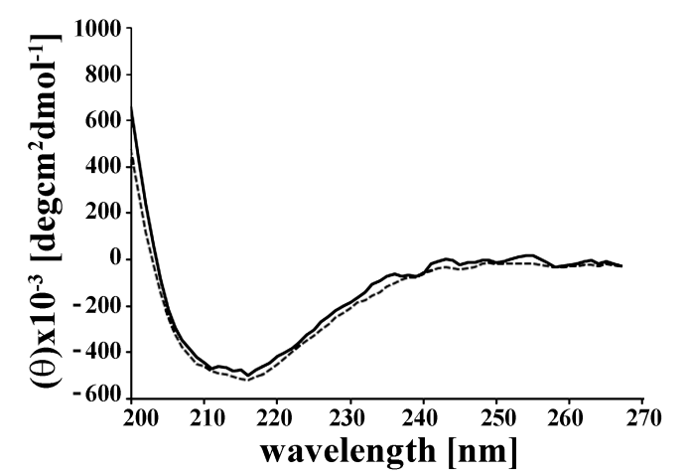

Fig. 3.

Fig. 4.

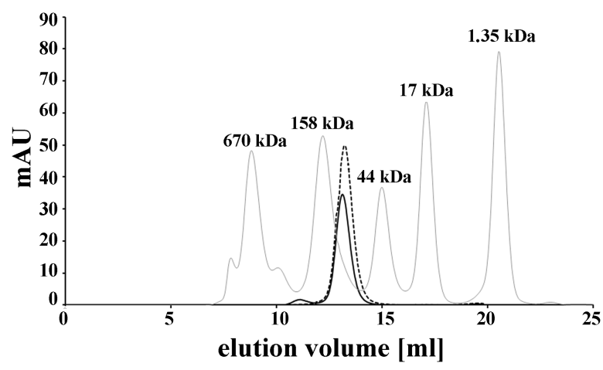

Fig. 5.

Supplementary tables
Table S1. p-values calculated using Student’s t-test for data shown in Fig. 3. Peptides with p-value below 0.05 are marked with an asterisk.

Peptide | Start | End | p-value
 |  |  | 10 sec | 20 min
SYNRNEVL  ASNGDKIESFVPKEGKKAGNKF  FVPKEGKKAGNKF  IVVERQKRSLTTSPVD  ISIIDSVNDRTYPGALQL  ADKAFVENRPTIL  MVKRKPININ  SIKVDDPTYGKVSGAIDE  SIKVDDPTYGKVSGA  LVSKWNEKYSST  VSKWNEKYSST  HTLPARTQY  HTLPARTQYSES  YSKSQISSAL  LNVNA  NVNAKVLENSL  KVLENSL  NAVANNEKKVMILA  ADLPKNPSDL  FDDSVTF  NDLKQKGVSNEAPPLM  KQKGVSNEAPPLM  VKLETTSSSKDVQAAF  ETTSSSKDVQAAF  KALIKNTDIKNSQQ  KALIKNTDIKNSQQYKDIYE  NSSFTA  TAVVLGGDAQEHNKVVTKD  TAVVLGGDAQEHNKVVTKDF  TAVVLGGDAQEHNKVVTKDFDE  FDEIRKVIKDNATF  EIRKVIKDNATF  IRKVIKDNATF  FSTKNPAYPISY  STKNPAYPISY  STKNPAYPISYTSVF  FLKDNSVA  FLKDNSVAAVHNKTDY  LKDNSVAAVHNKTDY  LKDNSVAAVHNKTDYIET  IETTSTE  YSKGKINL  YSKGKINLCHSGA  YVAQF  FEVAW  DEVSY  DEVSYDKEGNE  DEVSYDKEGNEVL  VLTHKTWDGNYQDKTAHY  NARNIRIKAREATGL  IRIKAREATGL  WADVISE  YDVPLTNNIN  INVSIWGTTLYPGSS  VSIWGTTLYPGSS  SIWGTTLYPGSS | 19  27  36  49  65  83  96  116  116  134  135  146  146  160  169  170  174  185  208  218  225  228  252  255  268  268  288  292  292  292  311  313  314  324  325  325  339  339  340  340  355  362  362  375  379  384  384  384  395  421  425  440  447  455  457  458 | 26  48  48  64  82  95  105  133  130  145  145  154  157  169  173  180  180  198  217  224  240  240  267  267  281  287  293  310  311  313  324  324  324  335  335  339  346  354  354  357  361  369  374  379  383  388  394  396  412  435  435  446  456  469  469  469 | 0.044284*  0.000135*  0.432942  0.000416*  0.000275*  0.461308  0.276035  0.00048*  0.003824*  0.000244*  0.00018*  0.000257*  0.00103*  0.098797  0.008822*  0.001355*  0.069019  0.049528*  0.00032*  0.000735*  0.002564*  0.160601  0.000361*  0.000459*  0.00225*  0.000554*  0.020135  0.00269*  0.016135*  0.017221*  0.000484*  0.000224*  0.000253*  0.000536*  0.005878*  0.165092  0.014121*  0.011508*  0.00617*  0.008365*  0.05906  0.000118*  0.003734*  0.020281*  0.053533  0.001365*  0.003773*  0.000382*  0.014337*  0.165339  0.001865*  2.49E-15*  0.009295*  0.007739*  0.000802*  0.002512* | 0.01836*  0.040046*  0.517952  0.195591  0.052353  0.07623  0.165248  0.014886*  0.025533*  0.006232*  0.010144*  0.010184*  0.004307*  0.508745  0.012426*  0.007126*  0.048001*  0.005827*  0.000442*  0.003225*  0.035379*  0.041968*  0.001333*  0.004113*  0.012747*  0.002718*  0.018487*  0.003224*  0.049882*  0.005288*  0.013283*  0.014755*  0.041597*  0.016218*  0.269471  0.240043  0.023152*  0.015554*  0.018486*  0.026696*  0.220977  0.02101*  0.102943  0.001616*  0.106919  0.080418  0.011477*  0.019962*  0.021305*  0.085172  0.029643*  1.4E-13*  6.97E-05*  0.003404*  0.000938*  0.00388*

* p-value ≤ 0.05

Table S2. p-values calculated using Student’s t-test for data shown in Fig. 4. Peptides with p-value below 0.05 are marked with an asterisk.

Peptide | Start | End | p-value
 |  |  | 10 sec | 20 min
SYNRNEVL  ASNGDKIESFVPKEGKKAGNKF  FVPKEGKKAGNKF  IVVERQKRSLTTSPVD  ISIIDSVNDRTYPGALQL  ADKAFVENRPTIL  MVKRKPININ  SIKVDDPTYGKVSGAIDE  SIKVDDPTYGKVSGA  LVSKWNEKYSST  VSKWNEKYSST  HTLPARTQY  HTLPARTQYSES  YSKSQISSAL  LNVNA  NVNAKVLENSL  KVLENSL  NAVANNEKKVMILA  ADLPKNPSDL  FDDSVTF  NDLKQKGVSNEAPPLM  KQKGVSNEAPPLM  VKLETTSSSKDVQAAF  ETTSSSKDVQAAF  KALIKNTDIKNSQQ  KALIKNTDIKNSQQYKDIYE  NSSFTA  TAVVLGGDAQEHNKVVTKD  TAVVLGGDAQEHNKVVTKDF  TAVVLGGDAQEHNKVVTKDFDE  FDEIRKVIKDNATF  EIRKVIKDNATF  IRKVIKDNATF  FSTKNPAYPISY  STKNPAYPISY  STKNPAYPISYTSVF  FLKDNSVA  FLKDNSVAAVHNKTDY  LKDNSVAAVHNKTDY  LKDNSVAAVHNKTDYIET  IETTSTE  YSKGKINL  YSKGKINLCHSGA  YVAQF  FEVAW  DEVSY  DEVSYDKEGNE  DEVSYDKEGNEVL  VLTHKTWDGNYQDKTAHY  NARNIRIKAREATGL  IRIKAREATGL  WADVISE  YDVPLTNNIN  INVSIWGTTLYPGSS  VSIWGTTLYPGSS  SIWGTTLYPGSS | 19  27  36  49  65  83  96  116  116  134  135  146  146  160  169  170  174  185  208  218  225  228  252  255  268  268  288  292  292  292  311  313  314  324  325  325  339  339  340  340  355  362  362  375  379  384  384  384  395  421  425  440  447  455  457  458 | 26  48  48  64  82  95  105  133  130  145  145  154  157  169  173  180  180  198  217  224  240  240  267  267  281  287  293  310  311  313  324  324  324  335  335  339  346  354  354  357  361  369  374  379  383  388  394  396  412  435  435  446  456  469  469  469 | 4.51269E-05*  0.00019276*  0.280520933  0.00675163*  2.33004E-05*  0.062309434  0.00054275*  0.00120551*  1.06513E-08*  0.00061284*  0.00122841*  0.00145761*  0.229118516  3.19619E-05*  6.62136E-05*  0.00094099*  0.00012463*  0.114875825  0.01215810*  7.61153E-05*  0.01350704*  0.01013150*  0.00092511*  0.00281257*  6.72542E-05*  8.56061E-06*  0.00136784*  0.00017302*  5.59077E-05*  0.00043150*  0.00198052*  0.00219047*  0.00109954*  0.00330453*  0.00117618*  0.00337631*  0.00161824*  0.00975685*  0.580502481  0.00087503*  9.39249E-05*  0.380276964  0.33463036  0.144462812  0.263268391  0.00120151*  0.02815465*  0.00379632*  0.02740600*  0.00012215*  0.00284658*  0.02188696*  2.30342E-07*  0.00176731*  1.19384E-05*  0.00044322* | 1.07055E-06*  0.00058616*  0.02299679*  6.96694E-05*  0.00014475*  2.26472E-06*  0.00061784*  2.1163E-05*  0.00012665*  0.00021896*  0.00029829*  0.00415620*  7.7436E-05*  0.059846013  3.12628E-06*  4.17698E-06*  0.00092224*  1.62122E-05*  2.59431E-05*  0.00042038*  0.00012330*  0.00038261*  1.15452E-06*  8.09469E-07*  0.00058314*  7.00845E-06*  0.687361801  0.00045824*  0.00385475*  0.00027899*  0.00106970*  0.00020817*  0.00171051*  6.06931E-06*  0.00017342*  0.00027394*  7.91534E-06*  0.00068421*  0.00364125*  0.00010509*  0.00078246*  0.100836874  0.00428053*  0.00087321*  0.103138343  0.00779087*  1.65579E-06*  1.92802E-05*  0.00164164*  0.00149619*  0.00019139*  0.00545125*  8.9303E-08*  3.75864E-06*  1.61255E-07*  5.04804E-07*

* p-value ≤ 0.05

