Supplementary information for:
Two mutations in mitochondrial ATP6 gene of ATP synthase, related to human cancer, affect ROS, calcium homeostasis and mitochondrial permeability transition in yeast

Katarzyna Niedzwiecka¹, Renata Tisi^{2,3}, Sara Penna^{2§}, Malgorzata Lichocka¹, Danuta Plochocka¹, Roza Kucharczyk¹*

¹Institute of Biochemistry and Biophysics, Polish Academy of Sciences, Warsaw, Poland
²Dept. Biotechnology and Biosciences, University of Milano-Bicocca, Milan, Italy
³Milan Center for Neuroscience

§ now San Raffaele Telethon Institute for Gene Therapy, Scientific Institute HS San Raffaele, Milan, Italy

*Corresponding author
E-mail: roza@ibb.waw.pl, Phone: +48 22 5921221, Fax: +48 22 6584636

Supplementary results:
  - ATP synthase functioning in atp6-K90E yeast mutant
In addition to P157>T, P163>S, I170>V, L232>P [1], we have introduced into yeast Atp6p one more mutation, changing the conserved lysine 90 into glutamic acid (corresponding to K64 in human MTATP6 protein). This mutation was found in thyroid cancer in position m.8716A>G of human mitochondrial DNA [2]. Although it is not a highly conserved fragment of ATP6 proteins, the alignment and structural model show that lysine 90 of yeast protein corresponds to lysin 64 of human protein (Fig. S1A and S5), in particular when taking into account the location of this lysine in a non-helical loop [1]. Several tests were performed in order to determine if Atp6-K90E mutation is detrimental to ATP synthase functionality. This mutation had no effect on yeast growth on fermentable substrates (glucose) as well as on carbon sources that require the presence of a functional ATP synthase (like glycerol), at 28°C and 36°C (Fig. S2A). The mitochondria isolated from mutant cells respired and produced ATP with even higher efficiency (up to 120%) comparing to the control mitochondria (Fig. S2B). Mutation did not change the assembly/stability of ATP synthase and ROS level in the cells (Fig. S2C). The analysis of oxidative phosphorylation in atp6-K90E mutant further supports our conclusion that mutations in yeast ATP6 gene, corresponding to those accumulating in human MT-ATP6 gene during cancer progression, have subtle effect on mitochondrial energy production.
  - Mitophagy analysis
As a marker of mitophagy we used the outer mitochondrial membrane protein Om45, fused to GFP in wild type and cancer-related atp6-K90E, atp6-P157T, atp6-P163S, atp6-I170V and atp6-L232P mutants. Following the uptake of mitochondria into the vacuole, Om45-GFP is degraded, releasing the GFP. Thanks to proteolytic resistance, free GFP may be detected by immunoblotting and its amount reflects mitophagy rate [3]. To induce mitophagy Om45-GFP expressing cells were grown in glycerol medium during three days. The same amount of cells was taken from the culture every day and total protein extracts were prepared for Western blotting. As shown on Fig. S3A, no difference in mitophagy rates was observed between strains. We validated this result in two mutants displaying higher ROS and calcium sensitivity: atp6-K90E and atp6-P163S in wild type and OM45-GFP background by using a fluorescent, pH sensitive reporter, mt-Rosella. Mt-Rosella localizes in mitochondrial network (pH ~8.2) exhibiting both green and red fluorescence, while under delivery of mitochondria to the vacuole (in acidic pH) exhibit red fluorescence [4]. When mitophagy is induced, in addition to red and green fluorescence labeling the mitochondria, cells accumulate red, but not green fluorescence in the acidic vacuolar lumen, resulting from the delivery of mitochondria to the vacuole. Scoring cells with red, but not green fluorescent vacuoles can be used as a measure of mitophagic activity. Cells transformed with plasmid encoding mt-Rosella were grown in glycerol minimal medium lacking uracil during five days and were viewed under fluorescence microscope every day. After three days of growth mitophagy was induced. No significant difference in the amount of cells expressing red vacuolar fluorescence was found between the wild type, single or double mutants (Fig. S3B).
  - atp6-P163S and atp6-K90E mutations induce similar structural modification when analyzed in vacuo
To better understand why two mutations in two different loops of Atp6p, can cause similar phenotypes in vivo, we checked if these mutations induced structural changes in Atp6p (a subunit) and in Atp9p (c subunit), which directly interacts with Atp6p. We introduced the mutations in structural models of yeast as well as human ATP synthase. Proton channel structures were subjected to energy minimization (in vacuo) using Amber94 force field as implemented in MAESTRO modeling interface, release 2016-1 (Schrödinger Inc.). Thereafter structures of wild type and mutated proteins were compared. Significant structure differences have been observed for both yeast and human ATP synthase proton channels, moreover similar for both mutations (Fig. S1 and S5). K90E mutation in yeast Atp6 protein leaded to a distortion in T83 - F96 and F155 - P166 regions together with changes in the helix of Atp9 adjacent to Atp6. Introduction of K64E point mutation in human ATP synthase resulted in introducing main structural changes in corresponding regions: M57 - L70 and F128 - P139 for MTATP6 and similarly in the adjacent helix of subunit c. Yeast Atp6-P163S mutation also induced differences in the main chain course of yeast ATP synthase. Mainly it concerns F155 - I170 for a subunit and neighboring helix of Atp9. P136S mutation in human protein is the cause of distortions in corresponding F128 - P139 fragment of MTATP6 as well as in the neighborhood of c subunit. We remark that conclusions arising from in vacuo calculations based on structural model, which is static, are speculative, as they do not provide natural conditions in which the structure of the enzyme is dynamic. They can only suggest some directions of searches and try to help in understanding the phenomenon. In any case the in silico methods indicated possibility of structural changes in the region of the loop containing P163/136 for both studied mutations proline into serine and lysine into glutamic acid, suggesting a possible explanation of the similar phenotypes observed in these two mutants in OM45-GFP background.
Supplementary Tables:

Table S1. Genotypes and sources of yeast strains
Strain | Nuclear genotype | mtDNA | Source
DFS160 | MATα leu2Δ ura3-52 ade2-101 arg8:: URA3 kar1-1 | ρº | [5]
NB40-3C | MATa lys2 leu2-3,112 ura3-52 his3∆HindIII arg8::hisG | ρ⁺ cox2-62 | [5]
MR6 | MATa ade2-1 his3-11,15 trp1-1 leu2-3,112 ura3-1 arg8::HIS3 | ρ⁺ | [6]
MR10 | MATa ade2-1 his3-11,15 trp1-1 leu2-3,112 ura3-1 arg8::HIS3 | ρ⁺ atp6::ARG8^{m} | [6]
RKY59 | MATα leu2Δ ura3-52 ade2-101 arg8::HIS3 kar1-1 | ρ⁻ atp6-K90E COX2 | This study
RKY61 | MATa ade2-1 his3-11,15 trp1-1 leu2-3,112 ura3-1 arg8::HIS3 | ρ⁺atp6-P163S | [1]
RKY62 | MATa ade2-1 his3-11,15 trp1-1 leu2-3,112 ura3-1 arg8::HIS3 | ρ⁺atp6-K90E | This study
MR6-Om45GFP | MATa ade2-1 his3-11,15 trp1-1 leu2-3,112 ura3-1 arg8::HIS3 OM45-GFP-KANMX6 | ρ⁺ | This study
RKY61-Om45GFP | MATa ade2-1 his3-11,15 trp1-1 leu2-3,112 ura3-1 arg8::HIS3 OM45-GFP-KANMX6 | ρ⁺atp6-P163S | This study
RKY62-Om45GFP | MATa ade2-1 his3-11,15 trp1-1 leu2-3,112 ura3-1 arg8::HIS3 OM45-GFP-KANMX6 | ρ⁺atp6-K90E | This study
KNY10 | MATa ade2-1 his3-11,15 trp1-1 leu2-3,112 ura3-1 arg8::HIS3 om14Δ∷KANMX4 | ρ⁺ | This study
KNY11 | MATa ade2-1 his3-11,15 trp1-1 leu2-3,112 ura3-1 arg8::HIS3 om14Δ∷KANMX4 | ρ⁺atp6-P163S | This study
KNY98 | MATa ade2-1 his3-11,15 trp1-1 leu2-3,112 ura3-1 arg8::HIS3 om14Δ::KANMX4 | ρ⁺atp6-K90E | This study
KNY20a | MATa ade2-1 his3-11,15 trp1-1 leu2-3,112 ura3-1 arg8::HIS3 OM45-GFP-KANMX6 om14Δ::KANMX4 | ρ⁺ | This study
KNY24 | MATa ade2-1 his3-11,15 trp1-1 leu2-3,112 ura3-1 arg8::HIS3 OM45-GFP-KANMX6 om14Δ::KANMX4 | ρº | This study
KNY26 | MATα leu2Δ ura3-52 ade2-101 arg8:: URA3 kar1-1 | ρ⁺atp6-P163S | This study
KNY41 | MATa ade2-1 his3-11,15 trp1-1 leu2-3,112 ura3-1 arg8::HIS3 OM45-GFP-KANMX6 om14Δ::KANMX4 | ρ⁺atp6-P163S | This study
KNY27 | MATα leu2Δ ura3-52 ade2-101 arg8:: URA3 kar1-1 | ρ⁺atp6-K90E | This study
KNY42 | MATa ade2-1 his3-11,15 trp1-1 leu2-3,112 ura3-1 arg8::HIS3 OM45-GFP-KANMX6 om14Δ::KANMX4 | ρ⁺atp6-K90E | This study

Supplementary Figures:
Supplementary Figure S1:
Bovine --MNE-------NLFTSFITPVILGLP-------LVTLIVLFPSLLFPTSNRLVSNRFVT 44
Human --MNE-------NLFASFIAPTILGLP-------AAVLIILFPPLLIPTSKYLINNRLIT 44
Yeast SPLDQFEIRTLFGLQSSFIDLSCLNLTTFSLYTIIVLLVITSLYTLTNNNNKIIGSRWLI 70

Bovine LQQWMLQLVSKQMMSIHNSKG-QTWTLMLMSLILFIGSTNLLGLLPHSFTPTTQLSMNLG 103
Human TQQWLIKLTSKQMMTMHNTKG-RTWSLMLVSLIIFIATTNLLGLLPHSFTPTTQLSMNLA 103
Yeast SQEAIYDTIMNMTKGQIGGKNWGLYFPMIFTLFMFIFIANLISMIPYSFALSAHLVFIIS 130

Bovine MAIPLWAGAVITGFRNKTKASLAHFLPQGTPTPLIPMLVIIETISLFIQPMALAVRLTAN 163
Human MAIPLWAGTVIMGFRSKIKNALAHFLPQGTPTPLIPMLVIIETISLLIQPMALAVRLTAN 163
Yeast LSIVIWLGNTILGLYKHGWVFFSLFVPAGTPLPLVPLLVIIETLSYFARAISLGLRLGSN 190

Bovine ITAGHLLIHLIGGATLALMSISTTT---ALITFTILILLTILEFAVAMIQAYVFTLLVSL 220
Human ITAGHLLMHLIGSATLAMSTINLPS---TLIIFTILILLTILEIAVALIQAYVFTLLVSL 220
Yeast ILAGHLLMVILAGLTFNFMLINLFTLVFGFVPLAMILAIMMLEFAIGIIQGYVWAILTAS 250

Bovine YLHDNT--- 226
Human YLHDNT--- 226
Yeast YLKDAVYLH 259
Fig S1. Sequence alignments of ATP6 subunits from human, bovine and yeast S. cerevisiae. The position of conserved lysine (64 in human protein and 90 in yeast protein) is indicated by red color. The regions of the ATP6 subunit structural changes by K>E mutation are marked in blue, the regions of changes by P>S mutation are underlined (as calculated by in vacuo energy minimization, see Fig. S5).

Supplementary Figure S2:
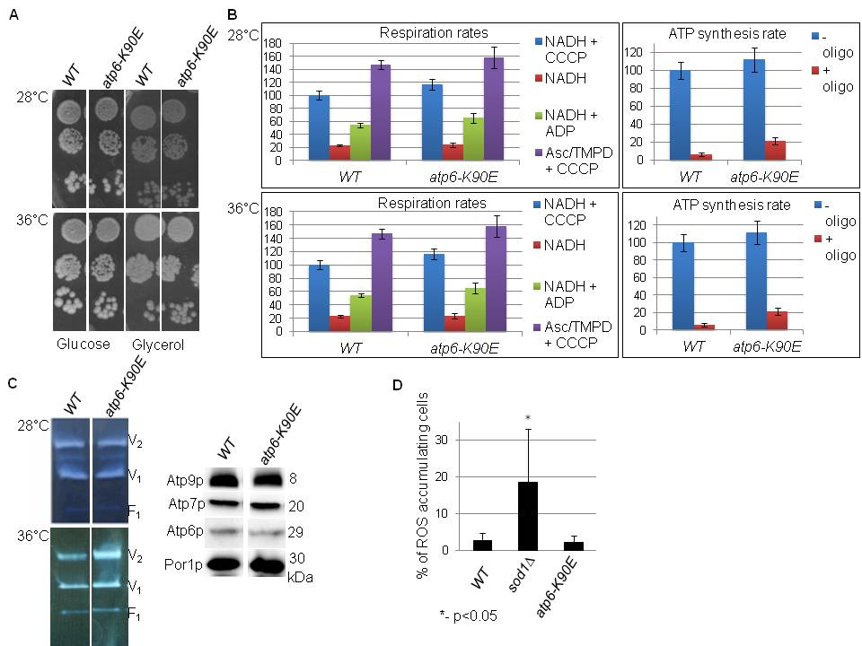
Fig. S2. Influence of atp6-K90E mutation on yeast respiratory growth (A), respiration and ATP synthesis (B), assembly/stability of ATP synthase, accumulation of its subunits (C), and % of ROS accumulating cells (D). (A) Fresh liquid glucose cultures were serially diluted and spotted onto rich glucose and glycerol plates. The plates were photographed after 4 days of incubation at the indicated temperatures. (B) Mitochondria were isolated from strains grown in rich galactose medium, at 28°C or 36°C, as indicated. Oxygen consumption rates were measured after consecutively adding 4 mM NADH (state 4 respiration), 150 µM ADP (state 3) or 4 µM carbonyl cyanide m-chlorophenylhydrazone (CCCP) (uncoupled respiration); they are expressed in percentage of the uncoupled respiration of wild-type mitochondria. The rates of ATP synthesis were determined using 4 mM NADH and 750 µM ADP, in the presence/absence of 3 mM oligomycin, as indicated, and are expressed in percentage with respect to wild-type mitochondria. (C) Left panel: BN-PAGE analysis of mitochondrial proteins. Dimeric (V2) and monomeric (V1) F₁F_{O} complexes, and free F₁ were revealed in gel by their ATPase activity. Right panel: SDS-PAGE analysis of mitochondrial protein samples (20 µg) probed with antibodies against the indicated proteins. (D) % of ROS accumulating cells grown in glucose medium, stained with DHE. As a control, yeast cells deleted for SOD1 gene were used, which encodes a cytosolic copper-zinc superoxide dismutase that enables cells to detoxify superoxide. The representative plates and gels are shown. The error bars and p-value vs WT were calculated on data from three independent experiments.

Supplementary Figure S3:
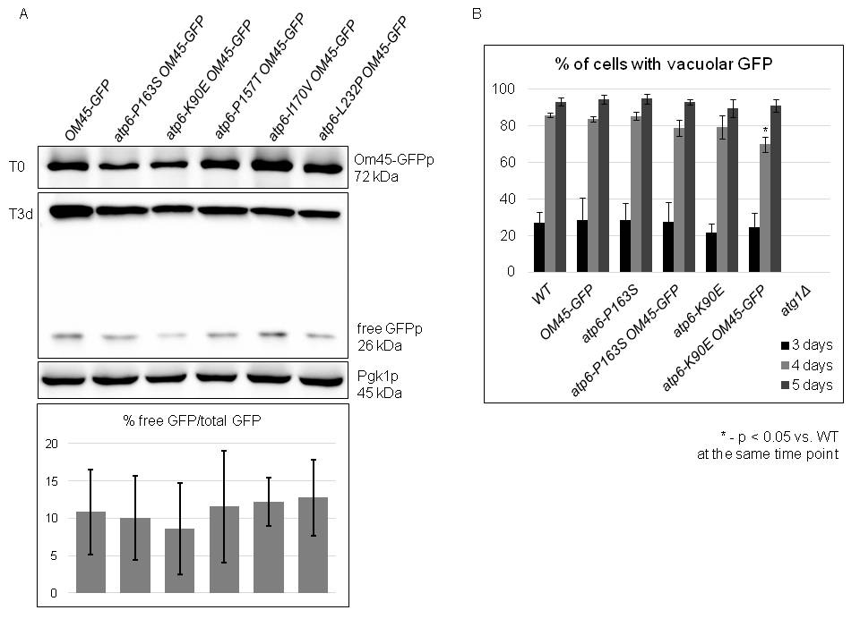
Fig. S3. Mitophagy is normally induced in atp6 mutants. (A) Om45-GFP processing in cancer-related atp6 mutants pre-grown in YPGA, transferred to YPGlyA (T0) or grown in YPGlyA during three days at 28 ºC. Total protein extracts from 0,5 OD of cells were loaded per lane, separated in 10% SDS-PAGE, transferred to membrane and probed with anti-GFP and anti-Pgk1 antibodies. Quantification of data from three independent experiments is presented. Differences are not statistically significant. (B) Strains expressing mt‐Rosella were grown at 28 ºC in W0 – uracil with glycerol as a carbon source and viewed every day. Quantification of data from three independent experiments in which at least 100 cells were scored is shown. Standard deviation and p-value calculated versus the wild type control are given.
Supplementary Figure S4:
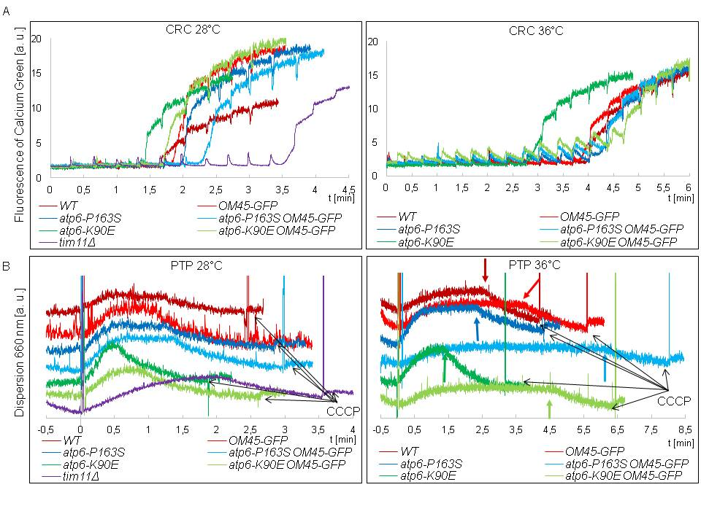
Fig. S4. Representative raw data of calcium retention capacity and swelling assays. (A) Ca²⁺ was added in 20 µM portions to the osmotically protected mitochondria (as described in Materials and Methods), every 20 seconds till the rapid increase of the fluorescence signal due to yPTP opening. a.u., arbitrary units. (B) Mitochondria swelling assay - mitochondria were incubated in reaction medium at the indicated temperature and 100 µM CaCl₂ was added at 0 time. The decrease in fluorescence is corresponding to the moment of the mitochondrial outer membrane rupture and is indicated by arrows. Black arrows indicate the point of CCCP addition at the end of experiment.

Supplementary Figure S5:
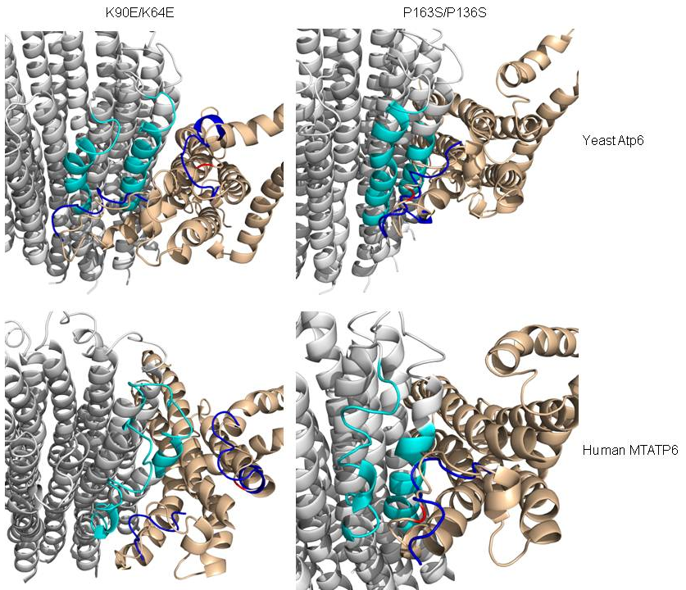
Fig. S5. The ATP synthase structural changes after energy minimization in atp6-P163S and atp6-K90E mutants (in vacuo). Cartoons of wild type proteins are highlighted in gray for Atp9 and in cream for Atp6p. The place of introduced mutation is shown in red. The localization of potential largest structure changes in Atp9 are shown in cyan and the main chain course for mutated Atp6 subunits is colored dark blue.

Supplementary references:
[1] K. Niedzwiecka, A.M. Kabala, J.P. Lasserre, D. Tribouillard-Tanvier, P. Golik, A. Dautant, J.P. di Rago, R. Kucharczyk, Yeast models of mutations in the mitochondrial ATP6 gene found in human cancer cells, Mitochondrion, 29 (2016) 7-17.
[2] V. Maximo, P. Soares, J. Lima, J. Cameselle-Teijeiro, M. Sobrinho-Simoes, Mitochondrial DNA somatic mutations (point mutations and large deletions) and mitochondrial DNA variants in human thyroid pathology: a study with emphasis on Hurthle cell tumors, The American journal of pathology, 160 (2002) 1857-1865.
[3] T. Kanki, D. Kang, D.J. Klionsky, Monitoring mitophagy in yeast: the Om45-GFP processing assay, Autophagy, 5 (2009) 1186-1189.
[4] D. Mijaljica, M. Prescott, R.J. Devenish, A fluorescence microscopy assay for monitoring mitophagy in the yeast Saccharomyces cerevisiae, Journal of visualized experiments : JoVE, (2011).
[5] D.F. Steele, C.A. Butler, T.D. Fox, Expression of a recoded nuclear gene inserted into yeast mitochondrial DNA is limited by mRNA-specific translational activation, Proceedings of the National Academy of Sciences of the United States of America, 93 (1996) 5253-5257.
[6] M. Rak, E. Tetaud, F. Godard, I. Sagot, B. Salin, S. Duvezin-Caubet, P.P. Slonimski, J. Rytka, J.P. di Rago, Yeast cells lacking the mitochondrial gene encoding the ATP synthase subunit 6 exhibit a selective loss of complex IV and unusual mitochondrial morphology, The Journal of biological chemistry, 282 (2007) 10853-10864.

