Novel (S)-1,3,4,12a-tetrahydropyrazino[2,1-c][1,4]benzodiazepine-6,12(2H,11H)-dione derivatives: Selective inhibition of MV-4-11 biphenotypic B myelomonocytic leukemia cells’ growth is accompanied by reactive oxygen species overproduction and apoptosis.

Adam Mieczkowski&,¹ Mateusz Psurski&,³ Maciej Bagiński,^{1,2} Bartosz Bieszczad,^{1,2} Magdalena Mroczkowska,^{1,2} Marcin Wilczek,², Joanna Czajkowska,^{3,4} Damian Trzybiński,⁵ Krzysztof Woźniak,⁵ Joanna Wietrzyk³

¹Institute of Biochemistry and Biophysics Polish Academy of Sciences, Pawinskiego 5a, 02-106 Warsaw, Poland
² Faculty of Chemistry, University of Warsaw, Pasteura 1, 02-093 Warsaw, Poland
³Ludwik Hirszfeld Institute of Immunology and Experimental Therapy, Polish Academy of Sciences, R. Weigl 12, 53-114 Wroclaw, Poland
⁴Department of Medicinal Chemistry and Microbiology, Wroclaw University of Technology, Wybrzeze Wyspianskiego 29, 50-373 Wroclaw, Poland
⁵Biological and Chemical Research Centre, University of Warsaw, Żwirki i Wigury 101, 02-089 Warsaw, Poland

& AM and MP contributed equally

GRAPHICAL ABSTRACT:

Abstract
A series of optically pure (R)- and (S)-1,3,4,12a-tetrahydropyrazino[2,1-c][1,4]benzodiazepine-6,12(2H,11H)-dione derivatives was designed and synthesized as novel anthramycin analogues in a three-step, one-pot procedure, and tested for their antiproliferative activity on nine following cell lines: MV-4-11, UMUC-3, MDA-MB-231, MCF7, LoVo, HT-29, A-549, A2780 and BALB/3T3. The key structural features responsible for exhibition of cytotoxic effect were determined: the (S)-configuration of chiral center and the presence of hydrophobic 4-biphenyl substituent in the side chain. Introduction of bromine atom into the 8 position (8g) or substitution of dilactam ring with benzyl group (8m) further improved the activity and selectivity of investigated compounds. Among others, compound 8g exhibited selective cytotoxic effect against MV-4-11 (IC₅₀= 8.7 μM) and HT-29 (IC₅₀= 17.8 μM) cell lines, while 8m showed noticeable anticancer activity against MV-4-11 (IC₅₀= 10.8 μM) and LoVo (IC₅₀= 11.0 μM) cell lines. The cell cycle arrest in G₁/S checkpoint and apoptosis associated with overproduction of reactive oxygen species was also observed for 8e and 8m.

Anthramycin (1) and structurally related tricyclic pyrrolobenzodiazepine (PBD) antibiotics produced by various actinomycetes, possess unique features, which permit them to bind covalently through N10-C11 bond to C2-NH₂ group of guanine within the minor groove of DNA (Fig. 1).^{1,2} This class of compounds exhibits antibacterial properties and selective cytotoxicity toward tumor cells, and in consequence, it received a great attention of medicinal chemists as a possible source of anticancer and anti-MRSA agents.³⁻⁵ One of the dimeric anthramycin derivatives, SJG-136, capable of formation of DNA cross-links, successfully completed Phase I clinical trials and progressed to Phase II.^{6,7} Even early reports revealed two main structural features of PBDs responsible for binding to the DNA’s minor groove: presence of a reactive, alkylating group (imine, carbinoloamine or carbinoloamine methyl ester) and an S configuration on the chiral center at the C11a-position, causing the longitudinal twist and isohelicity with the minor groove of DNA. Some later reports revealed that even compounds deprived of the alkylating group at the N10-C11 bond could still bind and interact with DNA strands, by non-covalent interactions, when the appropriate geometry of binding molecule was preserved. This phenomenon was mainly investigated on PBDs possessing amide^{8,9} or amidine group.¹⁰ Derivatives 2a⁸ and 4¹⁰ (Fig. 1) elevated the melting temperature of DNA by 3.3±0.8 K and 0.7±0.1 K, respectively. Recent report⁹ presented a C2-aryl pyrrolo[2,1-c][1,4]benzodiazepine-5,11-dione type 3 library, which exhibited a strong, non-covalent binding to DNA, and the newly introduced C2-aryl substituents to the PBD dilactam skeleton significantly enhanced helix stabilization, in comparison to the unsubstituted PBD dilactam. The possible application of PBD’s dilactams as antitumor compounds was initially reported by Kaneko et al.,¹¹ who observed, that diacetate 2b had a significant in vivo antitumor activity in the P388 lymphocytic leukemia mouse model. During cytotoxic studies, derivative 3 exhibited a high antitumor activity against A498 cell line (renal cancer), with GI₅₀ = 0.51 μM, the effect comparable with the reference compound – anthramycin (GI₅₀ = 0.195 μM).
Further experiments revealed that some other anthramycin analogues, such as 7,8,9,10-tetrahydrobenzo-[e]pyrido[1,2-a][1,4]diazepin-12(6aH)-ones type 5¹² or analogues containing hydroxamic acid moiety 6,¹³ could also bind to the calf thymus CT-DNA or exhibit promising anticancer activity against selected cell lines (PC-3, MCF-7). These results demonstrated that although alkylating group present on the benzodiazepine ring could facilitate binding of Anthramycin analogues to DNA, sometimes it could be replaced by non-covalent interactions. Additionally, it was reported that structurally related Fuligocandin B (7), isolated in 2004 from the myxomycete Fuligo candida, ¹⁴ sensitizes leukemia cells to apoptosis induced by tumor necrosis factor–related apoptosis-inducing ligand (TRAIL).¹⁵

Fig 1. Anthramycin (1) and its analogues 2-8

During our research on the design and discovery of novel anticancer compounds based on diverse heterocyclic structures, such as 6H-oxazolo[3,2-f]pyrimidine-5,7-dione,¹⁶ 3H-pyrrolo[2,3-d]pyrimidin-2(7H)-one,^{17,18} furo[2,3-d]pyrimidin-2(3H)-one,¹⁸ 5,6-dihydropyrimido[4,5-c]pyridazin-7(8H)-one¹⁸ and purine¹⁹ scaffold, we envisioned a possible synthesis of novel, anticancer anthramycin analogues, possessing a fused piperazine ring instead of a pyrrole ring (8, Fig. 1). This idea was partially inspired by our previous reports, concerning solid-phase syntheses of novel, rigid, bi- and tricyclic mimetics of peptide β-turn.^{20,21} As the solid-phase synthesis possess several disadvantages, including difficulties in scaling-up the synthesis and tracking reaction progress, we decided to develop a solution-phase synthesis of anthramycin analogues, starting from optically pure (S)-2-piperazinecarboxylic acid dihydrochloride (9a) (Scheme 1).

Scheme 1. The synthesis of (S)-enantiomers of anthramycin analogues

After several attempts, we found that 9a dissolved in the dioxane-water mixture, in the presence of 2 eq. of sodium hydroxide, reacts with acyl chlorides, giving predominantly (S)-4-acyl-piperazine-2-carboxylic acids 10a-e. In a similar manner, (R)-4-acyl-piperazine-2-carboxylic acids 10f-i were synthesized from (R)-2-piperazinecarboxylic acid dihydrochloride (9b) (Scheme 2). Intermediates 10a-i were then directly treated with an excess of isatoic anhydrides, in the presence of sodium carbonate as a base, which resulted in the formation of (R)-/(S)-1-(2-aminobenzoyl)-4-acyl-piperazine-2-carboxylic acids 11a-k (Schemes 1,2). The final cyclization step, leading to the tricyclic dilactam scaffold 8, was performed with HATU, in the presence of DIPEA as a base.
Scheme 2. The synthesis of (R)-enantiomers of Anthramycin analogues

In further structure-activity relationships studies, the lactam ring of 8e was alkylated with methyl iodide, benzyl bromide, and benzyl bromoacetate, in the presence of potassium carbonate, which led to the N-alkylated derivatives 8l-8n. The benzyl group in derivative 8n was removed in hydrogenation reaction, giving N-methylocarboxyl substituted product 8o.
Scheme 3. The alkylation of dilactam 8e

The structure of synthesized compounds was confirmed by detailed NMR spectra analysis (1H, 13C, dept135, COSY, HSQC, HMBC and temperature spectra) and crystallographic methods. In general, the obtained anthramycin analogs exist in two interconvertible conformations in deuterated DMSO solution, which resulted in two sets of signals. This dynamic system and vibrations of the molecule in the solution, together with the presence of axial and equatorial, magnetically non-equivalent hydrogens in three methylene groups of piperazine ring, resulted in the extension of signal bands observed as complex multiplexes in both aliphatic and aromatic part of the collected spectra (see SI). The identity of 8a (crystallized from acetone:water 1:1 v/v mixture) and 8i (crystallized from ethyl acetate) was proven by the single-crystal X-ray diffraction analysis. It turned out that investigated compounds crystallize in the hexagonal P6₅ (8a) and triclinic P1 (8i) space groups, with one (8a) or two (8i) molecules in the asymmetric units of the corresponding crystal lattices (Fig. 2). The details of crystallographic data and the refinement parameters are summarized in Table 1 of the Supplement file. The full list of values of bond lengths, valence and torsion angles can be found in the Supplementary Information (Tables 2–7).

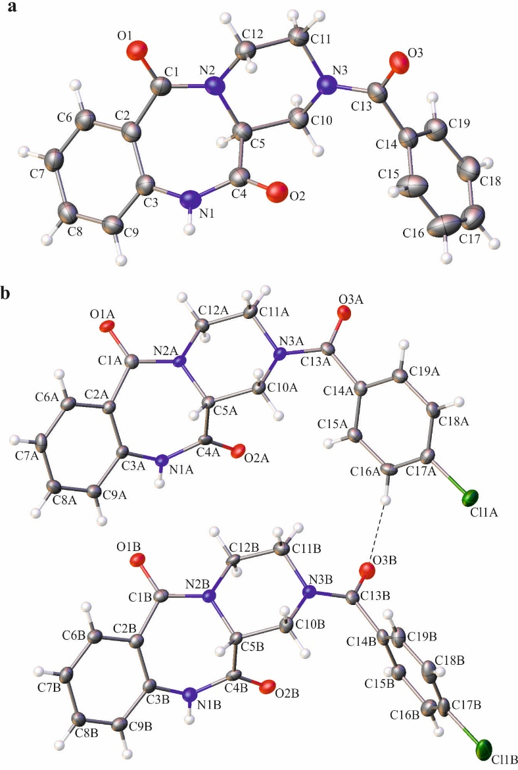

Figure 2. Molecular structure of 8a (a) and 8i (b) with crystallographic numbering schemes. The atomic displacement ellipsoids (ADPs) are drawn at the 50% probability level and the H-atoms are shown as small spheres of an arbitrary radius. The weak intermolecular C–H···O hydrogen bond is represented by dashed line.

The heterocyclic seven- and six-membered rings of tricyclic benzodiazepine moiety adopt the boat and chair conformations in all analysed molecules, which is in agreement with what was observed in the case of the (S)-2-(4-chlorobenzoyl)-1,2,3,4-tetrahydrobenzo[e]pyrazino[1,2-a][1,4]diazepine-6,12(11H,12aH)-dione (8b).²² In the case of 8a, the (S)-configuration of the chiral centre is observed, whereas in the case of 8i, both molecules of compound possess the (R)-configuration. Some noticeable differences in the geometry of molecules are observed in case of the spatial orientation of the benzoyl moiety. The value of dihedral angle between mean-planes, delineated by the carbon atoms of the phenyl rings of the benzoyl and the 1,2,3,4-tetrahydrobenzo[e]pyrazino[1,2-a][1,4]diazepine-6,12(11H,12aH)-dione moieties, is 92.03(14)° in 8a, and 64.38(14) and 85.63(14)° in the case of 8i (molecules A and B, respectively).
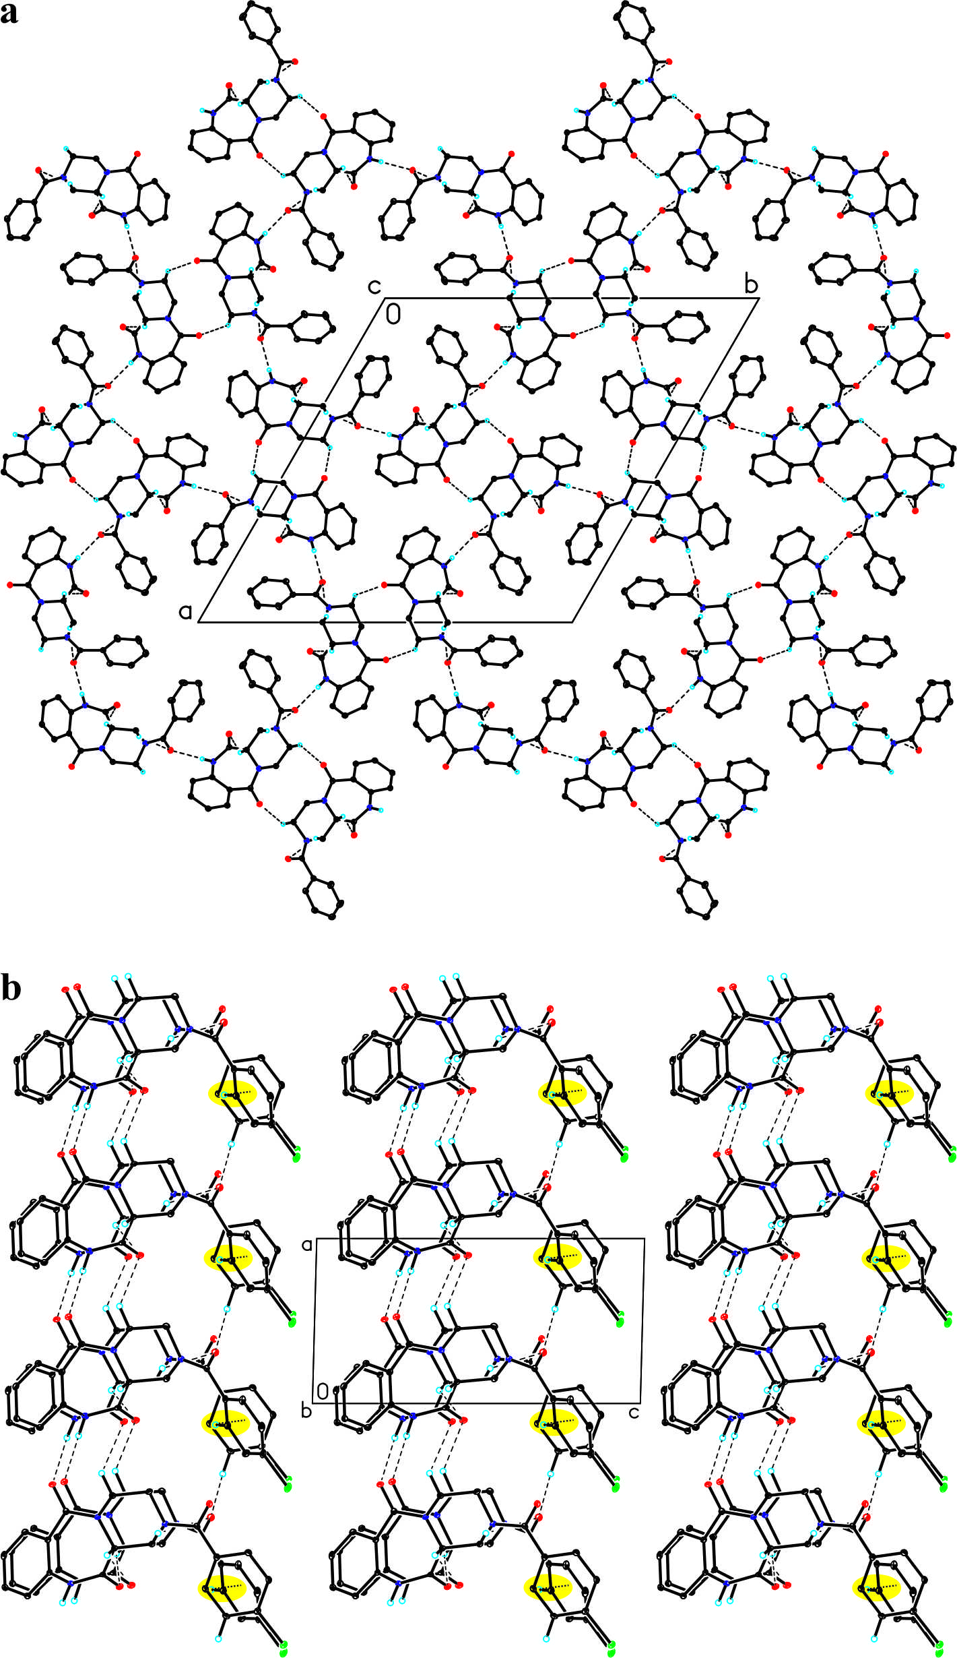

Figure 3. Arrangement of molecules in the crystal of 8a (a) and 8i (b), viewed along the a and b-direction in the case of 8a and 8i, respectively. The H-atoms not involved in the intermolecular interactions have been omitted for clarity. The hydrogen bonds are represented by the dashed lines, while the C–H···π contacts by dotted lines (marked in yellow).

The packing of molecules in crystals of both investigated compounds is dominated by formation of hydrogen bonds (Fig. 3, SI: Tables 8 and 10). The supramolecular architecture of 8i is similar to the one observed in the (S)-enantiomer, crystal structure of which was reported earlier.²² The full list of molecular interactions identified using PLATON²³ software can be found in the Supplementary Information (Tables 8–12).
A series of (S) and (R) enantiomers of anthramycin analogues was used to evaluate their antiproliferative potential on human biphenotypic B myelomonocytic leukemia (MV-4-11) and human urinary bladder TCC (UM-UC-3) (Table 1) cell lines. Cisplatin was used as positive control.

TABLE 1. Preliminary antiproliferative activity results of 8a-k (R)- and (S)-enantiomers, towards MV-4-11 and UM-UC-3 cell lines
Compd no. | IC₅₀ ± SD [µM]
 | MV-4-11 |  | UM-UC-3
8a | [27.1]* | ± 6.2 | [10.5]* | ± 4.5
8b | [32.3]* | ± 4.6 | [18.2]* | ± 7.2
8c | [44.0]* | ± 5.6 | [31.1]* | ± 5.1
8d | [19.8]* | ± 6.0 | [8.6]* | ± 6.6
8e | 17.5 | ± 2.4 | 61.5 | ± 13.0
8h | [28.8]* | ± 11.4 | [24.6]* | ± 4.6
8i | [36.7]* | ± 5.9 | [22.3]* | ± 7.3
8j | [39.8]* | ± 8.4 | [13.3]* | ± 2.3
8k | [39.6]* | ± 5.6 | [19.6]* | ± 2.6
Cisplatin | 0.84 | ± 0.25 | 4.89 | ± 1.16
* - proliferation inhibition at highest concentration used - 200 µM

Most of the tested compounds showed rater low activity, with IC₅₀ values, after 72 h from cancer cells exposure, exceeding 200 µM. No significant differences were observed between the (S) and (R) enantiomers, as well as different compounds comprising diverse substituents in R¹ position. The UM-UC-3 bladder cancer cell line proved to be slightly less sensitive to the compounds than MV-4-11, with over 3-fold difference for 8e. However, a high antiproliferative activity of the 8e — the representative (S)-enantiomer with a large hydrophobic moiety present at the R¹ position — makes it a good candidate for further modifications, since its activity is significantly higher than the (R) analogue (8k).
Based on the results of the first stage, additional compounds were synthesized, with modifications introduced at the 8 position of the anthramycin phenyl ring and lactam moiety. They were tested on a broader set of cancer cell lines, as well as on normal murine fibroblasts (Balb/3T3), used as a reference normal cell line. As expected, 8o with free carboxylic moiety proved to be completely inactive against all of the cell lines used, probably because of the lack of proper membrane transporter and disruption of passive diffusion with a presence of electric charge. At the same time, its benzyl ester (8n) showed much higher activity. In the case of LoVo (colon adenocarcinoma) and A2780 (ovary cancer) cell lines, its activity was even higher than for 8e. From the aryl halides analogues of 8e (namely 8f and 8g containing chlorine and bromine, respectively), 8g proved to be the most potent, especially towards the HT-29 cell line (colon carcinoma), where it was almost ten times more potent than the original compound (8e). The compounds 8g and 8m were almost two times more active than 8e, against the MV-4-11 cell line. At the same time, all modifications led to a decrease in the antiproliferative activity towards UM-UC-3 cell line. Based on the compound antiproliferative effect, the set of cell lines used in the present study can be divided into two groups those for which (with some exceptions) further modifications of 8e led to more active compounds (such as 8g, 8m on MV-4-11, LoVo) and those for which the antiproliferative activity diminished as a result of introduced modifications. The causes underlying these discrepancies are largely unknown at the moment and will be a subject of intensive studies in the future. All compounds tested showed lower activity in comparison to cisplatin, however most likely they do not share a common mechanism of action. Additionally , newly synthesized compounds with in vitro activity below 10µM in antiproliferative assay, are a good starting point for subsequent modifications in the future.

TABLE 2. Detailed antiproliferative activity of 8e-o derivatives on MV-4-11 and UM-UC-3, MDA-MB-231, MCF-7, LoVo, HT-29, A-549, A2780 and BALB/3T3 cell lines

Compd no. | IC₅₀ ± SD [µM]
 | MV-4-11 |  | UMUC-3 |  | MDA-MB-231 |  | MCF7 |  | LoVo |  | HT-29 |  | A-549 |  | A2780 |  | BALB/3T3
8e | 17.5 | ± 2.4 | 61.5 | ± 12.9 | 141.0 | ± 25.6 | 47.3 | ± 9.2 | 55.0 | ± 16.2 | 154.5 | ± 15.6 | 96.1 | ± 18.7 | 35.8 | ± 7.8 | 79.6 | ± 5.1
8f | 40.7 | ± 13.5 | 94.4 | ± 10.3 | 85.8 | ± 15.4 | 50.9 | ± 4.9 | 28.9 | ± 4.4 | 46.4 | ± 9.3 | 51.0 | ± 17.2 | 29.7 | ± 0.1 | 104.6 | ± 35.5
8g | 8.7 | ± 3.5 | 118.8 | ± 41.3 | 113.0 | ± 18.1 | 57.0 | ± 22.7 | 22.1 | ± 0.8 | 17.9 | ± 3.9 | 48.1 | ± 9.6 | 28.2 | ± 6.5 | 120.6 | ± 48.8
8l | 63.1 | ± 0.2 | 103.2 | ± 14.8 | 134.0 | ± 6.1 | 77.5 | ± 8.1 | 58.3 | ± 2.5 | 94.2 | ± 16.0 | 92.0 | ± 6.9 | 64.5 | ± 9.4 | [37.0]* | ± 7.2
8m | 10.8 | ± 3.9 | 135.7 | ± 38.7 | [41.0]* | ± 1.3 | 35.8 | ± 12.2 | 11.0 | ± 1.0 | 143.5 | ± 52.2 | 105.9 | ± 25.6 | 62.8 | ± 19.6 | 136.3 | ± 56.6
8n | 44.2 | ± 15.8 | 96.8 | ± 29.1 | [30.3]* | ± 11.1 | 146.6 | ± 36.5 | 23.1 | ± 1.7 | [40.1]* | ± 6.7 | [34.1]* | ± 14.3 | 28.0 | ± 3.8 | [31.0]* | ± 2.7
8o | [7.6]* | ± 3.5 | [3.0]* | ± 2.9 | [7.8]* | ± 1.1 | [7.6]* | ± 10.5 | [27.6]* | ± 6.0 | [17.8]* | ± 0.5 | [3.2]* | ± 0.1 | [19.6]* | ± 1.5 | [15.0]* | ± 2.6
Cisplatin | 0.84 | ± 0.25 | 4.89 | ± 1.16 | 5.31 | ± 1.55 | 2.48 | ± 0.98 | 1.16 | ± 0.14 | 3.18 | ± 1.71 | 1.68 | ± 0.16 | 0.43 | ± 0.11 | 2.17 | ± 0.51
* - proliferation inhibition at highest concentration used - 200 µM

Based on the results of antiproliferative activity screening, we selected two compounds, 8e and 8m, for follow-up studies, in order to evaluate their mechanism of action. The compound 8e was used as a reference, while the 8m was selected mainly because of its high differences in the activity between the MV-4-11, LoVo, MCF-7 cell lines on one side, and UM-UC-3, MDA-MB-231, HT-29 on the other. It should be noted that, at the same time, 8m exhibited a relatively low toxicity towards the Balb/3T3 cell line.
First, the potential as apoptosis inducers was evaluated, by caspase-3 activity analysis after 24 h incubation with the selected compounds at various concentrations (Fig. 4). Both compounds induced caspase-3 activation in the MV-4-11 cell line, in a dose-dependent manner. It should be noted though, that 8m showed slightly lower apoptosis induction potential than 8e at 100 µM concentration, but at the same time, its activity diminishes much slower with the decrease of concentration — the phenomenon readily visible for both compounds at 20 µM. The UM-UC-3 cell line proved to be less susceptible to the caspase-3 activation by 8e — at the highest concentration used, the observed caspase activity was over two times lower than in the MV-4-11 cell line. Low antiproliferative activity of 8m towards UM-UC-3 was confirmed in apoptosis studies; limited activation of the caspase-3, as well as phosphatidylserine translocation to the outer leaflet of the membrane, were observed at any compound concentration used. Flow cytometry studies for annexin V binding acknowledge previously described results and confirm high proapoptotic potential of 8m in MV-4-11.
In order to evaluate if and when the observed undergoing apoptosis is accompanied by a cell cycle arrest, we analyzed the cell cycle distribution after 24 h of treatment with the studied compounds (Fig. 5). A significant decrease in G₂/M and S subpopulations, accompanied by an increase in G₀/G₁ and sub-G₀, was observed in MV-4-11 cells, after treatment with 8e and 8m, especially at 100 µM concentration, where 8m almost completely eliminated G₂/M population. Similarly to the results of proapoptotic activity, the influence of 8m on the cell cycle distribution was more pronounced than that observed for 8e. At the same time, no significant differences were observed in the UM-UC-3 cell line after treatment with any of the studied compounds, even at higher concentrations. These results suggest that tested anthramycin analogues induced apoptosis is an outcome of the cell cycle arrest in the G₁/S checkpoint.
Next, we tested if the selected anthramycin analogues are capable of inducing oxidative stress, which is very often associated with apoptosis. We observed a dose-dependent increase of reactive oxygen species production, after 6 h of treatment with 8m at various concentrations, in the both cell lines used. The compound 8e was a visibly less potent inducer of oxidative stress (Fig 6). A high level of ROS in UM-UC-3 cells after treatment with 8m is surprising, since it does not correlate with its low proapoptotic potential, thus suggesting that reactive oxygen species overproduction is not directly associated with the compound’s antiproliferative activity.
Fig 4. Comparison of the proapoptotic potential of 8e and 8m in MV-4-11 (A, C, E) and UM-UC-3 (B, D, F) cell lines. (A, B) Induction of the caspase-3 activity was assessed after 24 h treatment with various concentrations of compounds. (C, D) Percentage of apoptotic cells was determined by flow cytometry, using annexin-V/PI. (E, F) Representative images for annexin-V/PI are presented.
Fig 5. Comparison of the potential of 8e and 8m as cell cycle arrest inducers in MV-4-11 (A, C) and UM-UC-3 (B, D) cell lines. (A, B) Cell cycle distribution was assessed after 24 h of treatment with various concentrations of compounds. (C, D) Only selected representative histograms are presented.

Fig 6. Comparison of the 8e and 8m potential as oxidative stress inducers in MV-4-11 (A, C) and UM-UC-3 (B, D) cell lines. (A, B) Reactive oxygen species level was assessed after 6 h of treatment with various concentrations of compounds using DCF-DA method. (C, D) Representative histograms are presented for control sample and compounds at 100 µM concentration.

In summary, a series of novel, optically pure (R)- and (S)-1,3,4,12a-tetrahydropyrazino[2,1-c][1,4]benzodiazepine-6,12(2H,11H)-dione derivatives was designed, synthesized, and tested for their antiproliferative activity, which resulted in the discovery of potent and selective inhibitors of MV-4-11 biphenotypic B myelomonocytic leukemia proliferation. Other susceptible cell lines include: HT-29 and LoVo (both human colorectal adenocarcinoma). Selective inhibition of MV-4-11 is accompanied by reactive oxygen species overproduction and apoptosis. Further studies on structure-activity relationships leading to the more potent and selective compounds, as well as identification of molecular targets and mode of action, are in the progress now and will be reported in due course.
Acknowledgements
The CCDC 1578194 (8a) and CCDC 1578193 (8i) contain the supplementary crystallographic data for this paper. The data can be obtained free of charge from the Cambridge Crystallographic Data Centre via www.ccdc.cam.ac.uk/structures. This work was supported by the National Science Centre OPUS grant (decision number: DEC-2011/01/B/NZ4/03566). The equipment used was sponsored in part by the Centre for Preclinical Research and Technology (CePT), a project co-sponsored by European Regional Development Fund and Innovative Economy, The National Cohesion Strategy of Poland. This study was also carried out at the Biological and Chemical Research Centre, University of Warsaw, established within the project co-financed by European Union from the European Regional Development Fund under the Operational Programme Innovative Economy, 2007–2013. This study was also supported by the National Science Centre Poland MAESTRO grant-DEC-2012/04/A/ST5/00609 (D.T. and K.W.), which enabled the X-ray structural analysis to be performed. We thank Jacek Olędzki for recording the ES-MS spectra.

References:
¹ Thurson DE, Bose DS. Chem Rev. 1994;94:433-465.
². Antonov D, Thurston DE. Chem Rev. 2011;111:2815-2864.
³ Kamal A, Rao MV, Laxman N, Ramesh G, Reddy GSK. Curr Med Chem – Anti-Cancer Agents. 2002;2:215-254.
⁴ Kumar R, Lown JW. Mini Rev Med Chem. 2003;3:323-339.
⁵ Cipolla L, Araujo AC, Airoldi C, Bini D. Anti-Cancer Agents Med Chem. 2009;9:1-31.
⁶ Alley MC, Hollingshead MG, Pacula-Cox,CM, Waud WR, Hartley JA, Howard PW, Gregson SJ, Thurston DE, Sausville EA. Cancer Res. 2004;64;6700-6706.
⁷ Hartley JA, Spanswick VJ, Brooks N, Clingen PH, McHugh PJ, Hochhauser D, Pedley RB,
Kelland LR, Alley MC, Schultz R, Hollingshead MG, Schweikart KM, Tomaszewski JE, Sausville EA, Gregson SJ, Howard PW, Thurston DE. Cancer Res. 2004;64;6693-6699.
⁸ Jones GB, Davey CL, Jenkins TC, Kamal A, Kneale GG, Neidle S, Webster GD, Thurston DE. Anti-Cancer Drug Des. 1990;5:249-264.
⁹ Antonow D, Jenkins TC, Howard PW, Thurston DE. Bioorg Med Chem 2007;15:3041-3053.
¹⁰ Foloppe MP, Rault S, Thurston DE, Jenkins TC, Robba M. Eur J Med Chem. 1996;31:407-410.
¹¹ Kaneko T, Wong H, Doyle TW, Rose WC, Bradner WT. J Med Chem. 1985;28:388-392.
¹² Markandeya N, Shankaraiah N, Reddy CS, Santos LS, Kamal A. Tetrahedron: Asymmetry 2010;21:2625-2630.
¹³ Tardibono LP, Miller MJ. Org. Lett. 2009;11:1575-1578.
¹⁴ Nakatani S, Yamamoto Y, Hayashi M, Komiyama K, Ishibashi M. Chem Pharm Bull. 2004; 52:368-370.
¹⁵ Hasegawa H, Yamada Y, Komiyama K, Hayashi M, Ishibashi M, Sunazuka T, Izuhara T, Sugahara K, Tsuruda K, Masuda M, Takasu N, Tsukasaki K, Tomonaga M, Kamihira S. Blood. 2007;110:1664-1674.
¹⁶ Mieczkowski A, Bazlekova M, Bagiński M, Wójcik J, Winczura A, Miazga A, Gajda R, Woźniak K, Tudek, B. Tetrahedron Lett. 2016;57:743-746.
¹⁷ Mieczkowski A, Makowska M, Sekuła J, Tomczyk E, Zalewska E, Nasulewicz-Goldeman A, Wietrzyk J. Tetrahedron. 2015;71:8454-8461.
¹⁸ Mieczkowski A, Tomczyk E, Makowska M, Nasulewicz-Goldeman A, Gajda R, Woźniak K, Wietrzyk J.
Synthesis. 2016;48:566-572.
¹⁹ Żołnierczyk JD, Olejniczak AB, Mieczkowski A, Błoński JZ, Kiliańska ZM, Robak T, Leśniowski ZJ. Bioorg. Med. Chem. 2016;24:5076-5087.
²⁰ Mieczkowski A, Koźmiński W, Jurczak J. Synthesis. 2010;42:221-232.
²¹ Mieczkowski A, Jurczak J. Tetrahedron. 2010;66:2514-2519.
²² Mieczkowski A, Trzybiński D, Wilczek M, Psurski M, Bagiński M, Bieszczad B, Mroczkowska M.; Woźniak, K. Molbank 2017;M964.
²³ Spek AL. Acta Cryst. D 2009;D65:148-155.

