Characteristics of the conjugative transfer system of the IncM plasmid pCTX-M3 and identification of its putative regulators

Authors: Michał Dmowskiª, Marcin Gołębiewski^{b}, and Izabela Kern-Zdanowicz#
Department of Microbial Biochemistry, Institute of Biochemistry and Biophysics, Polish Academy of Sciences, Warsaw, Poland

Running Head: The conjugation system of the pCTX-M3 plasmid
#Address correspondence to Izabela Kern-Zdanowicz, iza@ibb.waw.pl

ª Present Address: Laboratory of Mutagenesis and DNA Repair, Institute of Biochemistry and Biophysics, Polish Academy of Sciences, Warsaw, Poland
^{b} Present Address: Department of Biotechnology, Nicolaus Copernicus University, Toruń, Poland

Abstract
Plasmid conjugative transfer systems comprise type IV secretion systems (T4SS) coupled to DNA processing and replication. The T4SSs are divided into two phylogenetic subfamilies, namely, IVA and IVB or based on the phylogeny of the VirB4 ATPase into eight groups. The conjugation system of the IncM group plasmid pCTX-M3, from Citrobacter freundii, is classified in the IVB subfamily and in the MPF_{I} group, as are the conjugation systems of IncI1 group plasmids. Although the majority of the conjugative genes of the IncM and IncI1 plasmids display conserved synteny, there are several differences. Here, we present a deletion analysis of 27 genes in the conjugative transfer regions of pCTX-M3. Notably, the deletion of either of two genes dispensable for conjugative transfer, namely, orf35 and orf36, resulted in an increased plasmid mobilization efficiency. Transcriptional analysis of the orf35 and orf36 deletion mutants suggested an involvement of these genes in regulating the expression of conjugative transfer genes. We also revised the host range of the pCTX-M3 replicon by finding that this replicon is unable to support replication in Agrobacterium tumefaciens, Ralstonia eutropha and Pseudomonas putida although its conjugation system is capable of introducing plasmids bearing oriT_{pCTX-M3} into these bacteria, which are representatives of Alpha-, Beta- and Gammaproteobacteria, respectively. Thus, the conjugative transfer system of pCTX-M3 has a much broader host range than does its replicon.

Importance
Horizontal gene transfer is responsible for rapid changes in bacterial genomes, and the conjugative transfer of plasmids has a great impact on the plasticity of bacteria. Here, we present a deletion analysis of the conjugative transfer system genes of the pCTX-M3 plasmid of the IncM group, which is responsible for the dissemination of antibiotic resistance genes in Enterobacteriaceae. We found that deletion of the orf35 or orf36 genes, which are dispensable for conjugative transfer, increased the plasmid mobilization efficiency. RT-qPCR analysis suggested the involvement of orf35 and orf36 in regulating the expression of transfer genes. We also revised the host range of pCTX-M3 by showing that its conjugative transfer system has a much broader host range than does its replicon.

Introduction
Conjugative transfer is a prevalent phenomenon among bacteria; this phenomenon is crucial for horizontal gene transfer in the biosphere and is a major contributor to the rapid variability of bacterial genomes. In the process of conjugative transfer, DNA (a conjugative plasmid, a conjugative transposon or an integrative conjugative element - ICE) is transferred from a donor to a recipient cell after physical contact between the cells is established. The process may be regarded as a combination of DNA processing functions coupled to a type IV secretion system (T4SS; also known as Mpf - mating pair formation) by a dedicated protein (coupling protein - CP). The DNA processing functions are provided by the Dtr (DNA transfer and replication) system, also called the relaxosome complex (1). The T4SS systems of gram-negative bacteria are classified into two large phylogenetic groups, namely, IVA and IVB: the A. tumefaciens VirB/D4 secretion system and the conjugation systems of the IncF and IncP plasmids are classified as type IVA (T4ASS) (2, 3), whereas type IVB (T4BSS) is represented by secretion systems found in Legionella pneumophila (Dot/Icm) and in other important pathogens (4, 5). The majority of the Dot/Icm proteins share homology with the constituents of the conjugation system of the R64 plasmid of the IncI1 group. Despite an increasing amount of information becoming available in recent years on the organization and regulation of T4BSSs, they are still less thoroughly characterized than T4ASSs.
The canonical T4SS is represented by the Agrobacterium tumefaciens VirB/D4 secretion system responsible for T-DNA transfer into plant cells during infection. This T4SS consists of 11 proteins (VirB1-VirB11) and the coupling protein VirD4 (for review, see references (5, 7, 8). The translocation channel comprises the VirB3, B6, B7, B8, B9 and B10 proteins. In the translocation channel, three components form the core channel complex in the OM, also called outer membrane complex (OMC): VirB9, the pore-forming protein; VirB7, a small lipoprotein; and VirB10, the protein spanning both the inner membrane (IM) and the outer membrane (OM). Interactions of the OMC with the inner membrane complex (IMC), which comprises the VirB3, VirB6, and VirB8 proteins, and with the ATPases VirB4 and VirB11 result in the formation of a pore. The extracellular structure important for the establishment of contact between mating cells, namely, the T-pilus, is composed of the major subunit VirB2 and the minor component VirB5 localized at the tip. VirB3, the least-characterized Mpf component, is also necessary for T-pilus assembly. Finally, VirB1 shows homology to a lytic transglycosylase that cleaves peptidoglycan (3, 9). The system is energized by three cytoplasmic ATPases: VirB4, VirB11, and the coupling protein VirD4. Of all of the Vir proteins listed above, VirB4 is the only component present in every T4SS described so far (10). The universal presence of VirB4 allowed all known Mpfs of both gram-negative and gram-positive bacteria and archaea to be divided into eight groups on the basis of VirB4 phylogeny (11). The A. tumefaciens VirB/D4 system and the conjugation system of the IncP plasmids are now classified into the MPF_{T} group (11). The conjugation system of the F plasmid, one of the most well-known plasmids, belongs to the MPF_{F} group (11). In addition, the IncI1 plasmid R64 codes for TraU, which is a distant VirB4 homologue, and constitutes the prototype of the MPF_{I} group. The R64 conjugative transfer system is encoded by 22 transfer genes, namely, traE-traY; three trbA-C genes; and the nuc gene, 16 of which have been shown to be indispensable for conjugation (12). The homology of R64 to the VirB/D4 system of A. tumefaciens is rather low. However, TraO displays homology to VirB10 (13), and TraM is distantly homologous to VirB8; TraJ, to the VirB11 ATPase; and TraQ and TraR, to the pilin subunit VirB2 (11).
Another plasmid encoding an MPF_{I} conjugation system that displays homology to the T4BSS systems of the IncI1 plasmids is pCTX-M3 (Acc. No. AF550415), a member of the IncM incompatibility group (14). Plasmid pCTX-M3 was isolated from a clinical Citrobacter freundii strain in Poland in 1996 as a vector of the bla_{CTX-M-3} gene (14, 15). It is noteworthy that members of the IncM group are closely related not only to each other but also to plasmids of the IncL group (16), with which they were earlier classified jointly as the IncL/M group (17). IncL and IncM plasmids are widespread in Enterobacteriaceae (18) and are responsible for the dissemination of antibiotic resistance genes. These genes include bla_{CTX-M-3}, which encodes an extended spectrum β-lactamase; bla_{NDM-1}, which encodes a metallo-β-lactamase; bla_{OXA-48}, which encodes a carbapenem-hydrolysing enzyme (19, 20); bla_{KPC-4}, which codes for the Klebsiella pneumoniae carbapenemase (21); bla_{IMP-4}, which codes for imipenemase (22); and the aminoglycoside resistance gene armA (23).
The pCTX-M3 plasmid can be transferred by approximately 10% of cells in an E. coli donor population under optimal conditions (14). Bacteria bearing pCTX-M3 can also conjugate in liquid culture; however, in contrast to IncI1 plasmids, which require type IV pili for conjugation in liquid media, pCTX-M3 does not encode additional pili (14, 24, 25). The conjugative transfer genes of pCTX-M3 are localized in two separate regions with predicted operon structures, namely, tra and trb (14), and these genes do not exhibit substantial sequence similarity to genes with ascribed functions available in public databases apart from those encoded by IncI1 and IncL/IncM plasmids (Fig. 1). The tra and trb genes of IncL/IncM plasmids such as pCTX-M3 encode proteins that exhibit 39-65% similarity to those encoded by IncI1 plasmids (such as R64 and ColIb-P9) (Table 1); however, a number of genes from each system do not have counterparts in the other system (14). The pCTX-M3 plasmid can mobilize plasmids that contain the heterologous oriT_{ColIb-P9} (from the IncI1 plasmid ColIb-P9), and plasmids with oriT_{pCTX-M3} can be mobilized by a ColIb-P9-derived plasmid (14); both of these mobilizations occur at low frequencies.
Here, we present a deletion analysis of the tra and trb genes potentially involved in pCTX-M3 conjugative transfer. We found that the deletion of orf35 or orf36, both of which are dispensable for pCTX-M3 transfer, increases the mobilization efficiency of oriT_{pCTX-M3}-bearing plasmids into E. coli and A. tumefaciens. The deletion of these genes also affected the transcription of other conjugative transfer genes. In addition, we verified the host range of the pCTX-M3 conjugation system and found that the host range of its replicon, reported previously to comprise Alpha-, Beta- and Gammaproteobacteria (26), is in fact much narrower than previously believed and is limited to Enterobacteriaceae.

Results and discussion
Organisation of the regions coding for the conjugative transfer systems of the pCTX-M3 and R64 plasmids
In pCTX-M3, both the tra and trb regions coding for the conjugative transfer system display extensive conservation of synteny with the conjugation system genes of the IncI1 plasmids R64 and ColIb-P9 (Fig. 1) (14). However, there are certain differences. pCTX-M3 has no homologues of the traEFG, traST and traV genes. Neither traEFG nor traS is required for the conjugative transfer of R64, whereas traT and traV are indispensable (12). Moreover, in pCTX-M3, the nuc gene, which encodes a nuclease, is located at a distance from the tra region. In addition, the single orf38 located between traR and traU replaces traST, while orf36, which is found only in IncL and IncM plasmids, separates traL and traM. Furthermore, the trbN gene of pCTX-M3, which encodes a putative lytic transglycosylase, has no homologues in R64. The homologue of orf46 is also absent in R64. However, the major difference between these plasmids concerns the position of their oriT region with respect to the nikAB genes. In R64, oriT lies far from the tra genes in a tail-to-tail orientation with respect to the trb operon. In pCTX-M3, the oriT region, along with the nikAB genes, is situated immediately upstream of the tra genes, and the nikAB and tra genes are predicted to constitute a single operon (Fig. 1) (14).

Identification of genes necessary for conjugation
A systematic deletion analysis was performed for the pCTX-M3 genes in the tra and trb regions. For this purpose, a collection of twenty-seven derivatives with a deletion in each of the genes in the tra and trb regions, as well as orf35 from the pCTX-M3 leading region and orf46, which is located downstream of trbC, was constructed (Supporting information Table S1) by replacing a given gene with the cat gene (27). To avoid a difference in expression levels depending on the position of the gene in the operon, the cat gene with its own promoter sequence was inserted in the opposite orientation to the tra or trb genes. For each pCTX-M3 deletion derivative, the frequency of conjugative transfer (conjugation efficiency) from E. coli BW25113 cells to the recipient E. coli JE2571Rif^{R} cells, both in liquid and on filters, was determined (Fig. 2A and B). Liquid mating occurred at a lower efficiency than filter mating; therefore, further conjugative transfer analysis of the pCTX-M3 derivatives was performed using filter mating only. All the plasmids displayed a diminished or completely inhibited conjugative transfer ability except for pCTX-M3orf35::cat, pCTX-M3orf36::cat and pCTX-M3orf46::cat; these plasmids showed the same conjugation efficiency as the parental pCTX-M3 plasmid, which was approximately 10⁻¹ for filter mating (Fig. 2B). We therefore concluded that orf35, orf36, and orf46 are dispensable for conjugative transfer.

Complementation of the deleted tra and trb genes
To exclude the possibility that the reduced conjugative transfer of the pCTX-M3 deletion derivatives could be caused by a polar effect, each mutated plasmid was complemented with an appropriate gene cloned into pMT5 or pAL3 under the control of the P_{lac} promoter (Supporting information Table S1). For the majority of the pCTX-M3 derivatives, the complementation fully or at least partially restored the conjugation efficiency (10⁻⁴ – 10⁻¹ per donor cell). However, for the nikB, traM, traN, traU, traW, and traY deletion derivatives, the presence of the complementing gene rescued the conjugation efficiency only to levels less than 10⁻⁵; for traP and pri, the complementation had no detectable effect (Fig. 2B). Although several independent traP and pri deletion mutants were investigated, none regained the conjugative transfer ability upon complementation with pMT5traP or pALpri, respectively.
In R64, the disruption of nikB, which encodes nickase (relaxase), abolished conjugative transfer; however, nikB can be complemented well (28). Furthermore, the disruption of traM, traN, traW, and traY was detrimental to the transfer of R64, but these genes could be complemented by plasmids expressing the relevant gene to the WT (wild type) transfer efficiency or, for traY, 10× lower than the WT transfer efficiency (12). In R64, disruptions of traU are detrimental to transfer. Similar to the effect of limited complementation of pCTX-M3traU::cat, the transfer efficiency of R64 that expressed a traU gene disrupted close to its start site but that was complemented by a plasmid bearing traU was 9×10⁻⁷ (12). Taking into account the differences in complementation between the respective mutants of pCTX-M3 and R64, the nikB, traM, traN, traW, traY, pri, traP and traU mutants of pCTX-M3 were analysed further. First, the expression of the complementing genes was verified by RT-qPCR. The transcript levels of all these genes were at least 10-fold higher than those found in the strain bearing pCTX-M3 (Fig. 3A).
Given that a polar effect of the deletion of those genes was not strictly excluded, the transcription of genes located directly downstream of the target genes was quantified by RT-qPCR (Fig. 3B). Indeed, the transcript levels of each of the downstream genes analysed, except for those of the traN::cat and traY::cat derivatives, were lower than those found in the strain bearing intact pCTX-M3 (Fig. 3B). Complementation of the analysed deletions with the appropriate genes restored the expression of the downstream genes to the level observed in the strain with pCTX-M3 for the pri, traM, and traP deletion mutants and nearly restored expression for the traU deletion mutant, but complementation had only a small effect on the nikB::cat and traW::cat mutants (Fig. 3B). In the case of the traY::cat mutant, where no decrease in the expression of the downstream gene was found, the complementation had no effect on the transcript level of the downstream gene.
The results so far showed that five deletion mutants of pCTX-M3 behaved in an unexpected manner: traP and pri, which could not be complemented; traY, where the complementation was very poor; and nikB and traW, where the downstream genes, traH and traX, respectively, showed low expression in addition to poor complementation. To determine whether the behaviour of these genes was due to the deletion of the genes in question or was connected with the presence of the cat gene in their loci, the cat gene was eliminated from the mutants with the use of the pCP20-encoded FLP recombinase. The ability of the constructed plasmids (pCTX-M3ΔtraP, pCTX-M3Δpri, pCTX-M3ΔtraW, pCTX-M3ΔtraY, and pCTX-M3ΔnikB) to undergo conjugative transfer was tested after complementation with a plasmid bearing the corresponding gene (Fig. 4). All the pCTX-M3 derivatives lacking both the gene of interest and the cat gene could be transferred by conjugation when the missing gene was delivered in trans: the transfer efficiencies of the ΔnikB, ΔtraP, ΔtraW, and ΔtraY mutated plasmids were greater than 10⁻³ transconjugants per donor cell (Fig. 4). Therefore, we conclude that the lack of complementation of the previously described plasmids with mutated nikB, traP, traW, and traY was connected to the presence of the cat gene in the loci of the affected genes and was corrected by cat elimination.
However, the transfer efficiency of pCTX-M3Δpri after complementation was low (approximately 2×10⁻⁷). The results obtained for the pri deletion in pCTX-M3 differ from those for the sog deletion in R64, where the deletion resulted in only a small drop in the transfer efficiency, from 10⁻² to 10⁻³ (29). The sog gene encodes two proteins – the SogL primase (1255 aa), which generates RNA primers for plasmid replication, and the shorter SogS (844 aa), which is a product of translational reinitiation within the sog reading frame (30). It was speculated that Sog proteins could create a complex with DNA, coating the transferred single DNA strand to protect and stabilize it (31). Both proteins are transported from the donor to the recipient cell during conjugation, and the transport has been shown to rely on the pil genes encoding thin pili (32), which are absent in pCTX-M3 (14). The pri gene of pCTX-M3 also has the potential to encode two proteins – a primase (1070 aa) and a putative 689 aa-protein comprising the C-terminal moiety of the primase. The high level of the pri transcript (Fig. 3A) could result in the production of a large amount of these two proteins, which could coat the ssDNA of the transferred plasmid, and block the transporter. However, the reason for the lack of complementation of pri-deficient pCTX-M3 is highly speculative, and the pCTX-M3 pri gene therefore needs further study.
The results presented above demonstrate that though the disruptions in the majority of the tra and trb genes of the pCTX-M3 plasmid, which were done via cat insertion, do not prevent the expression of a functional conjugative transfer system, in some cases the deletion of the inserted cat gene was required. In these cases, the observed decreased transcript levels and lower conjugation efficiencies of the mutated plasmids even in the presence of the appropriate complementing genes suggest the defective regulation of gene expression. The mechanism of the regulation of the pCTX-M3 tra and trb operons is unknown and needs further research.

Putative roles of the tra and trb genes of pCTX-M3
Putative components of the T4CP subcomplex
The analysis of the trb region of pCTX-M3 showed that the deletion of either trbA, trbB, or trbC abolished conjugation. In R64, the trbA and trbC genes were found to be indispensable for conjugative transfer, while trbB was required for a high transfer efficiency (33). TrbC_{pCTX-M3}, with its ATPase Walker motifs A and B, is homologous to TrbC_{R64} and to DotL (IcmO) of L. pneumophila, which acts as a Type IV coupling protein (T4CP) (Table 1). In the Dot/Icm system, DotL forms the T4CP subcomplex along with other proteins that have no CP function: two inner membrane proteins, namely, DotM (IcmP) and DotN (IcmJ), and the secretion adapter proteins IcmS and IcmW (34). The DotM homologue of pCTX-M3 is encoded by the trbA gene. Homologues of TrbB_{pCTX-M3}, except for the TrbB proteins encoded by IncI1 plasmids, are putative disulfide bond isomerases. Therefore, the trbC gene of pCTX-M3 is likely to encode the coupling protein, while trbA codes for an element of the T4CP subcomplex, whose other components are to be characterized.
Putative components of the transmembrane subcomplex
The traN gene of both R64 (12) and pCTX-M3 encodes a homologue of DotH (IcmK) of L. pneumophila. The proper localization of DotH (IcmK) in the OM is assisted by the lipoproteins DotC and DotD, which together form a pore similar to that formed by the VirB7/VirB9 proteins of A. tumefaciens (13). DotC, DotD, and DotH, along with the IM proteins DotF (IcmG) and DotG (IcmE), have been found to form the core transmembrane subcomplex that bridges the IM and the OM in L. pneumophila (13, 35). A homologue of L. pneumophila DotC, encoded by traI, is indispensable for conjugative transfer of pCTX-M3, while the disruption of traI_{R64} only led to a reduction in the transfer efficiency (12). In pCTX-M3 and R64, TraH is a homologue of DotD of L. pneumophila; however, in contrast to deletion of traH_{R64} (12), disruption of traH_{pCTX-M3} abolishes the transfer of pCTX-M3. The putative localization of TraH_{pCTX-M3} in the cell membrane is supported by the presence of a predicted signal peptide and a lipid attachment motif in its sequence (Table 1). Distant homologues of DotF of L. pneumophila are TraP_{pCTX-M3} and TraP_{R64}, which are necessary for conjugative transfer of both plasmids. In the TraP_{pCTX-M3} sequence, a single transmembrane helix was found, suggesting IM localization (Table 1). DotG of L. pneumophila shares homology with TraO_{R64} (13) and TraO_{pCTX-M3} (Table 1) homologues of VirB10 of A. tumefaciens. Interestingly, deletion of the traO gene abolished the conjugative transfer of pCTX-M3, while in R64, traO deletion only reduced the transfer efficiency (12). Therefore, we propose that TraH, TraI, TraN, TraO, and TraP of both pCTX-M3 and R64 are components of the core transmembrane subcomplex. The different consequences of the deletion of traH, traI, or traO on the conjugative transfer of pCTX-M3 and R64 raise the possibility that the composition of the core transmembrane subcomplexes encoded by these two plasmids may also be different.
Putative functions of other pCTX-M3 encoded proteins
The nikA and nikB genes encode components of the nickase complex (an auxiliary protein and a relaxase, respectively). Deletion of these genes completely abolishes the conjugative transfer of pCTX-M3 and R64 (36). The traJ gene encodes an ATPase homologous to VirB11 of A. tumefaciens and DotB of L. pneumophila (37) (Table 1). Its deletion abolishes the conjugative transfer of pCTX-M3, while in R64, traJ deletion only reduced the transfer efficiency (12). In turn, TraK_{R64} and TraK_{pCTX-M3} (Table 1) are homologues of the IcmT protein of L. pneumophila, whose function is unknown (37). TraM_{R64} and TraM_{pCTX-M3} display homology with DotI (IcmL) of L. pneumophila and with VirB8 of A. tumefaciens (11, 38). The traU gene encodes a putative ATPase that is a homologue of DotO (IcmB) of L. pneumophila (37, 39). The encoded protein is also distantly homologous to VirB4 (11), which is involved in pilus assembly (40) and is essential for the virulence of Agrobacterium (41).
The traR and traQ genes, which are indispensable for the conjugative transfer of pCTX-M3 and R64 (12), code for proteins distantly homologous to each other (Table 1) and that belong to the VirB2 family, which forms the major T-pilus subunit in the A. tumefaciens VirB/D4 system (11). The product of traY is a distant homologue of DotA of L. pneumophila (37) and, together with ExcA, builds the entry exclusion system of R64 (42) and of pCTX-M3 (17). The putative functions of the other proteins encoded in the tra and trb regions of pCTX-M3 remain unknown (Table 1).

Putative regulators of the pCTX-M3 transfer genes
To identify the pCTX-M3 genes affecting the mobilization efficiency of plasmids bearing oriT_{pCTX-M3}, we compared the ability of E. coli cells carrying the pCTX-M3, pCTX-M3orf35::cat, pCTX-M3orf36::cat or pCTX-M3orf46::cat plasmids to mobilize the pToriT plasmid into the recipient E. coli JE2571Rif^{R} (Fig. 5A) cells. The helper plasmid pCTX-M3orf35::cat was over 200-fold more effective in aiding pToriT mobilization than were the other plasmids (2.76×10⁻¹ vs. 1.25×10⁻³, P=0.0042). Surprisingly, pCTX-M3orf36::cat was approximately 5 times more effective than the WT plasmid (3.61×10⁻³ vs. 1.25×10⁻³, P=0.0124). The protein product of orf35 of pCTX-M3 exhibits 44% amino acid sequence similarity with that of yggA, the first gene in the leading region of R64 (Supporting information Fig. S1), whose involvement in mobilization has not been studied.
With A. tumefaciens as the recipient, E. coli carrying pCTX-M3orf35::cat or pCTX-M3orf36::cat was over 100- and 10-fold more efficient, respectively, as a pToriT donor than was E. coli bearing pCTX-M3 or pCTX-M3orf46::cat (Fig. 5B). However, only the increase in mobilization efficiency in the presence of pCTX-M3orf35::cat was statistically significant (P=0.0024).
To further analyse the effects of orf35 and orf36 on plasmid mobilization, the deletions of these genes were complemented with appropriate plasmids, namely, pALorf35 or pALorf36, respectively. The pABBoriT plasmid was mobilized to an E. coli recipient from E. coli (DH5α) donors. The helper plasmids pCS, pC35S, and pC36S, which were derived from pCTX-M3, pCTX-M3orf35::cat, and pCTX-M3orf36::cat, respectively, and lack kanamycin resistance, were generated for use with the Km^{R} pABBoriT plasmid (Table 2).
In the presence of pC35S and the complementing pALorf35 plasmid, the mobilization efficiency of pABB20oriT was slightly reduced relative to that observed in the presence of pC35S and the pAL3 vector (Fig. 6A), but this reduction only occurred when freshly obtained transformants were used as donors and the experiment was performed at 28°C. It is worth noting that the growth of E. coli bearing both pCTX-M3 and pALorf35 was disturbed, while the presence of pALorf35 alone did not affect cell growth. This effect can result from the possible deregulation of the tra genes controlled by the product of the orf35 gene especially when expressed from the two co-resident plasmids.
The complementation of the orf36 mutation in pC36S by pALorf36 decreased the pABB20oriT mobilization efficiency even below the level obtained with pCS as the helper plasmid (Fig. 6B). Interestingly, in the strain bearing both pCS and pALorf36, the mobilization efficiency of pABB20oriT was reduced.
To address the question of the role of orf35 and orf36 in conjugative transfer, the transcript levels of the nikA, nikB and traH genes, the first three genes of the tra operon, were determined in E. coli strains bearing either pCTX-M3orf35::cat or pCTX-M3orf36::cat and were compared with those in the control strain bearing intact pCTX-M3 (Fig. 6C and D). In the strain bearing pCTX-M3orf35::cat, the transcript levels of all three genes were elevated, approximately 40-, 23- and 80-fold for nikA, nikB and traH, respectively, relative to those in the control strain. In the strain bearing pCTX-M3orf36::cat, the levels of the nikA and nikB transcripts were unchanged, while the traH transcript was approximately 120-fold more abundant than that in the control strain.
We propose that the pCTX-M3 tra operon, which encodes both the nickase complex and the T4SS, is subject to orf35-dependent repression. The effect of derepression of the tra operon in pCTX-M3orf35::cat cells would be visible for mobilizable multicopy plasmids, while the conjugation ability of the low-copy-number pCTX-M3orf35::cat would not benefit from the derepression of tra due to the limited number of accessible oriT-bearing plasmid molecules.
Similarly, the deletion of orf36, which is unique to IncL and IncM plasmids (14) and is dispensable for conjugation, increased the mobilization efficiency into E. coli and upregulated traH but not nikA or nikB. Moreover, the presence of additional copies of orf36 significantly impaired mobilization even in donors bearing the native pCTX-M3 conjugative transfer region. We propose that the expression of traH, and probably also that of the downstream genes encoding the T4SS, is additionally regulated by the orf36 product in a manner independent of nikAB transcription. The mechanism underlying the Orf35- and Orf36-dependent regulation is currently unknown and deserves further study, especially given that these predicted proteins do not contain known DNA-binding motifs (Table 1).

Host ranges of the replicon and the conjugative transfer system of pCTX-M3
Earlier studies (26) have demonstrated that pCTX-M3 can be transferred to A. tumefaciens via conjugation. Unexpectedly, despite a number of attempts, we were unable to transfer pCTX-M3 from E. coli to A. tumefaciens by mating (Fig. 5B). However, our mobilization experiments demonstrated that the conjugation system of pCTX-M3 is highly efficient in transferring the mobilizable, broad-host-range (oriV_{pBBR1}) plasmid pToriT, which contains oriT_{pCTX-M3}, into A. tumefaciens (10⁻⁴ transconjugants per donor after 30 min of mating).
The finding that pCTX-M3 is not transferred into A. tumefaciens is inconsistent with previous results (26) showing that the conjugative transfer efficiency of the entire pCTX-M3 into Alpha-, Beta- and Gammaproteobacteria was assessed to be on the order of 10⁻⁵ transconjugants per donor cell after 24 h of mating. To investigate this discrepancy, we performed a 24-h mating experiment using E. coli DH5α (pCTX-M3, pToriT) as the donor and E. coli, A. tumefaciens, R. eutropha, and P. putida as recipients. In such a system, the transfer of pCTX-M3 during mating reflects the host range of both its conjugation system and the IncM replicon, while the transfer of pToriT, the mobilizable broad-host-range plasmid containing oriT_{pCTX-M3}, reflects the host range of the conjugation system of pCTX-M3 only. Transconjugants carrying pCTX-M3 were selected on plates containing gentamicin and rifampicin, while those with pToriT were selected on plates with tetracycline and rifampicin (A. tumefaciens, R. eutropha and E. coli) or with kanamycin and rifampicin (A. tumefaciens and P. putida). As shown in Fig. 7, the pCTX-M3 conjugation system is highly efficient in transferring pToriT into A. tumefaciens and R. eutropha (2×10⁻³ and 3×10⁻⁴ transconjugants per donor cell, respectively) and, with a lower efficiency, also into P. putida (3×10⁻⁶ per donor cell). In contrast, pCTX-M3 transconjugants were obtained only in the E. coli recipient. Thus, pCTX-M3 itself, when transferred, cannot be established in A. tumefaciens, R. eutropha or P. putida. These results indicate that the host ranges of the pCTX-M3 conjugative transfer system and its replicon differ markedly; the former shows a broad range comprising Alpha-, Beta- and Gammaproteobacteria, and the latter is restricted to Enterobacteriaceae. A similar observation concerning the differences between the host ranges of the conjugation system and the replicon has been reported previously for the narrow-host-range, mobilizable Klebsiella pneumoniae plasmids pIGMS31 and pIGMS32 (43). These plasmids replicate only in Gammaproteobacteria, but their mobilization systems enable the conjugative transfer of a heterologous replicon into several Alphaproteobacteria hosts by the RK2 (IncP1α) conjugation system (43). In addition, recently, different host ranges of the conjugative and the replicative systems have been shown for the self-transferable P. putida plasmid NAH7 of the IncP-9 group (with the MPF_{T} system) (44).

Concluding remarks
Although the conjugation system of pCTX-M3 belongs to the MPF_{I} group, it differs from the one encoded by IncI1 plasmids. Therefore, it would be valuable to re-evaluate the mobilization host range of MPF_{I} systems. It has been shown that ssDNA transiently generated during conjugative transfer triggers the SOS response in recipient cells unless the plasmid codes for an anti-SOS factor (45). As a consequence, homologous recombination and integron integrase genes are induced, leading to DNA rearrangements (45). Therefore, plasmids with an Mpf host range broader than their replicon host range, such as pCTX-M3, which does not code for an anti-SOS factor but does bear an integron, may have a greater impact on the adaptability of bacterial populations than previously appreciated.

Material and Methods
Bacterial strains, plasmids and growth conditions
The strains used in this work are listed in Table 2. E. coli DH5α was used as the host strain for DNA cloning. In the mating experiments, E. coli strain BW25113 or, where stated, strain DH5α, bearing pCTX-M3 and its derivatives, were used as the donors, and E. coli strain JE2571Rif^{R} was used as the recipient. In trans-species matings, Pseudomonas putida, Ralstonia eutropha or Agrobacterium tumefaciens were used as the recipients. The bacteria were cultured with agitation in LB medium (Biocorp, Warsaw, Poland) or on agar-solidified LB plates (46) at either 37°C (E. coli and P. putida) or 28°C (A. tumefaciens and R. eutropha). When required, antibiotics were added to the medium at the following final concentrations (µg/ml): ampicillin (100), chloramphenicol (20), gentamicin (50), kanamycin (50), rifampicin (100), tetracycline (20, or 6 for pToriT selection).

Cloning and DNA manipulation
Plasmid DNA was isolated by alkaline lysis using Plasmid Mini or Plasmid Midi kits (A&A Biotechnology, Gdańsk, Poland) according to the manufacturer’s instructions. DNA cloning was performed according to standard protocols (46). All the enzymes used for cloning were from MBI Fermentas/Thermo Scientific (Vilnius, Lithuania).

Plasmid constructions
The plasmids that were constructed and used in this study are listed in Table 2 and Table S1. pCTX-M3 derivatives with deletions of genes from the tra and trb regions were constructed through λRed-mediated recombination (27). First, the BW25113 (pKD46) strain was electrotransformed with pCTX-M3 and was selected on LB agar plates with gentamicin at 28°C. PCR products comprising the cat gene sequence with extensions homologous to the gene to be replaced were obtained using the primers listed in Table S2 on the pKD3 plasmid template. Then, BW25113 (pCTX-M3, pKD46) cells were electrotransformed with these DpnI-treated PCR products and were selected on LB agar plates with chloramphenicol at 37°C (to avoid the propagation of pKD46, which shows temperature-sensitive replication). Single colonies were isolated by the streak plate method at 37°C, and the correct integration of the cat gene into the target gene was verified by PCR (35 cycles) with the primer pairs listed in Table S3 and Table S4. The integration of cat in the four longest genes (nikB, pri, traU and traY) was further analysed by multiplex PCR with three primers (Table S5): (i) catReVer, which anneals to the cat gene, (ii) a primer located upstream of the deleted gene (nikAF, priUVer, traUsU or traYsU, respectively), and (iii) a primer that anneals to the gene to be deleted (nikBDVer, priDVer, traUDVer or traYDVer, respectively); the primers were designed so that the expected products were smaller than 1 kb and allowed discrimination between the native pCTX-M3 and the appropriate mutant plasmid. All mutated plasmids were verified by sequencing with the catU142 primer. The loss of pKD46 was checked by multiplex PCR with the repKD46F and repKD46R primers, which were designed to amplify the repA101ts gene fragment and with the TEMfor and TnTEMrev primers (for amplification of the bla_{TEM-1} gene, which is present in both pCTX-M3 and pKD46) as an internal PCR control (Table S4). The constructed plasmid derivatives are listed in Table S1.
The cat gene was eliminated from six pCTX-M3 derivatives, namely, pCTX-M3nikB::cat, pCTX-M3pri::cat, pCTX-M3traP::cat, pCTX-M3traU::cat, pCTX-M3traW::cat and pCTX-M3traY::cat, using pCP20, which encodes FLP recombinase, as a helper plasmid. In this process, the strain DH5α (pCP20) was electrotransformed with the appropriate pCTX-M3 derivative, and transformants were selected on LB agar with gentamicin at 28°C. Then, the transformants were streaked in parallel on LB with both chloramphenicol and gentamicin and were grown at 37°C. After colony purification, the clones that were chloramphenicol-sensitive and gentamicin-resistant were verified by PCR with the primers listed in Table S3 and Table S5. The loss of pCP20 was verified by PCR with the repKD46F and repKD46R primers. The plasmids were then introduced into the BW25113 strain.
To construct the plasmids carrying individual genes from the tra and trb regions for use in the complementation experiments (Table S1), specific genes were amplified by PCR using Pfu DNA polymerase (Thermo Fisher Scientific, Waltham, MA, USA) with the primers listed in Table S6 and were cloned into the pMT5 or pAL3 vectors, as described in Table S1. Genes which, probably due to the harmful effects of high-level expression, could not be cloned into the multicopy plasmid pMT5 (oriV_{pMB1}), were cloned into the low-copy-number vector pAL3 (oriV_{P15A}). Only the pALpri plasmid was constructed without a PCR amplification step, as indicated in Table S1. The cloned genes were verified by sequencing (primers listed in Table S3 and Table S4). The expression of the complementing genes cloned into the pAL3 and pMT5 vectors is driven by the lactose operon promoter (P_{lac}).
Plasmids bearing oriT_{pCTX-M3} were obtained by cloning the oriT sequence into appropriate plasmids, as described in Table 2.
The plasmids pCS, pC35S, and pC36S (Table 2) were obtained by the digestion of pCTX-M3, pCTX-M3orf35::cat and pCTX-M3orf36::cat, respectively, with SalI and the recircularization of the largest DNA fragment. Thus, these plasmids are devoid of all resistance genes except the bla_{TEM-1} and bla_{CTX-M-3} genes present in pCTX-M3.

PCR conditions
PCR was performed in a Veriti thermal cycler (Applied Biosystems, Foster City, CA, USA) using DreamTaq or Pfu DNA polymerase with the supplied buffers (Thermo Fisher Scientific), dNTP mixture, template DNA (purified DNA or bacterial colonies), and the appropriate primer pairs listed in Tables S2 - S6, according to the manufacturer’s recommendations.

DNA sequencing
The sequencing was performed in the DNA Sequencing and Oligonucleotide Synthesis Laboratory at the Institute of Biochemistry and Biophysics, Polish Academy of Sciences, using a dye terminator sequencing kit and an automated sequencer (ABI 377, Perkin Elmer, Waltham, MA, USA).

Quantitative Real Time-PCR (RT-qPCR)
RNA from BW25113 strains bearing a specific pCTX-M3 deletion derivative alone or in combination with a plasmid carrying an appropriate complementing gene was isolated from cells in the late exponential phase of growth (OD₆₀₀=0.8-1) using a GeneJET RNA Purification Kit (Thermo Fisher Scientific) according to the manufacturer’s protocol. RNA quality and integrity were checked by agarose gel electrophoresis, and the concentration was estimated using a NanoDrop ND-1000 Spectrophotometer (Thermo Fisher Scientific). Three biological replicates were analysed.
Reverse transcription was performed with random hexamer primers using the Maxima First Strand cDNA Synthesis Kit for RT-qPCR with dsDNase (Thermo Fisher Scientific). The specific qPCR primers used to amplify the reference (the repA gene encoding the replication initiator protein of the pCTX-M3 plasmid) and target genes are listed in Table S7. Real-time PCR was carried out using Real-Time 2xHS-PCR Master Mix SYBR (A&A Biotechnology) in a final volume of 10 µl in the LightCycler 480 (Roche Life Sciences, Penzberg, Germany) system with the following parameters: initial denaturation at 95°C for 5 min followed by 40 cycles of amplification (95°C for 10 s and 50°C for 10 s). The relative gene expression in the deletion strains was calculated and was normalized to the value obtained for a strain carrying the native pCTX-M3 plasmid (47).

Plasmid conjugative transfer
Cultures of the donor and recipient strains (approximately 10⁸ CFU ml⁻¹) were grown in LB to stationary phase; the cultures were then washed twice with LB medium, and the donor strain was resuspended in a volume of LB equal to the initial volume of the culture, while the recipient strain was resuspended in 1/4 of the initial culture volume. Then, 0.5 ml of the donor and recipient suspensions was mixed and filtered through a sterile Millipore HA 0.45-µm filter (Millipore, Billerica, MA, USA). The filter was incubated on an LB plate for 30 min at 37°C (E. coli) or 28°C (A. tumefaciens and E. coli). For the pCTX-M3 host range tests, the filter was incubated on an LB plate for 24 h at 37°C (P. putida, E. coli) or 28°C (A. tumefaciens and R. eutropha). Bacteria were washed from the filter with 1 ml of sterile 0.85% NaCl solution. Conjugation was stopped by vigorously vortexing the mating mixture for 30 s and then placing it on ice. Serial dilutions of the mixture of donor, recipient, and transconjugant cells were plated on LB agar supplemented with the appropriate selection antibiotics. As a control, the donor and recipient cells were plated on LB supplemented with antibiotics for transconjugant selection. Mating in liquid was performed as above but without the use of the filter: the mating mix was incubated for 30 min at 37°C, and conjugation was stopped by vortexing for 30 s. The conjugative transfer efficiency is equivalent to the number of transconjugants per donor cell.

Bioinformatics analysis
Nucleotide sequences were analysed using Clone Manager 9 Professional Edition. Sequence similarity searches were performed using the BLAST programs (48) provided by the National Center for Biotechnology Information (NCBI) (http://blast.ncbi.nlm.nih.gov/Blast.cgi) to search against the NCBI ‘nr’ (non-redundant) DNA or protein database with standard parameters; no filters or masks were applied. The molecular weight and theoretical pI were calculated with the use of the ProtParam tool of Expasy (http://web.expasy.org/protparam/) (48). Motifs in protein sequences were searched with the use of MotifScan (http://myhits.isb-sib.ch/cgi-bin/motif_scan). SignalP v.2.0 (http://www.cbs.dtu.dk/services/SignalP-2.0/) was used to search for signal peptides, TMPred (http://www.ch.embnet.org/software/TMPRED_form.html) was used to determine the presence of transmembrane helices (TMH) (49), and LipoP (http://www.cbs.dtu.dk/services/LipoP/) was used to predict lipid attachment motifs (50).

Statistical analysis
Data concerning the plasmid conjugative transfer frequencies are presented as the means ± standard deviation (SD). The differences between the mobilization efficiencies of pToriT by the different plasmids (Fig. 5) were tested for statistical significance using the t-test (GraphPad Prism 6; GraphPad Software, Inc., La Jolla, CA, USA). P values < 0.05 were considered statistically significant.

Acknowledgements
This paper is dedicated to the memory of Prof. Piotr Cegłowski, our mentor. We are grateful to Professors D. Bartosik (Warsaw, Poland), C. M. Thomas (Birmingham, UK) and K. Smalla (Braunschweig, Germany) for providing bacterial strains (through Prof. G. Jagura-Burdzy) and to J. Cieśla (IBB PAS) for help in the RT-qPCR analysis. We acknowledge the technical assistance of M. N. Bułka (Warsaw University of Technology) and E. Bodo (Warsaw University of Life Sciences - SGGW). This work was supported by grants PBZ-MNiSW-04/I/2007 and N N401 534640 to IKZ. The authors declare no conflicts of interest.

References
1. Lawley T., Klimke W., Gubbins M., Frost L. 2003. F factor conjugation is a true type IV secretion system. FEMS Microbiol Lett 224:1–15.
2. Christie PJ, Atmakuri K, Krishnamoorthy V, Jakubowski S, Cascales E. 2005. Biogenesis, architecture, and function of bacterial type IV secretion systems. Annu Rev Microbiol 59:451–485.
3. Christie P.J. 2016. The Mosaic Type IV Secretion Systems. EcoSal Plus 7.
4. Nagai H, Kubori T. 2011. Type IVB secretion systems of Legionella and other gram-negative bacteria. Front Microbiol 2:136.
5. Grohmann E, Christie PJ, Waksman G, Backert S. 2018. Type IV secretion in Gram-negative and Gram-positive bacteria. Mol Microbiol 107:455-471.
6. Fronzes R, Christie PJ, Waksman G. 2009. The structural biology of type IV secretion systems. Nat Rev Microbiol 7:703–714.
7. Cabezon E, Ripoll-Rozada J, Pena A, de la Cruz F, Arechaga I. 2015. Towards an integrated model of bacterial conjugation. FEMS Microbiol Rev 39:81–95.
8. Fronzes R, Schäfer E, Wang L, Saibil HR, Orlova EV, Waksman G. 2009. Structure of a type IV secretion system core complex 323:266–268.
9. Bhatty M, Laverde Gomez JA, Christie PJ. 2013. The expanding bacterial type IV secretion lexicon. Res Microbiol 164:620–639.
10. Alvarez-Martinez CE, Christie PJ. 2009. Biological diversity of prokaryotic type IV secretion systems. Microbiol Mol Biol Rev 73:775–808.
11. Guglielmini J, Bertrand N, Abby SS, Garcillan-Barcia MP, de la Cruz F, Rocha EP. 2014. Key components of the eight classes of type IV secretion systems involved in bacterial conjugation or protein secretion. Nucleic Acids Res 42:5715–5727.
12. Komano T, Yoshida T, Narahara K, Furuya N. 2000. The transfer region of Incl1 plasmid R64: Similarities between R64 tra and Legionella icm/dot genes. Mol Microbiol 35:1348–1359.
13. Vincent CD, Friedman JR, Jeong KC, Buford EC, Miller JL, Vogel JP. 2006. Identification of the core transmembrane complex of the Legionella Dot/Icm type IV secretion system. Mol Microbiol 62:1278–91.
14. Gołębiewski M, Kern-Zdanowicz I, Zienkiewicz M, Adamczyk M, Żylinska J, Baraniak A, Gniadkowski M, Bardowski J, Cegłowski P. 2007. Complete nucleotide sequence of the pCTX-M3 plasmid and its involvement in spread of the extended-spectrum β-lactamase gene bla_{CTX-M-3}. Antimicrob Agents Chemother 51:3789–3795.
15. Gniadkowski M, Schneider I, Jungwirth R, Hryniewicz W, Bauernfeind A. 1998. Ceftazidime-resistant Enterobacteriaceae isolates from three Polish hospitals: identification of three novel TEM- and SHV-5-type extended-spectrum β-lactamases. Antimicrob Agents Chemother 42:514–520.
16. Bonnin RA, Nordmann P, Carattoli A, Poirel L. 2013. Comparative genomics of IncL/M-type plasmids: evolution by acquisition of resistance genes and insertion sequences. Antimicrob Agents Chemother 57:674–676.
17. Carattoli A, Seiffert SN, Schwendener S, Perreten V, Endimiani A. 2015. Differentiation of IncL and IncM plasmids associated with the spread of clinically relevant antimicrobial resistance. PLoS One 10:e0123063.
18. Carattoli A. 2013. Plasmids and the spread of resistance. Int J Med Microbiol 303:298–304.
19. Poirel L, Bonnin RA, Nordmann P. 2012. Genetic features of the widespread plasmid coding for the carbapenemase OXA-48. Antimicrob Agents Chemother 56:559–562.
20. Espedido BA, Steen JA, Ziochos H, Grimmond SM, Cooper MA, Gosbell IB, van Hal SJ, Jensen SO. 2013. Whole genome sequence analysis of the first Australian OXA-48-producing outbreak-associated Klebsiella pneumoniae isolates: the resistome and in vivo evolution. PLoS One 8:e59920.
21. Bryant KA, Van Schooneveld TC, Thapa I, Bastola D, Williams LO, Safranek TJ, Hinrichs SH, Rupp ME, Fey PD. 2013. KPC-4 is encoded within a truncated Tn4401 in an IncL/M plasmid, pNE1280, isolated from Enterobacter cloacae and Serratia marcescens. Antimicrob Agents Chemother 57:37–41.
22. Dolejska M, Papagiannitsis CC, Medvecky M, Davidova-Gerzova L, Valcek A. 2018. Characterization of the complete nucleotide sequences of IMP-4-encoding plasmids, belonging to diverse Inc families, recovered from Enterobacteriaceae of wildlife origin. Antimicrob Agents Chemother AAC.02434-17. doi: 10.1128/AAC.02434-17
23. González-Zorn B, Catalan A, Escudero J a, Domínguez L, Teshager T, Porrero C, Moreno MA. 2005. Genetic basis for dissemination of armA. J Antimicrob Chemother 56:583–585.
24. Yoshida T, Furuya N, Ishikura M, Isobe T, Haino-Fukushima K, Ogawa T, Komano T. 1998. Purification and Characterization of thin pili of IncI1 plasmids ColIb-P9 and R64: formation of PilV-specific cell aggregates by type IV pili. J Bacteriol 180:2842–2848.
25. Bradley DE. 1980. Determination of pili by conjugative bacterial drug resistance plasmids of incompatibility groups B , C , H , J , K , M , V , and X. J Bacteriol 141:828–837.
26. Mierzejewska J, Kulińska A, Jagura-Burdzy G. 2007. Functional analysis of replication and stability regions of broad-host-range conjugative plasmid CTX-M3 from the IncL/M incompatibility group. Plasmid 57:95–107.
27. Datsenko KA, Wanner BL. 2000. One-step inactivation of chromosomal genes in Escherichia coli K-12 using PCR products. Proc Natl Acad Sci U S A 97:6640–6645.
28. Furuya N, Komano T. 1997. Mutational analysis of the R64 oriT region: requirement for precise location of the NikA-binding sequence. J Bacteriol 179:7291–7297.
29. Guglielmini J, de la Cruz F, Rocha EP. 2013. Evolution of conjugation and type IV secretion systems. Mol Biol Evol 30:315–331.
30. Segal G, Feldman M, Zusman T. 2005. The Icm/Dot type-IV secretion systems of Legionella pneumophila and Coxiella burnetii. FEMS Microbiol Rev 29:65–81.
31. Kerr JE, Christie PJ. 2010. Evidence for VirB4-mediated dislocation of membrane-integrated VirB2 pilin during biogenesis of the Agrobacterium VirB/VirD4 type IV secretion system. J Bacteriol 192:4923–4934.
32. Berger BR, Christie PJ. 1993. The Agrobacterium tumefaciens virB4 gene product is an essential virulence protein requiring an intact nucleoside triphosphate-binding domain. J Bacteriol 175:1723–1734.
33. Narahara K, Rahman E, Furuya N, Komano T. 1997. Requirement of a limited segment of the sog gene for plasmid R64 conjugation. Plasmid 38:1–11.
34. Chatfield LK, Wilkins BM. 1984. Conjugative transfer of IncI 1 plasmid DNA primase. Mol Gen Genet 197:461–466.
35. Rees CE, Wilkins BM. 1989. Transfer of tra proteins into the recipient cell during bacterial conjugation mediated by plasmid ColIb-P9. J Bacteriol 171:3152–3157.
36. Wilkins BM, Thomas AT. 2000. DNA-independent transport of plasmid primase protein between bacteria by the I1 conjugation system. Mol Microbiol 38:650–657.
37. Furuya N, Komano T. 1996. Nucleotide sequence and characterization of the trbABC region of the IncI1 plasmid R64: existence of the pnd gene for plasmid maintenance within the transfer region. J Bacteriol 178:1491–1497.
38. Vincent CD, Friedman JR, Jeong KC, Sutherland MC, Vogel JP. 2012. Identification of the DotL coupling protein subcomplex of the Legionella Dot/Icm type IV secretion system. Mol Microbiol 85:378–391.
39. Sutherland MC, Binder KA, Cualing PY, Vogel JP. 2013. Reassessing the role of DotF in the Legionella pneumophila type IV secretion system. PLoS One 8.
40. Furuya N, Nisioka T, Komano T. 1991. Nucleotide sequence and functions of the oriT operon in Incll plasmid R64. J Bacteriol 173: 2231-2237.
41. Kuroda T, Kubori T, Thanh Bui X, Hyakutake A, Uchida Y, Imada K, Nagai H. 2015. Molecular and structural analysis of Legionella DotI gives insights into an inner membrane complex essential for type IV secretion. Sci Rep 5:10912.
42. Sakuma T, Tazumi S, Furuya N, Komano T. 2013. ExcA proteins of IncI1 plasmid R64 and IncIγ plasmid R621a recognize different segments of their cognate TraY proteins in entry exclusion. Plasmid 69:138–145.
43. Smorawinska M, Szuplewska M, Zaleski P, Wawrzyniak P, Maj A, Plucienniczak A, Bartosik D. 2012. Mobilizable narrow host range plasmids as natural suicide vectors enabling horizontal gene transfer among distantly related bacterial species. FEMS Microbiol Lett 326:76–82.
44. Kishida K, Inoue K, Ohtsubo Y, Nagata Y, Tsuda M. 2017. Host range of the conjugative transfer system of IncP-9 naphthalene-catabolic plasmid NAH7 and characterization of its oriT region and relaxase. Appl Environ Microbiol 83:1–17.
45. Baharoglu Z, Bikard D, Mazel D. 2010. Conjugative DNA transfer induces the bacterial SOS response and promotes antibiotic resistance development through integron activation. PLoS Genet 6:e1001165.
46. Sambrook J, Fritsch EF, Maniatis T. 1989. Molecular cloning: a laboratory manual. Cold Spring Harbor Laboratory, Cold Spring Harbor, N.Y.
47. Livak KJ, Schmittgen TD. 2001. Analysis of relative gene expression data using Real-Time quantitative PCR and the 2−ΔΔCT method. Methods 25:402–408.
48. Altschul S. 1997. Gapped BLAST and PSI-BLAST: a new generation of protein database search programs. Nucleic Acids Res 25:3389–3402.
49. Nielsen H, Engelbrecht J, Brunak S, von Heijne G. 1997. Identification of prokaryotic and eukaryotic signal peptides and prediction of their cleavage sites. Protein Eng Des Sel 10:1–6.
50. Juncker AS, Willenbrock H, von Heijne G, Brunak S, Nielsen H, Krogh A. 2003. Prediction of lipoprotein signal peptides in Gram-negative bacteria. Protein Sci 12:1652–1662.
51. Thomas CM, Thomson NR, Cerdeño-Tárraga AM, Brown CJ, Top EM, Frost LS. 2017. Annotation of plasmid genes. Plasmid 91:61–67.
52. Hanahan D. 1983. Studies on transformation of Escherichia coli with plasmids. J Mol Biol 166:557–580.
53. Grenier F, Matteau D, Baby V, Rodrigue S. 2014. Complete Genome Sequence of Escherichia coli BW25113. Genome Announc 2:e01038-14.
54. Koekman BP, Hooykaas PJJ, Schilperoort RA. 1982. A functional map of the replicator region of the octopine Ti plasmid. Plasmid 7:119–132.
55. Franklin FC, Bagdasarian M, Bagdasarian MM, Timmis KN. 1981. Molecular and functional analysis of the TOL plasmid pWWO from Pseudomonas putida and cloning of genes for the entire regulated aromatic ring meta cleavage pathway. Proc Natl Acad Sci U S A 78:7458–7462.
56. Top EM, Holben WE, Forney LJ. 1995. Characterization of diverse plasmids isolated from soil by characterization of diverse 2, 4-dichlorophenoxyacetic acid-degradative plasmids isolated from soil by complementation. Appl Environ Microbiol 61: 726 1691–1698.
57. Chang AC, Cohen SN. 1978. Construction and characterization of amplifiable multicopy DNA cloning vehicles derived from the P15A cryptic miniplasmid. J Bacteriol 134:1141–1156.
58. Kovach ME, Elzer PH, Steven Hill D, Robertson GT, Farris MA, Roop RM, Peterson KM. 1995. Four new derivatives of the broad-host-range cloning vector pBBR1MCS, carrying different antibiotic-resistance cassettes. Gene 166:175–176.
59. Cherepanov PP, Wackernagel W. 1995. Gene disruption in Escherichia coli: Tc^{R} and Km^{R} cassettes with the option of Flp-catalyzed excision of the antibiotic-resistance determinant. Gene 158:9–14.
60. Vieira J, Messing J. 1982. The pUC plasmids, an M13mp7-derived system for insertion mutagenesis and sequencing with synthetic universal primers. Gene 19:259–268.
61. Bartosik AA, Markowska A, Szarlak J, Kulińska A, Jagura-Burdzy G. 2012. Novel broad-host-range vehicles for cloning and shuffling of gene cassettes. J Microbiol Methods 88:53–62.

Figures

Fig. 1. Gene organization of type IV secretion systems: IVA – the A. tumefaciens virB/virD4 region and IVB – the transfer regions of pCTX-M3, R64, and the dot/icm region of L. pneumophila.
ORFs are represented by arrows indicating their orientation. The ORFs homologous in all systems are shown in the same colour (except grey and white). The ORFs homologous in the Type IVB systems are indicated by identical patterns. The ORFs homologous in both plasmids are shown in grey, and those specific for either system are shown in white. The bars under the genes (pCTX-M3, R64, and dot/icm) indicate homology of single genes. The lines above the genes indicate the gene designation, and the corresponding letter is indicated above each gene. A dotted line indicates a small region of unrelated genes, and a line break indicates a large gap. The ORFs not related to the T4SS are shown as black arrows.

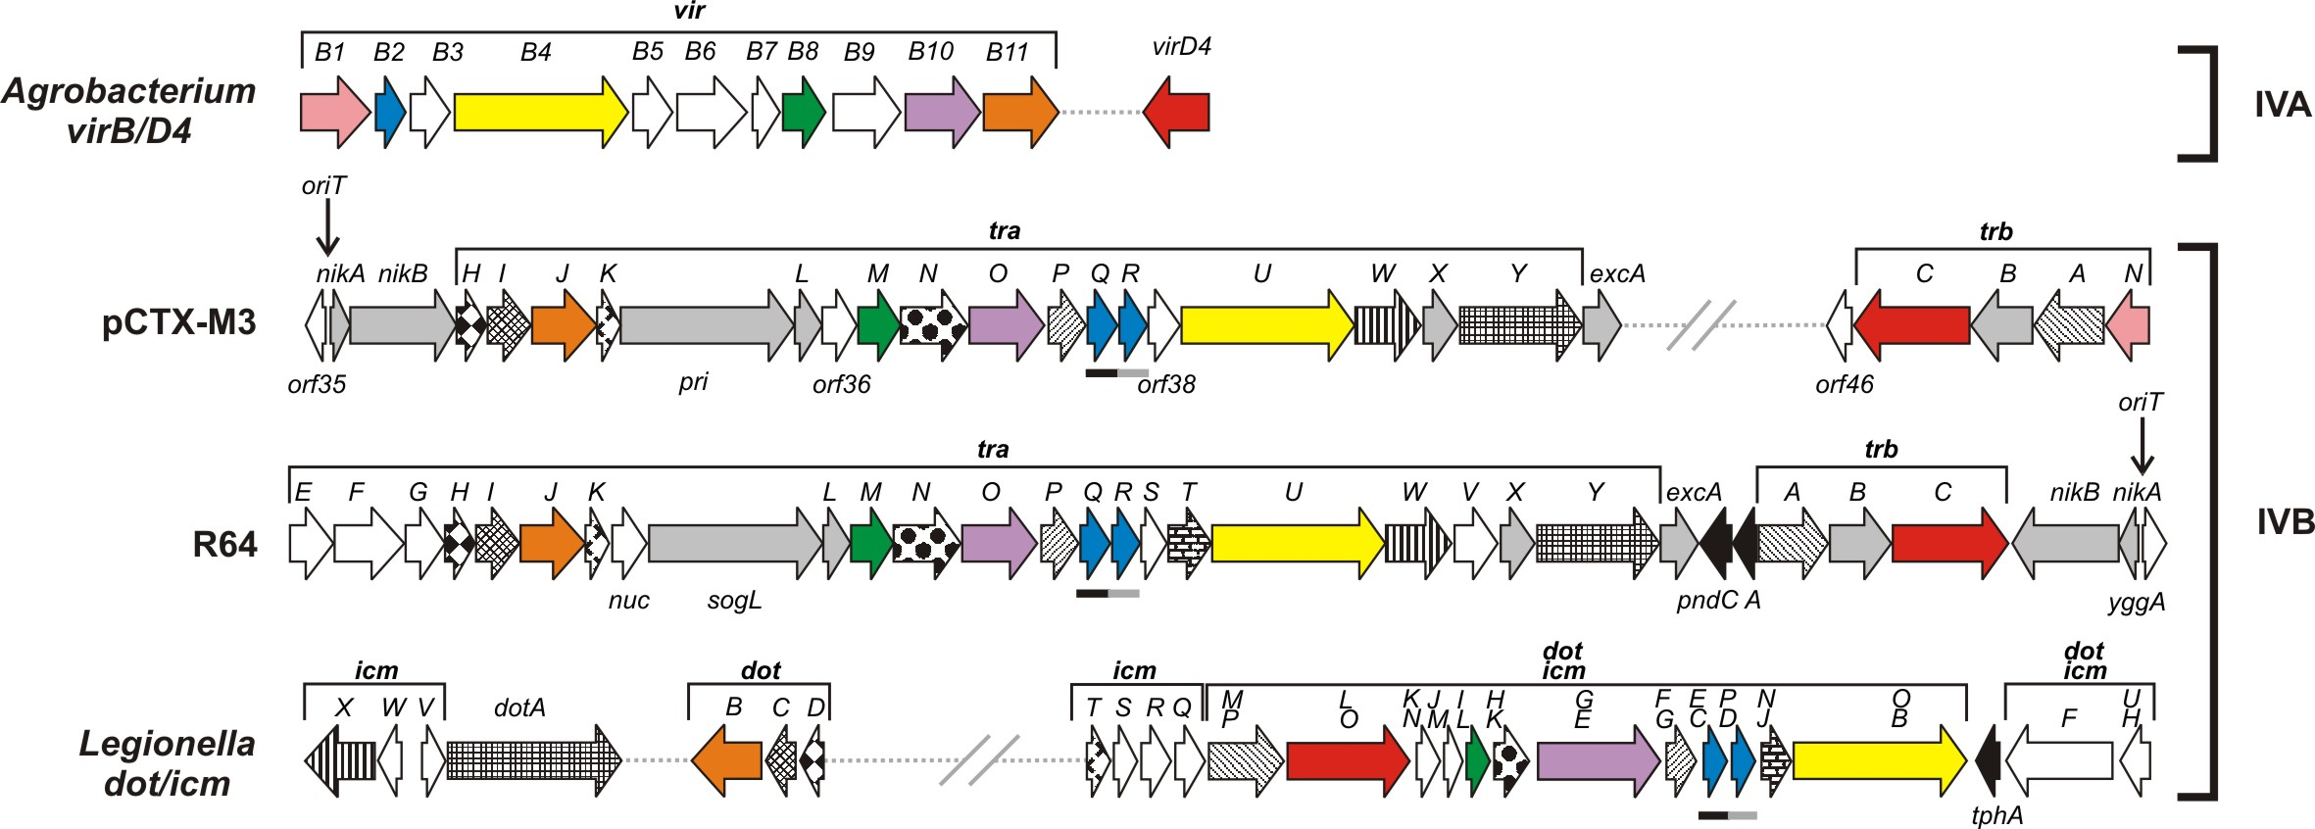

Fig. 2. Deletion analysis of the pCTX-M3 transfer region.
(A) Conjugative transfer efficiency of pCTX-M3 derivatives in liquid mating. (B) Conjugative transfer efficiency of pCTX-M3 derivatives (light grey) and pCTX-M3 derivatives complemented with plasmids bearing the relevant genes (dark grey) in filter mating. # undetectable transfer (< 10⁻⁷), * complementation not analysed. Each result is the mean of at least three experiments. Error bars indicate the SD.
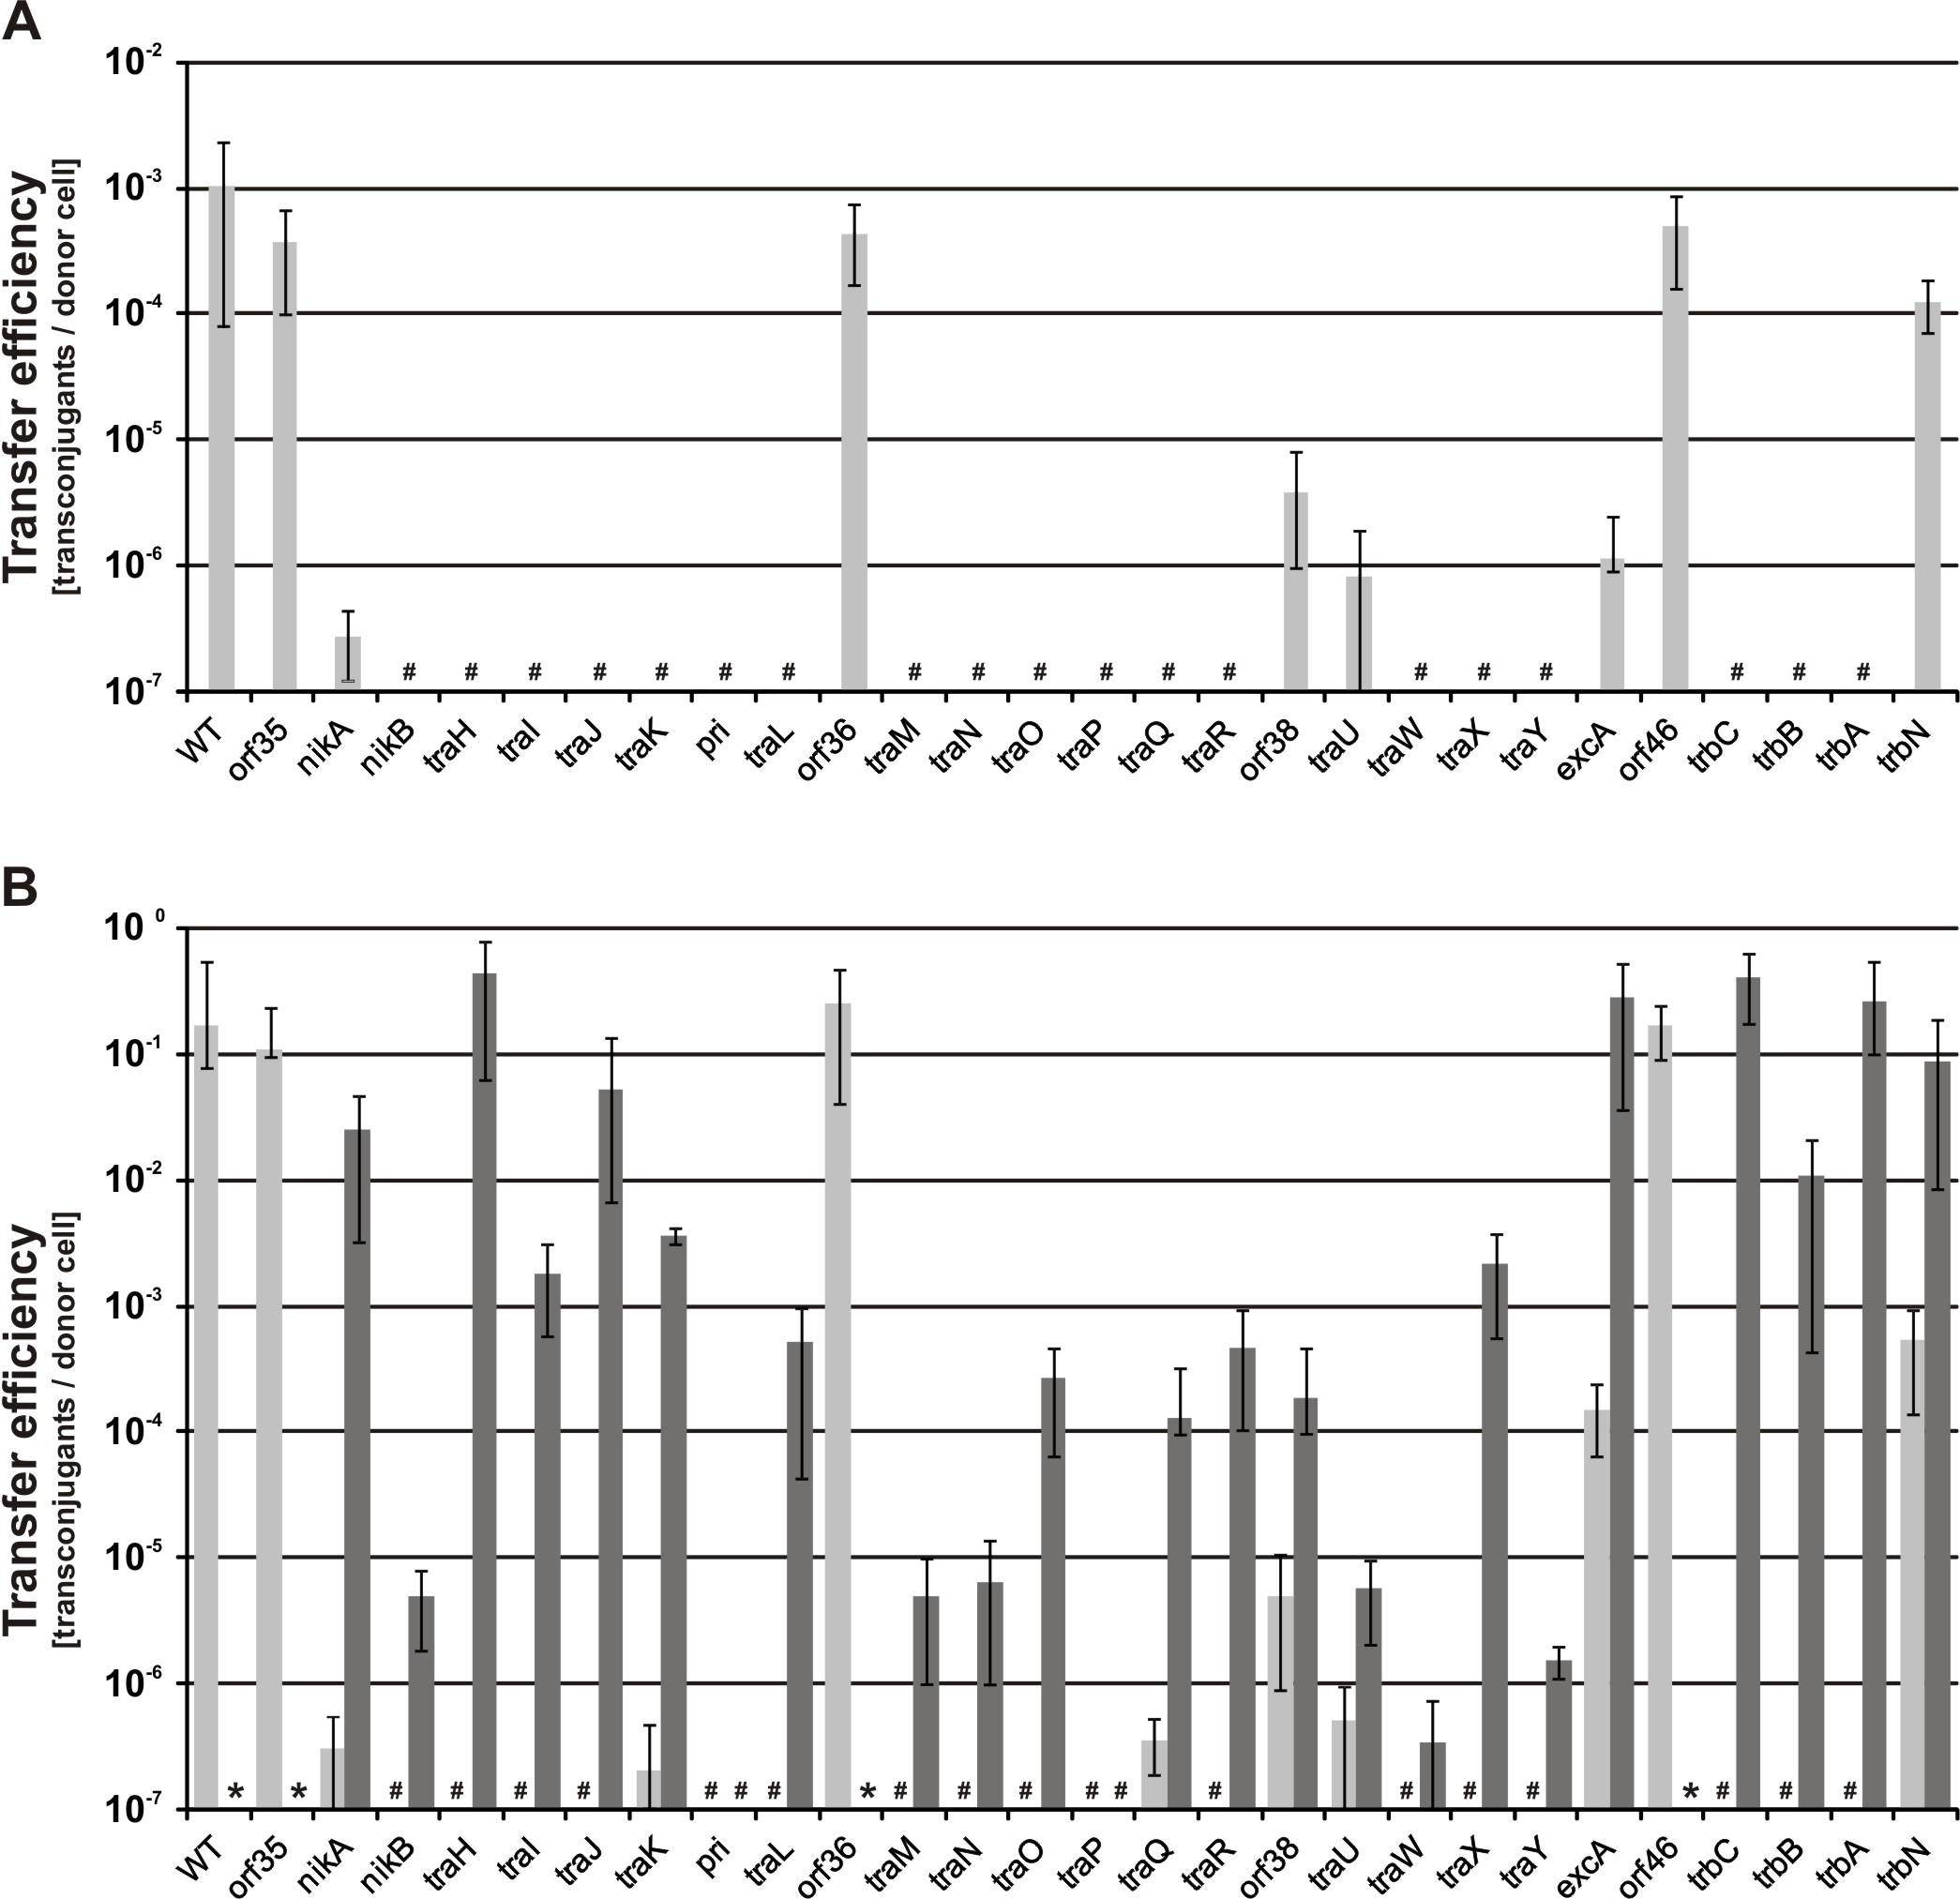
Fig. 3. Transcript levels of genes in the pCTX-M3 plasmid deletion derivatives.
(A) Transcript levels of the complementing genes (in bold) in the respective deletion derivatives. (B) Transcript levels of genes (in bold) located directly downstream of the deleted gene in the respective pCTX-M3 deletion derivatives (light grey) complemented with the appropriate plasmid (dark grey). Each result is the mean value of biological triplicates normalized to the transcript level of the appropriate gene in the BW25113 (pCTX-M3) strain. Error bars indicate the SD.
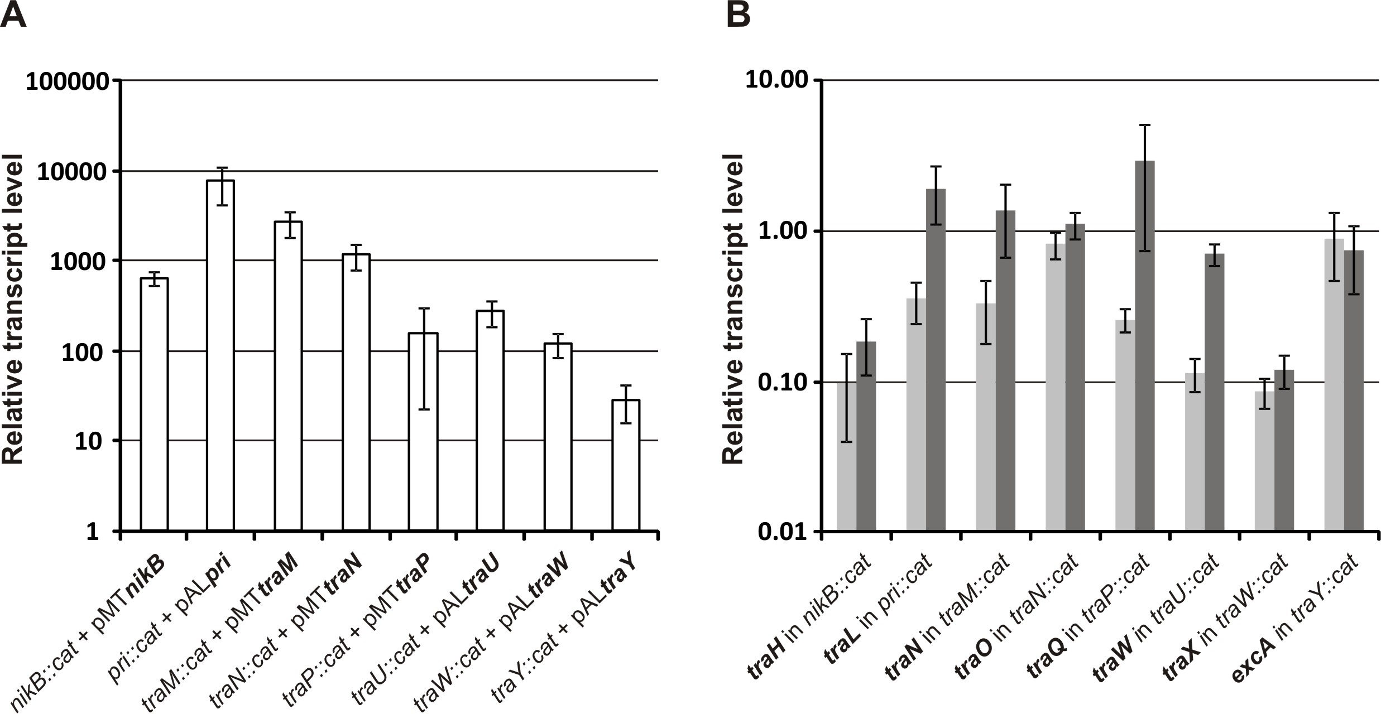

Fig. 4. Conjugative transfer efficiency of pCTX-M3 derivatives with the cat gene eliminated.
Conjugative transfer efficiency of pCTX-M3 (light grey) and pCTX-M3 derivatives (pCTX-M3ΔnikB, pCTX-M3ΔtraP, pCTX-M3ΔtraW, pCTX-M3ΔtraY, and pCTX-M3Δpri) complemented with plasmids bearing the appropriate genes (dark grey) in filter mating. vec empty vector, # undetectable transfer (< 10⁻⁷). Each result is the mean of at least five experiments. Error bars indicate the SD.
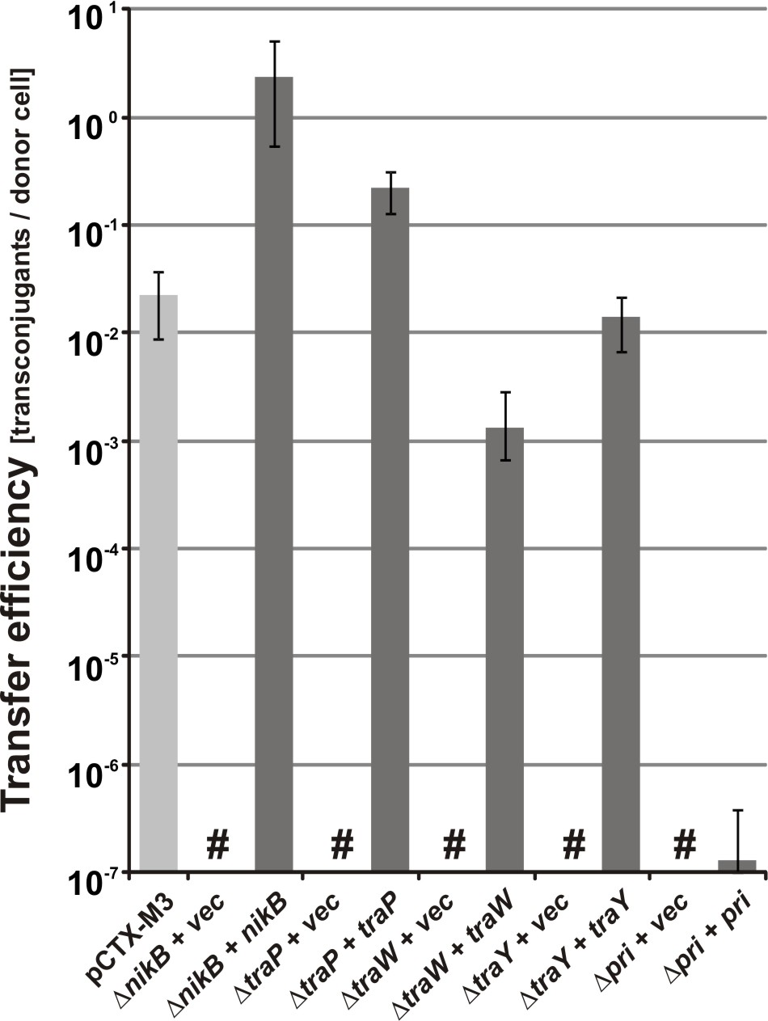

Fig. 5. Mobilization efficiency of pToriT for different pCTX-M3 derivatives.
Conjugative transfer efficiency of pCTX-M3 (light grey) and mobilization efficiencies of pToriT (dark grey) by pCTX-M3 or its deletion derivatives pCTX-M3orf35::cat, pCTX-M3orf36::cat and pCTX-M3orf46::cat as helper plasmids into recipient E. coli (A) and A. tumefaciens (B) cells. # undetectable transfer (< 10⁻⁷). Transconjugants with pCTX-M3 were selected on gentamicin; those with pToriT, on kanamycin. Each result is the mean of six experiments. Error bars indicate the SD. * P < 0.05, ** P < 0.01
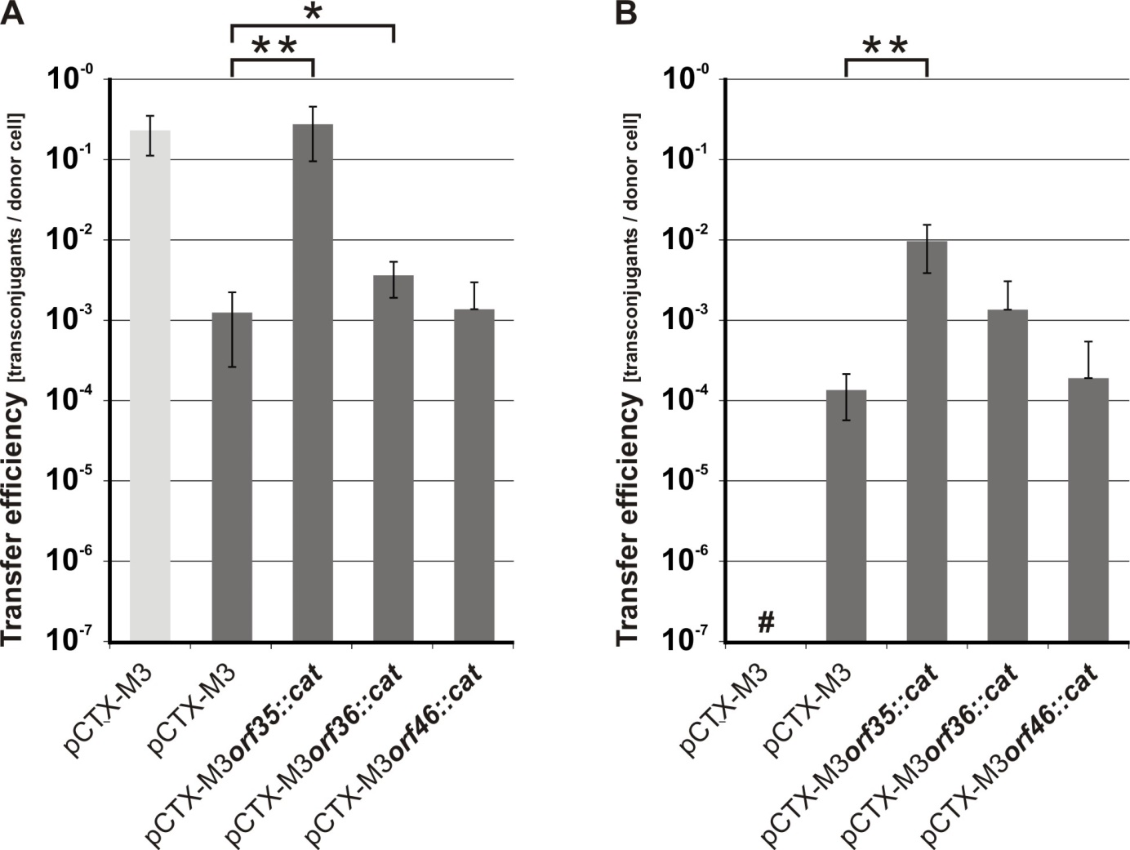

Fig. 6. Effect of orf35 and orf36 on the efficiency of pABB20oriT mobilization.
Mobilization efficiency of pABB20oriT into E. coli recipient cells by respective helper plasmids: pCS (pCTX-M3 devoid of all antibiotic resistance genes except bla_{TEM-1} and bla_{CTX-M-3}) (light grey) and its derivatives (A) pC35S (dark grey) and (B) pC36S (dark grey) in the presence of pAL3 (vector), pALorf35 (orf35) or pALorf36 (orf36). Relative transcript levels of nikA, nikB and traH in E. coli strains bearing pCTX-M3 deletion derivatives: pCTX-M3orf35::cat (C) or pCTX-M3orf36::cat (D). The transcript levels were normalized to those in cells bearing intact pCTX-M3. Each result is the mean of at least four experiments. Error bars indicate the SD.
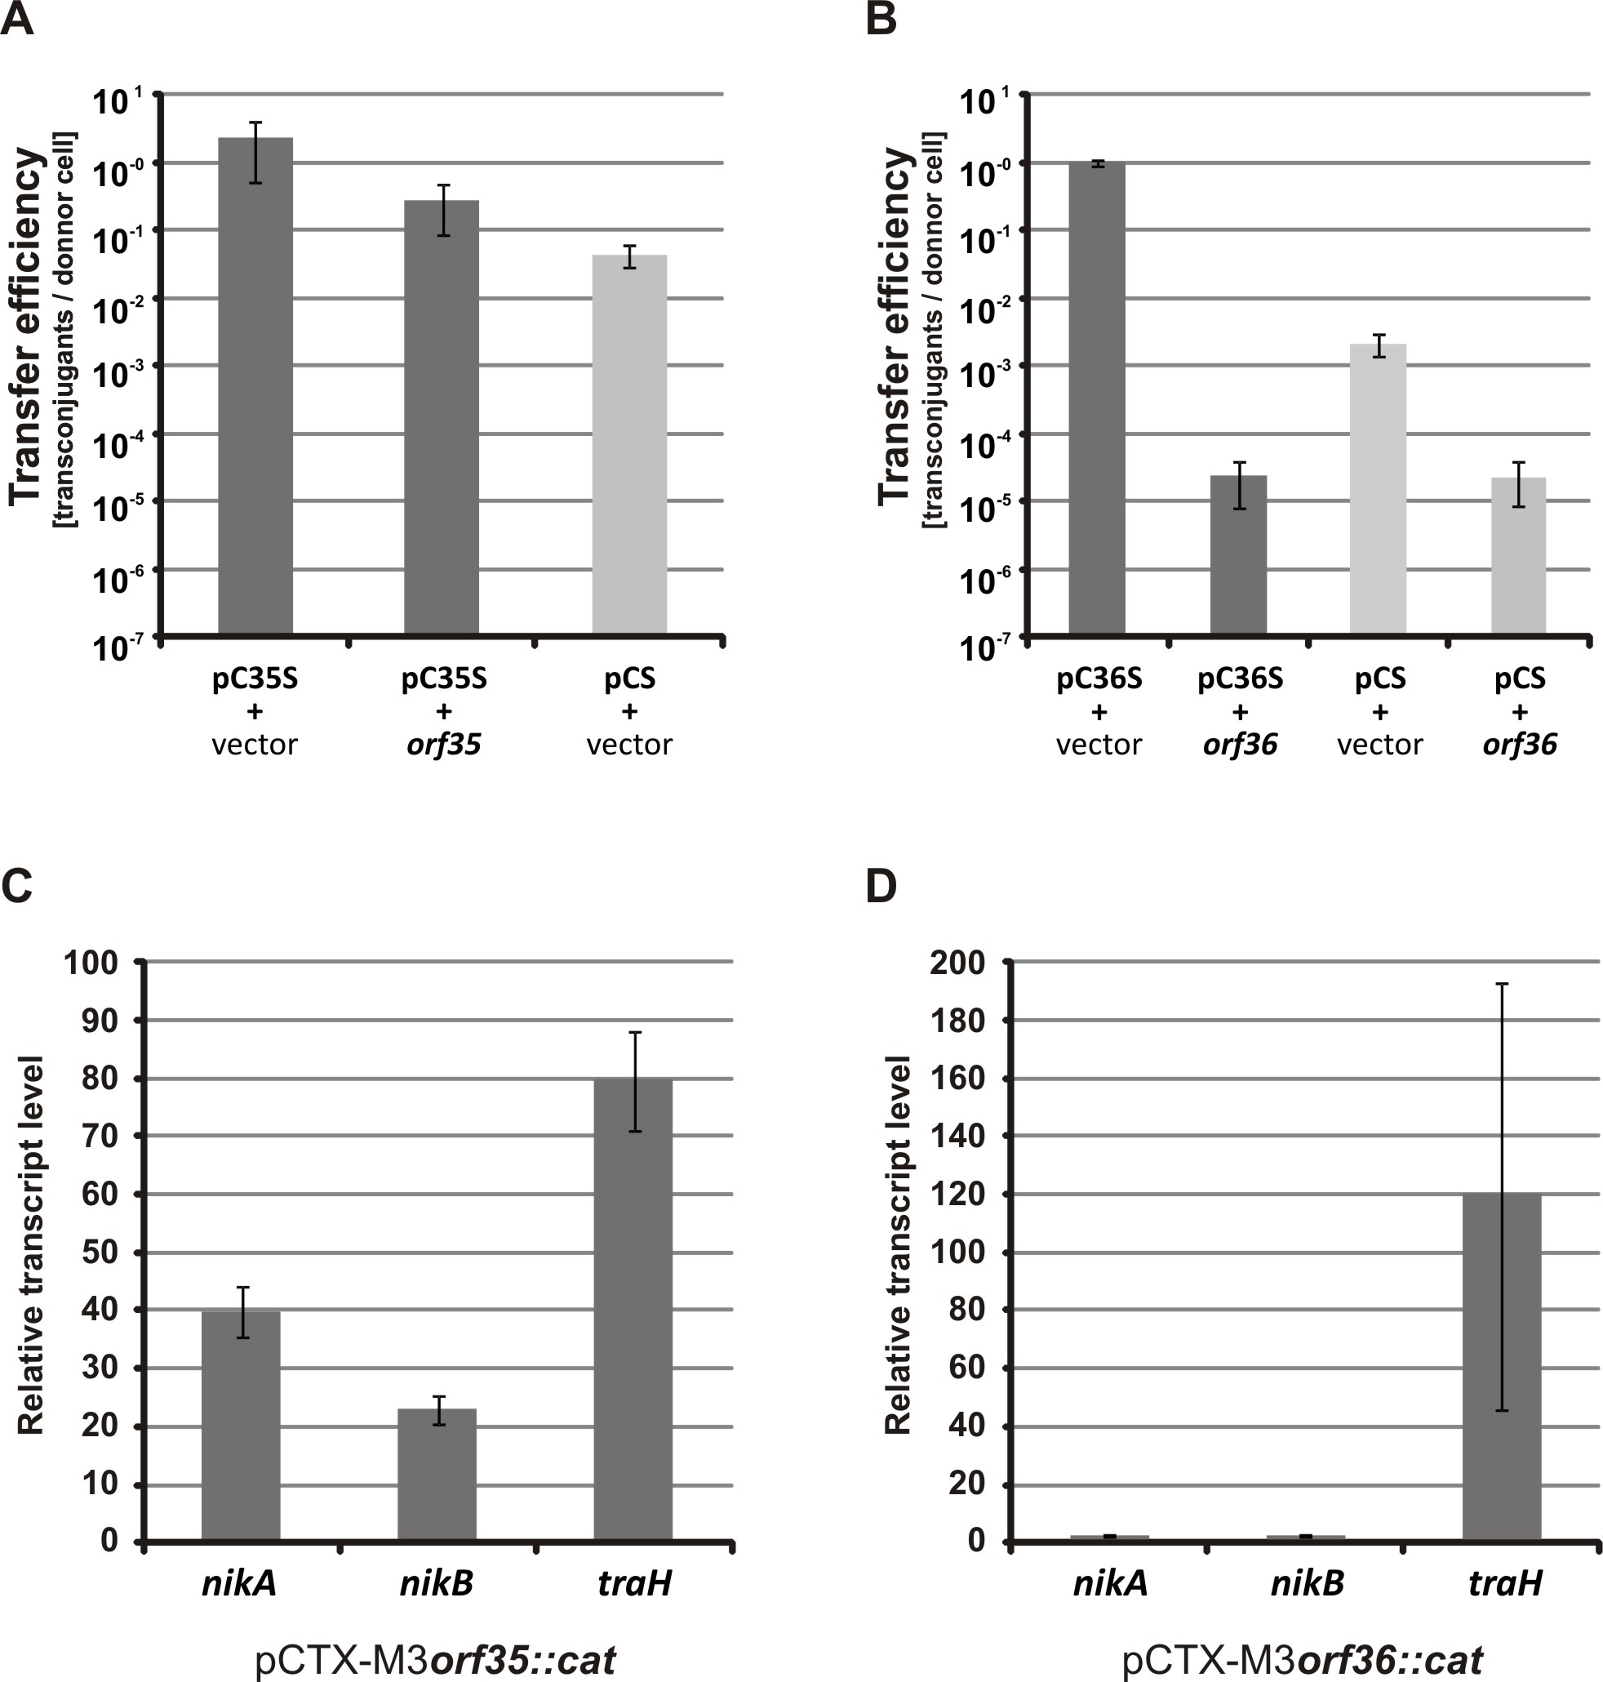
Fig. 7. Host ranges of the pCTX-M3 replicon and conjugation system.
Conjugative transfer efficiency of pCTX-M3 (light grey) and mobilization efficiency of pToriT (dark grey) from E. coli DH5α (pCTX-M3, pToriT) into E. coli, A. tumefaciens, R. eutropha and P. putida as recipients. Each result is the mean of at least three experiments. # undetectable transfer (< 10⁻⁷). Error bars indicate the SD.
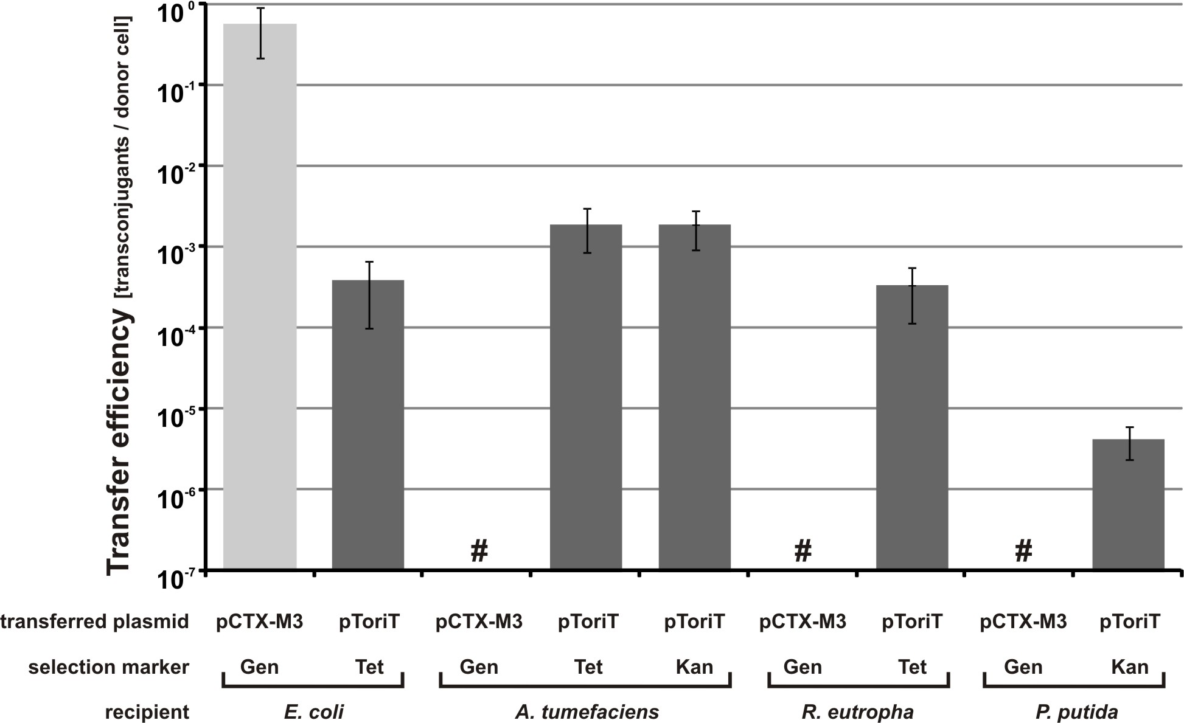

Tables
Table 1. Bioinformatic analysis of the predicted proteins encoded in the transfer region of pCTX-M3.
Protein | Size¹ | MW²  (kDa) | pI³ | SP⁴ | TMH⁵ | Motif⁶ found/putative function | Homologues⁷ in IncI1 plasmid and  Legionella pneumophila (L. pn.) dot/icm  (% aa sequence identity/% aa sequence similarity)
Orf35 | 121 | 9.0 | 13.57 | no | no |  | aa 6-108 (32 /53) to YggA of R64
NikA | 105 | 11.6 | 9.41 | no | no | helix-turn-helix motif/nickase accessory protein | aa 3-101 (30/62) to NikA of R64
NikB | 658 | 75.1 | 9.53 | no | no | relaxase domain/ nickase (Rlx)⁸ | aa 1-388 (31/48) to NikB of ColIb-P9
TraH | 166 | 18.7 | 9.77 | yes | 1 | lipoprotein⁹/ CTS | aa 70-157 (45/65) to TraH of ColIbP9
TraI | 259 | 29.2 | 9.33 | yes | 1 | / CTS | aa 29-258 (48/65) to TraI of ColIb-P9  aa 3-258 (28/46) to DotC of L. pn.
TraJ | 387 | 43.3 | 6.05 | no | 1 | GSPIIE domain with Walker motifs A and B / ATPase VirB11-like (TivB11)⁸ | aa 11-369 (40-63) to TraJ of ColIb-P9  aa 11-377 (31/51) to DotB of L.pn.
TraK | 86 | 10.3 | 10.55 | no | 2 |  | aa 6-82 (41/61) to TraK of ColIb-P9  aa 6-80 (25/45) to IcmT of L. pn.
Pri | 1070 | 117.6 | 5.00 | no | no | /primase (Pri)⁸ | aa 4-556 (30/45) and aa 389-954 (23/39) to SogL of R64
TraL | 170 | 17.9 | 6.27 | yes | 1 |  | aa 14-114 (33/58) to TraL of ColIb-P9
Orf36 | 221 | 25.0 | 9.41 | no | 3 |  | None
TraM | 260 | 29.5 | 5.72 | no | 1 | / VirB8-like (TivB8)⁸ | aa 53-254 (26/53) to TraM of ColIb-P9  aa 73-257 (31/53) to DotI (IcmL) of L.pn.
TraN | 383 | 40.7 | 5.97 | yes | 1 | / CTS | aa 119-382 (45/58) to TraN of ColIb-P9  47-381 (29/44) to DotH (IcmK) of L. pn.
TraO | 449 | 47.6 | 5.90 | no | 1 | VirB10 domain / CTS VirB10-like (TivB10)⁸ | aa 4-419 (30/45) to TraO of ColIb-P9  aa 208-390 (41/50) to DotG (IcmE) of L. pn
TraP | 234 | 24.7 | 9.20 | no | 1 | / CTS | aa 22-234 (23/40) to TraP of ColIb-P9
TraQ | 176 | 18.5 | 8.49 | no | 3 | / pilin | aa 32-174 (35/54) to TraQ of ColIb-P9  aa 5-172 (25/43) to DotE (IcmC) of L. pn.
TraR | 129 | 13.5 | 9.72 | yes | 3 | / pilin | aa 12-127 (26/47) to TraR of ColIb-P9
Orf38 | 164 | 18.9 | 6.96 | no | no |  | None
TraU | 1016 | 114.1 | 6.24 | no | 3 | Walker motifs A and B / ATPase VirB4-like (TivB4)⁸ | aa 1-1006 (35/56) to TraU of ColIb-P9  aa 27-1008 (28/47) to DotO (IcmB) of L. pn.
TraW | 402 | 43.3 | 8.58 | yes | 3 |  | aa 14-401 (36/55) to TraW of ColIb-P9
TraX | 216 | 24.1 | 9.23 | no | 3 |  | aa 92-201 (31/48) to TraX of ColIb-P9
TraY | 726 | 78.3 | 5.58 | yes | 7 | / Entry Exclusion system | aa 4-725 (37/55) to TraY of ColIb-P9  aa 4-217 (25/45) and aa 526-683 (25/46) to DotA of L. pn.
ExcA | 217 | 25.4 | 9.28 | yes | 3 | / Entry Exclusion system | aa 55-132 (31/47) to ExcA of ColIb-P9
Orf46 | 169 | 19,2 | 9.79 | no | no | transcriptional regulator of ROS / MUCR superfamily | None
TrbC | 695 | 79.5 | 5.08 | no | 3 | Walker motifs A and B / CP (Cpl)⁸ | aa 29-609 (34/52) to TrbC of ColIb-P9  aa 107-599 (30/50) to DotL (IcmO) of L. pn.
TrbB | 338 | 37.4 | 9.10 | no | 1 | thioredoxin-like domain / | aa 121-256 (37/47) to TrbB of ColIb-P9
TrbA | 435 | 49.1 | 6.43 | no | 3 | / CP (Cpl)⁸ complex | aa 13-124 (41/ (57) to TrbA of ColIb-P9  aa 80-368 (24/44) to DotM (IcmP) of L. pn.
TrbN | 131 | 14.7 | 9.14 | no | no | lytic transglycosylase signature / Slt⁸ | None
¹ aa
² molecular weight calculated with the use of the ProtParam tool of Expasy
³ pI calculated with the use of the ProtParam tool of Expasy
⁴ SP, signal peptide determined with the use of SignalP v.2.0
⁵ TMH, transmembrane helices determined with the use of TMPred
⁶ determined with MotifScan,
⁷ determined with BLASTp
⁸ protein name according to (51)
⁹ determined with LipoP
CP – coupling protein, CTS – core transmembrane subcomplex
Table 2. Strains and plasmids used in the study
Name | Relevant feature or construction description |  | Source
Escherichia coli | DH5α | ϕ80 lacZΔM15 deoR endA1 gyrA96 hsdR17 recA1 relA1 supE44 thi-1 Δ(lacZYA argF)U169 | (52)
 | BW25113 | Δ(araD-araB)567 Δ(rhaD-rhaB)568 ΔlacZ4787 (::rrnB-3) hsdR514 rph-1 | (27, 53)
 | JE2571 | leu, thr, thi, lacY, thy, pil, fla | (25)
 | JE2571Rif^{R} | JE2571 selected on LB + rifampicin | This work
Agrobacterium tumefaciens | LBA1010 | Rif^{R} | (54)
Pseudomonas putida | KT2442 | Rif^{R} | (55)
Ralstonia eutropha | JMP228 | Rif^{R}, gfp, Km^{R} | (56)
pCTX-M3 | IncM plasmid, 89468 bp, Ap^{R}, Pi^{R}, Azt ^{R}, Caz ^{R}, Cft^{R}, Km^{R}, Gen^{R}, To^{R} |  | (14, 15)
pACYC184 | vector (oriV_{P15A}, Tc^{R}, Cm^{R}) |  | (57)
pAL3 | pUC18 BstUI fragment containing the lacZ gene and MCS, cloned into ScaI-PvuII pACYC184 (oriV_{P15A}, Tc^{R}) |  | This work
pBBR1 MCS-2 | vector, (oriV_{pBBR1}, oriT_{RK2}, Km^{R}) |  | (58)
pKD3 | template for generation of the PCR products used in gene disruption, pir-dependent replicon (oriV_{R6Kγ}, Ap^{R}, Cm^{R}) |  | (27)
pKD46 | λRed recombinase expression plasmid, repA101(ts), (oriV_{R101}, Ap^{R}) |  | (27)
pCP20 | FLP recombinase expression plasmid, repA101(ts), (oriV_{R101}, Ap^{R}, Cm^{R}) |  | (59)
pMT5 | pACYC184 SspI-MscI fragment containing a gene for Tc^{R} cloned into DraI-SspI pUC18, (oriV_{pMB1}, Tc^{R}) |  | This work
pUC18 | cloning vector, (oriV_{pMB1}, Ap^{R}) |  | (60)
pABB20 | cloning vector, (oriV_{RA3}, Km^{R}) |  | (61)
pOriT | oriT_{pCTX-M3} (nucleotides 31616-31721) cloned into the pUC18-derived pMI3 vector, (oriV_{pMB1}, Cm^{R}) |  | (14)
pALoriT | pOriT EcoRI-PstI fragment containing oriT_{pCTX-M3} cloned into EcoRI-PstI pAL3, (oriV_{p15A}, Tc^{R}) |  | This work
pBBToriT | pALoriT XbaI-PvuI fragment containing the tetracycline resistance gene and oriT_{pCTX-M3} cloned into PvuI-XbaI pBBR1 MCS-2, (oriV_{pBBR1}, Tc^{R}) |  | This work
pToriT | pBBToriT derivative, fragment BsaI-Bst1107I with MOB_{RK2} removed (oriV_{pBBR1}, Km^{R}, Tc^{R}) |  | This work
pABB20oriT | pOriT BamHI-PstI (blunted) fragment containing oriT_{pCTX-M3} cloned into BamHI-PstI pABB20, (oriV_{RA3}, Km^{R}) |  | This work
pHS11 | pCTX-M3 derivative containing SexAI-SnaBI (nucleotides 36645-40568) and NruI-HindIII (nucleotides 51663-58653) fragments |  | This work
pCS | pCTX-M3 largest SalI fragment (nucleotides: 1- 595520 and 79940-89468) self-ligated, Cft^{R} |  | This work
pC35S | pCTX-M3orf35::cat largest SalI fragment self-ligated, Cft^{R}, Cm^{R} |  | This work
pC36S | pCTX-M3orf36::cat largest SalI fragment self-ligated, Cft^{R}, Cm^{R} |  | This work
Azt – aztreonam, Cft – cefotaxime, Caz – ceftazidime, Gen – gentamicin, Pi – piperacillin, To – tobramycin, (ts) – thermosensitive replication

