Cardiovascular disease in kidney transplantation and its association with blood concentrations of cyclosporine and cyclosporine metabolites
Ewa HRYNIEWIECKA^{1,2}, Jolanta ZEGARSKA², Dorota ZOCHOWSKA², Emilia SAMBOROWSKA³, Radoslaw JAZWIEC³, Maciej KOSIERADZKI⁴, Slawomir NAZAREWSKI⁵, Michal DADLEZ³, Leszek PACZEK^{2,6}

¹Department of Clinical Nursing, Medical University of Warsaw, 27 Ciolka St, Warsaw, Poland; tel. 0048228360972; fax 0048228360972
²Department of Immunology, Transplant Medicine and Internal Diseases, Medical University of Warsaw, 59 Nowogrodzka St, Warsaw, Poland; tel. +48225021461; fax +48225022127
³Institute of Biochemistry and Biophysics, Polish Academy of Science, 5a Pawinskiego St, Warsaw, Poland; tel. 0048225923476; fax 0048226584766
⁴Department of General and Transplantation Surgery, Medical University of Warsaw, 59 Nowogrodzka St, Warsaw, Poland; tel. 0048225021126; fax 0048225022155
⁵Department of General, Vascular and Transplant Surgery, Medical University of Warsaw, 1a Banacha St, Warsaw, Poland; tel. 0048225992467; fax 0048225991468
⁶Department of Bioinformatics, Institute of Biochemistry and Biophysics, Polish Academy of Sciences, 5a Pawinskiego St, Warsaw, Poland; tel. 0048225921108; fax 0048225922190

Ewa HRYNIEWIECKA; ewa.hryniewiecka@wum.edu.pl
Jolanta ZEGARSKA; zegarska@yahoo.com
Dorota ZOCHOWSKA; d_zochowska@wp.pl
Emilia SAMBOROWSKA; emi.sambor@gmail.com
Radoslaw JAZWIEC; rjazwiec@gmail.com
Maciej KOSIERADZKI; mpkosieradzki@gmail.com
Slawomir NAZAREWSKI; slawomir.nazarewski@wum.edu.pl
Michal DADLEZ; michald@poczta.ibb.waw.pl
Leszek PACZEK; leszek.paczek@gmail.com

Corresponding author: Leszek Paczek, Department of Immunology, Transplant Medicine and Internal Diseases, Medical University of Warsaw, 59 Nowogrodzka St, Warsaw 02-006, Poland; tel. +48225021461; fax +48225022127; leszek.paczek@gmail.com

Grant information: This work was supported by Polish National Science Centre (grant no. 2013/09/B/NZ2/00275) and Polish National Centre of Research and Development (grant no. NR13014410).
Key words: cyclosporine, kidney transplantation, cardiovascular diseases, diastolic blood pressure
Abbreviations:
BMI, body mass index
CNI, calcineurin inhibitor
CsA, cyclosporine A
DBP, diastolic blood pressure
DiH-CsA, dihydro-cyclosporine
DM, diabetes mellitus
dMC-CsA, desmethylcarboxy-cyclosporine
eGFR, estimated glomerular filtration rate
KTX, kidney transplantation
LC-MS/MS, liquid chromatography-tandem mass spectrometry method
MDRD, Modification of Diet in Renal Disease
SBP, systolic blood pressure
TriH-CsA, trihydro-cyclosporine
Tables: 2
Figures: 2

Abstract
Cyclosporine A (CsA) is the first calcineurin inhibitor used as immunosuppressive agent. Its administration is associated with multiple adverse effects including cardiovascular diseases (CVDs), but their mechanisms have not been fully elucidated. Cyclosporine metabolites are not well-studied in this context. The study was aimed at analysis of CVDs incidence and its association with concentrations of cyclosporine and its metabolites.
60 patients after kidney transplantation (KTX) taking immunosuppressive regimen including CsA participated in the study. There were 22 females (36.67%) and 38 males (63.33%), mean age 51.73 years, mean 109.38 months after KTX.
We observed correlation between mean diastolic blood pressure (DBP) and concentrations of metabolite to parent drug ratios of AM1-CsA/CsA (r=0.35, p=0.006), dihydroxy-CsA/CsA (r=0.42, p=0.001), trihydroxy-CsA/CsA (r=0.42; p=0.003) and desmethyl-carboxy-CsA/CsA (r=0.65, p=0.003). There were no significant associations of other CsA metabolites’ parameters with CVDs (coronary disease, hypertension, stroke, arrhythmia, diabetes mellitus, obesity).
Study results suggest that blood pressure increase associated with CsA therapy could be caused by CsA metabolites that influence mainly DBP levels. Lack of such differences in relation with other CVDs may suggest that more complex mechanisms are involved in the development of cardiovascular injury and disease after kidney transplantation.

Introduction
Cyclosporine A (CsA) is the first calcineurin inhibitor (CNI) introduced as an immunosuppressive agent in transplant medicine and its use has greatly improved the survival of graft in kidney transplantation [1-3]. Cyclosporine is biotransformated to over thirty metabolites [4, 5]. The main locations of CsA metabolism are liver, gastrointestinal tract and kidney. The clinical significance, immunosuppressive and toxic effects of cyclosporine metabolites has been studied for the last 30 years, which has not helped to explain all the issues involved. Furthermore, depending on specificity of used antibodies various immunoassays are characterised by various grades of interference with cyclosporine metabolites [6]. Due its precision and high sensitivity liquid chromatography-tandem mass spectrometry method (LC-MS/MS) is a gold standard in measurement of drugs and their metabolites, including cyclosporine A [7].
Methods
This was an open trans-sectional one-centre study including kidney transplant patients taking cyclosporine as an element of their immunosuppressive regimen. Consecutive 60 KTX patients attending outpatient clinic from May 2014 to April 2016 who agreed to participate in the study were included. Blood samples for CsA and its metabolites were drawn in occasion of routine blood testing 12 hours after administration of the evening dose of CsA (through levels). Graft function was assessed by estimated glomerular filtration rate (eGFR) calculated from Modification of Diet in Renal Disease formula (MDRD) [8]. Patients with eGFR <30 ml/min./1.73 m2 were classified as kidney graft dysfunction group. Data on cardiovascular diseases and diabetes mellitus (DM) were established based on patients’ medical records. Analysed systolic (SBP) and diastolic (DBP) blood pressure were calculated as a mean of three blood pressure measurements. Diagnosis of obesity was based on calculated body mass index (BMI) ≥35 kg/m².
Whole blood concentration of cyclosporine and its metabolites: AM1, AM9, dihydro-cyclosporine (DiH-CsA), trihydro-cyclosporine (TriH-CsA) and desmethylcarboxy-cyclosporine (dMC-CsA) were quantified at the Institute of Biochemistry and Biophysics using liquid chromatography-tandem mass spectrometry method (LC-MS/MS). Analyzes were performed using Waters Acquity Ultra Performance Liquid Chromatograph coupled with Waters TQ-S triple-quadrupole mass spectrometer (Waters Corporation, Milford, US). The compounds were separated using a Waters BEH C18 column (1.7 µm; 2.1 mm x 50 mm). Liquid chromatography method and mass spectrometer parameters were described previously [9]. The standards for CsA-D4 and its metabolites were purchased from Toronto Research Chemicals Inc. (North York, Canada), and CsA was obtained from Sigma-Aldrich (Sigma-Aldrich, St. Louis, US). The calibration curves range were 0.5-1000 ng/ml, 2-1500 ng/ml and 0.2-100 ng/ml for CsA, AM1 and AM4N, respectively. Concentration of AM9 was calculated using AM1 calibration curve, other CsA metabolites concentrations were quantified using CsA calibration curve.
All data were analysed using Statisitca 13.1 (Dell, Texas, US) software. Continuous variables were reported as mean values ± SD for normally distributed data and median and range for not-normally distributed data. Normally distributed data were subjected to parametric statistical analysis, nonparametric methods were used to test non-normally distributed variables. Multivariate analyses were adjusted for patients’ age, gender, eGFR, DM and CsA blood concentration. A p value of <0.05 was considered significant.
Results
36.67% (22) of patients were females, median age 51.73 (12.05) years, 109.38 (68.26) months after kidney transplantation. Table 1 shows patients’ clinical data. In univariate analyses, we have observed significant positive correlations of diastolic blood pressure with metabolite to parent drug (M/D) cyclosporine ratios of AM1, DiH-CsA, TriH-CsA and dMC-CsA (Figure 1). There were no such correlations with SBP and eGFR values, nor correlation of DBP with CsA blood concentration. Multivariate analysis confirmed that DBP was independently and significantly associated with AM1/CsA, DiH-CsA/CsA, TriH-CsA/CsA and dMC-CsA/CsA (Table 2).
Comparison of cyclosporine M/D ratios between subgroups divided basing on diagnosis of obesity, diabetes mellitus, arterial hypertension, coronary disease, stroke, atherosclerosis, cardiac arrhythmia, total cardiovascular disease, hypercholesterolemia, hypertriglyceridemia, hyperuricemia, and kidney graft dysfunction revealed significantly lower AM9/CsA in patients with obesity (54.89 [36.7-79.8] vs. 73.93 [27.9-139.8], p=0.0002) and DM (59.59 [36.7-84.4] vs. 70.47 [27.9-139.9], p=0.01) (Figure 2), and higher AM9/CsA in patients with stroke (83.55 [81.5-97.2] vs. 64.58 [27.9-139.9], p=0.037). AM1/CsA ratio was higher in patients with hyperuricemia (434.4 [206.2-937.7] vs. 365.6 [264.8-574.4], p=0.01). Regarding CsA blood concentration we have not observed such differences.
Discussion
It is hypothesised that approximately 65% of cyclosporine may be present in the blood in the form of various metabolites [10]. The search of causes of cyclosporine toxicity has led to increased interest in CsA metabolites [11-15]. In the early 1990’ the immunosuppressive and toxic actions of cyclosporine metabolites were studied extensively but their results were mostly inconclusive or contradictory [4, 14, 16-19]. It should be also emphasized that results of animal and in vitro studies cannot be directly extrapolated to the clinical situation. Studies conducted in the last decades of XX century suggested direct nephrotoxic effect of some cyclosporine metabolites [14, 15]. The primary CsA metabolite AM1 is found in high concentrations in the blood and has some immunosuppressive activity [17, 20]. It was also observed that AM1 and AM4N cause decrease of GFR and some toxic effects [14, 18]. It is suggested that metabolites AM19 and AM1c9 increase levels of vasoconstrictive endothelin and are associated with nephrotoxicity [12, 13]. Association of dihydroxylated CsA metabolites with nephrotoxicity was also reported [21]. Roby et al. reported direct effect of AM1, AM9 and AM4N on decrease of GFR in isolated perfused rat kidney [14]. There were no such associations of eGFR with CsA and its M/D ratios observed in our study. However, association of AM1/CsA, DiH-CsA/CsA, TriH-CsA/CsA and dMC-CsA/CsA ratios with higher DBP values may be a consequence of vasoconstrictive action of these metabolites. We are currently conducting a larger prospective study, which will also test this hypothesis.
We have found higher AM1/CsA ratios in hypertriglyceridemic and hyperuricemic patients that were not observed by other authors. However, our results have confirmed Akhlaghi et al. report of lower AM9/CsA ratio in diabetic patients compared to non-diabetic kidney transplant recipients but we did not find such differences for other metabolite/parent drug ratios (AM1, AM19 and AM1c) [22]. The authors hypothesised that it could be the consequence of lower activity of some isoenzymes of cytochrome P450 in the course of diabetes [23]. The only previous study evaluating association of CsA metabolites with various laboratory parameters was study of Vollenbroeker et al. [24]. Most of the observed correlations included liver function parameters and serum creatinine correlated not only with AM1, AM9, AM19 and DiH-AM1 but also with parent drug concentration that does not exclude the adverse effect of cyclosporine itself.
In conclusion, we have revealed association of AM1, DiH-CsA, TriH-CsA and dMC-CsA metabolites to cyclosporine ratios with diastolic blood pressure suggesting influence of these metabolites on arterial pressure. There were no significant differences of metabolite/cyclosporine ratios in kidney transplant recipients diagnosed with arterial hypertension, coronary disease, atherosclerosis, cardiac arrhythmia, total cardiovascular disease, and kidney graft dysfunction.
References
1. Kahan BD, Van Buren CT, Flechner SM, Payne WD, Boileau M, Kerman RH. Cyclosporine immunosuppression mitigates immunologic risk factors in renal allotransplantation. Transpl Proc 1983;15:2469-78.
2. Group C.M.T.S. A randomized clinical trial of cyclosporine in cadaveric renal transplantation. N Eng J Med 1983;309(14):809-15.
3. Calne R, White DJ, Thiru S, Evans DB, McMaster P, Dunn DC et al. Cyclosporin A in patients receiving renal allografts from cadaver donors. Lancet 1978;2(8104-8105):1323-7.
4. Fahr A. Cyclosporine clinical pharmacokinetics. Clin Pharmacokinet 1993;24(6):472-95.
5. Radeke H, Christians U, Bleck JS, Sewing KF, Resch K. Additive and synergistic effects of cyclosporine metabolites on glomerular mesangial cells. Kidney Int 1991;39(6):1255-66.
6. Kelly P et Kahan BD. Review: metabolism of immunosuppressant drugs. Curr Drug Metab 2002;3(3):275-87.
7. Taylor PJ, Jones CE, Martin PT, Lynch S, Johnson AG, Pond SM. Microscale high-performance liquid chromatography-electrospray tandem mass spectrometry assay for cyclosporin A in blood. J Chromatogr B Biomed Sci Appl 1998:705:2.
8. Levey A, Coresh J, Greene T, Stevens LA, Zhang YL, Hendriksen S et al. Using standardized serum creatinine values in the modification of diet in renal disease study equation for estimating glomerular filtration rate. Ann Intern Med 2006;145(4):247-54.
9. Hryniewiecka E, Zegarska J, Zochowska D, Jazwiec R, Borowiec A, Samborowska E et al. Hydroxylated, hydroxymethylated, dihydroxylated, and trihydroxylated cyclosporine metabolites can be nephrotoxic in kidney transplant recipients. Transpl Proc 2016;48(5):1551-5.
10. Murthy J, Yatscoff RW, Soldin SJ. Cyclosporine metabolite cross-reactivity in different cyclosporine assays. Clin Biochem 1998;31(3):159-63.
11. Gonzalez Molina M, Morales JM, Marcen R, Campistol JM, Oppenheimer F, Serón D et al. Renal function in patients with cadaveric kidney transplants treated with tacrolimus or cyclosporine. Transpl Proc 2007;39(7):2167-9.
12. Christians U, Kohlhaw K, Budniak J, Bleck JS, Schottmann R, Schlitt HJ et al. Ciclosporin metabolite pattern in blood and urine of liver graft recipients. I. Association of ciclosporin metabolites with nephrotoxicity. Eur J Clin Pharmacol 1991;41(4):285-90.
13. Copeland K et Yatscoff RW. Comparison of the effects of cyclosporine and its metabolites on the release of prostacyclin and endothelin from mesangial cells. Transplantation 1992;53(3):640-5.
14. Roby K et Shaw LM. Effects of cyclosporine and its metabolites in the isolated perfused rat kidney. J Am Soc Nephrol 1993;4:168-77.
15. Stephens E, Bolderson I, Clark B, Kinsey S, Gooi HC, Cook G. The measurement of whole blood pre-treatment cyclosporine A: metabolite ratios predicts the onset of renal dysfunction in recipients of allogeneic stem cell transplantation. Ann Clin Biochem 2006;43(5):382-8.
16. Maurer G et Lemaire M. Biotransformation and distribution in blood of cyclosporine and its metabolites. Transpl Proc 1986;18(Suppl 5):25-34.
17. Sadeg N, Pham-Huy C, Claude JR, Rucay P, Bismuth H, Righenzi S et al. In vitro and in vivo comparative studies on immunosuppressive properties of cyclosporines A, C, D and metabolites M1, M17 and M21. Immunopharmacol Immunotoxicol 1993;15(2-3):163-77.
18. Copeland K, Thliveris JA, Yatscoff RW. Toxicity of cyclosporine metabolites. Ther Drug Monit 1990;12(6):525-32.
19. Karamperis N, Koefoed-Nielsen PB, Brahe P, Hojskov C, Egfjord M, Poulsen JH et al. Correlations between calcineurin phosphatase Inhibition and cyclosporine metabolites concentrations in kidney transplant recipients: implications for immunoassays. Basic Clin Pharm Toxicol 2006;98(6):569-74.
20. Kovarik JM, Vernillet L, Mueller EA, Freiburghaus R, Niederberger W, Kutz K. Cyclosporine disposition and metabolite profiles in renal transplant patients receiving a microemulsion formulation. Ther Drug Monit 1994;16(5):519-25.
21. Sewing K, Christians U, Kohlhaw K, Radeke H, Strohmeyer S, Kownatzki R et al. Biological activity of cyclosporine metabolites. Transpl Proc 1990;22:1129-34.
22. Akhlaghi F, Dostalek M, Falck P, Mendonza AE, Amundsen R, Gohh RY et al. The concentration of cyclosporine metabolites is significantly lower in kidney transplant recipients with diabetes mellitus. Ther Drug Monit 2012;34(1):38-45.
23. Marques MP, Coelho EB, Dos Santos NA, Geleilete TJ, Lanchote VL. Dynamic and kinetic disposition of nisoldipine enantiomers in hypertensive patients presenting with type-2 diabetes mellitus. Eur J Clin Pharmacol 2002;58(9):607-14.
24. Vollenbroeker B, Koch JH, Fobker M, Suwelack B, Hohage H, Müller U. Determination of cyclosporine and its metabolites in blood via HPLC-MS and correlation to clinically important parameters. Transpl Proc 2005;37(4):1741-4.

Variable | Mean / Median / N | SD / Range / %
eGFR [ml/min/1.73m2] | 47.08 | 16.53
CsA dose [mg/day] | 150 | 50 – 400
CsA dose/body mass [mg/kg/day] | 2.02 | 0.8 – 5.54
SBP [mmHg] | 133.77 | 11.98
DBP [mmHg] | 82.11 | 6.9
Diabetes mellitus | 20 | 33.33%
Arterial hypertension | 56 | 93.33%
Total Cardiovascular disease | 21 | 35.0%
Hypercholesterolemia | 48 | 80.0 %
Hypertriglyceridemia | 40 | 66.67%
Hyperuricemia | 30 | 50.0%
Table 1. Patients’ clinical and background characteristics. Data are expressed as mean values and standard deviation (SD) for normally distributed variables or median and range for not-normally distributed data or frequencies with percentages for quantitative variables; CsA, cyclosporine A; DBP, diastolic blood pressure; eGFR, estimated glomerular filtration rate; SBP, systolic blood pressure.

 | β | SE | p |  | β | SE | p
AM1/CsA | 0.40 | 0.14 | 0.006 | DiH-CsA/CsA | 0.46 | 0.12 | 0.0003
CsA | 0.21 | 0.13 | >0.05 | CsA | 0.05 | 0.12 | >0.05
Age | -0.27 | 0.13 | 0.039 | Age | -0.28 | 0.12 | 0.023
DM | 0.17 | 0.13 | >0.05 | DM | 0.14 | 0.12 | >0.05
Female sex | -0.09 | 0.14 | >0.05 | Female sex | -0.04 | 0.12 | >0.05
 | β | SE | p |  | β | SE | p
TriH-CsA/CsA | 0.47 | 0.13 | 0.0008 | dMC-CsA/CsA | 0.63 | 0.16 | 0.002
CsA | 0.11 | 0.13 | >0.05 | CsA | 0.05 | 0.17 | >0.05
Age | -0.24 | 0.14 | >0.05 | Age | -0.26 | 0.19 | >0.05
DM | 0.21 | 0.14 | >0.05 | DM | 0.32 | 0.20 | >0.05
Female sex | 0.04 | 0.13 | >0.05 | Female sex | 0.07 | 0.17 | >0.05
Table 2. Linear regression analysis of relationships between DBP and metabolite to cyclosporine ratios. β, standardized partial regression coefficient; CsA, cyclosporine A; DBP, diastolic blood pressure; DiH-CsA, dehydroxylated cyclosporine; dMC-CsA, desmethyl-carboxylated cyclosporine DM, diabetes mellitus; SE, standard error; TriH-CsA, trihydroxylated cyclosporine.

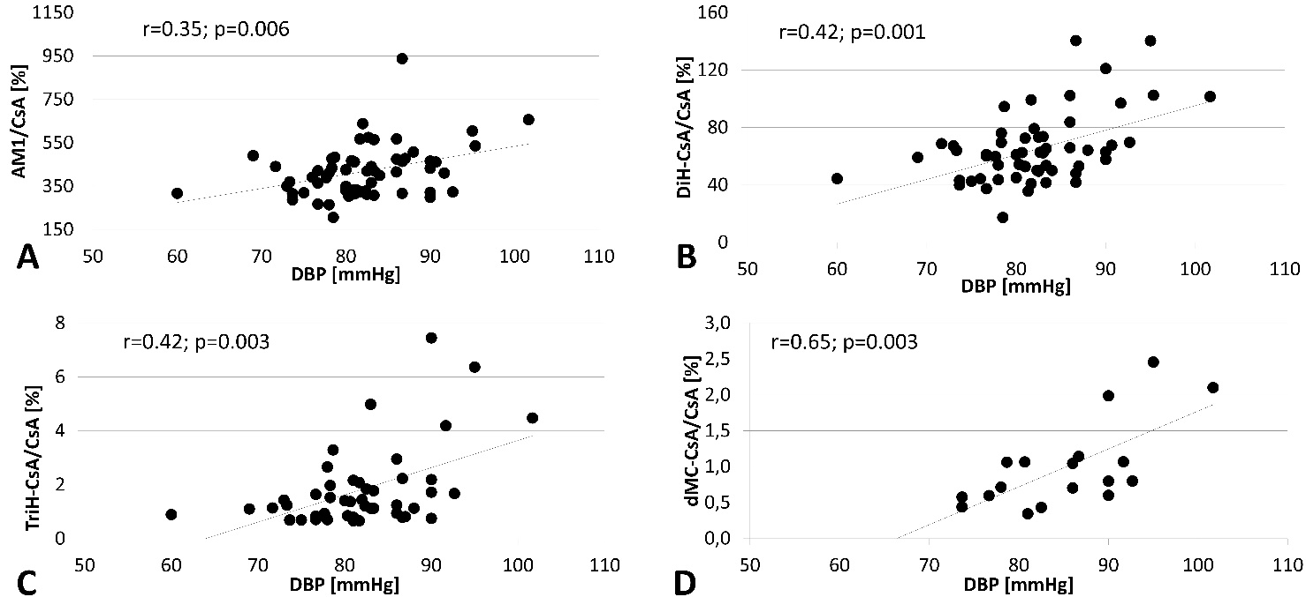
Figure 1. Correlations of diastolic blood pressure with metabolites to cyclosporine ratios of AM1 (1A), DiH-CsA (1B), TriH-CsA (1C) and dMC-CsA (1D). CsA, cyclosporine A; DBP, diastolic blood pressure; DiH-CsA, dehydroxylated cyclosporine; dMC-CsA, desmethyl-carboxylated cyclosporine; TriH-CsA, trihydroxylated cyclosporine.

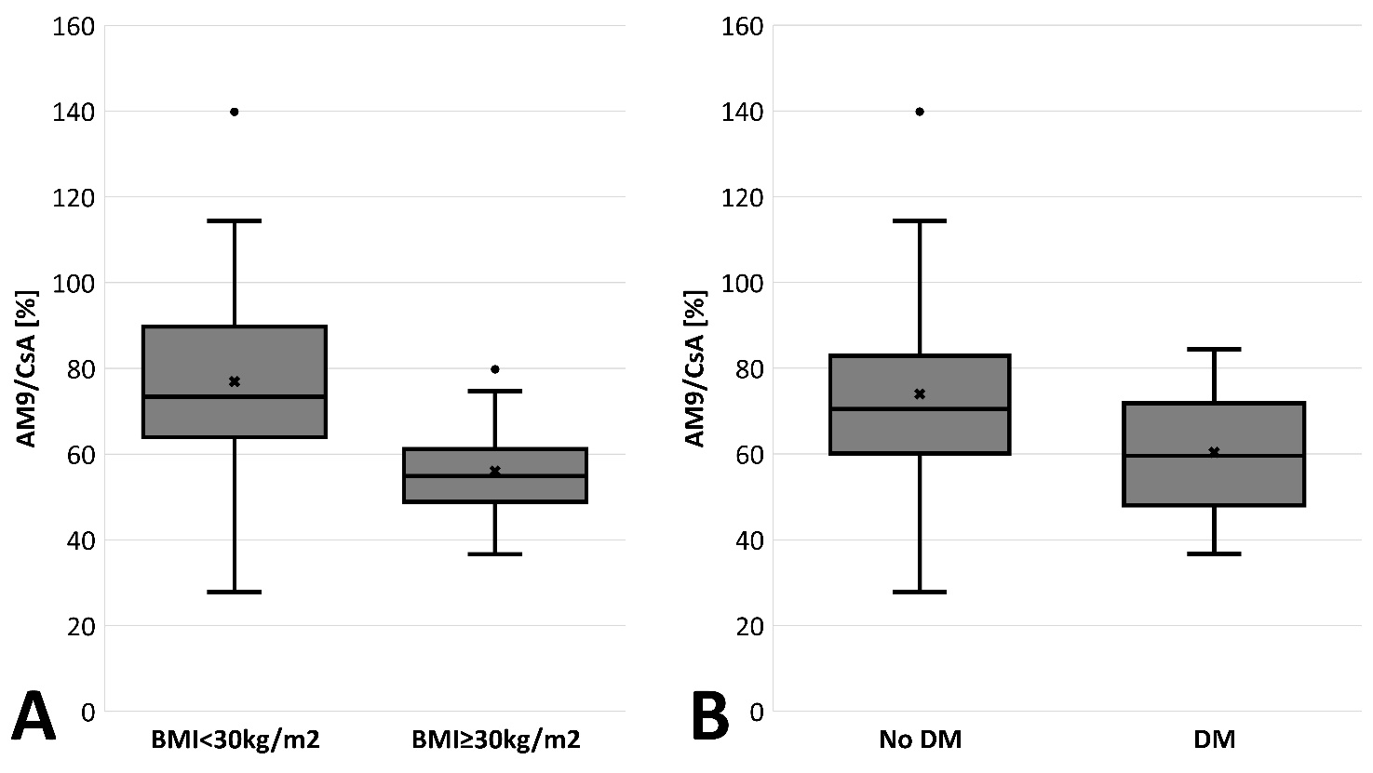
Figure 2. A. AM9/CsA ratios in patients with obesity (54.89 [36.7-79.8] vs. 73.93 [27.9-139.8], p=0.0002) and B. diabetes mellitus (59.59 [36.7-84.4] vs. 70.47 [27.9-139.9], p=0.01). CsA, cyclosporine A; DM, diabetes mellitus.

