This is a pre-copyedited, author-produced version of an article accepted for publication in Poultry Science following peer review. The version of record Stachyra et al., Poultry Science 2019 (98): 199–208 is available online at: http://dx.doi.org/10.3382/ps/pey392

Sequential DNA immunization of chickens with bivalent heterologous vaccines induce highly reactive and cross-specific antibodies against influenza hemagglutinin
Anna Stachyra,* Anna Góra-Sochacka,¹* Jan P. Radomski,† Agnieszka Sirko,*
*Institute of Biochemistry and Biophysics, Polish Academy of Sciences, Pawinskiego 5a, 02-106 Warsaw, Poland; and †Interdisciplinary Center for Mathematical and Computational Modeling, Warsaw University, Pawinskiego 5a, 02-106 Warsaw, Poland
¹Corresponding author: Anna Góra-Sochacka, Institute of Biochemistry and Biophysics, Polish Academy of Sciences, Pawinskiego 5a, 02-106 Warsaw, Poland;
tel. +48 225923408; e-mail: annag@ibb.waw.pl

Scientific section: Health and Disease

ABSTRACT
Vaccines against avian influenza are mostly based on hemagglutinin (HA), which is the main antigen of this virus and a target for neutralizing antibodies. Traditional vaccines are known to be poorly efficient against newly emerging strains, which is an increasing worldwide problem for human health and for the poultry industry. As demonstrated by research and clinical data, sequential exposure to divergent influenza HAs can boost induction of universal antibodies which recognize conserved epitopes. This strategy gave promising results, as it led to induction of polyclonal antibodies against HAs from both groups. These polyclonal antibodies showed cross-reactivity between different HA strains in ELISA, especially when bivalent formulations were used for immunization of birds. However, cross-reactivity of antibodies induced against H3 and H5 HA subtypes was rather limited against each other after homologous immunization. Using a cocktail of HA sequences and/or sequential DNA vaccination with different strains presents a good strategy to overcome the limited effectiveness of vaccines and induce broader immunity against avian influenza. Such a strategy could be adapted for vaccinating laying hens or parental flocks of different groups of poultry.
Key words: DNA vaccine, avian influenza, chicken, cross-reactivity, prime-boost
INTRODUCTION
Avian influenza, which is caused by Influenza A virus (IAV) has been recognized since the middle of 20th century, for causing mild or no symptoms in wild birds and occasional epidemics in domestic poultry. Since the 1990’s, avian influenza outbreaks have occurred more often and have had a greater impact on domestic birds (Alexander, 2007). Several serious epidemics have taken place since then in Mexico, Pakistan, Italy, Netherlands, Canada and, importantly, in China (Sonnberg et al., 2013). Specifically, southeast Asia have become the main source of new highly pathogenic avian influenza viruses belonging to numerous subtypes, such as H5N1 (Chen, et al., 2016; Harfoot and Webby, 2017), H7N9 and H9N2 (Chen et al., 2016; Pu, et al., 2015; Zhu, et al., 2015) H5N5, H5N6, and H5N8 (de Vries et al., 2015; Yang et al., 2017). Moreover, studying recent epidemics of H5N8 viruses in 2014 and 2016 showed that, under favorable circumstances, migratory wild birds can easily spread the virus throughout the world in just one season (Bevins et al., 2016; Lee et al., 2015; Russell, 2016). Therefore, the control of avian influenza is an issue of great importance, and development of efficient vaccines and vaccination strategies to protect poultry is needed.
Two issues with efficient vaccination against influenza are the high variability of hemagglutinin (HA), the main virus antigen and major target of neutralizing antibodies, and fast virus evolution. Traditional inactivated vaccines are usually highly strain specific and show no cross protection in the field. Many efforts have been made to broaden vaccine reactivity to make them more universal and increase possible protection against future pandemic viruses (de Vries et al., 2016; Liu et al., 2016; Soema et al., 2015).
One strategy is to compose polyvalent vaccines that include a cocktail of HAs originating from different strains. For example increased antibody titers, as well as cross-reactivity, were observed after polyvalent vaccination with different antigens from H5 (Kapczynski et al., 2016; Rao et al., 2008; Wang et al., 2011; Zhou et al., 2012), H2 (Lenny et al., 2017), H3 (Ault et al., 2012), and H5 with H7 (Kodihalli et al., 2000) subtypes, in comparison to monovalent vaccination. This strategy is, in essence, used in seasonal human vaccines, where three or four influenza strains are present (H1N1, H3N2 and B viruses). However, their short-term effectiveness suggests that traditional inactivated vaccines, which contain divergent strains, are not able to induce reactive antibodies to universal epitopes.
Another strategy is to perform sequential heterologous prime-boost immunization using different HA variants from different strains. This strategy redirects the immune response against common epitopes, possibly by breaking the immunodominance of the variable head domain. In several reports, increased cross-reactivity against heterologous antigens has been observed after such prime-boost vaccinations in comparison to homologous vaccinations. Importantly, the order of application of antigens is often crucial, and not all HA variants are equally effective (Gao, et al. 2012; Ikeno et al., 2011; Schwartzman et al., 2015; Van Reeth et al., 2017; Vergara-Alert et al., 2011). In another example, using different chimeric HAs, comprising “exotic” globular head domains for sequential immunization resulted in an increase in the pool of antibodies recognizing stem domain epitopes, which shows high cross-reactivity between distinct HAs and demonstrates neutralizing properties (Krammer et al., 2013; Margine et al., 2013). Other detailed studies also provide evidence that titers of broadly reactive stem domain antibodies in humans increase with age, very likely due to repeated exposure to divergent influenza viruses (Miller et al., 2013; Nachbagauer et al., 2016). This observation made the strategy of sequential immunization with different strains highly reasonable, especially since the situation in intensive poultry farming is different to that for wild birds (or humans), due to short life span and being kept in isolation. Therefore, there is no time or possibility to induce broadly reactive antibodies naturally, thus a tailored vaccination program could present a solution.
DNA vaccines, which induce synthesis of antigens in host cells offer simple but effective means of inducing broad-based immunity (Khan, 2013; Kutzler and Weiner, 2008). They have certain advantages over conventional vaccines, for example the construction of DNA vaccines is easy, a mixture of plasmids could be used to form a broad spectrum vaccine, they are more stable, their manufacture and storage is cost-effective, and their use permits the application of the DIVA strategy (Li et al., 2014a). In comparison to conventional vaccines the immunogenicity of DNA vaccines, especially in large animals is usually lower thus besides boosting strategy many other strategies to improve their efficacy are applied (Khan, 2013; Kobiyama et al., 2013; Saade and Petrovsky, 2012; Stachyra et al., 2014b; Xu et al., 2014). For example, codon optimization of HA encoding sequence (Jiang et al., 2007; Shan et al., 2011; Stachyra et al., 2014a), various biological adjuvants (Jalilian et al., 2010; Lim et al., 2012; Liniger et al., 2012; Oveissi et al., 2010; Yao et al., 2010), various DNA carriers (Jazayeri et al., 2012; Shan et al., 2016; Stachyra et al., 2017b), electroporation after injection (Ogunremi et al., 2013; Shan et al., 2011), prime-boost strategy with plasmid DNA and recombinant antigen (Stachyra et al., 2017a) and others were studied during vaccination of poultry against influenza.
As presented above, experiments with broadly reactive vaccines are frequent aims of research concerning influenza viruses, but many studies focus on intrasubtypic immunity. Our goal was to investigate the effect of multivalent-heterologous immunization of chickens, using a wide representation of HAs derived from different hosts and subtypes. In this study, we performed sequential vaccination of laying hens with bivalent or monovalent DNA vaccines encoding HAs from distinct strains belonging either to group 1 (H5, H1) or group 2 (H3). We observed the presence of broadly reactive antibodies and demonstrated that this strategy was effective. Immunization of naïve poultry with divergent HA vaccines could be a promising strategy to protect parental flocks or laying flocks, which live longer, against the avian influenza virus.

MATERIALS AND METHODS
Plasmid DNA vaccines
Genes encoding several variants of influenza virus hemagglutinins were synthesized by Thermo Scientific (Germany), with the exception of the gene from A/swan/Poland/305-135V08/06, which was synthesized earlier by GenScript (www.genscript.com). All sequences were cloned into a pCI vector (cat.# E1731, Promega, Madison, WI, USA). Final constructs were named according to the subtype to which they belonged (Table 1). The amino acid sequence alignments and the phylogenetic tree of the used HAs are shown in Supplementary Fig. S1 and S2, respectively.
Plasmids were propagated using the E. coli DH5α strain. The bacterial cultures were incubated in Luria-Bertani medium supplemented with ampicillin (50µg/mL) at 37°C with constant shaking (250 rpm) overnight. The flasks used were four times the volume of the medium. DNA plasmids were isolated with NucleoBond® PC 10000 EF Giga-scale purification kit (cat.# 740548, Macherey-Nagel, Duren, Germany). DNA was resuspended in PBS and, prior to immunization, Lipofectin Reagent (Invitrogen, cat. # 18292037, ThermoFisher Scientific; https://www.thermofisher.com/) was added in the ratio of 6:1, according to the manufacturer’s protocol and as described earlier (Stachyra et al., 2017b).

Immunization experiment
Animal ethics. Experiments were approved by the Second Local Ethical Committee for Animal Experiments at the Medical University of Warsaw, Permit Number 17/2009. All efforts were made to minimize suffering. All applicable international, national, and/or institutional guidelines for the care and use of animals were followed. At the end of the experiment the chickens were humanely euthanized by cervical dislocation.
Immunization. The experiment was performed in the experimental station of Warsaw University of Life Sciences (SGGW). The 17 to 19-week-old laying hens (ISA Brown) were kept in individual cages, in the standard farm conditions according to the ISA Brown Management Guide (www.hendrix-genetics.com). Hens were given a standard laying diet based on soybean meal as the main protein source. Birds were immunized with DNA vaccine in breast muscle via syringe; a single dose comprised 250 µg of the plasmid DNA. Four experimental groups (n=3) received two, three or four doses of different vaccine formulations: (1) H3N2 monovalent vaccine, (2) H5N1 monovalent vaccine, (3) H5N1/H3N2 bivalent vaccine, (4) H3N2/H3N2’ bivalent vaccine and (5) H5N8/H1N1 bivalent vaccine. The vaccine formulations were based on the plasmids listed in Table 1. The immunization schedules and vaccine combinations are presented in Fig. 1–4. The negative control group (n=2) received three doses of empty pCI vector. Blood samples were collected from each hen at 2, 4, 5, 6, 7, 8 or 10 weeks post initial immunization (wk p.i.), depending on the immunization schedule.

Immunological analysis
Sera from immunized birds were used to monitor the dynamics of the humoral response. An indirect ELISA test with different antigens, representing subtypes used in vaccine composition (H5N1, H3N2, H5N8, H1N1), homologous or distinct to vaccine strains was used to examine IgY cross-reactivity. A list of the used antigens is presented in Table 2. Indirect ELISA. Plates (96-well) were coated with 6 μg/ml of HA protein (Oxford Expression Technologies, England; https://oetltd.com/; recombinant HA protein produced in baculovirus system) or 2 µg/ml of HA protein (Immune Technologies, USA; www.immune-tech.com; recombinant HA proteins produced in mammalian cells) and incubated at 2–8˚C overnight. Next, the 1000 times diluted sera or IgY samples purified from the egg yolks were added and incubated at 2–8˚C overnight. The next day, plates were incubated with peroxidase-conjugated antibody goat anti-chicken IgY (Thermo Scientific, ) for detection of HA-specific antibodies. The enzymatic color reaction was generated using TMB substrate (Sigma), and the absorbance value was measured at 450 nm using a Synergy/HT microplate reader (BioTek).
Competitive ELISA. Assay was performed with the selected sera (dilution 1:5) according to the manufacturer’s protocol using ID Screen® Influenza H5 Antibody Competition kit (ID-Vet, France). The results were expressed as S/P values using the cutoff recommended in the manual: S/P < 35%, positive; S/P > 40%, negative; and S/P 35–40%, doubtful result.
Hemagglutination inhibition test (HI). Test was performed according to the OIE standard procedures using the inactivated antigen from the H5N2 strain A/chicken/Belgium/150/1999 and the H3N2 strain A/swine/Flanders/1/98 (DG Deventer, Netherlands). The sera to be tested was serially diluted in 25 μl of PBS, and an equal volume of HA antigen containing 4 HA units was added. After incubation for 25 min, the suspension of hen red blood cells was added and incubated for 25 min at RT. The reciprocal of the highest dilution of sera that completely inhibited hemagglutination was regarded as the HI titer.
Statistical analysis. Comparison of IgY levels was performed using Statistica 12 software, ANOVA for comparison of multiple groups and Student’s t-test (unpaired) for comparison of two groups. A value of P < 0.05 was considered significant.

IgY purification from the egg yolks
Isolation of IgY from the egg yolks was performed using the Pierce Chicken IgY purification kit (Thermo Scientific) from the eggs collected after the last dose from the hens of the HET-2 group. Cross-reactivity of the obtained antibodies was checked by the ELISA test.

RESULTS
Indirect ELISA
The presence of antibodies against influenza hemagglutinin (HA) induced in chickens after sequential immunization with different DNA vaccine formulations was analyzed using an ELISA test with a panel of HA antigens. All birds responded well to the vaccine, and a comparison of all four experimental groups was performed. In the HOM-1 group, which received two doses of the monovalent H3N2 vaccine, we observed a moderate level of serum antibodies recognizing H3 HA after the prime dose, which was apparently increased after the boost dose and stayed at a stable level until 8 wk p.i. (Fig. 1). In serum of one out of three birds from the HOM-1 group (immunized twice with the monovalent H3N2 vaccine) a background reactivity with H5 HA was observed, which was assumed as a non-specific signal and did not interfere with further observations.
In the HOM-2 group, which received three doses of H5N1 vaccine, the induction of a low level of antibodies recognizing H5 HA was observed after the prime dose. This H5 HA-specific humoral response was significantly increased (P = 0.024) after the first boost dose, was decreased in two out of three birds after the second boost dose, and was found to be even lower 10 wk p.i. (Fig. 2). We also observed higher deviations in this group (one bird responded only moderately) and noticed background reactivity (presumably a non-specific signal) with H3 HA in one of three birds.
Interesting observations were made in the HET-1 group, which received three doses of the vaccine, namely two doses of the bivalent H3N2 vaccine and one dose of the bivalent H5N8/H1N1 vaccine. A high content of anti-H3 antibodies (but no cross-reactivity with H5N1, H5N8 and H1N1 antigens) was observed after the first two doses of the vaccine. After the second boost with the vaccine containing different subtypes, only a minimal induction of antibodies against H5N1 and H5N8 was visible, and no reactivity with H1 was achieved. The level of anti-H3 antibodies remained stable until 8 wk p.i. (Fig. 3).
The fourth group, HET-2, received four doses of the vaccine: monovalent H5N1 as a prime dose, monovalent H3N2 as a first boost dose, bivalent H3N2/H5N1 as a second boost dose and bivalent H5N8/H1N1 as a third boost dose. After the first two doses, a relatively high level of anti-H5 HA antibodies and a moderate level of anti-H3 HA antibodies was observed. Both were increased after the third dose (bivalent H3N2/H5N1), and some cross-reactivity against the H5N8 antigen was induced by this booster. In one of three hens, cross-reactivity with H1 HA (regarded as unspecific) was observed. After the fourth dose of the vaccine (bivalent H5N8/H1N1), both anti-H5 or anti-H1 antibody levels were significantly increased (P = 0.007 or P = 0.034, respectively), but the level of anti-H3 antibodies was reduced (Fig. 4). Additional ELISA analysis with other antigens performed with sera from week 10 (for H5 antigens) and from week 6 (for H3 and H7 antigens) showed high cross-reactivity of induced IgY with two H5 antigens from the same and separate lineages and distinct H7 antigen, but moderate cross-reactivity with distinct H3 antigens (Fig. 5A). Additional ELISA tests with IgY purified from the eggs collected at the last (10th) week of the experiment showed high cross-reactivity with all four HA antigens (H5N1, H3N2, H5N8 and H1N1; Table 2) used for immunization of the hens in the HET-2 group (Supplementary Fig. S3).

Hemagglutination inhibition
The HI test was performed only with the serum samples from the selected groups at the chosen experimental points. The HI titers measured in the HET-2 group were higher against the H5 antigen (range 62–256) than the H3 antigen (range <8–16), which could be related to the fact that H3 DNA sequences used in the vaccine and the inactivated antigen used in the HI test were not from the avian strains. However, the seroconversion in this group was 100% and 66% for H5 and H3, respectively, 6 wk p.i. (Fig. 6A). Interesting differences (P = 0.047) in HI titers were also observed between the HET-1 group and the HOM-1 group, where two doses of the bivalent H3 composition resulted in much higher HI titers than two doses of monovalent H3 composition, respectively (Fig. 6B).

Competitive ELISA
Sera from the HET-2 group were also examined with the competitive H5 ID Screen ELISA test. The anti-H5 levels at the end of the experiment (10 wk p.i.) were prominent: all three birds were positive and two of them achieved very high titers. Importantly, such a high level of anti-H5 antibodies was not seen after the first dose of the H5 vaccine (none of the birds were positive), nor after the first boost with the H3 vaccine. The second dose of H5 allowed high competition titers to be achieved, which even increased after the third dose (Fig. 5B).

DISCUSSION
Heterologous prime-boost influenza vaccine administrations seem to be a good way to improve vaccine efficacy and broaden reactivity of antibodies, similar to the polyvalent vaccine formulations. Successful usage of this strategy against avian influenza has already been reported. However, the main serological test used for the response monitoring was mostly HI, which shows only the titers of the globular head domain-specific antibodies and may omit important common epitope antibodies specific to the stem domain. On the other hand, broadly reactive vaccine approaches focused mainly on the “human” universal vaccine with human seasonal or pandemic strains, using mice (or other mammals) as a model (Hashem, 2015; Neu et al., 2016) and not many researchers has worked on poultry subjects so far. Domestic poultry is usually infected with H5, H6, H7 and H9 subtypes (Chen et al., 2017; Verhagen et al., 2017), which belong to the group 1 and 2 HAs. Thus, we decided to use very distinct hemagglutinin strains to maximize the breadth of the immunological response. Two avian H5 constructs were prepared, one originating from clade 2.2. of Asian lineage of H5N1 (Li et al., 2014b), the second originating from the recent outbreaks of H5N8 in Europe (Conraths et al., 2016). Other vaccine plasmids were based on the HA from the viruses isolated from pigs in 2014 (H3), humans in 1992 (H3) or humans in 2012 (H1). The set of HAs was then diverse in terms of the hosts, geographic regions, subtypes and the year of circulation.
Two groups of birds received two homologous doses of the monovalent immunizations with either H3 (HOM-1) or H5 (HOM-2) HA DNA vaccine, whereas the other two groups (HET-1 and HET-2) received several heterologous sequential immunizations with different combinations of the HA DNA vaccines. The most multivalent composition was administered in the HET-2 group (Fig. 4). The HOM-1 and HOM-2 groups were expected to develop no or low cross-reactivity and to serve as reference points, whereas the HET-1 and HET-2 groups were expected to develop a greater level of cross-reactivity. Indeed, two doses of monovalent DNA vaccines gave a high anti-HA IgY response (ELISA); however, the response was significantly stronger after administration of the bivalent formulation, which was especially apparent in the HI test (P = 0.047) (Fig. 6B). Moreover, comparison of the results of the HET-2 and HOM-2 groups indicates that the longer time spacing between doses of the same strain results in a stronger humoral response, presumably because early application of the next dose suppresses the immunological response. This phenomenon was observed when comparing anti-H5 levels in these two groups: three doses of the H5 vaccine at 2-week intervals gave a decreasing level of anti-H5, whereas three doses of H5 vaccine given at 4- and 3-week intervals gave a high and stable level of anti-H5 antibodies (Fig. 2 vs Fig. 4). However, in our previous studies, the immunization protocol comprising of two-dose immunization with 2-week interval was successful and protective (Stachyra et al., 2014a). The current results indicated that to achieve a boost effect with the third dose of the vaccine (after successful induction of the antigen-specific antibodies with the two former doses), a longer interval between immunizations is necessary. Otherwise, the immune response may be silenced, as in the case of two of three hens in the HOM-2 group.
In the HET-1 group, a single dose of bivalent H5/H1 vaccine administered 3 weeks after two doses of H3/H3’ immunization apparently failed to induce anti-H5 and anti-H1 antibodies. This suggests that a single dose of the heterologous vaccine (from a different phylogenetic group) is not sufficient to redirect the response, and a subsequent booster immunization might be needed. This assumption was generally confirmed by the results obtained in the HET-2 group, where alternating vaccinations with H5, H3, H1 HA sequences resulted in the induction of antibodies against all strains, including H1, which was present only in one dose (the fourth) of the vaccine. Data from both groups support the statement that it is more likely to induce response after one dose in the naïve hosts than to redirect the response and induce antibody against distinct strains in effectively primed hosts. This phenomenon is likely connected with the “original antigenic sin” (Vatti et al., 2017) and is an important issue in developing efficient influenza vaccination programs. The occurrence of the “antigenic sin” can also explain other effects observed in the HET-2 group, where the H3 vaccine was administered second, and resulted in a less durable level of H3-specific IgY than the H5 vaccine (Fig. 4). The dynamics of anti-H3 and anti-H5 IgY are also in agreement with the general statements that due to the phylogenetic divergence, the cross-reactivity of antibodies against HAs from groups 1 and 2 is very limited. Usually, only a small fraction of antibodies recognizing the conserved epitopes shared between HAs from both groups, is induced after immunization or infection (Corti et al., 2017; Hashem, 2015). In our study, vaccination with the H5 vaccine primed antibodies recognizing H1, but not H3, since no increase in the anti-H3 IgY level was observed after the last vaccination dose (Fig. 4). However, the additional ELISA test performed with an extended panel of antigens revealed some surprising results (Fig. 5A). It was not surprising to observe the cross reactivity of IgY from the HET-2 group with the distinct H1 and H5 strains, since the phylogenetic distance between H5 and H1 is relatively close and could promote induction of the antibodies recognizing common epitopes. However, the high reactivity with the H7 antigen and the simultaneous moderate reactivity with H3 antigens (both belong to group 2) was unexpected. One possible explanation could be that the H7 strain used as a source of antigen was from the highly pathogenic (HP) avian virus isolated from chicken, and it includes some HP viral adaptation to the poultry hosts, common with HP H5 subtype strains, which most likely also concerns HA epitopes. The cross-reactivity between H3 and H7 was not expected because their phylogenetic distance is quite large, despite belonging to the one group. The phylogenetic tree of the used HAs is presented in Supplementary Fig. S1.
It should be stressed that, the HI titers measured in the HET-2 and HET-1 groups against H5 antigen was over 62 and 32, respectively (Fig. 6). In poultry HI titers that are needed for protective immune response is assumed to be 16 thus we could expect high protection in the case of contact with influenza virus subtype H5.
In conclusion, analysis of the humoral response induced after multivalent sequential immunizations, showed interesting trends and have deepened our knowledge on the hen immunological reaction to the DNA HA-based vaccine against influenza. Sequential heterologous immunizations seem to be a promising strategy for inducing broad cross-subtype immunity, which is much needed for protecting poultry against the quickly evolving influenza virus.
ACKNOWLEDGEMENTS
We thank Małgorzata Julia Riedel, Monika Michalczuk and Joanna Nerc (Warsaw University of Life Sciences) for help and veterinary support during the immunization experiment. The work was performed in frame of the Polish Vaccine Consortium.
This work was funded by Innovative Economy Program, Grant No. WND-POIG.01.01.02-00-007/08 and by Grant No. PBS2/A7/14/2014 from the National Centre for Research and Development.

REFERENCES
Alexander, D. J. 2007. An overview of the epidemiology of avian influenza. Vaccine 25:5637-5644. doi: 10.1016/j.vaccine.2006.10.051
Ault, A., A. M. Zajac, W. P. Kong, J. P. Gorres, M. Royals, C. J. Wei, S. Bao, Z. Y. Yang, S. E. Reedy, T. L. Sturgill, A. E. Page, J. Donofrio-Newman, A. A. Adams, U. B. Balasuriya, D. W. Horohov, T. M. Chambers, G. J. Nabel, and S. S. Rao. 2012. Immunogenicity and clinical protection against equine influenza by DNA vaccination of ponies. Vaccine 30:3965-3974. doi: 10.1016/j.vaccine.2012.03.026
Bevins, S. N., R. J. Dusek, C. L. White, T. Gidlewski, B. Bodenstein, K. G. Mansfield, P. DeBruyn, D. Kraege, E. Rowan, C. Gillin, B. Thomas, S. Chandler, J. Baroch, B. Schmit, M. J. Grady, R. S. Miller, M. L. Drew, S. Stopak, B. Zscheile, J. Bennett, J. Sengl, C. Brady, H. S. Ip, E. Spackman, M. L. Killian, M. K. Torchetti, J. M. Sleeman, and T. J. Deliberto. 2016. Widespread detection of highly pathogenic H5 influenza viruses in wild birds from the Pacific Flyway of the United States. Sci. Rep. 6:28980. doi: 10.1038/srep28980
Chen, L. J., X. D. Lin, W. P. Guo, J. H. Tian, W. Wang, X. H. Ying, M. R. Wang, B. Yu, Z. Q. Yang, M. Shi, E. C. Holmes, and Y. Z. Zhang. 2016. Diversity and evolution of avian influenza viruses in live poultry markets, free-range poultry and wild wetland birds in China. J. Gen. Virol. 97:844-854. doi: 10.1099/jgv.0.000399
Chen, L. J., X. D. Lin, J. H. Tian, Y. Liao, X. H. Ying, J. W. Shao, B. Yu, J. J. Guo, M. R. Wang, Y. Peng, M. Shi, E. C. Holmes, Z. Q. Yang, and Y. Z. Zhang. 2017. Diversity, evolution and population dynamics of avian influenza viruses circulating in the live poultry markets in China. Virology 505:33-41. doi: 10.1016/j.virol.2017.02.009
Conraths, F. J., C. Sauter-Louis, A. Globig, K. Dietze, G. Pannwitz, K. Albrecht, D. Höreth-Böntgen, M. Beer, C. Staubach, and T. Homeier-Bachmann. 2016. Highly Pathogenic Avian Influenza H5N8 in Germany: Outbreak Investigations. Transbound Emerg. Dis. 63:10-13. doi: 10.1111/tbed.12443
Corti, D., E. Cameroni, B. Guarino, N. L. Kallewaard, Q. Zhu, and A. Lanzavecchia. 2017. Tackling influenza with broadly neutralizing antibodies. Curr. Opin. Virol. 24:60-69. doi: 10.1016/j.coviro.2017.03.002
de Vries, E., H. Guo, M. Dai, P. J. Rottier, F. J. van Kuppeveld, and C. A. de Haan. 2015. Rapid Emergence of Highly Pathogenic Avian Influenza Subtypes from a Subtype H5N1 Hemagglutinin Variant. Emerg. Infect. Dis. 21:842-846. doi: 10.3201/eid2105.141927
de Vries, R. D., A. F. Altenburg, and G. F. Rimmelzwaan. 2016. Universal influenza vaccines: a realistic option? Clin. Microbiol. Infect. 22 Suppl. 5:S120-S124. doi: 10.1016/j.cmi.2015.12.005
Gao, Y., Z. Wen, K. Dong, G. Zhong, X. Wang, Z. Bu, H. Chen, L. Ye, and C. Yang. 2012. Characterization of immune responses induced by immunization with the HA DNA vaccines of two antigenically distinctive H5N1 HPAIV isolates. PLoS One 7:e41332. doi: 10.1371/journal.pone.0041332
Harfoot, R., and R. J. Webby. 2017. H5 influenza, a global update. J. Microbiol. 55:196-203. doi: 10.1007/s12275-017-7062-7
Hashem, A. M. 2015. Prospects of HA-based universal influenza vaccine. Biomed. Res. Int. 2015:414637. doi: 10.1155/2015/414637
Ikeno, D., K. Kimachi, K. Ibaragi, Y. Kudo, S. Goto, K. Odoh, S. Itamura, T. Odagiri, M. Tashiro, and Y. Kino. 2011. Differences in the priming effect of various clades/subclades of inactivated H5N1 vaccine for booster injection with heterologous clades of vaccine strains. Vaccine 29:4156-4161. doi: 10.1016/j.vaccine.2011.03.084
Jalilian, B., A. R. Omar, M. H. Bejo, N. B. Alitheen, M. Rasoli, and S. Matsumoto. 2010. Development of avian influenza virus H5 DNA vaccine and MDP-1 gene of Mycobacterium bovis as genetic adjuvant. Genet. Vaccines Ther. 8:4. doi: 10.1186/1479-0556-8-4
Jazayeri, S. D., A. Ideris, Z. Zakaria, K. Shameli, H. Moeini, and A. R. Omar. 2012. Cytotoxicity and immunological responses following oral vaccination of nanoencapsulated avian influenza virus H5 DNA vaccine with green synthesis silver nanoparticles. J. Control Release. 161:116-123. doi: 10.1016/j.jconrel.2012.04.015
Jiang, Y., K. Yu, H. Zhang, P. Zhang, C. Li, G. Tian, Y. Li, X. Wang, J. Ge, Z. Bu, and H. Chen. 2007. Enhanced protective efficacy of H5 subtype avian influenza DNA vaccine with codon optimized HA gene in a pCAGGS plasmid vector. Antiviral Res. 75:234-241. doi: 10.1016/j.antiviral.2007.03.009
Kapczynski, D. R., T. M. Tumpey, R. Hidajat, A. Zsak, K. Chrzastek, I. Tretyakova, and P. Pushko. 2016. Vaccination with virus-like particles containing H5 antigens from three H5N1 clades protects chickens from H5N1 and H5N8 influenza viruses. Vaccine 34:1575-1581. doi: 10.1016/j.vaccine.2016.02.011
Khan, K. H. 2013. DNA vaccines: roles against diseases. Germs 3:26-35. doi: 10.11599/germs.2013.1034
Kobiyama, K., N. Jounai, T. Aoshi, M. Tozuka, F. Takeshita, C. Coban, and K. J. Ishii. 2013. Innate Immune Signaling by, and Genetic Adjuvants for DNA Vaccination. Vaccines (Basel) 1:278-292. doi: 10.3390/vaccines1030278
Kodihalli, S., D. L. Kobasa, and R. G. Webster. 2000. Strategies for inducing protection against avian influenza A virus subtypes with DNA vaccines. Vaccine 18:2592-2599. doi.org/10.1016/S0264-410X(99)00485-5
Krammer, F., N. Pica, R. Hai, I. Margine, and P. Palese. 2013. Chimeric hemagglutinin influenza virus vaccine constructs elicit broadly protective stalk-specific antibodies. J. Virol. 87:6542-6550. doi: 10.1128/JVI.00641-13
Kutzler, M. A., and D. B. Weiner. 2008. DNA vaccines: ready for prime time? Nat. Rev. Genet. 9:776-788. doi: 10.1038/nrg2432
Lee, D. H., M. K. Torchetti, K. Winker, H. S. Ip, C. S. Song, and D. E. Swayne. 2015. Intercontinental Spread of Asian-Origin H5N8 to North America through Beringia by Migratory Birds. J. Virol. 89:6521-6524. doi: 10.1128/JVI.00728-15
Lenny, B. J., S. Sonnberg, A. F. Danner, K. Friedman, R. J. Webby, R. G. Webster, and J. C. Jones. 2017. Evaluation of multivalent H2 influenza pandemic vaccines in mice. Vaccine 35:1455-1463. doi: 10.1016/j.vaccine.2017.01.026
Li, C., Z. Bu, and H. Chen. 2014a. Avian influenza vaccines against H5N1 'bird flu'. Trends Biotechnol. 32:147-156. doi: 10.1016/j.tibtech.2014.01.001
Li, R., Z. Jiang, and B. Xu. 2014b. Global spatiotemporal and genetic footprint of the H5N1 avian influenza virus. Int. J. Health Geogr. 13:14. doi: 10.1186/1476-072X-13-14
Lim, K. L., S. D. Jazayeri, S. K. Yeap, N. B. Mohamed Alitheen, M. H. Bejo, A. Ideris, and A. R. Omar. 2012. Co-administration of avian influenza virus H5 plasmid DNA with chicken IL-15 and IL-18 enhanced chickens immune responses. BMC Vet. Res. 8:132. doi: 10.1186/1746-6148-8-132
Liniger, M., A. Summerfield, and N. Ruggli. 2012. MDA5 can be exploited as efficacious genetic adjuvant for DNA vaccination against lethal H5N1 influenza virus infection in chickens. PLoS One 7:e49952. doi: 10.1371/journal.pone.0049952
Liu, H., H. W. Frijlink, A. Huckriede, E. van Doorn, E. Schmidt, O. Leroy, G. Rimmelzwaan, K. McCullough, M. Whelan, and E. Hak. 2016. Influenza Vaccine Research funded by the European Commission FP7-Health-2013-Innovation-1 project. Vaccine 34:5845-5854. doi: 10.1016/j.vaccine.2016.10.040
Margine, I., F. Krammer, R. Hai, N. S. Heaton, G. S. Tan, S. A. Andrews, J. A. Runstadler, P. C. Wilson, R. A. Albrecht, A. García-Sastre, and P. Palese. 2013. Hemagglutinin stalk-based universal vaccine constructs protect against group 2 influenza A viruses. J. Virol. 87:10435-10446. doi: 10.1128/JVI.01715-13
Miller, M. S., T. J. Gardner, F. Krammer, L. C. Aguado, D. Tortorella, C. F. Basler, and P. Palese. 2013. Neutralizing antibodies against previously encountered influenza virus strains increase over time: a longitudinal analysis. Sci. Transl. Med. 5:198ra107. doi: 10.1126/scitranslmed.3006637
Nachbagauer, R., A. Choi, R. Izikson, M. M. Cox, P. Palese, and F. Krammer. 2016. Age Dependence and Isotype Specificity of Influenza Virus Hemagglutinin Stalk-Reactive Antibodies in Humans. MBio. 7:e01996-15. doi: 10.1128/mBio.01996-15
Neu, K. E., C. J. Henry Dunand, and P. C. Wilson. 2016. Heads, stalks and everything else: how can antibodies eradicate influenza as a human disease? Curr. Opin. Immunol. 42:48-55. doi: 10.1016/j.coi.2016.05.012
Ogunremi, O., J. Pasick, G. P. Kobinger, D. Hannaman, Y. Berhane, A. Clavijo, and S. van Drunen Littel-van den Hurk. 2013. A single electroporation delivery of a DNA vaccine containing the hemagglutinin gene of Asian H5N1 avian influenza virus generated a protective antibody response in chickens against a North American virus strain. Clin. Vaccine Immunol. 20:491-500. doi: 10.1128/CVI.00577-12
Oveissi, S., A. R. Omar, K. Yusoff, F. Jahanshiri, and S. S. Hassan. 2010. DNA vaccine encoding avian influenza virus H5 and Esat-6 of Mycobacterium tuberculosis improved antibody responses against AIV in chickens. Comp. Immunol. Microbiol. Infect. Dis. 33:491-503. doi: 10.1016/j.cimid.2009.08.004
Pu, J., S. Wang, Y. Yin, G. Zhang, R. A. Carter, J. Wang, G. Xu, H. Sun, M. Wang, C. Wen, Y. Wei, D. Wang, B. Zhu, G. Lemmon, Y. Jiao, S. Duan, Q. Wang, Q. Du, M. Sun, J. Bao, Y. Sun, J. Zhao, H. Zhang, G. Wu, J. Liu, and R. G. Webster. 2015. Evolution of the H9N2 influenza genotype that facilitated the genesis of the novel H7N9 virus. Proc. Natl. Acad. Sci. USA 112:548-553. doi: 10.1073/pnas.1422456112
Rao, S., W. P. Kong, C. J. Wei, Z. Y. Yang, M. Nason, D. Styles, L. J. DeTolla, A. Panda, E. M. Sorrell, H. Song, H. Wan, G. C. Ramirez-Nieto, D. Perez, and G. J. Nabel. 2008. Multivalent HA DNA vaccination protects against highly pathogenic H5N1 avian influenza infection in chickens and mice. PLoS One 3:e2432. doi: 10.1371/journal.pone.0002432
Russell, C. A. 2016. Sick birds don't fly or do they? Science 354:174-175. doi: 10.1126/science.aaj1646
Saade, F., and N. Petrovsky. 2012. Technologies for enhanced efficacy of DNA vaccines. Expert Rev. Vaccines 11:189-209. doi: 10.1586/erv.11.188
Schwartzman, L. M., A. L. Cathcart, L. M. Pujanauski, L. Qi, J. C. Kash, and J. K. Taubenberger. 2015. An Intranasal Virus-Like Particle Vaccine Broadly Protects Mice from Multiple Subtypes of Influenza A Virus. MBio. 6:e01044. doi: 10.1128/mBio.01044-15
Shan, S., S. Fenwick, T. Ellis, E. Poinern, J. Edwards, X. Le, and Z. Jiang. 2016. Evaluation of different chemical adjuvants on an avian influenza H6 DNA vaccine in chickens. Avian Pathol. 45:649-656. doi: 10.1080/03079457.2016.1195488
Shan, S., Y. Jiang, Z. Bu, T. Ellis, X. Zeng, J. Edwards, G. Tian, Y. Li, J. Ge, H. Chen, and S. Fenwick. 2011. Strategies for improving the efficacy of a H6 subtype avian influenza DNA vaccine in chickens. J. Virol. Methods 173:220-226. doi: 10.1016/j.jviromet.2011.02.008
Soema, P. C., R. Kompier, J. P. Amorij, and G. F. Kersten. 2015. Current and next generation influenza vaccines: Formulation and production strategies. Eur. J. Pharm. Biopharm. 94:251-263. doi: 10.1016/j.ejpb.2015.05.023
Sonnberg, S., R. J. Webby, and R. G. Webster. 2013. Natural history of highly pathogenic avian influenza H5N1. Virus Res. 178:63-77. doi: 10.1016/j.virusres.2013.05.009
Stachyra, A., A. Gora-Sochacka, R. Sawicka, K. Florys, V. Saczynska, M. Olszewska, A. Pikula, K. Smietanka, Z. Minta, B. Szewczyk, W. Zagorski, and A. Sirko. 2014a. Highly immunogenic prime-boost DNA vaccination protects chickens against challenge with homologous and heterologous H5N1 virus. Trials in Vaccinol. 3:40-46. doi.org/10.1016/j.trivac.2014.02.002
Stachyra, A., A. Góra-Sochacka, and A. Sirko. 2014b. DNA vaccines against influenza. Acta Biochim. Pol. 61:515-522.
Stachyra, A., M. Pietrzak, A. Macioła, A. Protasiuk, M. Olszewska, K. Śmietanka, Z. Minta, A. Góra-Sochacka, E. Kopera, and A. Sirko. 2017a. A prime/boost vaccination with HA DNA and Pichia-produced HA protein elicits a strong humoral response in chickens against H5N1. Virus Res. 232:41-47. doi: 10.1016/j.virusres.2017.01.025
Stachyra, A., M. Rak, P. Redkiewicz, Z. Madeja, K. Gawarecka, T. Chojnacki, E. Świeżewska, M. Masnyk, M. Chmielewski, A. Sirko, and A. Góra-Sochacka. 2017b. Effective usage of cationic derivatives of polyprenols as carriers of DNA vaccines against influenza virus. Virol. J. 14:168. doi: 10.1186/s12985-017-0838-x
Van Reeth, K., J. C. M. Gracia, I. Trus, L. Sys, G. Claes, H. Versnaeyen, E. Cox, F. Krammer, and Y. Qiu. 2017. Heterologous prime-boost vaccination with H3N2 influenza viruses of swine favors cross-clade antibody responses and protection. npj Vaccines 2:11. doi: 10.1038/s41541-017-0012-x
Vatti, A., D. M. Monsalve, Y. Pacheco, C. Chang, J. M. Anaya, and M. E. Gershwin. 2017. Original antigenic sin: A comprehensive review. J. Autoimmun. 83:12-21. doi: 10.1016/j.jaut.2017.04.008
Vergara-Alert, J., H. Fernández-Bellon, N. Busquets, G. Alcántara, M. Delclaux, B. Pizarro, C. Sánchez, A. Sánchez, N. Majó, and A. Darji. 2011. Comprehensive serological analysis of two successive heterologous vaccines against H5N1 avian influenza virus in exotic birds in zoos. Clin. Vaccine Immunol. 18:697-706. doi: 10.1128/CVI.00013-11
Verhagen, J. H., P. Lexmond, O. Vuong, M. Schutten, J. Guldemeester, A. D. Osterhaus, A. R. Elbers, R. Slaterus, M. Hornman, G. Koch, and R. A. Fouchier. 2017. Discordant detection of avian influenza virus subtypes in time and space between poultry and wild birds; Towards improvement of surveillance programs. PLoS One 12:e0173470. doi: 10.1371/journal.pone.0173470
Wang, S., A. Hackett, N. Jia, C. Zhang, L. Zhang, C. Parker, A. Zhou, J. Li, W. C. Cao, Z. Huang, Y. Li, and S. Lu. 2011. Polyvalent DNA vaccines expressing HA antigens of H5N1 influenza viruses with an optimized leader sequence elicit cross-protective antibody responses. PLoS One 6:e28757. doi: 10.1371/journal.pone.0028757
Xu, Y., P. W. Yuen, and J. K. Lam. 2014. Intranasal DNA Vaccine for Protection against Respiratory Infectious Diseases: The Delivery Perspectives. Pharmaceutics 6:378-415. doi: 10.3390/pharmaceutics6030378
Yang, L., W. Zhu, X. Li, H. Bo, Y. Zhang, S. Zou, R. Gao, J. Dong, X. Zhao, W. Chen, L. Dong, X. Zou, Y. Xing, D. Wang, and Y. Shu. 2017. Genesis and Dissemination of Highly Pathogenic H5N6 Avian Influenza Viruses. J. Virol. 91. doi: 10.1128/JVI.02199-16
Yao, Q., K. P. Fischer, L. Li, B. Agrawal, Y. Berhane, D. L. Tyrrell, K. S. Gutfreund, and J. Pasick. 2010. Immunogenicity and protective efficacy of a DNA vaccine encoding a chimeric protein of avian influenza hemagglutinin subtype H5 fused to CD154 (CD40L) in Pekin ducks. Vaccine 28:8147-8156. doi: 10.1016/j.vaccine.2010.09.081
Zhou, F., G. Wang, P. Buchy, Z. Cai, H. Chen, Z. Chen, G. Cheng, X. F. Wan, V. Deubel, and P. Zhou. 2012. A triclade DNA vaccine designed on the basis of a comprehensive serologic study elicits neutralizing antibody responses against all clades and subclades of highly pathogenic avian influenza H5N1 viruses. J. Virol. 86:6970-6978. doi 10.1128/JVI.06930-11
Zhu, Y., Y. Yang, W. Liu, X. Liu, D. Yang, Z. Sun, Y. Ju, S. Chen, and D. Peng. 2015. Comparison of biological characteristics of H9N2 avian influenza viruses isolated from different hosts. Arch. Virol. 160:917-927. doi: 10.1007/s00705-015-2337-y

Table 1. List of the HA plasmids used for DNA vaccination
Plasmid name (virus subtype) | Used for vaccination of group | Strain name | Phylogenetic group
H3N2 | HOM-1, HET-1, HET-2 | A/swine/Illinois/A01493469/2014 | 2
H5N1 | HOM-2, HET-2 | A/swan/Poland/305-135V08/06 | 1
H5N8 | HET-1, HET-2 | A/turkey/Germany-MV/R2472/2014 | 1
H1N1 | HET-1, HET-2 | A/Kenya/264/2012 | 1
H3N2’¹ | HET-1 | A/Hong-Kong/14/1992 | 2
¹this strain was used in the bivalent H3N2 vaccine only

Table 2. List of recombinant HA antigens used for indirect ELISA tests. Antigens regarded as homologous (or nearly homologous) to the corresponding vaccine antigens are in bold; the remaining antigens were used only for additional analysis of the HET-2 group. Antigen H5 HA (OET) was produced in a baculovirus system; the other antigens (Immune Tech) were produced in the mammalian cells.
Virus subtype (short name) | Strain name | Phylogenetic group | Source¹
H3N2 | A/Beijing/32/92 | 2 | Immune Tech
H5N1 | A/swan/Poland/305-135V08/06 | 1 | OET
H5N8 | A/turkey/Germany-MV/R2472/2014 | 1 | Immune Tech
H1N1 | A/New Caledonia/20/99 | 1 | Immune Tech
H3N2 (IW) | A/Iowa/08/2011 | 2 | Immune Tech
H3N2 (ON) | A/Ontario/RV1273/2005 | 2 | Immune Tech
H3N2 (PN) | A/Panama/07/99 | 2 | Immune Tech
H7N7 (NL) | A/chicken/Netherlands/1/2003 | 2 | Immune Tech
H5N1 (HU) | A/Hubei/1/2010 | 1 | Immune Tech
H5N1 (VN) | A/chicken/Vietnam/NCVD-016/08 | 1 | Immune Tech
¹Source: Immune Tech - Immune Technologies, USA; www.immune-tech.com; OET - Oxford Expression Technologies, England

Figures

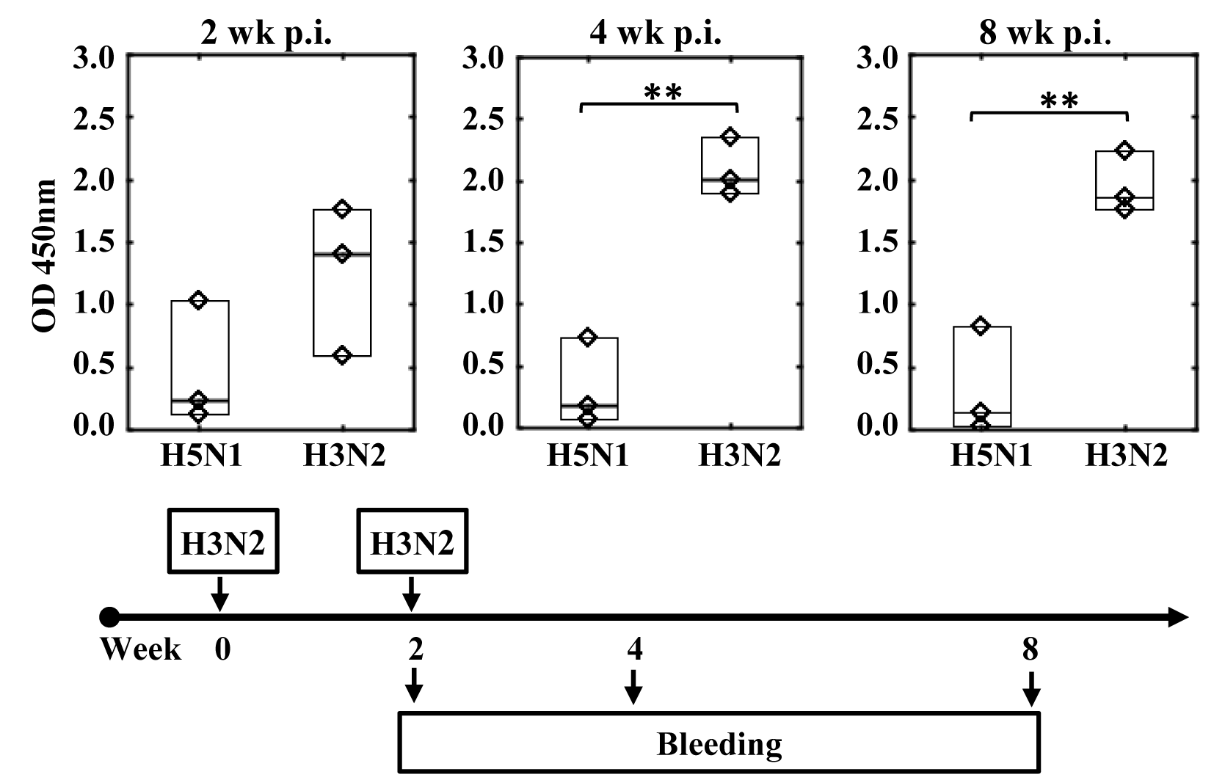

Figure 1. The levels of IgY in the HOM-1 group measured by indirect ELISA. The scheme of immunization is shown on the time scale graph at the bottom. The used vaccines (DNA plasmids), weeks of immunization and blood collection are indicated. The ELISA results from the blood samples collected at the indicated time points, weeks post initial immunization (wk p.i.), are presented as raw data (◊), median (—) and 10th–90th percentiles (). The used HA antigens are indicated in Table 2.
ANOVA was used to determine the significance of the differences; ** indicates P < 0.01.

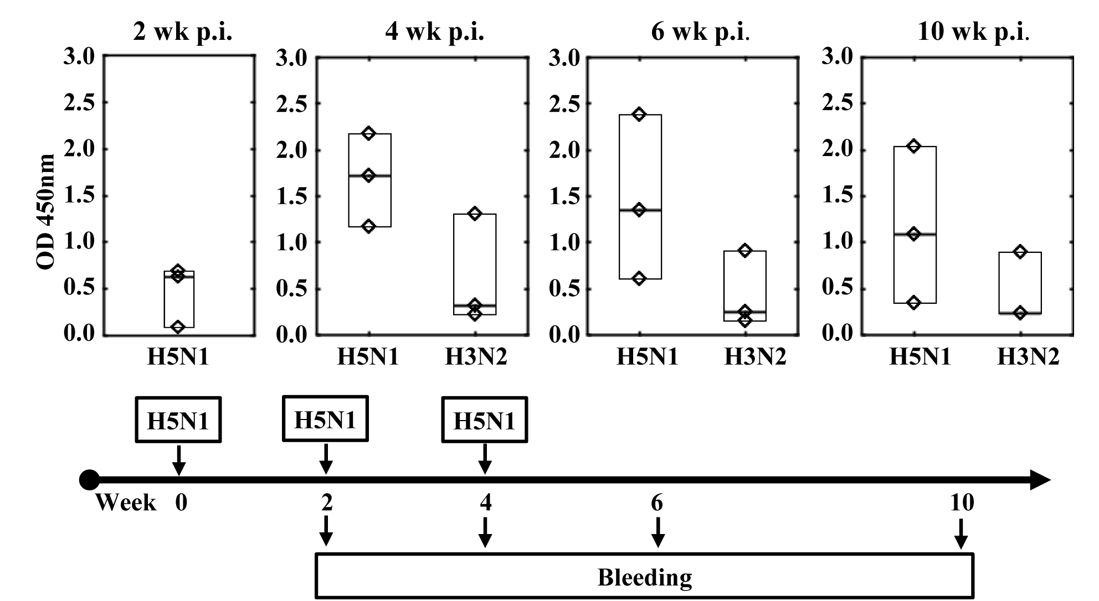

Figure 2. The levels of IgY in the HOM-2 group measured by indirect ELISA. The scheme of immunization is shown on the time scale graph at the bottom. The used vaccines (DNA plasmids), weeks of immunization and blood collection are indicated. The ELISA results from the blood samples collected at the indicated time points, weeks post initial immunization (wk p.i.), are presented as raw data (◊), median (—) and 10th–90th percentiles (). The used HA antigens are indicated in Table 2.

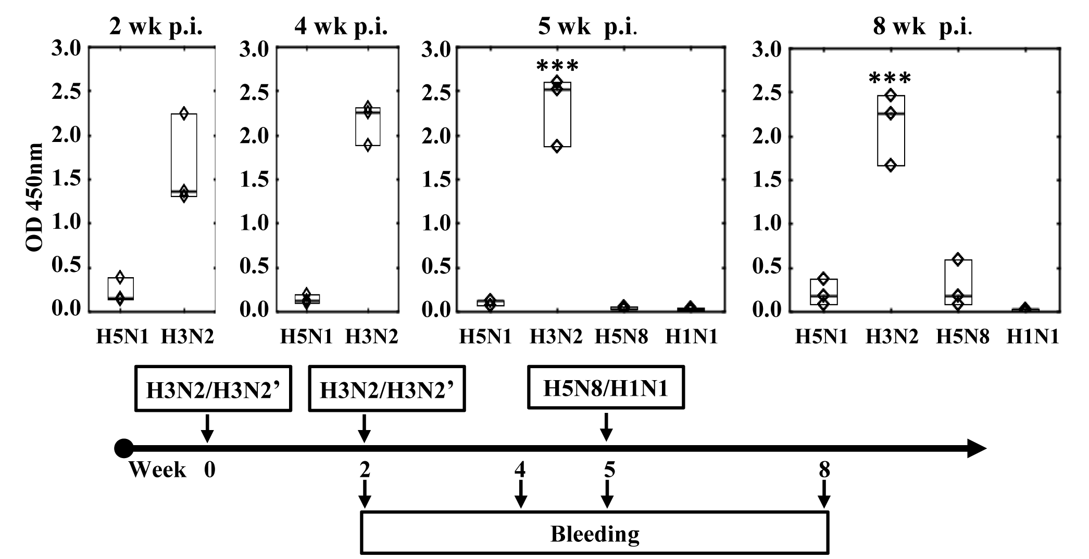

Figure 3. The levels of IgY in the HET-1 group measured by indirect ELISA. The scheme of immunization is shown on the time scale graph at the bottom. The used vaccines (DNA plasmids), weeks of immunization and blood collection are indicated. The ELISA results from the blood samples collected at the indicated time points, weeks post initial immunization (wk p.i.), are presented as raw data (◊), median (—) and 10th–90th percentiles (). The used HA antigens are indicated in Table 2. ANOVA was used to determine the significance of the differences; *** (P < 0.001) indicates differences between H3N2 and other antigens (H5N1, H5N5 and H1N1).

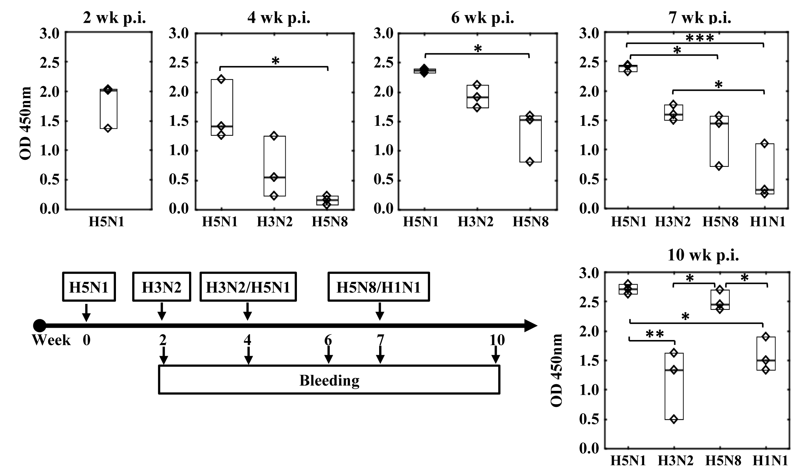

Figure 4. The levels of IgY in the HET-2 group measured by indirect ELISA. The scheme of immunization is shown on the time scale graph at the bottom. The used vaccines (DNA plasmids), weeks of immunization and blood collection are indicated. The ELISA results from the blood samples collected at the indicated time points, weeks post initial immunization (wk p.i.), are presented as raw data (◊), median (—) and 10th–90th percentiles (). The used HA antigens are indicated in Table 2. ANOVA was used to determine the significance of the differences; *, ** and *** indicate P < 0.05, P < 0.01 and P < 0.001, respectively.

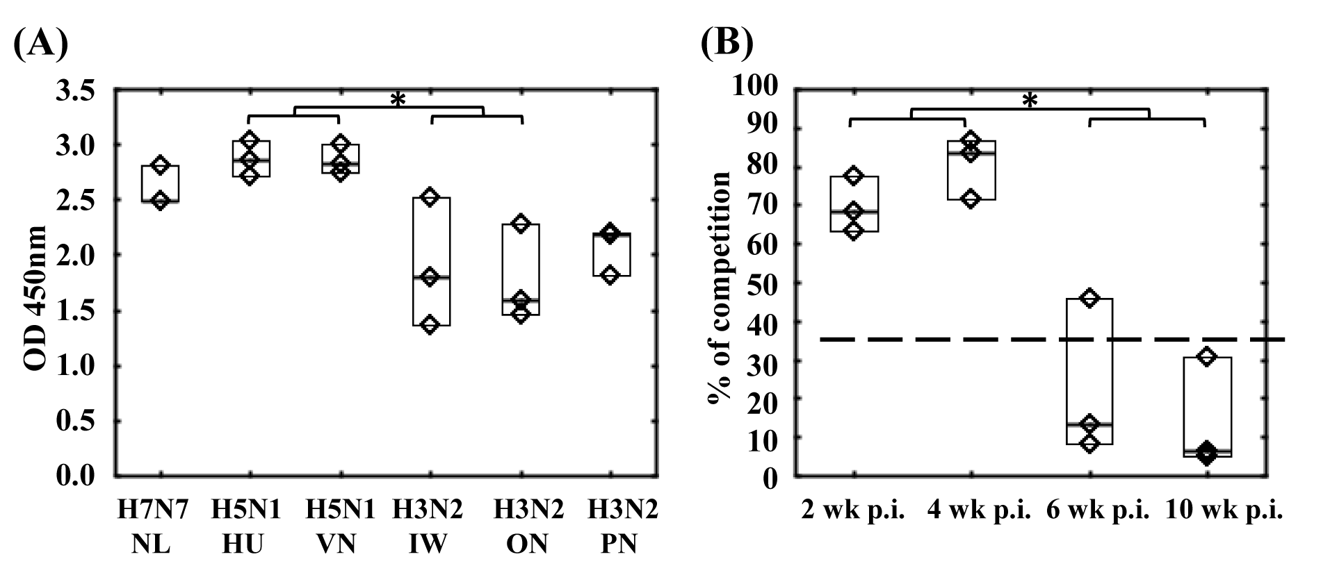

Figure 5. Analysis of sera from the HET-2 group with additional HA antigens. (A) Indirect ELISA with distinct antigens: NL – A/chicken/Netherlands/1/03, IW – A/Iowa/08/11, ON – A/Ontario/RV1273/05, PN – A/Panama/07/99 and HU – A/Hubei/1/10, VN – A/chicken/Vietnam/NCVD-016/08 was measured 6 and 10 weeks post initial immunization (wk p.i.), respectively. (B) Competitive H5 ID Screen ELISA with sera from indicated wk p.i. The cutoff value suggested by the manufacturer (35%) is marked as a dashed line. Results are presented as raw data data (◊), median (—) and 10th–90th percentiles (). The used HA antigens are indicated in Table 2. ANOVA was used to determine the significance of the differences; * indicates P < 0.05.

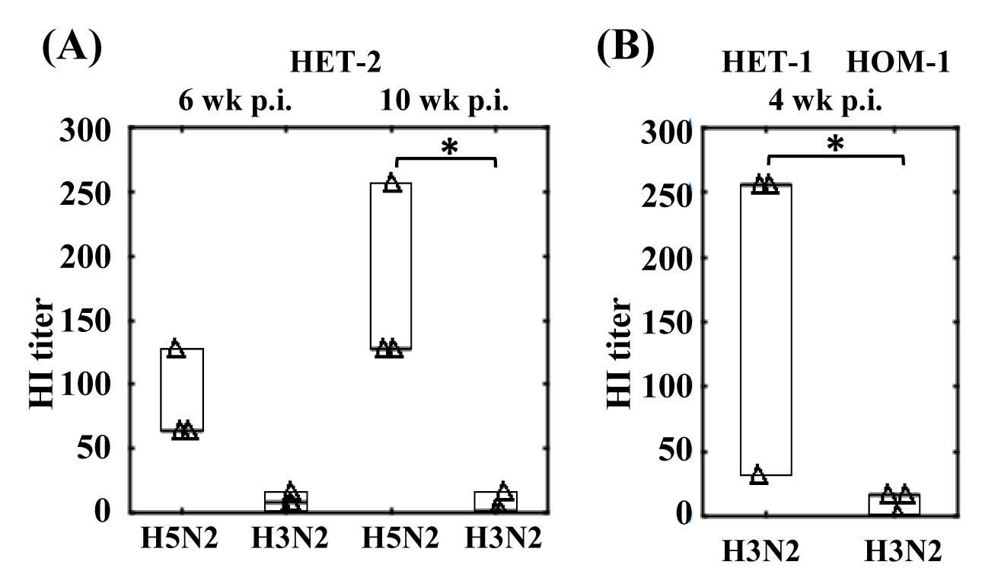

Figure 6. Results of HI test with sera from the selected groups. (A) The HI titers in HET-2 group measured 6 and 10 weeks post initial immunization (w.p.i.) using H5N2 and H3N2 inactivated antigens. (B) The HI titers in HET-1 and HOM-1 groups measured 4 weeks post initial immunization (w.p.i.) using H3N2 inactivated antigen. Results are presented as raw data data (◊), median (—) and 10th–90th percentiles (). The used HA antigens are indicated in Table 2. ANOVA (A) and student t-test (B) were used to determine the significance of the differences; * indicates P < 0.05.

Supplementary Material

H3N2 MKAI-IAFSCILCLVFAQKLPGSDNSMATLCLGHHAVPNGTLVKTITDDQIEVTNATELV
H3N2’ MKTI-IALSYILCLVFAQKLPGNDNSTATLCLGHHAVPNGTLVKTITNDQIEVTNATELV
H1N1 MKAILVVLLYTFATANAD----------TLCIGYHANNSTDTVDTVLEKNVTVTHSVNLL
H5N8 MEKI-VLLLAVVSLVKSD----------QICIGYHANNSTKQVDTIMEKNVTVTHAQDIL
H5N1 MEKI-VLLFAIVSLVKSD----------QICIGYHANNSTEQVDTIMEKNVTVTHAQDIL
*: * : : .. . :: :*:*:** . *.*: :.:: **:: :::

H3N2 QSSSTGRICNSPHQILDG------KNCTLIDALLGDPHCDDFQN-KEWDLFVERSTAYSN
H3N2’ QSSSTGRICDSPHRILDG------KNCTLIDALLGDPHCDGFQN-KEWDLFVERSKAYSN
H1N1 EDKHNGKLCK-----LRGVAPLHLGKCNIAGWILGNPECESLSTASSWSYIVETSKTNNR
H5N8 EKTHNGKLCD-----LNGVKPLILKDCSVAGWLLGNPMCDEFIRVPEWSYIVERANPAND
H5N1 EKTHNGKLCD-----LDGVKPLILRDCSVAGWLLGNPMCDEFLNVPEWSYIVEKINPAND
:.. .*::*. * * .*.: . :**:* *: : .*. :** .. .

H3N2 -CYPYYVPDYASLRSLIASSGTLK---FTQESFNWTG-VAQDGSSYACRRGSVKSFFSKL
H3N2’ -CYPYDVPDYASLRSLVASSGTLE---FINEDFNWTG-VAQNGDSYACKRGSVKSFFSRL
H1N1 TCYPGDFINYEELREQLSSVSSFERFEIFPKTSSWPNHDSNKGVTAACPHAGAKSFYKNL
H5N8 LCYPGTLNDYEELKHLLSRINHFEKTLIIPKS-SWPNHETSLGVSAACPYQGASSFFRNV
H5N1 LCYPGNFNDYEELKHLLSRINHFEKIQIIPKS-SWSDHEASSGVSSACPYQGRSSFFRNV
*** . :* .*: :: . :: : : .*.. :. * : ** . .**: .:

H3N2 NWLHNLNHKYPALNVTMPNNDRFDKLYIWGVHHPGTDKDQISLYVQASGIVTVSTKRSQQ
H3N2’ NWLHKSEYKYPALNVTMPNNDKFDKLYIWGVHHPSTDREQTSLYIRASGKVTVSTKRSQQ
H1N1 IWLVKKGNSYPKLSKSYINDKGKEVLVLWGIHHQNKKAEQQTPYQNADAYVFVGTSRYSK
H5N8 VWLIKKNDAYPTIKISYNNTNREDLLILWGIHHPNNAEEQTNLYKNPDTYVSVGTSTLNQ
H5N1 VWLIKKDNAYPTIKRSYNNTNQEDLLVLWGIHHPNDAAEQTRLYQNPTTYISVGTSTLNQ
** : ** :. : * . : * :**:** . :* * .. : *.*. .:

H3N2 TVIPNIGSRPWVRGVSSIISIYWTIVKPGDILLINSTGNLIAPRGYFKI-QGGKSSIMRS
H3N2’ TVIPNIGSRPWVRGLSSRISIYWTIVKPGDILLINSTGNLIAPRGYFKI-RTGKSSIMRS
H1N1 KFKPEIAIRPKVRDQEGRMDYYWTLIEPGDKITFEATGNLVVPRYAFAMERNAGSGIIIS
H5N8 RLVPKIATRSQVNGQRGRMDFFWTILKPNDAIHFESNGNFIAPEYAYKIVKKGDSTIMKS
H5N1 RLVPKIATRSKVNGQSGRMEFFWTILKPNDAINFESNGNFIAPENAYKIVKKGDSTIMKS
. *:*. *. *.. . :. :**:::*.* : :::.**::.*. : : : . * *: *

H3N2 DAPIDKCNSECITPNGSIPNDKPFQNVNRITYGACPRYVKQNTLKLATGMRNVPEKQ---
H3N2’ DAPIGTCSSECITPNGSIPNDKPFQNVNRITYGACPRYVKQNTLKLATGMRNVPEKQ---
H1N1 DTPVHDCNTTCQTPEGAINTSLPFQNIHPITIGKCPKYVKSTKLRLATGLRNVPSIQ---
H5N8 EVEYGHCNTKCQTPIGAINSSMPFHNIHPLTIGECPKYVKSNKLVLATGLRNSPLRERRR
H5N1 ELEYGNCNTKCQTPIGAINSSMPFHNIHPLTIGECPKYVKSNRLVLATGLRNSPQGERRR
: *.: * ** *:* .. **:*:: :* * **:***.. * ****:** * :

H3N2 -TRGIFGAIAGFIENGWEGMVDGWYGFRHQNSEGTGQAADLKSTQEAVNQITGKLNRVIK
H3N2’ -TRGIFGAIAGFIENGWEGMVDGWYGFRHQNSEGTGQAADLKSTQAAIDQINGKLNRLIE
H1N1 -SRGLFGAIAGFIEGGWTGMVDGWYGYHHQNEQGSGYAADLKSTQNAIDKITNKVNSVIE
H5N8 -KRGLFGAIAGFIEGGWQGMVDGWYGYHHSNEQGSGYAADKESTQKAVDGVTNKVNSIID
H5N1 KKRGLFGAIAGFIEGGWQGMVDGWYGYHHSNEQGSGYAADKESTQKAIDGVTNKVNSIIN
.**:*********.** ********::*.*.:*:* *** :*** *:: :..*:* :*.

H3N2 KTNEKFHQIEKEFSEVEGRIQDLEKYVEDTKIDLWSYNAELLVALENQHTIDLTDSEMNK
H3N2’ KTNEKFHQIEKEFSEVEGRIQDLEKYVEDTKIDLWSYNAELLVALENQHTIDLTDSEMNK
H1N1 KMNTQFTAVGKEFNHLEKRIENLNKKVDDGFLDIWTYNAELLVLLENERTLDYHDSNVKN
H5N8 KMNTQFEAVGREFNNLERRIENLNKKMEDGFLDVWTYNAELLVLMENERTLDFHDSNVKN
H5N1 KMNTQFEAVGREFNNLERRIENLNKKMEDGFLDVWTYNAELLVLMENERTLDFHDSNVKN
* * :* : :**..:* **::*:* ::* :*:*:******* :**::*:* **::::

H3N2 LFERTRKQLRENAEDMGNGCFKIYHKCDNACIGSIRNGTYDHDVYRDEALNNRFQIKSVQ
H3N2’ LFEKTRKQLRENAEDMGNGCFKIYHKCDNACIGSIRNGTYDHDVYRDEALNNRFQIKGVE
H1N1 LYEKVRNQLKNNAKEIGNGCFEFYHKCDNTCMESVKNGTYDYPKYSEEAKLNREKIDGVK
H5N8 LYDKVRLQLRDNAKELGNGCFEFYHKCDNECMESVRNGTYDYPKYSEEARLKREEISGVK
H5N1 LYDKVRLQLRDNAKELGNGCFEFYHRCDNECMESVRNGTYDYPQYSEEARLKREEISGVK
*:::.* **::**:::*****::**:*** *: *::*****: * :** :* :*..*:

H3N2 LRSGYKDWILWI-SFAISCFLLCVVLLGSIMWACQKGNIRCNICI
H3N2’ LKSGYKDWILWI-SFAISCFLLCVVLLGFIMWACQKGNIRCNICI
H1N1 LESTRIYQILAIYSTVASSLVLVVSLGAISFWMCSNGSLQCRICI
H5N8 LESIGTYQILSIYSTVASSLALAIIVAGLSLWMCSNGSLQCRICI
H5N1 LESIGTYQILSIYSTVASSLALAIMVAGLSLWMCSNGSLQCRICI
*.* ** * * . *.: * : : . :* *.:*.::*.***

Supplementary Figure 1. Alignment of the amino acid sequences of the HA used as a base of the DNA vaccines. CLUSTAL format alignment by MAFFT FFT-NS-i (v7.215).

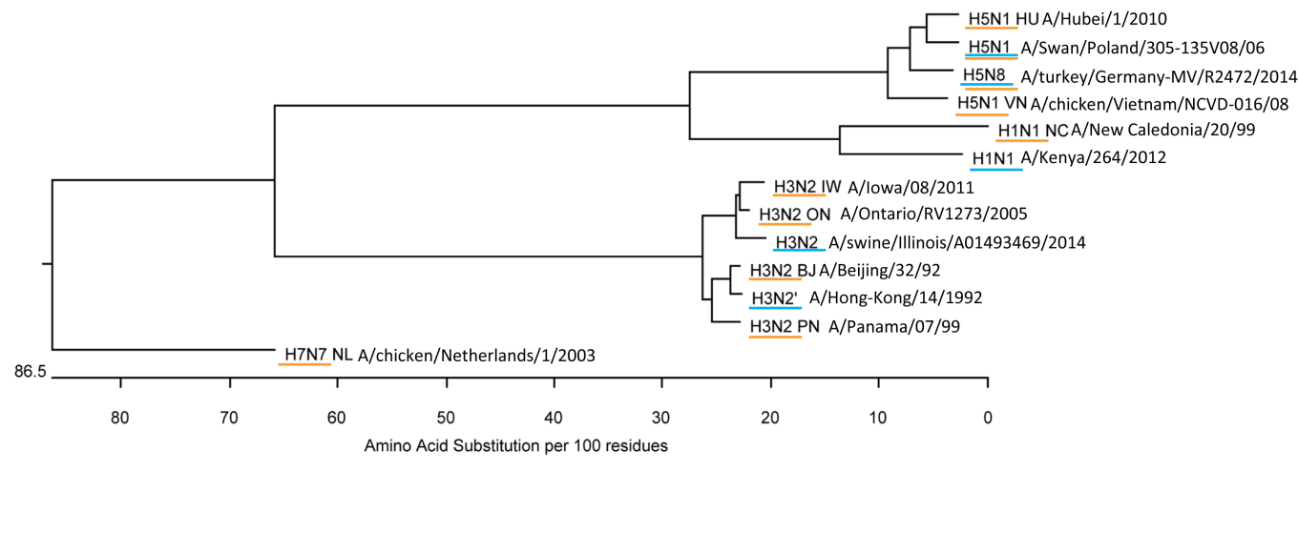

Supplementary Figure S2. Phylogenetic tree of HA variants used as vaccine templates and ELISA antigens. Tree was prepared in MegAlign program (DNASTAR Lasergene, USA). Vaccine sequences are marked with blue; antigen sequences are marked with orange.

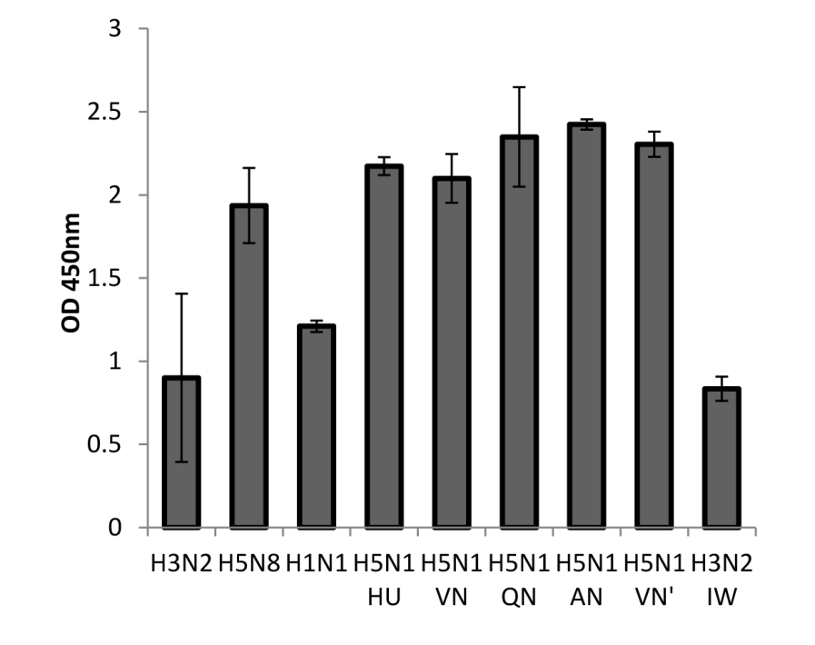

Supplementary Figure S3. The level of HA-specific IgY in eggs collected from the chickens from the HEK-2 group. Indirect ELISA test was performed with the indicated antigens HU – A/Hubei/1/10, VN – A/chicken/Vietnam/NCVD-016/08, QN – A/bar-headed goose/Qinghai/12/05, AN – A/Anhui/1/05, VN’ – A/Vietnam/1203/04, IW – A/Iowa/08/11 (see also Table 2). Data are presented as mean OD value for two IgY probes (each purified from one egg of an independent individual from group HEK-2 collected two weeks after final immunization – 10 weeks post initial immunization; 10 wk p.i.), with SD indicated.

