The C2H2 zinc finger transcription factors are likely targets for Ni(II) toxicity
Ewa Kurowskaª, Joanna Sasin-Kurowska^{b}, Arkadiusz Bonnaª, Marcin Grynbergª, Jarosław Poznańskiª, Łukasz Kniżewski^{b}, Krzysztof Ginalski^{b}, and Wojciech Bal*ª
Received (in XXX, XXX) Xth XXXXXXXXX 20XX, Accepted Xth XXXXXXXXX 20XX
DOI: 10.1039/b000000x
Ni(II) ions are able to hydrolyze Naa-(Ser/Thr) peptide bonds in Naa-(Ser/Thr)-Xaa-His-Zaa sequences. We found that various human transcription factors contain such nickel hydrolytic patterns within C2H2 zinc finger (ZF) domains. We demonstrated the hydrolysis on two peptide models, the 3rd ZF of Sp1 transcription factor and the 1st ZF of the ZNF302 transcription factor. The experimentally studied reaction rates indicate that the hydrolysis reaction is likely to be an element of intracellular nickel toxicity.

Introduction
Nickel compounds are toxic to humans. Respiratory exposure to particulate materials containing Ni(II) compounds can cause cancer, while contact exposure to nickel-containing objects is allergenic to susceptible individuals.¹ In the course of our search for chemical processes underlying nickel carcinogenesis, we discovered that Ni(II) ions hydrolyze a single, specific peptide bond in a hexapeptide derived from the histone H2A sequence.² Further studies demonstrated that the same hydrolysis reaction occurred in the whole histone H2A as well, both in vitro and in cell lines.^{3,4} Using model peptides we established that the sequence specificity of nickel hydrolysis is based on the Naa-(Ser/Thr)-Xaa-His-Zaa pattern, with the cleavage of the Naa-(Ser/Thr) peptide bond, regardless of the character of Naa (considered as any amino acid or N-terminal peptide sequence).^{5,6} The hydrolysis of this peptide bond was the sole reaction observed for all peptides and conditions tested. We then used a combinatorial peptide library to perform a broad screening of Xaa and Zaa residues. We determined the molecular mechanism of the reaction, which is based on the intramolecular acyl shift (Fig. 1). The peptides containing bulky and hydrophobic residues at positions Xaa and Zaa exhibited significantly accelerated reaction rates.^{7,8} This finding raised an issue of further targets of nickel toxicity among human proteins that could be cleaved similarly to histone H2A, yielding novel pathways of nickel toxicity. Zinc finger transcription factors may be such targets, because of the role they play in controlling cellular processes. In our previous research we found that zinc fingers (ZF) are reactive towards Ni(II) ions, with Zn(II)/Ni(II) substitution and ZF’s Cys oxidation as major reaction products.⁹ In this work we decided to look for the presence of Naa-(Ser/Thr)-Xaa-His-Zaa sequences susceptible to hydrolysis in the C2H2 ZF domains of transcription factors in order to find out whether Ni(II) can also exert hydrolytic damage in them.
Experimental
Peptide synthesis
All peptides were synthesized in our laboratory on a Prelude™ peptide synthesizer from Protein Technologies, Inc. (Tucson, AZ), according to the Fmoc strategy.¹⁰ Crude peptides were analyzed and purified by HPLC on an Empower system (Waters) equipped with an ACE 5 C18-300 analytical column (5 mm particle size, 250×4.6 mm) and a Vydac semi-preparative column (5 mm particle size, 250×10 mm), respectively. The mobile phase consisted of (A) 0.1% trifluoroacetic acid (TFA) in water and (B) 0.1% TFA in 90% acetonitrile in water. Pure lyophilized peptides were characterized on a Q-Tof Premier mass spectrometer (Waters), exhibiting correct molecular masses. The peptides synthesized and used in this study are presented in Table 1:
Table 1. Sequences of peptides synthesized and studied experimentally. The LSq and CSq1 hydrolysis sites are underlined with the solid and dotted lines, respectively. Dashes flanking peptide sequences denote N-terminal acetylation and C-terminal amidation.
Peptide name | Sequence
LSq-Site | -MRSDHLSK-
CSq-Site | -HLSKHIKT-
Sp1-3 | -KKACPECPKRFMRSDHLSKHIKTHQNK-
ZNF302-1 | -KIYTCSECGKAFGKQSILSRHWRIHTG-

Hydrolysis conditions
The susceptibility of zinc finger peptides to nickel hydrolysis was tested in conditions similar to those used previously for other peptides at pH 8.2 (100 mM Hepes) and 60 °C.¹⁰ Fresh stock solutions of peptides tested were prepared in Hepes buffer immediately prior to experiments. The remaining components of the reaction mixture were added in the following order:
Figure 1. The molecular mechanism of Ni(II)-dependent peptide bond hydrolysis.⁸

tricarboxyethylphosphine (TCEP, Sigma) at a 4-fold excess over the peptide, ZnCl₂ solution (Fluka) (none or at a 1 to 1 ratio to peptide), Ni(II) (10-fold excess over the peptide) and Hepes buffer to the desired volume. The pH was adjusted, if necessary, using concentrated NaOH or HCl. Final concentrations of peptides in reaction mixtures were 0.1 to 0.25 mM. 30 µl aliquots were withdrawn periodically from reaction mixtures and the reactions were quenched by adding them to 15 µl of 5% TFA. The zero time samples were collected just before the incubation start. Control runs were performed under identical conditions, in the absence of Ni(II) ions. Preliminary experiments were also performed at pH 7.4 and 37 °C, with 24 and 48 h incubations of samples. Prior to HPLC analysis, the samples were stored at 2-8 °C. HPLC analysis was performed on an Empower system (Waters) equipped with ACE 5 C18-300 (250×4.6 mm) analytical column, autosampler, and a double wavelength detector, set to 220 and 280 nm. Mobile phase consisted of (A) 0.1% (v/v) TFA in water and (B) 0.1 % (v/v) TFA in 90% (v/v) acetonitrile in water. Prior to loading samples into glass inserts of the autosampler carousel, they were diluted with 200 µl of MQ water and 200 µl of such mixture was injected into inserts. A total of 170µl of each sample was injected automatically into the HPLC system during the analysis. The reaction products were quantified by integration of HPLC peaks. Their identities were verified using ESI-MS.
Sequence searches
Human C2H2 ZF domains were obtained from the Pfam 25.0 database¹¹ (PF00096, zf-C2H2 family) and curated using human proteins from the Uniprot database.¹² The sequences of human C2H2 domains were aligned with PCMA software¹³ and scanned for specific Ni(II) hydrolytic motifs present in Table 2. Finally, all C2H2 domains from identified transcription factors were also scanned with a very general motif (Ser/Thr)-Xaa-His, where Xaa is any residue, but Pro.
Results
Establishment of nickel hydrolytic patterns in ZF sequences
The (Ser/Thr)-Xaa-His-Zaa sequences selected for the initial search are presented in Table 2. They correspond to peptides that were most susceptible to nickel hydrolysis in the mass spectrometry screening of Xaa/Zaa peptide combinatorial libraries.⁷ Among human proteins we identified 78 C2H2 ZF transcription factors, listed in ESI Table S1, with 83 C2H2 ZF domains containing our search tetrapeptides. The tetrapeptide sequences (11 out of 20 used) found in these domains are indicated in Table 2.

Table 2. The (Ser/Thr)-Xaa-His-Zaa sequences used for the search of nickel hydrolytic patterns in human proteins containing C2H2 ZF domains. The sequences are ordered according to (Ser/Thr) and Xaa substitutions. Sequences found in C2H2 transcription factors are marked bold.
SHHK  SHHW | SKHI  SKHK  SKHL  SKHW | SMHI  SMHL | SRHI  SRHK  SRHL  SRHR  SRHV  SRHW | SWHI  SWHL  SWHV | THHW  TKHW  TRHW

The initial analysis of the 83 ZF domains mentioned above revealed a non-random distribution of putative hydrolytic sites. Specifically, in 77 out of 83 domains hydrolytic motifs were located only at the first zinc-binding His residue. We labeled this pattern as Core Sequence 1 (CSq1 in brief). Among the remaining six domains, two included hydrolytic sites with the second zinc-binding His residue (thus labeled CSq2) and four were arranged at additional (non-zinc binding) His residues in the ZF loop. Therefore, we labeled them Loop Sequences (LSq).
All 78 identified transcription factors contain multiple C2H2 domains, what is typical for ZF transcription factors.¹⁴ Thus, we performed another search, now looking for any sequences potentially prone to nickel hydrolysis within the set of all 903 C2H2 ZF domains present in 78 initially selected transcription factors. This altered approach was justified by our parallel experiments. We found that sequences indicated by our previous studies^{7,8} as poorly susceptible to hydrolysis could be hydrolyzed effectively in the ZF context (see below). The new search sequence was therefore very general: Naa-(Ser/Thr)-Xaa-His, with Xaa comprising all amino acids except of Pro. This omission was dictated by the molecular mechanism of hydrolysis (Fig. 1), because a Pro residue between Ser/Thr and His prevents the formation of the hydrolytically active complex.^{7,8} The new search resulted in detection of 451 nickel hydrolytic sequences (hits) in 419 ZF domains with a very significant number of 359 hits for the CSq1 pattern (79.6%). The larger number of sequences allowed us also to confirm the presence of additional, less frequent patterns defined above, CSq2 and LSq. 32 ZF domains contain two hydrolytic patterns. Among them there are 25 instances of two neighbouring nickel hydrolytic sites: (Ser/Thr)-Aaa-His-Baa-(Ser/Thr)-Xaa-His-Zaa, (Aaa and Baa are any residues), where the C-terminal sequence corresponds to the CSq1 pattern. We labeled this pattern as LSqCSq1. Table 3 provides the statistics of this search, while examples of actual sequences are presented in Table 4. ESI Fig. S1 provides all results of this search.
The incidence of CSq1 hydrolytic patterns in the set of all human C2H2 domains catalogued in the Pfam 25.0 database was estimated by taking the number of Ser and Thr residues two positions upstream of the His residue. Among 14816 C2H2 domains identified in human proteins, 2922 contained a Thr residue (19.7%) and 854 contained a Ser residue (5.8%).

Figure 2. The example of experimental data and the fitting of the rate constant, of Ni(II)-dependent peptide bond hydrolysis for the ZNF302-1 peptide.

Table 3. The occurrence of single and double nickel hydrolytic patterns in 419 ZF domains of 78 transcription factors selected by the initial search.

 | Pattern
No. of hits | CSq1 | CSq2 | LSqª
328 | X
29 |  | X
30 |  |  | X
6 | X | X
25 | X |  | X
1 |  | X | X
0 | X | X | X
ª except of two sequences with nickel-susceptible sites within the aligned sequence but upstream to the CCHH motif.

Table 4. Examples of sequences carrying hydrolytic patterns found in the search summarized in Table 3. Conserved C2H2 ZF residues are highlighted black, nickel hydrolytic motifs are typed red.

ID | Sequence | Hydrolytic pattern
ZN302_HUMAN/281-303 | TCS--ECKAFGKQSILSRHWRIHT | CSq1
ZN302_HUMAN/449-471 | ECN--KCKVFSSFSFLVQHQSIHT | CSq2
SP1_HUMAN/627-651 | ICHIQGCKVYGKTSHLRAHLRWHT | LSq
SP1_HUMAN/687-709 | ACP--ECKRFMRSDHLSKHIKTHQ | LSqCSq1

Experimental verification of ZF hydrolysis by Ni(II)
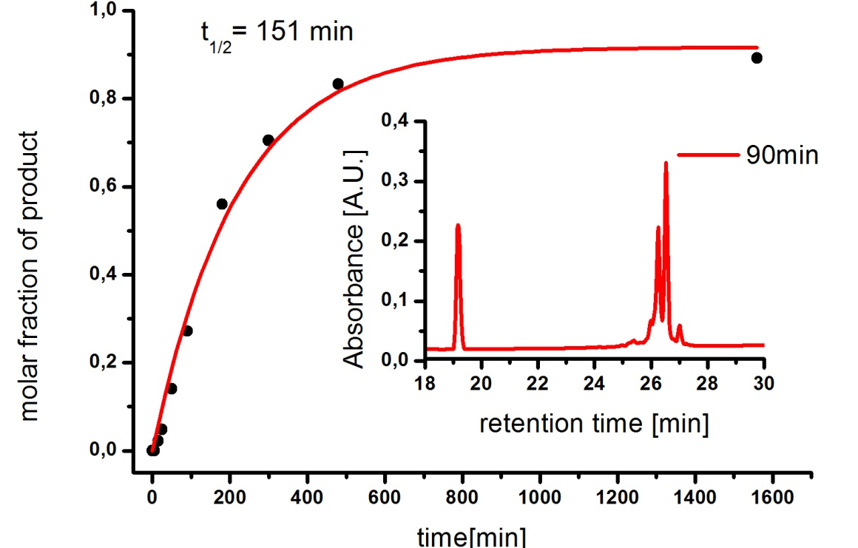
In order to verify experimentally the susceptibility of zinc fingers to Ni(II) hydrolysis, we chose two peptide models: (i) the third ZF of Sp1 transcription factor (Sp1-3), representing the LSqCSq1 pattern, and (ii) the first ZF of ZNF302 protein (ZNF302-1), which belongs to the major CSq1 pattern. Sp1-3 contains two potential hydrolysis sites, therefore, to facilitate analysis we also synthesized two shorter peptides, LSq-Site and CSq1-Site, modeling these sites separately. Table 5 presents the results of hydrolysis experiments, expressed as half-times of the 1st order reaction. Fig. 2 provides an example of the experimental data and the reaction rate calculations for the single hydrolysis site of ZNF302-1. Fig. 3 shows the HPLC/ESI-MS identification of all major products of products of hydrolysis of Sp1-3 at its both sites, with Table 6 decoding the labels of the products. The LSq hydrolysis yields P1 and P4, and the CSq1 hydrolysis provides P2 and P5. The formation of P3 is enabled by the occurrence of hydrolysis at both these patterns. Fig. 4 demonstrates the hydrolysis of Sp1-3 at pH 7.4 and 37 °C.
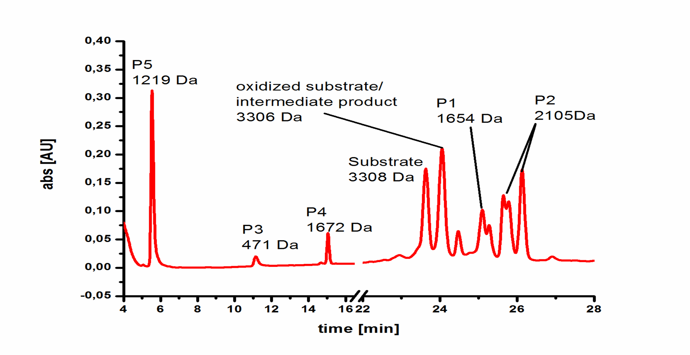
Figure 3. The chromatogram of Sp1-3 incubated for 45 min with Ni(II) ions at 60 °C and pH 8.2. All major final and intermediate products of hydrolysis at LSq and CSq1 patterns, determined by ESI-MS, are shown. See Table 6 for sequences of individual products. Peptide oxidation was limited to the formation of the intramolecular disulfide bond.

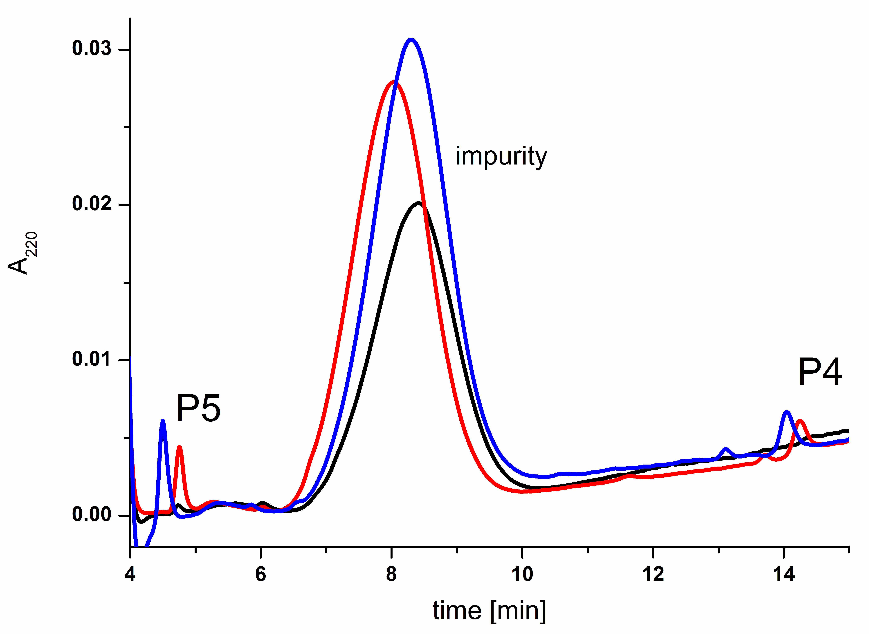
Figure 4. The chromatograms of Sp1-3 incubated for 48 h at pH 7.4 without Ni(II) ions (black), with Ni(II) ions (blue) and with Ni(II) and Zn(II) ions (red).

Table 5. The t_{1/2} valuesª [min] for the 1st order reaction of nickel-dependent peptide bond hydrolysis.

Peptide | Zn(II) | No Zn(II)
LSq-Site | n.t.^{b} | 120
CSq1-Site | n.t.^{b} | 22
Sp1-3 | 60 | 20
ZNF302-1 | 151 | 92
ª t_{1/2} = 0.693/k, where k is 1st order rate constant
^{b} not tested

Table 6. The major products of nickel hydrolysis of Sp1-3.

Label | Sequence | m/z
Substrate | -KKACPECPKRFMRSDHLSKHIKTHQNK- | 3308
P1 | -KKACPECPKRFMR | 1654
P2 | -KKACPECPKRFMRSDHL | 2105
P3 | SDHL | 471
P4 | SDHLSKHIKTHQNK- | 1672
P5 | SKHIKTHQNK- | 1219

All peptides underwent the hydrolysis according to the 1st order rate law. The reaction proceeded according to the previously established sequence specificity, with the sole cleavage of the peptide bond preceding the Ser residues, until the substrate exhaustion. Sp1-3 was cleaved preferably at the LSq motif both in the absence and presence of Zn(II) ions. The rates were rather fast, with t_{1/2} values of ca. 20 min. to 2½ hours. The presence of Zn(II) ions slowed the reaction significantly for both ZFs, but affected neither the sequence specificity nor the kinetic profile of the reaction.
Discussion
Susceptibility of ZF peptides to Ni(II) hydrolysis
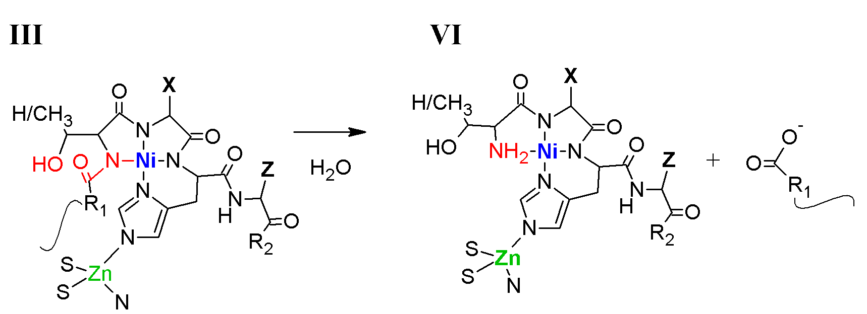
Our experiments demonstrated that Sp1-3 and ZF302-1 can undergo site-specific peptide bond hydrolysis in the presence of Ni(II) ions. We studied hydrolysis at elevated temperature and pH to facilitate the determination of the rate law and kinetic parameters that could be compared with previously studied peptides. A good knowledge of the reaction mechanism allows us, however, to extrapolate the reaction rate to milder conditions of pH 7.4 and 37 °C, at which the reaction was too slow to determine it accurately (see Fig. 4). The decrease of reaction temperature from 60 to 37 °C results in a four-fold decrease of the rate constant,⁸ and lowering of the pH from 8.2 to 7.4 should add another factor of ca. 5.¹⁵ The resulting 20-fold decrease of the reaction rate for physiological conditions is consistent both with our preliminary experiments and with our previous cell culture studies, where we saw the accumulation of nickel hydrolytic damage over several days.⁴
Precise determination of rate constants and t_{1/2} values allows us also to discuss novel elements of the reaction mechanism, which manifested themselves in the ZF hydrolysis. Although the LSq-Site peptide was hydrolyzed six times slower than the CSq1-Site one, in agreement with predictions based on our previous library studies,^{7,8} both peptides were hydrolyzed several-fold faster than predicted. Even more interestingly, in the absence of Zn(II) ions the Sp1-3 peptide was cleaved as fast as CSq1-Site (measured by substrate decay), but the hydrolysis at LSq was faster than that at CSq1. The addition of Zn(II) ions slowed the reaction by a factor of three, but it still occurred at both sites, including the one occupied by the Zn(II) ion. The LSq sequence of Sp1-3 contains amino acids expected to react very slowly, but it was apparently strongly activated in the structural context of the zinc finger. These facts, which encouraged the extension of our search over all (Ser/Thr)-Xaa-His-Zaa sequences, demonstrate how important the conformational factors are for Ni(II)-dependent peptide bond hydrolysis. The results obtained for ZNF302-1 were even more striking, as the addition of Zn(II) slowed down the hydrolysis only by the factor of 1.6. Ni(II) ions can substitute for Zn(II) ions in ZF domains, but only at a very high molar excess. For example, for Sp1-3 the Zn(II) binding constant is 6700 times higher than the Ni(II) binding constant,¹⁶ and the analogous ratio for another ZF peptide, XPAzf is 2300.⁹ If the replacement of Zn(II) with Ni(II) were necessary for ZF hydrolysis, then a similarly large reaction slowdown should be expected. However, the contrary is true. In the CSq sequence, which is the most abundant type of ZF hydrolytic patterns, and which is hydrolyzed in both ZNF302-1 and Sp1-3, the hydrolytic motif is partially shielded by the Zn(II) ion coordination to the Ni(II) anchoring His residue. The hydrolysis without Zn(II) displacement can be explained by the fact that the His imidazole has two nitrogen donors capable of binding metal ions, and it often forms heterometallic bridges. N1 is required to be available to Ni(II) to form the hydrolytic complex (Fig. 1), while Zn(II) is binding to N3 in Sp1-3 and apparently in most other C2H2 ZFs.¹⁷ This point is illustrated in Fig. 5. With this observation in mind, we think that the hydrolysis of C2H2 ZF domains may be quite likely in vivo. This opinion is also supported by the fact that C2H2 ZF domains in transcription factors, e.g. Sp1 extend from the bulk of the protein towards its DNA targets, enabling easy access to LSq and CSq1 hydrolytic motifs.¹⁷ Our studies were performed at a ten-fold molar excess of Ni(II) over the peptides. It is not known how many C2H2 ZF transcription factor molecules are present in the cell nucleus at any given moment of time, but some data are available for Ni(II) levels in tissues of exposed humans and experimental animals. The basal levels of Ni(II) are typically submicromolar to low micromolar, and various types of exposure elevate these levels by 50 to 10 000 %, the latter reaching values of 60-80 µM.¹⁸⁻²⁰ Therefore, intracellularly, the molar excess of dissolved Ni(II) over hydrolytic motifs in transcription factors may be very high. The rate of the nickel hydrolysis reaction is strongly dependent on the Ni(II) concentration, and so the hydrolysis in vivo may be faster than that observed in our experiments.⁸

Figure 5. The structures of hydrolytic complex and the hydrolysis products indicate that the reaction may occur without displacing Zn(II) from the C2H2 ZF. Numbers of structures correspond to Fig. 1.

We adopted two different strategies in choosing peptides for hydrolysis experiments. Sp1 is an absolutely crucial transcription factor, orchestrating cell growth, differentiation and apoptosis, and, on the tissue level, angiogenesis and immune response. It also controls the expression of p53, they key guardian of the cell against neoplastic transformation.²¹ Sp1 contains three fingers, with hydrolytic patterns in finger 1 (LSq) and finger 3 (LsqCsq1). ZNF302 is not well characterized, but is probably involved in ubiquitination signaling.²² ZNF302 contains seven ZF domains, with potential hydrolytic sites of CSq1 type in fingers 1 and 2, CSq1CSq2 in finger 3, LSqCSq1 in finger 6 and CSq2 in finger 7. It therefore provides a good example for multiple cleavage opportunities Ni(II) ions may have upon the cell nucleus exposure.
Summarizing, we found a significant number of potential Ni(II) targets: 419 domains from 78 C2H2 ZF transcription factor proteins may be hydrolyzed. The ease of hydrolysis of our model peptides makes us believe that Ni(II) dependent peptide bond hydrolysis may be an important, while yet overlooked element in nickel toxicity and carcinogenesis.
Conclusions
With this research, we demonstrated that C2H2 ZF domains may be new and extremely important targets of Ni(II) toxicity, related to Ni(II)-induced hydrolysis of peptide bond.
Acknowledgments
This research was supported in part by the project "Metal-dependent peptide hydrolysis. Tools and mechanisms for biotechnology, toxicology and supramolecular chemistry” carried out as part of the Foundation for Polish Science TEAM program, co-financed from European Regional Development Fund resources within the framework of Operational Program Innovative Economy. K.G. acknowledges support from EMBO and Foundation for Polish Science (TEAM, FOCUS).
Notes and references
ª Institute of Biochemistry and Biophysics, Polish Academy of Sciences, Pawinskiego 5a, 02-106 Warsaw, Poland. Fax: +48 22 6584636; Tel: +48 22 592 2346; E-mail: wbal@ibb.waw.pl
^{b} Laboratory of Bioinformatics and Systems Biology, Interdisciplinary Centre for Mathematical and Computational Modelling, University of Warsaw, Zwirki i Wigury 93, 02-089 Warsaw, Poland. Fax: +48 22 5540801; Tel: +48 22 5540800

† Electronic Supplementary Information (ESI) available: Table S1 contains names of 78 C2H2 ZF transcription factors, while Fig. S1 presents the alignment of 903 C2H2 ZF domains from these proteins and the occurrence of nickel hydrolytic patterns. See DOI: 10.1039/b000000x/

1. E. Kurowska and W. Bal in Advances in Molecular Toxicology, ed. J. C. Fishbein, Elsevier B. V. 2010, vol 4, ch. 3, pp. 85–126.
2. W. Bal, J. Lukszo, K. Bialkowski and K. S. Kasprzak, Chem. Res. Toxicol., 1998, 11, 1014–1023.
3. W. Bal, R. Liang, J. Lukszo, S.-H. Lee, M. Dizdaroglu and K. S. Kasprzak, Chem. Res. Toxicol., 2000, 13, 616–624.
4. A. A. Karaczyn, W. Bal, S. L. North, R. M. Bare, V. M. Hoang, R. J. Fisher and K. S. Kasprzak, Chem. Res. Toxicol., 2003, 16, 1555–1559.
5. M. Mylonas, A. Krężel, J. C. Plakatouras, N. Hadjiliadis and W. Bal, J. Chem. Soc., Dalton Trans., 2000, 4296–4306.
6. A.Krężel, M. Mylonas, E. Kopera and W. Bal, Acta Biochim. Polon. 2006, 53, 721–727.
7. A. Krężel, E. Kopera, A. M. Protas, J. Poznański, A. Wysłouch-Cieszyńska and W. Bal, J. Am. Chem. Soc. 2010, 132, 3355–3366.
8. E. Kopera, A. Krężel, A. M. Protas, A. Belczyk, A. Bonna, A. Wysłouch-Cieszyńska, J. Poznański and W. Bal, Inorg. Chem. 2010, 49, 6636–6645.
9. W. Bal, T. Schwerdtle and A. Hartwig, Chem. Res. Toxicol. 2003, 16, 242-248.
10. W.C. Chan and P.D. White, Fmoc Solid Phase Peptide Synthesis. A Practical Approach. Oxford University Press, New York 2000, pp. 41–76.
11. R. D. Finn, J. Mistry, J. Tate, P. Coggill, A. Heger, J. E. Pollington, O. L. Gavin, P. Gunesekaran, G. Ceric, K. Forslund, L. Holm, E. L. Sonnhammer, S. R. Eddy and A. Bateman, Nucleic Acids Res. 2010, 38 (Database issue), D211-D222.
12. R. Leinonen, F.G. Diez, D. Binns, W. Fleischmann, R. Lopez, R. Apweiler, Bioinformatics, 2004 20:3236-3237.
13. J. Pei, R. Sadreyev and N.V. Grishin, Bioinformatics 2003, 19, 427-428.
14. R. O. Emerson and J. H. Thomas, PLoS Genet. 5: e1000325, 2009. doi:10.1371/journal.pgen.1000325
15. A. M. Protas, A. Bonna, E. Kopera and W. Bal, J. Inorg. Biochem. 2011, 105, 10-16.
16. M. C. Posewitz and D. E. Wilcox, Chem. Res. Toxicol. 1995, 8, 1020-1028.
17. S. Oka, Y. Shiraishi, T. Yoshida, T. Ohkubo, Y. Sugiura and Y. Kobayashi, Biochemistry 2004, 43, 16027-16035.
18. P. A. Gillespie, G. S. Kang, A. Elder, R. Gelein, L. Chen, A. L. Moreira, J. Koberstein, K.-M. Tchou-Wong, T. Gordon and L. C. Chen, Nanotoxicology. 2010, 4, 106-119.
19. G. De Palma, M. Goldoni, S. Catalani, P. Carbognani, D. Poli, P. Mozzoni, O. Acampa, E. Internullo, M. Rusca and P. Apostoli, Acta Biomed. 2008, 79, Suppl. 1, 43-51.
20. P.-L. Kalliomaki, H.-K. Hyvarinnen, A. Aitio, E.-L. Lakoma and K. Kalliomaki, Brit. J. Ind. Med. 1986, 43, 112-119.
21. L. Li and J. R. Davie, Ann. Anat. 2010, 192, 275-283.
22. J. W. Pridgeon, E. A. Webber, S. Sha, L. Li and L.-S. Chin, FEBS J. 2009, 276, 118-131.

