Title: Ferritins in Chordata: potential evolutionary trajectory marked by discrete selective pressures.

Subtitle: History and reclassification of ferritins in chordates and geological events’ influence on their evolution and radiation

Keywords: ferritins, Chordata, evolution, phylogenetics, adaptation

Authors: Maciej P. Golan^{1*}, Sebastian Piłsyk^{2*}, Anna Muszewska³, Agata Wawrzyniak⁴

* These authors contributed equally to this work

^{1.} Department of Neuropathology, Institute of Psychiatry and Neurology, Sobieskiego 9, 02-957 Warszawa, Poland e-mail: mgolan@ipin.edu.pl
^{2.} Institute of Biochemistry and Biophysics, Polish Academy of Sciences, Pawińskiego 5a, 02-106 Warszawa, Poland e-mail: seba@ibb.waw.pl
^{3.} Institute of Biochemistry and Biophysics, Polish Academy of Sciences, Pawińskiego 5a, 02-106 Warszawa, Poland e-mail: musze@ibb.waw.pl
^{4.} Morphological Sciences Department, College for Medical Sciences of University of Rzeszów, Leszka Czarnego 4, 35-615 Rzeszów, Poland e-mail: awawrzyniak@ur.edu.pl

Abstract
Ferritins (FTs) are iron storage proteins that are involved in managing iron-oxygen balance. In our work, we present a hypothesis on the putative effect of geological changes that have affected the evolution and radiation of ferritin proteins. Based on sequence analysis and phylogeny reconstruction, we hypothesize that two significant factors have been involved in the evolution of ferritin proteins: fluctuations of atmospheric oxygen concentrations, altering redox potential, and changing availability of water rich in bioavailable ferric ions.
Fish, ancient amphibians, reptiles, and placental mammals developed the broadest repertoire of singular FTs, attributable embryonic growth in aquatic environments containing low oxygen levels and abundant forms of soluble iron. In contrast, oviparous land vertebrates, like reptiles and birds, that have developed in high oxygen levels and limited levels of environmental Fe²⁺ exhibit a lower diversity of singular FTs, but display a broad repertoire of subfamilies, particularly notable in early reptiles.

Introduction
Ferritins (FTs) are iron storage cage-forming oligomeric proteins that are involved in the transportation and managing iron-oxygen balance in all organisms. FTs belong to the Ferritin family (Pfam: PF00210). These proteins undergo oligomerization to form cages, able to store a large quantity of iron ions, up to 4500 atoms per cage, in bioavailable, nontoxic, and soluble Fe₂O₃(H₂O)_{n} ferric oxide forms [1,2]. TheFT cage is most often present as a 24 ferritin dimeric subunit form; albeit, in cardiac and skeletal muscles, a larger form that is composed of 36 subunits has been described [3,4,5]. FT cages may consist of ferritin units of either identical or mixed type.
Among all Animalia, Vertebrata display the broadest diversification of FT types. This phenomenon is most likely associated with whole genome duplication (WGD), occurring during the earliest period of evolutionary history, allowing for a rapid expansion of new taxons and species [6]. Traditionally, three types of FT have been described, based upon their relative molecular mass: H (heavy), M (medium), or L (light), a classification that is independent of other biological properties. FT tissue localizations have been described for only few Mammalia species and one Amphibia (Rana catesbeiana)[7]. For instance, in frogs, the FTM transcripts were detected in the liver, while transportive FTH and FTL were expressed in the blood cells [8]. Depending upon the tissue type, different types of the ferritin monomers will assemble into FT cages. In the tissues where iron is retained for long periods, such as spleen and liver, [9,10], the FTL type is predominant. In metabolically active tissues, such as heart [10], teeth [11] and brain (especially in the neurons and the oligodendrocytes), FTH is predominant [12,13]. The oligodendrocytes (OLG) are the most abundant glial cells in the central nervous system (CNS) responsible for the myelinization process, nerve bundles protection, and axon sheath development. They are also the source of the redox-active ferrous ions necessary for the brain's crucial metabolic processes [14]. Therefore, the OLG has the highest iron concentration among all CNS cells [15]. On the other hand, accumulation of the redox-active ions leads to the development of multiple pathologies, emphasizing the need for preserving the precise homeostasis provided by FT [16]. Destabilization of this delicate balance might lead to different neurological symptoms and diseases [17].
The production of FT occurs at the cytosolic ribosomes [18], and a portion of FT, synthesized on the ER–bounded polyribosomes, is secreted into the blood plasma and extracellular fluids [19,20]. A unique variant of the 'heavy' FTH type is present in the mitochondria [21]. The function of the heavy variant resembles that of the other FTs: iron sequestration (supply of Fe for the heme biosynthesis), with putative mitochondrial protection against the iron-dependent reactive oxygen species (ROS) production [22]. Iron-loaded ferritin is transported in mammalian blood in the form of a cage bound to apolipoprotein B through the heme moiety (ApoB–FT; [23]. Consequently, the FT ability to bind heme is evolutionarily conserved and appears to be crucial in iron transportation in the organism. FT are reabsorbed from blood by V-set Ig-type receptors and HAVCR (Hepatitis A virus cellular receptor) known also as TIM (T-cell immunoglobulin and mucin domains) [24,25], transferrin receptor-1 (TfR1) [26] or ferritoid, a FT-like protein [27].
Structural studies of the ferritin cages, formed by either FTL, or FTH-type-subunits, show that homo-FTH (PDB ID: 4OYN) displays a higher efficiency of iron binding and uptake compared to homo-FTL (PDB ID: 5LG8)[28,29]. Iron ions (II) are transported and loaded into the FT cage through inter-subunit pores formed by C-terminal regions of oligomerizing FT subunits [30]. A conserved residue found on FL subunits, Leu134 [31], is required for proper pore functioning, a process associated with subunit unfolding upon iron uptake. In mixed FTH-FTL cages, the FTLs are responsible for the nucleation and mineralization of the iron core, a process that improves ferroxidase activity [32,33]. FTH scarry on ferroxidase activity, converting Fe²⁺ into partly crystalline or amorphic structures of Fe²⁺ and Fe³⁺ oxides, along with hydroxides mineral form of ferrihydrite, magnetite, hematite in the ferritin shell [34,35]. In human FTH, the ferroxidation centre involves Glu27, Glu61, Glu62, His65, Gln141 [32,36]. Corresponding residues in FTL are involved in the cage stabilization by forming salt bridges, what makes FTL-based structure more stable [37]. The FTH cage incorporates more iron than the FTL cage by its nucleation to ferrihydrite on its inner surface within the ferritin complex [38,39]. Iron oxidation facilitates further iron incorporation and therefore is essential for the regulation of cellular iron levels. Oxidationis also responsible for detoxification of the bioactive ferrous form into the relatively inert ferric form [40]. FTs act as redox-balance buffering proteins in a finely-tuned cyclic conversion Fe²⁺-Fe³⁺ by various ferroxidase centres, with relatively slow rates of oxidation [41]. Small, although targeted, differences in amino acid residues between FTs lead to profound changes in electrochemical and biochemical properties.
In addition to ferroxidation, FTH cages possess UV-protection ability [42,43], probably due to the accumulated iron oxides [44]. Stress-related expression of the FTH gene seems to be conserved among the mammals and birds; exposure to environmental stressors such as UV radiation redox stress [42,45,46], infrared radiation [47] or heat [48], are associated with elevated levels of FTH transcripts. Increased levels of FTH lead to the repression of HIF (hypoxia-induced factor), a process that regulates the oxygen-sensing pathway in the cells [49]. Some studies in fish indicate a putative role of ferritins as a protective factor and part of the immunity mechanism against bacterial infection, due to competition for iron between pathogen and host [50].
FT is also involved in the magnetic field sensing observed in the fish and birds. In rainbow trout (Oncorhynchus mykiss), FT genes are overexpressed upon changes in the magnetic field [51]. In birds, FTH cages are abundantly present in the magnetosomes and are involved in the magnetic field sensing [52,53]. Some authors postulate that ferritins could also be responsible for the magnetodetection and navigation in the mammalian brain [54].
Previous studies of the ferritin sequences showed the conservation of residues forming the ferroxidase active site [1]. Authors speculated that multiple FTs originated from FTH, derived from an ancestral and ubiquitous rubrerythrin-like protein [2]. A mixed sequence-structure based approach supported the positioning of FTs among rubrerythrins [55]. These previous studies, albeit, did not seek to address the overall evolution of FT subfamilies.
Evolutionary relationships between vertebrate FTs and their non-vertebrate homologs were first presented by Lee et al. [56]. The authors hypothesized that the ancestral vertebrate FT originated from a single-chain type, similar to the one modelled for the extant basal chordates (Tunicata, Myxyni, Branhiostoma). For early vertebrates, they reported that duplication of the single FT chain occurred independently of invertebrates, resulting in lineage-specific duplications. Lee and co-workers [56] suggested that duplication might lead to the functional convergence. As an example, in both Drosophila and Mammalia, functional FTs are expressed in testicular mitochondria. In contrast, as amphibians need to adapt to the different aquatic and terrestrial environments during their life cycles, the presence of the divergent types of L/M FT chains reflects their iron demand. Hence, authors hypothesize that the differences between paralogous chains of teleosts FT and mammalian FTL evolved due to the adaptation of tetrapods to the terrestrial life, a process associated with significantly different requirements for iron uptake and storage.
In this paper, we classify vertebrate FTs into six subfamilies based upon their phylogeny, taxonomic distribution, and other traits such as ferroxidative ability. Our study clarifies the evolutionary relationships between vertebrate FTs. It allows us to speculate about the evolution of their functions in the context of vertebrate adaptations to different geological events, resulting in oxygen concentration changes in the atmosphere and iron availability during embryo development. The detailed information regarding phylogenetic analyses is provided in supporting information.

Chordata have biochemically diverse ferritin isoforms divisible for six FT subfamilies
A phylogenetic analysis of the 101 sequences from the 18 model chordates shows that vertebrate FTs form at least six subfamilies, unequally distributed among taxa (Fig. 1, Supplementary File 4-5). These subfamilies roughly correspond to previously described types of ferritins. Using this analysis, we are able to distinguish ancestral forms of FT named: FTA (ancestral), FToid (ferritoid), FT-HA (heavy chain A), FTM (medium), FTL (light) and FTH (heavy). There are limited number of published data, regarding this super – clades and they are not recovered using other tree reconstruction methods, therefore the monophyly of FTL and FTH subfamilies seems uncertain (Supplementary File 2). Although its position on the tree varies depending on the method used, the FToid subfamily forms a well-distinguished clade in all tested approaches.

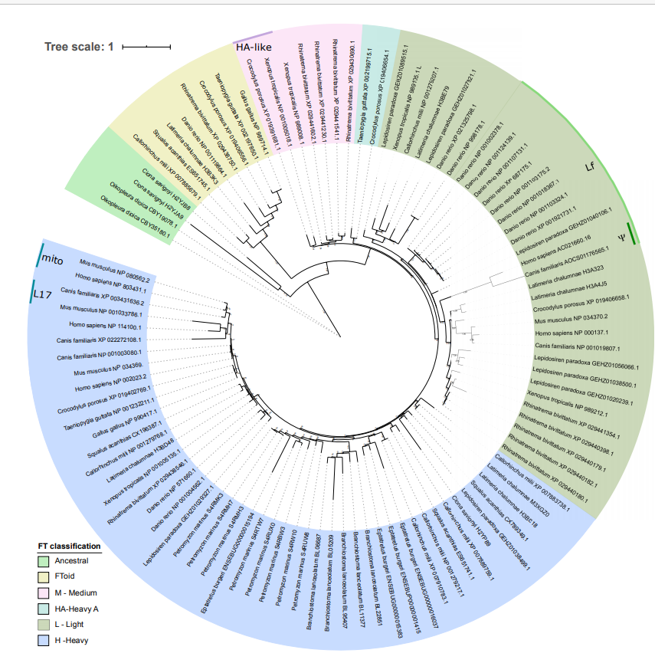
Figure 1. Maximum likelihood tree of 101 ferritins from model chordates. Subfamilies (legend) and specific variants (depicted around the perimeter). Representatives of Tunicata were selected as an outgroup and used to root the tree.

Among all animals, Vertebrata possesses the broadest spectrum of FT subfamilies and isoforms. As a highly organized and mobile group, this subphylum developed highly specialized iron transport systems as an adaptive response to environmental changes and diverse ecological niches. Due to evolutionary adaptations to various oxygen and iron content in the surrounding environment among Earth history (Fig. 3), the evolution of FTs is likely to have been substantially influenced by these conditions. We show that vertebrate FTs may be divided into the six subfamilies, and the vertebrates' FT were duplicated and derived from the ancient Chordata, like Tunicata, as suggested by Lee et al. [56], not from FTH, as it was thought until now in some earlier reports [1]. We also found that the ferroxidation active site is mostly conserved across FT representatives. Notable exceptions include FTL and FToid that lack conserved residues, corresponding to Glu27 and Gln141 in human FTL.

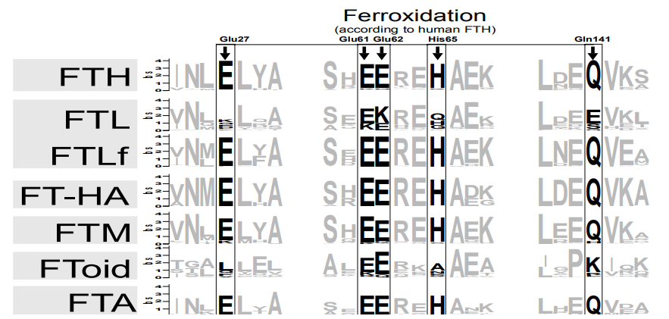
Figure 2. Alignment of six FT-subfamily sequence logo with an indication of amino acids potentially involved in iron ferroxidation (above alignment).

Calm Precambrian oceans' life and origin of ancient chordates' ferritins
Tunicata are considered to be 'living fossils', and represent the oldest chordate group, having evolved at the end of Precambrian, c.a. 541 My ago in anoxic oceans that were saturated with a high level of iron ions. The appearance of Tunicata coincides with the end of the Ediacarian-Cambrian hyperactive magnetic field changes (Fig. 3)[57]. During the Cambrian Explosion, atmospheric oxygen level increased to over 20%, albeit strong UV radiation through a weak ozone layer have led to generation of the reactive oxygen species (ROS), which might be a reason for the extinction of many early animals. Genomes of many tunicates possess two to three copies of FT genes, which encoded proteins form a separate clade, the ancestral FT (FTA), with putative ferroxidation ability. In the subsequent Cambrian epoch (530 Mya ago) the Cephalochordata appeared, with a different newly diverged FTHs instead of the ancestral ones, albeit still able to conduct ferroxidation and accumulate UV protective iron oxides. The presence of FTH in all Vertebrata and Cephalochordata analysed suggests, with the separation of these lineages, that the divergence of FTA into FTH occurred concomitantly.

Cornea, jaws and nervous system evolution in Vertebrata were concurrent with diversification of modern ferritin subfamilies during Ordovician-Silurian Great Extinction.
Similar to their Precambrian ancestors, early evolved vertebrate and jawed fish Chondrichthyes, Coelacanthimorpha, Actinopterygii and Dipnoi were subjected to significant environmental pressures during Ordovician-Silurian Great Extinction event. The depletion of Earth's magnetic field, low oxygen levels, high levels of UV irradiation, cooling of the climate, and increased release of high amounts of metal ions from the ocean's depth during tectonic events [58,59] were major selective pressures.
During this time, as an eye-protective structure called the cornea evolved in vertebrates. The subfamily of FT, forming a distant clade in all analyses, is FToid, localized in cornea cell nucleus, participates in UV and oxidative stress protection [60,45]. The first description of FToid was done on bird cornea [27]. FToid subfamily members have not retained the amino acid residues described as responsible for ferroxidative properties of FTH in human and horse. If FToid corneal localization is conserved among other vertebrates one might speculate its evolution was shaped by the eye protection against harmful ROS. It might suggest, that cornea, as an eye protective structure, occurred early in evolution of Chordata, in the ancestor of jawed fish. FToid subfamily members are present in most of vertebrate lineages.
Simultaneous occurrence of magnetic field disturbance could be a factor, revealing another useful property of FTs, a magnetoperception, ability to sense the magnetic field, observed in modern Actinopterygii [51] and birds [52,53]. Simultaneously to the jaw, which evolved from the first gill arch and primarily might be necessary for oxygen uptake support [61,62], external pharyngeal gills, nerve bundles, innervating them, and oligodentrocytes, evolved. Diversification of vertebrates co-occurred with the origin of several subfamilies of ferritins. FTL subfamily is represented in almost all vertebrates (excluding birds), gradually was losing its putative ferroxidative ability in favour to nucleate iron [32,33], with the exception of Actinopterygii and Dipnoi (hence named FTLf-ferroxidative, Tab.1), whereas FTH subfamily, which appeared already in Cephalochordata, is broadly distributed among all jawed vertebrates and parallel lineage Cyclostomata.

Vertebrata on land were equipped with a large arsenal of ferritins
Devonian Earth was unfriendly for early Amphibia, due to harmful UV exposure [63], low level of waters in the ocean, and limited water availability on land. For these reasons most of their life was still carried out in aquatic environments. It is possible that, similarly to fish, early amphibians possessed numerous FT belonging to diverse subfamilies. Modern amphibians (Lissamphibia), which appeared during the drying end of the Permian, might gradually reduce their ferritin repertoire FTs, a fish-specific ferroxidative variant of FTL, leaving only four ones: FTL (transporting one), FTM (liver-storage one), FToid (cornea specific) and FTH (another transporting)[8]. Regarding the complexity of Lissamphibia development, their FTs displayed functional and tissue specialization. Currently, due to lack of experimental data, it is hard to estimate which FT subfamily is particularly dominant in every developmental stage and tissue under variable iron availability and oxygen conditions, albeit their ratio is changing during development from FTH in tadpole to FTL ones in adult form [64]. Among FTL and FTH present in Lissamphibia, is unknown which FT is responsible for long distance-iron transport, since known characterized members are focused in particular tissue or cellular compartment, like frog FTM, which is attributed to liver [8]. Basing on our phylogenetic analysis and due to lack of some extinct fish taxa, we may only surmise that FTM members appeared early in the ancestor of jawed fish.

The reptilian epoch: Novel ferritins emerge
Around 305 million years ago, the Carboniferous rainforest collapsed, and early reptiles evolved a calciferous eggshell and amnion structures as protective measures that improved embryonic survival. Imbalance of water management, high oxygen content in the atmosphere (~30%) and limited iron availability on dry land were selective pressure’s factors. These changes coincide with the evolution of new FT-HA subfamily of unknown function, and with limited taxonomic distribution, in reptiles and birds. FT-HA subfamily members retained amino acid residues required for ferroxidase activity (supplementary file 2). One might speculate that this subfamily was involved in managing iron oxides and intracellular high oxygen content. Sequenced reptiles’ genomes possess ferritins belonging to all modern subfamilies FTH, FTL, FTM, FT-HA, and FToid. The latter was lost in sequenced representatives of snakes, and FTM is present only in their few taxons of lizards among Bifurcata (supplementary file 2).

Changes in the ferritin arsenal in the first mammals, and speciation of the FTH subfamily
After the Great Extinction in the late Permian, Mammalia evolved with its broad spectrum of FTH variants. Early oviparous mammals, like monotremes (i.e., platypus and echidna), possess a reptilian set of FTs, which underwent a graduate reduction to single FTL and FTH isoforms in marsupials. Viviparous mammals completely lost the FTM subfamily. Mammalian FTL is unable to ferroxidize [32,33], albeit mammals maintained a pseudogene resembling fish-specific FTLf variant as a remnant of FTL evolution (note in Fig. 1, Ψ-pseudogene subclass). FTH subfamily members have experimentally validated ferroxidative ability [32,36].
Contrary to reptilian-like platypus or marsupials, the evolution of the mammalian placenta [65] was associated with a high degree of anatomical changes in the reproductive system and resulted in increased delivery of nutrients, such as iron and oxygen, to the fetus, a process that could require novel FTH variants. Examples of novel sequences, which appearance coincide with these changes include the FTHmito variant expressed in the brain [66,67], heart [68,69], and testicular mitochondria [70,68], involved in iron supply to sex hormone steroidogenesis [70]. Iron delivery by FT is abundantly demanded also by Sertoli and Leydig cells for the spermatogenesis and protection of the testicular cells [71,72]. A second, newly evolved placentalian FT-HL17 variant was reported in mouse spermatogonia and in early embryonic cell [73]. Because FT-HL17 displays reduced stability, it appears to primarily transport, rather than store, iron. The placenta constitutes a barrier for Fe delivered by typical FTH [74,75]; the bulk of FT is accumulated in syncytiotrophoblast subsequently taken up by the fetus, by the process of ferritinophagy [76].

Jurassic extinction and modern bird radiation with reduced but specialized ferritin selection
After Triassic-Jurassic Extinction, birds were subjected to significant evolutionary pressures. Analyses of sequenced avian genomes showed that they completely lost FTL, and retained FTH as the main (and only) FT isoform able to transport iron [77,78]. Similar to the mammalian form, FTH also plays a protective role against UV radiation [42]. In some taxons, Neognathae, for instance inperching birds (Passeriformes), penguins (Sphenisciformes), pelican order (Pelecaniformes), and in diurnal birds such as falcons and caracaras (Falconiformes), the ancient reptilian FT-HA isoform was retained. Both subfamilies FTH and FT-HA potentially ferroxidize iron. There is no data for FT distribution in avian embryo, although Richards [79] observed dynamic changes of FT-like fraction during development. Similar to fish, early amphibians and reptile ancestors, all birds possess a potentially cornea-specific nuclear FToid [27]. Birds also have magnetosomes in labyrinthine domains [52], which, at least in pigeon hair cells [53], are formed with FTH since this taxon possesses only the FTH subfamily.

Further perspectives
Considering the available experimental and sequence data, we hypothesize that FT diversity reflects the need for new ways to manage iron and redox balance, through gradual ferroxidation. Immunohistological studies of embryonic development in chordate representatives would clarify the distribution of particular FTs in tissues and organs. Furthermore, to test the redox-tuning hypothesis, biochemical and biophysical data of each FT subfamily, like iron capacity, ferroxidation activity under alter redox potential or oxygen levels, and differential pulse voltammetry, should supplement our limited knowledge of the functions of FTs.

Conclusions
We propose a reclassification and an updated nomenclature for the ferritins in chordates, summarized in Table 1.

Table 1. A simplified summary of FT subfamily distribution and their ferroxidative ability (+/-) among various chordate taxa with their timescale of evolution. FTA (ancestral), FToid (ferritoid), FTM (medium), FT-HA (heavy like), FTL (light) and FTH (heavy).
 | Mya | FTA | FToid | FTM | FT-HA | FTH | FTL
 |  |  |  |  |  |  | F- | F+
Tunicata (outgroup) | 514-636.1^{[80]} | F+
Cephalochordata | 534-566^{[81]} |  |  |  |  | F+
Cyclostomata | 358.5-636.1^{[80]} |  |  |  |  | F+
Chondrichthyes | 433.4-443.8^{[82]} |  | F- |  |  | F+ | F-
Coelacanthimorpha | 407-419^{[83]} |  | F- |  |  | F+ | F-
Actinopterygii | 383-425^{[84]} |  | F- |  |  | F+ | F- | F+
Dipnoi | 380-400^{[85]} |  |  |  |  | F+ | F- | F+
Amphibia | 358.9-372.2^{[86]} |  | F- | F+ |  | F+ | F-
Reptilia | 310-320^{[87]} |  | F- | F+ | F+ | F+ | F-
Mammalia | 164.9-201.5^{[80]} |  |  |  |  | F+ | F- | F+
Aves | 168.3-170.3^{[88]} |  | F- |  | F+ | F+

Chordata radiation was shaped by geological events, resulting in the great extinction due to exposure to UV, changes in the water availability, atmospheric oxygen concentration; these events triggered redox imbalance. To deal with these environmental challenges, chordates evolved protective measures, such as FTs variants.
The extended FTs repertoire might have been an answer for a need of anti-UVB protection and to cope with a decreased oxygen level in the Precambrian and the Great Ediacaran Extinction [89].
A second expansion of FTs likely happened in the ancestor of Gnathostomata, leading to the formation of FTL and FToid subfamilies. This process might be connected to the Ordovician-Silurian Great Extinction with its significant environmental pressures, like rapidly falling oxygen level [90], redox imbalance, the necessity for UVB protection, and a declining magnetic field. The appearance of the cornea coincides with FToid evolution. Simultaneously, jaws evolved and the nervous system complexity increased together with oligodendrocytes.
Expansion of ferritins in vertebrates correlates with two rounds (three for Actinopterygii) of whole genome duplication, ~500 Mya [91,92]. For non-vertebrates, WGD occurred only in limited taxons, later in their evolution [91].
We observed a correlation between amount of FT isoforms and oxygen level and water dissolved Fe^{2+/3+} availability, especially during early embryonic development of each vertebrate group. Regarding these conditions, Amniota evolved the broadest repertoire of FTs, probably for subtle redox tuning and improved iron assimilation. The appearance of the new FTHmito and FTHL17 variants in Placentalia coincides with the placenta creation and aquatic fetus development. Reptiles and birds lack easily accessible iron from water, and reproduce via oviparity in dry and oxygenated conditions. They might therefore present a reduced number of FT isoforms as a response to increased redox stress in favour of expanded amount of FT subfamilies for reptiles.

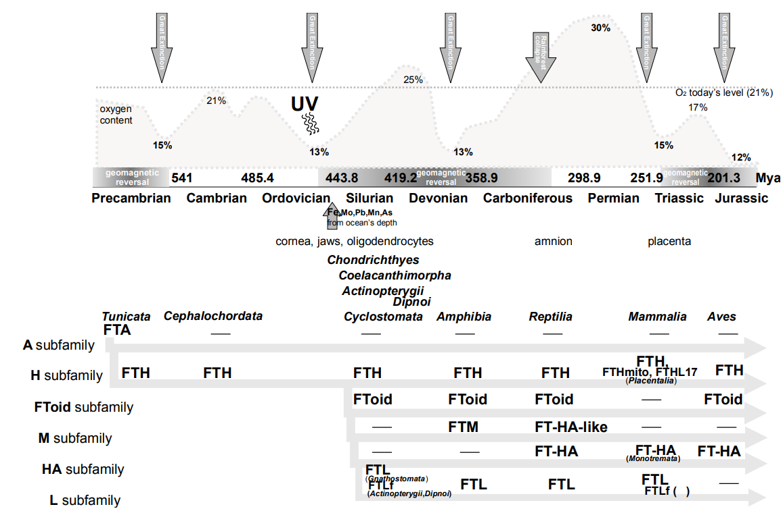
Figure 3. An outline of the chronologic timeline of geological events, vertebrate evolution, newly evolved anatomical structures and vertebrate FT subfamilies. Geological events are described in text. Oxygen level was overlaid according to published data [90].

Acknowledgements: The authors want to thank Professor Jason Eriksen (College of Pharmacy, University of Houston), Mr. David Coare and Dr. Kamil Steczkiewicz (Institute of Biochemistry and Biophysics, PAS) for careful reading, helpful advice and language adjustments.

References
[1] Andrews SC, Arosio P, Bottke W, Briat JF, et al. 1992. Structure, function, and evolution of ferritins. J Inorg Biochem 47: 161– 74.
[2] Andrews SC. 2010. The Ferritin-like superfamily: Evolution of the biological iron storeman from a rubrerythrin-like ancestor. Biochim Biophys Acta 1800: 691– 705.
[3] Vulimiri L, Linder MC, Munro HN, Catsimpoolas N. 1977. Structural features of rat cardiac ferritins. Biochim Biophys Acta 491: 67– 75.
[4] Linder MC, Nagel GN, Roboz M, Hungerford D.Jr. 1981. Heart cells contain a ferritin larger and more asymmetric than ferritins of other mammalian tissues. J Biol Chem 256: 9104– 11.
[5] Linder MC, Goode CA, Gonzalez R, Gottschling C, et al. 1989. Heart tissue contains small and large aggregates of ferritin subunits. Arch Biochem Biophys 273: 34– 41.
[6] Simakov O, Marlétaz F, Yue JX, O'Connell B, et al. 2020. Nat Ecol Evol 4: 820-30.
[7] Osaki S, James GT, Frieden E. 1974. Iron metabolism of bullfrog tadpoles during metamorphosis. Dev Biol 39:158-63.
[8] Dickey LF, Sreedharan S, Theil EC, Didsbury JR, et al. 1987. Differences in the regulation of messenger RNA for housekeeping and specialized-cell ferritin. A comparison of three distinct ferritin complementary DNAs, the corresponding subunits, and identification of the first processed in amphibia. J Biol Chem 262: 7901– 7.
[9] Brown PJ, Johnson PM, Ogbimi AO, Tappin JA. 1979. Characterization and localization of human placental ferritin. Biochem J 182: 763– 9.
[10] Kim M, Rho Y, Jin KS, Ahn B, et al. 2011. pH-dependent structures of ferritin and apoferritin in solution: disassembly and reassembly. Biomacromolecules 12: 1629– 40.
[11] Wen X, Paine ML. 2013. Iron deposition and ferritin heavy chain (Fth) localization in rodent teeth. BMC Res Notes 6:1.
[12] Sanyal B, Polak PE, Szuchet S. 1996. Differential expression of the heavy-chain ferritin gene in non-adhered and adhered oligodendrocytes. J Neurosci Res 46: 187– 97.
[13] Todorich B, Zhang X, Connor JR. 2011. H-ferritin is the major source of iron for oligodendrocytes. Glia 59: 927– 35.
[14] Simons M, Nave KA. (2015) Oligodendrocytes: Myelination and Axonal Support. Cold Spring Harb Perspect Biol 8: a020479.
[15] Reinert A, Morawski M, Seeger J, Arendt T, et al. 2019. Iron concentrations in neurons and glial cells with estimates on ferritin concentrations. BMC Neurosci 20: 25.
[16] Singh N, Haldar S, Tripathi AK, Horback K, et al. 2014. Brain iron homeostasis: from molecular mechanisms to clinical significance and therapeutic opportunities. Antioxid Redox Signal 20: 1324– 63.
[17] Dusek P, Jankovic J, Le W. 2012. Iron dysregulation in movement disorders. Neurobiol Dis 46: 1– 18.
[18] Theil EC. 2004. Iron, ferritin, and nutrition. Annu Rev Nutr 24: 327– 43.
[19] Campbell CH, Ismail R, Linder MC. 1989. Ferritin mRNA is found on bound as well as free polyribosomes in rat heart. Arch Biochem Biophys 273: 89– 98.
[20] Linder MC, Madani N, Middleton R, Miremadi A, et al. 1992. Ferritin synthesis on polyribosomes attached to the endoplasmic reticulum. J Inorg Biochem 47: 229– 40.
[21] Levi S, Corsi B, Bosisio M, Invernizzi R, et al. 2001. A human mitochondrial ferritin encoded by an intronless gene. J Biol Chem 276: 24437– 40.
[22] Richardson DR, Lane DJR, Becker EM, Huang MLH, et al. 2010. Mitochondrial iron trafficking and the integration of iron metabolism between the mitochondrion and cytosol. Proc Natl Acad Sci U S A 107: 10775– 82.
[23] Seki T, Kunichika T, Watanabe K, Orino K. 2008. Apolipoprotein B binds ferritin by hemin-mediated binding: evidence of direct binding of apolipoprotein B and ferritin to hemin. Biometals 21: 61– 9.
[24] Todorich B, Zhang X, Slagle-Webb B, Seaman WE, et al. 2008. Tim-2 is the receptor for H-ferritin on oligodendrocytes. J Neurochem 107:1495– 505.
[25] Chiou B, Lucassen E, Sather M, Kallianpur A, et al. 2018. Semaphorin4A and H-ferritin utilize Tim-1 on human oligodendrocytes: A novel neuro-immune axis. Glia 66: 1317– 30.
[26] Li L, Fang CJ, Ryan JC, Niemi EC, et al. 2010. Binding and uptake of H-ferritin are mediated by human transferrin receptor-1. Proc Natl Acad Sci U S A 107: 3505– 10.
[27] Beazley KE, Nurminskaya M, Linsenmayer TF. 2009. Phosphorylation regulates the ferritoid-ferritin interaction and nuclear transport. J Cell Biochem 107: 528– 36.
[28] Pozzi C, Di Pisa F, Bernacchioni C, Ciambellotti S, et al. 2015. Iron binding to human heavy-chain ferritin. Acta Crystallogr D Biol Crystallogr 71: 1909– 20.
[29] Pozzi C, Ciambellotti S, Bernacchioni C, Di Pisa F, et al. 2017. Chemistry at the protein-mineral interface in L-ferritin assists the assembly of a functional (μ3-oxo)Tris[(μ2-peroxo)] triiron(III) cluster. Proc Natl Acad Sci U S A 114: 2580– 5.
[30] Ingrassia R, Gerardi G, Biasiotto G, Arosio P. 2006. Mutations of ferritin H chain C-terminus produced by nucleotide insertions have altered stability and functional properties. J Biochem 139: 881– 5.
[31] Theil EC, Liu XS, Tosha T. 2008. Gated pores in the ferritin protein nanocage. Inorganica Chim Acta 361: 868– 74.
[32] Levi S, Yewdall SJ, Harrison PM, Santambrogio P, et al. 1992. Evidence of H- and L-chains have co-operative roles in the iron-uptake mechanism of human ferritin. Biochem J 288: 591– 6.
[33] Truman-Rosentsvit M, Berenbaum D, Spektor L, Cohen LA, et al. 2018. Ferritin is secreted via 2 distinct nonclassical vesicular pathways. Blood. 131: 342– 52.
[34] Bou-Abdallah F, Biasiotto G, Arosio P, Chasteen ND. 2004. The putative "nucleation site" in human H-chain ferritin is not required for mineralization of the iron core. Biochemistry 43: 4332– 7.
[35] Gálvez N, Fernández B, Sánchez P, Cuesta R, et al. 2008. Comparative structural and chemical studies of ferritin cores with gradual removal of their iron contents. J Am Chem Soc 130: 8062– 8.
[36] Levi S, Corsi B, Rovida E, Cozzi A, et al. 1994. Construction of a ferroxidase center in human ferritin L-chain. J Biol Chem 269: 30334– 9.
[37] Santambrogio P, Levi S, Arosio P, Palagi L, et al. 1992. Evidence that a salt bridge in the light chain contributes to the physical stability difference between heavy and light human ferritins. J Biol Chem 267: 14077– 83.
[38] Orino K, Watanabe K. 2008. Molecular, physiological and clinical aspects of the iron storage protein ferritin. Vet J 178: 191– 201.
[39] Theil EC. 1987. Ferritin: structure, gene regulation, and cellular function in animals, plants, and microorganisms. Annu Rev Biochem 56: 289– 315.
[40] Cozzi A, Corsi B, Levi S, Santambrogio P, et al. 2000. Overexpression of wild type and mutated human ferritin H-chain in HeLa cells: in vivo role of ferritin ferroxidase activity. J Biol Chem 275: 25122– 9.
[41] Chen P, De Meulenaere E, Deheyn DD, Bandaru PR. 2020. Iron redox pathway revealed in ferritin via electron transfer analysis. Sci Rep 10:4033.
[42] Cai CX, Birk DE, Linsenmayer TF. 1998. Nuclear ferritin protects DNA from UV damage in corneal epithelial cells. Mol Biol Cell 9: 1037– 51.
[43] Goralska M, Nagar S, Fleisher LN, McGahan MC. 2005. Differential degradation of ferritin H- and L-chains: accumulation of L-chain-rich ferritin in lens epithelial cells. Invest Ophthalmol Vis Sci 46: 3521– 9.
[44] Wadsworth J and S. Cockell CS. 2017. The Janus face of iron on anoxic worlds: iron oxides are both protective and destructive to life on the early Earth and present-day Mars. FEMS Microbiol Ecol 93(5).
[45] Cai C, Ching A, Lagace C, Linsenmayer T. 2008. Nuclear ferritin-mediated protection of corneal epithelial cells from oxidative damage to DNA. Dev Dyn 237: 2676– 83.
[46] Applegate LA, Scaletta C, Panizzon R, Frenk E. 1998. Evidence that ferritin is UV inducible in human skin: part of a putative defense mechanism. J Invest Dermatol 111: 159– 63.
[47] Applegate LA, Scaletta C, Panizzon R, Frenk E, et al. 2000. Induction of the putative protective protein ferritin by infrared radiation: implications in skin repair. Int J Mol Med 5: 247– 51.
[48] Atkinson BG, Blaker TW, Tomlinson J, Dean RL. 1990. Ferritin is a translationally regulated heat shock protein of avian reticulocytes. J Biol Chem 265: 14156– 62.
[49] Jin P, Kang J, Lee MK, Park JW. 2018. Ferritin heavy chain controls the HIF-driven hypoxic response by activating the asparaginyl hydroxylase FIH. Biochem Biophys Res Commun 499: 475– 81.
[50] Martínez D, Oyarzún R, PontigoJP, Romero A, et al. 2017. Front Immunol 19: 1153.
[51] Fitak RR, Wheeler BR, Ernst DA, Lohmann KJ, et al. 2017. Candidate genes mediating magnetoreception in rainbow trout (Oncorhynchus mykiss). Biol Lett 13 pii: 20170142.
[52] Jandacka P, Burda H, Pistora J. 2015. Magnetically induced behaviour of ferritin corpuscles in avian ears: can cuticulosomes function as magnetosomes? J R Soc Interface 12: 20141087.
[53] Nimpf S, Malkemper EP, Lauwers M, Ushakova L, et al. 2017. Subcellular analysis of pigeon hair cells implicates vesicular trafficking in cuticulosome formation and maintenance. Elife 6. pii: e29959.
[54] Brem F, Tiefenauer L, Fink A, Dobson J, et al. 2006. A mixture of ferritin and magnetite nanoparticles mimics the magnetic properties of human brain tissue. Phys Rev B 73, 224427: 1– 6.
[55] Lundin D, Poole AM, Sjöberg BM, Högbom M. 2012. Use of structural phylogenetic networks for classification of the ferritin-like superfamily. J Biol Chem 287:20565-75.
[56] Lee JH, Wan KL, Mohd-Adnan A, Gabaldon T. 2012. Evolution of the ferritin family in vertebrates. Trends Evol Biol 4: e3.
[57] Meert JG, Levashova NM, Mikhail L. Bazhenov ML, et al. 2016. Rapid changes of magnetic field polarity in the late Ediacaran: Linking the Cambrian evolutionary radiation and increased UV-B radiation. Gondwana Res 34: 149– 57.
[58] Barash MS. 2014. Mass extinction of the marine biota at the Ordovician-Silurian transition due to environmental changes. Oceanology 6: 780– 7.
[59] Vandenbroucke TRA, Emsbo P, Munnecke A, Nuns N, et al. 2015. Metal-induced malformations in early Palaeozoic plankton are harbingers of mass extinction. Nat Commun 6: 7966.
[60] Linsenmayer TF, Cai CX, Millholland JM, Beazley KE, Fitch JM. 2005. Nuclear ferritin in corneal epithelial cells: tissue-specific nuclear transport and protection from UV-damage. Prog Retin Eye Res 24: 139– 59.
[61] Mallatt J. 1996. Ventilation and the origin of jawed vertebrates: a new mouth. Zool J 117: 329– 404.
[62] Dearden RP, Stockey C, Brazeau MD. 2019. The pharynx of the stem-chondrichthyan Ptomacanthus and the early evolution of the gnathostome gill skeleton. Nat Commun 10: 2050.
[63] Cockell CS. 1999. Crises and extinction in the fossil record—a role for ultraviolet radiation? Paleobiol 25: 212– 25.
[64] Brown JE, Theil EC. 1978. Red cells, ferritin, and iron storage during amphibian development. J Biol Chem 253: 2673-– 8.
[65] Imakawa K, Nakagawa S, Kusama K. 2016. Placental Development and Endogenous Retroviruses. Uirusu 66: 1– 10.
[66] Snyder AM, Wang X, Patton SM, Arosio P, et al. 2009. Mitochondrial ferritin in the substantia nigra in restless legs syndrome. J Neuropathol Exp Neurol 68: 1193– 9.
[67] Wang L, Wang L, Dai Z, Wu P, et al. 2017. Lack of mitochondrial ferritin aggravated neurological deficits via enhancing oxidative stress in a traumatic brain injury murine model. Biosci Rep. 37 pii: BSR20170942.
[68] Wu W, Chang S, Wu Q, Xu Z, et al. 2016. Mitochondrial ferritin protects the murine myocardium from acute exhaustive exercise injury. Cell Death Dis 7: e2475.
[69] Drysdale J, Arosio P, Invernizzi R, Cazzola M, et al. 2002. Mitochondrial ferritin: a new player in iron metabolism. Blood Cells Mol Dis 29: 376– 83.
[70] Miller WL, Auchus RJ. 2011. The molecular biology, biochemistry, and physiology of human steroidogenesis and its disorders. Endocr Rev 32: 81– 151.
[71] Tvrda E, Peer R, Sikka SC, Agarwal A. 2015. Iron and copper in male reproduction: a double-edged sword. J Assist Reprod Genet 32: 3– 16.
[72] Wise T, Lunstra DD, Rohrer GA, Ford JJ. 2003. Relationships of testicular iron and ferritin concentrations with testicular weight and sperm production in boars. J Anim Sci 81: 503– 11.
[73] Ruzzenenti P, Asperti M, Mitola S, Crescini E, et al. 2015. The Ferritin-Heavy-Polypeptide-Like-17 (FTHL17) gene encodes a ferritin with low stability and no ferroxidase activity and with a partial nuclear localization. Biochim Biophys Acta 1850: 1267– 73.
[74] Oliveira CM, Rodrigues MN, Miglino MA. 2012. Iron transportation across the placenta. An Acad Bras Cienc 84: 1115– 20.
[75] Sangkhae V, Nemeth E. 2019. Placental iron transport: The mechanism and regulatory circuits. Free Radic Biol Med 133: 254– 61.
[76] Okuyama T, Tawada T, Furuya H, Villee CA. 1985. The Role of Transferrin and Ferritin in the Fetal-Maternal-Placental Unit. Am J Obstet Gynecol 152: 344– 50.
[77] Passanitti A, Roth TF. 1989. Purification of chicken liver ferritin by two novel methods and structural comparison with horse spleen ferritin. Biochem J 258: 413– 9.
[78] Stevens PW, Dodgson JB, Engel JD. 1987. Structure and expression of the chicken ferritin H subunit gene. Mol.Cell. Biol 7: 1751– 8.
[79] Richards MP. 1991. Mineral Metabolism in the Developing Turkey embryo--II. The Role of the Yolk Sac. Comp BiochemPhysiol A Comp Physiol 100: 1017– 23.
[80] dos Reis M, Thawornwattana Y, Angelis K, Telford MJ, et al. 2015. Uncertainty in the Timing of Origin of Animals and the Limits of Precision in Molecular Timescales. Curr Biol 25:2939-50.
[81] Igawa T, Nozawa M, Suzuki DG, Reimer JD, et al. 2017. Evolutionary history of the extant amphioxus lineage with shallow-branching diversification. Sci Rep 7:1157.
[82] Andreev PS, Zhao W, Wang NZ, Smith MM, et al. 2020. Early Silurian chondrichthyans from the Tarim Basin (Xinjiang, China). PLoS One 15:e0228589.
[83] Broughton RE, Betancur-R. R, Li C, Arratia G, Ortí G. Multi-locus phylogenetic analysis reveals the pattern and tempo of bony fish evolution. PLOS Currents Tree of Life. 2013 Apr 16 . Edition 1.
[84] Betancur-R. R, Broughton RE, Wiley EO, Carpenter K, López JA, Li C, Holcroft NI, Arcila D, Sanciangco M, Cureton II JC, Zhang F, Buser T, Campbell MA, Ballesteros JA, Roa-Varon A, Willis S, Borden WC, Rowley T, Reneau PC, Hough DJ, Lu G, Grande T, Arratia G, Ortí G. The Tree of Life and a New Classification of Bony Fishes. PLOS Currents Tree of Life. 2013 Apr 18 . Edition 1.
[85] Brinkmann H, Denk A, Zitzler J, Joss JJ, et al. 2004. Complete mitochondrial genome sequences of the South american and the Australian lungfish: testing of the phylogenetic performance of mitochondrial data sets for phylogenetic problems in tetrapod relationships. J Mol Evol 59:834-48.
[86] Beznosov PA, Clack JA, Lukševičs E, Ruta M, et al. 2019. Morphology of the earliest reconstructable tetrapod Parmastegaaelidae. Nature 574:527-31.
[87] Laurin M, Reisz RR. 1995. A reevaluation of early amniote phylogeny. Zool J Linn Soc 113:165–223.
[88] Godefroit P, Cau A, Dong-Yu H, Escuillié F, et al. 2013. A Jurassic avialan dinosaur from China resolves the early phylogenetic history of birds. Nature 498:359-62.
[89] Williams JJ, Mills BJW, Lenton TM. 2019. A Tectonically Driven Ediacaran Oxygenation Event. Nat Commun 10: 2690.
[90] Berner RA. 2006. GEOCARBSULF: A combined model for Phanerozoic atmospheric O₂ and CO₂. Geochim Cosmochim Acta 70: 5653– 64.
[91] Singh PP, Arora J, Isambert H. 2015. Identification of ohnolog genes originating from whole genome duplication in early vertebrates, based on synteny comparison across multiple genomes. PLoS Comput Biol 11:e1004394.
[92] Singh PP, Isambert H. 2020. Ohnologs v2: a comprehensive resource for the genes retained from whole genome duplication in vertebrates. Nucleic Acid Res 48: D724-D730.

