Voltammetric Detection of Specific DNA Sequence of Avian Influenza Virus H5N1 using HS-ssDNA Probe Deposited onto Gold Electrode
Kamila Malecka,ª Iwona Grabowska,ª Jerzy Radecki,ª Anna Stachyra,^{b} Anna Góra - Sochacka,^{b} Agnieszka Sirko,^{b} Hanna Radecka ^{a*}
ª Institute of Animal Reproduction and Food Research, Polish Academy of Sciences, Tuwima 10, 10-747 Olsztyn, Poland
^{b} Institute of Biochemistry and Biophysics, Polish Academy of Sciences, Pawińskiego 5A, 02-106 Warsaw, Poland
*e-mail: hanna.radecka@pan.olsztyn.pl
Received:
Accepted:
Abstract
The working principle of genosensor relay on the mechanism of ion–channel mimetic sensor. The analytical signals generated upon hybridization processes were recorded by redox active marker [Fe(CN)₆]^{3-/4-} present in the sample solution using voltammetric techniques. The developed genosensor was suitable for determination of 20-mer complementary oligonucleotide sequence, and also of PCR products containing the complementary 20-mer sequence in various positions, with detection limits in 10 pM range. Non-complementary 20-mer oligonucleotide sequence as well as PCR product without complementary region generated very weak response. The good discrimination of the position of complementary part in the PCR products was observed.

Keywords: Electrochemical genosensor, HS-ssDNA probe, PCR products, Avian Influenza Virus
DOI: 10.1002/elan.

1. Introduction
Wild aquatic birds are considered to be the natural reservoir of influenza viruses. They have been implicated as the source of influenza viruses for all other species of birds and mammals. Avian influenza viruses (AIVs), in particular highly pathogenic H5 subtype, could cause severe diseases. They are endemic in wild birds and their introduction and conversion to highly pathogenic avian influenza virus in domestic poultry is a cause of serious economic losses as well as a risk for potential transmission to humans [1, 2].
The ability to rapidly recognize AIVs in biological specimens [3], as well as development of efficient vaccine [4], is critical for limiting future spread of disease in poultry.
The conventional methods for virus analysis, such as viral isolation [5, 6], immunoassay [7, 8] and PCR-based techniques [9] are well established. The main disadvantages of these methods are time-consuming and sophisticated procedures demanding well trained personnel.
Biosensors are a very promising alternative to the conventional methods. These analytical devices are cost effective, offering the simple and fast analysis performance. The advances in the detection of influenza virus using non-labeling techniques such as surface plasmon resonance (SPR), quartz-crystal microbalance (QCM) and colorimetric functional polymers have been recently reviewed [3]. The applications of QCM type biosensors in influenza research are mainly limited to the study of virus/receptor interactions [10-12]. The SPR, offering obtaining the thermodynamic and kinetic data, become one of the most attractive techniques for detection of various biochemical analytes [13, 14].
Apart from the numerous advantages, these techniques demand quite sophisticated equipment and they are not suitable for design a simple, disposable pocket like type sensors for wide applications.
The biosensors which could fulfill these needs are electrochemical one, in which the recognition processes occurring on the sensing layers are converted by transducer part into analytical signals. The increasing number of publications clearly indicated that these types of sensors attract strong interests [15-18].
The electrochemical biosensors based on the hybridization of a DNA–specific probe previously immobilized onto electrode surface with its complementary sequence present in solution are a very attractive example suitable for biosensing applications [17]. They could be divided into three main groups based on analytical signal generations. In one group, the changes of electroactivity of nucleotides, such as guanidine, cytosine and adenine have been accommodated upon hybridization. The pioneering work for such type of sensors was done by Paleček and co-workers [19-25]. The main drawback of this type of DNA biosensors are quite weak analytical signals. The numerous methods for electroactivity amplification of nucleotides immobilized on the solid support have been reported. Among them there are: modification of the transducer layer with gold nanoparticles [18, 26, 27], carbon nanotubes [28-33] and graphene [34-37], just to name a few.
The intercalations of redox active compounds into DNA helix have been applied for another type of genosensors. The most frequently used intercalator is methylene blue [29, 31, 38, 39], however some other such as Actinomycin D or Proflavine [40-41] or phenanthroline Co (III) [42] are also applied. Although, these sensors displayed good analytical parameters, their main disadvantages are quite long analytical procedures which involved, apart hybridization, also intercalation process.
A different type of biosensors have been introduced and developed by Umezawa and co-workers [43, 44]. Their working principles are illustrated in Figure 1. The binding of analytes (target ssDNA) to receptors (ssDNA probe) immobilized on electrode surfaces facilitates or suppresses the access of an anionic (cationic) marker ions present in the sample solution to the modified surface due to electrostatic attraction or repulsion of the marker and/or distortion of the modification layer arrangement. This leads to the changes of the electron transfer rate between the marker and electrode surface through the modification layer. These sensors are named “ion-channel” because their working principle is similar to that of ligand gated ion-channel proteins in biomembranes [43-47].

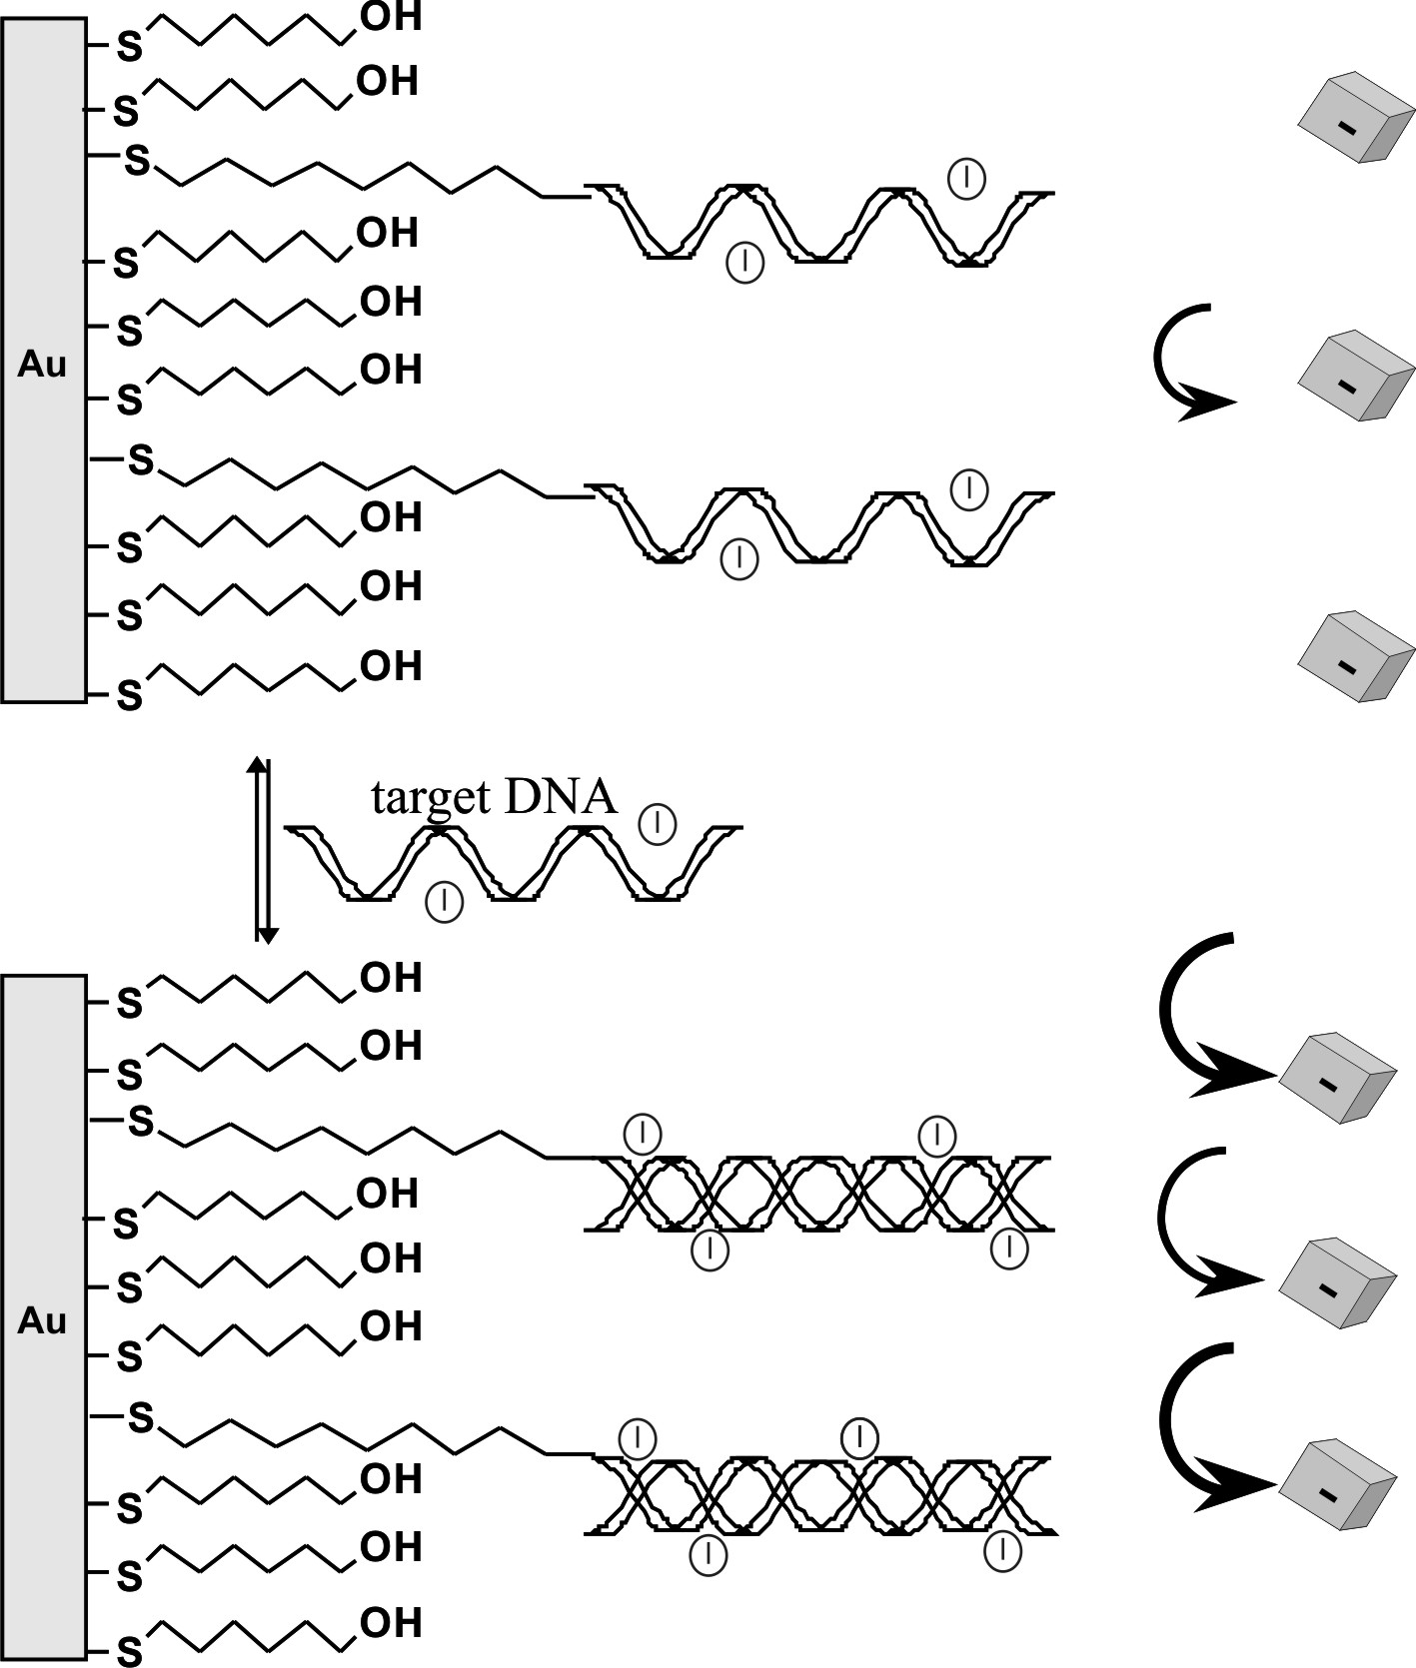
Fig. 1. Working principle of the ion-channel mimetic sensor on gold electrodes.
Here, we report on a high sensitive ion-channel mimetic genosensor incorporating mixed monolayers (20-mer HS-ssDNA probe and 6-mercaptohexan-1-ol) deposited onto gold electrodes for electrochemical determination of Avian Influenza Virus (AIV). The electroanalytical signals generated based on the DNA duplex formed at the electrode surface were explored using Osteryoung Square Wave Voltammetry (OSWV) and cyclic voltammetry (CV) in the presence of [Fe(CN)₆]^{3-/4-} as an electroactive marker. The genosensor sensitivity and selectivity have been explored with two types of targets, short (20-mer) single stranded DNA and long (179-183bp) double stranded PCR products with different localization of the 20-nt region complementary to the probe.

2. Materials and Methods

2.1. Reagents and Materials
6-Mercaptohexan-1-ol (MCH), potassium ferro- and ferricyanides, PBS buffer components (NaCl, KCl, Na₂HPO₄, KH₂PO₄), ethylenediaminetetraacetic acid (EDTA) and magnesium chloride hexahydrate were obtained from Sigma–Aldrich (Poznań, Poland). Alumina slurry 0.3 and 0.05 μm was purchased from Buehler (USA). Sulphuric acid, potassium hydroxide, hydrogen peroxide, ethanol and methanol were supplied by POCh (Poland).
For DNA immobilization and hybridization 10 mM PBS, pH 7.4 (consisting of 137 mM NaCl, 2.7 mM KCl, 10 mM KH₂PO₄, 1.8 mM Na₂HPO₄) was used.
The modified oligonucleotide HS-ss-DNA (5’-HS–(CH₂)₆-CCT CAA GGA GAG AGA AGA AG-3’) was used as a probe (named NC3) for immobilization on a surface of gold electrodes, while two unmodified oligonucleotides, c-NC3 (5’-CTT CTT CTC TCT CCT TGA GG-3’) and nc-NC3 (5’-GGA GTT CCT CTC TCA TCA TC-3’) served as complementary and non-complementary hybridization targets, respectively. The oligonucleotides were supplied by Biomers (Germany).
The double stranded PCR products (PCR1-PCR4) were obtained using a plasmid containing the full length H5 gene from the polish isolate of the influenza H5N1 virus (A/swan/Poland/305-135V08/2006; EpiFlu Database Acc No EPI156789) [48] as a template and the following pairs of oligonucleotides as primers: 5’-GTG AAT TGG AAT ATG GTA ACT-3’
and 5'-CTT CTT CTC TCT CCT TGA GG-3’ for PCR1, 5’-CCT CAA GGA GAG AGA AGA AG-3’ and 5’-TTG GTG ACT CCA TCT ATT GC-3’ for PCR2, 5’-ACA TCC ACC CTC TCA CCA-3’
and 5’-CAT ACC AAC CAT CTA CCA-3’ for PCR3, 5’-GGG GAC TCA ACA ATT ATG A-3’
and 5’-GCT ATT TCT GAG CCC AGT-3’ for PCR4. The 20-bp region complementary to the NC3 (HS-ssDNA probe) is located at the 3’-end of PCR1, at the 5’-end of PCR2 and in the middle (83-103 bp) of PCR3. No sequence complementary to the HS-ss-DNA exists in PCR4. The total length of DNA fragments is 181 bp, 179 bp, 180 bp and 183 bp for PCR1, PCR2, PCR3 and PCR4, respectively. Schematic representation of all four PCR products is shown in the Supporting Information (Scheme S1).
All aqueous solutions were prepared using autoclaved Milli-Q water, resistivity 18.2 MΩ·cm (Millipore Corporation, USA). Reagents and solvents were of analytical grade and used without further purification. All experiments were carried out at room temperature.

2.2. Fabrication of Genosensors – Successive Steps of Gold Electrode Modification
The elements of genosensors are schematically shown in Figure 1. Gold disk working electrodes with a radius of 2 mm² were obtained from Mineral (Poland) and Bioanalytical Systems (BAS), West Lafayette, IN.
Gold electrodes were initially cleaned mechanically by polishing with alumina slurries (Alpha and Gamma Micropolish; Buehler, Lake Bluff, IL) with particles sizes of 0.3 and 0.05 μm on microcloth pad (BAS) for 5 minutes each. Afterwards, they were carefully rinsed with Milli-Q water. The polished electrodes were further cleaned electrochemically by cyclic voltammetry. At first they were dipped in 0.5 M KOH solution and swept with the potential between –0.4 V and –1.2 V against the Ag/AgCl reference electrode and the platinum wire counter electrode with scan rate of 100 mVs^{–1}, number of cycles: 3, 50 and 10. Next, the electrodes were cleaned in 0.5 M H₂SO₄ in the potential window between -0.3 V and +1.5 V, number of cycles: 3, 10 and 3. Before modification, the surfaces of electrodes were refreshed in 0.5 M KOH solution for 10 cycles. After finishing the electrochemical cleaning, each electrode was washed with MiliQ water and stored in water (for several minutes, until the next step) to avoid contaminations from air. All solutions were deoxygenated by purging with nitrogen (ultra pure 6.0, Air Products, Poland) for 10 minutes.
Directly after cleaning, the electrodes were rinsed repeatedly with water and PBS buffer pH 7.4. Then,
10 μl droplets of the mixture containing 1 μM SH-ssDNA and 10 μM MCH (backfiller) in PBS buffer pH 7.4 were placed on the surface of each electrode. The electrodes were covered with tubes and stored for 3h at room temperature. After self-assembled monolayer formation and oligonucleotide immobilization, 10 µl of 1 mM MCH was spotted on each electrode and incubated for 1 h to reduce non-specific DNA binding. The modified electrodes were rinsed profusely with
10 mM PBS, pH 7.4 and stored overnight at room temperature.

2.3. Hybridization Processes
The DNA of the targets, either oligonucleotides
(c-NC3, nc-NC3) or double stranded PCR products (PCR1-PCR4), was diluted in the hybridization buffer (10 mM PBS, pH 7.4) to the concentration of 10, 20, 40, 60, 80 and 100 pM. The PCR products were heated before hybridization in the water bath at 95°C for
10 minutes and then rapidly cooled in the ice bath for
2 minutes in order to denature the double stranded DNA fragments. Hybridization reactions were performed by dropping of the 10-µl aliquots of the respective dilutions of the targets on
the HS-ssDNA/MCH modified gold electrodes. After 1 h at room temperature, the electrodes were rinsed with 5 ml of 10 mM PBS, pH 7.4 in order to remove the unbound targets.

2.4. Cyclic Voltammetry (CV) and Osteryoung Square Wave Voltammetry (OSWV) Measurements
All electrochemical measurements were performed with a potentiostat–galvanostat AutoLab (Eco Chemie, Utrecht, Netherlands) with a conventional three-electrode configuration. The voltammetric experiments were carried out in an electrochemical cell of 5 ml volume containing the modified gold working electrode, an Ag/AgCl electrode and a platinum wire as an auxiliary electrode. The measurements were performed in the presence of 10 mM PBS buffer and 1.0 mM K₃[Fe(CN)₆]/ K₄[Fe(CN)₆] purged with nitrogen for 10 minutes, in order to control electrode modification and to record the hybridization reaction.
OSWV was performed with potential from + 0.6 V to −0.2 V and with a step potential of 0.001 V, a square-wave frequency of 25 Hz, and amplitude of 0.05 V for [Fe(CN)₆]^{3-/4-}. In CV, potentials were cycled from +0.6 V to –0.2 V with the scan rate of 0.1 V/s.
The dependence of the sensor response on the concentration of analytes was expressed as the currents at the peak potential in OSWV measured in a solution containing no analyte.
The electrode responses were expressed as: (I_{n} – I₀) / I₀ where I_{n} is the peak current measured in the presence of the analyte and I₀ the peak current before applying analyte (in buffer without analyte).

3. Results and Discussion

3.1. Working Principle of Genosensor and its Selectivity for Complementary and Non-Complementary Target 20-mer ssDNA
Figure 1 illustrates the working principle of the genosensor proposed. The HS-ssDNA probe has been covalently attached on the surface of gold electrodes through Au-S bonds. The hybridization events with
c-NC3 and nc-NC3 sequence were detected with [Fe(CN)₆]^{3-/4-} redox marker present in the sample solution. The advantage of this approach is that oligonucleotides labeling is not necessary. Thus, such genosensor belongs to the ‘label free’ category.
The several fundamental parameters influencing the genosensor performance, such as ionic strength, passivation of the electrode surface after ssDNA probe immobilization as well probe length must be optimized [41, 49, 50]. The length of ssDNA probe has no significant influence on the surface coverage [50]. The most frequently used ssDNA probes were 20-mer oligonucleotides, thus the probe of this length was applied in study presented.
The concentration, distribution and orientation of ssDNA probe on the sensing surface have crucial influence on the hybridization efficiency [38, 41]. In order to get suitable distances between ssDNA probes which provide the best accessibility of ssDNA target to the ssDNA probe, 6-mercaptohexan-1-ol has been applied as a diluent compound. The optimum ssDNA probe: 6-mercaptohexan-1-ol molar ratio in the modification solution (10⁻⁶ M : 10⁻⁵ M) was found experimentally (Table 1S, Table 2S, Supplementary Materials).
After self-assembling the mixed ssDNA-MCH SAM, the electrode were treated with 1 mM solution of MCH to avoid non-specific adsorption and eliminate direct contact between the redox marker and Au surface. This step of genosensor fabrication with using HS-ssDNA probe is widely applied [38, 41, 47, 49].
The best conditions of measuring solution such as ionic strength, buffer composition and pH were found experimentally. In general, the analytical signals generated upon hybridization processes were higher when the solutions with lower ionic strength were applied [49]. The similar tendency was observed by us. The several hybridization solutions have been tested, differing in the electrolyte composition, concentrations and pH (Table 1S, Table 2S, Supplementary Materials).
The best parameters for SH-ssDNA probe immobilization and conducting of hybridization processes, ensuring the best genosensor performance were selected and described in the Supplementary Materials (Table 1S, Table 2S).
In the measuring conditions (pH 7.4), a single stranded DNA probe exists as a negatively charged molecule. The monolayer created on the electrode surface is quasi permeable for a negative charged [Fe(CN)₆]^{3-/4-} redox marker existing in the aqueous solution. Upon hybridization with c-NC3, the double stranded ds-DNA complex is formed. It causes that the negative charge on the electrode surface is doubled. Electrostatic repulsion between the negatively charged layer and the [Fe(CN)₆]^{3-/4-} with the same charge prevents the markers from reaching the electrode surface. This leads to the decreasing of the electron transfer rate between the marker and electrode surface through the modification layer. The reversibility of the
[Fe(CN)₆]^{3-/4-} markers decreased upon increasing concentration of c-NC3 (Figure 1S A, Supplementary Materials). The system was selective. In the presence of nc-NC3, the changes of reversibility were very weak (Figure 1S B, Supplementary Materials). The linear relationship between relative decrease of reduction or oxidation peak current of [Fe(CN)₆]^{3-/4-} redox marker were observed for the target c-NC3 in the concentration range from 10 pM to 60 pM. The genosensor was selective, the highest concentration of 20-mer ssDNA probes caused the decreasing of oxidation peaks current 20.0 ± 1.1% and 7.0 ± 1.9% (n=6), for c-NC3 and nc-NC3 sequences, respectively (Figure 2S A,B Supplementary Materials).
In order to eliminate the capacitive current, the hybridization processes performed with genosensor proposed were controlled with using OSWV [45, 46, 51, 52].
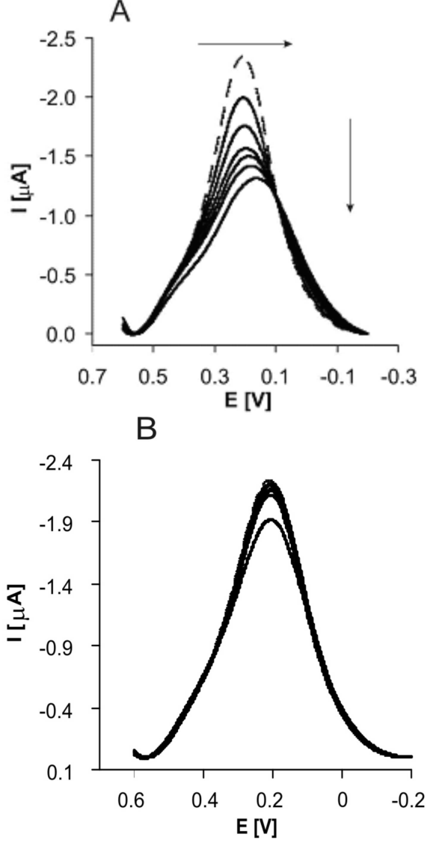
Fig. 2. Example of square wave voltammograms obtained for electrodes modified with HS-ssDNA and 6 – mercaptohexan-1-ol, upon hybridization. Dashed curve – before hybridization and next curves upon hybridization with target c-NC3 (A) and nc-NC3 (B) at concentration range: 10 pM, 20 pM, 40 pM, 60 pM, 80 pM and 100 pM. Solution composition: 1 mM K₃[Fe(CN)₆]/K₄[Fe(CN)₆], 0.1 M PBS (pH 7.4). The measuring conditions: three electrode configurations – Au working electrode, Ag/AgCl reference electrode and Pt counter electrode.
The representative OSWV recorded in the presence of 20-mer oligonucleotides (c-NC3 and nc-NC3) is presented in Figure 2. This technique was more sensitive than CV. The highest concentration of 20-mer ssDNA probes caused the decreasing of peaks current 35.0 ± 5.6% and 12.0 ± 2.4% (n=6), for c-NC3 and nc-NC3 sequences, respectively (Figure 3A).
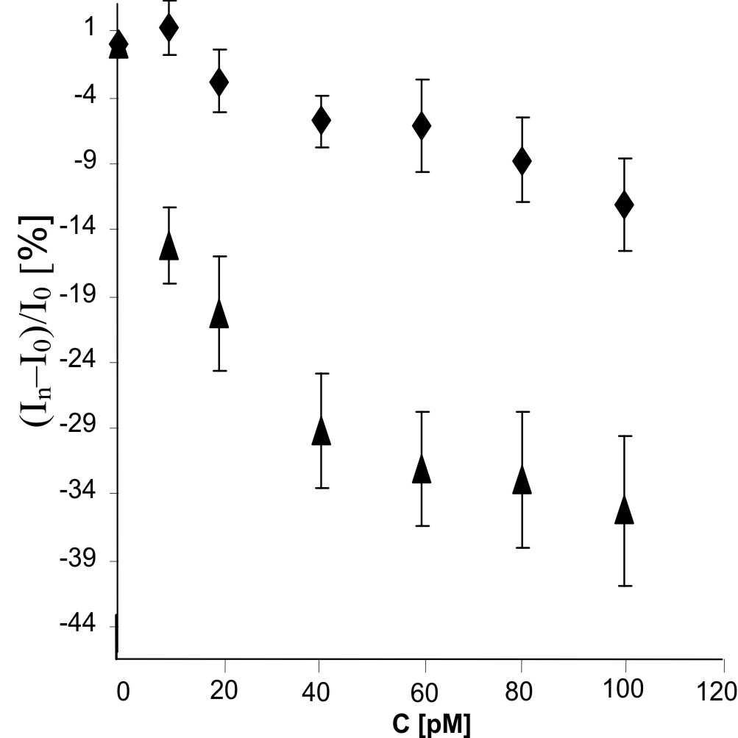
Fig. 3A. The relationship of (I_{n}–I₀)/I₀ (%) vs. concentration
C (pM) of nc-NC3 (♦) and c-NC3 (▲). I_{n} is the value of peak current after detection of given concentration
of analytes, and I₀ is the value of peak current without presence of analyte in pure 0.1 M PBS pH 7.4 (n=6).
The decreasing of redox peak current was assisted with peak potential shift into the negative potential direction. This parameter was changed linearly with increasing concentration of c-NC3. In the presence of nc-NC3, potential of redox peak remains unchanged (Figure 3B).
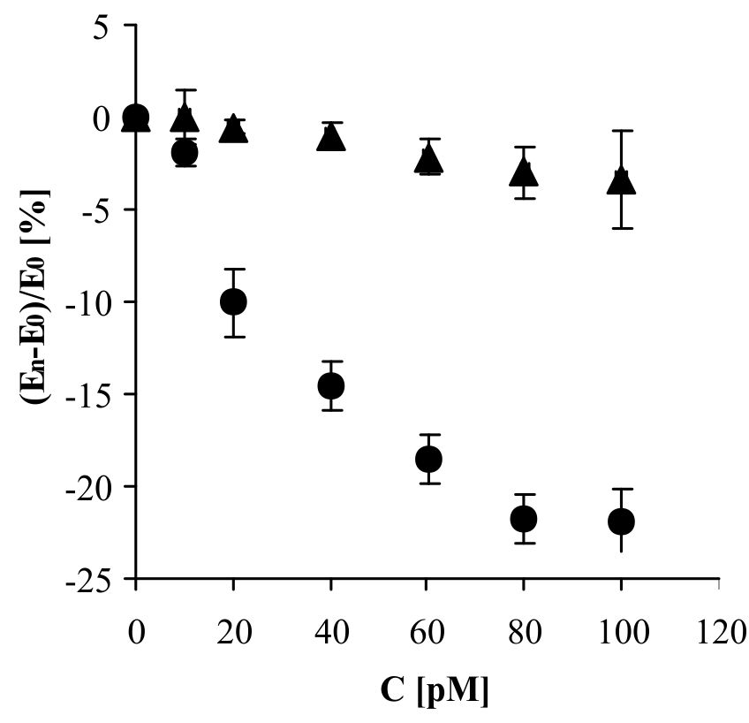
Fig. 3B. The relationship of (E_{n}–E₀)/E₀ (%) vs. concentration
C (pM) of nc-NC3 (▲) and c-NC3 (●). E_{n} is the value of peak potential after detection of given concentration of analytes, and E₀ is the value of peak potential without presence of analyte in pure 0.1 M PBS pH 7.4 (n=6).

3.2. Application of Genosensor for Monitoring of Hybridization Processes with PCR Products
The double stranded PCR products (PCR1-PCR4) used as targets in this study are schematically illustrated in Scheme S1 in Supplementary Materials. The location of the region of complementary to the probe is at the 3’-end, at the 5’-end and in the middle of the DNA fragment for PCR1, PCR2 and PCR3, respectively. The PCR4 has no complementary sequences to the probe at all and was used for demonstration of the selectivity of the genosensor.
The measuring conditions were kept the same as for experiments involving 20–mer oligonucleotides. The representative square wave voltammograms recorded upon successive increasing concentration of PCR1 (complementary to NC3) and of PCR4 (non-complementary to NC3) are illustrated in Figure 4A and Figure 4B, respectively.
The linear current decreasing was observed in the presence of all complementary products: PCR1, PCR2 and PCR3 target molecules in the concentration range from 10 pM to 100 pM (Figure 5A).
The strongest signal was generated by PCR1 with complementary sequences at the 3’-end. In this case the hybridization process with oligonucleotide probe take place at the vicinity of electrode surface, and the part of product which was not involved in the hybridization could be exposed toward the aqueous phase. For PCR2, which has the complementary sequence at opposite side of the strand (at 5’-end), the efficiency of hybridization was very weak. In this case, the accessibility towards oligonucleotide probe immobilized on the surface of electrode was very difficult, because the protruding part (159 nucleotides at 5’-end) was directed rather toward the electrode surface rather than aqueous phase. In the case of PCR3, where 82 nucleotides at 5’-end precede the sequence complementary to the probe (the region of complementarity to NC3 is in the middle of the PCR3) the “middle” response was generated. The non-complementary product, PCR4, caused only little increase of current. The decrease of current value correlates well with potential shift into the negative potential direction, indicating decreasing of reversibility of redox marker [Fe(CN)₆]^{-3/-4} (Figure 5B). Thus, this parameter could be also considered as the analytical signal, as it was in the case of 20-mer DNA target (Figure 3A, B). The similar phenomenon was reported for other ion–channel mimetic sensors [45, 46, 51, 52].

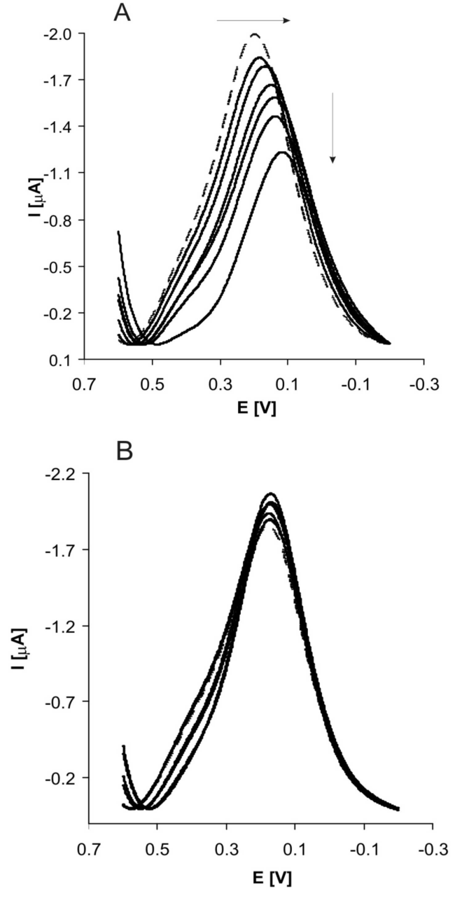
Fig. 4. Example of square wave voltammograms obtained for electrodes modified with HS-ssDNA and 6 – mercaptohexan-1-ol upon hybridization. Dashed curve – before hybridization and next curves upon hybridization with PCR1–NC3 (A) and PCR4–NC3 (B) at concentration range: 10 pM, 20 pM, 40 pM 60 pM, 80 pM and 100 pM. Solution composition: 1 mM K₃[Fe(CN)₆]/K₄[Fe(CN)₆], 0.1 M PBS (pH 7.4). The measuring conditions: three electrode configurations – Au working electrode, Ag/AgCl reference electrode and Pt counter electrode.
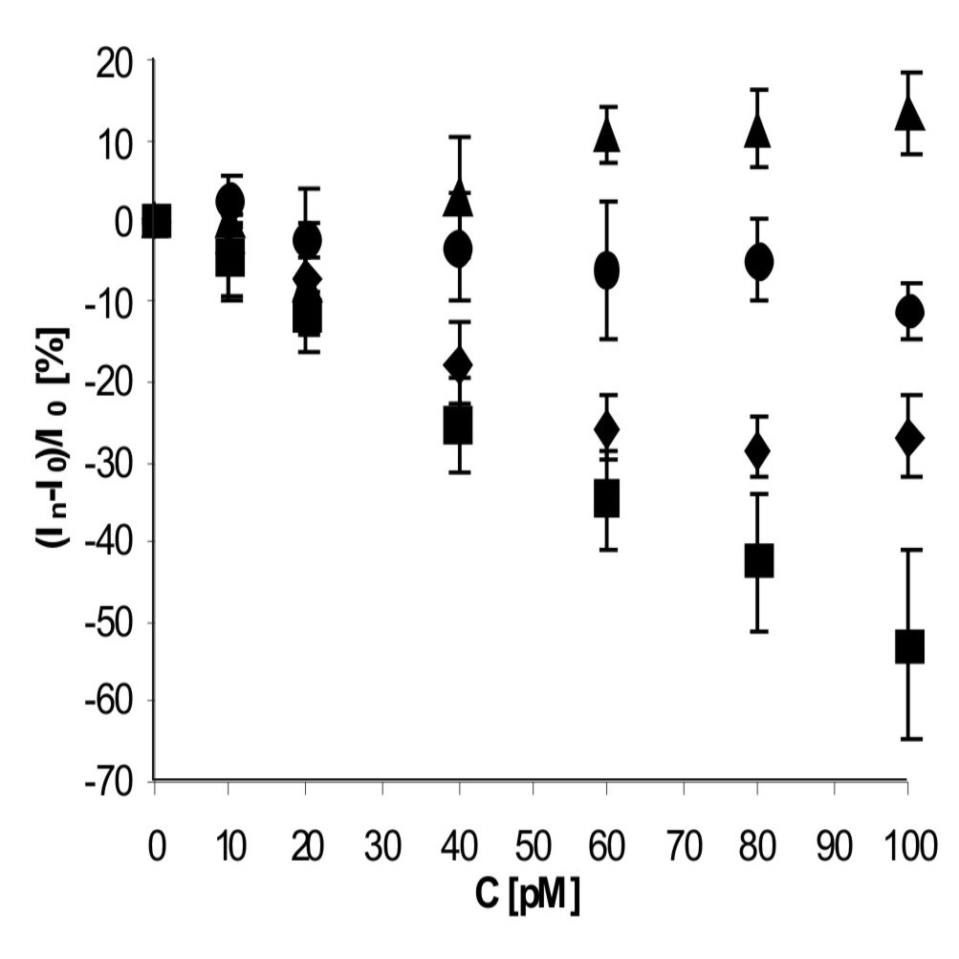
Fig. 5A. The relationship of (I_{n}–I₀)/I₀ (%) vs. concentration C (pM) of PCR1-NC3 (■), PCR2-NC3 (●), PCR3-NC3 (♦) and PCR4-NC3 (▲). I_{n} is the value of peak current after detection of given concentration of PCR-NC3 products, and I₀ is the value of peak current without presence of analyte in pure 0.1 M PBS pH 7.4 (n = 5 ÷ 6).

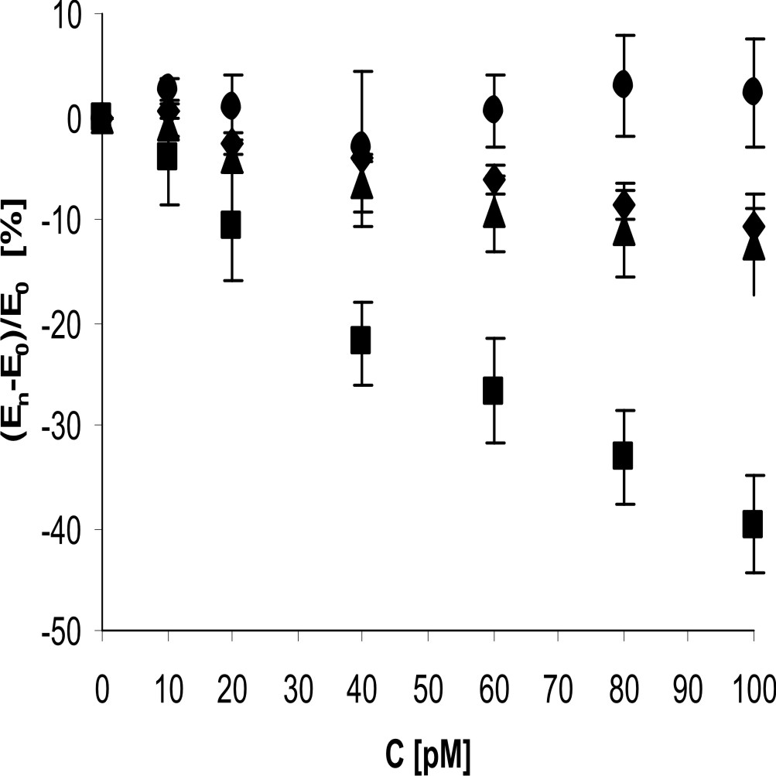
Fig. 5B. The relationship of (E_{n}–E₀)/E₀ (%) vs. concentration C (pM) of PCR1-NC3 (■), PCR2-NC3 (▲), PCR3-NC3 (♦) and PCR4-NC3 (●). E_{n} is the value of peak potential after detection of given concentration of PCR-NC3 products, and I₀ is the value of peak potential without presence of analyte in pure
0.1 M PBS pH 7.4 (n = 5 ÷ 6).

The proposed genosensor was sensitive with the detection limits 2.4·10⁻¹¹M and 2.2·10⁻¹¹M for c-NC3 and PCR1, respectively. It showed also good selectivity. In the presence of the highest used concentration (100 pM) of PCR1 product the 53.0 ± 12.0 % decrease of current assisted with 40.0 ± 4.7 % potential shift were observed (Figure 5A,B). The signals generated by PCR products were stronger in comparison to the c-NC3, which caused at 100 pM concentration only 35.0 ± 5.6% decrease of peak current. In addition, the genosensor presented is able to distinguish the DNA fragments having the complementary sequences in different positions (Figure 5 A, B).
Taking into account the parameters, such as sensitivity, selectivity and simplicity of sensor preparation, the genosensor presented is superior to numerous genosensors already reported (Table 1). The genosensor prepared in a similar way, with using ssDNA probes possessing the different length of spacer between the SH group and the oligonucleotide, displayed one order of magnitude higher detection limit only for 23-mer complementary sequences [59]. The lower detection limits in comparison to the results presented here were reported for genosensors with incorporated redox active intercalators [53, 54, 57, 58]. However, the sensitivity was estimated using only short oligonucleotide sequences. The sensitivity for 101-mer target ssDNA was reported only by Kara and co-workers [53].
It is worth to emphasize that one of the main advantages of the genosensor presented here is its simple fabrication and the suitability for determination of the double stranded DNA fragments, for example the PCR products.
The work on increasing the genosensor sensitivity with using materials improving electron transfer in the transducer layer such as gold nanoparticles or graphene are in progress in our laboratory.

4. Conclusions
The genosensor presented is fabricated based on self-assembling thiolated ssDNA probe on the gold electrode surface. The several parameters, important for genosensor performance, such as solution composition for HS-ssDNA probe immobilization and conditions for hybridization processes, have been optimized. The genosensor displayed good sensitivity, namely detection limits of 2.2·10⁻¹¹ M and of 2.4·10⁻¹¹ M for the complementary 20-mer ssDNA and for the double stranded 181-bp DNA containing 20 nucleotides complementary to the target at 3’-end, respectively. The genosensor shows also good selectivity. Both, the nc-NC3 and PCR4-NC3 generated weak responses. Also, the one of the main its advantage is the suitability for determination of PCR products (double stranded DNA fragments) and discrimination of different positions of the complementary parts. Considering the above analytically important parameters, the presented genosensor could be successfully applied for detection of the H5N1 virus.

Table 1. Comparison of genosensor presented with those already published.
Electrode  modification | Measuring  technique | Target | Detection limit [M] | References
Au/ HS-ssDNA/ MCH | DPV  (MDB) | 101 mer ss-DNA (Anthrax) | 2.0·10⁻¹¹ | [53]
GE/ H₂N-ssDNA | DPV, EIS | 101 mer ss-DNA (Anthrax) | 2.0·10⁻¹¹ | [53]
Au/ PNA /MCH | DPV (MB) | 15 mer ss-DNA (HCV) | 5.7·10⁻¹¹ | [54]
Au/ PNA/ MCH | CV, EIS | 17 mer ss-DNA | - | [55]
Au/ AOT/ PNA | OSWV | 10 mer ss-DNA | 5.1·10⁻¹⁰ | [46]
Au/ HS-ssDNA/ MCH | CV | 20 mer ss-DNA (VP) | 2.5·10⁻⁸ | [56]
Au/HDT/HGN/HS-ssDNA | CV, EIS, DPV (Co(Phen)₃³⁺) | 14 mer ss-DNA | 10⁻¹² | [57]
GCE/ PDC/ GNPs/ss-DNA | CV, EIS, DPV  (MB) | 20 mer ss-DNA (PAT gene) | 2.4·10⁻¹¹ | [58]
Au/MWNT/PPNWs/GNPs/HS- ssDNA/MCH | DPV (Co(Phen)₃³⁺) | 21 mer ss-DNA (AIV H5N1) | 4.3·10⁻¹³ | [42]
Au/HS-ssDNA + MCH /MCH | EIS | 23 and 120 mer ssDNA (AIV H5N1) | 23 mer  10⁻¹⁰ | [59]
Au/HS-ssDNA + MCH /MCH | CV, OSWV | 20 and 179-183 mer ssDNA (AIV H5N1) | 181 mer 2.4·10⁻¹ ¹  20 mer  2.2·10⁻¹¹ | This work
Abbreviations: Au – gold electrode, MCH – 6-mercaptohexan-1-ol, DPV – Differential Pulse Voltammetry, MDB – Meldola’s Blue, GE – graphite electrode, EIS – Electrochemical Impedance Spectroscopy, MB – Methylene Blue, HCV – Hepatitis C 3a Virus, CV – Cyclic Voltammetry, OSWV – Osteryoung Square Wave Voltammetry, AOT – 8-amino- 1-octanethiol, VP – Vibrio parahaemolyticus, HDT – 1,6-hexanedithiol, HGN – hollow gold nanoparticles, PDC – poly-2,6-pyridinedicarboxylic acid, GNPs – gold nanoparticles, MWNT – Multi-wall carbon nanotubes, PPNWs – polypyrolle nanowires.

5. Acknowledgement
This work was supported by Innovative Economy Program, No. POIG.01.01.01-14-007/08 and Institute of Animal Reproduction and Food Research of Polish Academy of Sciences, Olsztyn, Poland.

6. References
- M. Souris, J. P. Gonzales, J. Shanmugasundaram, V. Corvest, P. Kittayapong, Int. J. of Health Geograph. 2010, 9, 3-14.
- S. P. S. Pillai, Ch. W. Lee, Virol. J. 2010, 7, 5-13.
- Y. Amano, Q. Cheng, Anal. Bioanal. Chem. 2005, 381, 156-164.
- Ch. G. Liu, M. Liu, F. Liu, D. F. Liu, Y. Zhang, W. Q. Pan, H. Chen, Ch. H. Wan, E. C. Sun, H. T. Li, W. H. Xiang, J. Med Virol. 2011, 3, 321-327.
- C. T. Pachucki, Curr. Infect. Dis. Rep. 2005, 7, 187-192.
- D. Stamboulian, P. E. Bonvehi, F. M. Nacinovich, N. Cox, Infect. Dis. Cin. North. Am. 2000, 14, 141-166.
- A. C. Boon, A. M. French, D. M. Fleming, M. C. Zambron, J. Med. Virol. 2001, 65, 163-170.
- S. Kodihalli, V. Sivanandan, K. V. Nagaraja, S. M. Goyal, D. A. Halvorson, Am. J. Vet. Res. 1993, 54, 1385-1390.
- L. D. Trani, B. Bedini, I. Donatelli, L. Campitelli, B. Chiappini, M. A. De Marco, M. Delogu, C. Buonavoglia, G. Vaccari, BMC Infect. Dis. 2006, 6, 87-93.
- D. Li, J. Wang, R. Wang, Y. Li, D. Abi-Ghanem, L. Berghman, B. Hargis, H. Lu, Biosens. Bioelectron. 2011, 26, 4146-4154.
- R. Kannangai, A. M. Abraham, S. Sankar, G. Sridharan, Indian J. Med. Microbiol. 2011, 28, 95-99.
- T. W. Owen, R. O. Al-Kaysi, Ch. J. Bardeen, Q. Cheng, Sens. Actuators B. 2007, 126, 691-699.
- G. Lautner, Z. Balogh, V. Bardóczy, T. Meszaros, R. E. Gyurcsanyi, Analyst 2010, 135, 918-926.
- A. Francois, J. Boehm, S. Y. Oh, T. Kok, T. M. Monro, Biosens. Bioelectron. 2011, 26, 3154-3159.
- B. Rapp, F. J. Gruhl, K. Länge, Anal. Bioanal. Chem. 2010, 398, 2403-2412.
- Palchetti, M. Mascini, Anal. Bioanal. Chem. 2008, 391, 455-471.
- R. Miranda-Castro, N. de-los-Santos-Álvarez, M. Lobo-Castañón, A. Miranda-Ordieres, P. Tuñón-Blanco, Electroanalysis 2009, 21, 2077-2090.
- M. Castañeda, S. Alegret, A. Merkoçi, Electroanalysis 2007, 19, 743-753.
- E. Paleček, Nature 1960, 188, 656-657.
- E. Paleček, F. Jelen, Crit. Rev. Anal. Chem. 2002, 32, 261-270.
- E. Paleček, M. Fojta, F. Jelen, Bioelectrochemistry 2002, 56, 85-90.
- E. Paleček, Talanta 2002, 56, 809-819.
- E. Paleček, M. Fojta, Anal. Chem. 2001, 74, 74A-83A.
- E. Paleček, Electroanalysis 2009, 21, 239-251.
- M. Bartošík, E. Paleček, Electroanalysis 2011, 23, 1311-1319.
- Mannelli, M. P. Marco, Anal. Bioanal. Chem. 2010, 398, 2451-2469.
- A. M. Nowicka, A. Kowalczyk, M. Donten, D. Leech, M. Hepel, Z. Stojek, Electroanalysis 2010, 22, 2323-2329.
- D. S. Torres, F. Huerta, F. Montilla, E. Morallon, Electrochim. Acta 2011, 56, 2464-2470.
- L. Santiago-Rodríguez, G. Sánchez-Pomales, C. R. Cabrera, Electroanalysis 2010, 22, 2817-2824.
- M. A. Aziz, K. Jo, J.-A. Lee, M. R. H. Akanda, D. Sung, S. Jon, H. Yang, Electroanalysis 2010, 22, 2615-2619.
- A. V. Porfireva, G. A. Evtugyn, A. N. Ivanov, T. Hianik, Electroanalysis 2010, 22, 2187-2195.
- A. Caliskan, H. Karadeniz, Electroanalysis 2009, 21, 2116-2124.
- A. Erdem, H. Karadeniz, A. Caliskan, Electroanalysis 2009, 21, 464-471.
- K. R. Ratinac, W. Yang, J. J. Gooding, P. Thordarson, F. Braet, Electroanalysis 2011, 23, 803-826.
- M. Muti, S. Sharma, A. Erdem, P. Papakonstantinou, Electroanalysis 2011, 23, 272-279.
- T. Kuila, S. Bose, P. Khanra, A. K. Mishra, N. H. Kim, J. H. Lee, Biosens. Bioelectron. 2011, 26, 4637-4648.
- K. S. Kim, S. J. Park, Electrochim. Acta 2011, 56, 6547-6553.
- A. M. Nowicka, A. Kowalczyk, F. Schulz, Z. Stojek, Electroanalysis 2011, 23, 2817-2824.
- K. Yamanaka, M. Saito, K. Kondoh, M. M. Hossain, R. Koketsu, T. Sasaki, N. Nagatani, K. Ikuta, E. Tamiya, Analyst 2011, 136, 2064-2068.
- M. Gebala, L. Stoica, S. Neugebauer, W. Schuhmann, Electroanalysis 2009, 21, 325-331.
- M. Gebala, W. Schuhmann, ChemPhysChem 2010, 11, 2887-2895.
- X. Liu, Z. Cheng, H. Fan, S. Ai, R. Han, Electrochim. Acta 2011, 56, 6266-6270.
- H. Minami, M. Sugawara, K. Odashima, Y. Umezawa, M. Uto, E. K. Michaeli, T. Kuwana, Anal. Chem. 1991, 63, 2787-2795.
- Y. Umezawa, H. Aoki, Anal. Chem. 2004, 76, 321A-326A.
- H. Aoki, Y. Umezawa, Analyst 2003, 128, 681-685.
- H. Aoki, Y. Umezawa, Electroanalysis 2002, 14, 1-6.
- H. Aoki, P. Bühlmann, Y. Umezawa, Electroanalysis 2000, 12, 1272-1276.
- B. Gromadzka, K. Smietanka, J. Dragun, Z. Minta, A. Gora-Sochacka, B. Szewczyk, Mol. Cell. Probes 2008, 22, 301-304.
- M. Revenga-Parra, T. Garcia, F. Pariente, E. Lorenzo, C. Alonso, Electroanalysis 2011, 23, 100-107.
- P. D. Tam, M. A. Tuan, N. V. Hieu, N. D. Chien, Physica E 2009, 41, 1567-1751.
- H. Radecka, I. Szymańska, M. Pietraszkiewicz, O. Pietraszkiewicz, H. Aoki, Y. Umezawa, Chem. Anal. (Warsaw) 2005, 50, 85-101.
- K. Kurzatkowska, E. Dolusic, W. Dehaen, K. Sieroń- Sołtyn, A. Sieroń, H. Radecka, Anal. Chem. 2009, 81, 7397-7405.
- P. Kara, B. Meric, M. Ozsoz, Electroanalysis 2008, 20, 2629-2634.
- M. S. Hejazi, M. H. Pournaghi-Azar, F. Ahour, Anal. Biochem. 2010, 399, 118-124.
- T. H. Degefa, J. Kwak, J. Electroanal. Chem. 2008, 612, 37-41.
- M. Lan, Q. Zhou, , Y. Teng, Ch. Chen, H. Zhao, H. Yuan, Sci China Chem 2010, 53, 1366-1370.
- S. Liu, J. Liu, X. Han, Y. Cui, W. Wang, Biosens. Bioelectron. 2010, 25, 1640-1645.
- J. Yang, T. Yang, Y. Feng, K. Jiao, Anal. Biochem. 2007, 365, 24-30.
- A. Kukol, P. Li, P. Estrela, P. Ko-Ferrigno, P. Migliorato, Anal. Biochem. 2008, 374, 143-153.

