Localization of key amino acid residues in the dominant conformational epitopes on thyroid peroxidase recognized by mouse monoclonal antibodies

Marlena Godlewska¹, Barbara Czarnocka¹, Monika Gora^{2*}

¹ Department of Biochemistry and Molecular Biology, Medical Centre of Postgraduate Education, Warsaw, Poland
² Department of Genetics, Institute of Biochemistry and Biophysics Polish Academy of Sciences, Warsaw, Poland

* Correspondence: Monika Gora,
Institute of Biochemistry and Biophysics, Polish Academy of Sciences,
Pawinskiego 5A, 02-106 Warsaw, Poland,
Phone number: +4822 5921214, Fax number: +4822 6584636,
E-mail: mgora@ibb.waw.pl

Running head: Contact residues in TPO specific for mAbs binding

Keywords: epitope mapping, immunodominant regions, autoimmune thyroid diseases, thyroid peroxidase (TPO), mouse monoclonal antibody

Abstract
Autoantibodies to thyroid peroxidase (TPO), the major target autoantigen in autoimmune thyroid diseases, recognize conformational epitopes limited to two immunodominant regions (IDRs) termed IDR-A and -B. The apparent restricted heterogeneity of TPO autoantibodies was discovered using TPO-specific mouse monoclonal antibodies (mAbs) and later confirmed by human recombinant Fabs. In earlier studies we identified key amino acids crucial for the interaction of human autoantibodies with TPO. Here we show the critical residues that participate in binding of five mAbs to the conformational epitopes on the TPO surface. Using ELISA we tested the reactivity of single and multiple TPO mutants expressed in CHO cells with a panel of mAbs specifically recognizing IDR-A (mAb 2 and 9) and IDR-B (mAb 15, 18, 64). We show that antibodies recognizing very similar regions on the TPO surface may interact with different sets of residues. We found that residues K713 and E716 contribute to the interaction between mAb 2 and TPO. The epitope for mAb 9 is critically dependent on residues R646 and E716. Moreover, we demonstrate that amino acids E604 and D630 are part of the functional epitope for mAb 15, and amino acids D624 and K627 for mAb 18. Finally, residues E604, D620, D624, K627, and D630 constitute the epitope for mAb 64. This is the first detailed study identifying the key resides for binding of mAbs 2, 9, 15, 18, and 64. Better understanding of those antibodies’ specificity will be helpful in elucidating the properties of TPO as an antigen in autoimmune disorders.

Introduction
Human thyroid peroxidise (TPO), previously known as the thyroid microsomal antigen [1], is the major antigenic target for autoantibodies in thyroid autoimmune diseases (reviewed in Ref. 2, 3). TPO autoantibodies are detected in almost all patients with Hashimoto’s thyroiditis and in 75% of patients with Graves’ disease [4]. There is some evidence that these antibodies mediate damage of thyroid follicular cells by activation of the complement cascade and/or by an antibody-dependent cell cytotoxic mechanism. Additionally, the TPO autoantibodies may play a role in antigen presentation to autoaggressive T cells and may enhance the autoimmunity disease progress (reviewed in Ref. 2).
The TPO autoantibodies recognize conformational epitopes restricted to an immunodominant region (IDR) comprising chiefly two overlapping regions A and B [5]. However, the immunological response to other regions of TPO (IDR-C and –D) may represent a significant proportion of autoantibodies in some patients with autoimmune disorders [6]. The first epitopic map of the TPO molecule surface was established using a panel of mouse monoclonal antibodies (mAbs) and patients’ autoantibodies [5]. That report was further confirmed with the use of human monoclonal TPO autoantibodies expressed as Fab fragments [7, 8]. Both the mouse and human mAb panels defined the same immunodominant regions, however, since they were described separately, the terminology was inverted. IDR-A of the mouse mAbs corresponds to IDR-B of the human Fab fragments and vice versa. In this report we will refer to IDR-A and –B as they were first defined by the mouse mAbs.
Thyroid peroxidase is a thyrocyte apical plasma membrane enzyme and is crucial in thyroid hormone biosynthesis involving two separate reactions, namely the iodination of tyrosine residues in thyroglobulin followed by intramolecular coupling of the iodinated tyrosine to form T3 and T4 [9]. The TPO ectodomain consists of a large myeloperoxidase (MPO)-like domain, followed by complement control protein (CCP)- and epidermal growth factor (EGF)-like domains [10]. A three-dimensional model of the TPO ectodomain has been constructed in our laboratory, however, the localization of the TPO domains with respect to each other is still not clear [10]. Therefore, the identification of the amino acids in the autoantibodies’ epitopes is a difficult issue.
For the last fifteen years numerous attempts have been made to map the two immunodominant regions A and B on the TPO molecule (reviewed in Ref. 2). Early studies used proteolytic peptides generated by enzymatic hydrolysis of TPO [11], chimeras with myeloperoxidase regions swapped with the corresponding TPO regions [12, 13], and competition for TPO binding between mAbs or rabbit polyclonal antisera and human anti-TPO antibodies [5, 7, 10, 14, 15]. Other strategies were based on an analysis of the binding of human anti-TPO antibodies to recombinant and/or truncated antigen [16-20], eukaryotic cell expression of TPO mutants obtained by directed mutagenesis and binding analysis to TPO autoantibodies [21-27], epitopic footprinting [28], and peptide spot technology [23, 24]. To sum up the current understanding of the composition of the immunodominant regions, A-domain epitopes have been found to comprise amino acids R225 [25], H353-Y363 [23, 26], P377-R386 [23], R646, D707 [27], K713-S720 [23, 24], and Y766-Q775 [23]. The B domain includes following residues: F597-E604, T611-V618 [29], D620, D624 [27], K627 [25], and D630 [27].
A panel of thirteen anti-TPO mAbs produced against native human TPO, as it mentioned above, was used for the pioneering studies on the immunodominant regions located on the TPO molecule surface [5, 8]. Antibodies numbered 2, 9, 47, and 60 reacted with epitopes in domain A, mAbs 15, 18, 59, and 64 recognized domain B, mAb 24 bound to IDR-C, and 1, 30, 40, and 53 to IDR-D [5]. When rabbit antisera raised to the linear peptides exposed on the TPO surface were available, the localization of the immunodominant regions recognized by anti-TPO mAbs was further examined [29, 30]. It was determined that mAb 15, 18, and 64 strongly interacted with region 599-617 [29, 30], whereas the region recognized by mAb 2 was more complex. We showed that mAb 2 binding was significantly inhibited by a combination of antisera to peptides P12 (region 549-563), P14 (region 599-617), and P18 (region 210-225) [30]. In turn, Bresson et al. proposed that the IDR-A-specific mAb 2 binds to regions 353-372, 549-563, 599-617, and 702-721 [29]. The structure of the epitope for mAb 47 was most precisely defined. Using TPO protein fragments expressed from an hTPO cDNA sub-library, the mAb 47 epitope was restricted to region 713-721 [31]. Further studies based on spot analysis and site-directed mutagenesis have assigned the minimal epitope recognized by this antibody to residues between amino acids K713 and D717, with K713, P715, and E716 being essential for the antibody binding [24]. Overall, despite the quite extensive usage of mAbs in various studies on TPO [e.g., 24, 29, 32-35], the amino acid residues crucial for the binding of a majority of anti-TPO mAbs remain to be determined. Therefore, the aim of the present study was to map the epitopes recognized on thyroid peroxidase by five mAbs, mAb 2, 9, 15, 18, and 64, using molecular modelling and site-directed mutagenesis followed by eukaryotic cell expression of each TPO mutant.
Materials and methods
Guided mutagenesis, stable expression of wild-type and mutated TPO cDNA, and membrane protein extraction
We constructed a panel of single and multiple TPO mutants in IDR-A: R225A, R646A, D707N, K713A, E716A, R225A/R646A, R225A/D707N, R646A/D707N, R225A/R646A/D707N (RRD), and in the IDR-B region: E604A, D620R, D624S, K627G, D630N, K627G/E604A, D620R/D624S, K627G/E604A/D620R/D624S (KDDE), and K627G/E604A/D620R/D624S/D630N (KDDED). The construction of all these mutant cDNAs, transfection, and expression in CHO cells was described previously [25, 27]. Membrane proteins were extracted from stably transfected CHO cells as described [27].
Mouse mAbs
A panel of five mouse anti-TPO monoclonal antibodies (mAb) specific for IDR-A (mAb 2 and 9) and IDR–B region (mAb 15, 18, and 64) were generously provided by Dr. J. Ruf [5]. mAb A4 was used to monitor TPO expression in CHO cells by ELISA [36].
ELISA
ELISA was carried out as previously described [25] with some modifications. Membrane proteins extracted from stably transfected CHO cells expressing TPO (wild-type and mutants) were used to coat microtitre plates at 20 µg/ml in PBS and incubated for two hours at room temperature followed by overnight incubation at 4ºC. The wells were washed three times with TBST and blocked with 2% bovine serum albumin (BSA) in TBST for one hour at room temperature. After washing three times in TBST, a suitable dilution of mouse monoclonal antibody (diluted to give a final OD₄₅₀ reading of between 1.0 and 2.0) in TBST containing 0.2% BSA (TBST-BSA) was added and incubated for one hour at room temperature. After three washes with TBST, 1:1000 dilution of HRP-conjugated goat anti-mouse IgG (Sigma-Aldrich) in TBST-BSA was added and incubated for one hour at room temperature followed by washing three times in TBST. The plates were developed with 0.1 mg/ml tetramethylbenzidine (TMB) in citrate buffer, pH 4.0 for about 15 min. The reaction was terminated with 100 µl of 0.5 M sulphuric acid and the OD was read at 450 nm.
All the experiments were repeated at least 6 times, each in triplicate. Background binding to membrane proteins prepared from untransfected CHO cells was subtracted from the antibody binding to proteins extracted from CHO cells expressing wild-type and mutant TPO. The results are presented as the percentage of wild-type TPO binding. This value was calculated according to the equation: A x 100 / B, where A is the mean OD for a TPO mutant, B is the mean OD for wild-type TPO. Moreover, to normalize the results for binding of mAb 2, 9, 15, 18, and 64 to TPO mutants, the following formula was applied: C x 100 / D. C stands for the percentage of wild-type TPO binding of mAb 2, 9, 15, 18, or 64 to a TPO mutant and D stands for the percentage of wild-type TPO binding of mAb A4 to the same TPO mutant as used to estimate the C value.
Statistical analysis
The results were expressed as the mean ± SD. The statistical significance of the difference between means was determined by the Mann-Whitney U test using Statistica 10.0 software (StatSoft, Inc.). The difference was considered significant at p<0.05.

Results
Construction and expression of TPO mutants
To study the reactivity of mAbs with IDR-A and -B, we used a series of TPO mutants in region A (R225A, R646A, D707N, K713A, E716A, R225A/R646A, R225A/D707N, R646A/D707N, R225A/R646A/D707N (RRD)) and in region B (E604A, D620R, D624S, K627G, D630N, K627G/E604A, D620R/D624S, K627G/E604A/D620R/D624S (KDDE), K627G/E604A/D620R/D624S/D630N (KDDED)). All of the TPO mutants were stably expressed in CHO cells as surface membrane proteins, as confirmed previously using Western blotting and immunodetection [25, 27].
Normalization of ELISA results
Binding of the mAbs to the TPO mutants was studied using the antigen coated directly on the microtitre plates. To check whether the amount of the TPO protein bound to the wells was similar for each mutant, we tested their reactivity with mAb A4. This antibody recognizes a linear epitope [36] located in a region of TPO outside IDR-A and –B (unpublished data). Applying the same amount of extracts isolated from CHO cells expressing various TPO variants to each well (20 µg of total protein per milliliter of PBS), we obtained results ranging from 82% (for the D620R mutant) to 127% (for the KDDED mutant) (Figure 1). Further analysis showed that only the differences between the reactivity of wild-type TPO and the mutants R225A, D707N, K713A, R225A/R646A, R225A/D707N, D624S, K627G, D630N, and KDDE were not statistically significant. Therefore, to avoid errors in data interpretation due to variations in the amounts of individual TPO mutants coated on the plates, all the results for mAb binding (i.e., mAb 2, 9, 15, 18, and 64) to TPO mutants were normalized to the mAb A4 results (see Materials and Methods for details).
Characterization of IDR-A-specific mAb 2 and 9 antigenic epitopes on TPO mutants
The binding of IDR-A-specific mAb 2 was totally abrogated by the substitutions at positions K713 or E716 (Figure 2A). Although the single mutation R225A only slightly decreased mAb 2 binding (by 16%), in combination with R646A and/or D707N, namely in mutants R225A/R646A, R225A/D707N, and RRD, it brought about a statistically significant reduction in binding (38%, 45%, 48%, respectively). At the same time, the recognition of mutant R646A/D707N by mAb 2 was not affected confirming the importance of residue R225.
The replacement of the amino acids R646 or E716 with alanine resulted in an about 80% reduction of the interaction of mAb 9 with TPO (Figure 2A). Furthermore, all the multiple mutants containing the R646A mutation, i.e., R225A/R646A, R646A/D707N, and RRD, as expected, also showed a dramatically decreased mAb 9 binding (100%, 83%, 96%, respectively). Simultaneously, the reactivity of mAb 2 and 9 with mutants in IDR-B was examined (Figure 2B) and no statistically significant difference in comparison with wild-type TPO was observed except for E604A and D620R/D624S in reaction with mAb 2 and KDDED in interaction with mAb 9. The reactivity of those three mutants was reduced by no more than 22%.
Characterization of IDR-B-specific mAb 15, 18, and 64 antigenic epitopes on TPO mutants
The interaction of mAb 15 (Figure 3A) with the single mutants E604A and D630N was drastically reduced (about 80% and 100%, respectively) and, to a lesser extent, with D620R (about 50%). In the case of multiple mutants, a decrease in mAb 15 binding was also observed which ranged from about 60% for K627G/E604A to about 80% for D620R/D624S and about 100% for KDDE and KDDED (Figure 3A). Interestingly, the single mutation D624S had no effect on the reactivity of mAb 15, however, the D620R and D624S mutations together (mutant D620R/D624S) caused an about 80% reduction in mAb 15 binding (Figure 3A). This additive effect confirmed that D620 and D624 participate in the structure of the epitope for mAb 15. The mAb 18 binding was significantly decreased in reaction with single mutants D624S and K627G (about 80%) and less dramatically with E604A (about 40%) (Figure 3A). In line with expectations, all the multiple mutants were poorly recognized by mAb 18, i.e., K627G/E604A (reduction by about 80%), D620R/D624S (about 90%), KDDE (about 100%), and KDDED (about 100%). Finally, the composition of the epitope for mAb 64 was explored (Figure 3B), and notably, all the single mutants in region B showed markedly weaker reaction with this antibody. The D620R and K627G mutations each caused an about 100% reduction in binding, whereas D630N and E604A produced binding reduction by about 80% and 70%, respectively. All the double and multiple mutations reduced the binding of mAb 64 to an almost undetectable level. At the same time, the interaction of all mutants in region A with the IDR-B-specific mAbs was determined (Figure 3B), and in most cases those substitutions did not affect the binding of mAb 15, 18, or 64. However, there were also some statistically significant effects: mutant R225A/D707N in reaction with mAb 15, mutants E716A and R225A/D707N in reaction with mAb 18, and R225A/D707N and RRD in reaction with mAb 64 showed reactivities decreased by no more than 20%.

Discussion
In our previous studies we have successfully used molecular modelling combined with site-directed mutagenesis to explore the discontinuous conformational epitopes for human autoantibodies on the TPO surface [25, 27]. Here we used a similar approach to delineate the epitopes for five TPO-specific mouse monoclonal antibodies, namely mAb 2, 9, 15, 18, and 64. To conduct the study we used a panel of previously described single and multiple TPO mutants expressed in CHO cells as membrane-anchored proteins and checked their reactivity with the mAbs by ELISA. Our goal was to identify the residues forming functional epitopes, in other words, the residues that contribute significantly to the binding energy. A functional epitope (3-5 amino acids) is a part of the structural epitope that contains usually between 15 and 20 amino acid residues (reviewed in Ref. 37). Replacement of residue belonging to the functional epitope usually causes reduction or a complete loss of antibody binding, while mutations of other residues elsewhere within the structural epitope may lead to much smaller, if any, changes in affinity.
We showed that residues K713 and E716 are critical for mAb 2 binding to TPO. These findings are in agreement with earlier results suggesting that region 702-721 participates in binding of mAb 2 [29]. These amino acid residues are also the main contributors to mAb 47 binding [24], thus, the epitopes recognized by mAb 2 and mAb 47 overlap. The same conclusion was drawn from a study analyzing inhibition of mAb 2 binding by mAb 47 and vice versa [5]. The interaction of mAb 2 with TPO is also inhibited by human Fab TR1.9 [38]. It was demonstrated that P715 and D717 were directly involved in binding of this human antibody [24]. The third candidate key contact point for TR1.9 binding was K713 [28]. Further studies showed that although K713 is a contact residue for TR1.9 it contributes very little, if at all, to TR1.9 affinity [24]. It is worth emphasizing that in the computer model of TPO ectodomain all listed residues, i.e., K713, P715, E716, and D717 form a compact cluster well-accessible to the solvent [24]. This may explain why mAb 2, mAb 47, and Fab TR1.9 are effective in inhibiting one another.
We observed that residues R646 and E716 are critical contributors to the binding of mAb 9. In an earlier study Fab TR1.8 inhibited mAb 9 binding to TPO by about 20% and it was suggested that both antibodies recognize the same subdomain in IDR-A [38]. More recently the specificity of Fab TR1.8 for immunodominant regions was re-examined [29]. It was assumed that this monoclonal autoantibody does not only bind to IDR-A but also binds strongly in the region 599-617. Two explanations may be given to elucidate the low inhibition of mAb 9 binding by Fab TR1.8. (i) The epitopes of both antibodies do not contain sufficiently many residues in common (especially key contact ones). (ii) The inhibition may be partly masked by the poor recognition of ¹²⁵I-TPO that was used in the experiment by mAb 9 [38]. It has already been proposed that the epitope of mAb 9 is located near a tyrosine involved in TPO radioiodination [5]. Furthermore, Czarnocka et al. indicated Y226 as a site of radioiodination [8]. Interestingly, Y226 is situated in close vicinity to R646 and E716 in the three-dimensional model of TPO ectodomain (Figure 4).
As it was already mentioned, mAb 2 and 9 recognize slightly different regions on the TPO surface, albeit both located predominantly in IDR-A. We have shown here that E716 is simultaneously a key residue for these two antibodies, which confirms overlapping of their epitopes. Earlier observation of partial competition between these two antibodies for the antigen supports these findings [5], similarly as the results of studies on the competition between mAbs and human autoantibodies [14].
Recently we have identified also R225 and D707 as important components of region A [25, 27]. Here we did not observe an impact of the D707N mutation on mAb 2 and mAb 9 binding. Likewise, it seems that residue R225 is not a key contact amino acid for either antibody, however, it may be a part of the structural epitope for mAb 2, because all the multiple mutants containing the R225A substitution reacted significantly worse with mAb 2 in comparison with wild-type TPO. Overall, these results confirm that the structure of region A is complex and antibodies recognizing very similar regions on the TPO surface may interact with different sets of residues.
Analyzing the structure of epitopes for the IDR-B-specific mAbs, we found a strong contribution of amino acid residues E604, D630, and a lesser one of D620 (about 50% inhibition) and D624 (additive effect with D620), to the binding of mAb 15, whereas D624 and K627 appeared to be essential for mAb 18. Similarly, residues D620, K627, D630, E604, and D624 were critical for the interaction between mAb 64 and TPO. Bresson et al. demonstrated that the binding of mAb 15, 18, and 64 to TPO was inhibited by 72%, 54%, and 65%, respectively, by rabbit antiserum specific for peptide P14 [29]. One of the key residues in the region recognized by this serum (599-617) is E604 [27, 29]. Our results indicated that the mutation E604A affected the binding of all IDR-B-specific mAbs examined, especially mAb 15 and mAb 64 (inhibition of 81% and 66%, respectively), and to a lesser extent, mAb 18 (inhibition of 36%). Interestingly, the more significant effect of the substitution at position E604 on the binding of a given mAb, the higher inhibition of the mAb binding by antiserum P14. Earlier competition studies between mAb 15, 18, and 64 demonstrated that mAb 64 is the best inhibitor [5]. This inhibition pattern may be caused by the fact that mAb 64 has at least three key contact amino acids common with the mAb 15 epitope, and two common with mAb 18, whereas the epitopes recognized by mAb 15 and mAb 18 probably have no critical residues in common. Therefore, the epitope for mAb 64 is probably located in the centre of IDR-B, whereas epitopes for mAb 15 and 18 are near the borders of this region (Figure 4). Similar conclusions have been arrived at by flow cytometry for the positioning on the TPO surface of the areas recognized by mAb 18 and mAb 64 [33]. It should be also indicated that all examined residues in region B constitute a contiguous area not exceeding 1000 Å² [27], compatible with an antigen-antibody binding area [36]. Taken together, our results confirmed that residues D620, K627, D630, E604, and D624 are important components of the IDR-B region not only for IDR-B-specific autoantibodies but also for mouse monoclonal antibodies specifically recognizing region B.
It has to be underlined that in most cases the mutations tested led specifically to a loss of the binding of IDR-A- or –B-specific mAb, without affecting the binding of mAbs to the other determinant. However, there were a few exceptions to this rule. Our interpretation is that (i) there were some conformational changes in the three-dimensional structure while coating the antigen directly on the well surface and/or (ii) the epitopes for the mAbs analyzed are not strictly limited to only one immunodominant region (some overlapping between regions A and B). Even if the first hypothesis is true, the conformation changes are probably minor, because the decrease in the reactivity was never higher than 22%. Additionally, an interaction analysis of mAb 2, 9, 15, 18, and 64 with native human thyroid peroxidase protein was conducted earlier and revealed no differences between the results obtained using TPO in solution or coated on the solid phase [5]. mAb 64 was the only exception, because it reacted better with soluble TPO than with solid phase-bound one [5]. Undoubtedly, the best way to demonstrate indisputably the structure of the epitopes would be co-crystallization of TPO with the appropriate antibody, however, this approach is technically too difficult at present to be performed.
In conclusion, we provided new insight into the structure of conformational epitopes recognized by a panel of mouse monoclonal antibodies specific to TPO (mAb 2, 9, 15, 18, and 64). We demonstrated that residues K713 and E716 are crucial for mAb 2 binding, as are R646 and E716 for mAb 9. We defined two crucial amino acid residues for mAb 15, namely E604 and D630. Moreover, we assigned residues D624 and K627 as key components of the mAb 18 epitope, whereas E604, D620, D624, K627, and D630 were shown to constitute the mAb 64 recognition site on TPO. Understanding the structure of epitopes recognized by TPO-specific mAbs should help not only in research on thyroid peroxidase but also may be useful in diagnostics of autoimmune thyroid diseases. It has already been suggested that mAb 64 is a helpful marker of the immune process in the thyroid gland [33].

Acknowledgements
We are grateful to Dr. J. Ruf for providing the mouse anti-TPO-specific antibodies. We acknowledge Drs. A. Gardas and J. P. Banga for helpful discussions. We thank Wanda Krasuska for technical assistance.

Declaration of interests: The authors report no conflicts of interest. The authors alone are responsible for the content and writing of the paper.

Disclosure of funding sources
This work was supported by a grant from the Medical Centre of Postgraduate Education No. 501-1-25-01-11.

References
- Czarnocka B, Ruf J, Ferrand M, et al. Purification of the human thyroid peroxidase and its identification as the microsomal antigen involved in autoimmune thyroid diseases. FEBS Lett. 1985; 190: 147-52.
- McLachlan SM, Rapoport B. Thyroid peroxidase as an autoantigen. Thyroid. 2007; 17: 939-48.
- Hadj-Kacem H, Rebuffat S, Mnif-Féki M, et al. Autoimmune thyroid diseases: genetic susceptibility of thyroid-specific genes and thyroid autoantigens contributions. Int J Immunogenet. 2009; 36: 85-96.
- Saravanan P, Dayan CM. Thyroid autoantibodies. Endocrinol Metab Clin North Am. 2001; 30: 315-37.
- Ruf J, Toubert ME, Czarnocka B, et al. Relationship between immunological structure and biochemical properties of human thyroid peroxidase. Endocrinology 1989; 125: 1211-8.
- Jastrzębska-Bohaterewicz E, Gardas A. Proportion of antibodies to the A and B immunodominant regions of thyroid peroxidase in Graves and Hashimoto disease. Autoimmunity. 2004; 37: 211-6.
- Chazenbalk GD, Costante G, Portolano S, et al. The immunodominant region on human thyroid peroxidase recognized by autoantibodies does not contain the monoclonal antibody 47/c21 linear epitope. J Clin Endocrinol Metab. 1993; 77: 1715-8.
- Czarnocka B, Janota-Bzowski M, McIntosh RS, et al. Immunoglobulin G kappa antithyroid peroxidase antibodies in Hashimoto's thyroiditis: epitope-mapping analysis. J Clin Endocrinol Metab. 1997; 82: 2639-2644.
- Taurog A, Dorris ML, Doerge DR. Mechanism of simultaneous iodination and coupling catalyzed by thyroid peroxidase. Arch Biochem Biophys. 1996; 330: 24-32.
- Hobby P, Gardas A, Radomski R, et al. Identification of an immunodominant region recognized by human autoantibodies in a three-dimensional model of thyroid peroxidase. Endocrinology. 2000; 141: 2018-26.
- Estienne V, Duthoit C, Vinet L, et al. A conformational B-cell epitope on the C-terminal end of the extracellular part of human thyroid peroxidase. J Biol Chem. 1998; 273: 8056-62.
- Nishikawa T, Nagayama Y, Seto P, et al. Human thyroid peroxidase-myeloperoxidase chimeric molecules: tools for the study of antigen recognition by thyroid peroxidase autoantibodies. Endocrinology. 1993; 133: 2496-501.
- Nishikawa T, Rapoport B, McLachlan SM. Exclusion of two major areas on thyroid peroxidase from the immunodominant region containing the conformational epitopes recognized by human autoantibodies. J Clin Endocrinol Metab. 1994; 79: 1648-54.
- Czarnocka B, Pastuszko D, Carayon P, et al. Majority of thyroid peroxidase autoantibodies in patients with autoimmune thyroid disease are directed to a single TPO domain. Autoimmunity. 1996; 23: 145-54.
- Gardas A, Watson PF, Hobby P, et al. Human thyroid peroxidase: mapping of autoantibodies, conformational epitopes to the enzyme surface. Redox Rep. 2000; 5: 237-41.
- Banga JP, Barnett PS, Ewins DL, et al. Mapping of autoantigenic epitopes on recombinant thyroid peroxidase fragments using the polymerase chain reaction. Autoimmunity. 1990; 6: 257-68.
- Arscott PL, Koenig RJ, Kaplan MM, et al. Unique autoantibody epitopes in an immunodominant region of thyroid peroxidase. J Biol Chem. 1996; 271: 4966-73.
- Grennan Jones F, Ziemnicka K, Sanders J, et al. Analysis of autoantibody epitopes on human thyroid peroxidase. Autoimmunity. 1999; 30: 157-69.
- Xiong Z, Farilla L, Guo J, et al. Does the autoantibody immunodominant region on thyroid peroxidase include amino acid residues 742-771? Thyroid. 2001; 11: 227-31.
- Blanchin S, Estienne V, Guo J, et al. Human thyroperoxidase folds in one complex B-cell immunodominant region. Biochem Biophys Res Commun. 2002; 295: 1118-24.
- Nishikawa T, Rapoport B, McLachlan SM. The quest for the autoantibody immunodominant region on thyroid peroxidase: guided mutagenesis based on a hypothetical three-dimensional model. Endocrinology. 1996; 137: 1000-6.
- Estienne V, Duthoit C, Blanchin S, et al. Analysis of a conformational B cell epitope of human thyroid peroxidase: identification of a tyrosine residue at a strategic location for immunodominance. Int Immunol. 2002; 14: 359-66.
- Bresson D, Cerutti M, Devauchelle G, et al. Localization of the discontinuous immunodominant region recognized by human anti-thyroperoxidase autoantibodies in autoimmune thyroid diseases. J Biol Chem. 2003; 278: 9560-9.
- Bresson D, Pugniere M, Roquet F, et al. Directed mutagenesis in region 713-720 of human thyroperoxidase assigns ⁷¹³KFPED⁷¹⁷ residues as being involved in the B domain of the discontinuous immunodominant region recognized by human autoantibodies. J Biol Chem. 2004; 279: 39058-67.
- Gora M, Gardas A, Watson PF, et al. Key residues contributing to dominant conformational autoantigenic epitopes on thyroid peroxidase identified by mutagenesis. Biochem Biophys Res Commun. 2004; 320: 795-801.
- Rebuffat SA, Bresson D, Nguyen B, et al. The key residues in the immunodominant region 353-363 of human thyroid peroxidase were identified. Int Immunol. 2006; 18: 1091-99.
- Dubska M, Banga JP, Plochocka D, et al. Structural insights into autoreactive determinants in thyroid peroxidase composed of discontinuous and multiple key contact amino acid residues contributing to epitopes recognized by patients' autoantibodies. Endocrinology. 2006; 147: 5995-6003.
- Guo J, Yan XM, McLachlan SM, et al. Search for the autoantibody immunodominant region on thyroid peroxidase: epitopic footprinting with a human monoclonal autoantibody locates a facet on the native antigen containing a highly conformational epitope. J Immunol. 2001; 166: 1327-33.
- Bresson D, Rebuffat SA, Nguyen B, et al. New insights into the conformational dominant epitopes on thyroid peroxidase recognized by human autoantibodies. Endocrinology. 2005; 146: 2834-44.
- Gora M, Gardas A, Wiktorowicz W, et al. Evaluation of conformational epitopes on thyroid peroxidase by antipeptide antibody binding and mutagenesis. Clin Exp Immunol. 2004; 136: 137-44.
- Finke R, Seto P, Rapoport B. Evidence for the highly conformational nature of the epitope(s) on human thyroid peroxidase that are recognized by sera from patients with Hashimoto's thyroiditis. J Clin Endocrinol Metab. 1990; 71: 53-9.
- Czarnocka B, Pastuszko D, Janota-Bzowski M, et al.Is there loss or qualitative changes in the expression of thyroid peroxidase protein in thyroid epithelial cancer? Br J Cancer. 2001; 85: 875-80.
- Bossowski A, Stasiak-Barmuta A, Czarnocka B, et al. Application of mouse monoclonal antibodies for identification of antigen regions of human thyroid peroxidase in adolescents with Graves' disease and non-toxic multinodular goiter by flow cytometry. Autoimmunity. 2005; 38: 605-11.
- Le Fourn V, Siffroi-Fernandez S, Ferrand M, et al. Competition between calnexin and BiP in the endoplasmic reticulum can lead to the folding or degradation of human thyroperoxidase. Biochemistry. 2006; 45: 7380-8.
- Song Y, Ruf J, Lothaire P, Dequanter D, et al. Association of duoxes with thyroid peroxidase and its regulation in thyrocytes. J Clin Endocrinol Metab. 2010; 95: 375-82.
- Ewins DL, Barnett PS, Tomlinson RW, et al. Mapping epitope specificities of monoclonal antibodies to thyroid peroxidase using recombinant antigen preparations. Autoimmunity. 1992; 11: 141-9.
- Chakrabarti P, Janin J. Dissecting protein-protein recognition sites. Proteins. 2002; 47: 334-43.
- Guo J, McIntosh RS, Czarnocka B, et al. Relationship between autoantibody epitopic recognition and immunoglobulin gene usage. Clin Exp Immunol. 1998; 111: 408-14.
Figure captions

Figure 1. Reactivity of mAb A4 recognizing linear epitope outside regions A and B with mutant TPO proteins. Membrane proteins extracted from CHO cells expressing wild-type and mutated TPO were coated on microtitre plates followed by incubation with mAb A4 and developed using horseradish peroxidase-conjugated goat anti-mouse IgG. Data are presented as percentage of wild-type TPO reactivity. All values are mean ± SD. Asterisks mark statistically significant differences in mAb A4 binding between mutants and wild-type TPO (*p < 0.05, **p < 0.01).

Figure 2. Reactivity of mAb 2 and mAb 9 specific for region A with mutant TPO proteins. Membrane proteins extracted from CHO cells expressing wild-type and mutated TPO were coated on microtitre plates followed by incubation with mAb 2 or mAb 9 and developed using horseradish peroxidase-conjugated goat anti-mouse IgG. Data are presented as percentage of wild-type TPO reactivity corrected for differences in antigen coating/reactivity with mAb A4. All values are mean ± SD. A, Mutants in IDR-A, B, mutants in IDR-B. Asterisks mark statistically significant differences in mAb binding between mutants and wild-type TPO (*p < 0.01, **p < 0.001).

Figure 3. Reactivity of mAb 15, 18 and 64 specific for region B with mutant TPO proteins. Membrane proteins extracted from CHO cells expressing wild-type and mutated TPO were coated on microtitre plates followed by incubation with mAb 15, 18, or 64 and developed using horseradish peroxidase-conjugated goat anti-mouse IgG. Data are presented as percentage of wild-type TPO reactivity corrected for differences in antigen coating/reactivity with mAb A4. All values are mean ± SD. A, Mutants in IDR-A, B, mutants in IDR-B. Asterisks mark statistically significant differences in mAb binding between mutants and wild-type TPO (*p < 0.01, **p < 0.001).

Figure 4. Structural model of the MPO-like domain of TPO. Amino acid residues (except for residue Y226) whose participation in the mAb binding was analyzed in this study are shown as sticks and labeled with numbers. The proposed binding sites for mAbs examined are indicated. The model was adjusted using the Swiss-PDB Viewer 4.0.2 freeware available at http://www.expasy.org/spdbv.

Figure 1.

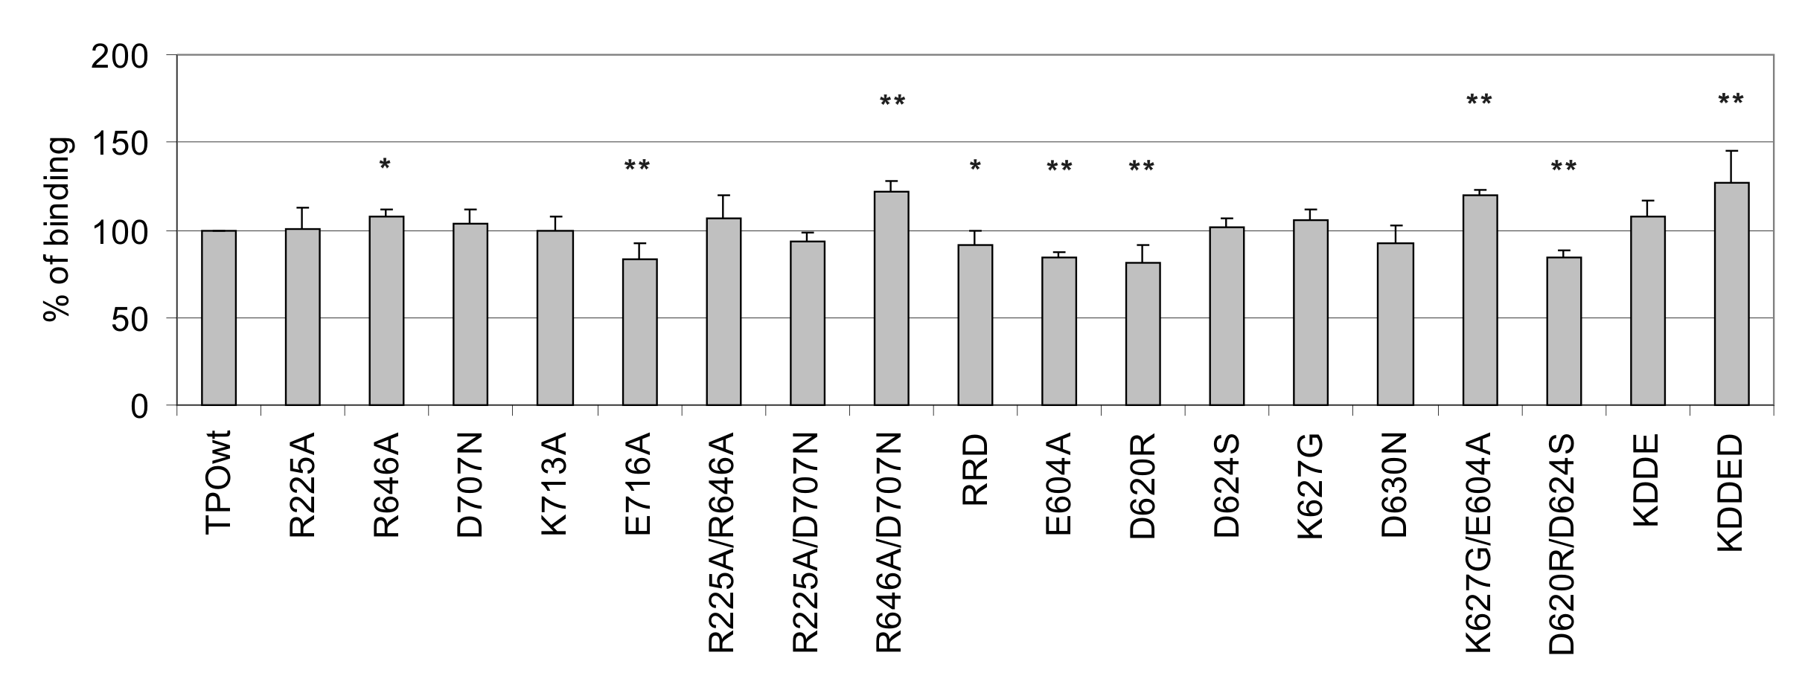

Figure 2.

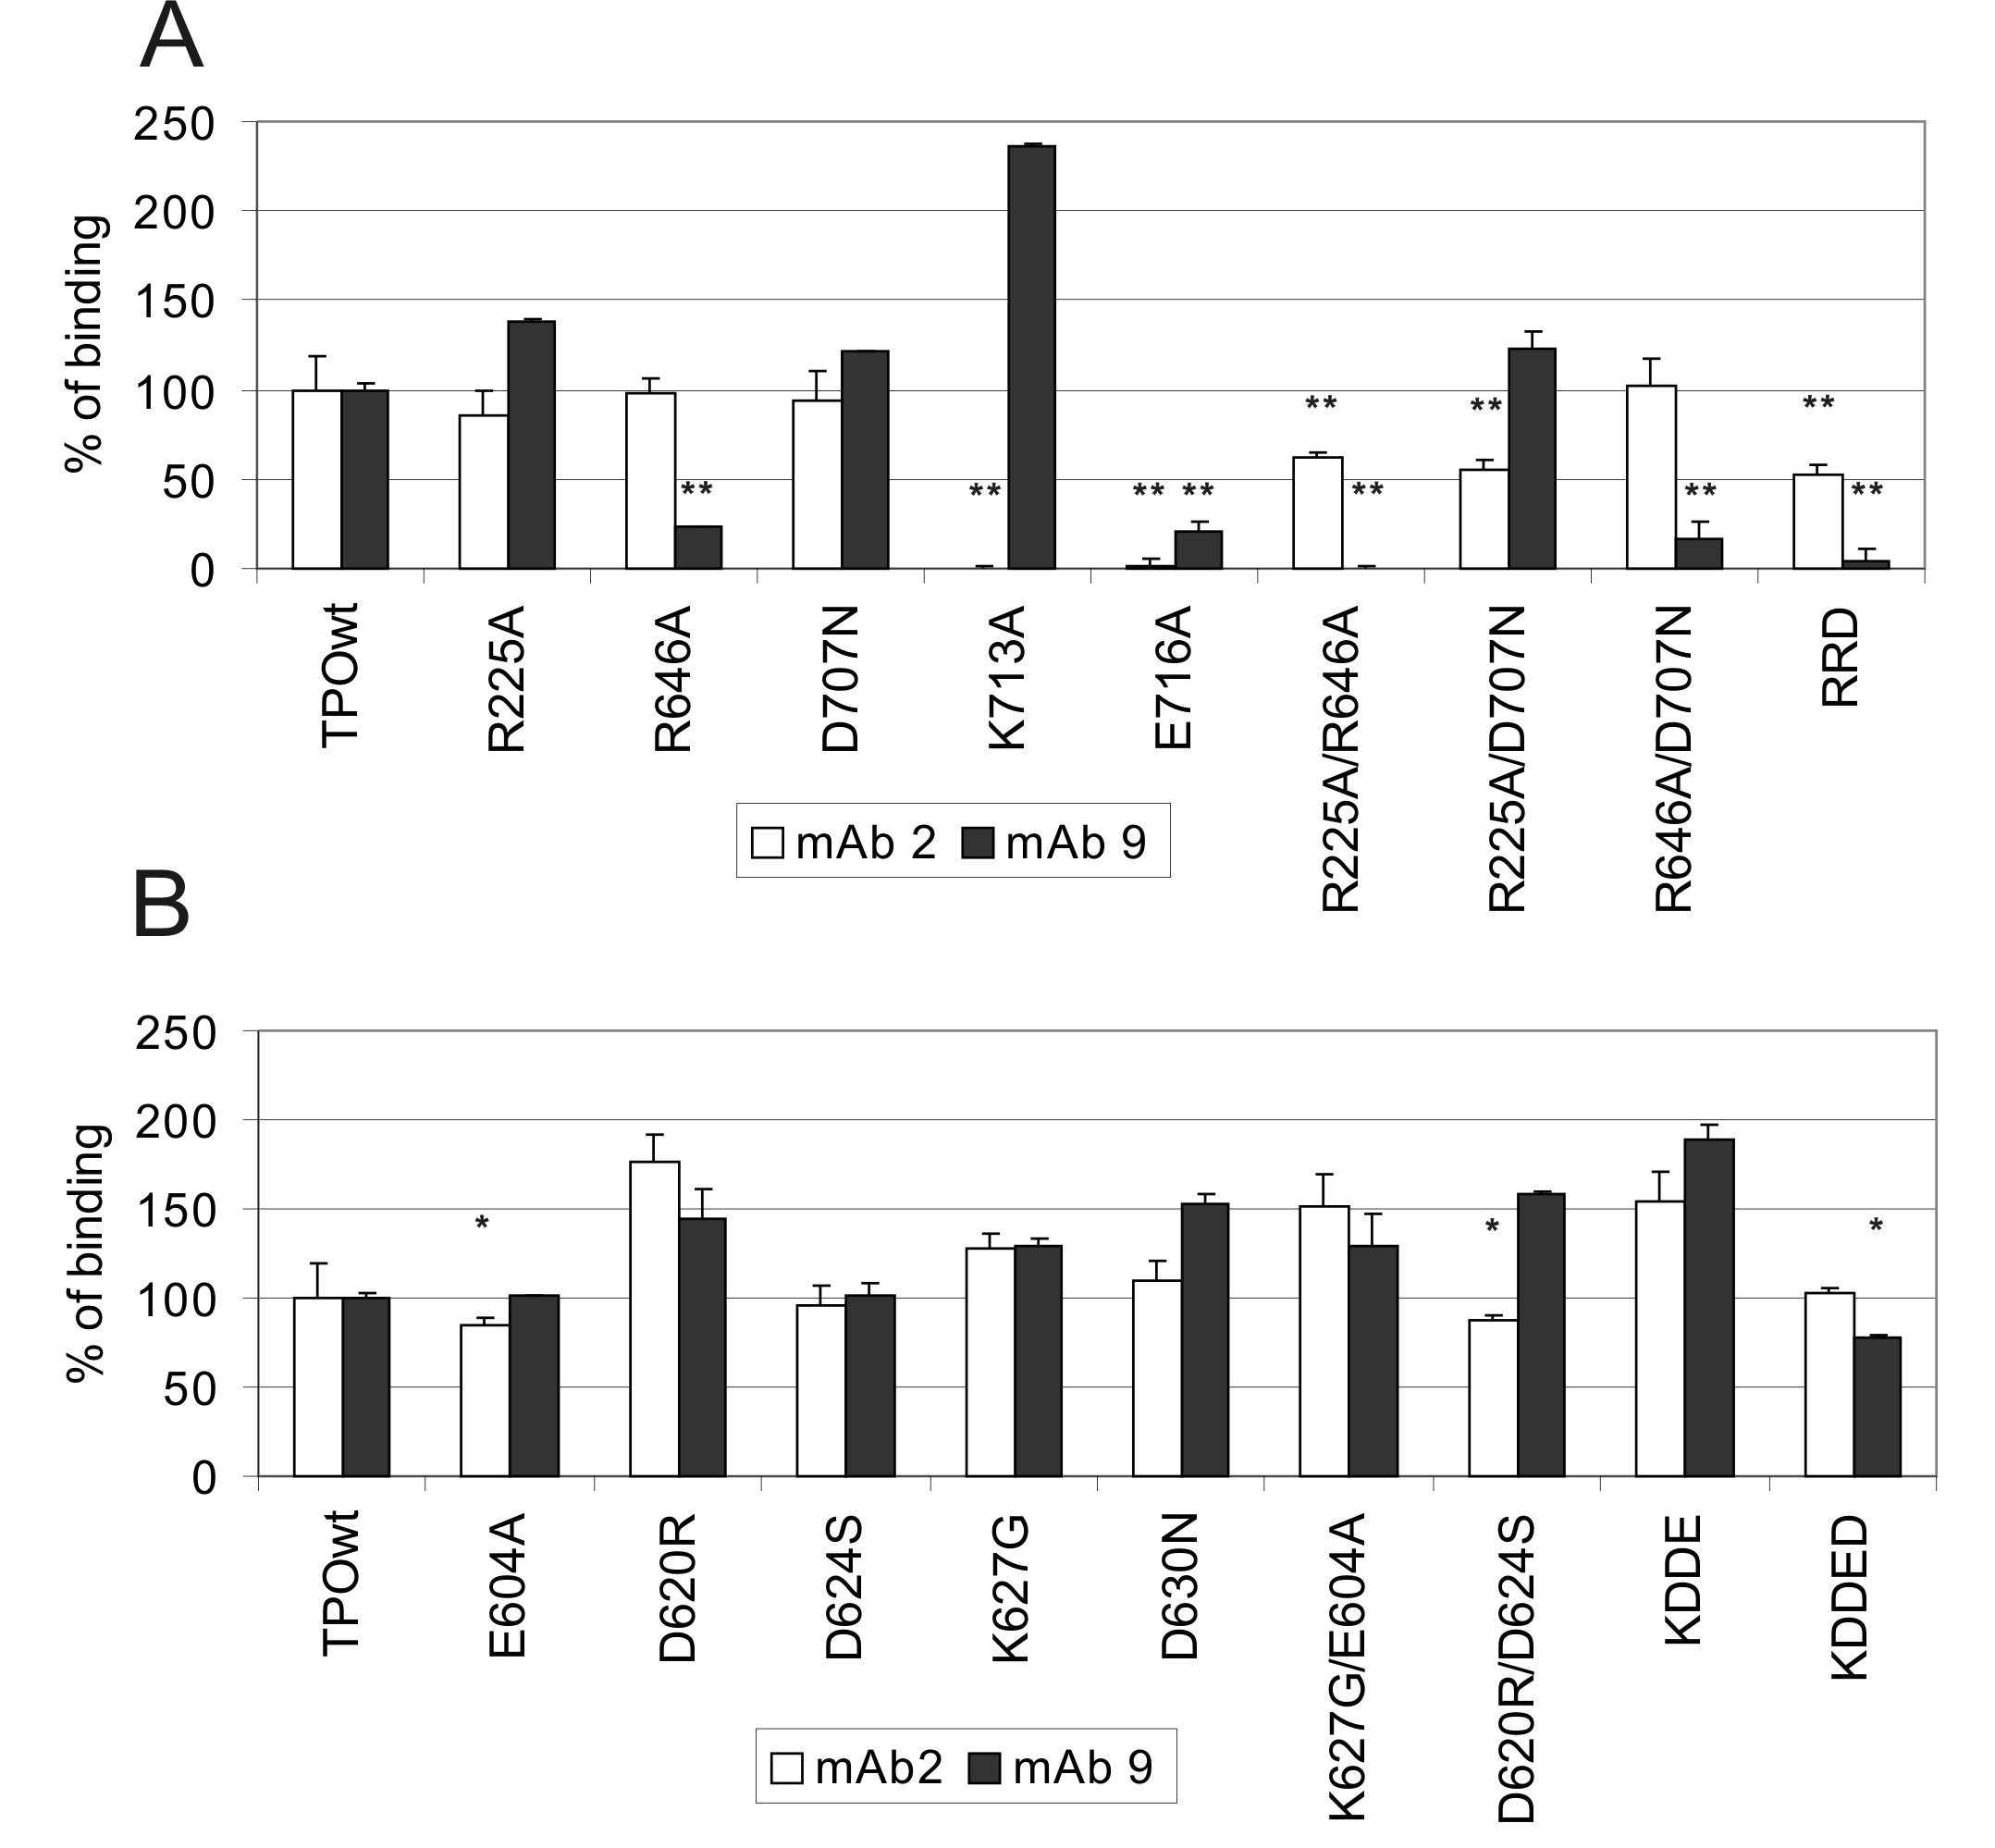
Figure 3.

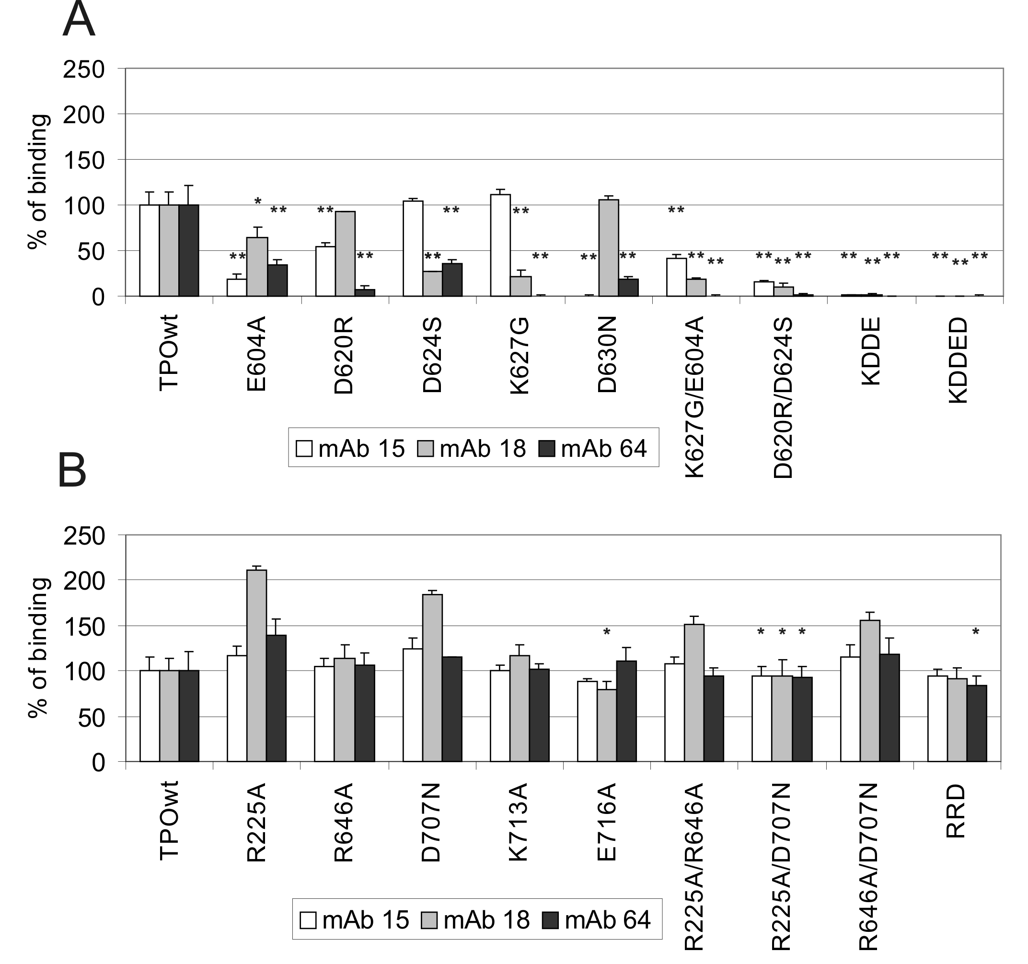
Figure 4.
