Role of damage-specific DNA polymerases in M13 phage mutagenesis
induced by a major lipid peroxidation product trans-4-hydroxy-2-nonenal

Beata Janowska¹, Dagmara Kurpios-Piec², Paulina Prorok³, Grzegorz Szparecki⁴, Marek
Komisarski¹, Paweł Kowalczyk⁵, Celina Janion¹, Barbara Tudek^{1,3 *}

¹ Institute of Biochemistry and Biophysics, Polish Academy of Sciences, Pawińskiego 5a, 02-
106 Warsaw, Poland;
² Department of Biochemistry, Medical University of Warsaw, Banacha 1, 02-097 Warsaw, Poland;
³ Institute of Genetics and Biotechnology, Warsaw University, Pawińskiego 5a, 02-106
Warsaw, Poland.
⁴ Medical University of Warsaw, Zwirki i Wigury 61, 02-097 Warsaw, Poland.
⁵ Interdisciplinary Centre for Mathematical and Computational Modelling, Warsaw University, Pawińskiego 5a, 02-106 Warsaw, Poland.

*Corresponding author: Barbara Tudek,
Institute of Biochemistry and Biophysics,
Polish Academy of Sciences,
Pawińskiego 5a,
02-106 Warsaw, Poland
tel: (+4822) 592-3334; fax: (+4822) 592-2190
e-mail: tudek@ibb.waw.pl

Key words: trans-4-hydroxy-2-nonenal; HNE-DNA adducts; mutations; NER, DNA repair;
M13 phage, SOS-dependent mutations; Pol II, Pol IV and Pol V
Abbreviations: EH, 2,3-epoxy-4-hydroxynonanal; HNE, trans-4-hydroxy-2-nonenal; IPTG,
isopropyl-β -D-thiogalactopyranoside; LPO, lipid peroxidation; MMS, methyl
methanesulfonate; ONPG, o-nitrophenyl-β -D-galactoside; Pol II, DNA polymerase II; Pol IV,
DNA polymerase IV; Pol V, DNA polymerase V; X-gal, 5-bromo-4-chloro-3-indolyl-β-D-galactoside.

Abstract

One of the major lipid peroxidation products trans-4-hydroxy-2-nonenal (HNE), forms
cyclic propano- or ethenoadducts bearing six- or seven-carbon atom side chains to
G>C>>A>T. To specify the role of SOS DNA polymerases in HNE-induced mutations, we
tested survival and mutation spectra in the lacZα gene of M13mp18 phage, whose DNA was
treated in vitro with HNE, and which was grown in uvrA⁻ E. coli strains, carrying one, two or
all three SOS DNA polymerases. When Pol IV was the only DNA SOS polymerase in the bacterial
host, survival of HNE-treated M13 DNA was similar to, but mutation frequency was lower
than in the strain containing all SOS DNA polymerases. When only Pol II or Pol V were
present in host bacteria, phage survival decreased dramatically. Simultaneously, mutation frequency was substantially increased, but exclusively in the strain carrying only Pol V, suggesting that induction of mutations by HNE is mainly dependent on Pol V. To determine the role of Pol II and Pol IV in HNE induced mutagenesis, Pol II or Pol IV were expressed together with Pol V. This resulted in decrease of mutation frequency, suggesting that both enzymes can compete with Pol V, and bypass HNE-DNA adducts in an error-free manner. However, HNE-DNA adducts were easily bypassed by Pol IV and only infrequently by Pol II.
Mutation spectrum established for strains expressing only Pol V, showed that in uvrA⁻ bacteria the frequency of base substitutions and recombination increased in relation to NER proficient strains, particularly mutations at adenine sites. Among base substitutions A:T → C:G, A:T → G:C, G:C → A:T and G:C → T:A prevailed.
The results suggest that Pol V can infrequently bypass HNE-DNA adducts inducing mutations at G, C and A sites, while bypass by Pol IV and Pol II is error-free, but for Pol II infrequent.

1. Introduction
Mutations are the main source of variability. Research on mutations provided much information on the mechanisms of gene expression and functioning of cells. By modification
of DNA, several endogenous and exogenous chemicals may decrease the survival of cells and
increase mutation frequency; they are also potentially carcinogenic.
Trans-4-hydroxy-2-nonenal (HNE) is a major product of membrane lipid peroxidation, which forms adducts to DNA bases. These adducts show strong mutagenic, potentially carcinogenic and lethal properties [1,2]. In humans HNE contributes to several pathologies, e.g. inducing apoptosis in the neuronal cells. Neuronal apoptosis may occur in stroke and in Alzheimer and Huntington diseases [3]. Hence, HNE is of appreciable medical interest.
HNE forms adducts to all four DNA bases, prevailingly to G and C, less efficiently to A and very infrequently to T [4,5]. These are cyclic propano- or ethenoadducts bearing six- or seven-carbon atom side chains [5,6]. In oxidizing conditions HNE may also form small amounts of unsubstituted etheno-DNA adducts, however the available data from in vitro studies are not consistent. Chen and Chung [7] demonstrated that under oxidizing conditions the ratio of unsubstituted to substituted ethenoadenine is 6:100, of unsubstituted to substituted guanine equals 24:100, and the number of unsubstituted ethenoadducts is significantly decreased under nitrogen. However, our previous in vitro studies showed that in oxidizing conditions only guanine yielded unsubstituted 1,N²-εdG, and only in the amount of 1-2 % of modified dG [5]. Unsubstituted ethenoadducts are formed from unsaturated fatty acids in animals and humans [8], however the exact pathway of their formation is not clear. One suggested possibility of 1,N²-εdG formation is from HNE precursor, 4-hydroperoxy-2-nonenal (HPNE) [9]. HNE- DNA adducts might also form DNA-DNA or DNA-protein crosslinks [1]. HNE strongly decreases survival of cells, being more cytotoxic than mutagenic. HNE-DNA adducts block DNA synthesis and mRNA transcription in vitro and in extracts of human cells [10]. They also induce the SOS response in S. typhimurium [11] and trigger mutations in phages, bacteria, and human cells [12]. It has been shown that HNE-guanine adducts in DNA are recognized by bacterial and mammalian nucleotide excision repair (NER) system [13,14]. They are preferentially removed from the transcribed strand by transcription coupled repair [4,10], and also from the whole genome by the global genome repair system [4]. Unsubstituted etheno-DNA adducts are repaired by base excision repair [15] and by oxidative demethylases of AlkB family [16,17].
In this work we are testing the survival and mutations in the lacZα gene induced by HNE in M13mp18 phage DNA grown in various E. coli K12 host strains, proficient or deficient in NER (uvrA) as well as in SOS DNA polymerases, Pol II, Pol IV and PolV induced in response to DNA damaging agents. In E. coli the SOS system consists of about 50 genes encoding proteins involved in DNA repair, replication, metabolism and mutagenesis, which improve the repair and integrity of damaged DNA [18].
In E. coli five DNA polymerases, Pol I – Pol V, are engaged in maintaining correct DNA structure. Two of them are engaged in replication: Pol III, the main replicative DNA polymerase, which in the form of Pol III holoenzyme synthesizes DNA in the most faithful and processive way, and Pol I, which excises primers and fills gaps enabling Okazaki fragments to mature. In addition, Pol I participates in DNA repair. Their expression is constitutive. There are also three DNA polymerases expressed in response to DNA damage as part of the SOS response, Pol II (polB), Pol IV (dinB) and Pol V (umuDC). SOS-response DNA polymerases replicate DNA less faithfully, and with lower processivity, which is improved by interaction with the β-clamp, the processivity factor of Pol III [19-21]. These polymerases have the ability to bypass DNA lesions faithfully or introducing incorrect nucleotides. Both modes make bacteria more resistant to genotoxic treatments, but the error-prone bypass of lesions results in the induction of mutations [22]. Only 10-20 molecules of Pol III and 400 molecules of Pol I are synthesized per cell. At the same time the level of SOS DNA polymerases varies and may appreciably exceed that of the replicative enzymes. Both Pol II and Pol IV are synthesized in the SOS non-induced cells in substantial amounts. The ratio of the number of SOS DNA polymerase molecules in SOS-uninduced cells in comparison to that in SOS-induced cells is as follows: 40:330 for Pol II [23], 250:2500 for Pol IV [24], and undetectable level, calculated as maximum 15 Pol V molecules in uninduced cell to about 60 - 200 molecules of Pol V in induced cell [25,26]. Pol V is the major error prone and probably the only mutagenic protein, which requires induction of the SOS response in order to be expressed within the cell [18,21]. However, other SOS DNA polymerases are also important in induction of mutations. Pol IV contributes to mutations during stationary phase, or when overexpressed, and Pol II contributes to mutations in response to specific mutagens, like 2-acetylaminofluorene [27]. Pol II is the only SOS DNA polymerase that possesses a 3’→5’ exonuclease proofreading activity and is the least error-prone [28,29]; probably due to this fact its role is the recovery of replication forks when they collapse. Pol II is induced at the earliest stage of the SOS response, whereas Pol V is induced at the latest one [30]. It was established that while some lesions require Pol V DNA polymerase in order to produce mutations, others do not [25]. The most mutagenic lesions requiring Pol V are induced by UV radiation: TT-cis-syn cyclobutane dimers and CT or TT (6-4) photoproducts [31], as well as abasic sites. However, whether and which mutagenic DNA polymerase is required for a mutation to occur depends on the type of the lesion and the surrounding sequences [32].
Here we show that HNE-DNA adducts in E. coli cells are bypassed efficiently and in an faithfully by DNA polymerase IV. On the other hand, HNE-DNA adducts form a strong barrier for Pol V and the enzyme induces several types of mutations on HNE-damaged templates. They include base substitutions and frameshifts, mainly at guanine, cytosine and adenine sites in the template, as well as deletions. The presence of Pol IV or Pol II together with Pol V significantly decreases the frequency of mutations in HNE-adducted DNA, suggesting that both Pol IV and Pol II may substitute for Pol V and provide faithful DNA synthesis. Such competition among SOS DNA polymerases in the access to HNE-DNA adducts may explain the relatively low mutagenic activity of HNE in bacteria.

2. Materials and Methods

2.1. Oligonucleotides and substrates
HNE was synthesized in the form of dimethylacetal derivative according to Chandra and Srivastava [33]. Prior to use, the dimethylacetal of HNE was hydrolyzed to aldehyde by incubation in 0.01 M HCl in a methanol-water solution (2:1) at 37 °C for 1 h and neutralized with 1.5 M triethylammonium bicarbonate (TEAB) buffer pH 5.5. The BT3 primer used in this study for sequencing of the lacZα gene, 5’-TCG CCATTC AGG CTG CG-3’, was synthesized according to standard procedures using an Applied Biosystems synthesizer (Oligonucleotide Synthesis Laboratory, IBB PAS, Warsaw, Poland). X-gal was from POCH (Gliwice, Poland) and IPTG from Promega (Madison, WI, USA).

2.2. Bacteria, phages and media
Characteristics of host bacterial strains used and M13 phage are given in Table 1. Medium and plates used for bacterial growth and M13 phage transfection were as described elsewhere [14]. To construct new bacterial strains bacteria were routinely transformed with the P1vir phage bearing the desired gene [34]. To verify the correctness of construction, the frequency of Rif^{S}→Rif^{R} mutations was checked in bacteria. It was possible due to the fact that deletion of SOS DNA polymerases affects the frequency of MMS-induced mutations (decreases in Pol IV and Pol V mutants, and increases in Pol II mutants).
M13 mp18 phage DNA contains an operator, promoter and fragments of the N-terminal part of the lacZ sequence (lacZα) encoding β-galactosidase. Its C-terminal part (with operator and promoter) encoding the 146 amino acid part of the lacZ gene (lacZβ ) is situated on the F' episome of the derivatives of JM105 host bacterial strain. These fragments restore β - galactosidase activity by α-complementation. Hence, by sequencing the M13mp18 phage the forward mutations in lacZα fragment occurring by point or frameshift mutations or by RecA-mediated recombination are detected [35].

2.3. Modification of phage DNA

M13mp18 phage was grown in E. coli strain JM105 in 2YT medium overnight at 37 °C
(Table 1) [35]. Double-stranded phage DNA was isolated from bacteria by the alkaline lysis method [36]. M13 phage dsDNA was incubated with 10, 15, 20, 30, 50 and 100 mM HNE at cacodylate buffer pH 5.5 for 48 h, at 37 °C. For each HNE concentration, as well as for control untreated DNA, 20 μg of phage DNA in a total volume of 100 μl was used. Subsequently, the DNA was precipitated with ethanol and re-suspended in 100 μl of sterile water.

2.4. Preparation of competent cells and transformation
Bacteria were made competent by the CaCl2 method [36]. Transfection was performed according to Sambrook et al. [36]. Phage DNA (100 ng) was used to transfect 100 μl of competent cells. Transfection mixtures were plated on LB solid medium with 3 ml of LB soft agar supplemented with 0.4 mM IPTG and 0.5 mg/ml X-gal. Plates were incubated overnight at 37 °C and phage plaques were scored.

2.5. Collecting lacZα mutants and their sequencing
M13 lacZα mutants lacking α-complementation and exhibiting low or no β-galactosidase activity were recognized as colorless or light blue plaques on LB plates containing IPTG and X-gal. For each bacterial strain used, from 10 000 to 30 000 plaques were analyzed, and 30 - 70 individual mutant phages were isolated only from plates with 100 mM HNE. Mutated phages were purified by 2-3 passages of each plaque and their phenotype was verified by mixing with the wild type phage and plating together. The frequency of mutations was determined by the ratio of colorless or light blue plaques to all plaques formed after transfection with phage DNA modified with a defined HNE concentration. DNA of mutated phages was isolated and sequenced by the Laboratory of Sequencing and Oligonucleotide Synthesis, IBB PAS. A specific 19 nucleotide primer (BT3) annealing at base positions for amino acids 71-78 of the lacZα gene of the M13 "+" strand was used for DNA sequencing. To ensure that mutants were not derived from expansion of clones, eight independent HNE modifications of the phage DNA were performed. Only one transformation was done after each DNA modification, and transformation mixtures were plated onto 4 plates. Usually only one mutant was picked from each plate (three at maximum).

2.6. Observation of bacterial cell filamentation by fluorescence microscopy
Bacterial filamentation is observed in response to a defect in completing replication upon exposure of bacteria to various stresses. Filamentous cells are characterized by their elongated shape, which can be detected by fluorescence microscopy. To the exponentially growing JM105 cells either HNE (2 mM final concentration) or MMS (20 mM final concentration) was added. In control cultures HNE was substituted with water. Samples were incubated at 37 °C with shaking (200 rpm) for 20 min. Subsequently cells were washed with MgSO4 (in order to remove the mutagenic compound) and further incubated in fresh medium for 2 h. Then, cells were centrifuged (Beckman J2-21M/E) and re-suspended in 0.9 % NaCl (10 μl) and microscope slides, fixed with methanol were prepared. Bacteria were stained with acridine orange (2 ng/ml) and analyzed under fluorescent microscope at 520 nm.

2.7. β -Galactosidase assay
The level of SOS induction was investigated in E. coli AB1157 strain bearing plasmid
pSK1002. The pSK1002 plasmid possesses lacZ gene coding for β -galactosidase under the control of umuC promoter regulated by the LexA repressor. When the SOS system is induced, the LexA protein is cleaved and β -galactosidase is expressed. The activity of β -galactosidase was determined by hydrolyzing the artificial substrate ONPG to galactose and yellow-colored
o-nitrophenol (at pH>7), which can be measured spectrophotometrically at 420 nm, as described by Quillardet and Hofnung [37]. Briefly, the SOS response was induced by addition to exponentially growing cells of HNE (3 mM final concentration) or MMS (20 mM final concentration). The control was prepared without mutagenic compound. Treatment of bacteria was performed for 20 min at 37°C with shaking, and then the cultures were centrifuged and washed with MgSO4. The cell pellet was re-suspended in colorless TGA medium and incubated for up to 3 h. β-galactosidase activity was analyzed directly after HNE or MMS removal and following incubation at 37 °C for 1, 2 or 3 h. Units of the β -galactosidase were calculated using the following equation:

OD420 and OD550 were read from the reaction mixture
OD600 reflected the cell density before the measurements
t – time of the reaction in min
υ – volume of culture used in the assay, in ml

Additionally, the survival of bacteria was measured at the same time as β - galactosidase by plating diluted cultures on LB solid media. The results were expressed as the response factor (RF), which represented the number of β -galactosidase units per 10⁶ of surviving bacteria. The level of the SOS induction is presented as the induction factor (IF), which was calculated by division of the RF in cells treated with genotoxins by the RF of the appropriate control.

2.8. Expression of TLS-pathway genes (dinB, polB and umuC)
Expression of TLS pathway genes was assayed by quantification of mRNA level of dinB, polB and umuC genes using Real Time-PCR method. TLS-pathway genes mRNA level was measured in JM105 strain of E. coli. Overnight cultures of JM105 strain were diluted (1:50) in fresh LB medium and incubated at 37 °C with vigorous shaking until the bacterial density reached an OD₆₀₀ of 0.4-0.6 (2-5 x 10⁸ cells/ml). Then E. coli cells were incubated for 20 minutes with HNE (final concentrations were 1 mM, 2 mM and 4 mM) or MMS (final concentrations were 20, 30 and 60 mM). The control was prepared without mutagenic compound. RNA was isolated following 2 hours incubation in fresh LB medium. Bacteria were centrifuged at 4000 rpm, for 5 min (Beckman J2-21M/E). The pellet was re-suspended in 1 ml of TRIzol reagent.

2.8.1. RNA extraction
Total RNA was isolated from E. coli strains using a TRIzol reagent from Invitrogen [38], according to the manufacturer’s recommendations. The quality of RNA was checked by a formaldehyde-agarose gel electrophoresis and concentration was assayed spectrophotometrically at 260 nm using NanoDrop 1000 (Thermo Scientific).

2.8.2. cDNA synthesis
1 μg of total RNA from each sample was used to synthesize cDNA using ImProm-IITM Reverse Transcription System kit (Promega) with random primers, according to the manufacturer’s protocol. 1 μg of total RNA was used as starting material. Concentration of cDNA was assayed spectrophotometrically at 260 nm using NanoDrop 1000.

2.8.3. Real-time PCR using SYBR-Green chemistry

Real-time PCR assays were carried out on the Applied Biosystems 7500 apparatus. Each reaction was carried out in 25 µl mixture containing: 1x Taq polymerase buffer (without MgCl₂), 3 mM MgCl₂, 0.01 % Tween 20, 0.8 % glycerol, 5 % DMSO, 0.5 ng/μl acetylated BSA, dATP, dCTP, dGTP and dTTP – 400 μM each, 1x concentrated reference dye ROX, 1:40000 diluted SYBR Green, 0.625 U of Taq polymerase, forward and reverse primers 400 μM each, and cDNA template in various amounts. The sequences of primers are given in Table 2. Time-temperature program was as follows: 95 ºC 3 minutes as initial denaturation step followed by 45 cycles consisting of denaturation step at 95 ºC for 15 sec, primers annealing at 60 ºC for 15 sec and extension step at 72 ºC for 1 minute. Fluorescence was read during extension step of each cycle. Analysis of melting-point temperature was performed in the range of 60 ºC to 95 ºC with temperature increments of 0.33 ºC. Background range and threshold for C_{t} evaluation in each experiment were adjusted manually.
For each cDNA sample four reactions were carried out using two template amounts 10 and 40 ng, each in duplicate. Evaluation of the quality of results was based on expected C_{t} differences between two cDNA amounts, as well as on products melting curves. Rare outlying results were omitted from calculations. For each gene the amounts of cDNA were chosen individually (if possible the same for all genes) to obtain C_{t} values in the range between 14 and 34 cycles.
For each reaction the apparent amount of template was calculated using efficiency (E) of appropriate primers pair and C_{t} using formula: $N_{\text{app}}={\left(1+E\right)}^{−\text{Ct}}$. All values obtained were normalized to one cDNA amount. Resulting numbers for each gene assay were averaged, and the expression was calculated as a ratio between ${\overline{N}}_{\text{app}}$ for the studied gene and ${\overline{N}}_{\text{app}}$ for the reference gene, 16SrRNA.

2.9. Statistical analysis
All data are presented as means ±SD. The STATISTICA (version 5.1) software (Stat Soft, Inc., Tulsa) was used for the statistical analysis. All parameters were tested for normal distribution with the Shapiro-Wilk and Kolmogorov-Smirnov with Lillefors correction tests. The homogeneity of variances was evaluated by the Leven test. Differences among strains were evaluated using ANOVA and Tukey’s HDS test as the post hoc one. Statistical significance was considered at P < 0.05.

3. Results
3.1. Induction of the SOS response in E. coli by HNE-DNA lesions
The ability of HNE to induce the SOS response was tested by three methods: (i) by observation of the filamentation of JM105 E. coli strain (host cells for M 13 phages) in the fluorescence microscope when bacteria were grown in the absence or presence of 2 mM HNE and 20 mM MMS (Fig. S1), (ii) by using the AB1157/pSK1002 strain bearing a plasmid containing umuC’:: lacZ fusion, which enables to quantify β-galactosidase activity in response to DNA damaging agents, and thus to measure the potency of the SOS system induction (Fig. 1), (iii) by measuring mRNA induction of SOS DNA polymerases by Real Time PCR (Fig. 2). Cells treated with standard SOS inducer, methyl methane sulphonate (MMS), and similarly with HNE (Fig. S1B and S1C) showed characteristic elongated filamentous bacterial forms, indicating induction of the SOS response. By measuring β-galactosidase expression, we also attempted to quantify SOS induction by HNE and MMS. One hour after incubation of bacteria with 3 mM HNE for 20 min, β-galactosidase activity increased about 10-fold (Fig. 1). Two hours following HNE treatment the level of β-galactosidase still increased by about 30% of the activity observed after 1 h, and remained at the same level 3 h following HNE removal from cell culture (Fig. 1). Incubation of bacteria with MMS for 20 min significantly induced β-galactosidase, 30-fold in 1 hour after MMS removal from cell culture, 72-fold in 2 h, and 48-fold in 3 h (Fig. 1). MMS appeared to be less toxic than HNE since after exposure to MMS the growth of bacteria was also inhibited in relation to control untreated bacteria, but to a much lower extent than after HNE treatment (Fig. S2, supplementary materials).
Using quantitative PCR we also investigated the level of mRNA transcription of the SOS DNA polymerases induced by HNE and control SOS inducer MMS. mRNA level was measured after 20 min of the incubation of JM105 E. coli strain with HNE or MMS, and next 2 hours of incubation in fresh LB medium in order to express SOS response.
In JM105 E. coli strain 2 mM HNE increased mRNA level in the following manner: 5.34 times for DNA polymerase IV, 1.66 times for Pol II and 1.52 times for Pol V. 4 mM HNE increased mRNA level as follows: 11.76 times for Pol IV, 10.26 times for Pol II and 7.1 times for Pol V (Fig. 2A). MMS at 40 mM concentration increased mRNA level as follows: 6.7 times of Pol IV, 3.12 times of Pol II and 3.4 times of Pol V. 60 mM MMS increased mRNA level as follows: 12.3 times for Pol IV, 3.6 times for Pol II and 6 times for Pol V (Fig. 2B).

3.2 Effect of SOS dependent mutagenic DNA polymerases in host bacteria on survival
and lacZα mutations in HNE-induced dsDNA M13 phages
To estimate the role of error prone DNA polymerases in survival and mutagenesis induced by HNE-DNA adducts, we monitored survival and mutation frequency in the lacZα gene of M13 phages, whose DNA was modified in vitro with HNE and which were subsequently grown in E. coli host strains defective in nucleotide excision repair (uvrA⁻), and possessing either one, or two or all three SOS DNA polymerases, II, IV and V (see Table 1). Modification of double stranded M13 phage DNA with HNE resulted in a decrease in phage survival (Fig. 3) and increase in mutation frequency of the lacZα gene of M13 phage (Fig. 4). Lack of NER in the host bacteria (BH430 strain) caused a substantial decrease in HNE-modified phage survival in comparison to that in the wild type E. coli strain (JM105, P < 0.0001, Fig. 3). Additional deficiency of SOS DNA polymerases also affected the growth of the phage, although to a different extent. When only DNA polymerase IV was present in UvrA deficient bacterial host (BJ10 - BH430 polB⁻ umuDC⁻), the survival of HNE-modified phage was similar to that in uvrA- strain containing all three SOS DNA polymerases (BH430, P=0.41, Fig. 3A). However, HNE-DNA adducts formed a strong barrier for Pol II and Pol V since in UvrA deficient bacterial hosts, which in addition to replicative DNA polymerases carried only Pol II or Pol V, phage survival was again substantially lower than that in uvrA- strain containing all three SOS DNA polymerases (BJ9 - BH430 dinB⁻ umuDC⁻ vs BH430, P < 0.0001; BJ8 - BH430 dinB⁻ polB⁻ vs BH430, P < 0.0001, Fig. 3A). When, however, Pol IV was present together with replicative DNA polymerases and Pol II or Pol V, the survival of HNE-modified phage was similar to that when all three SOS DNA polymerases were active in NER-deficient bacterial host (BJ7 - BH430 umuDC⁻ vs BH430, P=0.0505; (BJ6 - BH430 polB⁻, vs BH430, P=0.051, Fig. 3B). When Pol II and Pol V were simultaneously active in bacterial host strain, no amelioration of phage survival was observed in comparison to when only one of these DNA polymerases was present in bacteria (BH430 dinB⁻ vs BH430, P = 0.0002 and BH430 dinB⁻ vs BH430 dinB⁻ umuDC⁻ or BH430 dinB⁻ polB⁻, P < 0.0001, Fig. 3A and B). This might suggest that Pol IV may bypass HNE-DNA adducts in E. coli, whereas Pol II and Pol V are blocked by HNE-DNA adducts.
Mutation frequency in the lacZα gene of M13mp18 phage was increased upon the treatment of phage DNA with HNE, and was dependent on the presence of SOS DNA polymerases (Fig. 4 A, B). The highest mutation rate in the lacZα gene of M13mp18 was observed when phage DNA was propagated in bacterial host expressing replicative DNA polymerases and only Pol V (BJ8 - BH430 dinB- polB-, Fig. 4). The presence of only Pol II resulted in lowering of the mutation frequency below the level observed when all SOS DNA polymerases were active in bacteria (BH430 dinB⁻ umuDC⁻ vs BH430, P = 0.019), while the presence of only Pol IV caused mutation frequencies similar to those observed when all SOS DNA polymerases were active (BH430 polB⁻ umuDC⁻ vs BH430, P=0,4115, Fig. 4). However, simultaneous expression of Pol V and Pol IV in bacterial host or of Pol V and Pol II significantly decreased the mutation rate in the lacZα gene of M13 phage modified with HNE in comparison to the mutation frequency in the strain expressing only Pol V (BJ6 - BH430 polB⁻ vs BJ8 - BH430 dinB⁻ polB⁻, P < 0.0001 and BJ5 - BH430 dinB⁻ vs BJ8 - BH430 dinB⁻ polB⁻, P < 0.0001, Fig. 4). This suggests that Pol V is responsible for the majority of mutations induced by HNE in Escherichia coli. In contrast, Pol IV may bypass HNE-DNA adducts in an error-free manner, and Pol II also limits the mutagenic activity of Pol V.

3.3. Spectrum of mutations in the lacZα gene of M13mp18 phage DNA induced by HNE
Mutants in the lacZα gene of M13mp18 phage, obtained after treatment of phage DNA with 100 mM HNE were collected from UvrA proficient and deficient bacterial hosts, which expressed only one of SOS DNA polymerases, Pol V. This was due to the fact that only in strains expressing exclusively Pol V, mutation frequency increased above the level observed in strains carrying all three DNA polymerases. Thus, the probability that M13 mutants arising in this strain were due to HNE-DNA adducts bypassed by Pol V was high. Mutants were sequenced, and the results of analyses are summarized in Table 3, as well as in Figs. 5 and 6. Sequencing of mutants aimed to verify if bypass of HNE-DNA adducts by Pol V is error-prone, and to reveal which HNE-DNA lesions are repaired by the NER system. The major type of spontaneous mutations in the wild type JM105 were base substitutions (61.3 % of all mutations), and in the phage DNA deriving from one plaque only one mutation was found. In 24 % of M13 mutants grown in BJ11 - JM105 dinB- polB-, and in 21.4 % grown in BJ8 – BH430 dinB- polB-, two or three mutations were found in the M13 phage DNA isolated from one plaque (Figs. 5 and 6). This might suggest that HNE-DNA adducts are strongly mutagenic for Pol V in E. coli. A large fraction of all mutations were deletions. They constituted 29 % of spontaneous mutations in wild type JM105 strain, and among HNE induced mutations 39 % in JM105 dinB -polB- and 43.1 % in BH430 dinB- polB- mutant, (Table 3). The most frequent deletion occurred in the polylinker region (30.6 % for JM105 dinB- polB-, with mutation frequency, MF=169.5 x 10⁻⁵ and 15.7 % for BH430 dinB⁻ polB-, with mutation frequency, MF=103.2 x 10⁻⁵). Also 4-14 - fold increase of MF of double deletions of 93 and 54 nucleotides,
accompanied by A→G substitution in EcoR1 site, was found in the above mentioned strains in relation to spontaneous mutations in the wild type JM105 strain (Table 3). Simultaneous deletion of 93 and 54 nucleotides, and additional A→G substitution in EcoR1 site in M13mp18 phage system was shown to derive from recombination between phage DNA and the DNA of lacZ gene of F’ factor [39]. This might also confirm that HNE-DNA adducts constitute a strong steric hindrance for replicative DNA polymerases, but also for Pol V, and that this hindrance can be rescued by recombination.
Base substitutions and frameshift mutations were also strongly augmented in JM105 dinB- polB- (MF=107.8 x 10⁻⁵ for base substitution and MF=231 x 10⁻⁵ for frameshifts) and BH430 dinB- polB- (MF=245.1 x 10⁻⁵ for base substitution and MF=129 x 10⁻⁵ for frameshifts) strains in comparison to spontaneous mutations in the wild type JM105 E. coli strain (MF=34.2 x 10⁻⁵ for base substitution and MF=5.4 x 10⁻⁵ for frameshifts). Base substitutions and frameshift mutations were found at G, C and A loci, and much less frequently at T. Among frameshifts +C, +G and -G prevailed, and their frequency increased over an order of magnitude above the level observed in the wild type bacteria (Table 3). Two hotspots for frameshift mutations were found in the M13 lacZα gene, when the phage was grown in JM105 dinB- polB- E. coli strain (Fig. 5). Addition of one C was found within CCCC run upstream -35 promoter, and deletion of G occurred in GAGG*C sequence within ΔM15 sequence (Fig. 5). In BH430 dinB- polB- deletion of G was also found in GAGG*C sequence, although, with a low frequency (Fig. 6). This may suggest that HNE may preferably react with GAGG*C sequence. In the UvrA deficient strain only one hotspot for +A mutations was found within ΔM15 sequence (Fig. 6). The frequency of HNE induced base substitutions increased 3-fold in JM105 dinB-polB- and almost 7-fold in BH430 dinB- polB- in relation to spontaneous mutations in the wild type JM105 strain (Table. 3). In the strain JM105 dinB- polB- with an active NER system the majority of base substitutions were localized at G and C sites in M13 DNA. However, in strain BH430 dinB- polB- mutations were distributed almost equally among G, C, and A sites in the template. This suggests that although HNE makes adducts primarily to G and C, HNE adducts to A also have a strong mutagenic potential for Pol V. The increase in mutation frequency at A sites in BH430 dinB- polB- strain may also suggest that HNE adducts to adenine are efficiently repaired by bacterial UvrABC enzymes. Thymine is the least reactive base, and, consequently, very few mutations were found at T loci in the template. In BJ8 (BH430 dinB- polB-) E. coli strain, but not in BJ11 (JM105 dinB- polB-) two tandem mutations, GC → TA and CG → TC, were observed (Figs. 5 and 6). Tandem mutations might derive from DNA-DNA crosslinks, which were shown to be formed in calf thymus DNA in the amount of 1 - 2 % of 1,N²-εG adducts [40].

4. Discussion
The goal of our study was to investigate a role of SOS DNA polymerases in the survival and lacZα mutagenesis in HNE treated dsDNA of M13 phage. This DNA was propagated in various bacterial strains differing in the lack or presence of SOS DNA polymerases, II, IV, V and uvrA genes involved in the NER system. We applied the M13 phage system since it allows to avoid HNE toxicity related to protein modification, as well as to formation of DNA-protein crosslinks, which might change the spectrum of mutations, and allows to introduce a high number of HNE adducts directly to DNA molecules. M13 phage genome does not code for its own replication enzymes, so bacterial host delivers the whole replication machinery. In the rolling circle mode of M13 phage replication only one DNA strand serves as a template to produce phage progeny. Using ssDNA of M13 phage might, probably be a more sensitive tool to study the role of low fidelity DNA polymerases, since the effect of most DNA repair systems, e.g. NER, MMR, BER would be excluded due to the fact that these proteins work on dsDNA. However, we also wanted to study repair of HNE-DNA adducts by NER and recombination, which decided about the choice of the model. By sequencing of the lacZα gene in M13 phage DNA, it is possible to estimate all kinds of mutations arising in the HNE-treated phage DNA, namely, base substitutions, frameshifts, deletions, and recombinations of different length. Sequencing additionally allows to identify the sites of NER and recombinational repair.
It is widely accepted that the specificity of mutations in E. coli greatly depends on the SOS induced DNA polymerases (Pol II, IV and V). We have verified if HNE induces SOS response in E. coli, and hence induces SOS DNA polymerases. All three methods used, bacterial filamentation (Fig. S1), increase in β-galactosidase activity controlled by umuC gene promoter (Fig. 1), and the level of mRNA of Pols II, IV and V (Fig. 2) in bacteria treated with HNE, and a control compound, MMS confirmed SOS response induction in E. coli by HNE. Different degree of β-galactosidase induction by HNE and MMS (Fig. 1) might probably be caused by the lower number of lesions introduced to DNA by HNE than by MMS due to higher toxicity of HNE than MMS (Fig. S2 and the discussion in supplementary materials).
All of DNA polymerases, like the main replicative Pol III, may bypass modified DNA bases or baseless sites by translesion synthesis (TLS) with varying efficiency either faithfully or introducing incorrect nucleotides. For TLS activity every polymerase requires β-clamp processivity factor, and Pol V additionally requires RecA protein [18]. Only Pol II possesses 3’→ 5’ exonuclease activity, which can correct replicative errors. Pol IV and Pol V possess additionally AP/5’-dRP lyase activity, which is approximately 80-fold lower than the lyase activity of human DNA Pol β [41], which acts mainly in BER [42]. It is not documented whether AP/5' (-dRP) lyase activity of Pol IV or Pol V is used in BER, and participates in repair of low amount of unsubstituted ethenoadducts induced by HNE. Pol V is the main component of mutasome frequently used to induce base substitution mutations, whereas the activity of Pol II and Pol IV frequently leads to frameshift mutations, which arise by slipping on monotonous sequences [27,43].
Here we observed that polymerases II, IV and V may bypass HNE modified bases by TLS and restore DNA synthesis beyond the arrested site, although with different efficiencies. Survival experiments suggested that Pol IV could bypass HNE-DNA adducts much more efficiently than Pol II or Pol V, and when only Pol IV was present in E. coli cells, phage survival was similar to that when all SOS DNA polymerases operated on HNE-damaged DNA (Fig. 3A). Further, Pol IV seemed to replicate HNE modified DNA of M13 phage faithfully, since mutation frequency was decreased in the strain carrying Pol V and Pol IV in comparison to mutation rate in the strain carrying only Pol V (BH430polB⁻ and BH430polB⁻dinB⁻, respectively) (Fig. 4). Mutagenesis experiments also suggest that Pol II, similarly to Pol IV, bypasses HNE-DNA adducts in an error-free way, although the TLS is much less efficient for Pol II than for the Pol IV. The reason for that may be different, and has not been completely elucidated. Firstly, there is more than one HNE modified lesion in the DNA, and each of the polymerases may perhaps differ in specificity towards these lesions, as well as differs in the number of the molecules. Secondly, TLS activity and, perhaps, the ability of Pol II, IV and V to associate with the processivity β-clamp factor and RecA protein (required for more effective TLS process) may be different. This may be also limited by the number of UmuD subunits processed to UmuD'. Our data strongly suggest that in E. coli Pol IV is the main bypass DNA polymerase for HNE modified DNA, and Pol II is much less active, however it is also less abundant (2500 molecules of Pol IV and 330 of Pol II in SOS induced cells. HNE-DNA adducts constitute a strong hindrance for most known DNA polymerases, from bacteria to mammals [5,44], and our data suggest that for Pol II as well (Fig. 3). Inhibition of replication fork by the presence of DNA lesion may cause its regression and formation of the “chicken foot” structure. The role of Pol II would be to restart DNA synthesis on the template of newly synthesized daughter strand, thus avoiding the formation of mutations [45]. Alternatively, 3' → 5' exonuclease activity of Pol II may contribute to counteract the impediment caused by HNE-DNA adducts. Although this model was published, other groups failed to confirm it [46,47]. When only Pol II was present in bacteria, the mutation rate in our experiments was lower than that when all SOS DNA polymerases operated on HNE-damaged DNA, even with very low survival rates (Fig. 4). The presence of Pol II in the strain expressing also Pol V likewise lowered the mutation rate in comparison to the situation when only Pol V was expressed, although the survival rate was very low (Fig. 3B). This could support the suggestion that HNE-DNA adducts strongly block Pol II and Pol V, but not Pol IV. In E. coli DNA polymerases I, II, and III compete with Pol IV in the stressed cells [48]. If more abundant Pol II also competes with Pol V, the mechanism of regression of replication fork and its restart by Pol II on the template of daughter, undamaged strand [45] would explain lowering of the mutation rate by Pol II in the presence of Pol V. Alternatively, the proofreading activity of Pol II might correct wrongly incorporated nucleotides. Competition or cooperation of Pol IV with Pol V could also explain lowering of mutation frequency when Pol IV was active in bacteria together with Pol V. Cooperation of low-fidelity DNA polymerases in bypassing HNE-DNA adducts was observed in eukaryotic cells. Pol ι was able to incorporate correctly matched nucleotide opposite the HNE-dG adduct, although it was not able to elongate the synthesized DNA strand and fell off the template. Pol κ, in turn, could elongate the HNE-dG:C pair, which ensured further DNA synthesis [44]. In this way the HNE-dG adducts were bypassed by two damage-specific DNA polymerases in an error-free manner. If such mechanism operates also in E. coli, Pol IV which is the analogue of pol κ [49] could extend the synthesized DNA end and promote error-proof replication. Which DNA polymerase would be able to incorporate a correctly matched nucleotide opposite the HNE adducts in E. coli is, however, not clear. Since exocyclic HNE-dG adducts are linearized in dsDNA and tend to correctly pair with C [50], it is possible that suitable DNA polymerases, including replicative DNA polymerases might randomly incorporate C opposite HNE-dG adducts. HNE adducts to other DNA bases were shown to be either cyclic or linear [5], and our previous studies suggested that some of these adducts, e.g. HNE-dC adducts may not need expression of the SOS DNA polymerases to be bypassed in an error-prone manner [14].
By testing the mutagenic activity of HNE-DNA adducts, we found that Pol V is the main DNA polymerase introducing mutations on HNE-DNA adducts. The highest activity is observed when host bacteria are NER lacking, the majority of HNE-DNA lesions are not repaired, and Pol II and Pol IV are not active. This seems to confirm the mechanisms suggested above. Yet more interesting results come from the examination of the frequency and specificity of HNE-induced mutations in the lacZα gene of M13 phage. Astonishingly, when Pol IV, Pol II and NER are simultaneously lacking in E. coli, the specificity of M13 phage mutants differs greatly from that obtained in the NER proficient strain (Table 3). The frequency of base substitutions A → C, A → G and G → A in M13 phage DNA is much higher than all other base substitutions when the phage is cultured in UvrA deficient E. coli host than in proficient one. This may suggest that HNE-adenine adducts, although formed less abundantly than HNE adducts to G and C [5], have a significant mutagenic potential and are efficiently repaired by the NER system. Interestingly, two tandem mutations, GC → TA and CG → TC, were observed, albeit only in UvrA deficient bacteria (Figs. 5 and 6). The reaction of the aldehyde group of HNE adducts to DNA bases is reversible, and in dsDNA HNE-dG adducts are linearized [51]. The liberated aldehyde group can form a Schiff bond to the amino group of opposite or adjacent DNA base, forming intra- or interstrand DNA-DNA cross-link. These crosslinks were recently quantified in HNE treated calf thymus DNA in the amount of 1 - 2 % of 1,N²-εG adducts [40]. Similar tandem mutations were induced by HNE in supF gene of shuttle vector pSP189 replicated in human cells, and it was suggested that they derive from HNE-DNA cross-links [52]. Hence, it is possible that tandem mutations observed in this study derive from HNE-DNA cross-links. The fact that they were found only in UvrA deficient bacterial host may suggest that the NER system is engaged in their elimination from DNA. A large fraction of mutations were frameshifts, +C, +G, -G and less readily +A, which reflects the spectrum of modifications of different DNA bases by HNE. It is generally accepted that -1 and -2 frameshift mutations are introduced mainly by Pol II and Pol IV by slipping on specific repeated sequences (mainly GC and GA), and this slippage is elicited by a modified base. The mechanism of induction of this type of mutations was found firstly in NarI site sequence containing N²-guanine adduct of acetylaminofluorene (AAF) (GGCG ^{AAF}CCGG → GGCGGG and - CG AAF) [27,53]. This study suggests that Pol V may also slip on repeated sequences containing bulky adducts, like HNE-DNA adducts. The hotspots for frameshift mutations observed in our study involve such repeated sequences, GAGG*C sequence (Figs. 5 and 6) and CCCC run (Fig. 5). The frequency of recombinational deletion of 93 and 54 nucleotides, as well as a variety of other deletions also increased over an order of magnitude in both UvrA deficient and proficient bacteria (Table 3). Moreover, in one individual mutant of the lacZα gene, there is more than one mutation induced by HNE-DNA adduct. The phages, therefore, become hypermutated (double mutations in 21.4 % of phage progeny in BH430 dinB- polB- strain and double mutations in 14.8 % of phage progeny and triple mutations in 9% in JM105 dinB-polB- strain). This suggests that HNE-DNA adducts are difficult to bypass for DNA polymerase V, and the cell can be rescued only by recombination.
In summary, our results suggest that Pol V is the major E. coli DNA polymerase responsible for induction of mutations by HNE, among which G, C, as well as A adducts have the highest miscoding potential. Pol IV and Pol II bypass these lesions in an error-free manner, however DNA synthesis by Pol II is strongly inhibited on HNE modified template, while Pol IV is not.

Conflict of interest statement
The authors declare that there are no conflicts of interest.
Acknowledgments:
This work was supported by the grant of the Polish Ministry of Science and Higher
Education N303 328834.

References:
[1] G. Poli, R.J. Schaur, W.G. Siems and G. Leonarduzzi 4-hydroxynonenal: a membrane lipid oxidation product of medicinal interest, Med Res Rev 28 (2008) 569-631.
[2] R.J. Schaur Basic aspects of the biochemical reactivity of 4-hydroxynonenal, Mol Aspects Med 24 (2003) 149-159.
[3] K.S. Montine, P.J. Kim, S.J. Olson, W.R. Markesbery and T.J. Montine 4-hydroxy-2-nonenal pyrrole adducts in human neurodegenerative disease, J Neuropathol Exp Neurol 56 (1997) 866-871.
[4] F.L. Chung, J. Pan, S. Choudhury, R. Roy, W. Hu and M.S. Tang Formation of trans-4-hydroxy-2-nonenal- and other enal-derived cyclic DNA adducts from omega-3 and omega-6 polyunsaturated fatty acids and their roles in DNA repair and human p53 gene mutation, Mutat Res 531 (2003) 25-36.
[5] P. Kowalczyk, J.M. Ciesla, M. Komisarski, J.T. Kusmierek and B. Tudek Long-chain adducts of trans-4-hydroxy-2-nonenal to DNA bases cause recombination, base substitutions and frameshift mutations in M13 phage, Mutat Res 550 (2004) 33-48.
[6] I.G. Minko, I.D. Kozekov, T.M. Harris, C.J. Rizzo, R.S. Lloyd and M.P. Stone Chemistry and biology of DNA containing 1,N(2)-deoxyguanosine adducts of the alpha,beta-unsaturated aldehydes acrolein, crotonaldehyde, and 4-hydroxynonenal, Chem Res Toxicol 22 (2009) 759-778.
[7] H.J. Chen and F.L. Chung Formation of etheno adducts in reactions of enals via autoxidation, Chem Res Toxicol 7 (1994) 857-860.
[8] H. Bartsch and J. Nair Accumulation of lipid peroxidation-derived DNA lesions: potential lead markers for chemoprevention of inflammation-driven malignancies, Mutat Res 591 (2005) 34-44.
[9] S.H. Lee, J.A. Arora, T. Oe and I.A. Blair 4-Hydroperoxy-2-nonenal-induced formation of 1,N2-etheno-2'-deoxyguanosine adducts, Chem Res Toxicol 18 (2005) 780-786.
[10] L. Maddukuri, E. Speina, M. Christiansen, D. Dudzinska, J. Zaim, T. Obtulowicz, S. Kabaczyk, M. Komisarski, Z. Bukowy, J. Szczegielniak, A. Wojcik, J.T. Kusmierek, T. Stevnsner, V.A. Bohr and B. Tudek Cockayne syndrome group B protein is engaged in processing of DNA adducts of lipid peroxidation product trans-4-hydroxy-2-nonenal, Mutat Res 666 (2009) 23-31.
[11] M. Benamira and L.J. Marnett The lipid peroxidation product 4-hydroxynonenal is a potent inducer of the SOS response, Mutat Res 293 (1992) 1-10.
[12] H. Esterbauer, R.J. Schaur and H. Zollner Chemistry and biochemistry of 4-hydroxynonenal, malonaldehyde and related aldehydes, Free Radic Biol Med 11 (1991) 81-128.
[13] S. Choudhury, J. Pan, S. Amin, F.L. Chung and R. Roy Repair kinetics of trans-4-hydroxynonenal-induced cyclic 1,N2-propanodeoxyguanine DNA adducts by human cell nuclear extracts, Biochemistry 43 (2004) 7514-7521.
[14] B. Janowska, M. Komisarski, P. Prorok, B. Sokolowska, J. Kusmierek, C. Janion and B. Tudek Nucleotide excision repair and recombination are engaged in repair of trans-4-hydroxy-2-nonenal adducts to DNA bases in Escherichia coli, Int J Biol Sci 5 (2009) 611-620.
[15] L. Gros, A.A. Ishchenko and M. Saparbaev Enzymology of repair of etheno-adducts, Mutat Res 531 (2003) 219-229.
[16] A.M. Maciejewska, B. Sokolowska, A. Nowicki and J.T. Kusmierek The role of AlkB protein in repair of 1,N-ethenoadenine in Escherichia coli cells, Mutagenesis 26 401-406.
[17] A.M. Maciejewska, K.P. Ruszel, J. Nieminuszczy, J. Lewicka, B. Sokolowska, E. Grzesiuk and J.T. Kusmierek Chloroacetaldehyde-induced mutagenesis in Escherichia coli: the role of AlkB protein in repair of 3,N(4)-ethenocytosine and 3,N(4)-alpha-hydroxyethanocytosine, Mutat Res 684 24-34.
[18] C. Janion Inducible SOS response system of DNA repair and mutagenesis in Escherichia coli, Int J Biol Sci 4 (2008) 338-344.
[19] M.D. Sutton, J.M. Duzen and R.W. Maul Mutant forms of the Escherichia colibeta sliding clamp that distinguish between its roles in replication and DNA polymerase V-dependent translesion DNA synthesis, Mol Microbiol 55 (2005) 1751-1766.
[20] C.A. Bonner, P.T. Stukenberg, M. Rajagopalan, R. Eritja, M. O'Donnell, K. McEntee, H. Echols and M.F. Goodman Processive DNA synthesis by DNA polymerase II mediated by DNA polymerase III accessory proteins, J Biol Chem 267 (1992) 11431-11438.
[21] J.G. Bertram, L.B. Bloom, M. O'Donnell and M.F. Goodman Increased dNTP binding affinity reveals a nonprocessive role for Escherichia coli beta clamp with DNA polymerase IV, J Biol Chem 279 (2004) 33047-33050.
[22] Z. Wang, E. Lazarov, M. O'Donnell and M.F. Goodman Resolving a fidelity paradox: why Escherichia coli DNA polymerase II makes more base substitution errors in AT- compared with GC-rich DNA, J Biol Chem 277 (2002) 4446-4454.
[23] C.A. Bonner, S.K. Randall, C. Rayssiguier, M. Radman, R. Eritja, B.E. Kaplan, K. McEntee and M.F. Goodman Purification and characterization of an inducible Escherichia coli DNA polymerase capable of insertion and bypass at abasic lesions in DNA, J Biol Chem 263 (1988) 18946-18952.
[24] S.R. Kim, K. Matsui, M. Yamada, P. Gruz and T. Nohmi Roles of chromosomal and episomal dinB genes encoding DNA pol IV in targeted and untargeted mutagenesis in Escherichia coli, Mol Genet Genomics 266 (2001) 207-215.
[25] R. Woodgate and D.G. Ennis Levels of chromosomally encoded Umu proteins and requirements for in vivo UmuD cleavage, Mol Gen Genet 229 (1991) 10-16.
[26] M. Patel, Q. Jiang, R. Woodgate, M.M. Cox and M.F. Goodman A new model for SOS-induced mutagenesis: how RecA protein activates DNA polymerase V, Crit Rev Biochem Mol Biol 45 171-184.
[27] R.P. Fuchs and S. Fujii Translesion synthesis in Escherichia coli: lessons from the NarI mutation hot spot, DNA Repair (Amst) 6 (2007) 1032-1041.
[28] I. Tessman and M.A. Kennedy DNA polymerase II of Escherichia coli in the bypass of abasic sites in vivo, Genetics 136 (1994) 439-448.
[29] S. Rangarajan, G. Gudmundsson, Z. Qiu, P.L. Foster and M.F. Goodman Escherichia coli DNA polymerase II catalyzes chromosomal and episomal DNA synthesis in vivo, Proc Natl Acad Sci U S A 94 (1997) 946-951.
[30] S. Rangarajan, R. Woodgate and M.F. Goodman A phenotype for enigmatic DNA polymerase II: a pivotal role for pol II in replication restart in UV-irradiated Escherichia coli, Proc Natl Acad Sci U S A 96 (1999) 9224-9229.
[31] M. Tang, P. Pham, X. Shen, J.S. Taylor, M. O'Donnell, R. Woodgate and M.F. Goodman Roles of E. coli DNA polymerases IV and V in lesion-targeted and untargeted SOS mutagenesis, Nature 404 (2000) 1014-1018.
[32] R. Napolitano, R. Janel-Bintz, J. Wagner and R.P. Fuchs All three SOS-inducible DNA polymerases (Pol II, Pol IV and Pol V) are involved in induced mutagenesis, Embo J 19 (2000) 6259-6265.
[33] A. Chandra and S.K. Srivastava A synthesis of 4-hydroxy-2-trans-nonenal and 4-(3H) 4-hydroxy-2-trans-nonenal, Lipids 32 (1997) 779-782.
[34] H. MILLERJ, Cold Spring and . (Eds.) Experiments in Molecular Genetics., Harbor Laboratory, Cold Spring HarborN, .Y., 1972.
[35] J. Messing New M13 vectors for cloning, Methods Enzymol 101 (1983) 20-78.
[36] F. Sambrook J, EF, Maniatis T. (Ed.) Molecular Cloning: A Laboratory Manual, Cold Spring Harbor Laboratory Press, Cold Spring Harbor, 1989.
[37] P. Quillardet and M. Hofnung The SOS Chromotest, a colorimetric bacterial assay for genotoxins: procedures, Mutat Res 147 (1985) 65-78.
[38] P. Chomczynski A reagent for the single-step simultaneous isolation of RNA, DNA and proteins from cell and tissue samples, Biotechniques 15 (1993) 532-534, 536-537.
[39] T.A. Kunkel Mutational specificity of depurination, Proc Natl Acad Sci U S A 81 (1984) 1494-1498.
[40] I.D. Kozekov, R.J. Turesky, G.R. Alas, C.M. Harris, T.M. Harris and C.J. Rizzo Formation of deoxyguanosine cross-links from calf thymus DNA treated with acrolein and 4-hydroxy-2-nonenal, Chem Res Toxicol 23 1701-1713.
[41] X. Shen, R. Woodgate and M.F. Goodman Lyase activities intrinsic to Escherichia coli polymerases IV and V, DNA Repair (Amst) 4 (2005) 1368-1373.
[42] J. Yamtich and J.B. Sweasy DNA polymerase family X: function, structure, and cellular roles, Biochim Biophys Acta 1804 1136-1150.
[43] B. Tippin, S. Kobayashi, J.G. Bertram and M.F. Goodman To slip or skip, visualizing frameshift mutation dynamics for error-prone DNA polymerases, J Biol Chem 279 (2004) 45360-45368.
[44] W.T. Wolfle, R.E. Johnson, I.G. Minko, R.S. Lloyd, S. Prakash and L. Prakash Replication past a trans-4-hydroxynonenal minor-groove adduct by the sequential action of human DNA polymerases iota and kappa, Mol Cell Biol 26 (2006) 381-386.
[45] S. Rangarajan, R. Woodgate and M.F. Goodman Replication restart in UV-irradiated Escherichia coli involving pols II, III, V, PriA, RecA and RecFOR proteins, Mol Microbiol 43 (2002) 617-628.
[46] C.T. Courcelle, J.J. Belle and J. Courcelle Nucleotide excision repair or polymerase V-mediated lesion bypass can act to restore UV-arrested replication forks in Escherichia coli, J Bacteriol 187 (2005) 6953-6961.
[47] C.J. Rudolph, A.L. Upton and R.G. Lloyd Maintaining replication fork integrity in UV-irradiated Escherichia coli cells, DNA Repair (Amst) 7 (2008) 1589-1602.
[48] P.J. Hastings, M.N. Hersh, P.C. Thornton, N.C. Fonville, A. Slack, R.L. Frisch, M.P. Ray, R.S. Harris, S.M. Leal and S.M. Rosenberg Competition of Escherichia coli DNA polymerases I, II and III with DNA Pol IV in stressed cells, PLoS One 5 e10862.
[49] M.F. Goodman Error-prone repair DNA polymerases in prokaryotes and eukaryotes, Annu Rev Biochem 71 (2002) 17-50.
[50] H. Huang, H. Wang, N. Qi, A. Kozekova, C.J. Rizzo and M.P. Stone Rearrangement of the (6S,8R,11S) and (6R,8S,11R) exocyclic 1,N2-deoxyguanosine adducts of trans-4-hydroxynonenal to N2-deoxyguanosine cyclic hemiacetal adducts when placed complementary to cytosine in duplex DNA, J Am Chem Soc 130 (2008) 10898-10906.
[51] H. Huang, I.D. Kozekov, A. Kozekova, H. Wang, R.S. Lloyd, C.J. Rizzo and M.P. Stone DNA cross-link induced by trans-4-hydroxynonenal, Environ Mol Mutagen 51 625-634.
[52] Z. Feng, W. Hu, S. Amin and M.S. Tang Mutational spectrum and genotoxicity of the major lipid peroxidation product, trans-4-hydroxy-2-nonenal, induced DNA adducts in nucleotide excision repair-proficient and -deficient human cells, Biochemistry 42 (2003) 7848-7854.
[53] J. Wagner, S. Fujii, P. Gruz, T. Nohmi and R.P. Fuchs The beta clamp targets DNA polymerase IV to DNA and strongly increases its processivity, EMBO Rep 1 (2000) 484-488.
[54] S.R. Kim, G. Maenhaut-Michel, M. Yamada, Y. Yamamoto, K. Matsui, T. Sofuni, T. Nohmi and H. Ohmori Multiple pathways for SOS-induced mutagenesis in Escherichia coli: an overexpression of dinB/dinP results in strongly enhancing mutagenesis in the absence of any exogenous treatment to damage DNA, Proc Natl Acad Sci U S A 94 (1997) 13792-13797.
[55] M. Escarceller, J. Hicks, G. Gudmundsson, G. Trump, D. Touati, S. Lovett, P.L. Foster, K. McEntee and M.F. Goodman Involvement of Escherichia coli DNA polymerase II in response to oxidative damage and adaptive mutation, J Bacteriol 176 (1994) 6221-6228.

Figure legend

Fig. 1. Kinetics of SOS system induction by HNE and MMS.
Fig. 2. mRNA level of TLS DNA polymerases (Pol II ■-■, Pol IV ●-●, and Pol V▲-▲) in JM105 E.coli strain. mRNA level was measured by QPCR in relation to 16S rRNA after 20 min incubation of E. coli cells with (A) HNE and (B) MMS, and subsequent 2 h incubation in fresh LB medium for SOS system expression.
Fig. 3. (A) Survival of M13mp18 phage whose DNA was modified with HNE and transformed into wild-type (JM105), BH430 (JM105 uvrA-), BJ8 (BH430 dinB- polB-), BJ9 (BH430 dinB- umuDC-) and BJ10 (BH430 polB- umuDC-) mutants. (B) Survival of M13mp18 phage whose DNA was modified with HNE and transformed into wild-type (JM105), BH430 (JM105 uvrA-), BJ5 (BH430 dinB-), BJ6 (BH430 polB-) and BJ7 (BH430 umuDC-) mutant
Fig. 4. (A) Mutation frequency of M13mp18 phage whose DNA was modified with HNE and transformed into BH430 (JM105 uvrA-), BJ8 (BH430 dinB- polB-), BJ9 (BH430 dinB- umuDC-) and BJ10 (BH430 polB- umuDC-) mutants. (B) Mutation frequency of M13mp18 phage whose DNA was modified with HNE and transformed into BH430 (JM105 uvrA-), BJ5 (BH430 dinB-), BJ6 (BH430 polB-), BJ7 (BH430 umuDC-) and BJ8 (BH430 dinB- polB-) mutants.
Fig. 5. Spectrum of HNE-induced point mutations in dsM13mp18 lacZ DNA transformed into the E. coli BJ11 (JM105 dinB- polB-) mutant. The 5’→3’ DNA sequence of the lacZ fragment of M13mp18 is shown, from the first nucleotide after lacI termination codon through the coding sequence for amino acid 65 of the gene. The –10 and –35 promoters, as well as transcription start site (TST) are marked over the sequence. Base substitution mutations are marked in capital letters above the sequence, and frameshifts below, with indication of deletion (“-“) or addition (“+”) event. Spontaneous base substitutions are superimposed on the spectrum, and are marked below the sequence in a lower case, while spontaneous frameshift mutations are marked above the sequence, also in a lower case. Single mutants are marked in black. Mutations marked at the same color belong to one mutant. (1) First and last nucleotide of the 54-nucleotide deletion of the polylinker region; (2) first and last nucleotide of the 93-nucleotide M15 deletion; (3) first and last nucleotide of the 230- nucleotide deletion within the lacZ gene; (4) first and last nucleotide of the 57-nucleotide deletion of the polylinker region.
Fig. 6. Spectrum of HNE-induced point mutations in dsM13mp18 lacZ DNA transformed into the E. coli BJ8 (BH430 dinB- polB-) mutant. Explanations as in Fig. 7.

Table 1. Bacterial E. coli strains used in this study.

Strain | Genotype | Phenotype | Source or reference
AB1157/pSK1002 (AB1157 transformed with plasmid bearing umuC::lacZ) | E.coli (thr-1 ara-14 leu B6 Δ(gpt-proA)62 lacY1 tsx33 supE44amber galK2 hisG4 rfbD1 mgl-51 rpsL31 kdgK51 xyl-5 mtl-1 argE3 thi-1 [umuC::lacZ]) | Plasmid in this strain bears umuC::lacZ, coding β-galactosidase activity, which is under control of umuDC promoter regulated by LexA repressor | IBB PAS collection
JM105 | E.coli K12 (supE endA sbc B15 hsd R4 rpsL thi Δ(lac-proAB)/F’lacZ ΔM15) | wild-type for DNA repair | IBB PAS collection
BH430 | as JM105 but uvrA::Tet^{r} | NER deficient | S. Boiteux collection
BJ4  (JM105 dinB⁻) | as JM105 but dinB:: Kan^{r} | Pol IV deficient | [Pl(YG7207) → JM105 kan^{r}] [54]  This work
BJ5 | as BH430 but dinB::Kan^{r} | NER, Pol IV deficient | [Pl(YG7207) → BH430 Kan^{r}] [54]  This work
BJ6 | as BH430 but polB::Spc^{r} Str^{r} | NER, Pol II deficient | [Pl(SH2101) → BH430 Spc^{r} Str^{r}] [55]  This work
BJ7 | as BH430 but umuDC::Cm^{r} | NER, Pol V deficient | [Pl(RW82) → BH430 Cm^{r}] [34]  This work
BJ8 | As BJ5 but  polB::Spc^{r} Str^{r} | NER, Pol IV, Pol II deficient | [Pl(SH2101) → BJ5 Spc^{r} Str^{r}] [55]  This work
BJ9 | As BJ5 but umuDC::Cm^{r} | NER, Pol IV, Pol V deficient | [Pl(RW82) → BJ5 Cm^{r}] [34]  This work
BJ10 | As BJ6 but umuDC::Cm^{r} | NER, Pol II, Pol V deficient | [Pl(RW82) → BJ6 Cm^{r}] [34]  This work
BJ11 | as BJ4 but polB::Spc^{r} Str^{r} | Pol IV, Pol II deficient | [Pl(SH2101) → BJ4 Spc^{r} Str^{r}] [55]  This work

Table 2. Sequence of primers used for Real Time PCR

Gene | Access code | Primer name | Primer sequence
16S | NC_000913.2 | 16SF | GCTTGCTTCTTTGCTGACGAG
16S | NC_000913.2 | 16SR | TCTTGCGACGTTATGCGGTA
DinB | YP_001729178.1 | dinB-F | ACTGCTTTTTCGCCGCAGT
DinB | YP_001729178.1 | dinB-R | GATAATTGGCGGTGCTGATCA
PolB | NP_414602.1 | polB-F | CCTCCTCGCTTGATTTCGAA
PolB | NP_414602.1 | polB-R | CGTTCCAACCGATGATCACAT
UmuC | YP_001730132.1 | umuC-F | TGCCCTCTGTGATGTAAACGC
UmuC | YP_001730132.1 | umuC-R | GCGATAACGCAACCGTCATT

Table 3. Frequency and mutational specificity of each base substitution mutation, frameshifts, recombination events and deletions induced by HNE treatment of dsDNA of M13mp18 phage replicated in E. coli BJ11 (JM105 dinB⁻ polB⁻) and BJ8 (BH430 dinB⁻ polB⁻) mutants. Mutations found in double and triple mutants were included into different types of mutations.

Type of mutation | Spontaneous mutations |  |  | HNE induced mutations
 | JM105 |  |  | JM105 dinB⁻ polB⁻ |  |  |  | BH430 dinB⁻ polB⁻
 | Number of mutants | Mutation frequency  x10⁵ | % | Number of mutants |  | Mutation frequency  x10⁵ | % | Number of mutants | Mutation frequency  x10⁵ | %
Base substitutions
A:T→C:G | 1 | 1.8 | 61.3 |  | 1 | 7.7 | 19.4 | 4 | 51.6 | 37.3
A:T→G:C | 2 | 3.6 |  |  | 2 | 15.4 | 19.4 | 3 | 38.7 | 37.3
A:T→T:A | 1 | 1.8 |  |  | 1 | 7.7 | 19.4 | 2 | 25.8 | 37.3
G:C→T:A | 3 | 5.4 |  |  | 5 | 38.5 | 19.4 | 4 | 51.6 | 37.3
G:C→A:T | 9 | 16.2 |  |  | 3 | 23.1 | 19.4 | 4 | 51.6 | 37.3
G:C→C:G | 3 | 5.4 |  |  | 2 | 15.4 | 19.4 | 2 | 25.8 | 37.3
Total base substitutions | 19 | 34.2 |  |  | 14 | 107.8 | 19.4 | 19 | 245.1 | 37.3
Frameshifts
+A | nd | nd | 9.7 |  | 2 | 15.4 | 41.6 | 3 | 38.7 | 19.6
+C | nd | nd |  |  | 10 | 77 | 41.6 | nd | nd | 19.6
+G | nd | nd |  |  | nd | nd | 41.6 | 4 | 51.6 | 19.6
+T | nd | nd |  |  | 5 | 38.5 | 41.6 | nd | nd | 19.6
-A | 1 | 1.8 |  |  | 1 | 7.7 | 41.6 | nd | nd | 19.6
-C | nd | nd |  |  | 1 | 7.7 | 41.6 | nd | nd | 19.6
-G | 1 | 1.8 |  |  | 10 | 77 | 41.6 | 3 | 38.7 | 19.6
-T | 1 | 1.8 |  |  | 1 | 7.7 | 41.6 | nd | nd | 19.6
Total frameshifts | 3 | 5.4 |  |  | 30 | 231 | 41.6 | 10 | 129 | 19.6
Recombination deletion of 93+54 nucleotides | 2 | 3.6 | 6.5 |  | 2 | 15.4 | 2.8 | 4 | 51.6 | 7.8
Deletion of polylinker | nd | nd | nd |  | 22 | 169.4 | 30.6 | 8 | 103.2 | 15.7
Deletion of region complementary to primer | nd | nd | nd |  | 4 | 30.8 | 5.6 | 9 | 116.1 | 17.6
Deletion of 230 nucleotides within lacZ gene | 7 | 12.6 | 22.5 |  | nd | nd | nd | 1 | 12.9 | 2
Total deletions | 9 | 16.2 | 29 |  | 28 | 215.6 | 39 | 22 | 283.8 | 43.1
Total mutations | 31 | 55.8 | 100 |  | 72 | 554.4 | 100 | 51 | 657.9 | 100

nd - not detected

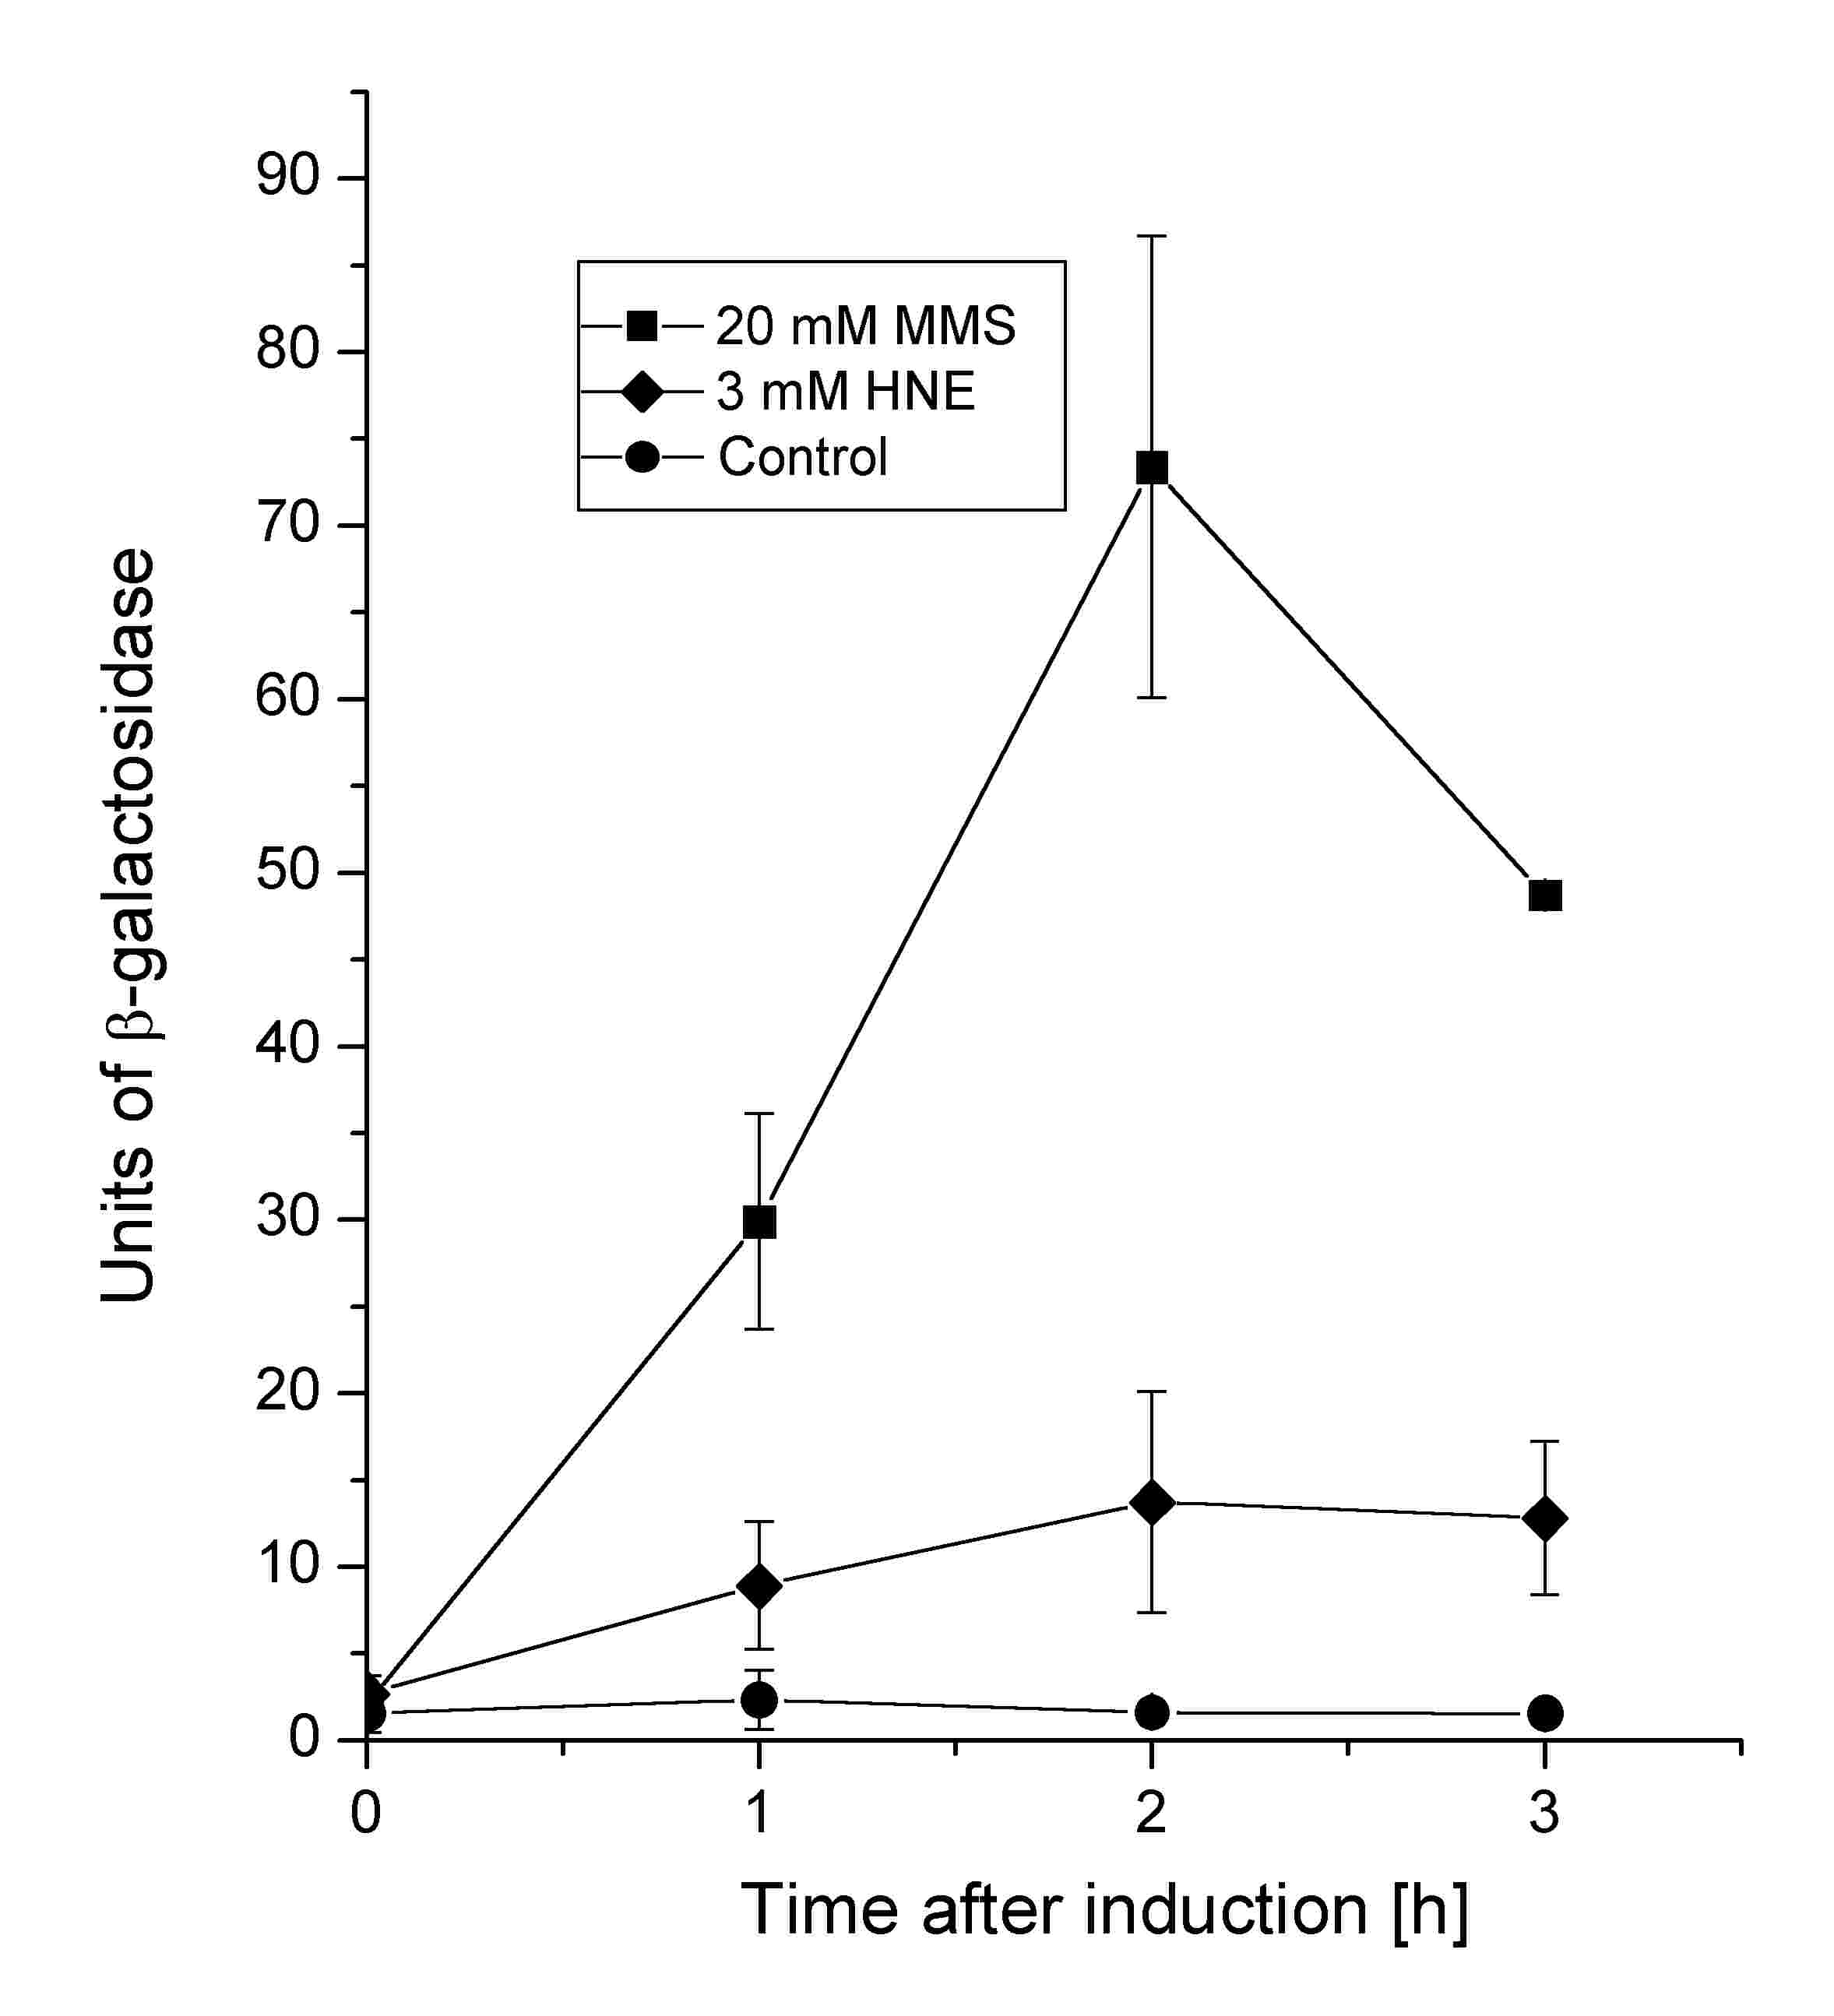
Fig. 1.
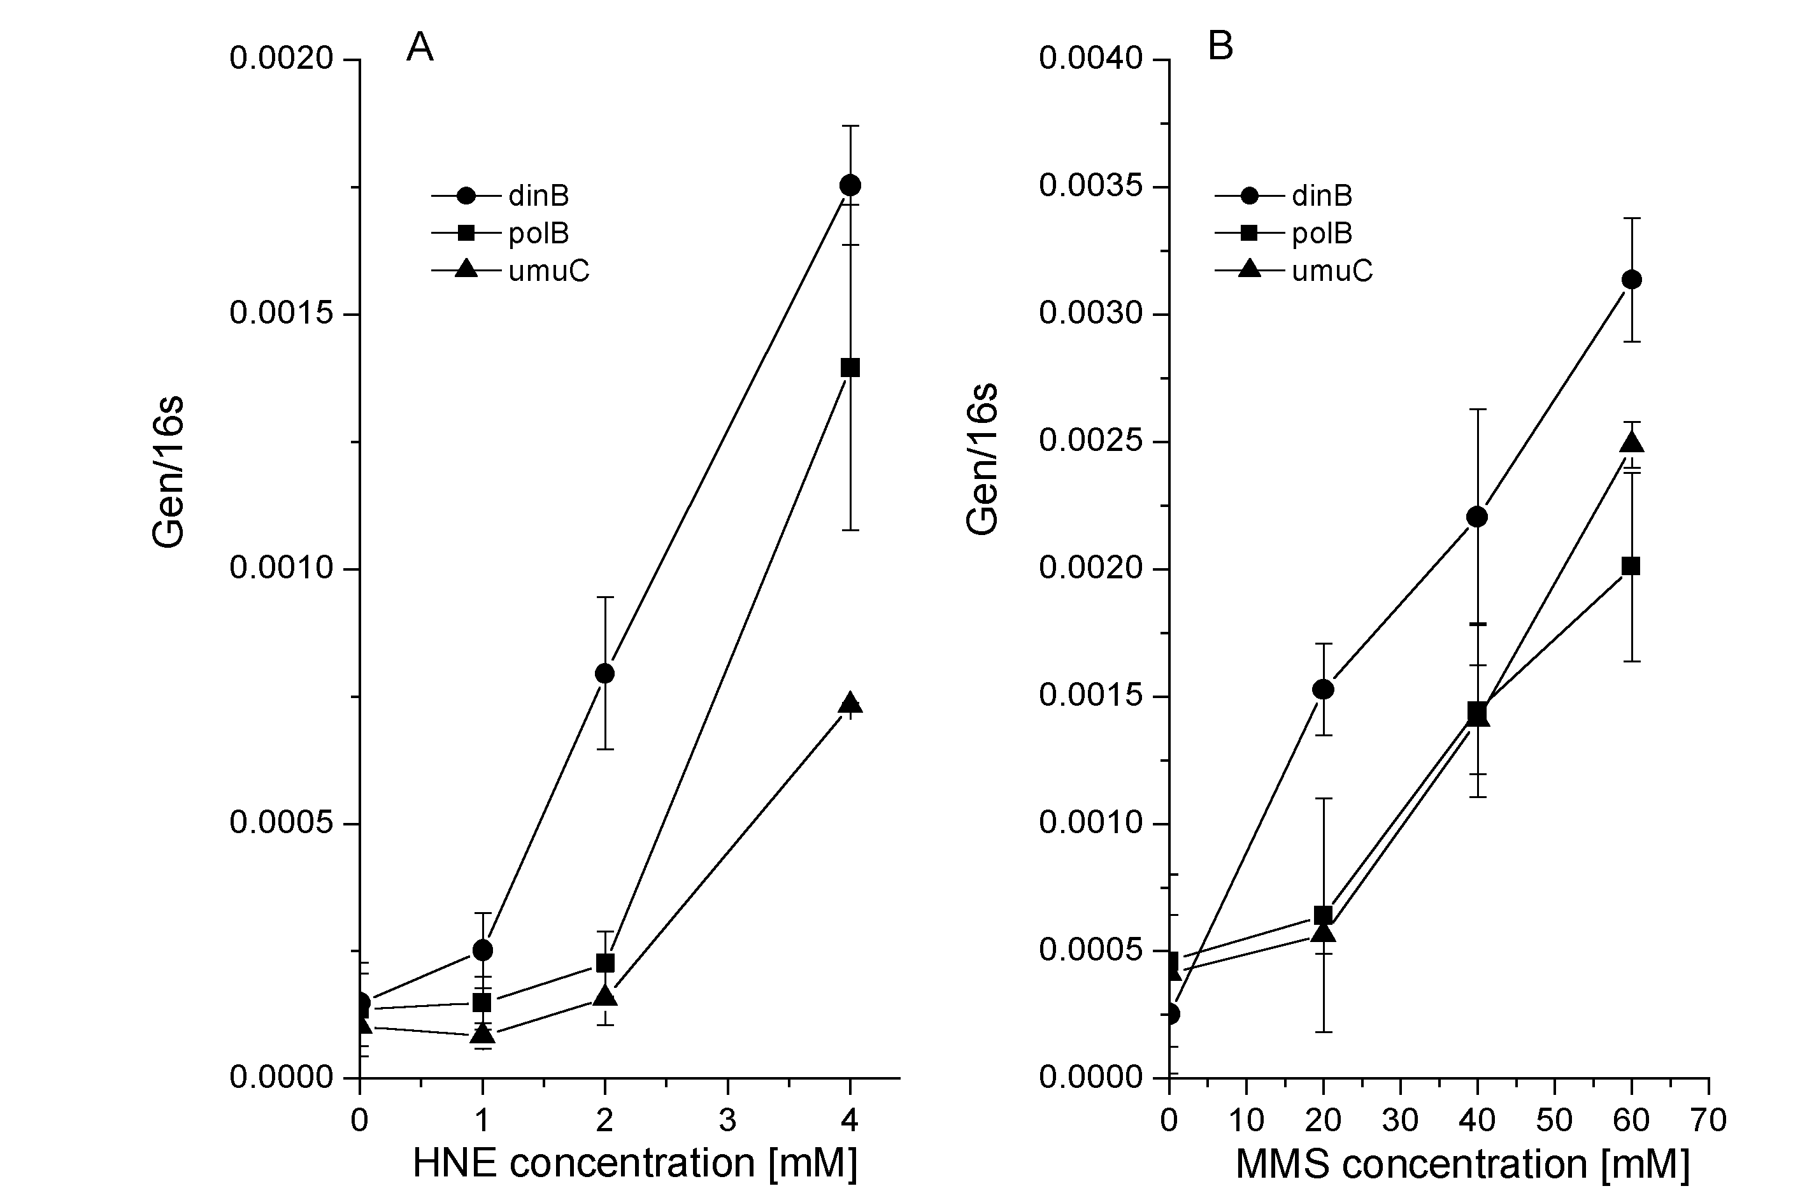
Fig. 2.
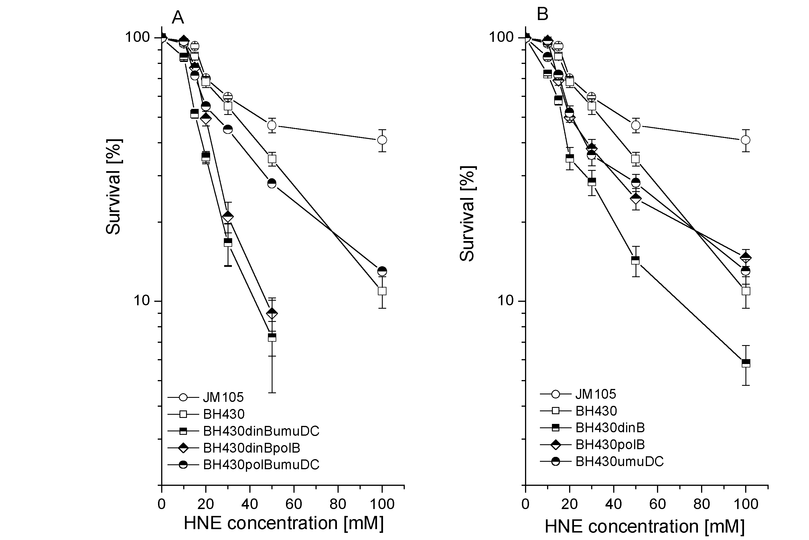
Fig. 3.
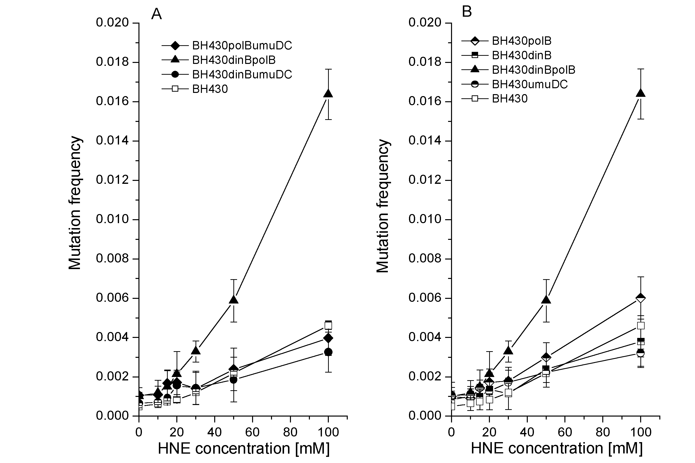

Fig. 4.
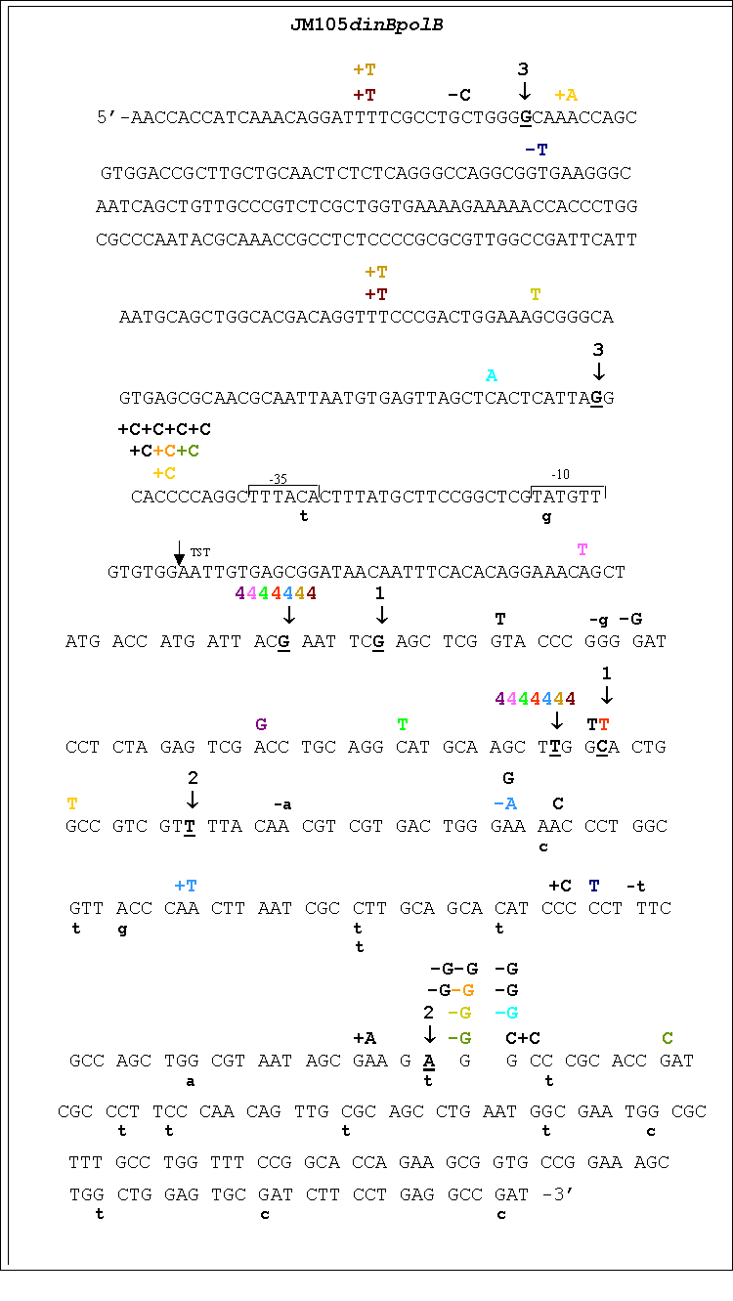
Fig. 5.
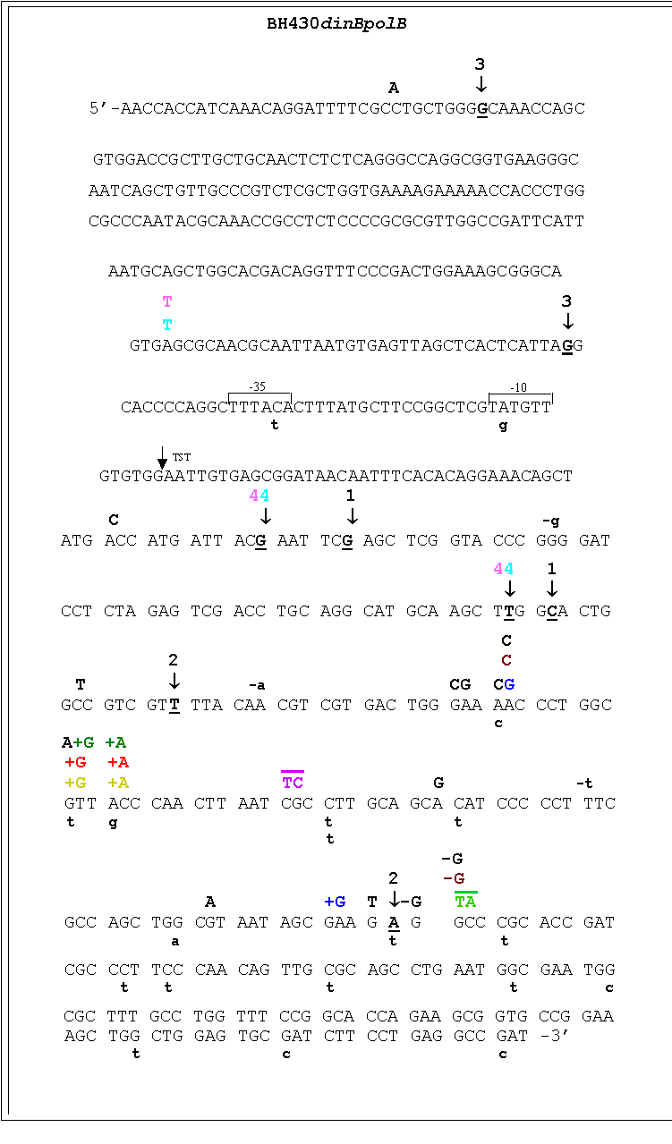
Fig. 6

Supplementary materials

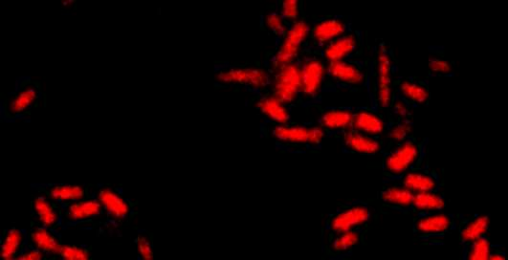

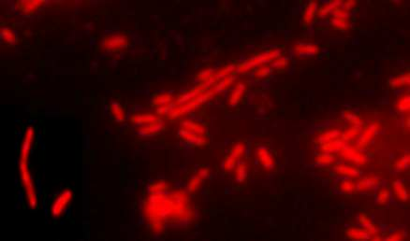

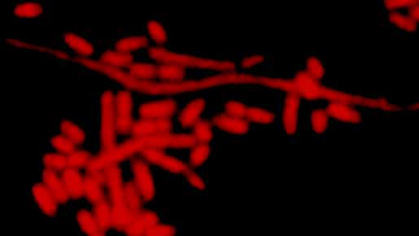

Fig. S1

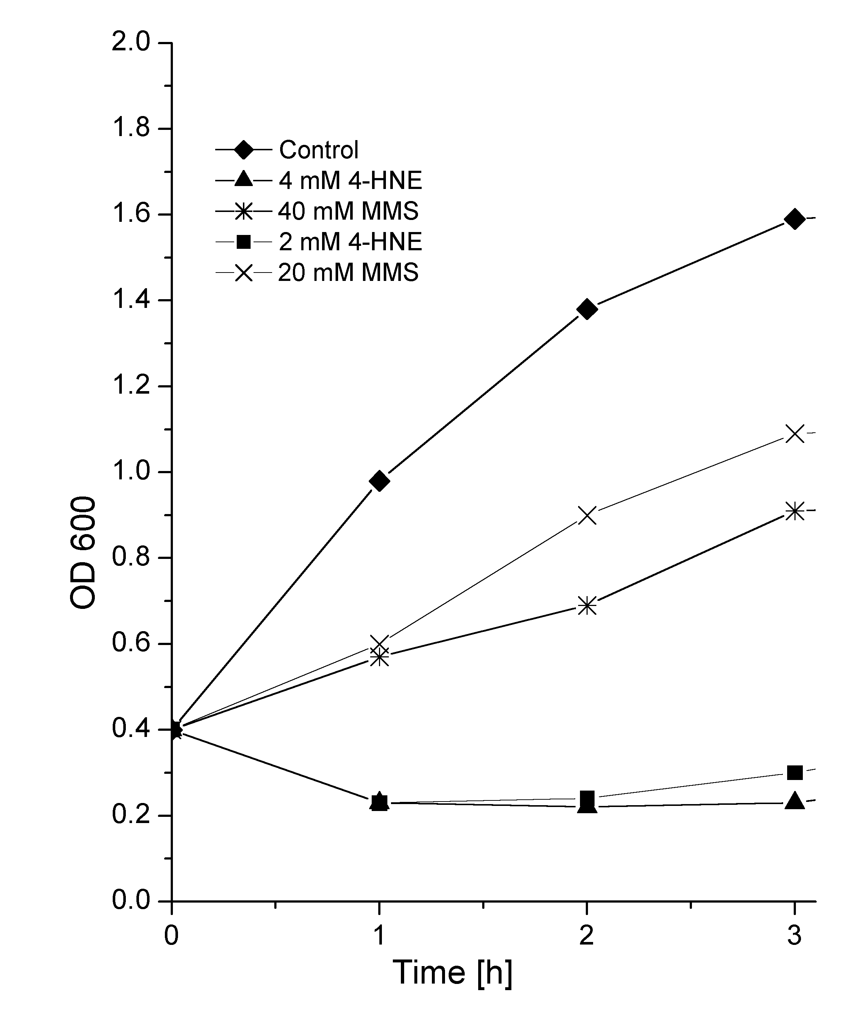
Fig. S2.

