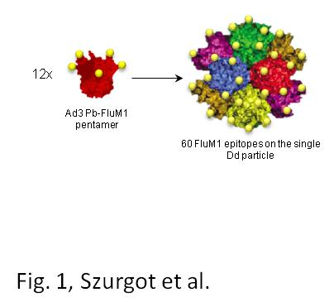
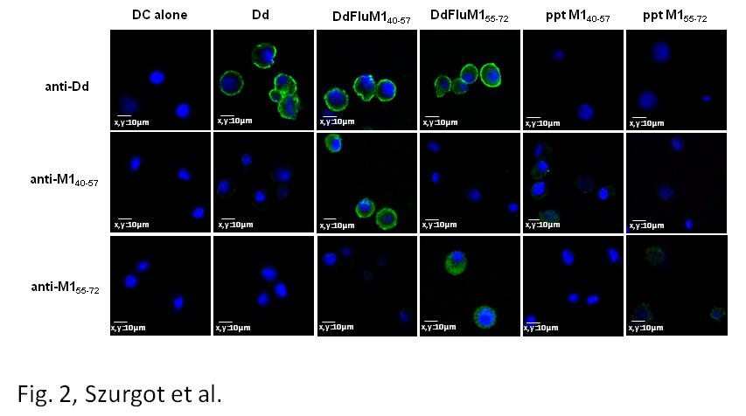
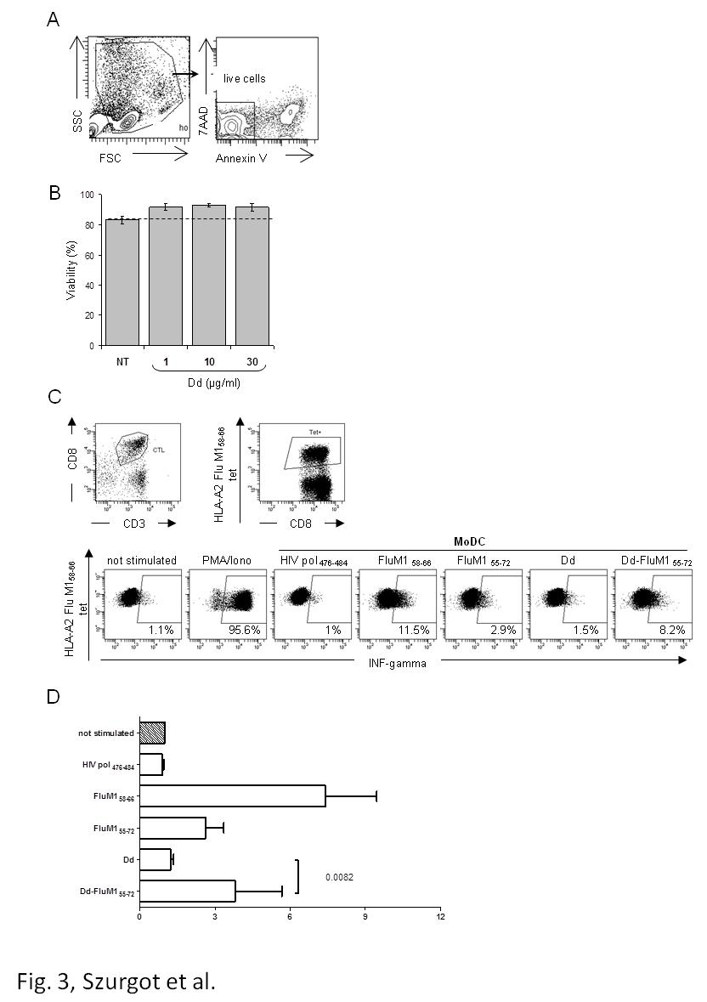
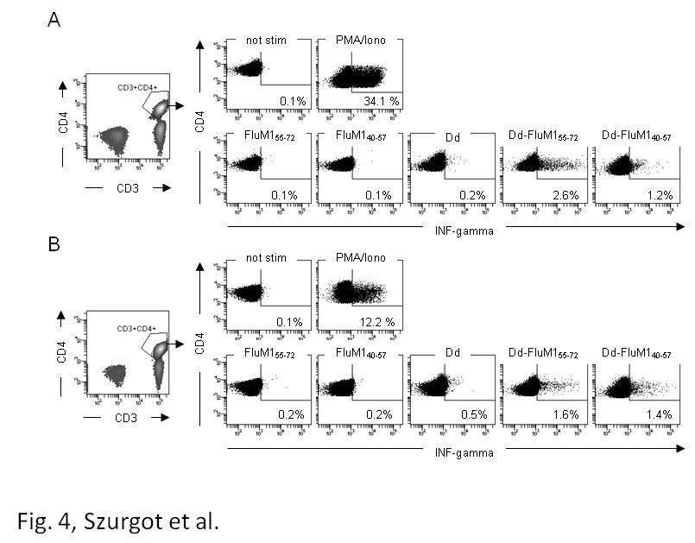
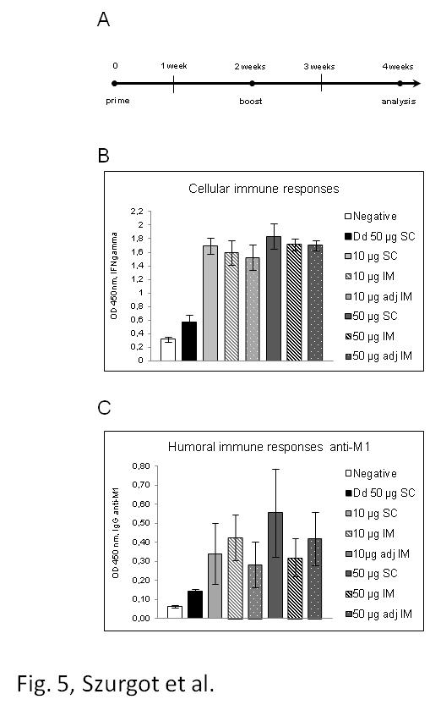
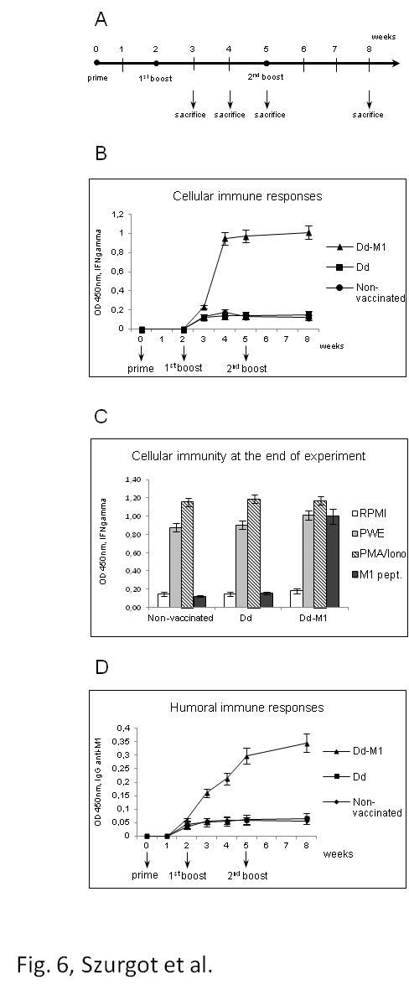
Figure captions
Figure 1. Schematic representation of Dd bearing M1 epitopes. Upon expression in baculovirus system 12 pentameric penton bases self-assemble into dodecahedra containing 60 copies of M1 epitopes on the single paricle.

Figure 2. Dd-M1 internalization into human dendritic cells. Dd, Dd-FluM1₄₀₋₅₇, Dd-FluM1₅₅₋₇₂, peptide M1₄₀₋₅₇ or M1₅₅₋₇₂ were applied onto cells for 1.5 h. Cells were analyzed by confocal microscopy using rabbit anti-Dd antibody, anti-M1₄₀₋₅₇ or anti-M1₅₅₋₇₂ followed by Alexa Fluor 488-conjugated chicken anti-rabbit secondary antibody (green signal). Cell nuclei were counterstained with DAPI (blue signal).

Figure 3. Cross-presentation of Dd-FluM1₅₈₋₆₆ to specific CD8⁺ T cells. (A and B) Absence of cytotoxicity of dodecahedric platform, analyzed on human PBMC. (A) PBMC morphology gating was based on scatter parameters. FSC, forward scatter; SSC, side scatter. Live cells were defined as Annexin V- and 7-aminoactinomycin D (7AAD) negative. (B) Viability after one-day exposition to Dd analyzed on PBMC of three independent donors. NT, not treated. (C and D) Cross-presentation of Dd-FluM1₅₈₋₆₆ epitope to specific CD8⁺ T cells. (C) Specific T cells were analyzed by flow cytometry by gating live CD3⁺CD8⁺ HLA-A2 FluM1₅₈₋₆₆ tetramer⁺ cells. Secretion of IFN-γ was analyzed on cells that were either non-stimulated or exposed to PMA/Iono (negative and positive controls, respectively) or stimulated by autologous MoDC after 18h processing of HIVpol₄₇₆₋₄₈₄, FluM1₅₈₋₆₆, FluM1₅₅₋₇₂ peptides, Dd or Dd-FluM1₅₅₋₇₂. (D) Changes of the frequencies of IFN-γ CD3⁺CD8⁺ HLA-A2 FluM1₅₈₋₆₆ tetramer⁺ producing cells with non-stimulated specific T cells generated from three different donors.

Figure 4. Cross-presentation of Dd-FluM1₅₅₋₇₂ and Dd-FluM1₄₀₋₅₇ to specific CD4⁺ T cells. PBMC from donors (A) or (B) were incubated for 7 days in the presence of FluM1₅₅₋₇₂ and FluM1₄₀₋₅₇ peptides, or in the presence of Dd, Dd-FluM1₅₅₋₇₂ or Dd-FluM1₄₀₋₅₇, and restimulated with the same antigens. The secretion of IFN-γ by CD3⁺CD4⁺ T cells was then analyzed. T cells, non-stimulated or exposed to PMA/Iono were used as negative and positive controls, respectively (two upper panels).

Figure 5. Initial characterization of vaccination regimen. Eight groups of chickens (n=10) were vaccinated via different routes with different doses of Dd-M1 vaccine composed of DdM1₄₀₋₅₇ and DdM1₅₅₋₇₂ mixed 1:1 (w/w), with or without complete Freund’s adjuvant. Birds non-vaccinated or vaccinated subcutaneously (SC) with Dd alone served as controls. Negative - non-vaccinated chickens, Dd - chickens vaccinated with the vector, SC - subcutaneous vaccination, IM - intramuscular vaccination, adj IM - vaccination with complete Freund’s adjuvant. Bars represent the average values for each group of chickens. (A) The diagram of vaccination schedule. (B) Cell-mediated immunity evaluated by ELISA assay of IFN-γ (IFNgamma) secretion by M1-specific memory T cells in the spleens of control and immunized chickens. (C) Humoral immunity evaluated by ELISA assay of anti-M1 antibody level.

Figure 6. Chicken immunization with Dd-M1 vaccine composed of DdM1₄₀₋₅₇ and DdM1₅₅₋₇₂ mixed 1:1. One of three groups of chickens (n=25) was vaccinated with 50µg of mixed vaccine in total volume of 100 µl. Non-vaccinated birds and those immunized with Dd vector (50µg, 100µl) served as controls. (A) Schematic representation of the vaccination regimen used in the experiment. (B) Secretion of IFN-γ (IFNgamma) by splenocytes of immunized or control chickens at the indicated timepoints. Isolated splenocytes were restimulated with the 1:1 mixture of M1₄₀₋₅₇ and M1₅₅₋₇₂. After 72h the secretion of IFN-γ was measured by ELISA. Average values for each group of chickens at the indicated timepoints are shown. (C) Secretion of IFN-γ by T cells in spleens obtained 3 weeks after the second boost (the 8th week of the experiment) from immunized or control chickens. The cells incubated in RPMI medium were used as a negative control and splenocytes stimulated with pokeweed (PWE) or PMA/Iono as positive controls. Results are shown as the average value for each group. (D) Humoral anti-M1 immune responses. Sera from chickens were isolated at the indicated timepoints and assayed by ELISA. Average values for each group of chickens at the indicated timepoints are shown.

