Title: Transport of NaYF₄: Er³⁺, Yb³⁺ upconverting nanoparticles into HeLa cells

Authors names: Bożena Sikora*¹, Krzysztof Fronc¹, Izabela Kamińska¹, Kamil Koper^{2,3}, Sebastian Szewczyk⁴, Bohdan Paterczyk⁵, Tomasz Wojciechowski¹, Kamil Sobczak¹, Roman Minikayev¹, Wojciech Paszkowicz¹, Piotr Stępień^{2,3} and Danek Elbaum¹

Author Affiliations: ^{[1]} Institute of Physics, Polish Academy of Sciences, al Lotników 32/46, 02-668 Warsaw, Poland; ^{[2]} Institute of Genetics and Biotechnology, University of Warsaw ul. Pawińskiego 5a, 02-106 Warsaw;
^{[3]} Institute of Biochemistry and Biophysics PAN ul. Pawińskiego 5a, 02-106 Warsaw; ^{[4]} Department of Physics UAM, ul. Umultowska 85, 61-614 Poznan; ^{[5]} Faculty of Biology, University of Warsaw, ul. Miecznikowa 1, 02-096 Warsaw

E-mail: sikorab@ifpan.edu.pl

Abstract. An effective, simple and practically useful method to incorporate fluorescent nanoparticles inside live biological cells was developed. The internalization time and concentration dependence of a frequently used liposomal transfection factor Lipofectamine 2000 was studied. An users friendly, one-step technique to obtain water and organic solvents soluble Er³⁺and Yb³⁺ doped NaYF₄ nanoparticles coated with polyvinylpyrrolidone (PVP) was obtained. The nanoparticles structural analysis confirmed the formation of nanocrystals of desired sizes and spectral properties. Internalization of NaYF₄ nanoparticles in HeLa cervical cancer cells were determined at different nanoparticles concentrations and for incubation periods from 3 to 24 hours. The images revealed a redistribution of nanoparticles inside the cell, which increases with incubation time, concentration levels and depends on the presence of the transfection factor. The study identifies, for the first time, factors responsible for an effective endocytosis of the up-converting nanoparticles to HeLa cells. Thus the method could be applied to investigate a wide range of future “smart” theranostic agents. The nanoparticles incorporated into the liposomes appear to be very promising fluorescent probes for imaging real-time cellular dynamics.

Keywords: lanthanide, nanocrystal, polyvinylpyrrolidone, Lipofectamine2000, up-conversion, HeLa cell, biological application, incubation, endocytosis

1. Introduction
Fluorescence imaging is a non-invasive method that plays an important role in biomedicine [1]. Typical fluorescence imaging techniques are based on fluorophores that are excited with UV light. In vivo imaging using a UV or short-wavelength visible light has several disadvantages, such as small penetration depth of the tissue, autofluorescence from other fluorophores in the sample, and the possibility of damaging the sample during the test [2]. The “single photon” fluorescent labels emit a low energy photon as a result of a higher energy photon absorption, typically in UV or visible range. The sensitivity and resolution of fluorescence imaging can be improved when “multiphoton” process and near-infrared light (NIR) is applied to excite the samples.
The use of near-infrared (NIR) radiation within the "optical transmission window" of biological tissues (700 - 1000 nm) offers several advantages: an increase of optical contrast, a greater depth of light penetration, minimized autofluorescence and reduced light scattering [2-4]. Furthermore, NIR does not cause radiation damage of cellular functions and structures [5,6]. In addition, the use of femtosecond pulses permits to reduce the thermal load causing tissue damage. Minimizing the damage allows to perform bio-dynamical imagining requiring long duration of exposure to the light irradiation. Therefore, samples showing efficient and stable optical conversion of multiphoton fluorescence, after excitation by femtosecond NIR, are suitable for imaging of the time-dependent intracellular processes [3].
In recent years, rapid advances of nanotechnology caused development of new nanoparticles that emit light after excitation with NIR energy. Substantial reduction of the nanoparticles size results in an enhanced cellular penetration, thus allowing intracellular imaging and applications in photodynamic therapy [7-12].
Quantum dots [13,14] and metallic nanoparticles [15] of different size have recently been extensively studied as two-photon fluorescent biomarkers in living cells. The studies have been aimed to obtain images with a relatively high contrast [16]. In these cases, the two-photon emission spectra obtained with NIR excitation strongly depend on the shape of the nanocrystals and the local environment around them. Moreover, there is a problem of toxicity of nanocrystals because of the presence of metal ions in their composition. Therefore, there is an ongoing need for additional research on new materials, which could help in overcoming various problems associated with current use of fluorophores, and would maintain a low toxicity profile [3]. For biological applications, it is recommended to use fluorescent markers that can be excited in the near-infrared (NIR) region [17]. Nanocrystals which up-convert the infrared to visible light are a good choice [18,19], as they emit a single photon of higher energy after absorbing two or more photons of lower energy. Different wavelength colors of visible light can be obtained by combining various up-converting fluorophores excited by the same IR laser [18]. In contrast to the down-converting nanocrystals, up-converting crystals show very low background emission of biological environment as a consequence of NIR excitation. In addition, the photo-damage of biological tissue is strongly reduced, due to their transparency in NIR spectrum [20]. Up-converting crystals are composed of an active element of rare-earth atoms, which are embedded in a crystalline host matrix. The rare-earth atoms absorb two or more photons and emitting visible light. The up-conversion mechanism can be described as either a sequential excitation of the same atom or excitation of two centers, followed by an energy transfer [21-24]. Light emission spectrum of up-converting nanoparticles consists of a sharp lines characteristic for atomic transitions embedded in the crystal matrix [25]. NaYF₄ is regarded as the most efficient host material for Er³⁺/Yb³⁺ (or Tm³⁺/Yb³⁺) dopants up-converting the NIR to visible light [26]. Colloidal NaYF₄ nanocrystals doped Er³⁺/Yb³⁺ and Tm³⁺/Yb³⁺ have been prepared with a strong up-conversion fluorescence, several orders of magnitude larger than up-conversion fluorescence of CdSe/ZnS core/shell nanoparticles [14,24]. Moreover, they are not prone to bleaching observed in organic dyes and fluorescent proteins. This is due to the fact that up-converting nanoparticles emitting photons from rare-earth 4f shell are effectively shielded by lying on the outside 5s and 5p electrons [25].
Several reports have described the up-converting NaYF₄ nanocrystals of various shapes and sizes [12,29,24,27]. The efficiency of up-conversion emission depends strongly on the size of the nanoparticles, due to the fact that rare earth metal ions on the surface do not participate in the process of up-conversion [28,29]. An important factor is the choice of the host material. Generally, the host material should have the crystal structure matched to ion-doped and low phonon energy to minimize non-radiative relaxation processes and to maximize radiative emission. NaYF₄ crystals satisfy those requirements [26]. Efficiency of the up-conversion process also depends on the concentration of both, the absorber and the activator, in the crystal. Therefore, in part of our work, we study the concentration of the absorber (Yb³⁺ dopant ions) in order to maximize up-conversion efficiency.
Previously, ethylenediaminetetraacetic acid (EDTA) was applied as a chelating agent to control the NaYF₄ crystal growth, but the nanocrystals have a tendency to precipitate in the solutions as a result of the lack of hydrophilic and hydrophobic chemical groups on their surface [29,27]. Before was reported colloidal solutions synthesis of NaYF₄ nanocrystals were based on toxic chemicals and laborious procedures. The nanocrystals were hydrophobic and could only be suspended in sonicated organic solvents such as hexane and dimethyl sulfoxide [24,30,31]. The use of nanocrystals directly for biological applications was therefore limited because of their low solubility in water and unfavorable surface properties. Thus there is a need to develop suitable methods for the synthesis of up-converting NaYF₄ nanocrystals which would be soluble in water and organic solvents and also would have functional groups on the surface, which could be utilized for attaching biomolecules [14]. Selection of an appropriate chelating agent to control the crystal growth, a surfactant to stabilize the nanocrystals and providing them with relevant surface properties is a key to solving these problems. Polyvinylpyrrolidone (PVP) is an amphiphilic surfactant, which can lead to improved solubility of the nanocrystals in polar and hydrophobic solvents [32]. In addition, pyrrolidone group can coordinate lanthanum ions [33]. Therefore, in this work we applied PVP as a chelating agent and stabilizer in the synthesis of NaYF₄. PVP controlled the product geometry, and as a surface modifier solubilized the crystals in water. The PVP-stabilized NaYF₄ nanocrystals can be directly coated with a layer of SiO₂ in order to produce an appropriate surface for the biomolecules attachment [34].
In this publication, the synthesis of NaYF₄ nanoparticles doped with 2 % Er³⁺ and different concentration of Yb³⁺ coated PVP is described. The time and concentration dependent distribution of up-converting NaYF₄: Er³⁺, Yb³⁺ nanoparticles, in the presence and absence of the cellular transfection reagent, was systematically analyzed inside HeLa cells for the first time.

2. Materials and methods

2.1. Synthesis of NaYF4: 2 % Er³⁺, x % Yb³⁺ coated with PVP
All chemical reagents were bought from Sigma-Aldrich. NaYF₄: Er³⁺, Yb³⁺ nanoparticles were synthesized as previously described [34]:, Y₂O₃ (1-x mmol), Yb₂O₃ (x mmol, where x = 0.1; 0.18; 0.2; 0.3 mmol and 0.02 mmol) was dissolved in 10% HNO₃ (10 ml) and then heated to evaporate water. Ethylene glycol (10 ml) was added to dissolve the obtained rare earth nitrate. Polyvinylpyrrolidone - PVP40 (0.556 g) and NaCl (1 mmol) was added and the solution was then heated to 80 °C until a homogeneous solution. NH₄F (4 mmol) was dissolved in ethylene glycol (10 ml) at 80 °C and then added drop wise to a solution of nitrate. The solution was then heated to 160 °C for 2 h and then cooled to room temperature. The final product was obtained by centrifugation and washing twice with ethanol.

2.2. Introduction of NaYF₄: 2 % Er³⁺, 30 % Yb³⁺ to HeLa cells
The cells used in this study are a standard HeLa line. This is a commonly employed line derived from cervical cancer. Human cancer cells were routinely cultured with DMEM (Dulbecco's Modified Eagle Medium) containing 10% fetal calf serum (FCS), 100 units/ml penicillin, 100 μg/ml streptomycin. Cultures of cells were kept at 37 °C in a humidified atmosphere containing 5% CO₂. Liposomal vesicle transfection agent (Lipofectamine 2000) was used to introduce nanoparticles into the cells. Cells were cultured in 6 well plates dishes (6 x 10 cm ²) at a density of 100 000 / plate. The cells were incubated with NaYF₄: 2 %Er ³⁺, 30 % Yb³⁺ nanoparticles alone and with nanoparticles and transfection agent Lipofectamine 2000 together. 10 μl of the selected concentration of sonicated initial colloidal solution of nanoparticles in water was dissolved in 500 μl miliR H₂O. 20μl Lipofectamine 2000 was dissolved in 500μl miliR H₂O and incubated for 15 minutes. The two solutions were mixed and incubated for 20 minutes. 500 μl of this solution was added to 10 cm² dish with HeLa cells and incubated at different times. Then the medium was changed to DMEM. In order to investigate the potential use of NaYF₄: 2 %Er ³⁺, 30 % Yb³⁺ nanoparticles for testing intracellular activity, different sets of variables were tested the incubation times of 3 h, 6 h, 12 h and 24 h; concentration of nanoparticles: 0.2 μM, 0.4 μM, 2.0 μM, 4.0 μM, 20 μM and 40 μM.
2.3. Characterization of NaYF₄: 2 % Er³⁺, x % Yb³⁺ nanoparticles
The crystal structure of up-converting nanoparticles was determined from X-ray diffraction (XRD) patterns collected in Philips X´Pert Pro Alpha1 MPD (Panalytical) diffractometer in the range of 2θ 10° - 150° for 15 h. Size of the crystals was determined with a full width half maximum (FWHM) of peak 111 using the Scherrer formula [35]. The structure refinement was performed using Fullprof [36].
The study was performed using the transmission electron microscope JEOL JEM 2000EX at 200 keV beam energy. The specimens for the TEM observations were prepared by dropping the methanol particle dispersion, created by an ultrasonic technique, on a carbon film supported on a 300 mesh copper grid. The surface morphology of the nanoparticles were analyzed by field emission scanning electron microscopy (FE-SEM) using an Auriga - Zeiss instrument. Elemental analysis of the samples was done by using Energy-dispersive X-ray spectroscopy (EDX)-system QUANTAX 400 Bruker attached to the FE-SEM. Fluorescence spectrum was measured with a 960 nm continues wave (CW) laser diode (ThorLabs LDC 220C) with 194 mW power and CCD detection (Spex 270M).
The cells were analyzed using a fluorescence confocal microscope (Zeiss 710 NLO) with a NIR femtosecond laser (Coherent, Chameleon). We observed two channels: one with excitation 980 nm (femtosecond laser) and emission range from 515 to 671 nm; the second with excitation 488 nm (continues wave CW) and emission range from 508 to 585 nm. The ratios of nanoparticle to cell areas for various nanoparticles concentrations and various of incubation time in the presence and absence of Lipofectamine 2000 was analyzed by CellProfiler program [37].

3. Results and discussion
In this publication the synthesis of NaYF₄ nanoparticles doped with 2 % Er³⁺ and different concentration of Yb³⁺ (10 %, 18 %, 20 %, 30 %) coated PVP, is described (table 1).

Table 1. Name of nanoparticles sample depending on dopants concentrations.

 | Name of nanoparticles sample
A | NaYF₄
B | NaYF₄: 2 % Er³⁺, 10 % Yb³⁺
C | NaYF₄: 2 % Er³⁺, 18 % Yb³⁺
D | NaYF₄: 2 % Er³⁺, 20 % Yb³⁺
E | NaYF₄: 2 % Er³⁺, 30 % Yb³⁺

These nanoparticles were characterized by Transmission Electron Microscopy (TEM), Scanning Electron Microscopy (SEM), X-ray diffraction and photoluminescence. The nanoparticles were introduced to HeLa cells, and intracellular luminescence was observed. For the first time the effect of incubation time and concentration of up-converting nanoparticles on their distribution inside cells was examined to optimize the introduction of nanoparticles into the cells. A transfection factor was applied in order to improve the efficiency of nanoparticles uptake into cells. Lipofectamine 2000 is a common transfection factor used in molecular and cell biology. It is used to introduce siRNA or DNA into cells by lipofection. Lipofectamine 2000 is composed of subunits of lipids that form liposomes in aqueous medium, which allows transfection of materials. Liposomes containing DNA interact with the cellular membrane and penetrate into cytoplasm through endocytosis, thus enabling replication and/or expression of the introduced DNA. The liposomes were applied to enhance the efficiency of the nanoparticles transportation into the cell. The distribution of nanoparticles, as a function of incubation time and the nanoparticles concentration in the presence and absence of the cellular transporter, was systematically analyzed for the first time inside HeLa cells.

3.1. Structural characterization
The results obtained by X-ray diffraction (XRD) of nanocrystals (a representative pattern is shown in figure 1) are consistent with cubic structured NaYF₄ nanocrystals. This indicates a high cubic structure purity of the obtained crystals. Majority of previously published results report on obtaining mixtures of cubic and hexagonal NaYF₄ nanocrystals, although some methods of pure cubic and hexagonal crystals are available as well [20,24,38]. Therefore, the method presented here appears to b 3.e effective for the synthesis of pure cubic phase NaYF₄ in solution [34]. The size of the nanocrystals evaluated from the Scherrer formula [35,39] ranged from 30 nm for nanoparticles without doping (A), and for B and C. The size of D nanoparticles was 36 nm and for E nanoparticles was 28 nm (table 1).
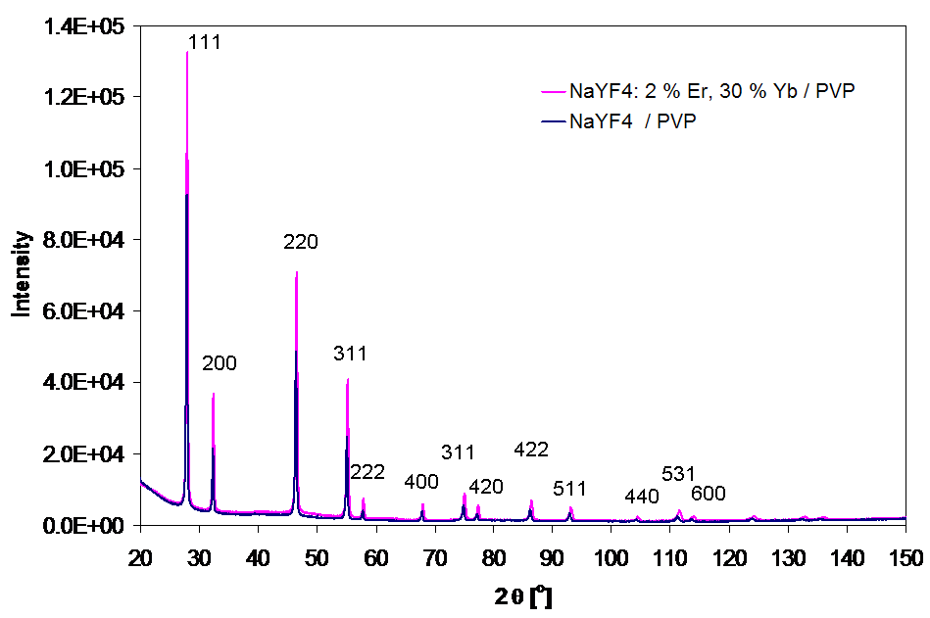
Figure 1. X-ray diffraction pattern of NaYF₄ nanoparticles and NaYF₄ doped 2 % Er³⁺ and 30 % Yb³⁺ nanoparticles.

NaYF₄ lattice constant for several dopants concentrations was obtained from calculations using the data from the XRD. It is summarized in figure 2. Lattice constant was calculated using the Rietveld method [36] (see figure S1). As a result of the nanoparticles doping with rare earth ions NaYF₄ network the lattice parameters changes from 5.52 Å to 5.51 Å. No visible change of lattice constant depending on the content of ytterbium ions in the crystal was observed in the studied concentration range. The lattice constant obtained for NaYF₄ nanoparticles without dopant was 5.518. The lattice constant of nanoparticles is greater than that of bulk crystal as published in the JCPDS card (No. 77-2042, a = 5.470 Ǻ). A similar effect was already observed for nanoparticles and is connected with other stresses in lattice in the nanocrystals than in bulk materials [40].
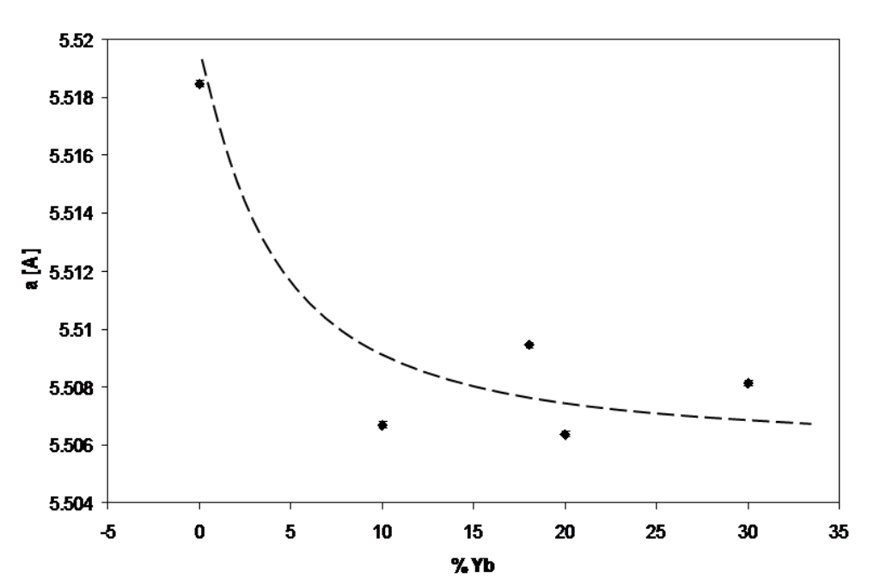
Figure 2. NaYF₄ lattice constant obtained from calculations using the data from XRD depending on the concentration of dopants.

Elemental analysis of NaYF₄: 2 % Er³⁺, 30 % Yb³⁺/PVP nanoparticles was obtained from EDX and were as follows: for ratio of donor ions (Yb³⁺) to the ion emitter (Er³⁺) is about 11.5 (in reaction 15.0); ratio F³⁺/Y³⁺ ~ 5.4 (in reaction 5.9); Y³⁺/Er³⁺ ~ 31.4 (in reaction 34.0); Y³⁺/Yb³⁺ ~ 2.7 (in reaction 2.3); Y³⁺/Na³⁺ ~ 1.1 (in reaction 0.7); F³⁺/Na³⁺ ~ 5.9 (in reaction 4.0). The analysis was performed for all of the nanoparticles samples. The results with details are available in Table S1. The elemental analysis shows that the reaction ratios agree with the ratios obtained from the quantitative EDX analysis.
It is known that only ions incorporated in the crystal lattice are involved in the up-conversion process. Several dopants inside crystals were analyzed using Rietveld method based on X-ray diffraction measurements [36]. The Rietveld refinements show that the Y³⁺ site is partially occupied by Yb³⁺ ions. Assuming for simplicity, that all Er³⁺ ions occupy the Y³⁺ sites, the calculations provide the Yb³⁺ fractional occupancy which is lower than the technological fraction (from about 60% for C, D, E nanoparticles to about 90 % for B nanoparticles). A linear dependence of luminescence intensity versus Yb³⁺ occupancy supports the expectation that only site-located Yb³⁺ ions contribute to luminescence (figure 3). The remaining part is located on the surface of the particles, and is not involved in the up-conversion process. Full table of the results was placed in Table S2.
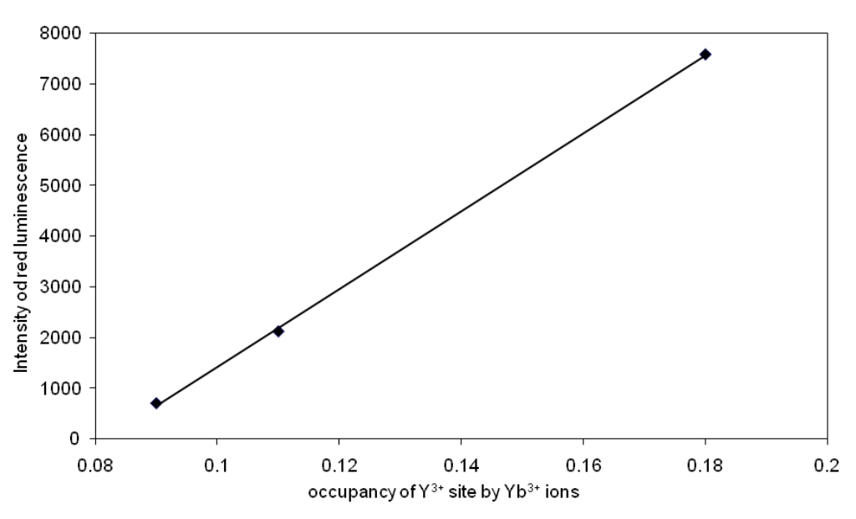

Figure 3. Variation of the luminescence intensity on the occupancy of Y³⁺ sites by Yb³⁺ ions.

TEM images of NaYF₄: 2 % Er³⁺, 30 % Yb³⁺ /PVP nanoparticles show a well-defined crystal structure (figure. 4). The crystals are polyhedral in shape and uniform in size with average size around 30 nm (figure 5). The TEM measurements were performed for all samples (A, B, C, D and E). The results are shown in figure S2 and figure S3. The apparent size differences between 10, 18, 20 and 30 % Yb³⁺ content in NaYF4: Er³⁺, Yb³⁺ are not statistically significant based on 100-160 individual nanostructures per sample TEM determinations.
Black areas in the figures are due to PVP adsorbed on the surface of nanocrystals, which is burned during the electron beam exposure during TEM measurements. The same effect has been reported previously [34]. Electronograms indicated that the attached rings correspond to the cubic structure.
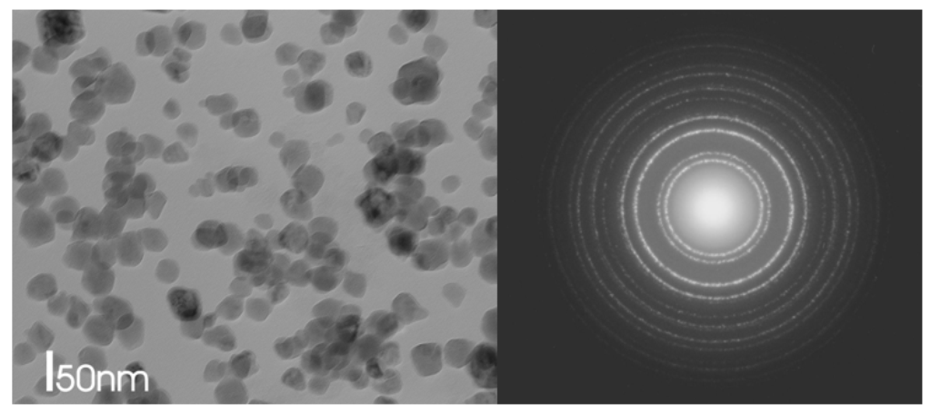
Figure 4. Transmission electron microscope image in bright field of NaYF₄: 2 % Er³⁺, 30 % Yb³⁺/PVP nanoparticles; on the right side (left); electronogram corresponding to nanoparticles structure (right).
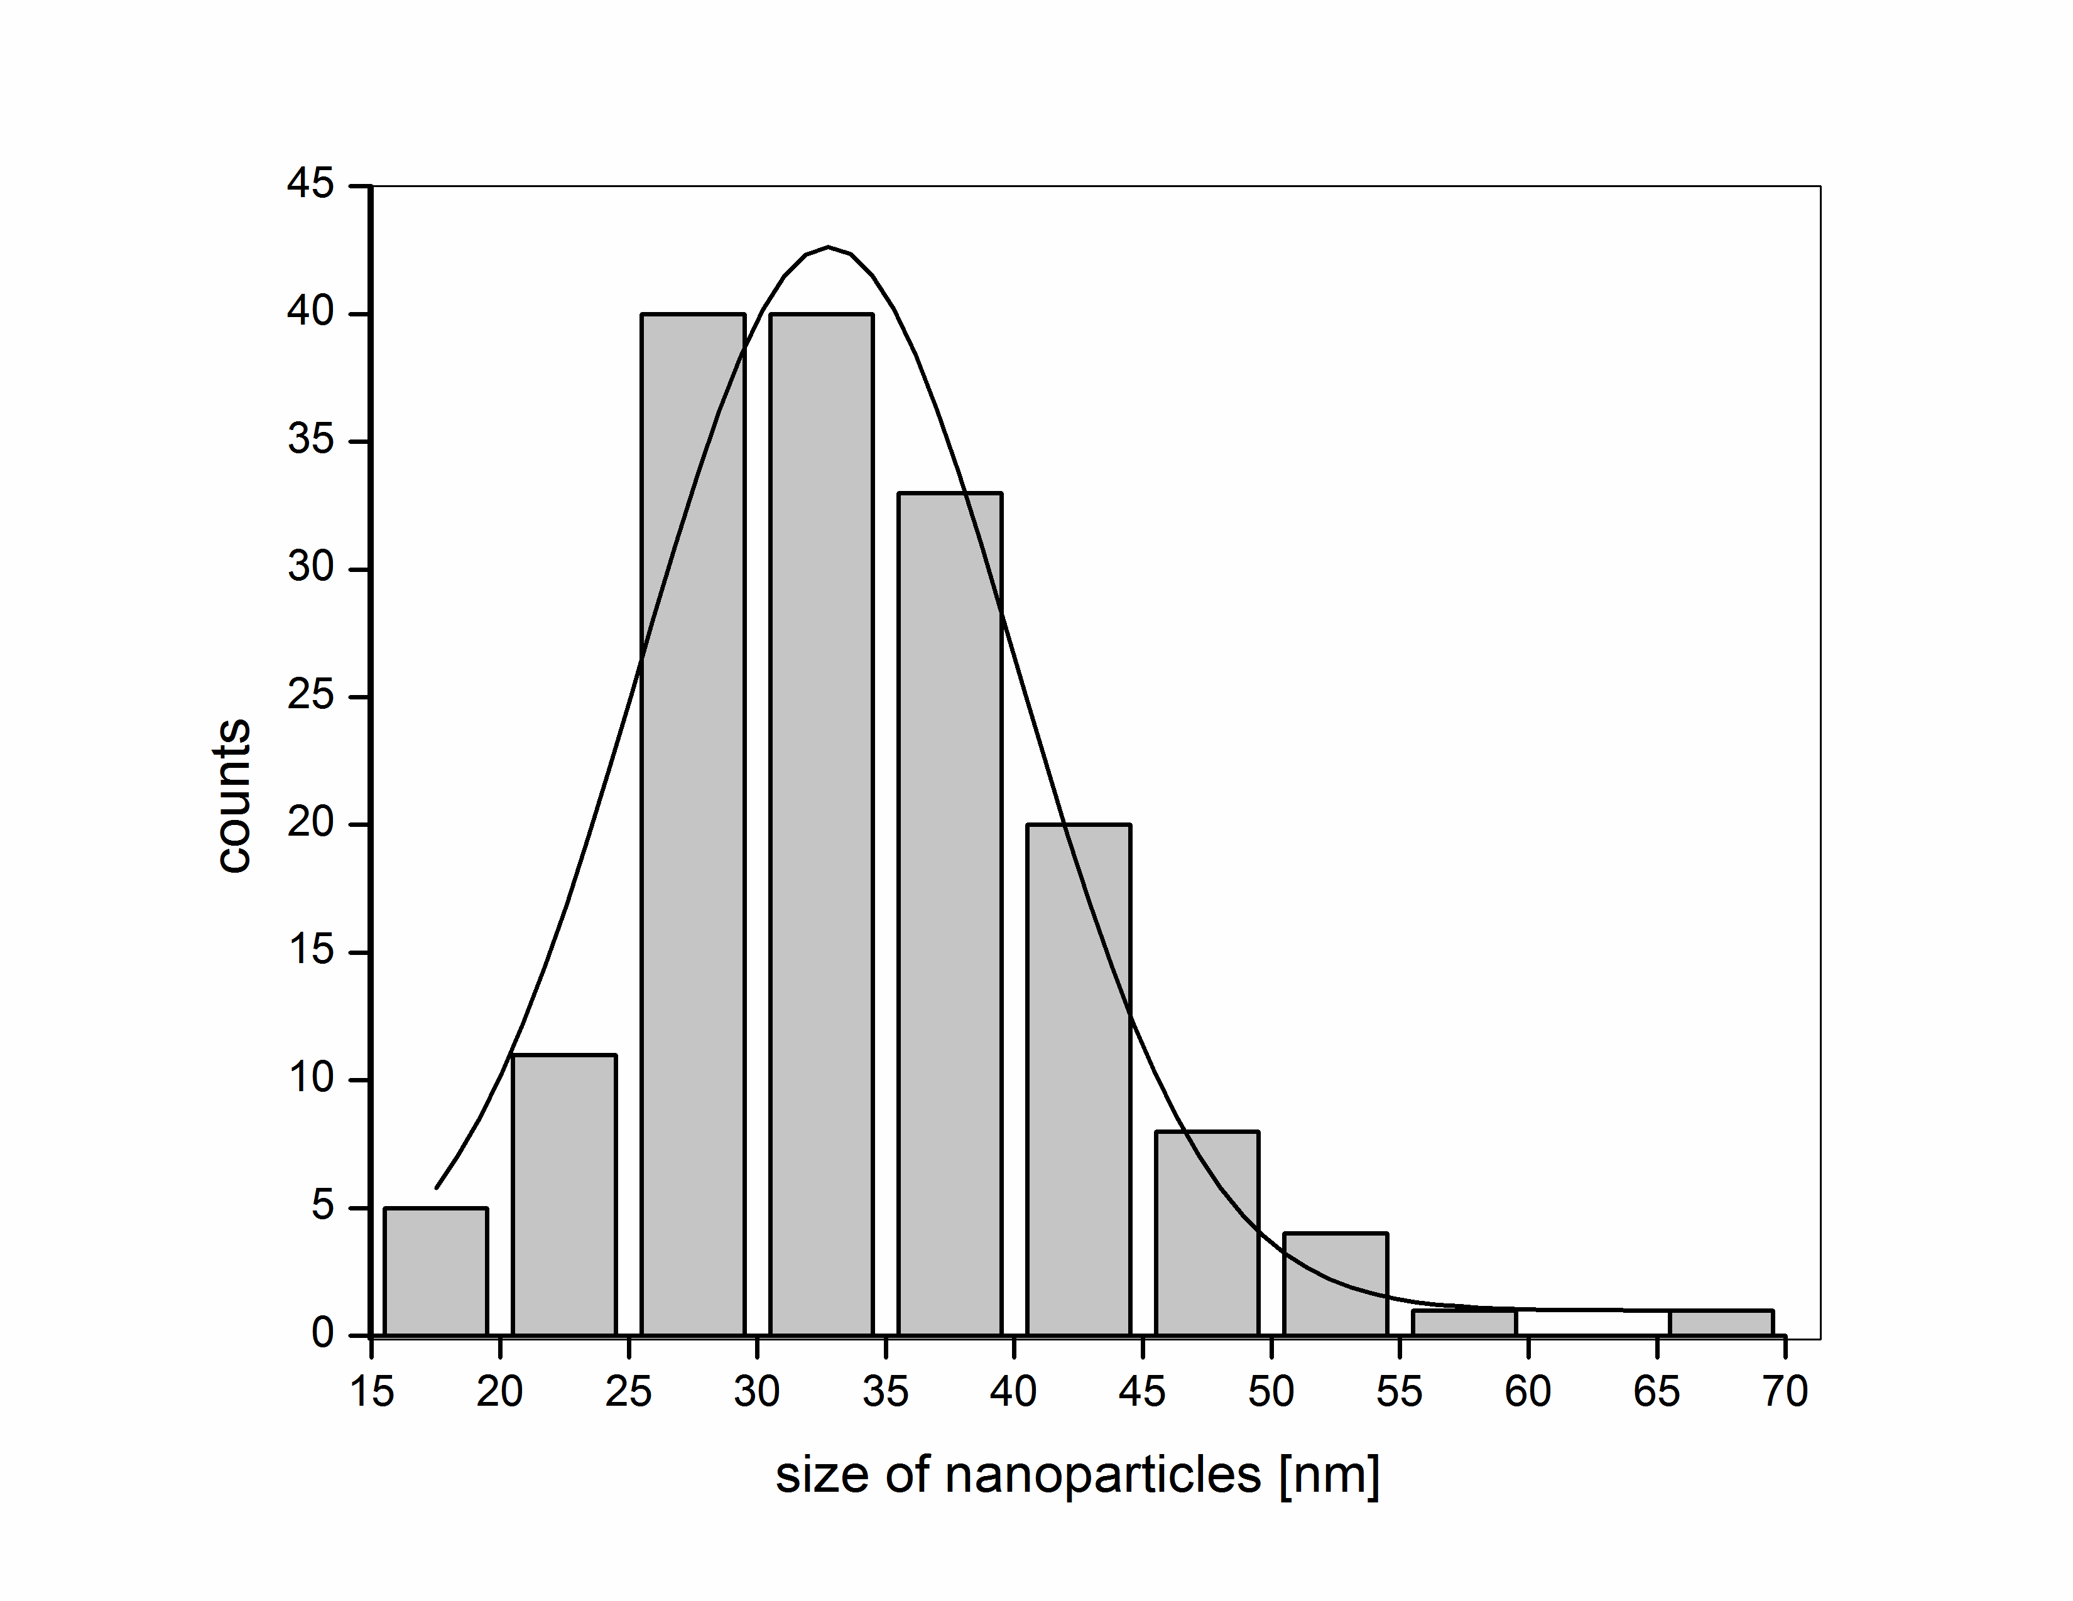
Figure 5. Histogram of diameter of NaYF₄: 2 % Er³⁺, 30 % Yb³⁺/PVP nanoparticles.
It has been previously reported that only micron-sized NaYF₄ crystals are synthesized when water is used as a solvent without any chelating agent [19,27]. In the present work, lanthanide ions are complexed by the pyrrolidone group of PVP and then slowly released into solution to react with fluoride ions in viscous and less polar solution of ethylene glycol, therefore small crystals were formed (see figure 4 and figure S3). Furthermore, PVP can also be used as a stabilizer of nanoparticles [41]. Due to the fact that PVP is soluble in water and in several organic solvents, NaYF₄/PVP nanoparticles are also highly soluble in water and in several organic solvents, which form colloidal solutions [34].

3.2. Luminescence properties
NaYF₄/PVP nanoparticles fluorescence spectra depend on concentration of Yb³⁺ ions in water as summarized in figure 6. The emission peaks of NaYF₄: Er ³⁺, Yb³⁺ at 522, 541 and 652 nm are the result from ⁴H_{11/2}, ⁴S_{3/2}, ⁴F_{9/2} to ⁴I_{15/2} transition of Er³⁺ions, respectively, which occurs as a result of the efficient energy transfer from Yb³⁺ to Er³⁺ [20,42]. The position of these two bands does not depend on the size of nanoparticles, their shape and the environment, which is advantageous in comparison with the bands of quantum dots or gold nanoparticles. Bands of quantum dots and gold nanoparticles obtained by two photons excitation are very sensitive to these parameters [43,44]. It is well known that the crystal structure and surface properties of nanocrystals can change the intensity of the fluorescence peaks of doped ions. For NaYF₄ created by co-precipitation, the peak intensity of green fluorescence is much higher than the peak of red fluorescence [19,27], while the red fluorescence peak is higher than the peak of green fluorescence for nanocrystals stabilized with oleic acid [31]. For nanoparticles NaYF₄: Er³⁺, Yb ³⁺/PVP strong red fluorescence was observed, as opposed to the earlier observation [34]. The ratio of red to green luminescence changes depend on the amount of ions of ytterbium in lattice crystal. The increase of the amount of ytterbium ions increase the ratio of the peak area of red luminescence to peak area of green luminescence in the following manner: 6.4 for 10 % Yb³⁺, 5.9 for 18 % Yb³⁺, 11.4 for 30 % Yb³⁺. This agrees with the amount of ions in a lattice crystal designated from the Rietveld method, where for B was 9 % Yb³⁺ in lattice, for C was 11 % Yb³⁺ and for E was 18 % Yb³⁺ (see Table S2).

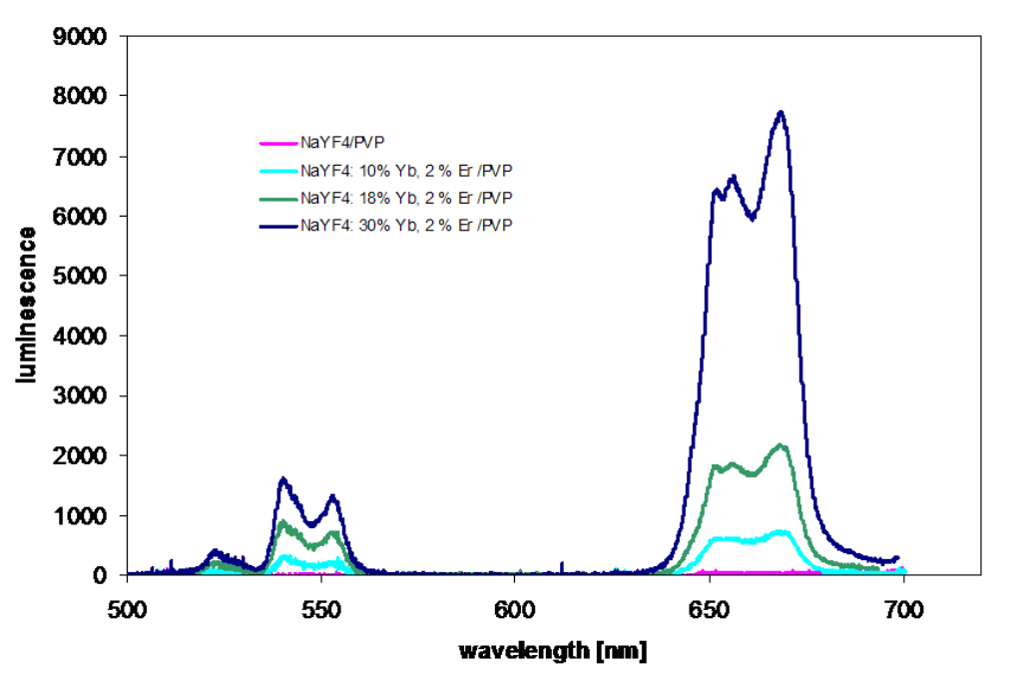
Figure 6. Fluorescence spectra of NaYF₄: 2 % Er³⁺, Yb³⁺ nanoparticles in water depending on amount of doping Yb³⁺ ions under excitation from NIR CW laser (960 nm).

Fluorescent bands of NaYF₄: Er³⁺, Yb³⁺ nanoparticles show the well defined structure as opposed to the fluorescent bands generated by quantum dots or gold nanoparticles (have no fine structures). This could be caused by the simultaneous emission of the different close electron energy levels of Er³⁺ ions, where the population is determined by the temperature of the environment. In addition, the emission bands of NaYF₄: Er³⁺, Yb³⁺ nanoparticles are narrower than the quantum dots or gold nanoparticles [3] resulting in higher contrast images through better spectral distinction from the autofluorescence of cells. These advantages make NaYF₄ nanoparticles excellent candidates for the next generation of nanoprobes for in vivo bioluminescence imaging.
Specific labelings of cancer cells were recently reported by attaching antibodies to the functionalized NaYF₄: Er³⁺, Yb³⁺ nanoparticles [45-47]. These antibody functionalized nanoparticles labeled specific HeLa membrane cell markers (antigens) as a result of antibody - antigen affinity, which led to the detection and imaging the surface antigens.
3.3. HeLa cells labeling with NaYF₄: Er³⁺, Yb³⁺ nanoparticle
In this work, aqueous suspensions of up-converting NaYF₄: Er³⁺, Yb³⁺ nanoparticles were effectively introduced into the HeLa cancer cells by simple incubation and, consequently, direct endocytosis. This permitted us to obtain high-contrast two-photon fluorescence images of individual HeLa cells with very low autofluorescence. F. Vetrone et. al. [3] has shown the single-cell images obtained after different incubation times NaYF₄ nanoparticles with HeLa cells. The results have demonstrated a dynamical behavior of the nanoparticles inside the cell as a consequence of the intracellular activity. For short incubation times, the nanoparticles have been homogeneously distributed inside the cell. For longer incubation times, and as consequence of the intracellular transportation of nutrients from the cellular membrane to the Golgi apparatus, the spatial distribution of the nanoparticles has become highly inhomogeneous. In contrast to F. Vetrone et. al. [3], other authors J. Im et. al. [48] and L. W. Zhang et. Al. [49] have found that probably endosome – mediated transport is responsible to the nanoparticles translocation from the cell membrane to the cytoplasm and then to the proximity of the nuclei.
In this publication usefulness of NaYF₄ nanoparticles for intracellular dynamics research was explored, images of single cells were obtained after different incubation times, as shown previously and for various concentrations. The effect of incubation time of the nanoparticles with cells in the presence of Lipofectamine 2000 on their absorption has been examined and compared with the results obtained in the absence of the transfection factor. Also the influence of the liposomes on the nanoparticle uptake into HeLa cells for different nanoparticle concentrations was examined.
Confocal image of HeLa cells after 3 h, 6 h, 12 h and 24 h incubation in a solution of only 2.0 μM nanoparticles and in a solution of 2.0 μM nanoparticles with Lipofectamine 2000 is shown in Fig. 7. Cellular autofluorescence was marked with green color that was obtained at excitation of 488 nm (CW) and detected at 508-585 nm. Clusters of NaYF₄: 2% Er³⁺, 30% Yb³⁺ / PVP were marked with red color (excitation 980 nm femtosecond laser and detection 515-671 nm). In the absence of the liposomes no luminescent nanoparticles were observed after 3 h incubation (figure 7). Some small quantities of the nanoparticles enter the cell after 6 h. They accumulate in the cytoplasm and some can be observed on the cell membrane. With prolonged incubation time, increased quantities of nanoparticles inside the HeLa cells were observed (figure 8).
In the presence of the liposomes we observed significant amounts of nanoparticles inside the cells after 3 h (figure 7). The quantities of nanoparticles inside the cells increased for longer incubation times. Some effects of time on localization inside the cell is apparent. The nanoparticles are predominantly concentrated within the cytoplasm near the nucleus as evidenced by the luminescence from the cell and the lack of luminescence from the nucleus is noted after 24 h (figure 7). Our results revealed a significant improvement of the incorporation of nanoparticles into HeLa cells in the presence of Lipofectamine 2000. Interestingly, the liposomes causes NaYF₄: Er³⁺, Yb³⁺ accumulation around cell nuclei. Significant improvement of the nanoparticles endocytosis by Lipofectamine 2000 is probably due its ability to form liposomes in which the nanoparticles are enclosed. Once the nanoparticles are introduced into cells, their spatial distribution can be altered by the intracellular dynamics. It is clear that for a short incubation time (3h with Lipofectamine 2000 and 6 h without the liposomes) the red emission is more homogeneously distributed within the cell showing a few peaks in the vicinity of the cellular membrane. On the other hand, for longer incubation times (24 h with and 24 h without the vesicles) nanoparticles were mainly localized in the vicinity of the nucleus. Perhaps this is an evidence that the spatial redistribution of the nanoparticles is caused by the transport of nutrients (and pseudo-nutrients such as nanoparticles) from the cell membrane to the vicinity of the cell nucleus probably via endosome – mediated transport, as was shown previously [48,49]. The results summarized in figure 8 confirmed that the up-converting nanoparticles can be used to monitor intracellular dynamics requiring relatively long measurement times. An evidence of the nanoparticles cellular internalization, based on co-localization of the autofluorescence and the luminescence of the nanoparticles in the position of confocal z-axis, is presented in the figure S4.
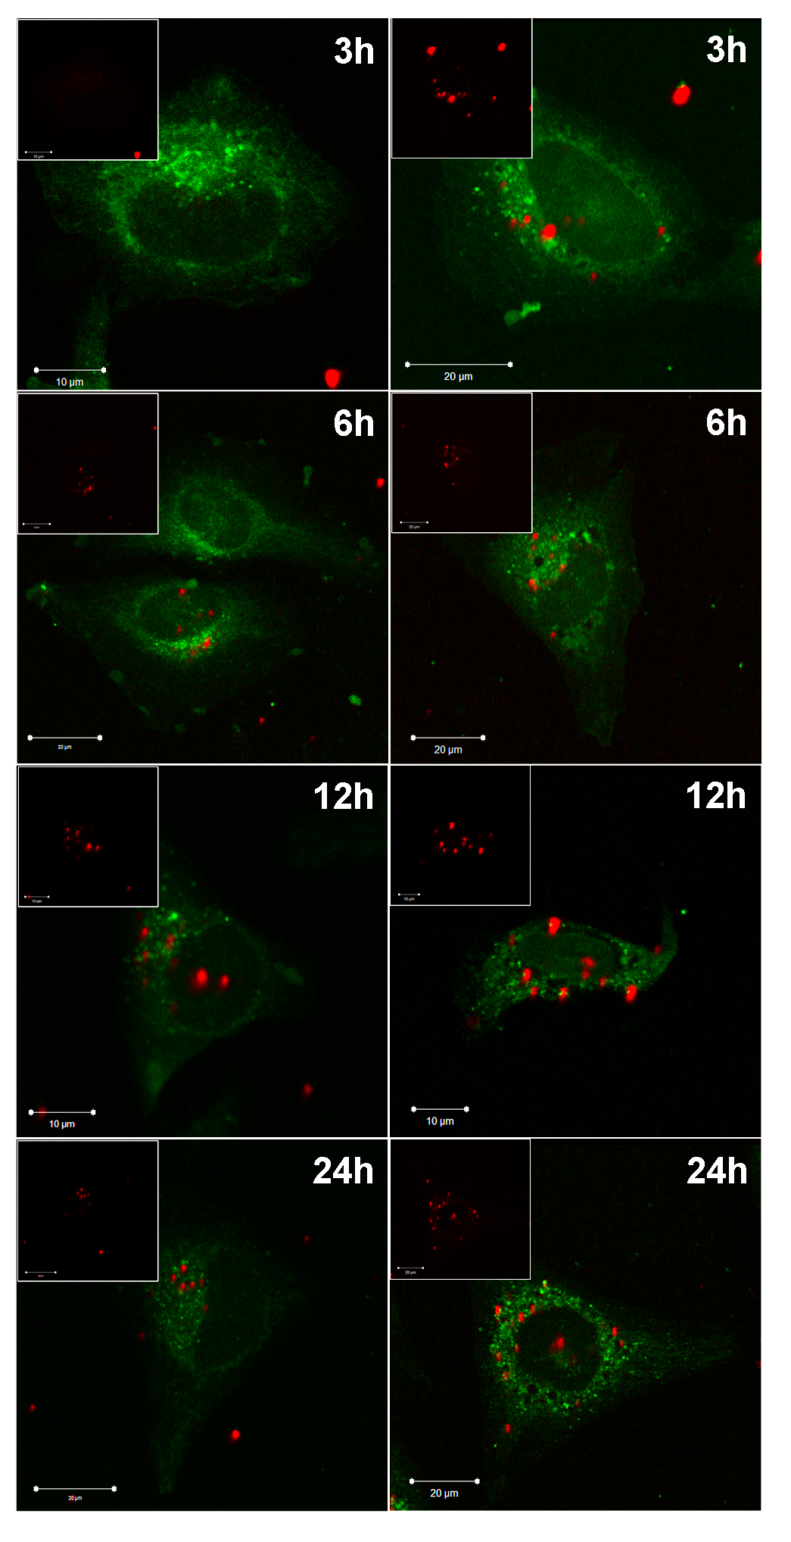
Figure 7. Confocal images of HeLa cells after 3 h, 6 h, 12 h and 24 h incubation in a solution of 2.0 μM NaYF₄: 2 % Er³⁺, 30 Yb³⁺ nanoparticles (on the left side) and in a solution of 2.0 μM nanoparticles with Lipofectamine 2000 (on the right side). Autofluorescence of cells was marked of green color that was obtained at excitation 488 nm (CW) and detection 508-585 nm. Clusters of nanoparticles NaYF₄: 2% Er³⁺, 30% Yb³⁺ / PVP were marked with red color at excitation 980 nm (femtosecond laser) and detection 515-671 nm. Insert: nanoparticle canal. Images obtained from confocal microscopy.

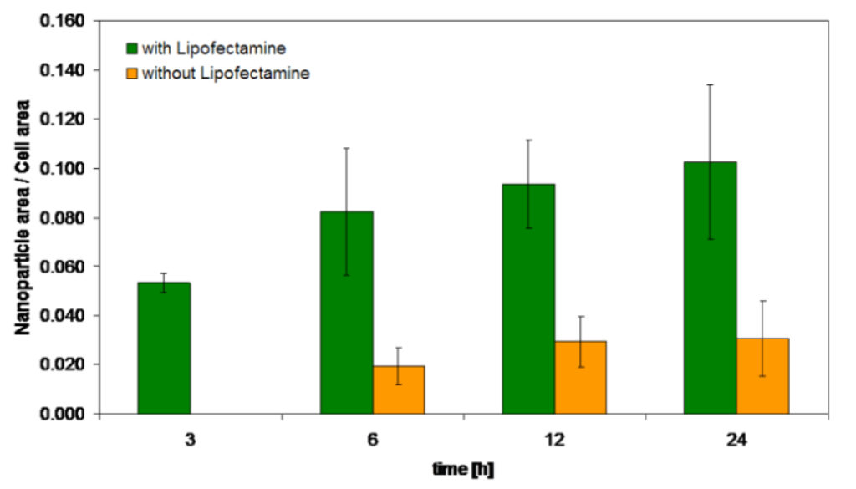
Figure 8. The ratios of nanoparticle to cell areas for different incubation time in the presence and absence of Lipofectamine 2000 analyzed by CellProfiler program [37]. The intensity of the nanoparticles was similar for each incubation time. Results were obtained for several confocal images at the same laser power and gain settings.

The up-conversion emission spectra obtained when the laser pulse was focused inside cells on the nanoparticles, inside cells without nanoparticles and outside the cell (points marked as A , B and C in figure 9, respectively) is shown in figure 9. The red and green emission characteristics for up-converting nanoparticles are observed when the laser spot is located inside the cell on the nanoparticles. A very low autofluorescence is observed, when the laser spot is located inside the cell without nanoparticles. On the other hand, no detectable fluorescence (including the autofluorescence) was observed when the laser beam was localized outside the cell. The emission spectra for other incubation times are observed as well (data not shown).
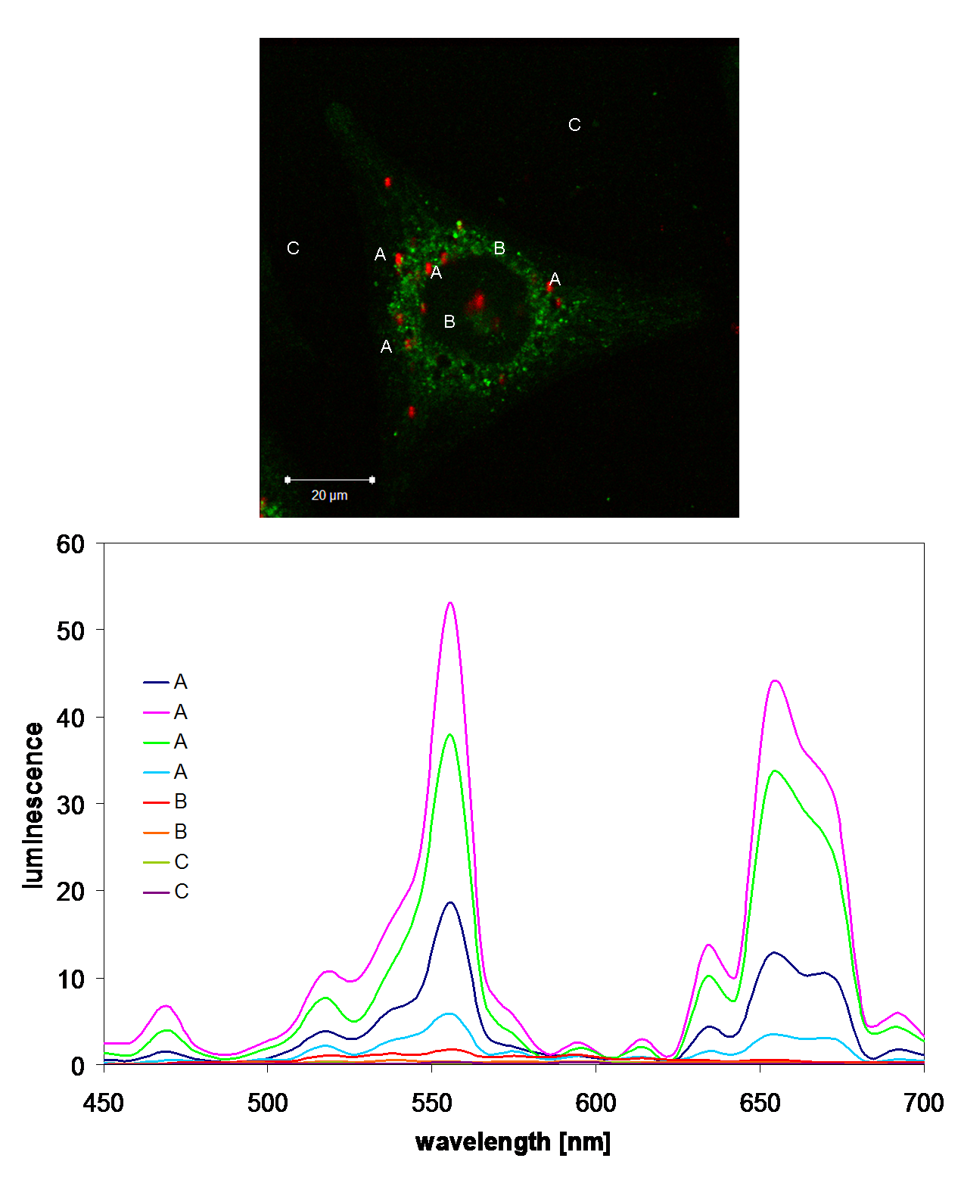
Figure 9. Up-conversions emission spectrum obtained when the laser pulse was focused inside cells on nanoparticles, inside cells without nanoparticles and outside the cell (points marked as A, B and C in figure 9, respectively). Luminescence obtained for 980 nm excited (lambda scan mode from a confocal microscope).

We also examined the effect of the nanoparticles concentration on their internal cellular distribution. For this purpose, solutions were used at a 0.2 μM, 0.4 μM, 2.0 μM, 4.0 μM, 20 μM and 40 μM. The incubations were carried out for 24 hours in the presence and absence of Lipofectamine 2000. The results for 0.2 μM, 2.0 μM and, 20 μM are shown in figure 10. The results for concentrations of 0.4 μM, 4.0 μM, and 40 μM are shown in figure S5.
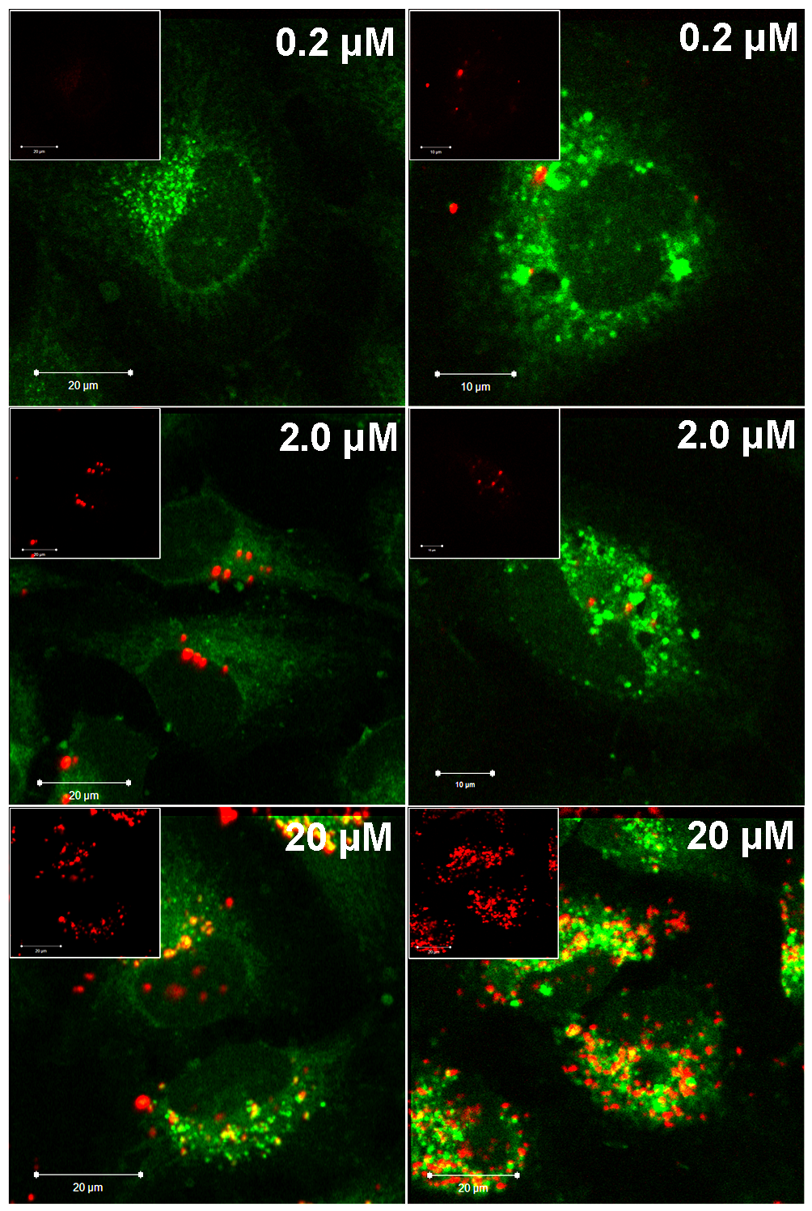
Figure 10. Confocal images of HeLa cells after 24 h incubation in a solution of 0.2 μM, 2.0 μM and, 20 μM NaYF₄: 2 % Er³⁺, 30 Yb³⁺ nanoparticles (on the left side) and in a solution of 0.2 μM, 2.0 μM and, 20 μM nanoparticles with Lipofectamine 2000 (on the right side). Autofluorescence of cells was marked of green color that was obtained at excitation 488 nm (CW) and detection 508-585 nm. Clusters of nanoparticles NaYF₄: 2% Er³⁺, 30% Yb³⁺ / PVP were marked with red color at excitation 980 nm (femtosecond laser) and detection 515-671 nm. Inside: nanoparticle channel. Images obtained from confocal microscopy.

Nanoparticles were not observed inside the cells at concentration of 0.2 μM in the absence of the liposomes. When the concentration of nanoparticles increases by 10 times (2.0 μM), some nanoparticles appear in the cytoplasm inside cells and on their membranes. For higher concentration (20 μM), many particles are distributed throughout the cytoplasm. In the case of nanoparticles incubated with cells in the presence of Lipofectamine 2000 much more nanoparticles enter into cells in comparison to incubation without Lipofectamine 2000 (see figure 11). Several nanoparticles are visible in the cytoplasm and near the cell membrane for the concentration of 0.2 μM. It is worth emphasizing that for the same concentrations of nanoparticles without the presence of the vesicles we did not observe any nanoparticles in the interior of the cells. When the concentration of nanoparticles was increased 10 times a higher number of clusters of nanoparticles inside the cell were observed (incubation with the liposomes). Nanoparticles have a clear tendency to cluster around the nucleus. There are more nanoparticles inside the cells than in the case of incubation without the Lipofectamine 2000 vesicles. The results are presented in figure 11. A similar correlation can be observed for concentrations of 0.4 μM, 4.0 μM, and 40 μM (figure S5).

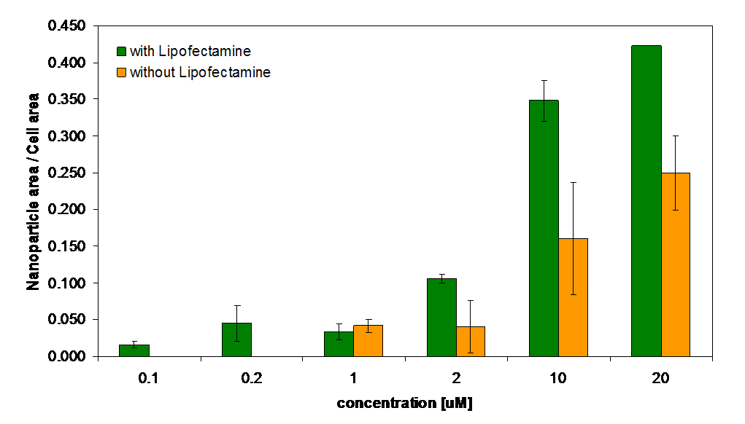
Figure 11. The ratios of nanoparticle to cell areas for various nanoparticles concentrations in the presence and absence of Lipofectamine 2000 analyzed by CellProfiler program [37]. The intensity of the nanoparticles was similar for each incubation time. Results were obtained for several confocal images at the same laser power and gain settings.

4. Conclusions

Small, pure cubic phase NaYF₄ nanoparticles doped with different amounts of rare earth ion Er³⁺ and Yb³⁺ were synthesized using PVP as a chelating agent. Nanoparticles are uniform and their size is adjusted depending on the experimental conditions. In addition, the crystals are monodisperse in water and several commonly used organic solvents. These nanocrystals have great potential for biological application. We have shown that PVP coated, water-soluble, up-converting NaYF₄ nanoparticles can be easily introduced into cells by endocytosis. A very efficient fluorescence from NIR to visible light of nanoparticles after excitation with 980 nm femtosecond laser was used to obtain images with an excellent intracellular contrast and temporal stability. Images of single cells obtained after different incubation times and with or without the liposomes show the dynamic behavior of nanoparticles inside the cell as a consequence of intracellular activity. For short incubation times and without the liposomes, nanoparticles are not internalized. However, for short incubation times in the presence of the vesicles, nanoparticles are endocytosed. Incubation with the liposomes causes enhanced incorporation of nanoparticles. The reported results present an evidence of potential applications of NaYF₄ nanoparticles to static and dynamic bioimaging. Similar observations were made based on the nanoparticles concentration dependent study in the presence and absence of the transporter. A tendency to accumulate around the nucleus already at low concentrations was noted as consequence of the intracellular transportation of nutrients from the cellular membrane to the vicinity of the nuclear envelope probably by endosome – mediated transport.
Selection of optimal nanoparticles concentration and time of incubation is important in dynamic imagining studies and has critical influence on cellular viability and provide a facial strategy to synthesize and develop multimodal imagining materials.
We have not determined toxicity of NaYF₄: Er³⁺, Yb³⁺ nanoparticles. Several previously published result reported relatively low toxicity of NaYF₄: Er³⁺, Yb³⁺. For example: Zhou J-C et al [50] published in vitro and in vivo toxicity of NaYF₄: Yb³⁺,Tm³⁺ nanoparticles coated with polyethylenimine (PEI) with HeLa cell. The cell viability of the NaYF₄: Yb³⁺, Tm³⁺ nanoparticles was tested on HeLa cells by CCK-8 assay. Cells viability have been greater than 80% when the concentration of NaYF₄:Yb³⁺, Tm³⁺ nanoparticles was as high as 1000 µg/ml, after 24 h incubation. Xiong L et al [51], based on the MTT assay with human nasopharyngeal epidermal carcinoma cell line KB, reported cytotoxicity of polyacrylic acid (PAA)-coated NaYF₄: Yb³⁺, Tm³⁺ nanoparticles. No significant differences in the cellular proliferation were observed in the absence or presence of 6-480 µg/ml (PAA)-coated NaYF₄: Yb³⁺, Tm³⁺ nanoparticles. After 24 h incubation with nanoparticles, the cellular viabilities were estimated to be greater than 94%. Even after 48 h of incubation with PAA-NaYF₄: Yb³⁺, Tm³⁺ nanoparticles, at a concentration as high as 480 µg/ml, KB cells maintained greater than 80% cell viability. These results demonstrated that PAA-NaYF₄: Yb³⁺, Tm³⁺ have low cytotoxicity, suggesting their potential for in vivo imaging. Shan J et al. [52] report cellular toxicity and uptake by incubating the amino and carboxyl functionalized NaYF₄: Er³⁺, Yb³⁺ nanoparticles with human osteosarcoma cells. Amino groups were added by using the 3-aminopropyltrimethoxysilane reaction after a thin layer of SiO₂ coating. The carboxyl groups on the surface were added directly by coating the modified amphiphilic polyacrylic acid polymer. The authors reported the MTT toxicity measurements of the amino and carboxyl groups functionalized nanoparticles. At the concentration of 1 mg/ml, after nine days incubation, with amino functionalized nanoparticles were 96.2% alive compared with the control group, while 92.8% for cells incubated with carboxyl functionalized nanoparticles. The results demonstrated that nanoparticles functionalized by both amino and carboxyl groups show relatively low toxicity. Two additional samples with 0.25 mg/ml and 0.0625 mg/ml nanoparticles were incubated with cells at the same conditions. The results showed that 93.0% and 96.3% survived, respectively. Therefore, a slight difference among the three concentrations indicated that the concentration effects of the functionalized nanoparticles on the toxicity were negligible, under the above assay conditions.
Zhang Y et al. [53] reported a study investigating the cytotoxicity of polyethylenimine-coated upconversion fluorescent nanocrystals, PEI-NaYF₄: Yb³⁺, Er³⁺. They incubated the PEI-NaYF₄:Yb³⁺, Er³⁺ nanoparticles with rat skeletal myoblasts and bone marrow-derived stem cells and used MTS and LDH assays to assess the in vitro cytotoxicity. The cell viability decreased significantly from 98 ± 5% to 65 ± 7% as the concentration of the nanocrystals increased from 5 to 100 μg/ml.
In this study we applied from 0,2 µM (0,03 µg/ml) to 40 µM (5,55 µg/ml) NaYF₄: 2 % Er³⁺, 30 % Yb³⁺. Thus we used much lower concentrations than applied in the previous cytotoxicity publications which report no or low toxicity under their experimental conditions.

Acknowledgements:
The research was partially supported by the European Union within European Regional Development Fund, through grant Innovative Economy (POIG.01.01.02-00-008/08) and was partially supported by the grant from the Polish National Centre for Research and Development NR13004704 and Center of Excellence. The study was carried out with the support of the project financing agreements POIG.02.02.00-14-024/08-00. This work has been done in the NanoFun laboratories co-financed by the European Regional Development Fund within the Innovation Economy Operational Programme, the Project No. POIG.02.02.00-00-025/09/. Acknowledgements to dr Remigiusz Worch (Institute of Physics, Polish Academy of Science) for assistance in confocal measurements, prof. Grzegorz Wilczyński (Nencki Institute of Experimental Biology, Polish Academy of Science), dr Jakub Włodarczyk (Nencki Institute of Experimental Biology, Polish Academy of Science) for access to the confocal microscope and mgr Paweł Krawczyk (Institute of Biochemistry and Biophysics, Polish Academy of Science) for Cellprofiler program analysis.

References:
[1] Ntziachristos V, Ripoll J, Wang L V and Weissleder R 2005 Nat Biotechnol 23 313-20
[2] König K 2000 J Microsc 200 83-104
[3] Vetrone F, Naccache R, de la Fuente A J, Sanz-Rodriguez F, Blazquez-Castro A, Rodriguez E M, Jaque D, Sole J G and Capobianco J A 2010 Nanoscale 2 495-8
[4] Sevick-Muraca E M, Houston J P and Gurfinkel M 2002 Curr Opin Chem Biol 6 642-50
[5] Piston D W 1999 Trends Cell Biol 9 66-9
[6] Xu C, Zipfel W, Shear J B, Williams R M and Webb W W 1996 Proc Natl Acad Sci USA 93 10763-8
[7] Brigger I, Dubernet C and Couvreur P 2002 Adv Drug Deliv Rev 54 631-51
[8] Chatterjee D K, Fong L S and Zhang Y 2008 Adv Drug Deliv Rev 60 1627-37
[9] Gao X, Cui Y, Levenson R M, Chung L W K and Nie S 2004 Nat Biotechnol 22 969-76
[10] Li J L, Wang L, Liu X Y, Zhang Z P, Guo H C, Liu W M and Tang S H 2009 Cancer Lett 274 319-26
[11] Park Y I, Kim J H, Lee K T, Jeon K-S, Na H B, Yu J H, Kim H M, Lee N, Choi S H, Baik S-I, Kim H, Park S P, Park B-J, Kim Y W, Lee S H, Yoon S-Y, Song I C, Moon W K, Suh Y D and Hyeon T 2009 Adv Mater 21 4467–71
[12] Ye X, Collins J E, Kang Y, Chen J, Chen D T N, Yodh A G and Murray C B 2012 Proc. Natl. Acad. Sci. USA 109(51) 20826-31
[13] He G S, Yong K T, Zheng Q, Sahoo Y, Baev A, Ryasnysnskiy A I and Prasad P N 2007 Opt Express 15 12818-33
[14] Larson D R, Zipfel W R, Williams R M, Clark S W, Bruchez M P, Wise F W and Webb W W 2003 Science 300 1434-6
[15] Park J, Estrada A, Sharp K, Sang K, Schwartz J A, Smith D K, Coleman C, Payne J D, Korgel B A, Dunn A K and Tunnell J W 2008 Opt Express 16 1590-9
[16] Wang D S, Hsu F Y and Lin C W 2009 Opt Expres 17 11350-9
[17] Sertchook H and Avnir D 2003 Chem Mater 15 1690-4
[18] van de Rijke E H, Zijlmans H, Li S, Vail T, Raap A K, Niedbala R S and Tanke H J 2001 Nat Biotechnol 19 273-6
[19] Yi G S, Lu H C, Zhao S Y, Yue G, Yang W J, Chen D P and Guo L H 2004 Nano Lett 4 2191-6
[20] Suyver J F, Aebisher A, Biner D, Gerner P, Grimm J, Heer S, Kramer K W, Reinhard C and Gudel H U 2005 Opt Mater 27 1111-30
[21] Auzel F 2004 Chem Rev 104 139-73
[22] Corstjens P L A M, Li S, Zuiderwijk M, Kardos K, Abrams W R, Niedbala R S and Tanke H J 2005 IEE Proc-Nanobiotechnol 152 64-72
[23] Kunigas K, Rantanen T, Karhunen U, Lovgren T and Soukka T 2005 Anal Chem 77 2826-34
[24] Heer S, Kompe K, Gudel H U and Haase M 2004 Adv Mater 16 2102-5
[25] Lim S F, Riehn R, Tung C, Ryu W S, Zhuo R, Dalland J and Austin R H 2009 Nanotechnology 20 405701-1-5
[26] Kramer K W, Biner D, Frei G, Gudel H U, Hehlen M P and Luthi S R 2004 Chem Mater 16 1244-51
[27] Zeng J H, Su J, Li Z H, Yan R X and Li Y D 2005 Adv Mater 17 2119-23
[28] Schietinger S, Menezes L de S, Lauritzen B and Benson O 2009 Nano Lett 9(6) 2477-81
[29] Boyer J X and van Veggel F C J M 2010 Nanoscale 2 1417-9
[30] Mai H X, Zhang Y W, Si R, Yan Z G, Sun L D, You L P and Yan C H 2006 J Am Chem Soc 128 6426-36
[31] Boyer J C, Vetrone F, Cuccia L A and Capobianco J A 2006 J Am Chem Soc 128 7444-5
[32] Yang Y, Li J R, Mu J, Rong H L and Jiang L 2006 Nanotechnology 17 461-5
[33] Li Q, Li T and Wu J G 2001 J Phys Chem B 105 12293-6
[34] Li Z and Zhang Y 2006 Angew Chem 118 7896-9
[35] Rau R C 1962 Advances in X-ray Analysis New York: Plenum vol 5
[36] Rodriguez-Carvajal J 1993 Physica B: Condensed Matter 192 55-69
[37] CellProfiler cell image analysis software. The CellProfiler project is based at the Broad Institute Imaging Platform. It was started by Anne E. Carpenter and Thouis (Ray) Jones in the laboratories of David M. Sabatini and Polina Golland at the Whitehead Institute for Biomedical Research and MIT's CSAIL.
[38] Aebischer A, Heer S, Biner D, Kramer K, Haase M and Gudel H U 2005 Chem Phys Lett 407 124-8
[39] Schlenker J L and Peterson B K 1996 J Appl Crystallogr 29 178-85
[40] Zhang F, Chan S, Spanier J E, Apak E, Jin Q, Robinson R D and Herman I P 2002 Appl Phys Lett 80 127-9
[41] Si R, Zhang Y W, You L P and Yan C R 2006 J Phys Chem B 110 5994-6000
[42] Auzel F 2004 Chem Rev 104 139-73
[43] Alivisatos A P. 1996 Science 271 933-7
[44] Tong L, Wei Q, Wei A and Cheng J X 2009 Photochem Photobiol 85 21-32
[45] Jiang S, Zhang Y, Lim K M, Sim E K W and Ye L 2009 Nanotechnology 20 155101-9
[46] Wang M, Mi C C, Wang W X, Liu C H, Wu Y F, Xu Z R, Mao C B and Xu S K 2009 ACS Nano 3 1580-6
[47] Hu H, Xiong L, Zhou J, Li F, Cao T and Huang C 2009 Chem Eur J 15 3577-84
[48] Im J, Maiti K K, Kim W, Kim K -T and Chung S -K 2011 Bull Korean Chem Soc 32(4) 1282-92
[49] Zhang L W and Monteiro-Riviere N A 2009 Toxicol Sci 110(1) 138–55
[50] Zhou J-C, Yang Z-L, Dong W, Tang R-J, Sun L-D and Yan C-H 2011 Biomaterials 32 9059-67
[51] Xiong L, Yang T, Yang Y, Xu C and Li 2010 Biomaterials 31 7078-85
[52] Shan J, Chen J, Meng J, Collins J, Soboyejo W, Friedberg J S and Ju Y 2008 J Appl Phys 104 094308-1-7
[53] Zhang Y, Rufaihah A J, Sim E K W, Ye L and Chen N G 2008 Biomed Proceedings 21 82–5

