Title: Luminescence of colloidal ZnO nanoparticles synthesized in different alcohols for future biological application

Authors names: Bożena Sikora*^{[1]}, Krzysztof Fronc^{[1]}, Izabela Kamińska^{[1]}, Kamil Koper^{[2] [3]}, Anna Baranowska-Korczyc^{[1]}, Piotr Stępień^{[2] [3]}, Danek Elbaum^{[1]}

Author Affiliations: ^{[1]} Institute of Physics, Polish Academy of Sciences, al Lotników 32/46, 02-668 Warsaw, Poland; ^{[2]} Institute of Genetics and Biotechnology, University of Warsaw ul. Pawińskiego 5a, 02-106 Warsaw;
^{[3]} Institute of Biochemistry and Biophysics PAN ul. Pawińskiego 5a, 02-106 Warsaw

E-mail: sikorab@ifpan.edu.pl

Abstract. This report presents the results of spectroscopic measurements of colloidal ZnO nanoparticles synthesized in various alcohols. Luminescence of colloidal ZnO was monitored, under different reaction condition, to elucidate the mechanism of the visible emission. We perform the process in different alcohols, temperatures and reaction time for two different reactants: water and NaOH. Based on the presented and previously published results it is apparent that the luminescence of the nanoparticles is influenced by several competing phenomena: the formation of new nucleation centers, the growth of the nanoparticles and surface passivation. Superimposed on the above effects is a size dependent luminescence alterations resulted from the quantum confinement. The study contributes to understanding the origin of ZnO nanoparticles green emission which is important in a rational design of fluorescent probes for nontoxic biological applications. Thus produced nanoparticles are coated with a magnesium oxide layer, and introduced into the HeLa cancer cell.

Keywords: nanocrystals; green luminescence; sol-gel; quantum dots; colloids; ZnO

1. Introduction
Semiconductor nanostructures have been in focus of attention because of a wide range of potential applications in photonics, spintronics, optoelectronics, piezoelectronics, gas sensing, and hopefully in the next generation of biosensors and medical imaging devices [1].
ZnO nanoparticles, as a relatively biocompatible and environmentally friendly material, is potentially suitable for biomedical applications. These nanoparticles can be functionalized by biological molecules that are capable of attaching themselves to specific molecules in the cell through chemical interactions (e.g. the antibody – antigen, avidin – biotin, DNA hybridization or to receptors in a biological cell membrane). The impact of the size of ZnO nanoparticles on cytotoxicity has been reported [2-4]. Antibacterial properties of 0.04 to 1.3 mM ZnO aqueous solutions were demonstrated on Escherichia coli [5]. ZnO reduced adhesion of bacteria and blocked bacterial invasion of the intestinal cells [6]. Antibacterial activity of ZnO was observed also on a broad spectrum of microorganisms [7], pointing to their potential external bacteriostatic applications in ointments, lotions and mouthwashes.
While selective cytotoxicity of 60 nm ZnO nanoparticles was reported in various glioma cells, no cytotoxic effect was observed in normal human fibroblasts. The nanoparticles induced death in breast and prostate cancer cells, but did not effect cells viability of the respective normal cell lines [8]. Similarly, cancerous T cells were found to be substantially more susceptible to ZnO nanoparticles (8 – 13 nm) mediated cytotoxicity than the normal T-cells [9]. A strong preferential ability of ZnO nanoparticles to kill cancer cells could suggest their potential pharmacological application. It has been observed [10] that ZnO nanoparticles (11 nm) increased E. coli cells permeability and was internalized in the bacteria. While in the presence of the ZnO nanoparticles, at concentration between 3 mM to 10 mM, a complete inhibition of bacterial growth was observed, at 1 - 1.5 mM, an increased of the bacteria growth was observed, suggesting that ZnO could be a metabolite at low concentration levels, as well.
Fluorescent probes have been intensively applied to investigate cellular physiology and morphology. Majority of fluorescent probes currently applied are based on either organic dyes or luminescent macromolecules. However their usefulness is limited by their instability, predominantly due to photobleaching. Semiconducting nanoparticles offer a logical alternative. However, the biological toxicity generated by nanoparticles is of major concern and was reported previously for heavy metals cations and Reactive Oxygen Species generated by nanoparticles in aqueous environments [11].
A successful application of ZnO nanoparticles in biomedical imagining requires in depth understanding of their luminescence properties. ZnO (a donor – bound excitons band gap of 3.1 - 3.4 eV – structure and size dependent at 300 K, a large exciton binding energy – 60 meV) has efficient emission in room temperatures and size-tunable photoluminescence. Colloidal suspension of ZnO nanocrystals exhibits two emission bands: the excitonic band edge at approximately 380 nm and a intensive and broad visible emission band assigned to various trap states and attributed to surface defects [12]. The precise nature of the blue-green emission is not yet defined, its intensity, as well as fluorescence maxima, could be tailored by controlling the kinetics and thermodynamics of the ZnO synthesis in the colloidal solutions.
Although there are several hypotheses which rationalize the origin of defective ZnO luminescence [13], none have yet been unequivocally proven. Several mechanisms of the blue emission from ZnO were recently proposed and attributed to interstitial zinc defects [14]. We decided to examine of the nature of green luminescence of 3 – 6 nm ZnO nanoparticles, by studying the sol-gel synthesis under various reaction conditions for two different reactants. The results were found to be consistent with the previously proposed mechanism which attributes the 510 – 540 nm emission band being a result of shallowly trap electrons recombining with deeply trapped double charged vacancies [15]. Involvement of surface defects in the green emission was confirmed. This report will contribute to understanding the nature of ZnO green luminescence and general defect related fluorescence required for future biological applications. To the best of our knowledge, a direct and simultaneous compression of the ZnO nanoparticles synthesis, under such a diversify conditions (two reactants, various alcohols, temperatures and reaction times), has been reported for the first time. Kinetyka syntezy otrzymywanych przez nas nanocząstek została przez nas opisana wcześniej w publikacji Sikora et al []. Tak otrzymane nanocząstki zostały pokryte warstwą tlenku magnezu i wprowadzone do komórek nowotworowych HeLa.

2. Material and Methods.
Suspension of nanocrystalline ZnO particles was prepared as previously [16]. 0.01 mM Zn(CH₃COO)₂ x 2H₂O (Chempur, pure p. a.) dissolved in 10 ml ethanol (Chempur, min 99.8 %, pure p. a), isopropanol (Chempur, min 99.7 %, pure p. a), 2-butanol (Chempur, min 99.5 %, pure p. a), pentanol (Chempur, min 98.5 %, pure p. a) and hexanol (Fluka, min 98 %) respectively. 3 ml of 1 mM salt solution was placed in quartz cuvette, constantly stirred, followed by injection of either 22 μl of freshly prepared de-ionized and distilled water pH 7 (final concentration 400 mM), or 0.84 ml 5.7 mM NaOH solution (final concentration 1.6 mM) [17,18]. Real time reactions was monitoring across absorption and luminescence in different temperatures (25, 35, 45, 55, and 65 °C) and time for up to 101 min.
The absorption and emission spectra were monitored and recorded at defined reaction times using Cary 50 Scan UV-Vis Spectrophotometer and Fluorolog III Spectrophotometer, both instruments were equipped with thermo-stated cuvette holder. The appropriate solvents were used as references at various temperatures.

3. Results and Discussion.

3.1. Mechanism of green luminescence of ZnO.
The absorption and luminescent spectra recorded for different ZnO samples (synthesized either from water or from NaOH ) are depicted in figure 1. Absorption spectra for the water synthesis (figure 1A) and the NaOH synthesis (figure 1C) revealed that the UV band moves towards higher wavelengths due to the size increase resulted from the time dependent growth of the nanoparticles. Luminescence spectra for the water synthesis (figure 1B) depicted a change of the surface defects (Vis) band and increase of the exciton emission which could be interpreted as a decrease of the surface to volume ratio resulted from o the nanoparticles growth. Interestingly, when NaOH was used as a reactant (figure 1D) the luminescence spectra were dominated by the visible band. Pointing to a different nature of the surface defects compared to the water synthesis.

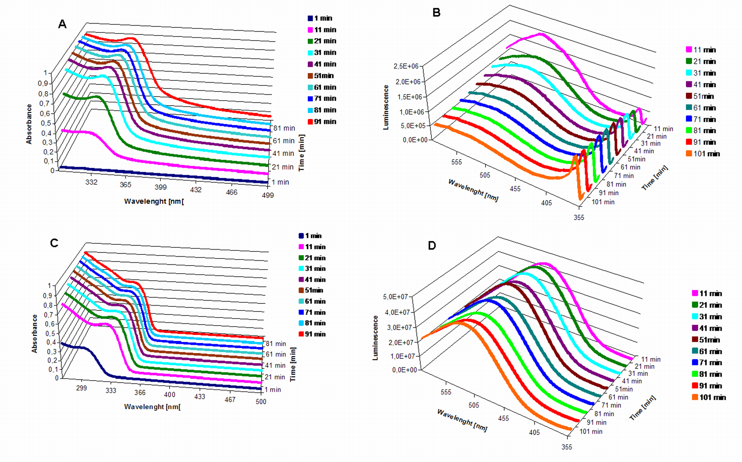
Figure 1. Left: absorption spectra, right: luminescence spectra of ZnO nanoparticles obtained at 55 °C in hexanol from zinc acetate and water (A and B) or zinc acetate and NaOH (C and D) [16]. Excitation at 325 nm.

Luminescence spectra presented in figure 2 resulted from the time dependent synthesis and growth of the colloidal ZnO nanoparticles in various alcohols in the presence of water (left panels) and NaOH (right panels). It is apparent from the results that several competitive processes contribute to the time dependent luminescence intensity and the emission maxima: nanoparticle number, size and a substrate dependent nature of the surface defects (table 1, table 2).

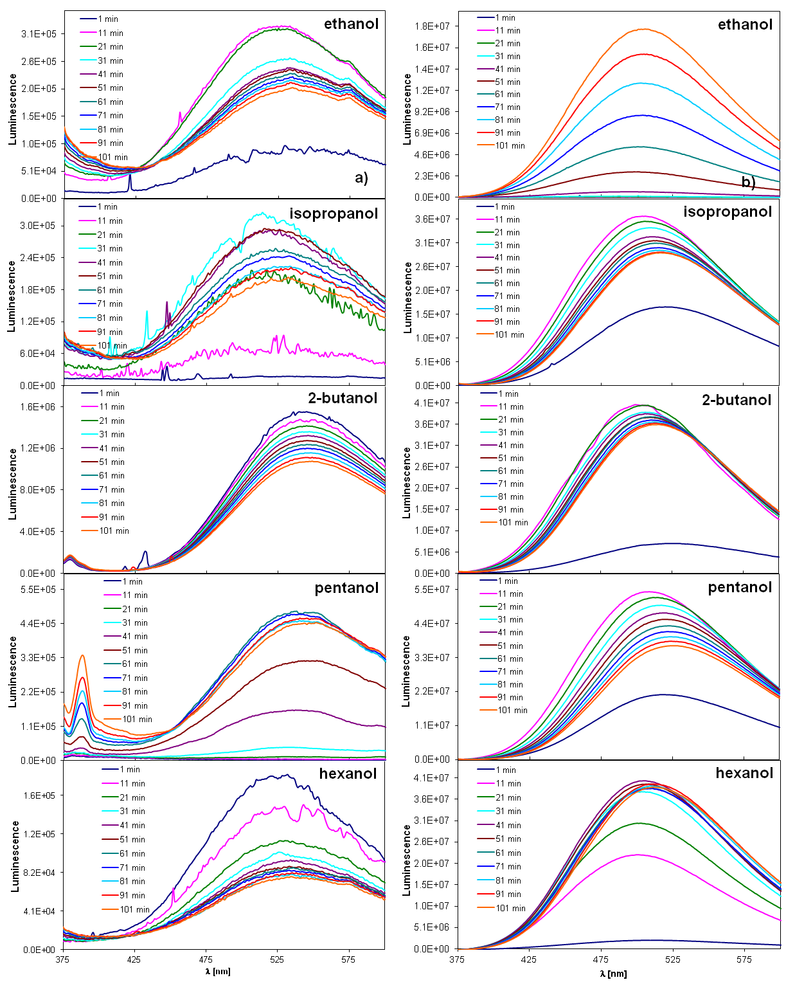
Figure 2. Luminescence spectra of ZnO nanoparticles obtained from zinc acetate and a) water, b) NaOH, depending on the time of synthesis. Nanoparticles prepared in different solvents (ethanol, isopropanol, 2-butanol, pentanol, hexanol) at 45 °C. Excitation at 325 nm.
Table 1. ZnO sizes based on the Effective Mass Approximation [16]. ZnO obtained from H₂O in hexanol in different temperature.

H₂O  hexanol | 25 °C | 35 °C | 45 °C | 55 °C | 65 °C
t [min] | 2R [nm] | 2R [nm] | 2R [nm] | 2R [nm] | 2R [nm]
0 | 0 | 0 | 0 | 0 | 0
1 | 4.7 | 4.4 | 4.6 | 0 | 4.6
11 | 4.6 | 4.4 | 4.6 | 4.7 | 4.8
21 | 4.6 | 4.4 | 4.6 | 4.8 | 4.9
31 | 4.6 | 4.4 | 4.6 | 4.9 | 5.2
41 | 4.6 | 4.4 | 4.7 | 5.0 | 5.2
51 | 4.6 | 4.4 | 4.7 | 5.0 | 5.3
61 | 4.6 | 4.4 | 4.7 | 5.1 | 5.3
71 | 4.6 | 4.4 | 4.8 | 5.1 | 5.3
81 | 4.6 | 4.4 | 4.8 | 5.3 | 5.3
91 | 4.6 | 4.4 | 4.8 | 5.6 | 5.3
101 | 4.6 | 4.4 | 4.8 | 5.6 | 5.3

Table 2. ZnO sizes based on the Effective Mass Approximation [16]. ZnO obtained from NaOH in hexanol in different temperature.

NaOH  hexanol | 25 °C | 35 °C | 45 °C | 55 °C | 65 °C
t [min] | 2R [nm] | 2R [nm] | 2R [nm] | 2R [nm] | 2R [nm]
0 | 0 | 0 | 0 | 0 | 0
1 | 3.8 | 3.9 | 4.0 | 4.1 | 4.2
11 | 4.0 | 4.2 | 4.3 | 4.5 | 4.6
21 | 4.0 | 4.3 | 4.4 | 4.6 | 4.7
31 | 4.1 | 4.3 | 4.4 | 4.6 | 4.8
41 | 4.1 | 4.3 | 4.5 | 4.7 | 4.8
51 | 4.2 | 4.4 | 4.5 | 4.7 | 4.8
61 | 4.2 | 4.4 | 4.5 | 4.7 | 4.8
71 | 4.2 | 4.4 | 4.6 | 4.7 | 4.8
81 | 4.2 | 4.4 | 4.6 | 4.8 | 4.8
91 | 4.2 | 4.5 | 4.6 | 4.8 | 4.8
101 | 4.2 | 4.5 | 4.6 | 4.8 | 4.8

Room temperature luminescence of ZnO nanostructures consists of a UV (band edge emission) and one or more visible bands resulted from structure defects [13]. While the UV emission observed for ZnO nanoparticles at approximately 380 nm (just above the onset of absorption) was attributed to radiative annihilation of excitons, the etiology of visible luminescence has not been yet elucidated. Several different hypothesis have been proposed to explain green luminescence in ZnO nanostructures:
a. transition of photogenerated electrons close to conductive band to the singly ionized oxygen vacancy centers [19-22],
b. presence of Cu impurity [23], sulfur impurities [24], adsorbed oxygen [25],
c. oxygen vacancies and zinc interstitials [26],
d. presence of zinc vacancies [27,28],
e. presence of surface hydroxyl anions (OH⁻) [29],
f. presence of antisite oxygen [30],
g. combination of various transitions involving intrinsic defects: donor-acceptor transition, recombination at double charged oxygen vacancies with shallow trap state photogenerated electrons, responsible for one or more shallow donors to a deep acceptor transitions, oxygen and zinc vacancy and surface defects [31-34].
Although the nature of defects present in ZnO colloidal nanoparticles responsible for the green fluorescence has not been unequivocally defined. Our results (figure 1, figure 3) are consistent with involvement of the nanostructure’s surface. Almost an order of magnitude of drop of the UV to visible fluorescence ratio was observed for smaller nanoparticles synthesized when water was used as the reactant. Similar, however less pronounced, trend was observed for the NaOH synthesis (figure 3). Thus the green fluorescence of small nanostructures (3 nm – 4,5 nm), having a significant number of ZnO exposed to surface, generates more pronounced visible luminescence compared to the larger particles (5 nm – 6 nm).
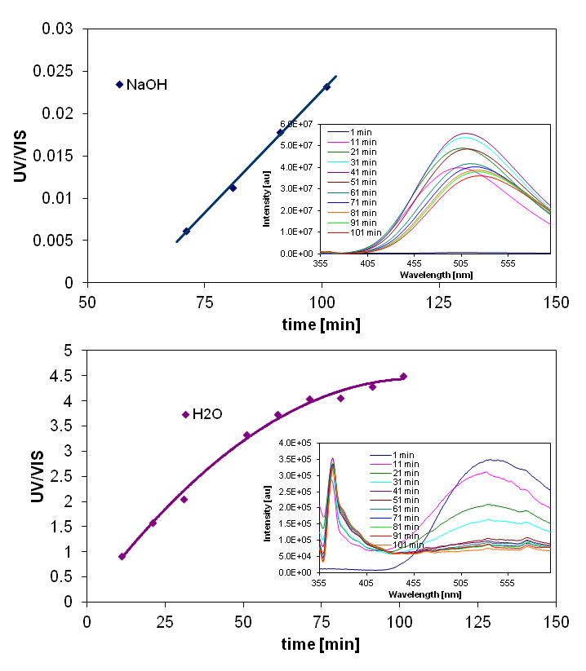

Figure 3. Time dependent ratios of UV to VIS luminescence maxima for the ZnO synthesis: (a) the reactant was NaOH, (b) the reactant was water. Insert: luminescence spectra (exc: 325 nm). Nanoparticles were synthesized in hexanol at 65 °C.
Figure 3 compares the ratios of UV luminescence to visible luminescence for two reactants: NaOH and water. Note drastic differences between ZnO emission spectra observed in the presence of two different reactants. When NaOH was used, a substantial enhancement of the green luminescence was observed. Pointing to a role of the reactant induced surface defects to the ZnO luminescence.
Involvement of ZnO conduction band and its shallow trap states electrons (e⁻) in the green luminescence can be conjectured based on the comparison of excitation, emission and absorption spectra for ZnO at two different temperatures: 35 °C and 55 °C synthesized in hexanol for 100 min (figure 4).
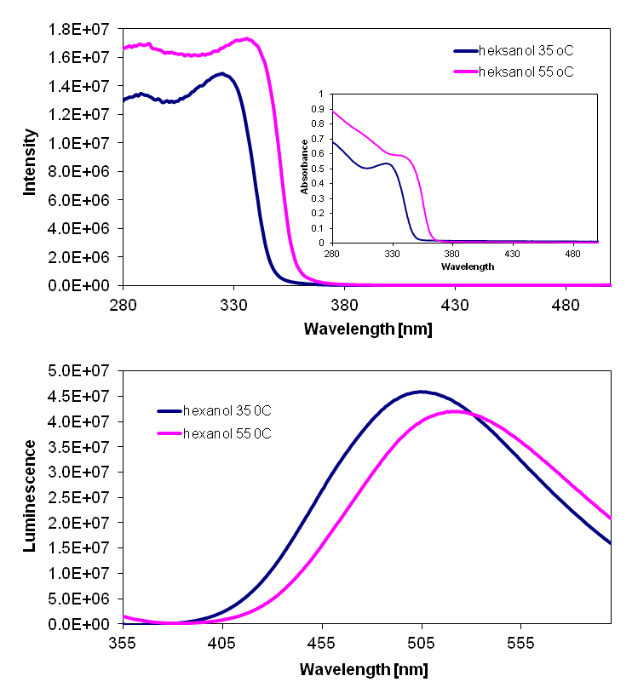

Figure 4. Up: the excitation spectrum at a wavelength 535 nm recorded for 35 °C and 55 °C in hexanol after 100 minutes of ZnO synthesis using NaOH. Insert contains the absorption spectrum for ZnO nanoparticles. Down: luminescence spectra of ZnO nanoparticles recorded at the excitation wavelength 325 nm. All three spectra were recorded on the same sample and identical conditions.

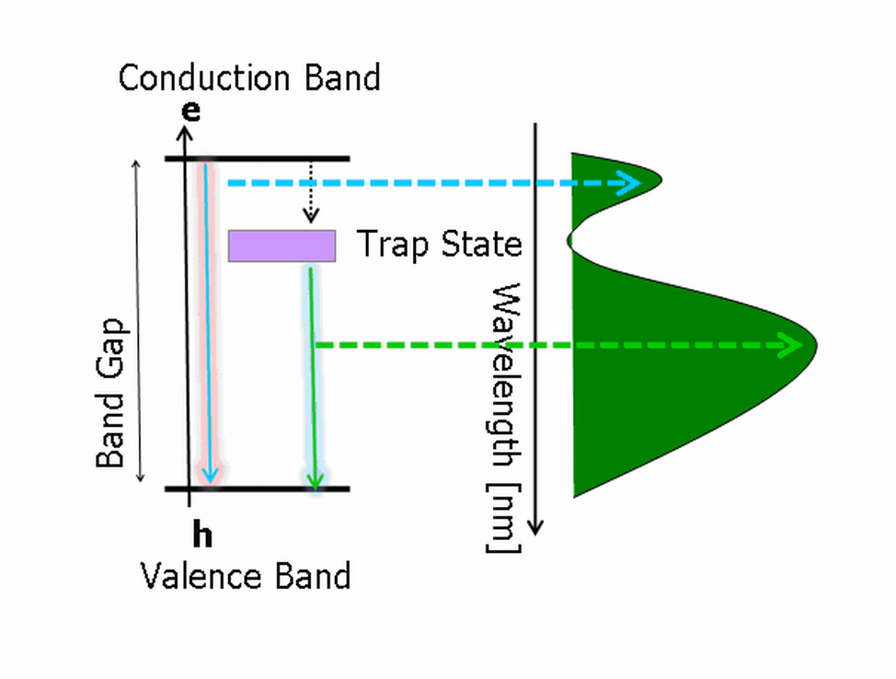

Figure 5. Energy level diagram describing radiative recombination for ZnO excitons.

The results summarized by figure 4 point to the observation that at maximum green luminescence (535 nm), excitation energy has intensity maxima at 325 nm (in 35 °C) and 338 nm (in 55°C). This is consistent with the involvement of energies equal or larger than the band gap energy in generating green luminescence and supports the hypothesis of ZnO conduction band shallow trap state (e⁻) participate in the green luminescence. Thus the green luminescence (535 nm) could result from a photogenerated conduction band electrons transition to deep trap oxygen vacancy (Vo⁺⁺) states as suggested previously [35]. Comparison of excitation, emission and absorption spectra for ZnO points to the energy level diagram (figure 5).

3.2. Influence of synthesis conditions on defect luminescence.
Figure 6 shows plots of the wavelength dependence on the maxima of green emission for the various time of the ZnO synthesis. The plots were obtained for ZnO prepared from NaOH (blue) and water (red) in ethanol in different temperatures (35 °C, 45 °C, 55 °C , 65 °C). The green emission shifts towards lower energy with the size growth of nanoparticles (for water and NaOH). The maxima of the luminescence in all studied cases, were substantially lower (higher energy) for the NaOH synthesis compared to the water reaction. We observed a higher energies of emission for all reactions where NaOH was used as a reactant compared to the water reactions. Clearly, presence of interacting cations (Na⁺) with the ZnO surface affected the observed luminescence.

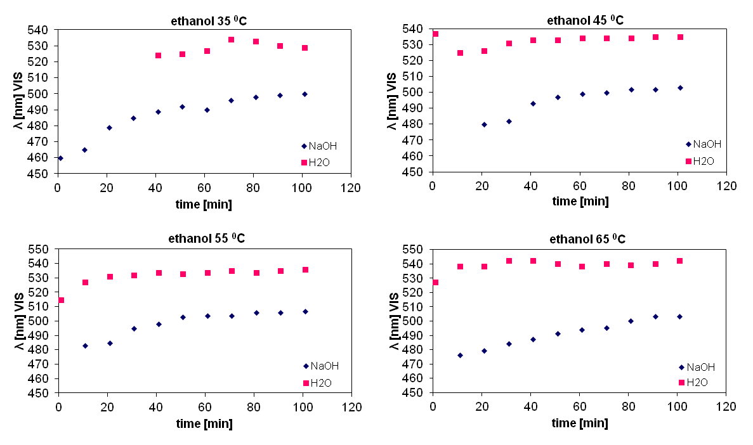

Figure 6. Graphs of maximum emission wavelength originating from defects in ZnO nanoparticles as a function of time of synthesis. Graphs were obtained for ZnO synthesized from NaOH (blue) and water (red) in ethanol at temperatures of 35 °C, 45 °C, 55 °C, 65 °C.

A contribution of Na⁺ ions on the intensity of ZnO green luminescence as a function of the synthesis time are depicted by figure 7. A substantial enhancement of the luminescence intensity was observed for the NaOH synthesis compared to the H₂O reaction.
Figures 6 and 7 point to an important contribution of sodium ions to the energy and intensity of green luminescence observed for colloidal ZnO nanoparticles. The role of sodium could be a result of amphoteric properties of Na acting as an acceptor when substituting for Zn or as a donor occupying interstitial sites [36]. Na ions are known to generate deep acceptor centers producing shallow donor – deep acceptor recombination manifested by the green fluorescence. On the other hand the authors postulated that presence of Na and Li could induced shallow acceptors as well. In addition, co-doping of Na with H, as a hydrogen – acceptor complex, was postulated to be an effective pathway to increase Na acceptors concentration [37].

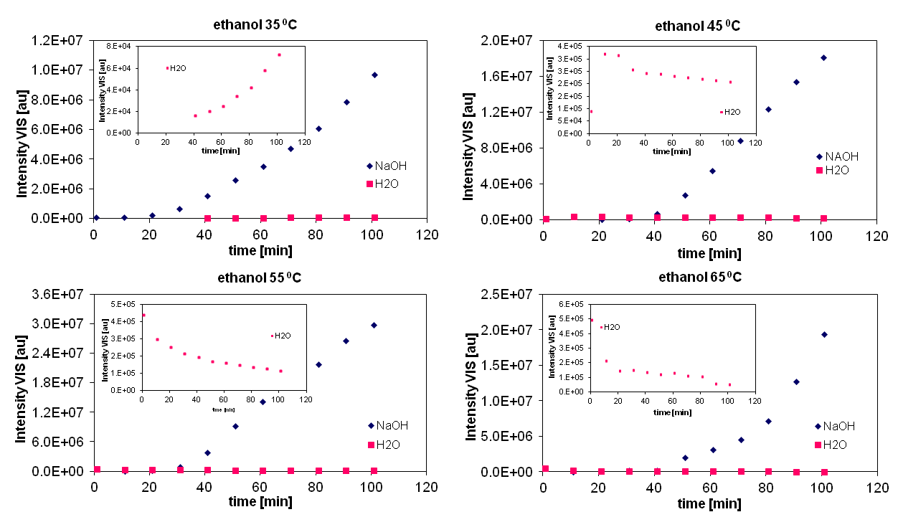

Figure 7. Intensity of luminescence derived from defects in ZnO nanoparticles depending on time of synthesis of ZnO. Graphs were obtained for the ZnO synthesized from NaOH (blue) and water (red) in ethanol at temperatures of 35 °C, 45 °C, 55 °C, 65 °C.

The role of Na⁺ ions on the kinetics of colloidal ZnO growth was noted [38]. The growth rate was shown to depend on the hydroxyl ion concentration and an effective surface passivating layer consisting of sodium ions localized on the surface of ZnO forming a capping shell. It is of interest to note (figure 7 inserts) that at the lowest temperature (35 °C) (the slowest rate of crystal seeding) the increasing number of nanoparticles could be responsible for the increase of UV intensity. On the other hand, at higher temperatures (45, 55, 65 °C) , the crystals growth could be the dominant factor resulted the decrease of the UV luminescence.

4. Conclusions
Nanoparticles of 3 – 6 nm wurtzite ZnO were synthesized by a sol – gel method. The reactions of Zn(CH₃COO)₂ with water and NaOH were performed in several alcohols (ethanol, 2-propanol, pentanol and hexanol) and temperatures (25, 35, 45, 55, 65 °C). Luminescence of colloidal ZnO was monitored, under different reaction condition, to elucidate the mechanism of the visible emission. Based on the reported results, it is apparent that the luminescence of the nanoparticles is influenced by several competing phenomena: the formation of new nucleation centers (increase of luminescence), the growth of the nanoparticles (decrease of visible luminescence due to change of surface to volume), surface passivation (enhancement of green luminescence). Superimposed on the above effects is a size dependent luminescence alterations resulted from the quantum confinement. Based on our results we conjecture: the green fluorescence originates from recombination of conduction band trapped electrons and deep trap state holes (excitation, emission and absorption spectra). The visible luminescence is influence by the nanocrystals surface passivation which for Na⁺ could result from formation of additional surface defects and acceptor centers. Therefore, in order to tailor desired for biological application green luminescence probe synthesized by sol – gel method the surface and structural defects should be considered. Altering the reaction condition (substrate, temperature, time, solvent) the optimal fluorophore can be synthesized.

Acknowledgements
This work has been supported by grant from Innovative Economy POIG.01.02-00-008/08.

Reference:
[1] Provenzale J M, Silva G A 2009 Am. J. Neuroradiol 30 1293
[2] De Berardis B, Citivitelli G, Condello M, Lista P, Pozzi R, Arancia G, Meschim S 2010 Toxicol. Appl. Pharmacol. 246 116
[3] Guo D, Wu C, Jiang H, Li Q, Wang X, Chen B 2008 Journal of Photochemistry and Photobiology B: Biology 93 119
[4] Li J, Guo D, Wang X, Jiang H, Chen B 2010 Nanoscale Res. Lett. 5 1063
[5] Zhang L, Jiang Y, Ding Y, Daskalakis N, Jeuken L, Povey M, O’Neill A, York D 2010 J. Nanopart. Res. 12(5) 1625
[6] Roselli M, Finamore A, Garaguse I, Britti M S, Mengheri E 2003 Biochemical and Molecular Actions of Nutrients 4077
[7] Jones N, Ray B, Ranjit K T, Manna A C 2008 FEMS Microbiol. Lett. 279 71
[8] Ostrovsky S, Kazimirsky G, Gedanhen A, Brodie C 2009 Nano Res. 2 882
[9] Hanley C, Layne J, Punnoose A, Reddy K M, Coombs I, Coombs A, Feris K, Wingett D 2008 Nanotechnology 19(29) 295103-1
[10] Brayner R, Ferrari-lliou R, Brivois N, Djediat S, Benedetti M F, Fievet F 2006 Nano Lett. 6 866
[11] Schneider R, Wolpert C, Guilloteau H, Balan L, Lambert J, Merlin C 2009 Nanotechnology 20 225101(1)
[12] Norberg N S, Gamelin D R 2005 J. Phys. Chem. B 109 20810
[13] Djurisic A B, Leung Y H 2006 Small 2 No 8-9 944
[14] Zeng H, Duan G, Li Y, Yang S, Xu X, Cai W 2010 Adv. Funct. Mater 20 1
[15] van Dijken A, Maulenkamp E A, Vanmaekelbergh D, Meijerink A 2000 J. Phys. Chem. B 104(8) 1715
[16] Sikora B, Fronc K, Kaminska I, Baranowska-Korczyc A, Sobczak K, Dłużewski P, Elbaum D 2012 Journal of Sol-Gel Science and Technology 61 494
[17] Viswanatha R, Santra P K, Dasgupta C, Sarma D D 2007 PRL 98 255501
[18] Hu Z, Oskam G, Searson P C 2003 Journal of Colloid and Interface Science 263 454
[19] Meng X Q, Shen D Z, Hang J Y, Zhao D X, Lu Y M, Dong L, Hang Z Z, Liu Y C, Fan X W, 2005 Solid State Commun. 135 179
[20] Chen Y Q, Jiang J, He Z Y, Su Y, Cai D, Chen L 2005 Mater. Lett. 59 3280
[21] Ng H T, Chen B, Li J, Han J, Meyyappan M, Wu J, Li S X, Haller E E 2003 Appl. Phys. Lett. 82 2023
[22] Wang Z, Lin C, Liu X, Li G, Luo Y, Quan Z, Xiang H, Lin J 2006 J. Phys. Chem. B 110(19) 9469
[23] Garces N Y, Wang L, Bai L, Giles N C, Halliburton L E, Cantwell G 2002 Appl. Phys. Lett. 81 622
[24] Lehman W 1968 J. Electrochem. Soc. 115 538
[25] Van Craeynest F, Maenhout-Van der Vorst W, Dekeyser W 1968 Phys. Status Solidi 8 841
[26] Liu X, Wu X, Cao H, Chang R P H J. 2004 Appl. Phys. 95 3141
[27] Zhao Q X, Klason P, Willander M, Zhong H M, Lu W, Yang J H 2005 Appl. Phys. Lett. 87 211912
[28] Heo Y W, Norton D P, Pearton S J, 2005 J. Appl. Phys. 98 073502
[29] Norberg N S, Gamelin D R 2005 J. Phys. Chem. B 109(44) 20810
[30] Yang Q, Tang K, Zuo J, Qian Y 2004 Appl. Phys. A 79 1847
[31] Reynolds D C, Look D C, Jogai B 2001 J. Appl. Phys. 89 6189
[32] van Dijken A, Meulenkamp E, Vanmaekelbergh D, Meijerink A 2000 J. Phys. Chem. B 104 1715
[33] van Dijken A, Meulenkamp E, Vanmaekelbergh D, Meijerink A 2000 J. Lumin. 90 123
[34] Djurisic A B, Choy W C H, Roy V A L, Leung Y H, Kwong C Y, Cheah K W, Gundu Rao T K, Chan W K, Lui H F, Surya C 2004 Adv. Funct. Mater. 14 856
[35] Zhou H, Alves H, Hofmann D M, Kriegseis W, Mayer B K, Kaczmarczyk G, Hoffmann A 2002 Appl. Phys. Lett. 80 210
[36] Meyer B K, Stehr J, Hofstaetter A, Volbers N, Zeuner A, Sann 2007 J Applied Physics A 88 119
[37] Lee E C, Chang K J 2006 Physica B: Condensed Matter 367-377 707
[38] Viswanatha R, Amenitsch H, Sarma D D, 2007 J. Am. Chem. Soc. 129(14) 4470

