Dual catalytic role of the metal ion in nickel-assisted peptide bond hydrolysis

Ewa Izabela Podobas, Arkadiusz Bonna*, Agnieszka Polkowska-Nowakowska, Wojciech Bal*

Institute of Biochemistry and Biophysics, Polish Academy of Sciences, Pawińskiego 5a, 02-106 Warsaw, Poland.

* Corresponding authors: A. Bonna: E-mail abonna@ibb.waw.pl, Fax: +48 22 659 4636; W. Bal, E-mail wbal@ibb.waw.pl, Fax: +48 22 659 4636
Abstract
In our previous research we demonstrated the sequence specific peptide bond hydrolysis of the R₁-(Ser/Thr)-Xaa-His-Zaa-R₂ in the presence of Ni(II) ions. The molecular mechanism of this reaction includes an N-O acyl shift of the R₁ group from the Ser/Thr amine to the side chain hydroxyl group of this amino acid. The proposed role of the Ni(II) ion is to establish favorable geometry of the reacting groups. In this work we aimed to find out whether the crucial step of this reaction – the formation of the intermediate ester – is reversible. For this purpose we synthesized the test peptide Ac-QAASSHEQA-am, isolated and purified its intermediate ester under acidic conditions, and reacted it, alone, or in the presence of Ni(II) or Cu(II) ions at pH 8.2. We found that in the absence of either metal ion the ester was quickly and quantitatively (irreversibly) rearranged to the original peptide. Such reaction was prevented by either metal ion. Using Cu(II) ions as CD spectroscopic probe we showed that the metal binding structures of the ester and the final amine are practically identical. Molecular calculations of Ni(II) complexes indicated the presence of steric strain in the substrate, distorting the complex structure from planarity, and absence of steric strain in the reaction products. These results demonstrated the dual catalytic role of the Ni(II) ion in this mechanism. Ni(II) facilitates the acyl shift by setting the peptide geometry, and the prevents the reversal of the acyl shift, by stabilizing subsequent reaction products.

Keywords
Peptide bond hydrolysis; Ni(II) complexes; Acyl shift, Ni(II) molecular catalysis

1. Introduction
Nickel and its compounds are toxic to humans, via inhalatory, dermal and alimentary routes. Contact allergy and respiratory cancers are two major health hazards related to nickel exposure, under environmental and occupational conditions, respectively. While it has become clear that Ni(II) ions are the ultimate toxic species, the exact molecular mechanisms of toxicity are the subject of dispute [1-9].
Nickel(II) dependent peptide bond hydrolysis (in brief, nickel-assisted hydrolysis) is a promising molecular concept for several aspects of nickel toxicity. This sequence specific reaction may impair function of important intracellular proteins, such as zinc finger transcription factors, at the same time yielding stable and reactive Ni(II) complexes, capable of damaging DNA and proteins [10-16]. Peptides susceptible to nickel hydrolysis have a general sequence R₁-(Ser/Thr)-Xaa-His-Zaa-R₂, (where Xaa and Zaa are any amino acids except of Pro and Cys as Xaa, and Cys as Zaa, and R₁ and R₂ are nonspecific N-terminal and C-terminal peptide sequences). The hydrolysis occurs, with an absolute selectivity, at the peptide bond preceding Ser/Thr. Scheme 1 illustrates key steps of the reaction [13, 14]. The reaction is enabled by the formation of a square-planar complex in which the Ni(II) ion bonded by the imidazole nitrogen of the His residue and three preceding amide nitrogens. The first crucial step of the reaction is the N-O acyl shift of the carbonyl group of to hydrolysable R₁-Ser/Thr peptide bond to the Ser/Thr hydroxyl group. This step follows an apparent 1st order kinetic regime (k₁ in Scheme 1). The resulting ester intermediate product (IP) is unstable in water solution, hydrolyzing into two peptides, also according to the apparent 1st order kinetics (k₂ in Scheme 1). The C-terminal peptide product of this reaction step remains bonded to the Ni(II) ion. Therefore, the overall reaction is stoichiometric (1:1), rather than catalytic, with respect to Ni(II). The reaction rate is strongly dependent on the spatial orientations of side chains of amino acids belonging to the Ni(II) coordination site [17], and is strongly (up to a factor of 200) enhanced in the presence of bulky residues C-terminal to the His residue [18]. These facts confirm the notion that crucial role of the Ni(II) ion is largely geometrical. The square-planar coordination mode induces strain on the hydrolysable peptide bond, modulated by sterical crowding of the above mentioned side chains.
In the course of our studies we noted that the stability of IP varies significantly among various peptide sequences studied. In all cases the overall reaction was irreversible, resulting in the full conversion of the substrate into final products. This was assured by the irreversible character of the 2nd step of the reaction, the well-known acid- or base-catalyzed ester hydrolysis [19]. Nevertheless, the data we collected so far did not provide information on the reversibility of the 1st step, the IP formation. This issue can be quite important for many purposes, including the practical application of the reaction for purification of recombinant proteins [20].
We decided to study this issue using a peptide of the sequence Ac-QAASSHEQA-am, (Ac- denotes the N-terminal acetylation, and –am the C-terminal amidation of the peptide chain), which yields a long-lived and easy to extract IP. This peptide was chosen on the basis of our current research on hydrolysis of filaggrin, a protein involved in the process of outer skin keratinization [21].

2. Experimental
2.1 Reagents
N-α-9-Fluorenylmethyloxycarbonyl (F-moc) amino acids were purchased from Sigma-Aldrich, and Fluka Co. Trifluoroacetic acid (TFA), piperidine, O-(Benzotriazol-1-yl)-N,N,N′,N′-tetramethyluronium hexafluorophosphate (HBTU), triisopropylsilane (TIS), N.N-diisopropylethylamine (DIEA) and nickel(II) nitrate hexahydrate were obtained from Sigma-Aldrich. TentaGel® S RAM resin was obtained from Rapp Polymer Inc. Acetonitrile (HPLC grade) was obtained from Rathburn Chemicals Ltd. Pure sodium hydroxide was obtained from Chempur. HEPES (≥99.5%) was purchased from Carl Roth GmbH.

2.2. Peptide Synthesis
The Ac-QAASSHEQA-am (substrate, S) and SSHEQA-am (product, P) peptides were synthesized in the solid phase according to the Fmoc protocol [22] using an automatic synthesizer (Protein Technology Prelude). The syntheses were accomplished on a TentaGel S RAM resin, using HBTU as a coupling reagent, in the presence of DIEA. The acetylation of the N-terminus was carried out in 10 % acetic anhydride in DCM. In both cases the cleavage was done manually by the cleavage mixture composed of 95 % TFA, 2.5 % TIS and 2.5 % water. S and P were isolated from cleavage mixtures by precipitation by the addition of cold diethyl ether. Following precipitation, peptides were dissolved in water and lyophilized.
S and P were purified by HPLC (Waters) using an analytical C18 column (ACE 250x 4.6 mm) monitored at 220 and 280 nm. The eluting solvent A was 0.1% (v/v) TFA in water, and solvent B was 0.1% (v/v) TFA in 90% (v/v) acetonitrile. The correctness of molecular masses and purities of peptides were confirmed using a Q-Tof1 ESI-MS spectrometer (Waters). After this step the S and P solutions were frozen in liquid nitrogen and lyophilized.

2.3. UV-vis and CD spectroscopies
UV-visible spectra were recorded in the range of 300-800 nm, on a Cary 50-Bio (Varian) UV-vis spectrometer, using 1 cm cuvettes. The solutions contained 0.95 mM substrate with 0.9 mM Ni(II), 1 mM substrate or product with 0.9 mM Cu(II), and 0.2 mM intermediate product with 0.18 mM Cu(II), all dissolved in H₂O. The pH of the solution was adjusted manually in the range of 4-12 for Ni(II), and 2-12 for Cu(II), by adding small amounts of concentrated NaOH. The pK_{a} values for the complex formation were obtained by fitting the absorption value at the band maximum to the Hill equation [23]. Circular dichroism (CD) spectra of Cu(II) complexes with S, IP, and P were recorded in the range of 270-800 nm, on a Jasco J-815 spectropolarimeter, using the same samples as for UV-vis experiments.

2.4. Ni(II) dependent Ac-QAASSHEQA-am peptide hydrolysis
The hydrolysis experiment were performed in a 20 mM HEPES buffer. The concentration of peptide and nickel(II) nitrate were 0.5 and 2 mM respectively. After setting the pH to 8.2, the samples were incubated at 50 °C in a heating block (J.W. Electronics). These conditions were chosen on the basis of previous studies to optimize the data collection timing [14]. The aliquots were collected at 0, 15, 30, 60, 120, 240, 480 and 1440 minutes. Control samples, containing peptide and buffer, but without Ni(II), were gathered at the same time points. The 50 µl aliquots were added to 50 µl of 2 % (v/v) TFA to stop the hydrolysis reaction (acidification results in separation of nickel(II) from the Ni(II)-peptide complex). Solutions were stored at 4 °C. For analysis, reaction mixtures were diluted by water 4 to 1 and injected into the HPLC system (Waters), equipped with an analytical C18 column. The eluting solvent A was 0.1% (v/v) TFA in water, and solvent B was 0.1% (v/v) TFA in 90% (v/v) acetonitrile. The gradient conditions are presented in Table 1. The chromatograms were obtained at 220 and 280 nm. Based on the retention times and molecular masses, confirmed using a Q-Tof1 ESI-MS spectrometer (Waters), peaks of the substrate (molecular mass 968.98), the IP (the same mass), and co-eluting final products (molecular masses: 330.34 and 656.65) were identified. The relative amounts of these fractions in each chromatogram were calculated by peak integration using data analysis software Origin 8.1 (OriginLab Corporation).

2.5. Kinetic analysis
To calculate the rate constants k₁ and k₂ for the hydrolysis reaction the set of three equations (Kinet A, Kinet B, and Kinet C) was used, similarly to previous studies [14, 17, 18].
Kinet A
Kinet B 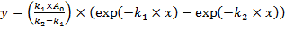
Kinet C 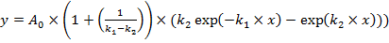
In these equations y is a molar fraction of a given species, x is the time axis, and A₀ denotes the initial concentration of the substrate.

2.6. Intermediate product isolation
Additional hydrolysis reactions were performed in order to isolate the IP for separate experiments. On the basis of the preceding kinetic study under the same conditions, 45 min. was selected as incubation time at 50 °C in the heating block. Then, the hydrolysis reaction of 0.5 mM S with 2 mM Ni(II) in a 20 mM HEPES buffer, pH 8.2 was stopped by adding 2 % TFA (v/v) in a volume ratio of 1 to 1. This step allowed to separate the Ni(II) ions from the IP. Subsequently, the whole sample was purified using HPLC at conditions described above. The fractions containing intermediate product was lyophilized and used for further experiments. To measure the final concentration of IP, we compared its HPLC peak areas with that of S of the known concentration.

2.7. Reactions of IP alone, and with Ni(II) and Cu(II) ions
Lyophilized IP samples were dissolved in a 20 mM HEPES, pH 8.2 to a final 0.5 mM concentration, in the absence or presence of metal ions. The pH measured under dissolution at ambient temperature was 7.9. After setting the pH to 8.2 using concentrated NaOH, the sample was incubated at 50 °C in the heating block. The aliquots were collected for HPLC analysis at 0.5, 1, 2, 3, 4, 5 min and 24 h for the peptide alone, at 15, 30, 60, 120 min and 24 h in the presence of 2 mM Ni(II), and at 0.5, 1, 2, 3, 4, 5 and 15 min in the presence of 2 mM Cu(II). For the peptide alone and with Cu(II), additional samples were collected before and immediately after the pH adjustment. The HPLC analysis was performed as described above.

2.8. Molecular modeling of Ni(II) complexes
All molecular mechanics simulations were performed using AMBER03 forcefield [24] and YASARA software [25]. Point charges for coordinated residues in substrate, product and intermediate product complexes with Ni(II) ions were obtained using the RESP fitting procedure available at R. E. D. Server [26-29]. To obtain the molecular electrostatic potential, three amino acid models were built for complexes using Accelrys Discovery Studio Visualizer 2.0 on the basis of the structure of a highly analogous Ni(II) complex with glycylglycyl-α-hydroxy-D, L-histamine [30]. Modifications were introduced to match the studied sequence. The correct geometry of each model was predicted by energy minimization using Dreiding-like forcefield [31]. Final geometries of the models were optimized on the B3LYP/6-31G** level of theory [32, 33]. The stationary points were confirmed to be the minimum by frequency analysis. Molecular electrostatic potentials (MEP) of the optimized models were calculated on the B3LYP/cc-pVTZ level of theory using continuum solvent model. Quantum mechanical calculations were performed with the aid of Gaussian09 rev. D1 [34]. Simulated annealing was performed in 1000 cycles, consisting of 9 ps heating from 300 to 1100 K and then 4.512 ps cooling to 300 K, 4.5 ps equilibration period at 300 K, followed by energy minimization. The script for calculations was built by us on the basis of available scripts for NMR structure refinement in vacuum in YASARA package. The change introduced was using more steps for gradual increment of nonbonding forces during the cooling phase. Lowest energy conformers were used as a representation of the structure of the complex. Molecular graphics were created with YASARA (www.yasara.org) and POVRay (www.povray.org).

3. Results
3.1. Ni(II) dependent Ac-QAASSHEQA-am peptide hydrolysis.
The first step of our research was the characterization of Ni(II) binding by the Ac-QAASSHEQA-am peptide and its susceptibility to nickel-asssisted hydrolysis. We started with the UV-vis spectroscopic pH titration of the equimolar Ac-QAASSHEQA-am / Ni(II) system. The spectra and the resulting titration curve are presented in Figure 1. The pK_{a} value for the formation of the square-planar Ni(II) complex, determined from the pH dependence of the absorption band at 461 nm was 8.31 ± 0.01, with a high cooperativity (Hill coefficient 2.6 ± 0.1) [23]. This value is typical for the cooperative deprotonation of amide nitrogens upon the formation of fused chelate rings around the metal ion in complexes of hydrolysable histidine peptides [14, 18].
The hydrolysis of 0.5 mM Ac-QAASSHEQA-am with a fourfold excess of Ni(II) ions at 50 ºC and pH 8.2 was studied by HPLC, according to our standard methodology [13, 14, 17, 18]. Figure 2 presents the kinetics of this reaction, analyzed according to the model of two sequential 1st order processes (Kinet A, Kinet B, and Kinet C equations), and Table 2 presents values of the corresponding k₁ and k₂ rate constants. The reaction is relatively fast, as compared with those studied by us previously [14, 17, 18, 20]. The highest levels of IP can be observed at 45-75 min. of incubation, and the full conversion of the substrate to the final products is accomplished within 16 hours.
Based on these results, 45 min. was chosen as the most suitable incubation time for IP collection. Further experiments were carried out using lyophilized IP fractions, calibrated by a comparison of the HPLC peak areas of IP and the standard substrate samples.

3.2. IP reaction with Ni(II) ions.
Figure 3 presents HPLC chromatograms of samples at different times of incubation of IP with Ni(II) ions, along with the control chromatogram of pure lyophilized IP (top panel). The identity of IP was further confirmed by the ESI-MS spectrum (m/z identical to that of the reaction substrate, as shown in the Supplementary file, but a significantly different retention time). At 15 min. partial conversion of IP to substrate was observed, followed by gradual decrease of substrate, through IP towards the final reaction products, according to the pattern observed in the standard hydrolysis scheme (Figure 2). In contrast, the control sample contained only the substrate after a 24 h incubation without Ni(II) ions.
These results prompted us to repeat the experiment without Ni(II) ions, but with a closer look at the first few minutes of incubation. During the preparation of samples, the pH was measured before and after the addition of IP to the HEPES buffer. The peptide dissolved in HEPES of pH 8.2 had pH 7.9, because it was lyophilized in acidic conditions of HPLC separation. Therefore, the pH of the sample had to be readjusted to 8.2 with concentrated NaOH under ambient conditions. Figure 4 shows HPLC chromatograms of these two samples, before and after pH adjustment, and those collected at short incubation times at 50 ºC. As soon as the IP was added to HEPES buffer, small amounts of substrate were observed in the sample. After adjusting the pH to 8.2 the IP level decreased rapidly. After 5 minutes of incubation at 50 ºC the whole IP was converted into substrate, and remained as such, as confirmed by the 24 hour incubation, shown in Figure 3. The conversion of IP into the substrate follows the 1st order rate law, as illustrated in Figure 5. The 1st order rate constant for this process, k₃ (Table 2), is ca. 15 times faster than k₁ in the presence of Ni(II) ions at the same pH and temperature.
The final hydrolysis experiment, presented in Figure 6, was designed analogously to that shown in Figure 3, but Cu(II) ions were added to IP instead of Ni(II) ions. Cu(II) ions are able to rapidly (much faster than Ni(II) ions) form complexes with peptides with equatorial coordination of peptide nitrogens. These complexes with His-3 peptides, such as the IP and the C-terminal final products (see Scheme 1) are analogous to those of Ni(II) in terms of the formation of the chelate ring system, but more stable by several orders of magnitude of the equilibrium constant [35]. On the other hand, the Cu(II)-dependent peptide bond hydrolysis, analogous to the Ni(II)-dependent process described here, proceeds at least 10 times slower under similar conditions [11]. Therefore, assuming that the substitution of Ni(II) with Cu(II) ions yields the analogous peptide conformation, and the reaction proceeds according to Scheme 1, the Cu(II) ions could be expected to stabilize IP and protect it from rearrangement to either substrate or final reaction products, within the time window of 5 minutes, which was sufficient for the reversal of IP into substrate in the absence of metal ions.
As shown in Figure 6, a small amount of IP was rearranged into substrate during the pH adjustment, but this process was stopped immediately after the Cu(II) addition. Even after 15 minutes of incubation, the proportion of peaks of IP and substrate were unchanged and the reaction final products were not detected.

3.3 Spectroscopic characterization of IP using Cu(II) ions
The inertness of IP in the presence of Cu(II) ions prompted us to investigate the structure of its molecule using Cu(II) ions as spectroscopic probe. For comparative purposes we performed UV-vis and CD spectroscopic titrations of S, IP and P samples in the broad pH range. Table 3 collects the spectral parameters, and Figure 7 illustrates the results by showing the CD spectra and titrations curves, constructed using the maximum wavelengths of intense charge transfer (CT) transitions above 300 nm. The complex formation for S was biphasic, and spectral parameters can be readily assigned to 3N and 4N complexes. In contrast, the complexation process for IP and P was monophasic – the 4N complex was formed directly from the Cu(II) aqua ion. The CD spectra and the pH range of this process were very similar for these two compounds, with practically identical pK_{a} values of 4.0, much lower from the complex formation for S (Table 3).

3.4 Molecular modeling of Ni(II) complexes
Ten calculated lowest energy structures of the S, IP and P complexes with Ni(II) ions are presented in Figure 8. In the IP structures the chelate ring conformations are very similar to each other and to those of P. The N-terminal part in IP is connected to the Ser residue by a rotatable ester bond and adopts many conformations in the simulated structures. The lowest energy structures of S are much more diverse. These effects are visualized directly in Figure 9 which shows the comparison between chelate rings of single lowest energy conformers for IP and P and four conformers for S.

4. Discussion
4.1. Reversibility of hydrolysis
Our experiments started with the confirmation that Ac-QAASSHEQA-am is a suitable hydrolysis substrate to study the properties of the IP. As shown in Figure 1, This peptide forms a square planar Ni(II) complex in the alkaline pH range (pK_{a} value of 8.31), as confirmed by parameters of the d-d band (λ_{max} = 461 nm, ε = 92 M⁻¹ cm⁻¹) [14, 35, 36]. The pK_{a} value, somewhat lower than typical for similar peptides, containing a His residue in the middle of the peptide chain (ca. 9), is responsible for a high k₁ value observed for Ac-QAASSHEQA-am. The value of k₁ at a given pH is the product of the relative abundance of the hydrolytically productive 4N square-planar complex and the maximum reaction rate, determined at 100 % abundance of this complex, typically at high pH [14, 17]. Taking the k₁ value presented in Table 2, and recalculating it according to the profile of formation of the active square-planar complex, determined by its pK value (see Figure 1), we obtained the maximum rate constant for Ac-QAASSHEQA-am hydrolysis about 2 × 10⁻³ s⁻¹, which is similar to those found under similar conditions for the fastest reacting among the previously studied peptides [14].
The experiment presented in Figure 3 demonstrated that the addition of Ni(II) ions to the isolated IP of the hydrolysis reaction resulted in the initial rearrangement of IP to the starting peptide, followed by the standard hydrolysis reaction. The subsequent experiment, performed in the absence of any metal ion (Figure 4), showed that metal-free IP fully reverted to the starting peptide. In mechanistic terms, the ester rearranged itself into the amide. The rate of this reaction, k₃, is ca. ten-fold faster from that of maximum rate of IP formation in the presence of Ni(II) ion.
The final experiment in which IP was incubated in the presence of Cu(II) ions, indicated that the partial formation of the substrate in the analogous Ni(II) experiment was due to the slowness of the formation of the square-planar Ni(II) complex. Such complexes form sluggishly under similar conditions, with typical apparent 1st order association constants of 10⁻² to 10⁻⁴ s⁻¹ [37], which gives enough time for IP to rearrange into amide, at least partially. The analogous Cu(II) complexes are formed much faster, essentially within the mixing time [37]. On the other hand, their ability to hydrolyze peptides is weaker than that of Ni(II) ions [11]. In accord with these principles, the formation of substrate was largely prevented in the presence of Cu(II), compared to Ni(II), and no hydrolysis final product was detectable within 15 minutes of incubation in this experiment.

4.2. Reaction mechanism
The experiments discussed above revealed a very important role of the metal ion in the mechanism of hydrolysis of R₁-(Ser/Thr)-Xaa-His-Zaa-R₂ sequences. We found out that the presence of a metal ion in the reaction IP prevents the rearrangement of the ester group back to amide. The fact that Cu(II) ions, less competent hydrolytically, are at least as efficient in preventing this reaction as the Ni(II) ion, clearly indicates that the complex formation is both necessary and sufficient for this purpose. The stability of IP under acidic conditions of HPLC separation (pH ~2), seen also in all our previous experiments on nickel-assisted peptide bond hydrolysis in peptides [10, 11, 13-15, 17, 18] indicates that protonation of the amine is also sufficient to stabilize it. This uniform behavior confirms the validity of the results obtained in this work for other instances of this reaction. Therefore, we can state that the stability of IP, and prevention of its O-N acyl rearrangement to the starting peptide requires the absence of the lone electron pair on the amine nitrogen.
The titrations of Cu(II) complexes of S, IP and P clearly demonstrated that the actual IP structure has the 4N metal binding core identical to that of P. Such structure was predicted by the acyl shift molecular mechanism, and thus directly confirms the mechanism of the reaction shown in Scheme 1. The molecular modeling, presented in Figures 8 and 9, visualises this situation.
These facts can be interpreted in the context of the catalytic role of the Ni(II) ion in the studied reaction. The Ni(II) ion is not an external catalyst for the peptide, because it stays bound to the C-terminal reaction product, that is, its turnover number is one. It can, however, be considered as a local catalyst in mechanistic terms. The studied reaction belongs to the family of metal-catalyzed nucleophilic substitutions in carboxylic acid derivatives [38]. The Ni(II) ion binding to the leaving group (Ser/Thr nitrogen) engages its electron pair by coordination. This occurs in the substrate, thus enhancing the nucleophilic attack. The further effect of the Ni(II) ion is geometrical – by generating the steric strain on the peptide bond being hydrolyzed [13, 14, 17, 18]. Such strain is clearly seen in Figure 9, which shows that the metal binding core is strongly distorted from planarity in S, compared to the relaxed, planar structures in IP and P. In the transition state, shown in brackets in Scheme 1, the involvement of this electron pair in the coordination bond decreases the resonance stability of the transition state, thus catalyzing its rearrangement towards the ester. Furthermore, the Ni(II) binding constant of the C-terminal reaction product is higher by several (4-7) orders of magnitude than that of the substrate [14]. Thus, the additional catalytic role of Ni(II) is via the product stabilization. The crucial step of the reaction, described experimentally in this study, is the prevention of the nucleophilic attack of the amine on the ester carbonyl, again by the Ni(II) coordination involving the electron pair of the amine nitrogen.
This result confirms the mechanism of the hydrolysis, akin to that of intein self-splicing [39]. The crucial difference between that mechanism and the Ni(II)-dependent mechanism proposed in Scheme 1 [14] is that the roles played by various residues in the intein mechanism are uniquely played by the Ni(II) ion.
Many metal ions were demonstrated to assist or catalyze hydrolysis of peptide bonds in peptides. The non-exhaustive list includes Cu(II), Zn(II), Pt(II), Pd(II), Co(II) and Zr(IV) [40-46]. In these cases, the metal ion played a catalytic role, activating the hydrolysable bond or the reactive water molecule. The participation of the acyl-shift mechanism in the hydrolysis was proposed in several cases of Ser/Thr containing peptides [43, 44, 46]. Therefore our results may also contribute to the understanding of other metal-dependent peptide hydrolysis reactions.

5. Conclusion
In the experiments described above we demonstrated that the key steps of nickel-assisted peptide bond hydrolysis are irreversible The process of reverse (O-N) acyl shift from the metal free IP, in the amine-deprotonated form to the peptidic substrate of hydrolysis is much faster than the IP formation in the presence of Ni(II) ions. The direction of the process from the peptide through IP to the final hydrolyzed products (Scheme 2) is ensured by the engagement of the amine lone pair in the Ni(II) binding. These results provide the detailed support for the reaction mechanism indicated in Scheme 1. The Ni(II) ion plays a dual catalytic role in this mechanism: one is facilitation of the acyl shift, and another is prevention of its reversal, by stabilization of subsequent reaction products.
Our results open up the way for obtaining stable Ser/Thr esters from the R₁-(Ser/Thr)-Xaa-His-Zaa-R₂ peptides. These esters are close analogs of Brenner esters (the only difference is the presence of the free amine in our IP) . Therefore, they can be further treated according to Brenner reaction [47, 48]. This expands the range of available modifications in recombinant proteins purified according to our method [20]. For example, the methods will be established for selective formation of C-terminal esters and amides of recombinant proteins.

6. Abbreviations
DIPEA N,N-diisopropylethylamine, or Hünig's base
DMF dimethylformamide
ESI-MS electrospray ionization mass spectrometry or electrospray mass spectrometry
Hepes 4-(2-hydroxyethyl)-1-piperazineethanesulfonic acid or 2-[4-(2-hydroxyethyl)piperazin-1-yl]ethanesulfonic acid
HBTU O-(Benzotriazol-1-yl)-N,N,N′,N′-tetramethyluronium hexafluorophosphate
IP intermediate product of hydrolysis reaction
P final C-terminal product of the hydrolysis reaction
S substrate of the hydrolysis reaction
TFA trifluoroacetic acid
TIS triisopropylsilane

Acknowledgments
This research was supported by the project “Metal-dependent peptide hydrolysis. Tools and mechanisms for biotechnology, toxicology and supramolecular chemistry” carried out as part of the Foundation for Polish Science TEAM program, co-financed from European Regional Development Fund resources within the framework of Operational Program Innovative Economy. The equipment used was sponsored in part by the Centre for Preclinical Research and Technology (CePT), a project co-sponsored by European Regional Development Fund and Innovative Economy, The National Cohesion Strategy of Poland. Part of the QM computations were performed at the Interdisciplinary Centre for Mathematical and Computational Modelling (ICM) of the Warsaw University, Poland, in the frame of computational grant no. G51-9.

Appendix A. Supplementary data
Supplementary data to this article can be found online at http://dx.doi.org/10.1016/j.jinorgbio. The ESI-MS characterization of peptides studied in this work are presented.

References
[1] International Agency for Research on Cancer, IARC Monographs on the Evaluation of Carcinogenic Risk to Humans. Vol. 49. Chromium, Nickel and Welding, Lyon, France, 1990.
[2] K. S. Kasprzak, F. W. Sunderman Jr., K. Salnikow, Mutat. Res. 533 (2003), 67–97.
[3] K. S. Kasprzak, W. Bal, A.A. Karaczyn, J. Environ. Monit. 5 (2003) 183–187.
[4] J. P. Thyssen, T. Menne, Chem. Res. Toxicol. 23 (2010) 309–318.
[5] E. Kurowska, W. Bal, Adv. Mol. Toxicol 4 (2010) 85–126.
[6] A. Arita, M. Costa, Metallomics 1 (2009) 222–228.
[7] K. S. Kasprzak, W. Bal, in Encyclopedia of Metalloproteins, eds. R. H. Kretsinger, V. N. Uversky, E. A. Permyakov,
http://www.springerreference.com/docs/html/chapterdbid/358199.html, Springer 2013
[8] W. Bal, A. M. Protas, K. S. Kasprzak, Met. Ions Life Sci. 8 (2011) 319–373.
[9] A. Hartwig, Free Radic. Biol. Med. 55 (2013) 63-72.
[10] W. Bal, J. Lukszo, K. Bialkowski, K. S. Kasprzak, Chem. Res. Toxicol. 11 (1998) 1014–1023.
[11] W. Bal, R. Liang, J. Lukszo, S. H. Lee, M. Dizdaroglu, K. S. Kasprzak, Chem. Res. Toxicol. 13 (2000) 616–624.
[12] A. A. Karaczyn, W. Bal, S. L. North, R. M. Bare, V. M. Hoang, R. J. Fisher, K. S. Kasprzak, Chem. Res. Toxicol. 16 (2003) 1555–1559.
[13] A. Krężel, E. Kopera, A. M. Protas, J. Poznański, A. Wysłouch-Cieszyńska, W. Bal, J Am. Chem. Soc. 132 (2010) 3355–3366.
[14] E. Kopera, A. Krężel, A. M. Protas, A. Belczyk, A. Bonna, A. Wysłouch-Cieszyńska, J. Poznański, W. Bal, Inorg. Chem. 49 (2010) 6636–6645.
[15] E. Kurowska, J. Sasin-Kurowska, A. Bonna, M. Grynberg, J. Poznański, Ł Kniżewski, K. Ginalski, W. Bal, Metallomics 3 (2011) 1227–1231.
[16] R. Liang, S. Senturker, X. Shi, W. Bal, M. Dizdaroglu, K. S. Kasprzak, Carcinogenesis 20 (1999) 893–898.
[17] H. H. Ariani, A. Polkowska-Nowakowska, W. Bal, Inorg. Chem. 52 (2013) 2422–2431.
[18] A. M. Protas, H. H. Ariani, A. Bonna, A. Polkowska-Nowakowska, J. Poznański, W. Bal, J. Inorg. Biochem. 127 (2013) 99–106.
[19] R. A. Cox, Int. J. Mol. Sci. 12 (2011) 8316–8332.
[20] E. Kopera, A. Belczyk, W. Bal, PLoS ONE 7 (2012) e36350.
[21] E. I. Podobas, W. Bal, 4th Georgian Bay International Conference on Bioinorganic Chemistry (CanBIC-4), Parry Sound, Canada, July 21st-25th May 2013, P32.
[22] W. Chan, P. White, Fmoc Solid Phase Peptide Synthesis: A Practical Approach, Oxford University Press, Oxford 2000.
[23] L. Acerenza, E. Mizraji, Biochem. Biophys. Acta 1339 (1997) 155–166.
[24] Y. Duan, C. Wu, S. Chowdhury, M. C. Lee, G. Xiong, W. Zhang, R. Yang, P. Cieplak, R. Luo, T. Lee, J. Caldwell, J. Wang, P. A. Kollman, J. Comput. Chem. 24 (2003) 1999–2012.
[25] E. Krieger, T. Darden, S. Nabuurs, A. Finkelstein, G. Vriend, Proteins, 57 (2004) 678–683.
[26] C. I. Baylay, P. Cieplak, W. D. Cornell, P. A. Kollman, J. Comput. Chem., 97 (1993) 10269–10280.
[27] P. Cieplak, W. D. Cornell, C. Baylay, P. A. Kollman, J. Phys. Chem., 16 (1995) 1357–1377.
[28] E. Vanquelef, S. Simon, G. Marquant, E. Garcia, G. Klimerak, J. C. Delepine, P. Cieplak, F. Y. Dupradeau Nucl. Acids Res. (web server issue) 39 (2011) W511–W517.
[29] F. Y. Dupradeau, A. Pigache, T. Zaffran, C. Savineau, R. Lelong, N. Grivel, D. Lelong, W. Rosanski , P. Cieplak, Phys. Chem. Chem. Phys., 12 (2010) 7821–7839.
[30] W. Bal. M. I. Djuran, D. W. Margerum, E. T. Gray, M. A. Mazid,R. T. Tom, E. Nieboer, P. J. Sadler, J. Chem. Soc., Chem. Commun. (1994) 1889–1990.
[31] S. L. Mayo, B. D. Olafson, W. A. Goddard III, J. Phys. Chem. 94 (1990) 8897–8909.
[32] A. D. Becke, Phys. Rev. A, 38 (1988) 3098–3100.
[33] J. P. Perdew, Phys. Rev. B, 33 (1986) 8822–8224.
[34] M. J. Frisch, G. W. Trucks, H. B. Schlegel, G. E. Scuseria, M. A. Robb, J. R. Cheeseman, G. Scalmani, V. Barone, B. Mennucci, G. A. Petersson, H. Nakatsuji, M. Caricato, X. Li, H. P. Hratchian, A. F. Izmaylov, J. Bloino, G. Zheng, J. L. Sonnenberg, M. Hada, M. Ehara, K. Toyota, R. Fukuda, J. Hasegawa, M. Ishida, T. Nakajima, Y. Honda, O. Kitao, H. Nakai, T. Vreven, J. A. Montgomery, Jr., J. E. Peralta, F. Ogliaro, M. Bearpark, J. J. Heyd, E. Brothers, K. N. Kudin, V. N. Staroverov, T. Keith, R. Kobayashi, J. Normand, K. Raghavachari, A. Rendell, J. C. Burant, S. S. Iyengar, J. Tomasi, M. Cossi, N. Rega, J. M. Millam, M. Klene, J. E. Knox, J. B. Cross, V. Bakken, C. Adamo, J. Jaramillo, R. Gomperts, R. E. Stratmann, O. Yazyev, A. J. Austin, R. Cammi, C. Pomelli, J. W. Ochterski, R. L. Martin, K. Morokuma, V. G. Zakrzewski, G. A. Voth, P. Salvador, J. J. Dannenberg, S. Dapprich, A. D. Daniels, O. Farkas, J. B. Foresman, J. V. Ortiz, J. Cioslowski, D. J. Fox, Gaussian 09, Revision D.01, Gaussian, Inc., Wallingford CT, 2013.
[35] H. Kozlowski, W. Bal, M. Dyba, T. Kowalik-Jankowska, Coord. Chem. Rev. 184 (1999) 319–346.
[36] M. Mylonas, A. Krężel, J. C. Plakatouras, N. Hadjiliadis, W. Bal, J. Chem. Soc., Dalton Trans. (2002) 4296–4306.
[37] M. Sokołowska, A. Krężel, M. Dyba, Z. Szewczuk, W. Bal, Eur. J. Biochem. 269 (2002) 1323–1331.
[38] R. P. Houghton, Metal complexes in organic chemistry, Cambridge University Press, 1979, pp. 155–168.
[39] N. D. Clarke, Proc. Natl. Acad. Sci. 91 (1994) 11084–11088.
[40] M. A. Smith, M. Easton, P. Everet, G. Lewis, M. Payne, V. Riveros-Moreno, G. Allen, Int. J. Peptide Protein Res. 48 (1996) 48–55.
[41] N. M. Milović, N. M. Kostić, J. Am. Chem. Soc. 124 (2002) 4759–4769.
[42] N. M. Milović, L-M. Dutca, N. M. Kostić, Inorg. Chem. 42 (2003) 4036–4045.
[43] M. Yashiro, Y. Sonobe, A. Yamamura, T. Takarada, M. Komiyama, Y. Fujii, Org. Biomol. Chem. 1 (2003) 629–632.
[44] D. P. Humphreys, L. M. King, S. M. West, A. P. Chapman, M. Sehdev, M. W. Redden, D. J. Glover, B. J. Smith, P. E. Stephens, Protein Eng. 13 (2000) 201–206.
[45] H. G. T. Ly, G. Absillis. T. N. Parac-Vogt, Dalton Trans. 42 (2013) 10929–10938.
[46] S. Vanhaecht, G. Absillis, T. N. Parac-Vogt, Dalton Trans. 42 (2013) 15437-15446.
[47] M. Brenner, J. P. Zimmermann, J. Wehrmüller, P. Quitt, A. Hartmann, W. Schneider, Helv. Chim. Acta 40 (1957) 1497–1517.
[48] M. Brenner, J. Cell. Comp. Physiol. 54 (1959) 221–230.
Figure captions

Figure 1. UV-vis spectra of complexes formed by the Ac-QAASSHEQA-am (0.95 mM) with Ni(II) ions (0.9 mM). The pH values are indicated in the graph.

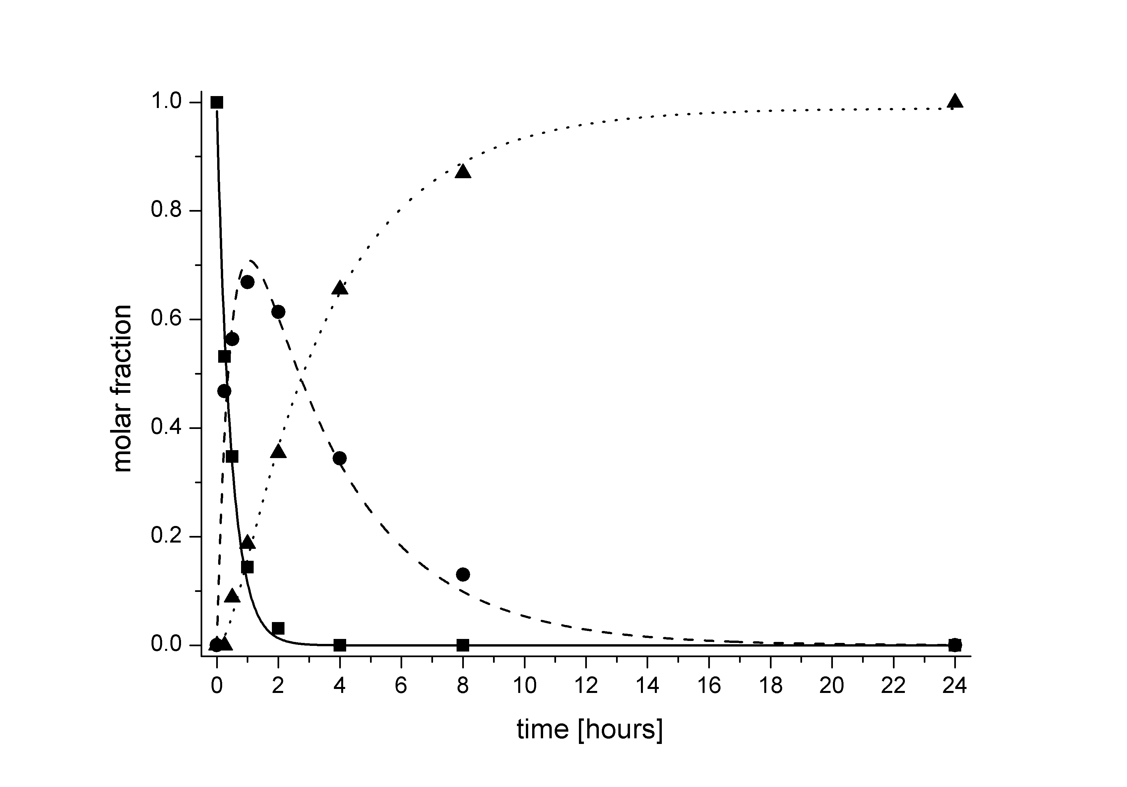
Figure 2. Kinetics of Ni(II) dependent peptide bond hydrolysis of the Ac-QAASSHEQA-am peptide at pH 8.2 (20 mM Hepes) and 50 °C. Squares – substrate, circles – IP, triangles – products.
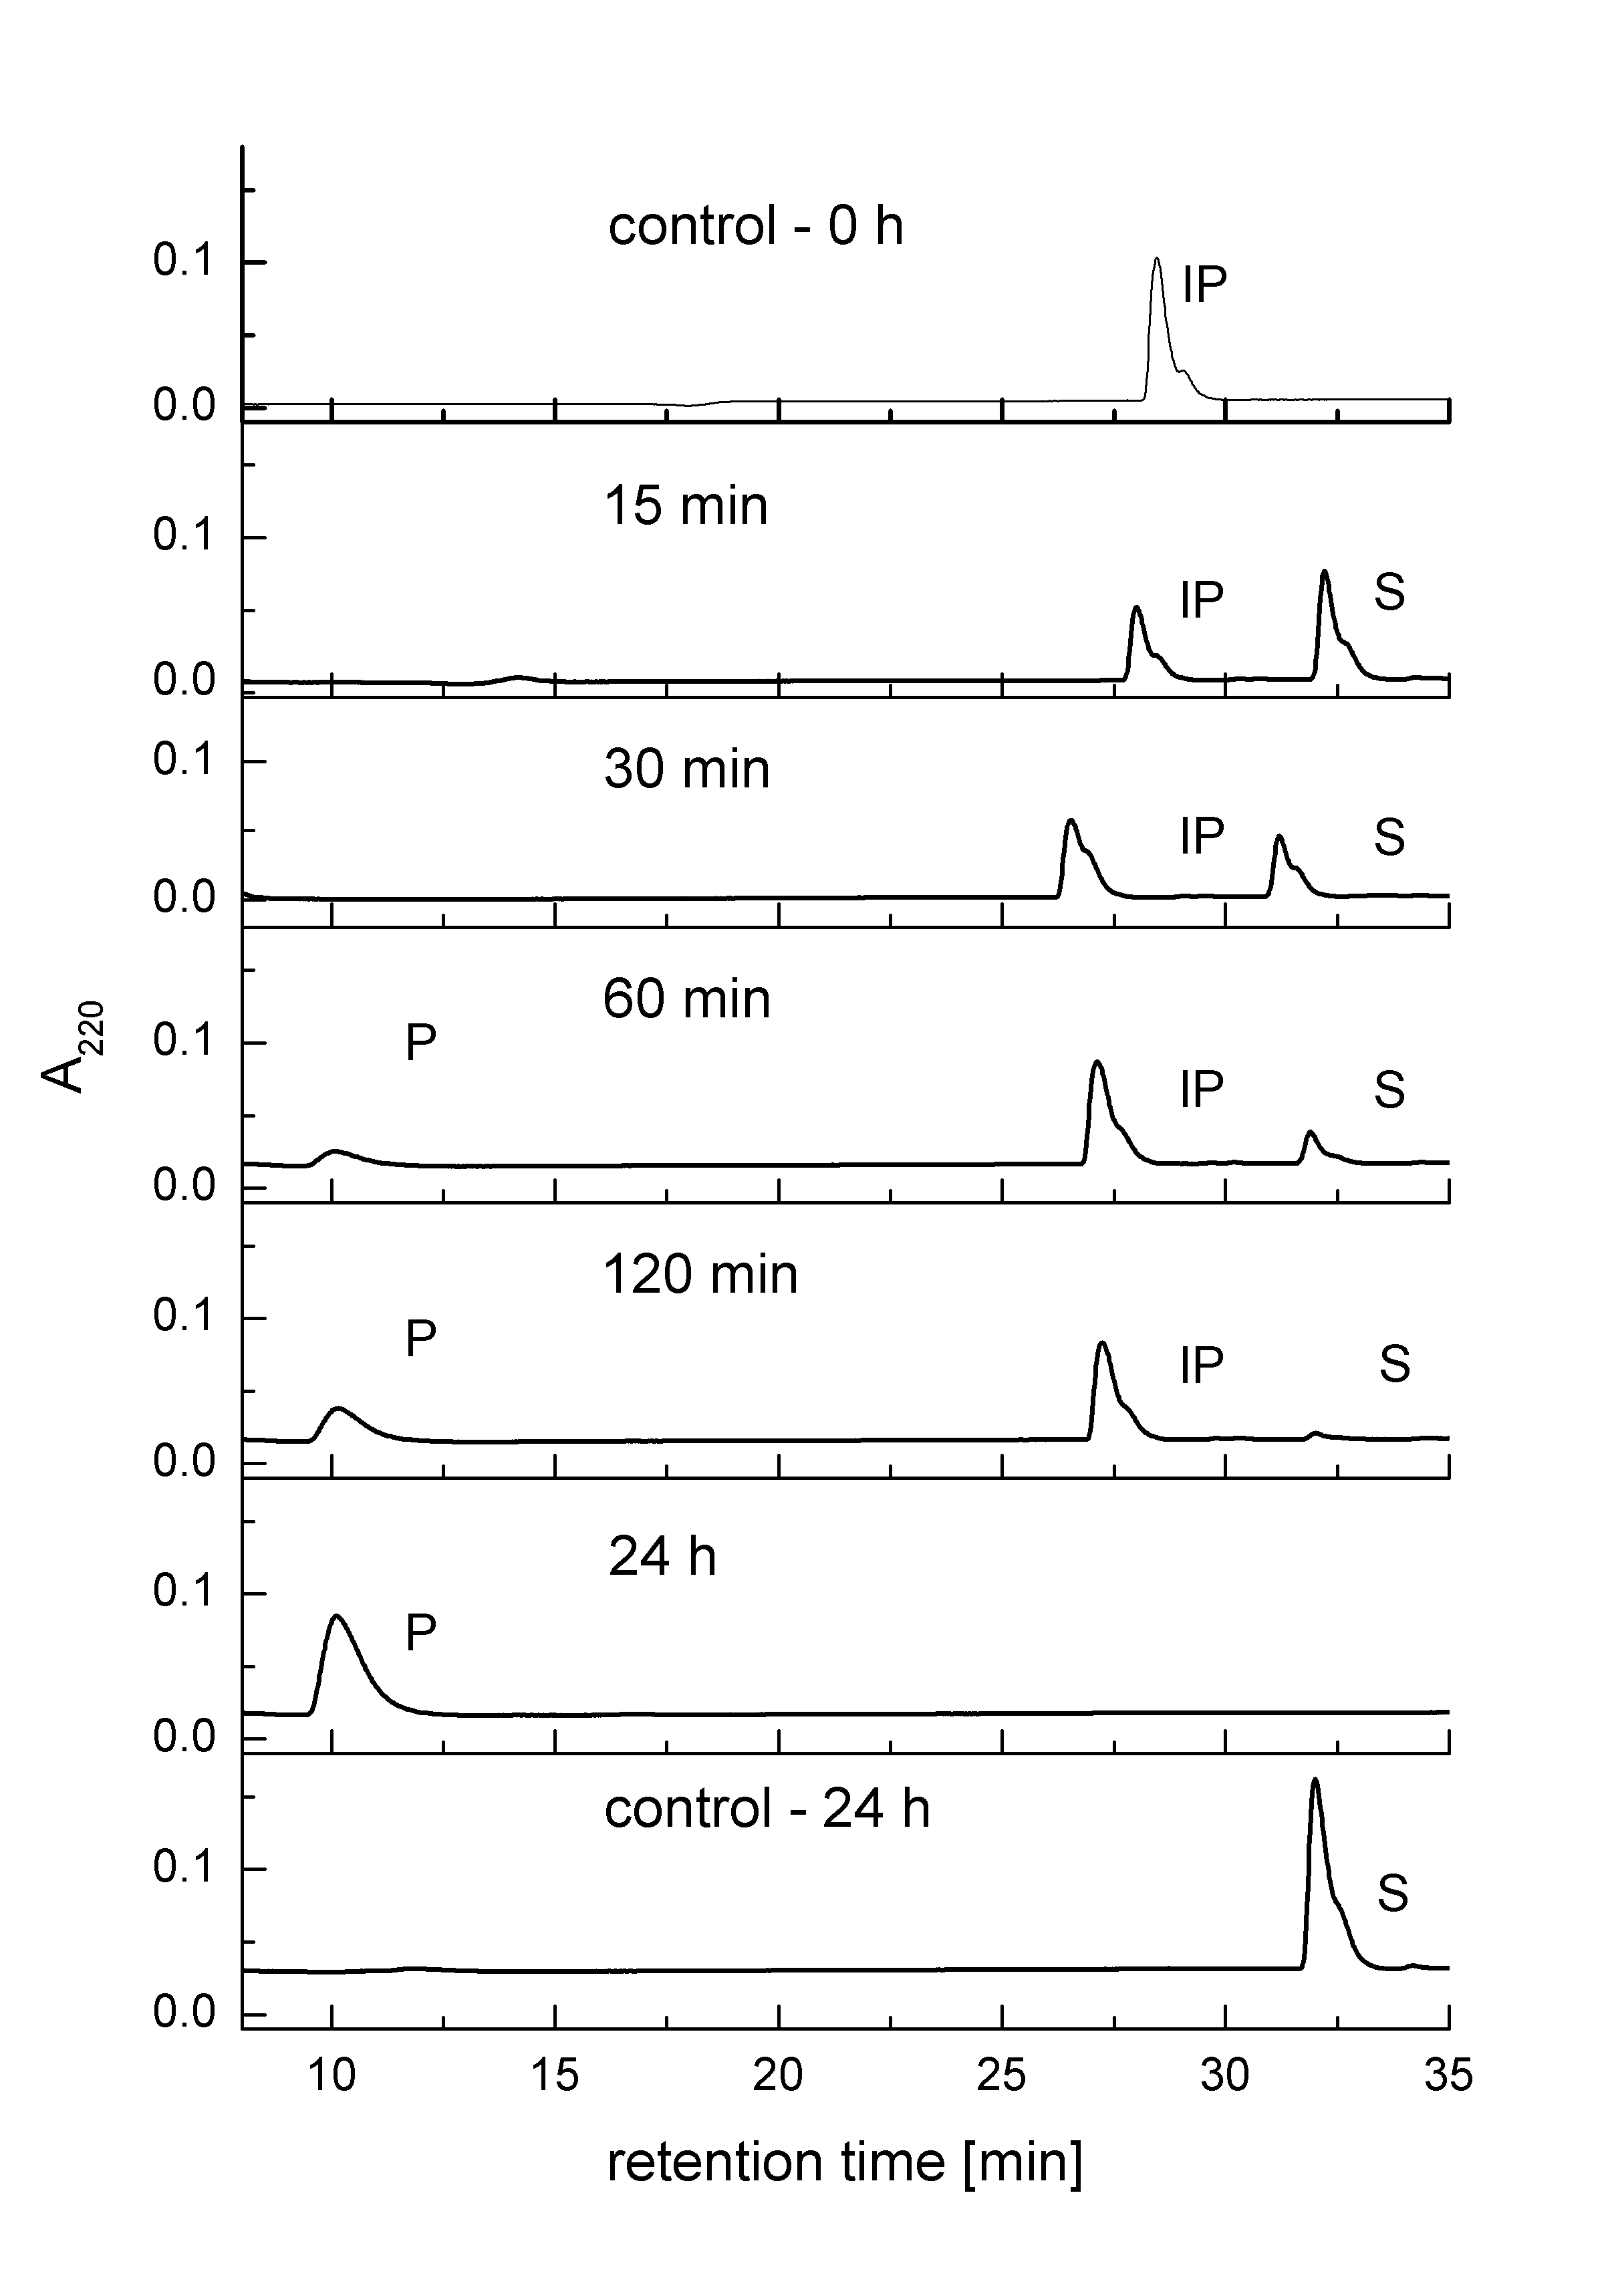
Figure 3. The examples of HPLC chromatograms of reaction mixtures initially containing 0.5 mM IP, 2 mM NiNO₃ and 20 mM HEPES buffer, pH 8.2, incubated at 50°C. The top panel shows the control run of the lyophilized IP, while the bottom panel shows the chromatogram of the control sample without Ni(II) ions, incubated under the same conditions. Incubation times are showed on the plots. Peak labels mark the reaction substrate Ac-QAASSHEQA-am (S), IP (IP) and hydrolysis products (P), identified using ESI-MS.
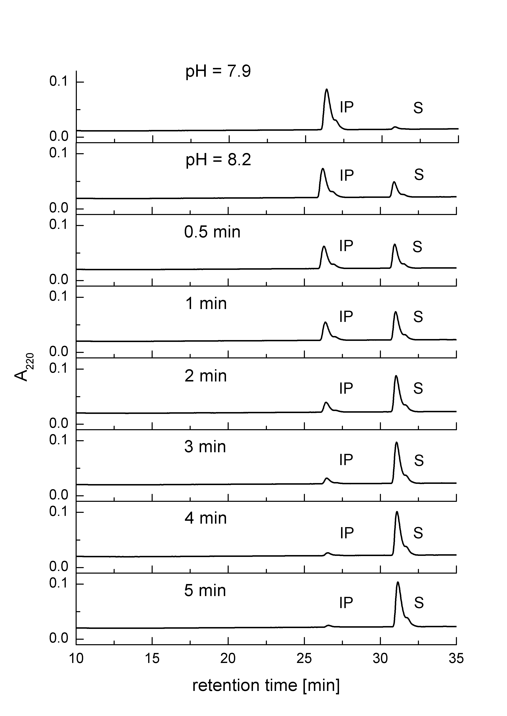
Figure 4. The examples of HPLC chromatograms of reaction mixtures initially containing 0.5 mM IP and 20 mM HEPES buffer, pH 8.2, incubated at 50°C. Incubation times are showed on the plots, except of the two topmost panels, which show chromatograms of samples collected before and after setting the pH to 8.2 at ambient temperature. Peak labels mark the reaction substrate Ac-QAASSHEQA-am (S), and IP (IP).
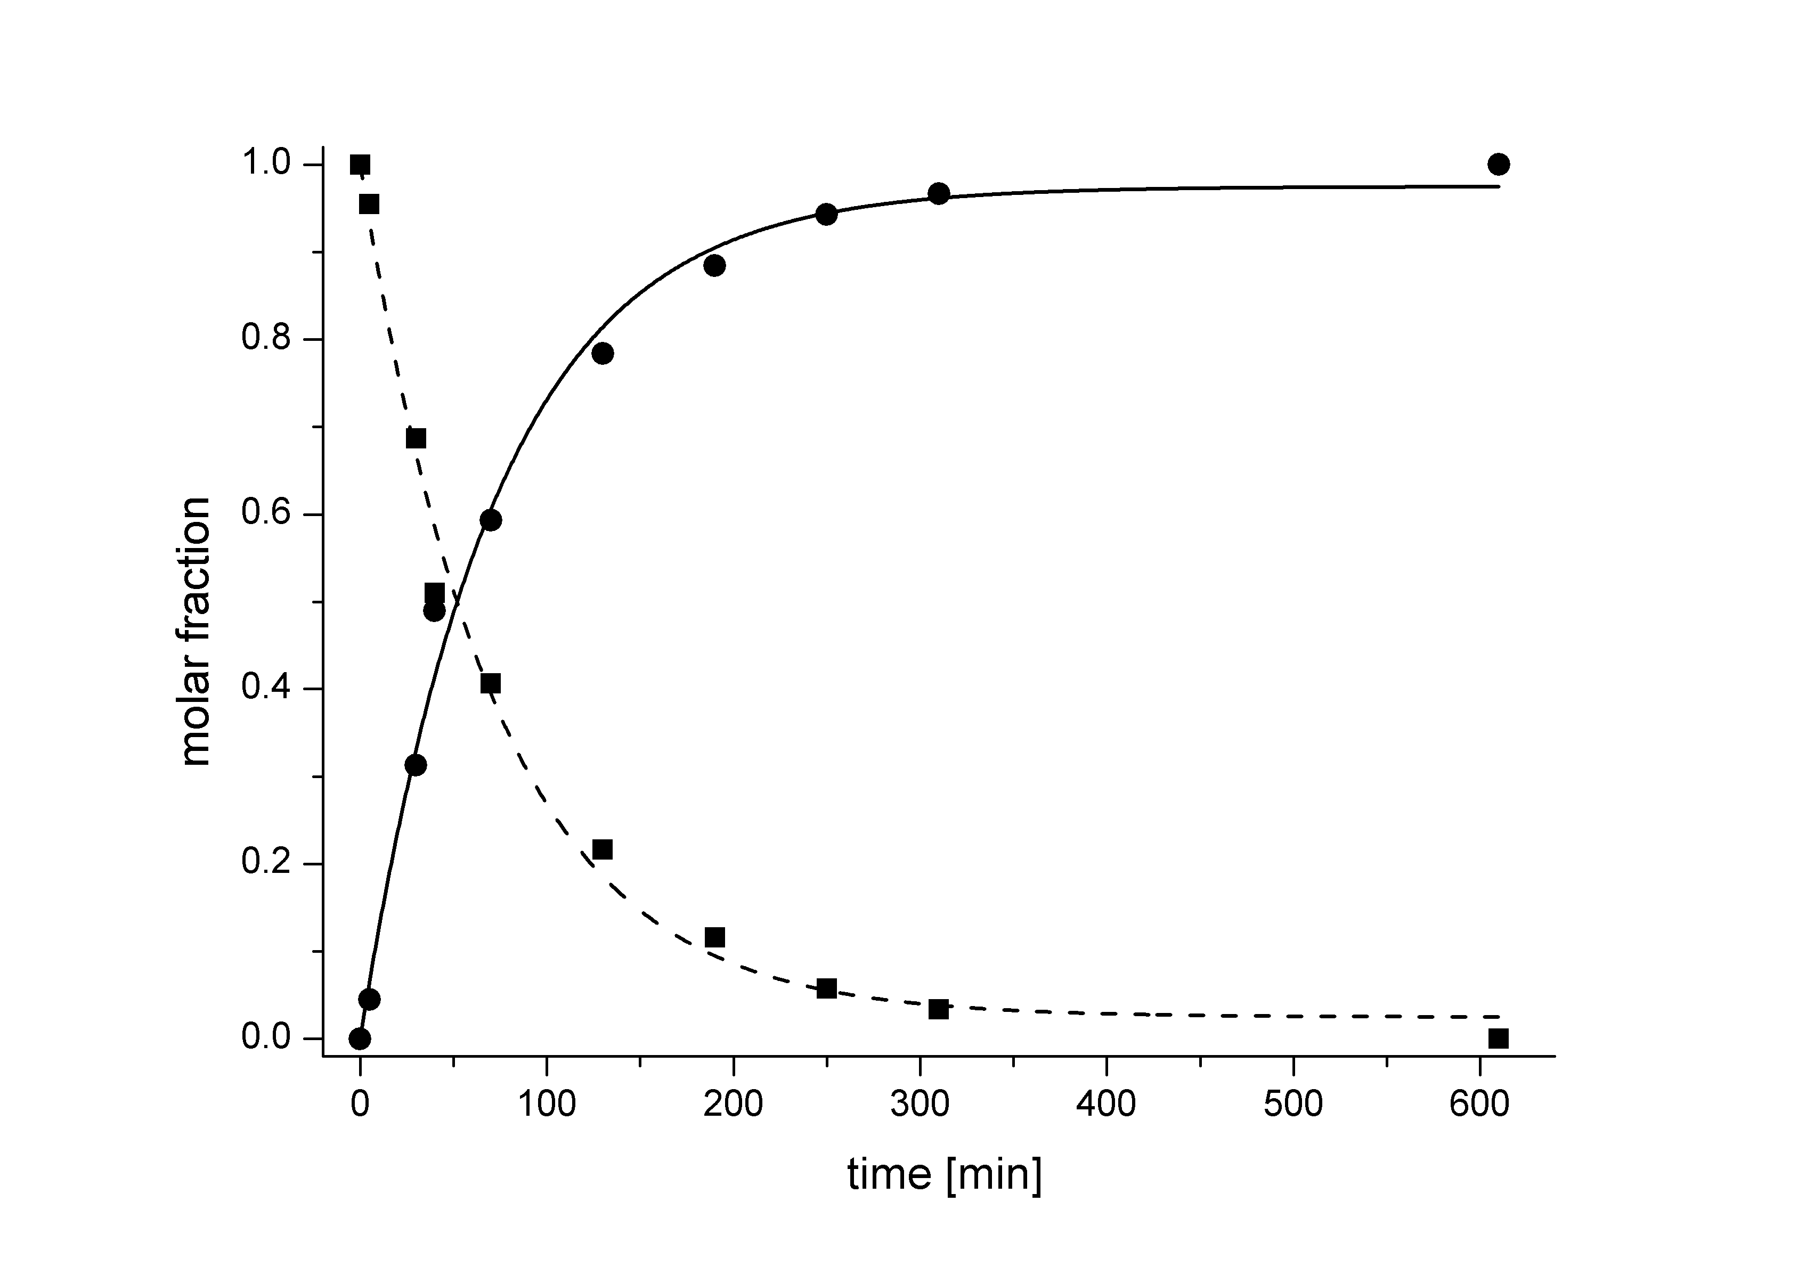
Figure 5. Kinetics of conversion of 0.5 mM IP (squares) into substrate (circles) at 50 °C and pH 8.2 (20 mM HEPES buffer).
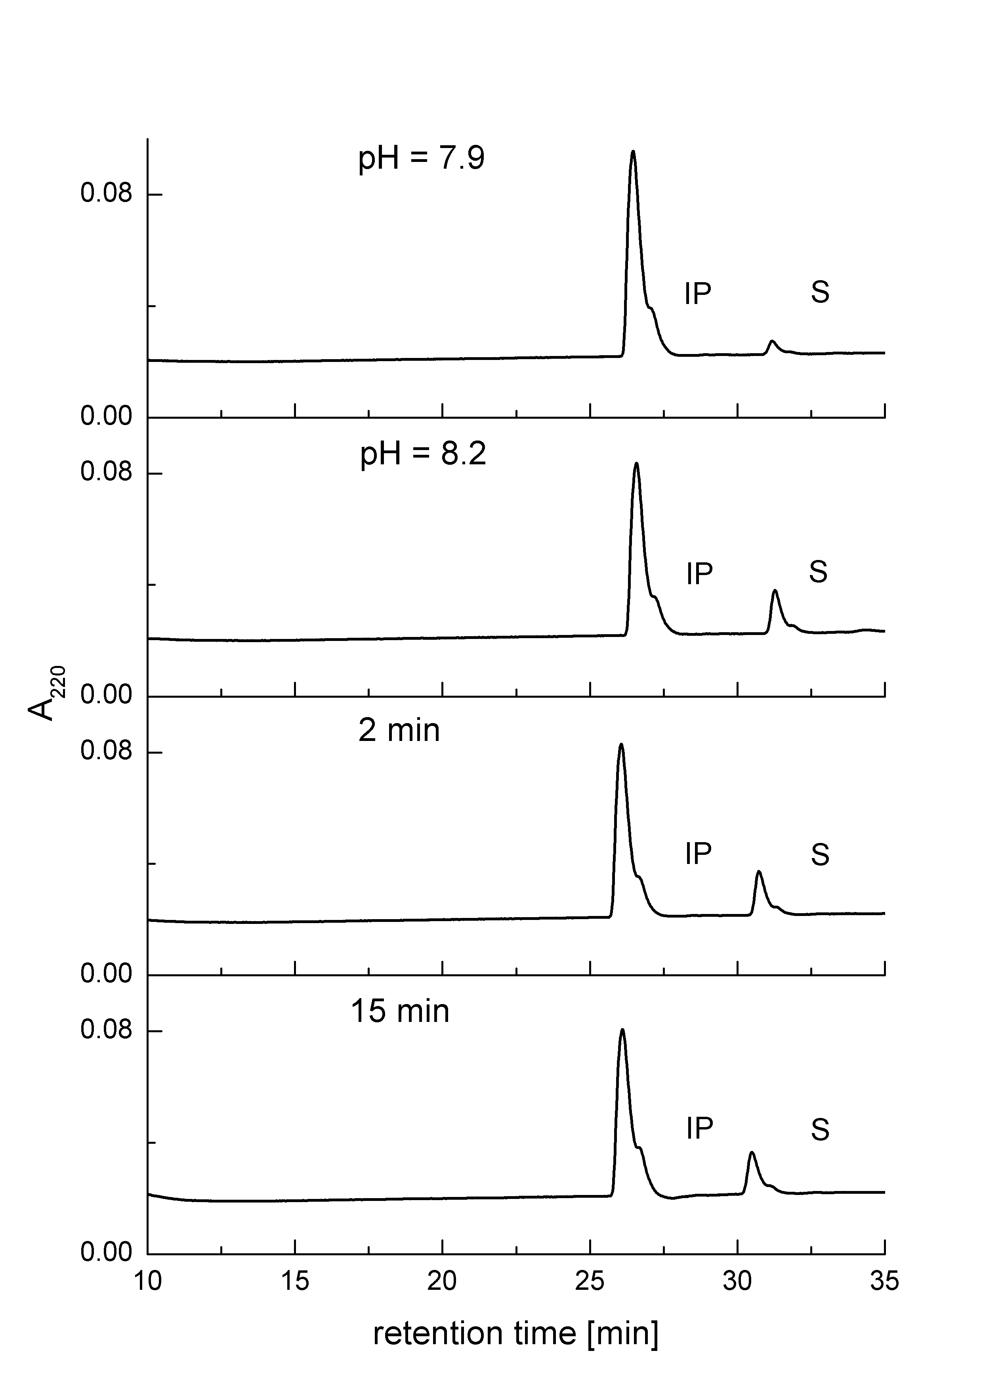
Figure 6. The examples of HPLC chromatograms of reaction mixtures initially containing 0.5 mM IP, 0.5 mM CuSO₄ and 20 mM HEPES buffer, pH 8.2, incubated at 50°C. Incubation times are showed on the plots. except of the two topmost panels, which show chromatograms of samples collected before and after setting the pH to 8.2 at ambient temperature. Peak labels mark the reaction substrate Ac-QAASSHEQA-am (S), and IP (IP).

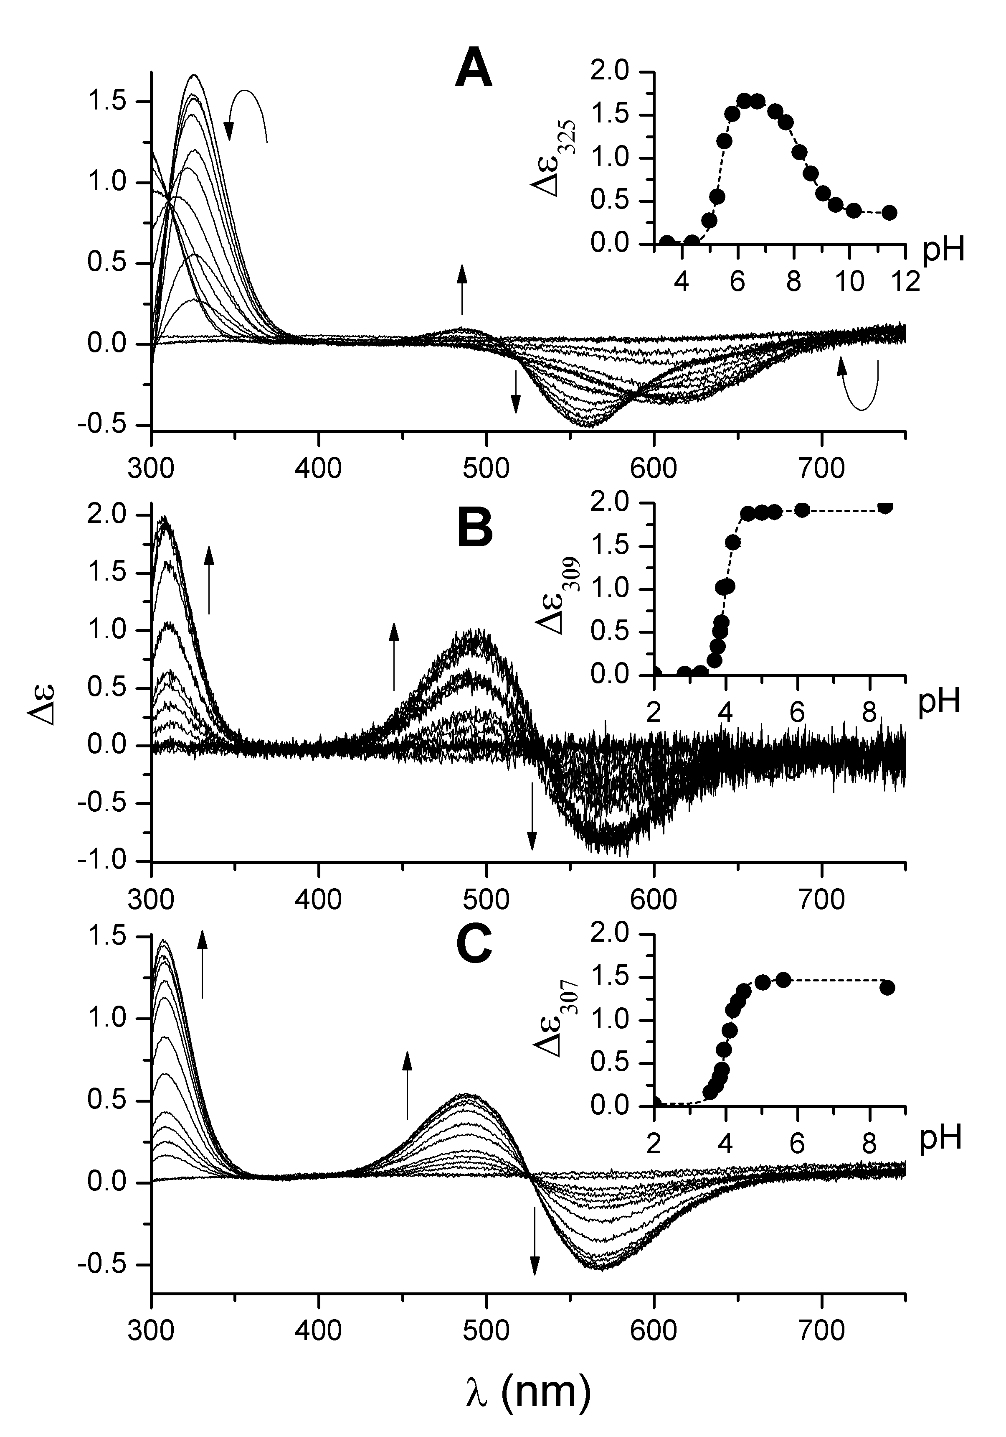
Figure 7. The CD spectra of Cu(II) complexes of S (A), IP (B) and P (C), recorded at 25 °C. Arrows indicate the direction of changes upon the increase of pH. The insets present pH titration curves, generated using the maximum of the bands at 325, 309, and 307 nm, respectively. Standard errors of determination of Δε values for titration curves are lower than the size of the symbols.
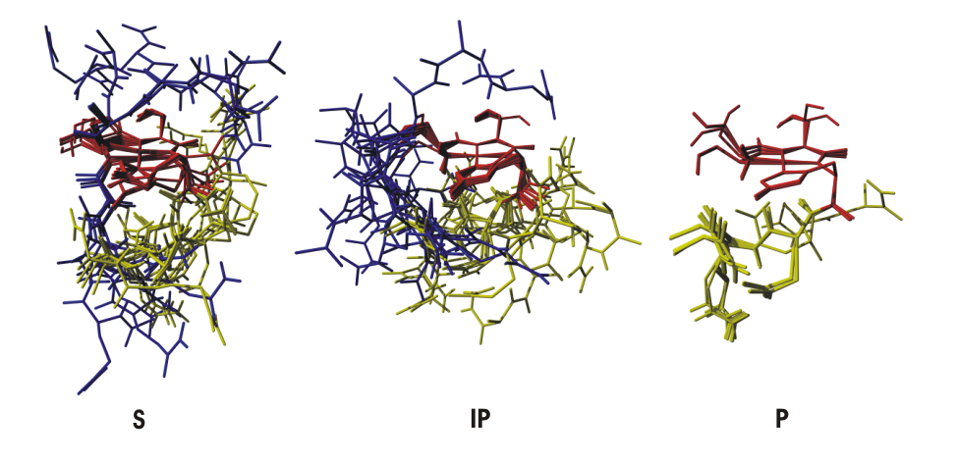
Figure 8. Calculated models of Ni(II) complexes with S, IP and P. Shown are 10 lowest energy structures superposed on atoms of Ni(II) and residues coordinated by the metal ion: Ser, Ser and His. Residues directly chelating the Ni(II) ion are colored red, the N-terminal part is in blue and the C-terminal part in yellow. Aliphatic hydrogens were omitted for clarity.
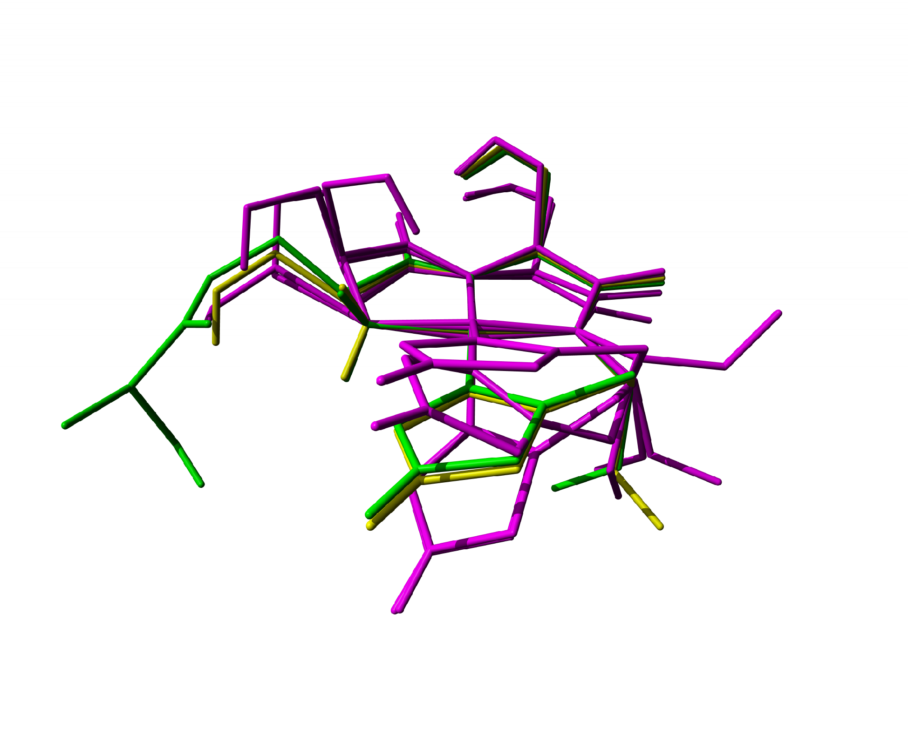
Figure 9. Lowest energy structures of Ni(II) complexes with S (magenta), IP (green) and P (yellow). Structures are superposed on amide nitrogens. Only the Ni(II)-binding residues are shown and aliphatic hydrogens are omitted for clarity. One structure each is presented for IP and P. Four distinct structures are shown for S, because of the conformational diversity of this species.
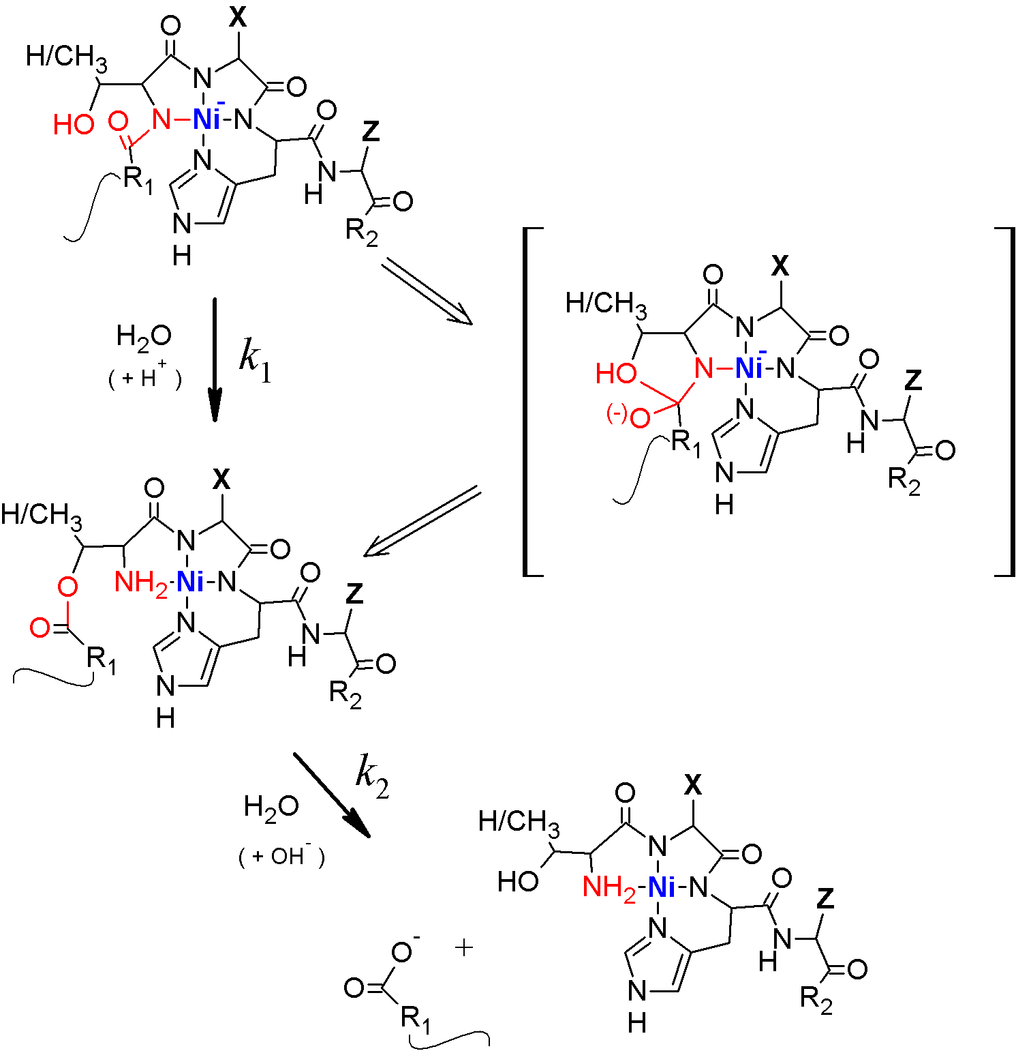
Scheme 1. The molecular mechanism of Ni(II)-assisted peptide bond hydrolysis. The experimentally available rate constants, k₁ and k₂, are associated with respective molecular structures. The postulated tetrahedral transition state is shown in brackets.
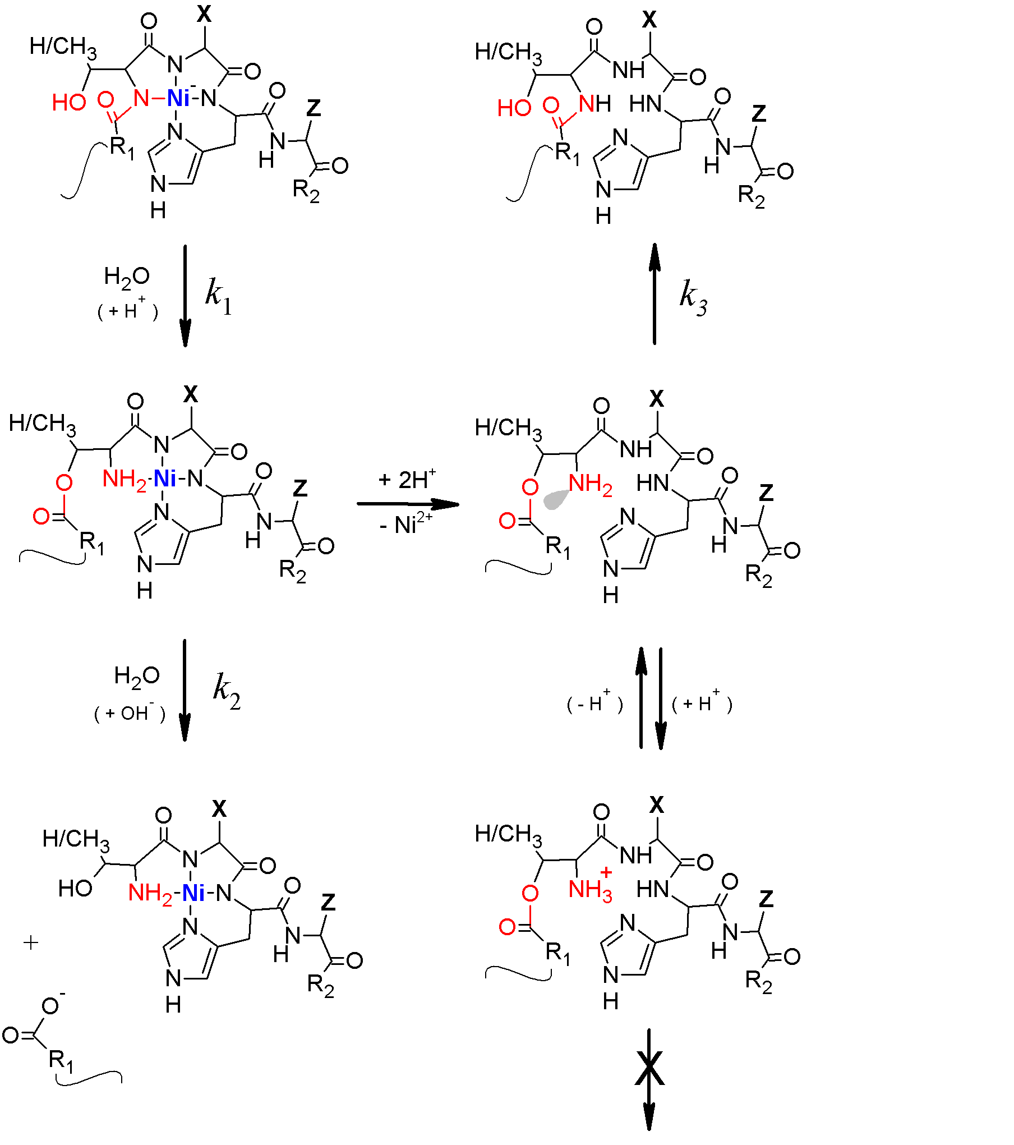
Scheme 2. The reactions studied in this work. Protonation or metal ion binding to the amine group prevents the O-N acyl shift by engaging the nitrogen’s lone electron pair (grey).
Tables

Table 1. The flow conditions in HPLC separation of reaction substrate, IP and products during Ni(II) dependent hydrolysis of the Ac-QAASSHEQA-am peptide. Solvent A was 0.1% (v/v) TFA in water, and solvent B was 0.1% (v/v) TFA in 90% (v/v) acetonitrile.
Time | % A | % B | Time | % A | % B
0 min | 99 | 1 | 32 min | 0 | 100
5 min | 99 | 1 | 33 min | 99 | 1
30 min | 94 | 6 | 40 min | 99 | 1
31 min | 0 | 100

Table 2.
The values k₁ and k₂ of the two-step sequential hydrolysis of 0.5 mM Ac-QAASSHEQA-am peptide at 50 °C and pH 8.2 in the presence of 2 mM Ni(II). Values of t_{½} are also shown. For a comparison, the value k₃ of the metal-free rearrangement of IP into Ac-QAASSHEQA-am under the same conditions is provided.
 | k (s⁻¹) | t_{½} (min)
k₁ | 6.0 ± 0.3 × 10⁻⁴ | 19
k₂ | 8.5 ± 0.5 × 10⁻⁵ | 135
k₃ | 1.4 ± 0.1 × 10⁻² | 1.2

Table 3.
The parameters of UV-vis and CD spectra of Cu(II) complexes of S, IP and P, and pK_{a} values of formation of respective complexes. Standard deviations of these values refer solely to random errors, generated by the noise in the spectra.
Species | UV-vis |  | CD |  | pK_{a} ± S.D.
Species | λ (nm) | ε (M⁻¹ cm⁻¹) | λ (nm) | Δε (M⁻¹ cm⁻¹) | pK_{a} ± S.D.
S  3N complex | 592 | 61 | 607  535sh  325 | -0.34  -0.13  +1.66 | 5.37 ± 0.02
S  4N complex | 564 | 81 | 640sh  560  486  290 | -0.08  -0.50  +0.09  +1.45 | 8.30 ± 0.02
IP  4N complex | 524 | 133 | 573  493  309 | -0.85  +0.86  +1.93 | 3.98 ± 0.02
P  4N complex | 526 | 88 | 568  489  307 | -0.50  +0.50  +1.38 | 4.03 ± 0.03

